

AdventureWorks Cycles’ Database Design and Implementation
Databases and Application Development – ACCA5026
Lucy Boyt - 2308345

Data Security and Compliance – ACCA5034
Lucy Boyt - 2308345

Contents
Introduction 2
Database Creation 3
Database Design 3
Database Implementation 4
Insert Data and Test constraints 9
Rollback and Commit 12
Transactional Scenario 12
Rational behind the operations: 13
Performance Tuning Enhancement 17
REFERENCES: 20
APPENDIX: 21

Introduction
AdventrueWorks Cycles is a leading bicycle manufacturer that has been influential in the cycling industry for over two decades. The business offers a diverse range of bicycles, including road, mountain, hybrid models, and an array of cycling accessories.
In an attempt to modernise the business's operations and expand its demographic reach, AdventureWorks Cycles is looking to establish an online marketplace to provide a comprehensive experience for its clientele. The marketplace will allow users to explore, purchase and customise items with the assistance of leading manufacturers.
The company acknowledges the importance of creating a robust and scalable infrastructure for data. This report will detail the intricacies of database solutions offering recommendations tailored to the needs of AdventureWorks Cycles' online cycling marketplace.

Database Creation

Database Design
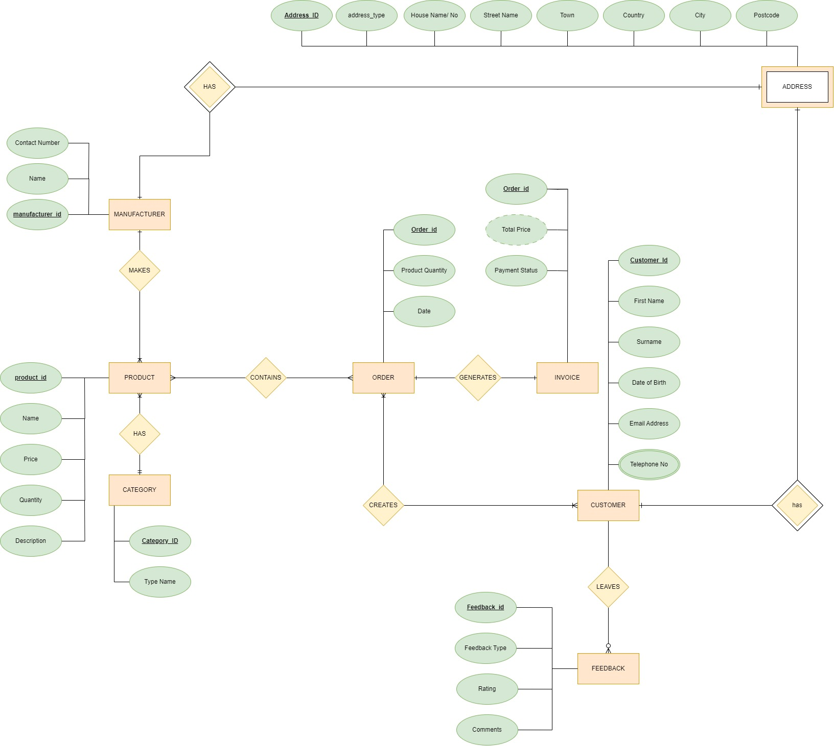
Figure 1 - Entity Relationship Diagram
Normalisation is an important technique required when designing a database. It helps improve efficiency, consistency and accuracy, making it easier to maintain and manage the data whilst ensuring the database is adaptable to the business’ ever-changing needs.
Normalisation eliminates redundancy by minimising duplicate data by breaking it into smaller related tables. It prevents anomalies when updating, deleting or inserting data into the database, ensuring data integrity. It enhances scalability and reduces unnecessary data storage. [1]
An unnormalised database will hold redundant data without constraints. First Normal Form (1NF) will ensure a table has a primary key, ensures each column have atomic values and removes repeated groups. Second Normal Form (2NF) carries the same features as 1NF; however, it also ensures that every non-candidate key is fully functionally dependent on any candidate key. Third Normal From (3ND) builds on 1NF and 2NF by eliminating non-key attributes which depend on another non-key attribute (Transitive dependency).

Database Implementation
Once the database has been created, tables need to be designed and implemented to store the data effectively. Each table represents a specific entity within the system, and it is structured to include columns which correspond to the attributes of that entity. The design of these tables considers Primary Keys, Foreign Keys, Constraints and Indexes.
Within these tables, the use of numeric (INT & DECIMAL), character (TEXT, VARCHAR), enumeration (ENUM) and date (DATE) data types are used to define the data that can be held by each attribute. Primary Keys are set using AUTO_INCREMENT which allows a unique number to generate when a new record is added. Foreign keys are used to allow tables to be linked, referring to the primary key in a different table.
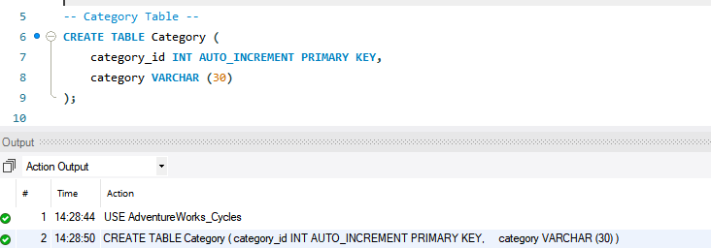
Figure 2- Creation of Category Table
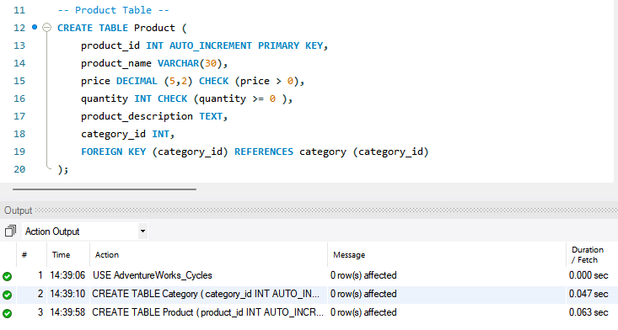
Figure 3 - Creation of Product Table
NOT NULL is used within the Address table and customer table as a constraint to enforce mandatory fields. This ensures that certain fields always contain a value. REGEX is also used within a constraint in the Address Table to validate the postcode ensuring a UK postcode has been entered by the user. The expression accepted allows for the first and second characters to be letters, followed by a single digit or the letter ‘R’, an optional letter and or space, a further single digit, and, to end, two further letters. [2]
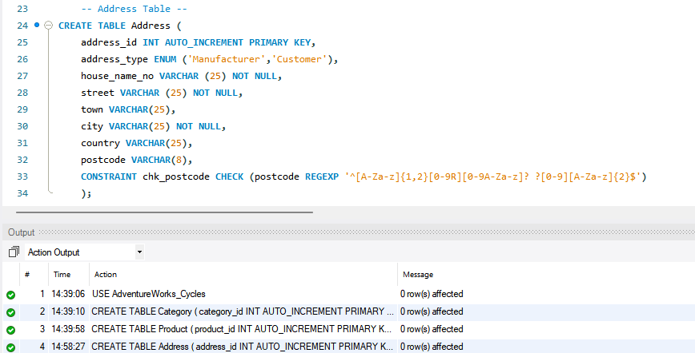
Figure 4 - Creation of Address Table

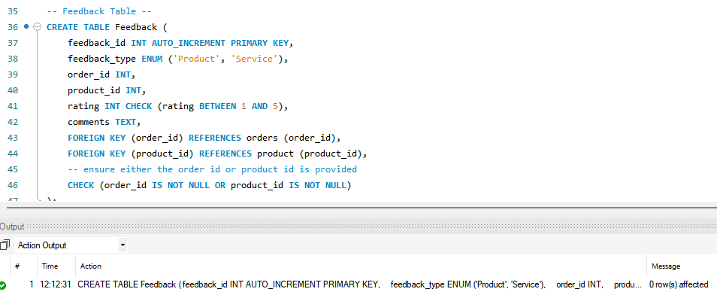
Figure 5 - Creation of Feedback Table
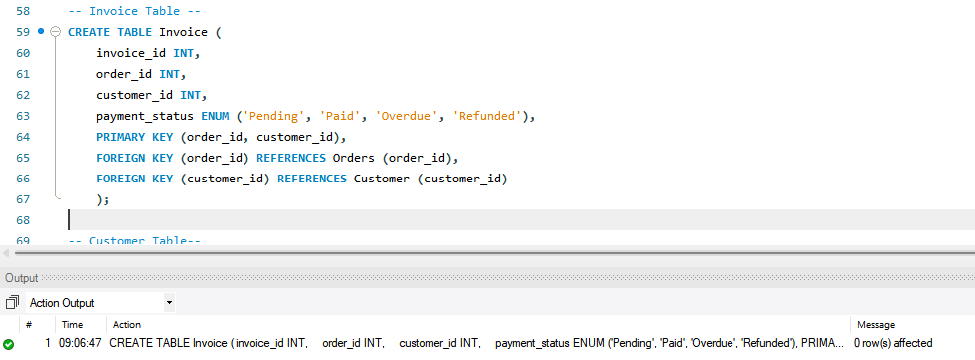
Figure 6 - Creation of Invoice Table
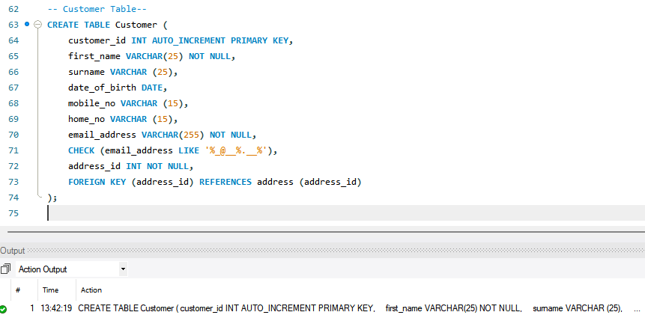
Figure 7 - Creation of the Customer Table
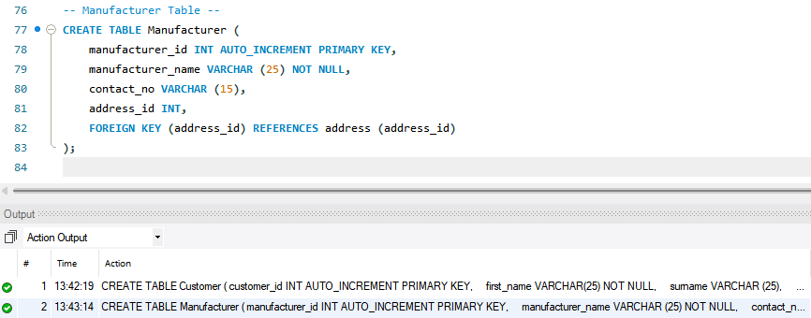
Figure 8 - Creation of Manufacturer Table
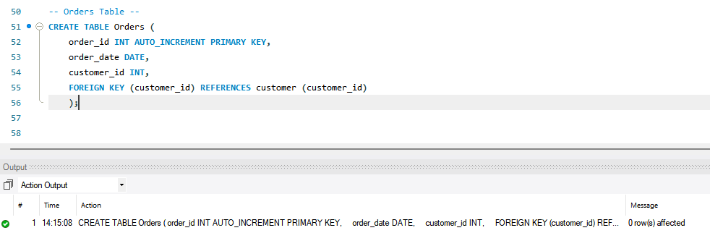
Figure 9 – Creation of the Order table
The use of a composite key can be seen within the Order_details table and the Invoice table. In the order_details the primary key is made up of order_id and product_id, ensuring that each product can appear once per order.
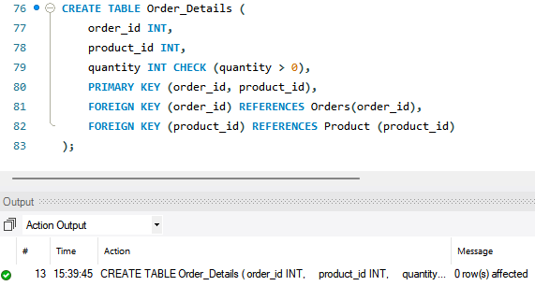
Figure 10 - Creation of Order Details Table

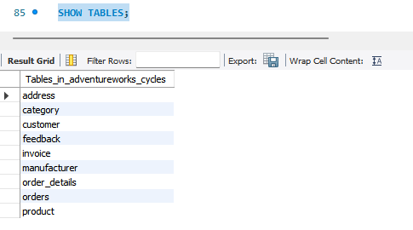
Figure 11 - Show all Tables

Insert Data and Test constraints

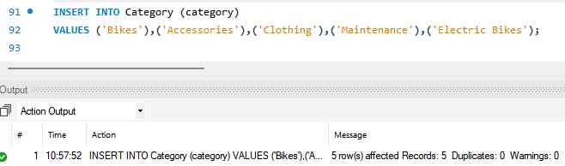
Figure 12 - Insert category values
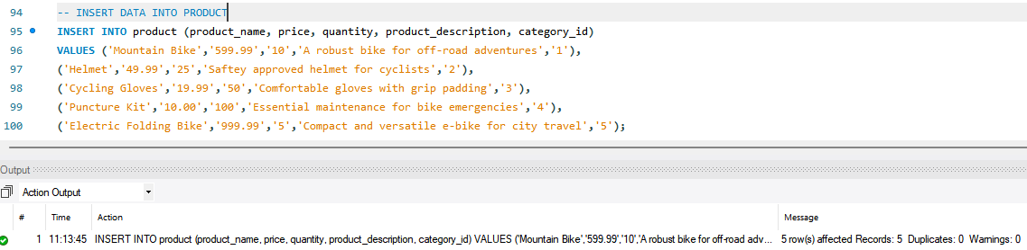
Figure 13 - Insert Product Values
CHECK is used within the Product, Customer, Address, Feedback and Order Details tables to restrict the user input. The use of this constraint enforces specific rules which act as a tool to maintain data integrity.

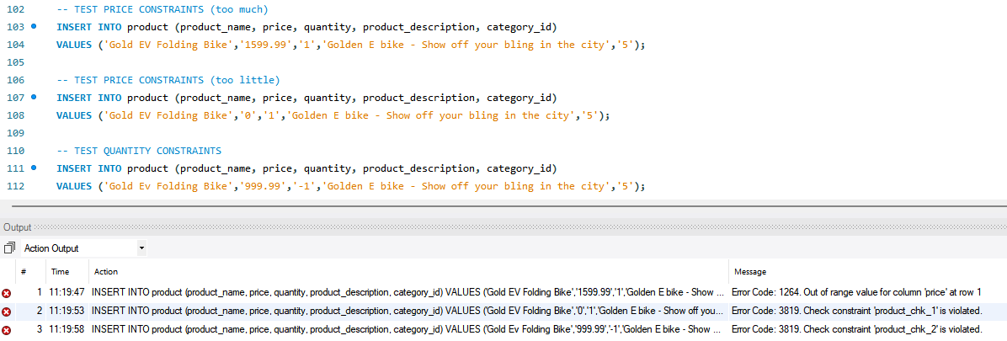
Figure 14 - Check constraints for Category values
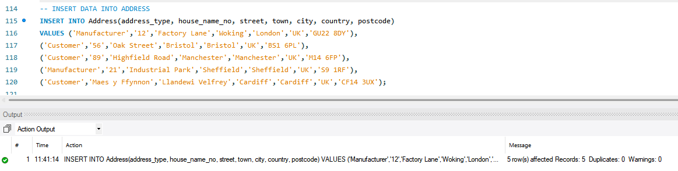
Figure 15 - Insert data into the Address Table

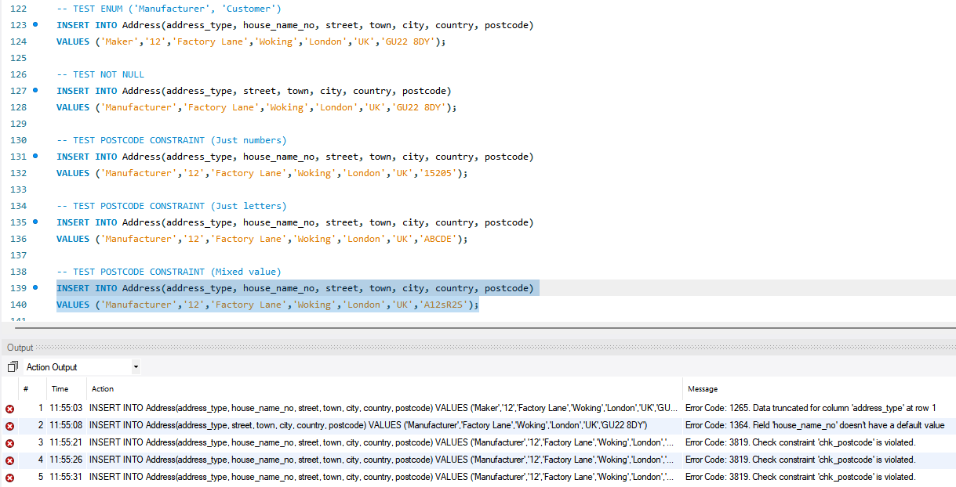
Figure 16 - Postcode, Not Null and Enum Constraints
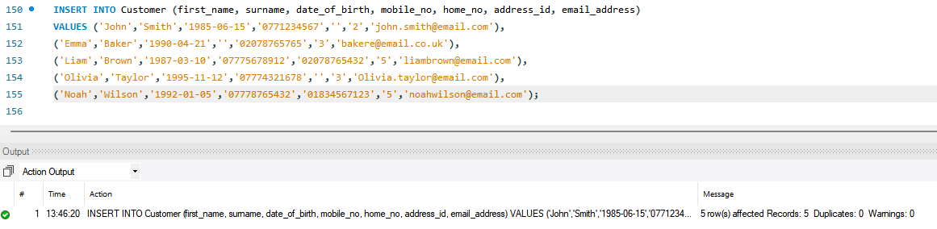
Figure 17 - Insert Data into the Customer table
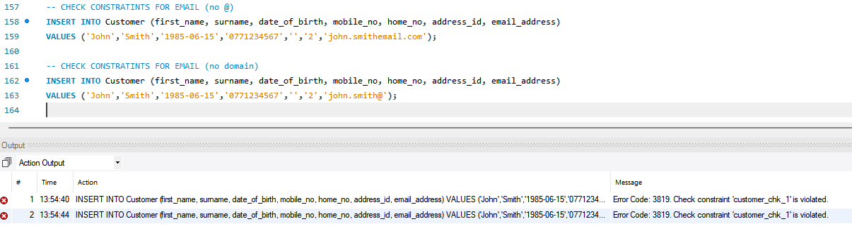
Figure 18 - Check constraints for email address
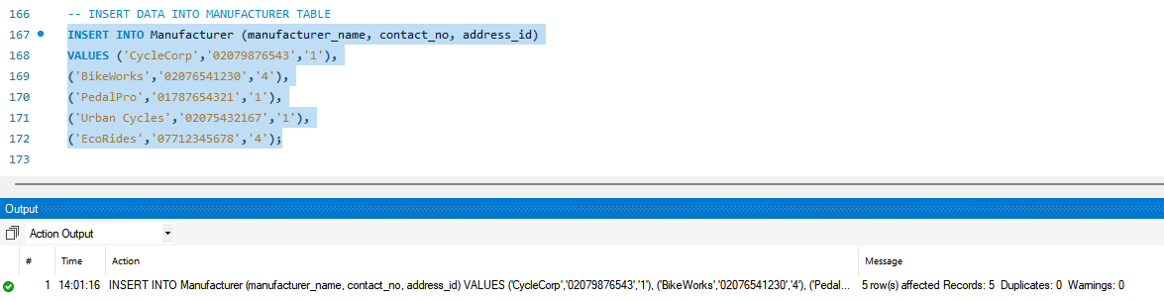
Figure 19 - Insert data into Manufacturer Table
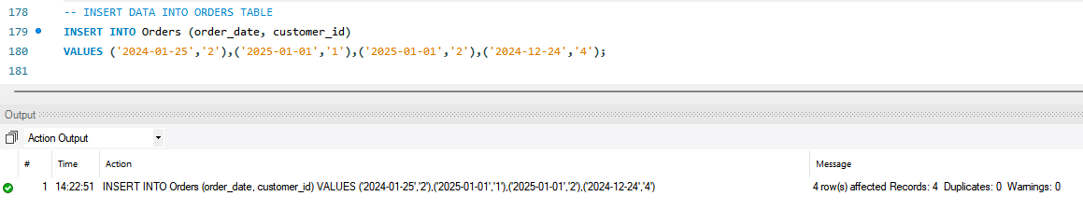
Figure 20 - Insert data into Order Table

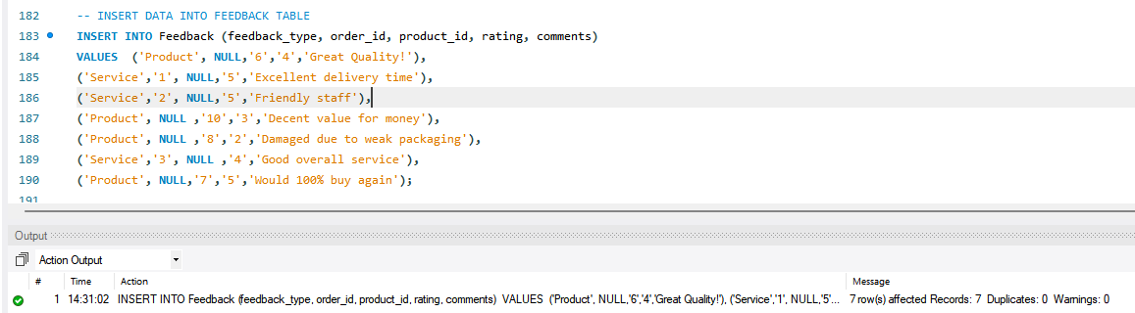
Figure 21 – Insert into Feedback Table
Within the feedback table, restrictions are added with the use of CHECK constraints to ensure feedback is linked to a product_id and/or an order_id. The feedback rating is also limited to between 1 and 5, restricting users from inputting a larger scaled amount, ensuring consistency.
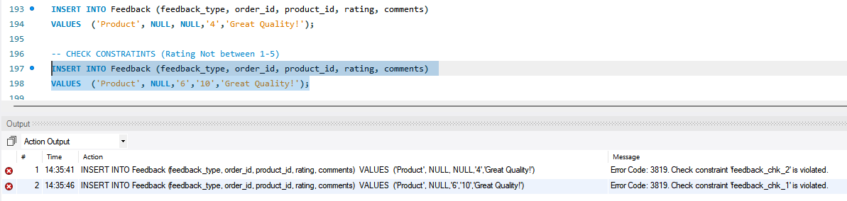
Figure 22 - Check constraints on OR and BETWEEN limits
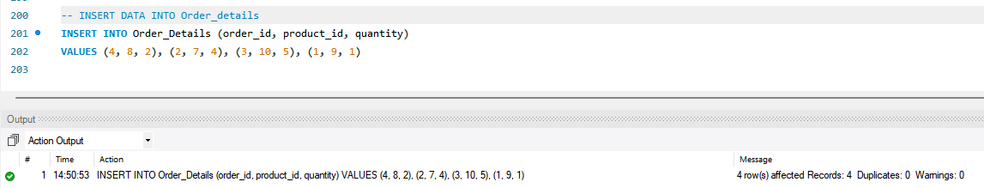
Figure 23 - Insert data into the Order_Details Table
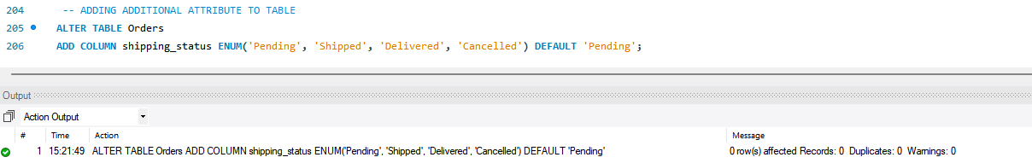
Figure 24 - Adding an attribute to the Orders table
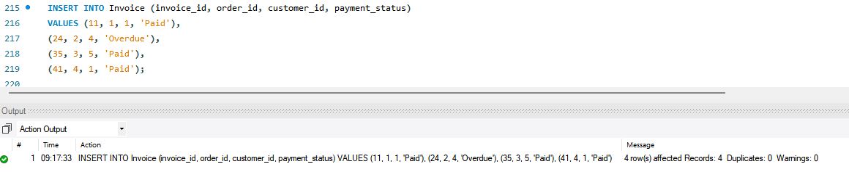
Figure 25 - Adding data into the Invoice Table

Rollback and Commit

Transactional Scenario
Database management systems allow manipulation of data by multiple users; as such, the environment requires a form of isolation to prevent uncontrolled and undesired transactions. As multiple users can engage in a database at any given time, there is a risk that a user will engage in tasks with tentative information that may be changed by others, impacting their task. As such, it is important to protect the database as the changes may invalidate what work has been completed, and the user will need to retract the actions taken within the system.
Haerder and Reuter advised that in order for transactions to achieve indivisibility, it must have four properties: Atomicity (All or nothing either is fully successful or it fails), Consistency (Each successful transaction commits only valid results), Isolation (Transaction events are hidden from others, which allows them to run concurrently) and Durability (Once committed to the system it must be guaranteed to survive any future failures.)[3] [4] [5]
Process_order is designed to manage the full cycle of an order, ensuring that all required conditions have been met before shipping an order to the customer. It follows a step-by-step transactional approach to validate the order, verify stock availability and payment completion and update the database. If any step fails, the transaction is rolled back to maintain data integrity in line with the required atomicity property.

Rational behind the operations:
Preparing for and starting the transaction:
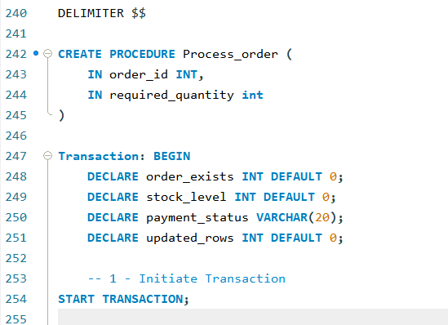
Figure 26 - Preparation and Start Transaction
The Delimiter statement indicates to MySQL that the semicolon delimiter has been redefined to prevent it from ending the definition prematurely.
CREATE PROCEDURE defines the procedure in MySQL with the name Process_Order; it holds the input parameters, which in this scenario would be the order number and the requested stock.
Transaction: BEGIN is a labelled block which allows the transaction to be exited throughout the process should the requirements not be met and the statement leads to a LEAVE statement.
BEGIN indicates the start of the transaction block (initiating the transaction), grouping the statements that follow together.
DECLARE is used to state variables within the transaction and where required sets the pre-set values of Integers to 0.

START TRANSACTION follows to start the transaction in MySQL, indicating to the system that what follows will be part of the transaction until a commit or Rollback is encountered.

The following statements check if the order exists and is in a pending state. By ensuring that the order is valid and ready for processing there is a prevention of unnecessary operations if the order does not exist or it has already shipped.

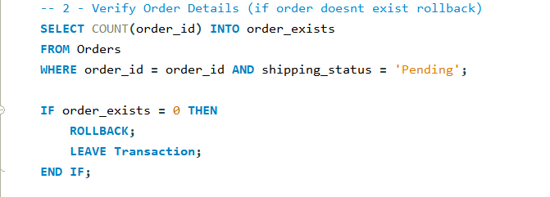
Figure 27 - Verify Order Exists
SELECT Count () INTO counts the input criteria and enters the aggregated amount into the variable.

IF the value in the variable equals 0 then any changes are rolled back as the order has not been traced and the transaction ends. If the variable does not equal 0 the transaction continues, and the next statement will be executed.

The next statement ensures that there is sufficient stock in the warehouse to fulfil the order. It does so by calculating the minimum stock level across all products within the order and rolls back if any product is out of stock, preventing over-committing inventory.
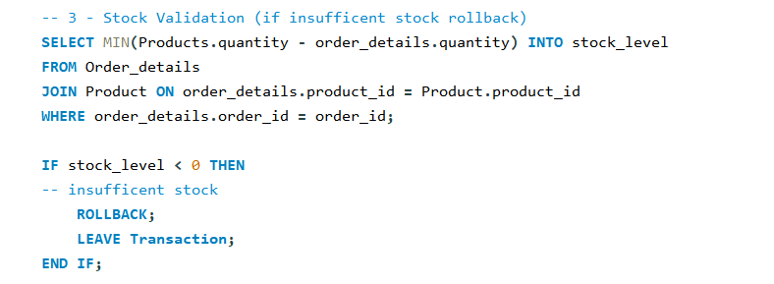
Figure 28 - Validate stock availability
SELECT MIN () INTO selects the minimum stock level across each product within the users order and maps the value to the variable. Like the previous statement if the variable value equals 0 the transaction is rolled back to the start and the transaction ends, in all other cases the transaction continues, and the next statement is checked.
The following statement checks if the payment has been marked as paid, preventing the shipment of orders which have not been paid for ensuring financial and operational accountability. 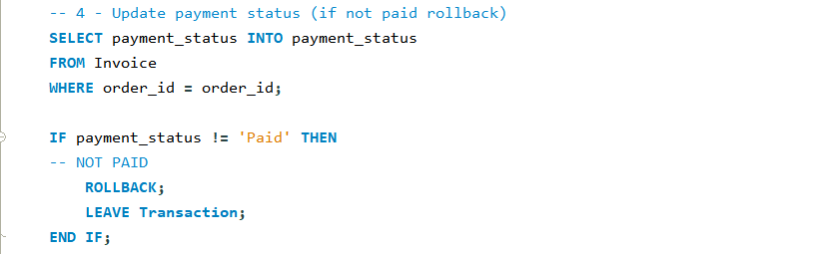
Figure 29 - Confirm payment status = Paid
SELECT INTO places the payment status into the variable of the same name. If the status is not marked as Paid then the transaction is Rolled Back and the transaction ends. If the status is marked as Paid then the IF statement ends and the next statement is run.
Now that the order has been identified, the stock is confirmed as available and the payment has been received the stock levels need to be updated to reflect the change, the following statement reduces the stock quantity for the products within the order ensuring accurate stock tracking.
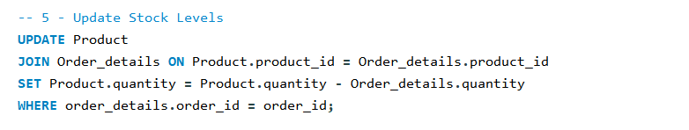
Figure 30 - Update the stock holding
Update stipulates the table which needs updating, joining the relevant tables together to set the product quantity from the calculation (product id (product quantity held – ordered quantity).
The shipping statement must then be updated to mark the products as shipped, this indicates the order has been processed and is in transit providing clarity for downstream operations such as tracking and delivery.
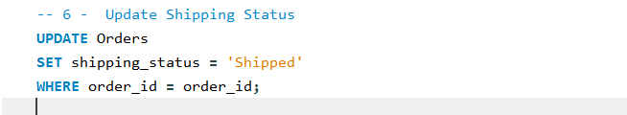
Figure 31 - Update shipping status
The principle of these operations are the same as the previous statement, Update indicates which table requires updating followed by what is being changed (Shipping_Status) which matches the order_id.
The next statement validates that the shipping status has been successful which prevents inconsistent data if the update fails. 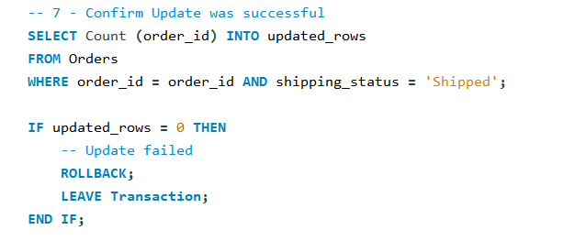
Figure 32 - Validate the database has been updated with shipping status
Similar to the initial validation checks this statement counts the number of Order_id’s that match ‘Shipped’ adding the aggregated value into the variable updated_rows. If the value when checked still equals 0 then the update has failed and the transaction will rollback and end. If the value does not equal 0 then the update was successful and the transaction can be Commit to the database.
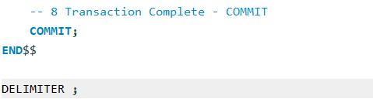
Commit finalises the transaction making the changes permanent.
END$$ marks the end of the stored procedure and DELIMITER ; is reset to the MySQL default.

Performance Tuning Enhancement
Query optimisation ensures that SQL queries execute as efficiently as possible. Queries without using indexes need to be repeatedly scanned throughout all records regardless of whether the record required is the initial record scanned, this can have a negative impact on the overall system performance as queries consume larger CPU cycles increasing operational costs and can lead to bottlenecks as the dataset increases. [6]
Secondary Indexes can speed up the retrieval of rows by adding an index to commonly filtered columns. Some example queries AdventureWorks would use frequently include The retrieval of any orders and their details by the shipping status or payment status, Lists of all products ordered and the retrieval of email addresses for marketing.
With the use of Explain Analyze a user will be presented with information about the query execution plan. Which helps to identify bottlenecks and possible optimization.[7]
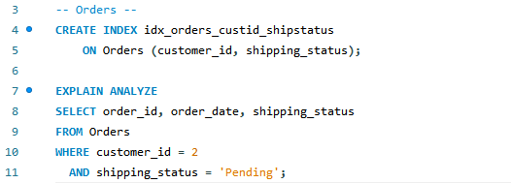
Figure 33 - Secondary Indexes on Orders using customer_id and shipping_status
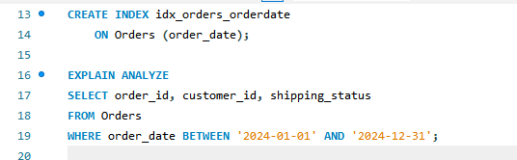
Figure 34 - Index on Order date
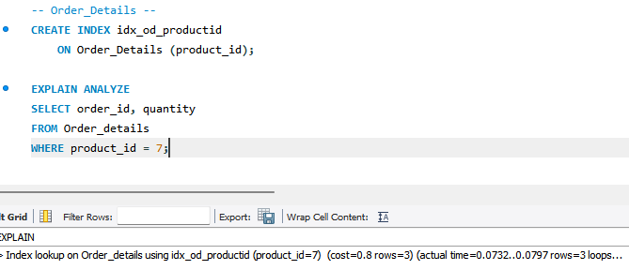
Figure 35 - Order details index using product id

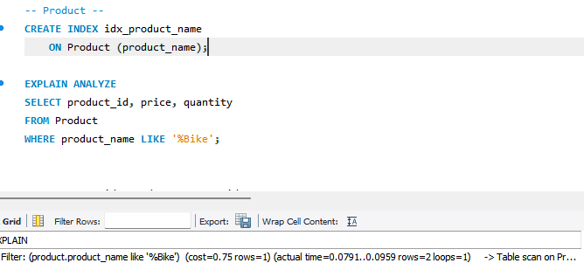
Figure 36 – Index product name for streamlined queries
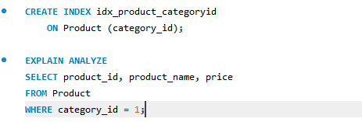
Figure 37 – Index using product Category id

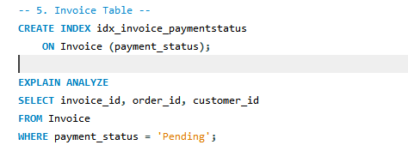
Figure 38 - Invoice Table index by Payment status

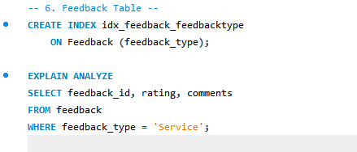
Figure 39 – Index by feedback type allowing all service feedback to be retrieved in one query.

REFERENCES:
[1] E. Eessaar. E. Eessaar. The database normalization theory and the theory of normalized systems: Finding a common ground. The database normalization theory and the theory of normalized systems: Finding a common ground. Baltic Journal of Modern Computing Baltic Journal of Modern Computing 44pp. 5–33. pp. 5–33. 2016. .
[2] Anonymous (-01-31 22:45:45+00:00). MySQL | Regular Expressions (Regexp). Available: https://www.geeksforgeeks.org/mysql-regular-expressions-regexp/.
[3] T. Haerder and Reuter Andreas. T. Haerder and Reuter Andreas. Principles of transaction - oriented database recovery. Principles of transaction - oriented database recovery. Computing Surveys Computing Surveys 1515(4), pp. 287–317. pp. 287–317. 1983. Available: file:///C:/Users/L-A_J/Downloads/Principles_of_Transaction-Oriented_Database_Recove.pdf.
[4] T. M. Connolly and C. E. Begg. T. M. Connolly and C. E. Begg. Database Systems : A Practical Approach to Design, Implementation, and Management Database Systems : A Practical Approach to Design, Implementation, and Management (2nd ed., rev. and updated by / Thomas M. Connolly, Carolyn E. Begg ed.) 1999.
[5] T. Halpin. T. Halpin. Information Modeling and Relational Databases : From Conceptual Analysis to Logical Design Information Modeling and Relational Databases : From Conceptual Analysis to Logical Design (1st ed.) 2001Available: https://ebookcentral.proquest.com/lib/[SITE_ID]/detail.action?docID=298493.
[6] S. Faroult. S. Faroult. SQL Success : Database Programming Proficiency SQL Success : Database Programming Proficiency 2013.
[7] Anonymous Anonymous MySQL :: MySQL 8.0 reference manual :: 15.3.1 START TRANSACTION, COMMIT, and ROLLBACK statements. MySQL :: MySQL 8.0 reference manual :: 15.3.1 START TRANSACTION, COMMIT, and ROLLBACK statements. Available: https://dev.mysql.com/doc/refman/8.0/en/commit.html.

APPENDIX:
I acknowledge the use of ChatGPT [https://chatgpt.com] on 03/01/2025 to support my research using the prompt(s):
1. I have been given the following information in lectures regarding index. What are the key takeaways from these slides: Indexing 桠Create and implement indexes to improve their performance 桠Serve as pointers associated with the data of a particular table. ¬A SQL index is used to retrieve data from a database very fast. ¬A SQL index is a quick lookup table for finding records users need to search frequently 24 What Exactly is an Index? • The index can be sorted or unsorted and a pointer from each record points to their corresponding record in the original table where the data is actually stored 26 Indexes An index improves the speed of data retrieval by creating a pointer to the data in a table. CREATE TABLE products ( id INT AUTO_INCREMENT PRIMARY KEY, name VARCHAR(100), category VARCHAR(50), price DECIMAL(10, 2) ); Indexes INSERT INTO products (name, category, price) VALUES ('Laptop', 'Electronics', 999.99), ('Smartphone', 'Electronics', 499.99), ('Desk Chair', 'Furniture', 150.00), ('Coffee Table', 'Furniture', 200.00), ('Headphones', 'Electronics', 89.99), ('Monitor', 'Electronics', 299.99), ('Bookshelf', 'Furniture', 120.00); Indexes CREATE INDEX index_name ON table_name (column1, column2, ...); create an index on the LastName field in the Members table to speed up searches. CREATE INDEX idx_category ON products(category); Analysing Indexes EXPLAIN ANALYZE SELECT * FROM products WHERE category = 'Electronics’; CREATE INDEX idx_category ON products(category); EXPLAIN ANALYZE SELECT * FROM products WHERE category = 'Electronics';
2. What is the difference between clustered and non-clustered indexes
I confirm that I have not presented any AI generated text as my own work. I confirm I have copies of my drafts, notes, and other resources I used before, and after the use of AI tools which I may be asked to provide in evidence.

