
Pharmacy Services
Sobia Zafar 2522561


introduction to health and Social care
LCHS4003

PHARMACY SERVICES
Pharmacy services provide patients with medicines and healthcare advice. Pharmacists are highly trained healthcare professionals who ensure that medicines are used safely and effectively. Pharmacy services are available in community pharmacies, hospitals, GP practices, and other healthcare settings.
💊 WHAT ARE PHARMACY SERVICES?
• Dispense prescription medicines
• Provide healthcare advice
• Deliver vaccinations
• Support long-term conditions
• Promote healthy lifestyles


Brief History of Pharmacy Services
Timeline
1841
- The Pharmaceutical Society of Great Britain was established.
1948
- The National Health Service (NHS) was created, making pharmacy services an important part of public healthcare.
1980s–1990s
- Pharmacists began providing more patient-centred services rather than only dispensing medicines.
2005
- New NHS pharmacy contracts expanded pharmacists' clinical roles.
2020s
- Community pharmacies play a key role in vaccination programmes, health screening, and prescribing services.

This Photo by Unknown Author is licensed under CC BY
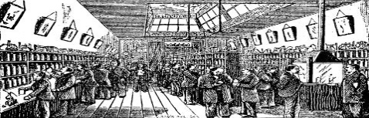







This Photo by Unknown Author is licensed under CC BY





🔄 HOW PHARMACY SERVICES WORK
PATIENT
↓
COMMUNITY PHARMACY
↓
Advice • Medicines • Vaccinations • Referrals
↓
BETTER HEALTH OUTCOMES

This Photo by Unknown Author is licensed under CC BY
This Photo by Unknown Author is licensed under CC BY-SA



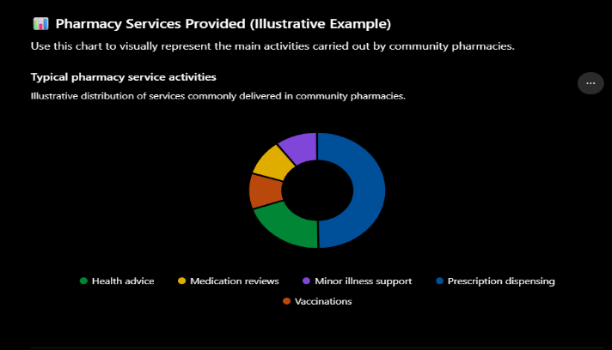
🏥 TYPES OF SERVICES
Essential: Prescriptions, medicine disposal, health advice
Advanced: Vaccinations, blood pressure checks, smoking cessation
Clinical: Medicine reviews, long‑term condition support

⚠ CHALLENGES FACED BY PHARMACY SERVICES
📊 KEY FACTS
• Over 1 billion prescriptions dispensed annually in England
• Millions of vaccinations delivered through pharmacies
• Helps reduce pressure on GP practices and hospitals
• One of the most accessible healthcare services
- Pharmacy services play an important role in supporting public health (NHS England, 2024).
- Community pharmacies provide a range of clinical services (NHS, 2024).
- Pharmacists are highly trained healthcare professionals (Royal Pharmaceutical Society, 2024).

Pharmacy service

Workforce Shortages
• Increased workload
• Longer waiting times
• Staff pressure
• Recruitment difficulties

CHALLENGES FACED BY PHARMACY SERVICES
Increasing Demand
• Ageing population
• More long‑term conditions
• More prescriptions
• Pressure on resources

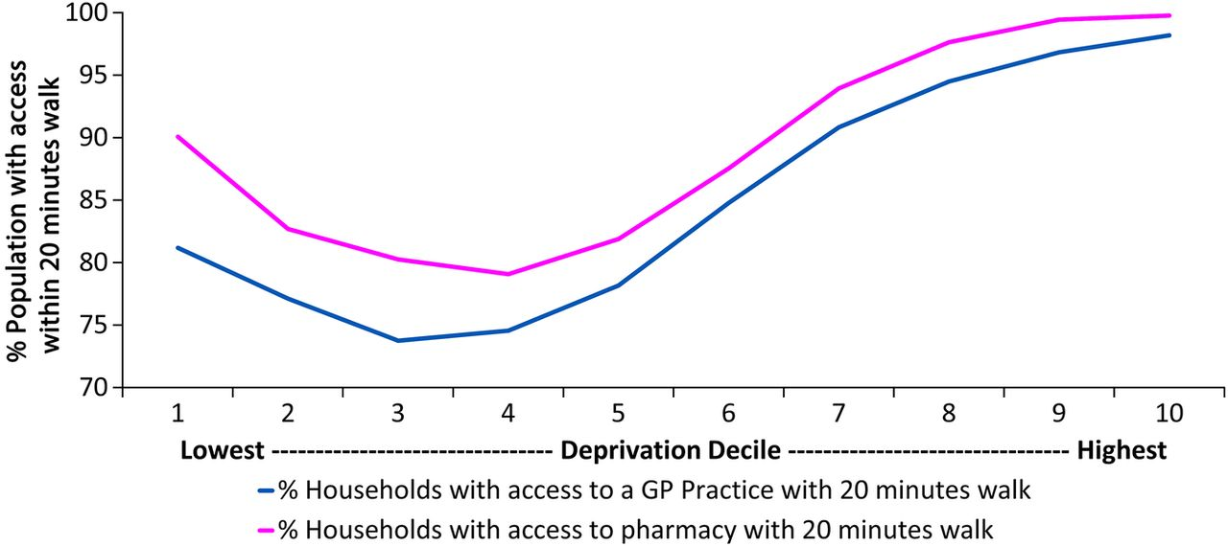
✔ CONCLUSION
Pharmacy services are a vital part of the NHS. They provide safe access to medicines, healthcare advice, vaccinations, and preventative care while reducing pressure on GP surgeries and hospitals.

NHS England (2024) Community pharmacy services. Available at: https://www.england.nhs.uk/primary-care/pharmacy/ (Accessed: 4 June 2026).
NHS (2024) How pharmacies can help. Available at: https://www.nhs.uk/nhs-services/pharmacies/how-pharmacies-can-help/ (Accessed: 4 June 2026).
Royal Pharmaceutical Society (2024) About pharmacy. Available at: https://www.rpharms.com (Accessed: 4 June 2026).
Pharmaceutical Services Negotiating Committee (2024) Community Pharmacy England. Available at: https://cpe.org.uk (Accessed: 4 June 2026).
General Pharmaceutical Council (2024) The role of pharmacy professionals. Available at: https://www.pharmacyregulation.org (Accessed: 4 June 2026).
Department of Health and Social Care (2023) Primary care and community pharmacy services. Available at: https://www.gov.uk/government/organisations/department-of-health-and-social-care (Accessed: 4 June 2026).
Health Education England (2023) The pharmacy workforce and future healthcare needs. Available at: https://www.hee.nhs.uk (Accessed: 4 June 2026).
National Pharmacy Association (2024) The role of community pharmacies in healthcare. Available at: https://www.npa.co.uk (Accessed: 4 June 2026).

Community Mental Health Services: Origins, Contemporary Functioning, and Significance
Community mental health services are important because they help people with mental health challenges stay in their communities. These services cover assessment, treatment, rehabilitation, and ongoing support for different mental health conditions. Learning how these services developed over time helps us understand why they are structured as they are and why they matter in today’s social care (Golightley and Holloway, 2020).
Community mental health services began to develop in the nineteenth and early twentieth centuries, a time when people with mental illnesses were usually placed in large psychiatric hospitals or asylums. These places were often separated from the rest of society and were primarily intended to contain patients rather than help them recover (Jones, 1993). By the middle of the twentieth century, people became concerned about poor living conditions, overcrowding, and the lack of personalised care in these institutions (Pilgrim and Rogers, 2014). New advances in psychiatric medicine, especially the introduction of antipsychotic drugs in the 1950s, allowed many people to manage their conditions outside of institutions (Rogers and Pilgrim, 2021).
In the United Kingdom, mental health care changed a lot in the 1960s and 1970s with the move toward deinstitutionalisation (Jones, 1993). The government began closing long-stay psychiatric hospitals and encouraged new community-based services. Laws and policies such as the Mental Health Act 1983 (United Kingdom Parliament, 1983) and the National Service Framework for Mental Health (Department of Health, 1999) helped shift care into the community. These changes reflected new social attitudes that valued human rights, social inclusion, and the idea that people with mental health conditions should be supported to live as independently as possible (Department of Health, 2011).
Community mental health services today rely on teams comprising social workers, psychiatrists, psychologists, community psychiatric nurses, occupational therapists, and support workers (Thornicroft and Tansella, 2004). These professionals work together to offer care that fits each person's needs. Services often include mental health assessments, crisis support, counselling, medication management, rehabilitation programs, and help with employment, education, and housing (Gould, 2018). Community Mental Health Teams (CMHTs) usually coordinate these efforts, ensuring people receive continuous and well-integrated care (Thornicroft, Deb, and Henderson, 2016).
Community mental health services have many strengths, but they also face some challenges. For example, the demand for mental health support has grown a lot, which has led to longer waiting times and more pressure on resources (Mental Health Foundation, 2024). Limited funding can make it harder for people to access specialist services and early intervention programmes (World Health Organisation, 2022). There are also differences in how services are provided across regions, which can lead to inequalities in care (Department of Health, 2011). Some people find it hard to navigate the system or get help during a mental health crisis (Thornicroft, Deb and Henderson, 2016). These issues show that although community-based care is usually seen as preferable to institutionalisation, there is still work to do to ensure everyone can access timely and fair support.
Community mental health services play an important role in improving the quality of life for people who use them. By offering support in familiar settings, these services help people maintain social relationships, stay connected with family, find work, and participate in their communities (Trowler, 2011). This approach to care helps people become more independent and experience less stigma than they might in institutional settings (Pilgrim and Rogers, 2014). Service users are also encouraged to be active in their own recovery, which can boost their self-esteem, confidence, and overall well-being (Department of Health, 2011).
Community mental health services help prevent hospital admissions and lower the risk of relapse by providing ongoing monitoring and early support (Thornicroft and Tansella, 2004). Helping people with housing, education, and jobs also addresses wider social issues that impact mental health (World Health Organisation, 2022). This well-rounded approach shows that recovery is about more than just managing symptoms; it also means reaching important life goals and being included in society (Golightley and Holloway, 2020).
To sum up, community mental health services grew out of a shift from institutional care to more person-centred and community-based support (Jones, 1993). Even though today’s services face challenges like limited resources and rising demand, they still play a key role in helping people recover, become more independent, and feel included in society (World Health Organisation, 2022). By improving the quality of life for those who use them, these services demonstrate their importance in today’s health and social care systems (Department of Health, 2011).
References
Department of Health (1999) National Service Framework for Mental Health: Modern Standards and Service Models. London: Department of Health.
Department of Health (2011) No Health Without Mental Health: A Cross-Government Mental Health Outcomes Strategy for People of All Ages. London: The Stationery Office.
Golightley, M. and Holloway, M. (2020) Social Work and Mental Health. 6th edn. London: Learning Matters.
Gould, N. (2018) Mental Health Social Work in Context. London: Routledge.
Jones, K. (1993) Asylums and After: A Revised History of the Mental Health Services from the Early 18th Century to the 1990s. London: Athlone Press.
Mental Health Foundation (2024) The Fundamental Facts About Mental Health. London: Mental Health Foundation.
Pilgrim, D. and Rogers, A. (2014) A Sociology of Mental Health and Illness. 5th edn. Maidenhead: Open University Press.
Rogers, A. and Pilgrim, D. (2021) Mental Health Policy in Britain. 4th edn. London: Palgrave Macmillan.
Thornicroft, G. and Tansella, M. (2004) ‘Components of a modern mental health service: A pragmatic balance of community and hospital care’, British Journal of Psychiatry, 185(4), pp. 283–290.
Thornicroft, G., Deb, T. and Henderson, C. (2016) ‘Community mental health care worldwide: Current status and further developments’, World Psychiatry, 15(3), pp. 276–286.
Trowler, P. (2011) Social Care and Social Work: An Introduction. Maidenhead: Open University Press.
United Kingdom Parliament (1983) Mental Health Act 1983. London: HMSO.
World Health Organization (2022) World Mental Health Report: Transforming Mental Health for All. Geneva: World Health Organization.

