Student Name: Megan Wozencroft

P Number: 1901946

Programme of Study: Photography in the Arts

Module: M4X01560

Tutor: Ryan Moule

Tasks in the order I received them:

Task One: Semiotic Analysis (Ryan Task) = 519 words

Task Two: Manifesto (Julia Task) = 510 words

Task Three: Reflective Writing (Jon Task) = 509 words

Task One: Semiotic Analysis (Ryan’s Task)

As part of our critical thinking, we have been discussing semiotics and how meaning is created, communicated, and interpreted by signs. A way in which to define semiotics is the analysis of signs and symbols. To better describe this, signs can be viewed as words, gestures, images or even numbers. All these communicate some form of meaning and can be seen each day in our everyday life. A good example of this being a red traffic light. The physical sign of the red traffic light is what is known as the signifier, showing what is actually, physically there (the literal). However, the initial concept of stopping is otherwise known as the signified (the symbolic and mental concept). The two words signifier and signified were commonly used by Ferdinand de Saussure, a semiotician. The book “Semiotics: The Basics” discusses how “Saussure’s term ‘semiology’ is sometimes used to refer to the Saussurean tradition”. The semiotician explained how the two forms of signs “would seem to violate the principle that the connection between a signifier and its signified is always arbitrary”.
Furthermore, we have also been looking into ideology. A way in which to expand on this term, ideology is a system of ideas that form a way of thinking what we are looking at isn’t reality. A good way of understanding this is by studying Rene Magritte’s ‘The Treachery of Images’, ‘Ceci n’est pas une pipe’- translating to ‘This is not a pipe’. The image clearly shows a pipe, however, it is not a literal pipe but a painting of one. A branch of philosophy known as metaphysics asks the very question, ‘what is real? And how do we define real?’.
In my opinion, semiotics is very important to understand as a photographer and interprets how individuals see your work, unconsciously seeing the signifier and the signified. It is very important to understand how the different signs and symbols work, to present the meaning I wish to within my images.
For my semiotic analysis, I have chosen to analyse the advertisement for ‘Daisy Dream’ the fragrance by Marc Jacobs.


The first and most obvious thing to discuss is how the bottle is not true to scale and is being held up as if a god like figure (being worshipped). This can be highlighted as a connoted sign, potentially implying that if you purchase this product you will be praised. Looking at the image from a more literal side of things (denoted), the bottle is being held up which appears very eye-catching.
The name of the fragrance and designer appears twice very vividly on the poster, both centred, allowing it to catch the attention of its audience – along with the bright, contrasting colours that make the poster aesthetically pleasing.
From an indexical point of view, the floral packaging could link in with how flowers are used to create a fragrance or how they are considered ‘dreamy’. Placed in the background are clouds. Clouds are more than often linked with dreams or floating on cloud 9.
To me, the advertisement doesn’t use any displacement in comparison to others we have discussed in lectures.

Bibliography
Chandler, D. (2007). Semiotics: The Basics. 2nd ed. London, Routledge. p.3

Cline, A. (2019). What is Metaphysics? ‘what is real? And how do we define real?’ Learn Religions, 25th June. Available at
https://www.learnreligions.com/what-is-metaphysics-250530. (Accessed October 12th)

Foucault, M. (1983). This Is Not a Pipe. 1st ed. America, University of California Press

Silverman, K. (1984). The Subject of Semiotics. 1st ed. America, Oxford University Press USA. p.7

Task Two: Manifesto (Julia’s Task)

- Being original in my work – look at things from a different perspective.
- Experimenting with new things – equipment, angles, going out of my comfort zone.
- Capture what I love – create work that inspires me and makes me want to continue and do my best.
- Be real – capture real moments, and allow people to feel more connected with my work.
- Be creative – think outside the box, embrace my creativity.
- Be ambitious – put determination and effort into my work in order to succeed.
- Confidence – be confident in what I produce, allow myself to meet new people and opportunities.
- Be technical – continue to experiment with editing software.

In my practice as a photographer, I believe it is very important to reflect on what I believe in and my intentions. I will begin so by writing a manifesto of my beliefs and how I wish to focus upon them more throughout my practice.
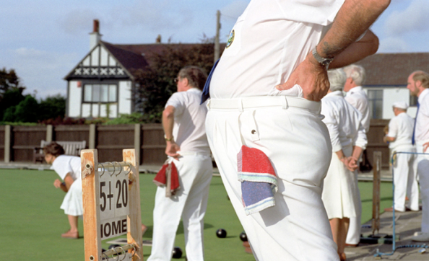

To begin with, I strongly believe that it is important to be original in my work – looking at things that I wish to capture from unique perspectives. For me, photography is about seeing things from a personal point of view, and using that to adapt and present to a wider audience. From personal experience, when looking at an artist’s work that is original, it draws me in, encouraging me to find out more about them. An example of this being the photographer Martin Parr. In Martin’s book ‘Think of England’, his work is known for being unique, which is very inspiring. He allows his audience to think in a way that is different and unusual. Personally I believe this is how, out of the many photographers I have studied, Martin Parr stands out.
Furthermore, capturing what I am passionate about, and moments I wish to treasure is important to me. Creating work that I am passionate about instantly inspires me to continue and work my hardest. I am fascinated about taking photographs of moments that I can then reflect on in the future, as well as doing so for others. When doing research, I came across an article by Photography Life, written by John Bosley. The author goes on to talk about how he found his love for photography “because it gave me the ability to capture scenes from my life to remember and study”. John discusses how he begun taking photographs of seemingly meaningless things, and evolved by creating memories not only for himself, but for his clients. I can relate to this on a personal level, and is vital for me in my practice to include my passions in my work.
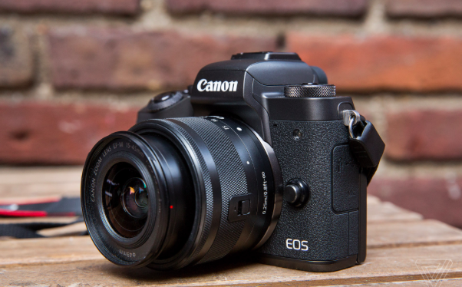

Finally, the last belief I wish to discuss is confidence. Having confidence in my work is something I feel is vital. In my opinion, each and every one of us interprets things in unique ways, especially when it comes down to art and photography. A source in which supports my belief, comes from the website Picture Correct. The author Margaret Cranford goes on to talk about how “photography is an art in which tastes and opinions vary, and so there will always be a subjective element when any photograph is being assessed”. I personally think that being creative comes with the risk of potentially being judged and not feeling confident with what you produce, but from personal experience, I have learnt that as long as I am happy and satisfied with what I produce, others will respect my work. The author of the article continues to speak upon constructive criticism.

In my opinion, I enjoy receiving constructive criticism, as it allows me to know how I can improve in order to make my work better, giving me more of a confidence boost.


Bibliography

Bosley, J. (2014). Why Do You Enjoy Photography? “because it gave me the ability to capture scenes from my life to remember and study”. October 29th. Available at https://photographylife.com/why-do-you-enjoy-photography. (Accessed November 5th).

Cranford, M. (2017). Developing Your Confidence in Photography. “photography is an art in which tastes and opinions vary, and so there will always be a subjective element when any photograph is being assessed”. Available at https://www.picturecorrect.com/tips/developing-your-confidence-in-photography/. (Accessed November 5th)

Parr, M. (2000). Think of England. 1st ed. London, Phaidon Press.

Task Three: Reflective Writing (Jon’s Task)

For my reflective writing, I have decided to look upon the artwork ‘Starry Night’ created by Vincent van Gogh in the year 1889. This infamous piece has always interested me, as it is so unique – hence its popularity. Today the iconic artwork is located at the ‘Museum of Modern Art’ in New York City. The artwork was created by Van Gogh whilst “during his stay at a mental hospital in Saint Rémy”. The piece

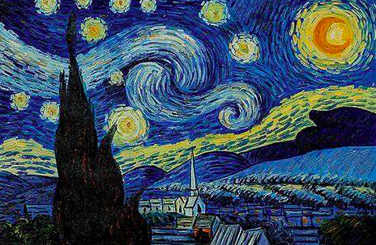

illustrates the artists take on what he saw through his window while in complete isolation. Painting was a form of escapism for the artist whilst going through this difficult time as it was one of the only things he could participate in. The shapes shown within the image are reflections of Van Gogh’s “unique state of mind at the time”. In true Van Gogh style, the work portrays subtle but eye-catching colours, mixed with unique, unrealistic patterns that stand out. It is believed that the main influence of the iconic piece was the view from the asylum window. As imagined, being in isolation there was not much going on around him for inspiration. Throughout his stay, Vincent would write frequent letters to his brother, Theo. When describing this astonishing piece, Vincent wrote, “This morning I saw the countryside from my window a long time before sunrise, with nothing but the morning star, which looked very big”. In my opinion, the sky is the main focal point of the image – highlighting the stars and the moon in bright, eye-catching colours, instantly capturing the viewer’s attention.
Van Gogh really expressed his feelings and emotions into Starry Night – going through trouble with his mental health and using that to express his thoughts and feelings in art. The piece was not very well known during the time it was created, it was only recognised when the Museum of Modern Art bought the artwork from a collector. The painting “has since become one of Van Gogh’s most famous, if not one of the most recognized, works in the art history canon”. I personally believe that its success has risen from the painting being so unique. The artwork is so aesthetically pleasing to the eye, as well as being so interesting – taking a step into the artists mindset at the time.
It is believed that the piece Starry Night really impacted modern art. Starry Night was created during the prime era of Modern Art – this time period runs between the years of around the 1860s to the 1970s. The artwork has been featured in many books regarding modern art – such as ‘History of Modern Art: Painting, Sculpture, Architecture’, which talks about the evolution of the art and some of the most successful, iconic pieces to come of it. This infamous painting has inspired me to express myself in my practice, and make my work completely original to set itself apart from anything else. It has been proven that the more unique, the more interesting. People want to know the meaning behind what is being portrayed.

Bibliography

Arnason, H. Kalb, P.(2003). History of Modern Art: Painting, Sculpture, Architecture, Photography. 5th ed. America, Prentice Hall.

N.A. (2010). “This morning I saw the countryside from my window a long time before sunrise, with nothing but the morning star, which looked very big”. Vincent Van Gogh: Emotion, Vision, and A Singular Style. Moma Learning. Available at https://www.moma.org/learn/moma_learning/vincent-van-gogh-the-starry-night-1889/. (Accessed December 15th).

Thomson, R. (2008). Vincent Van Gogh: The Starry Night. “during his stay at a mental hospital in Saint Rémy”. 2nd ed. London, Museum of Modern Art. P.3

Thomson, R. (2008). Vincent Van Gogh: The Starry Night. “unique state of mind at the time”. 2nd ed. London, Museum of Modern Art. P.3

Zelazko, A.(2017). “has since become one of Van Gogh’s most famous, if not one of the most recognized, works in the art history canon”. The Starry Night. Encyclopedia Britannica, 20th September. Availble at https://www.britannica.com/biography/Vincent-van-Gogh. (Accessed December 16th).

