A report on
Effective Team Work and Communication

Student name: Vikramkumar Mahendrakumar Patel
Student ID: 2133821
Module code: BMSW4002
Module leader (Teacher): SOBAN SADIQ
Session: T2_22/23_Oct_OV_1_GW3, SH4

Contents
Introduction 3
Illustration of different types of models of communications 4
Shannon and Weaver model of communication and its diagram 4
Analysing the case study of Maria and Pedro 5
Schramm model of communication 5
The strategy of avoiding misunderstanding in communication 6
Berlo’s model of communication 7
Difference between Berlo’s model of communication with other model of communication 8
Illustration of communication skill 8
Verbal communication 8
Non-verbal communication 9
Listening communication 9
Discussion of the case study of Professor and the village people 9
Illustration of the advantages and disadvantages of Technology in communication 10
Advantages of using modern technology in communication 10
Disadvantages of using modern technology in communication 10
Conclusion 11
References 12

Introduction
Proper communication is essential for every sector of the world. Proper communication ensures proper engagement with the speaker and the listener on a particular topic (Kurtz et al., 2017). It helps a speaker to make his audience listen to him. Moreover, misunderstanding reduces when proper communication is ensured. This report discussed many essential factors of proper communication such as different models of communication, different communication skills, and the advantages and disadvantages of Technology in communication. To analyze that thing properly, some case studies are properly evaluated also to conclude.

Illustration of different types of models of communications

Shannon and Weaver's model of communication and its diagram
Shannon and Weaver's model of communication is one of the oldest models of communication which was developed in 1948 by an American Mathematician named Shannon. He shared the proper framework for receiving and sending a message through this model (Van Dalen, 2013). Shannon and Weaver also illustrated the actual reason for misinterpretation of the massage between a sender and a receiver. Noise is a big factor that is broadly discussed in this model. To make this subject clearer, those two mathematicians demonstrated five essential components of communication. Which are illustrated-

Figure: Diagram of Shannon and Weaver’s model of communication
Source: (Kumar, 2011)

A source: The source is considered the originator of the message. Normally a sender plays the role here. For sharing his messages, he used to find out proper information from different information sources.
A transmitter/Encoder: The main role of a transmitter is to convert the message into a signal. In that case, a transmitter converts the message into a binary-coded signal. The message is converted so that it can be easily transmitted through satellite or cable.
A channel/Noise: A message is sent by following a transferable process (Kubota, 2019). A channel is a platform that is used to ensure the transfer of a message from its encoder to the decoder. It's seen that the quality of the message goes down for several reasons such as horn sound, different types of noise created by the crowd, etc. So, external noise creates a big problem here.
A receiver/Decoder: The main function of the decoder is to convert a binary signal into a message so that it can be readable by the reader (Moore et al., 2018).
A destination. A destination is a place where the message is finally sent.

Analyzing the case study of Maria and Pedro
Q: Why do you think Pedro misunderstood Maria?
According to the case study, I think external noise is the main reason why Pedro did not understand Maria and heard kitchen instead of chicken.
Q: Whose Model of Communication explains this confusion and why?
Shannon and Weaver’s model of communication can properly explain this. According to this model, we can see that a message is interpreted or influenced by external noise which happened with Pedro. In the case study, it was noticed that Pedro works on a building site. So, a lot of noise might come from his surroundings. As a result, he didn’t understand Maria properly.
Q: How could this have been prevented?
This misunderstanding could be prevented if Pedro could have phoned Maria to ask whether she did mean ‘Kitchen’.

Schramm's model of communication
Schramm's model of communication emphasizes the process of communication. In this case, the two main sides of this process are an encoder and a decoder. According to Schramm, a message is valueless if the sender did not get proper feedback from its receiver (Gillespie, 2018). He also illustrated that there are some reasons which interpret the communications between the sender and receiver such as the environment of a person, his experiences and knowledge, etc.
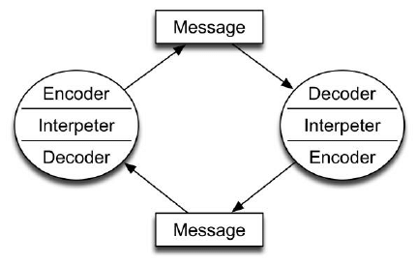
Figure: Model of Schramm model of communication
Source: (Barker, 2010)
Schramm's model of communication is different from Shannon and Weaver's model of communication. It noticed that the Shannon and Weaver model of communication illustrates the process of transmitting a message from the sender to its receiver. Moreover, this model illustrates five basic elements of transmitting a message which are the sender, the encoder, the channel, the receiver, and the destination. On the other hand, the Schramm model of communication tries to explain that proper engagement is essential for both the sender and the receiver. That’s the reason why this model is considered the equal model of communication.

The strategy of avoiding misunderstanding in communication
Several strategies can be followed to minimize misunderstanding in communication which are illustrated below-
- A speaker should think before speaking
- A listener has to be concentrated when he is listening.
- A speaker has to be specific
- If the listener doesn’t understand, he can ask the speaker.

Berlo’s model of communication
David Berlo shared his thoughts in his model in 1960 (Backer, 2013). According to his thoughts, there are four elements of communication which are sources, message, channel, and receive. He also described six different stages of communication.
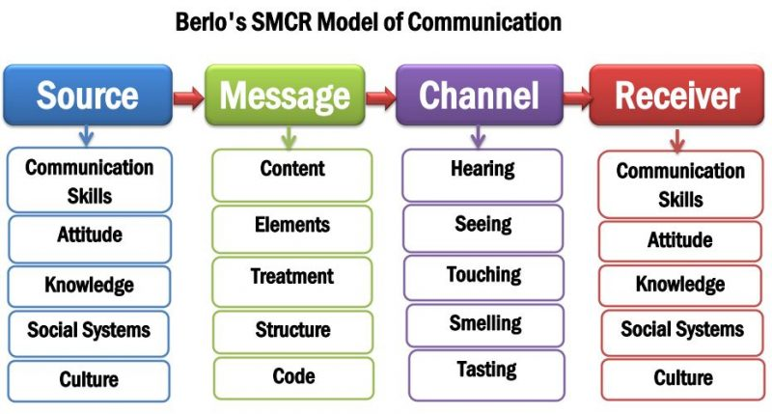
Figure: Diagram of Berlo’s model of communication
Source: (Moorhead et al., 2013)
Sources: The source is considered the sender of the message who was used to initiate the communication process. In this theory, Berlo illustrates that several factors are linked with the sources such as proper communication skills, attitude, level of knowledge, and the culture where the senders and the receiver belong.
Message: The message is considered the primary substance which is mainly sent to the receiver. Different things are directly related to a message such as the content of the message, basic elements, structure of the message, and the code which is used in the message.
Channel: Different channels are used for sending a message such as news media, social media platforms, telephone, etc. In that case, several factors are so connected here such as seeing, hearing, touching, etc. (Arkorful, 2015)
Receiver: Finally, the receiver is considered the person who normally receives information and message from the sender. Those factors are related to the receiver which is related to the senders. In that case, it's noticed that if both the senders and the receivers belonging to the same society or culture, the level of noise goes down because they know each other very well.

Difference between Berlo’s model of communication with another model of communication
It noticed that Berlo’s model of communication is unique and different from other communication models. It's seen that Berlo’s communication model gives more priority to the emotion of the message of the senders. When another model of communication emphasizes the contribution and engagement of both the speaker and the listener, Berlo’s model of communication emphasizes on speaker’s engagement in the communication. According to this model, Berlo’s tried to clarify that the misunderstanding will be reduced if a speaker or a sender can properly send his message to the listener.

Illustration of communication skill
Proper communication skill is very essential to engage both the listener and the speaker. Proper communication skill plays a big role in reducing misunderstanding between the speaker and the receiver. Different types of communication skills are

Verbal communication
Verbal communication is a type of communication where the speaker uses language for communicating with each other. In that case, the speaker needs to understand his audience. Moreover, the right language should be used so that the listener can properly understand the words of the speakers which are delivered by the speaker. Finally, using appropriate words for communication is equally important for communication.

Non-verbal communication
Nonverbal communication is effective when the speaker is unable to use language for communicating with their listeners (Kluver, 2011). In that case, body language is the best option. Moreover, the speaker also uses different communicational tools such as facial expressions, gestures, etc. for communicating with each other.

Listening communication
Proper listening is also a very effective tool for communication. Communication is incomplete if the listener fails to understand the words of the speaker. In that case, a listener should pay more attention to the speaker. At that time, a listener should not concentrate on other things like a mobile phone, reading, or concentrating on other things.

Discussion of the case study of the Professor and the village people
Q: Why didn’t the village people help the Professor?
The village people did not help the professor when his house was burning because the village people did not understand about words of the professor when he was saying “The edifice is being consumed by a great conflagration.
Q: What should he have done to get them to help him?
The professor did not get help from the villagers when his house was burning. He failed to make the villagers understand the condition. If the professor normally said that “his house was on fire” villagers would help him.
Q: Whose model of communication do you think can explain this situation?
I think Berlo’s communication model can give the best solution here. According to this model, communication is incomplete if the speaker fails to make his audience understand and listen to him. So, if the professor would use the appropriate words, he would get proper support from the audience.

Illustration of the advantages and disadvantages of Technology in communication
It's noticed that modern technology plays a big role in proper communication. There are some advantages and disadvantages of using modern technology which is illustrated below-

Advantages of using modern technology in communication
Currently, we are living in the age of modern digitalization. The advantages of using modern technology in communication are illustrated-
- Using modern technology in communication makes communication more efficient.
- Modern technology makes communication faster and more effective (Abaidoo, 2015).
- Technology plays a big role to decrease the limitation of distance.
- Technology reduces communication costs.
- The cultural gap is reduced in communication when high technology is used.
- Modern technology creates more sectors in education and business.

Disadvantages of using modern technology in communication
Modern technology also has some negative impacts on communication which are illustrated below-
- First of all, using technology is insecure. Confidentiality is hardly noticed in communication when modern technology is used.
- Modern technology increases difficulties in normal communication because of editing and filtering.
- Communication in technology is emotionless.
- Modern technology wastes our time in excessive engagement.

Conclusion
Both the speakers and the listener have to be conscious when they are communicating with each other. In that case, the speaker has to use the most appropriate words. On the other hand, a listener has to be sincere when he is listening to the words of the speaker. In that case, he should not engage with another thing. In that case, if a listener fails to understand the words of the speaker, he may ask the question to the speaker. Modern technology plays a big role in communication because most of us are dependent on modern technology. Despite having a lot of advantages, modern technology creates many negative impacts on communication.

References

Al-Fedaghi, S., 2012. A conceptual foundation for the Shannon-Weaver model of communication. International journal of soft computing, 7(1), pp.12-19.
Arkorful, V. and Abaidoo, N., 2015. The role of e-learning, advantages, and disadvantages of its adoption in higher education. International journal of instructional technology and distance learning, 12(1), pp.29-42.
Baecker, D., 2013. Systemic theories of communication. Handbooks of communication science, 1, pp.85-100.
Barker, A., 2010. Improve your communication skills (Vol. 39). Kogan Page Publishers.
Gillespie, D.J. and Schiffman, R., 2018. A critique of the Shannon-Weaver theory of communication and its nursing implications. Research and Theory for Nursing Practice, 32(2), pp.216-225.
Gungor, V.C., Sahin, D., Kocak, T., Ergut, S., Buccella, C., Cecati, C. and Hancke, G.P., 2011. Smart grid technologies: Communication technologies and standards. IEEE Transactions on Industrial informatics, 7(4), pp.529-539.
Klüver, J., 2011. A mathematical theory of communication: Meaning, information, and topology. Complexity, 16(3), pp.10-26.
Kubota, M., 2019. What is “Communication”?―Beyond the Shannon & Weaver’s Model―. International Journal, 13(1), pp.54-65.
Kumar, S. and Lata, P., 2011. Communication skills. Oxford University Press.
Kurtz, S., Silverman, J., Draper, J., van Dalen, J. and Platt, F.W., 2017. Teaching and learning communication skills in medicine. CRC press.
Menachemi, N. and Collum, T.H., 2011. Benefits and drawbacks of electronic health record systems. Risk management and healthcare policy, 4, p.47.
Moore, P.M., Rivera, S., Bravo‐Soto, G.A., Olivares, C. and Lawrie, T.A., 2018. Communication skills training for healthcare professionals working with people who have cancer. Cochrane Database of Systematic Reviews, (7).
Moorhead, S.A., Hazlett, D.E., Harrison, L., Carroll, J.K., Irwin, A. and Hoving, C., 2013. A new dimension of health care: a systematic review of the uses, benefits, and limitations of social media for health communication. Journal of medical Internet research, 15(4), p.e1933.
van Dalen, J., 2013. Communication skills in context: trends and perspectives. Patient education and counseling, 92(3), pp.292-295.

