Accounting fundamentals

Assessment 1

Name: Paul-Silvian Vornicescu
Student ID: 2246785
Module code: LCBB4001
Module name: Accounting fundamentals
Lecturer: Konstantina Mari

Table of contents
Question 1 | 3
Question 2 | 6
Question 3 | 6
- Ratios | 6
- Financial performance | 8

Question 1
- This statement seems to mistakenly merge two different forms of financial statements, the Statement of Financial Position and the Cash flow statement.
The Statement of Financial Position, commonly known as the balance sheet, provides a detailed snapshot of a company's financial condition at a specific point in time. However, it does not include details about cash inflows and outflows. This statement adheres to the basic accounting equation: Assets = Liabilities + Capital.
The Cash flow statement is a thorough record of the actual cash movements during a certain time frame. This statement is crucial in revealing the company’s ability to manage its liquidity and financial stability, and its capability to adjust its cash flows. This statement accurately tracks the flow of cash into and out of the business within an accounting period, and shows the closing cash balance at the end of that period.

- This statement represents a misconception in financial accounting. Non-current assets, also referred to as fixed assets, constitute long-term resources anticipated to be utilized over a period exceeding one year.
Contrary to the notion of immobility, the attribute of non-current assets is their durability and their significance in the context of a firm's extended financial health. This category encompasses both tangible and intangible assets.
Amortization or depreciation is typically applied to these assets, reflecting their use, deterioration, or technological redundancy over time. This allows for a more precise depiction of a company's financial status and operational performance over long periods.
Hence, while it is true that certain non-current assets, such as real estate or industrial equipment, are physically non-transferable, the classification of an asset as non-current is primarily based on its projected enduring benefit to the company, rather than on its physical mobility.

- The statement that managers should limit the distribution of financial information solely to a company's existing shareholders does not align with current standards in financial reporting.
Public companies are legally required to disclose financial information not just to their present shareholders, but also to potential investors, regulatory bodies, and the broader public. Such disclosure is critical for maintaining the integrity of the financial markets and ensuring confidence among investors.
This information is crucial for potential investors and other interested parties, enabling them to make informed decisions about engaging with a company's securities. Moreover, a company's financial health affects a wide range of stakeholders, including its employees, customers, suppliers, and the surrounding community. Therefore, from the standpoint of corporate responsibility and social ethics, it is imperative to make financial information available to a wider group than just the current shareholders.

- This statement contradicts the basic principles of the Statement of Financial Position, that is designed to accurately reflect a company's financial status at a specific point in time by detailing its assets, liabilities and equity. In financial reporting, prepayments are classified as current assets. These are payments made in advance for goods or services to be received in future accounting periods.
Accruals are included in current liabilities, representing expenses that have been incurred but not paid yet. They are essential to the accrual accounting, which records income and expenses in the period they are incurred, regardless of when cash transactions happen.
Neglecting prepayments and accruals in the Statement of Financial Position would result in a misleading view of a company's financial state. Their inclusion is crucial for an accurate and complete illustration of a company’s economic commitments and overall financial health.

- This statement overlooks the critical importance of regulations in the financial system. Regulations are fundamental in guaranteeing that companies report their financial status and operations in a manner that is both accurate and transparent, which is essential for the decision-making processes of investors, creditors, regulatory bodies, and other relevant parties.
Regulatory frameworks, such as the Generally Accepted Accounting Principles (GAAP) or International Financial Reporting Standards (IFRS), are vital in preventing financial fraud and mismanagement. These standards provide a comprehensive set of guidelines for financial reporting and auditing, promoting uniformity, comparability, and clarity across various businesses and industries.
In the absence of effective regulatory errors, the risk of financial malpractices escalates, potentially eroding investor trust and causing negative repercussions for the overall economy. Historical precedents, including financial crises and corporate scandals, have vividly demonstrated the catastrophic consequences of insufficient financial regulation.

- Ledger (T) accounts and the trial balance are fundamental before creating financial statements, both being key principles in the field of accounting. This step is crucial for verifying the accuracy and truthfulness of financial data, which underpins the preparation of fundamental financial statements like the balance sheet, income statement, and cash flow statement.
Ensuring that the total debits match the total credits in each ledger account is a crucial process. This balancing act confirms the correct recording of transactions within the accounting system. Additionally, the trial balance, which lists all the ledger accounts and their balances, serves as a preliminary measure of the accounting system's consistency. An imbalance between the debits and credits in the trial balance suggests potential errors that require investigation and correction.
They are indispensable for eliminating discrepancies in financial reporting and maintaining the integrity of financial information, which is essential for decision-making by company management.

Question 2
INCOME STATEMENT FOR THE YEAR ENDED 31st December 2022 Wales Plc

 | £
Revenue (900,000 + 1,000) | 901,000
Cost of sales (578,650 + 65,000) | (643,650)
Gross profit | 257,350
Distribution costs | (28,000)
Administration expenses (160,000 + 10,000+ 5,000 + 2,000) | (177,000)
Operating profit | 52,350
Interest payable (100,000 x 4%) | (4,000)
Profit before taxation | 48,350
Taxation | (15,000)
Profit for the year | 33,350

P.S.: It appears that the information from second point in not accurate, I assume the company paid salaries on 3rd of January 2023.

Question 3
a.
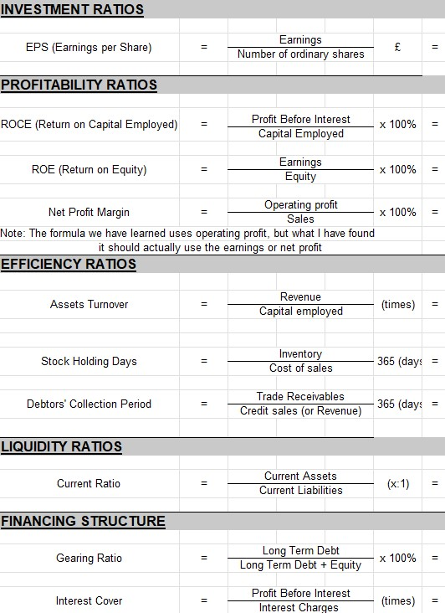

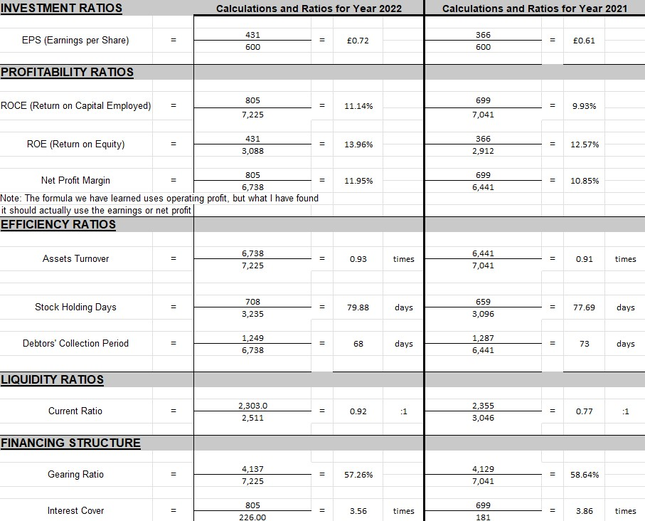
b.

This report will analyse the financial status and performance of Sweets Plc by examining several indicators such as profitability, investment, efficiency, liquidity, and financing, using data from their financial statements from 2021 and 2022.
Investment Ratio
The EPS rose from £0.61 to £0.72, indicating an increase in profitability per share, which is advantageous for shareholders.
Profitability Ratio
There was an upward trend in operating profit, moving from £699 million in 2021 to £805 million in 2022, indicating enhanced efficiency in operations. Similarly, the Net Profit Margin showed growth, rising from 10.85% to 11.95%, suggesting better revenue conversion into profit. This improvement may be due to more effective cost control or possibly higher profit margins on products.
The increase in ROE from 12.57% to 13.96% reflects a more effective generation of profit from shareholders' equity, signalling a positive development for investors.
The growth in ROCE from 9.93% to 11.14% suggests a more efficient use of the company's capital in profit generation, indicative of competent asset management.
Efficiency Ratio
The asset turnover ratio experienced a slight uptick from 0.91 to 0.93 times, indicating a marginal improvement in utilizing assets to generate revenue, which points to operational efficiency.
While there was a slight increase in stock holding days, indicating slower inventory turnover, the decrease in the debtors collection period suggests enhanced efficiency in receivables collection.
Liquidity Ratio
There is a slight improvement in the current ratio, moving it closer to the ideal 1:1 ratio, suggesting enhanced short-term financial stability and a better capability to meet immediate liabilities.
Financing structure
The decrease in the gearing ratio from 58.64% to 57.26% suggests a reduction in financial risk due to lower leverage.
The interest cover ratio showed a decrease from 3.86 to 3.56 times, implying a slight reduction in the company's ability to cover interest expenses, potentially due to increased borrowing costs or reduced pre-interest earnings.
In summary, Sweets Plc has demonstrated improved profitability and operational efficiency. The company's growth in revenue and steady increase in profits are commendable. The positive changes in ROE and ROCE are significant, reflecting efficient use of equity and capital. However, the company should maintain a vigilant approach towards its liquidity and balance between debt usage and financial risk, as indicated by its gearing and interest coverage ratios. The incremental rise in EPS is a favourable sign for shareholders, indicating the company's potential for continued growth and value creation.

