Creative Business Project – Proposal
Rory Grant-Wood – 1909411

Project Idea
For my Creative Business Project, I wish to present an idea that I have previously thought about and briefly looked into. I have previously wanted to enact on this idea; however, it wasn’t close enough to the brief in my previous dissertation.
My project idea is to create an online platform/hub, which caters to independent musicians, and the various relevant industries that may be required when launching a musical career. Examples of these relevant sectors include, editing, filming, location hire, music lawyers, accountants, marketeers, sponsors, and many more. The service will work on a freemium model, with many various incentives, deals and discounts to entice people to join. Whilst these various industries are important to the site, the primary focus is on the musicians who want to the use the service to propel their career further, without the worry of losing their creative control over their work.
This idea has much space to grow, expanding into other sectors and industries. For this business idea, many areas will be looked into such as, competitors, finance, marketing, law, personnel, and implementation. The idea is an original one, and ties into the project brief well, as it contributes to independent musicians’ careers, and acts as a hub for all music related assets to be displayed and easily contacted.

Project Research
To successfully explore the potential of this idea, conducting primary and secondary research is essential. Although I have not yet decided on the exact methods of primary research I want to use, fortunately I have some primary research conducted for a previous similar assignment. Gathering new primary research is the main focus however, as I now have access to better facilities and people who would provide valuable insights and advice on my idea. To determine who is most relevant to interview/contact, I will meet with my mentor and find out who would be willing to participate in my study. Using both Quantitative and Qualitive research methods will be ideal in this particular project and shouldn’t be too difficult to obtain.
Secondary research is also essential in completing this project. Luckily there is an abundance of academic journals, articles and books that explore the freemium model, current state of the music industry and the importance of digital technology in the market. These are the key areas of research that need to be analysed.

Project Aims
This project is an in-depth, real-world representation of an idea that we believe in. It is therefore important to lay down 3 main project aims to assist in completing the project to its full potential.
- Identify thorough and valuable research to aid the engagement for the idea
- Analyse and implement the research to bolster arguments for why it will be a successful venture
- Influence the readers views on how the independent music market can be transformed
Whilst these three aims are the core aims of the project, there are many other aims that need to be completed to ensure a successful end project. These include tasks such as: contacting and meeting with mentor regularly, and creating a schedule/timeline for when tasks need to be completed.

4.0 Reflection
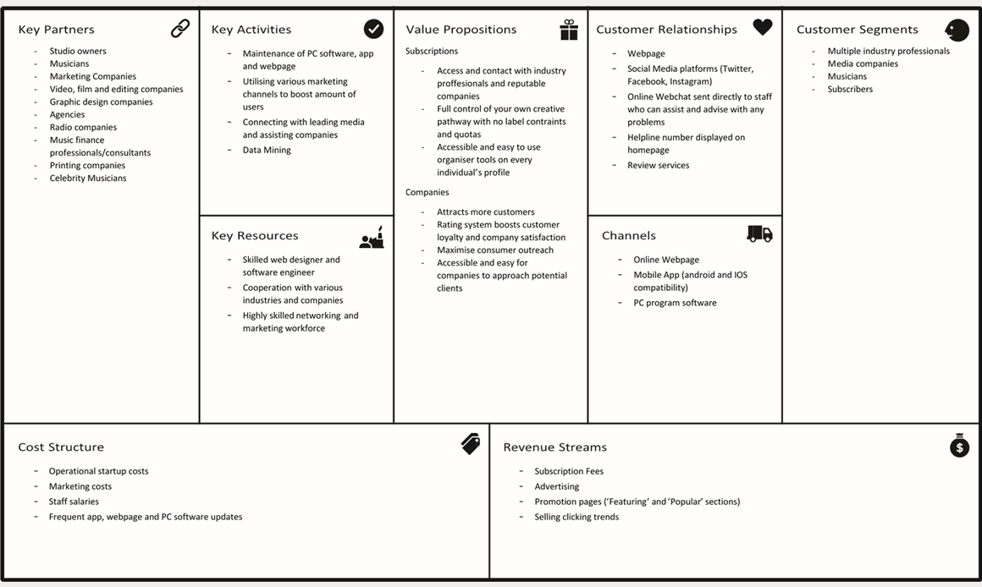
A reflection of the process and implementation of the idea will also be undertaken after completion of the project. Conducting this reflection provides valuable insight into the processes undertaken at each stage regarding the research, organisation and decision making. For this particular idea, it could reveal further potential avenues to grow into, or methods which are not as productive or efficient as other for example.

Business Model Canvas
To ensure full clarity of my aims and intentions for this project, I have filled in a watered-down Business Model Canvas (BMC). Each section is filled out on a preliminary basis and may be subject to alterations/corrections. The final BMC will be more in-depth than the one displayed in this proposal.
Figure 1: Business Model Canvas.
Source: Strategyzer.com

