Network Operating Systems and Services
Worksheet 1

Samuel Kelly – Student ID 173943
Network Operating Systems and Services
8th May 2022

Table of Contents
1.Introduction 2
2.Observational Tasks 2
3. Conclusion 5
4.Appendicies 6
5.References 13

1.Introduction
This report will contain a small writing section on observational tasks relating to hypervisors and various network and operating system functionality. There will also be a breakdown of screenshots in the appendices showing the process of creating and setting up two server virtual machines and two client virtual machines to establish a small network for demonstration. All screenshots of the process in the appendices will be annotated and have a brief explanation

2.Observational Tasks
Virtualisation requires the use of hypervisors. Hypervisors require a host machine to run the software installed on them and when a virtual machine is set up on a hypervisor it is typically called a guest machine. There are two main types of hypervisors, type 1 and type 2. Type 1 hypervisors run directly on the host machines hardware. In terms of security type 1 hypervisors are often considered the most secure because each guest machine has it’s own operating system (OS)[1]. This means that if someone was to launch an attack on the virtual machine it would be isolated to the machine and would not put any of the host machines files at risk. In the workplace type 1 hypervisors are often the preferred choice as it allows organisations to have higher workloads and increased uptimes of the virtual machines. However, due to the nature of type 1 hypervisors they often require a level of external management. Some examples of interfaces for external management are Microsoft System Centre Virtual Machine Manager and VMWare vCenter. Type 2 hypervisors are installed on top of the previous OS and relies on the host machines OS to make the calls it needs to the CPU. The use of type 2 hypervisors and their processes often comes with a big latency issue. The cost of setup for a type 2 hypervisor is often much lower than the type1 therefore they are the choice for home setups and rarely if ever used in professional environments. Oracle VM Virtual box, VMWare Workstation and Parallels Desktop are some examples of type 2 hypervisor vendors.
Cloud computing has revolutionised the way things are run in the modern world. Cloud computing is used in every aspect of a modern business with an online presence. Some of the key uses for cloud computing is to provide a digital backup for a file system or as a way to aid with disaster recovery should an organisation be put in that situation. Cloud computing can also be used in the testing and development of new software that are going to be released to the market[2]. They do this by providing a business with both virtual and real devices allowing quality assurance engineers from many different sources to test the product and provide feedback to the developers. Cloud computing is incredibly beneficial because it provides high speed, secure connections that come with automatic software updates and installations minimising the time required and money to hire specialists in order to install the new software. Some of the most popular cloud computing vendors are Microsoft Azure, Amazon Web Services, Google Cloud, and IBM Cloud.
The Domain Name System or (DNS) is essentially the yellow pages phone book of the internet. When using the internet most users will type the domain name of a website into their search engine[3]. A DNS makes the search process incredibly easy for users by not requiring them to remember the IP address of every website they wish to go to. Every device on the internet is provided with an IP address by their respective ISP. When a request is made from a client to the server it first goes to the root server. The root server is access with a DNS recursor. The recursor can be thought of in simple terms as a helper to make additional requests on behalf of the client. The root server will translate the simple domain name into an IP address which is then used to reference a certain server. Once the root server has done it’s job the DNS will move onto the top level domain server (TLD). The TLD is used to break down the domain name further and take the dot com/org or other ending and narrow the search. Once the TLD has done its job the authorative nameserver then takes over and finds what the user asked from in the initial query. Some websites do not require a DNS server and the user can access the website from a single call however this is not very common.
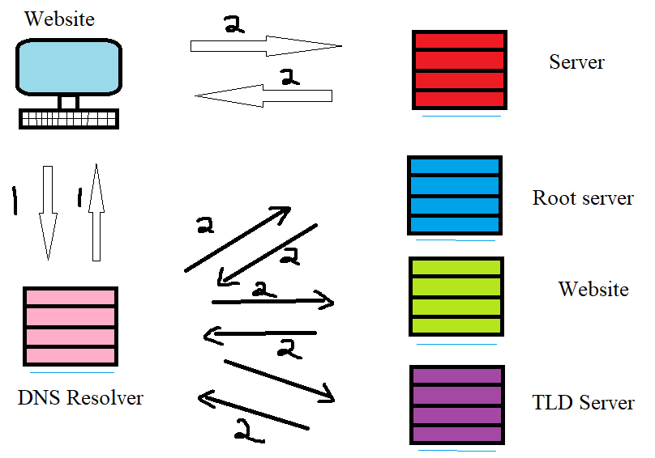
Figure 1. DNS map

When choosing roles and features for a server there are a few key ones to consider. AD is of course a critical one that is demonstrated in the appendices with the screenshots however, there are other critical roles needed for a server. Dynamic Host Configuration Protocol (DHCP) and File Storage Services are ideal for every server. DHCP are used to set up a default route and configure IP addresses for the computers on a network[4]. The DHCP services can be used to provide an IP address for a user that lasts a limited amount of time they essentially provide. The user must manually request a new IP address before the old one expires as they will not be able to continue using it. Having DHCP creates less room for error as manually assigning IP address to users on a network would. File and Storage Services are also key for keeping a network up and running. These services allow you to set users permissions to access certain files on a network[5]. This is key for every network as there will always be files management may need to access that lower level employees or students in a school environment will not need access to. By using file management systems you can stop users from seeing files and folders they are not permitted to see completely eliminating the risk of information and data ending up in the wrong hands.
There are a number of operations and terminologies within the computer world. Some are quite obscure and don’t offer an easy interpretation and some are quite simple and straightforward. The simplest term to cover is Ping the ping command is used widely across network and server testing to make sure that the routing and server configuration the ping command is used in conjunction with an IP address to test that the packets can be sent and received between the host computer and the ping destination. Often times firewalls are used to stop people from pinging a server. The firewall will often check if the ping is coming form an authorised destination, if it isn’t then the packets being sent are denied entry and sent back to where they came from. Forests are used on domain services to provide a logical structure for the domains and group the domains together. The domains provided places to store users and groups on a system and keep the roles and authorisations in order.

3. Conclusion
The task for this worksheet was to create a barebones network for two servers and two client virtual machines. The setup was fairly straightforward and adding users to the network was an interesting and easy task to do. Setting up permissions for each user group was a good practice and seeing how easy it was to do helped improve literacy with server management systems in windows systems. I would now be much more confident would I be asked to set up a similar system in an area of work as a part of a team and would be confident to provide help to others should it be required. Initially the worksheet seemed like a rather daunting task however, upon getting started it became apparent that the software was easy to work with and not too complicated when setting up. Adding roles and features to the server was simple with the pre installed wizard that accompanies Microsoft server 2019.

4.Appendicies
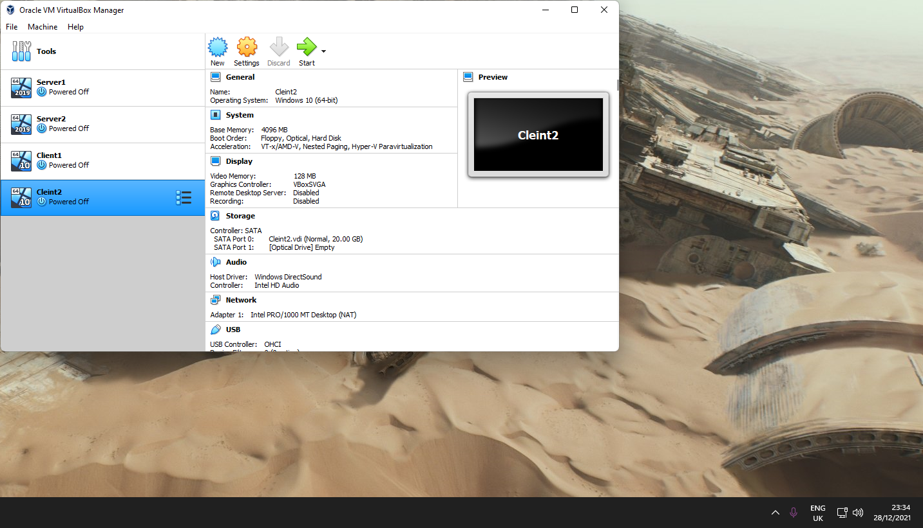
Figure A. Initial two server, two client setup in virtual box
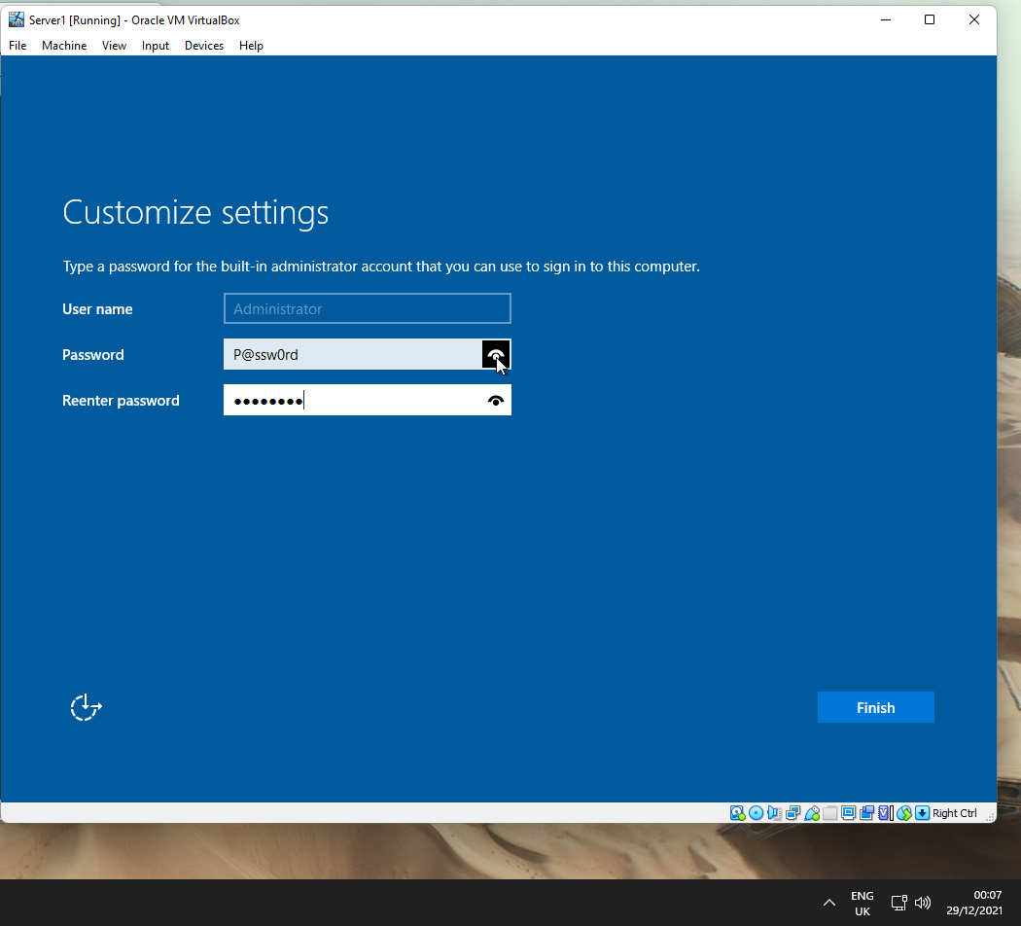
Figure B. Appropriate password complexity being implanted to administrator account
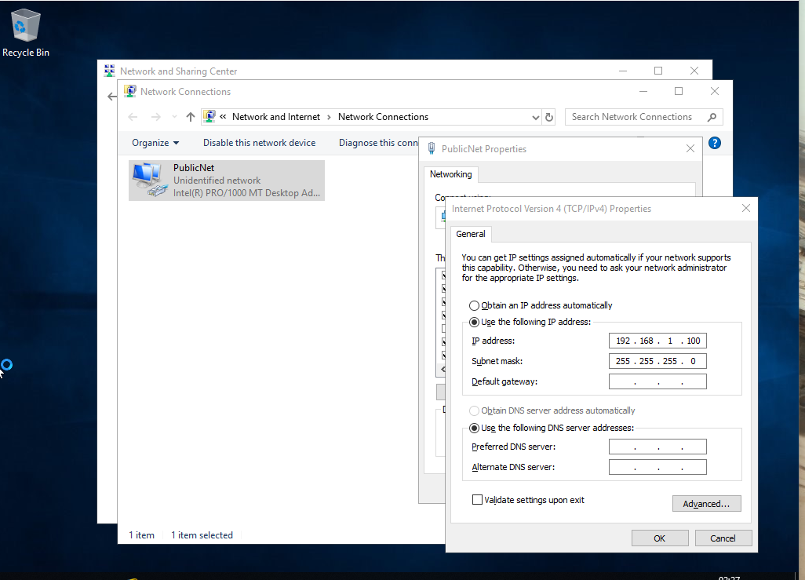
Figure C. PublicNet IP address being statically allocated
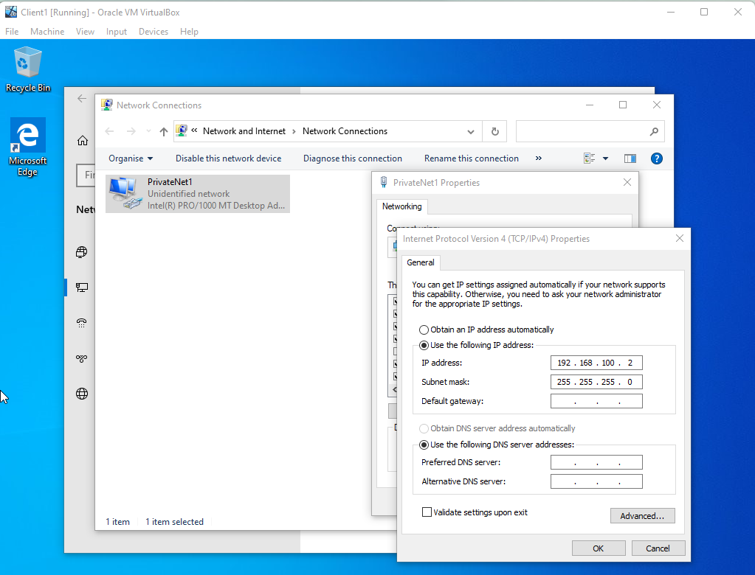
Figure D. PrivateNet1 IP address being statically set on Client1
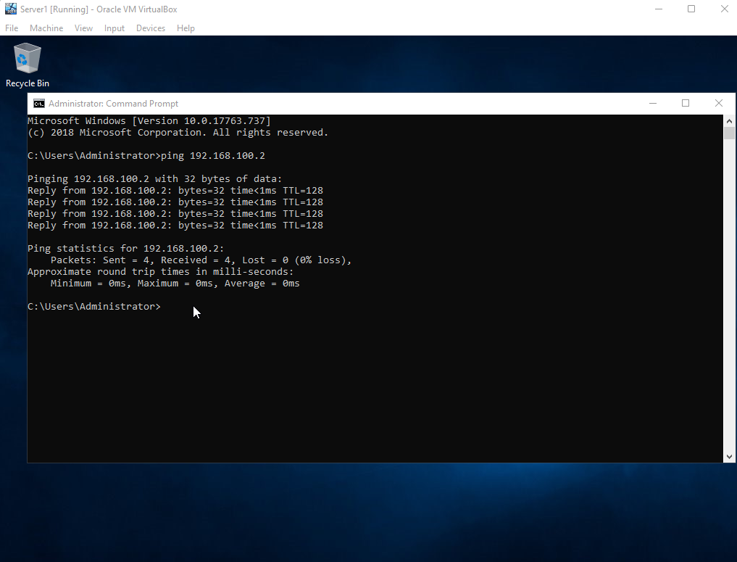
Figure E. Server 1 pinging Client1 on PrivateNet IP
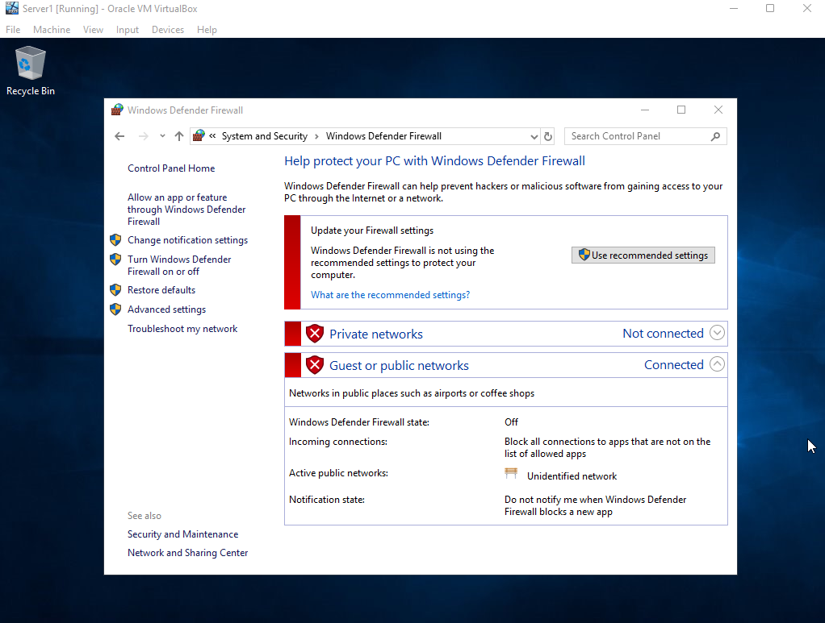
Figure F. Firewall being disabled on Server1
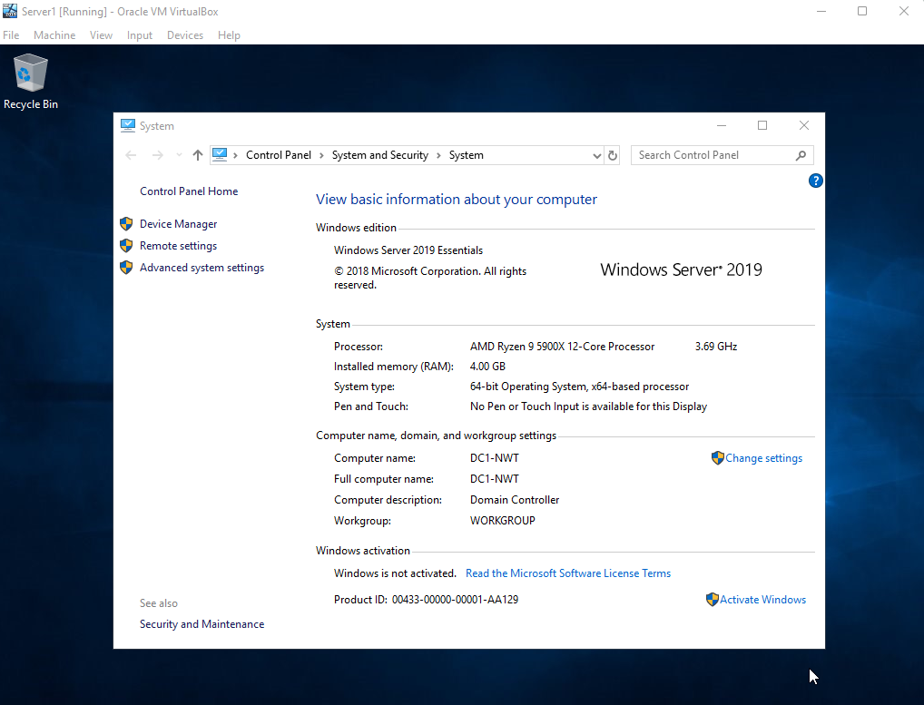
Figure G. Server1 being given the appropriate identifying name DC1-NWT
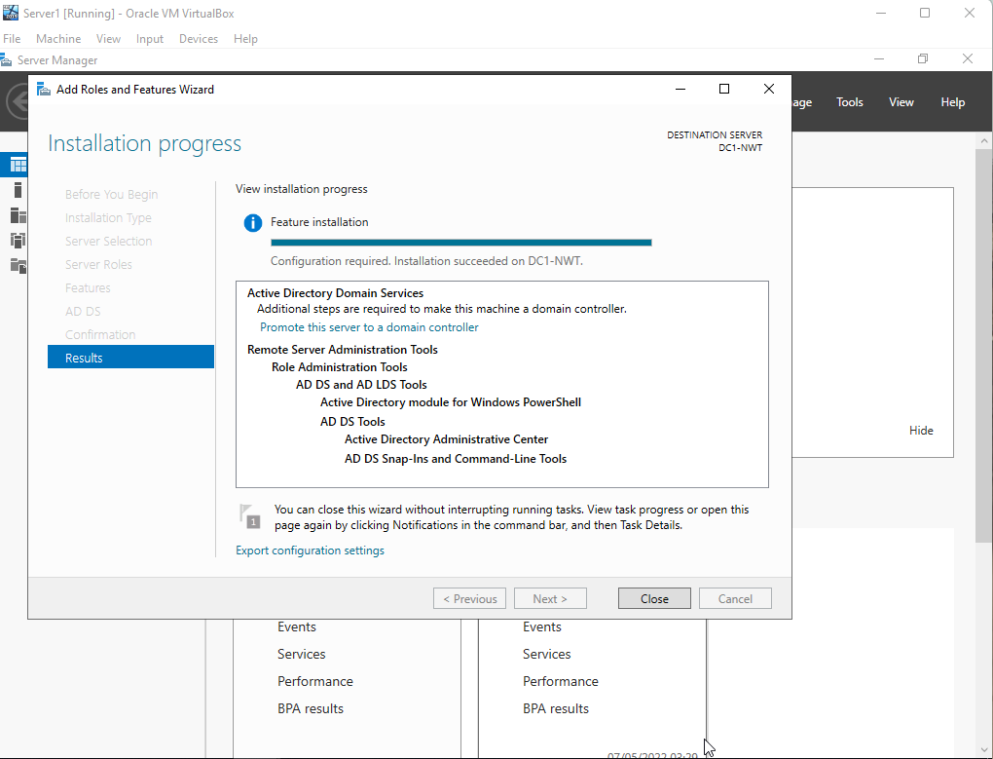
Figure H. Active Directory Domain Services(ADDS) being installed on Server1
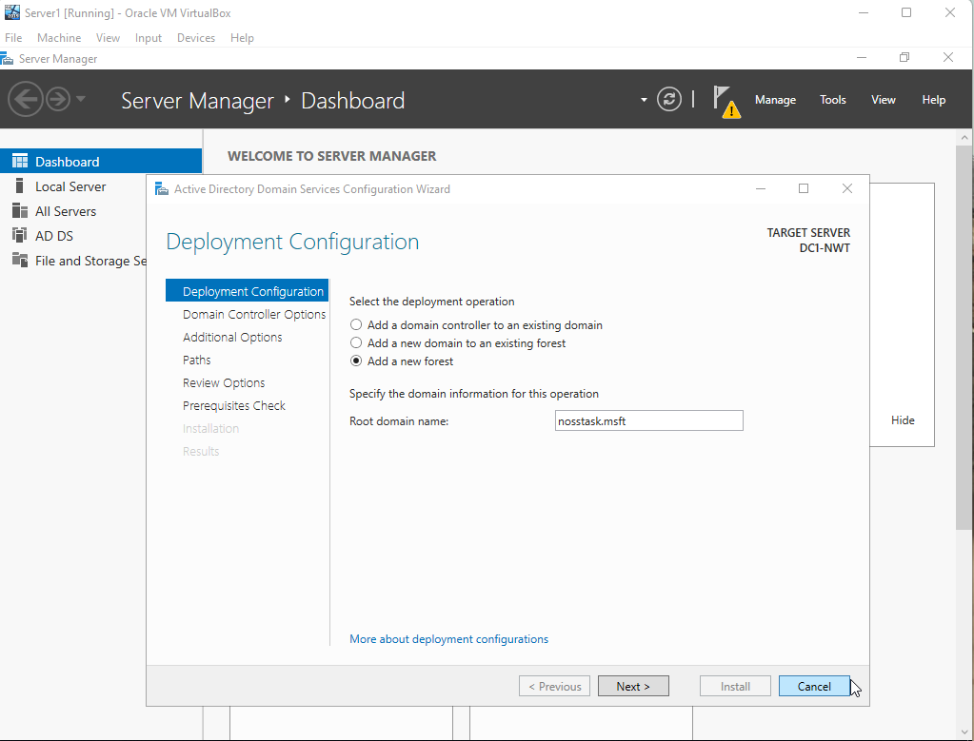
Figure I. New ADDS being configured.
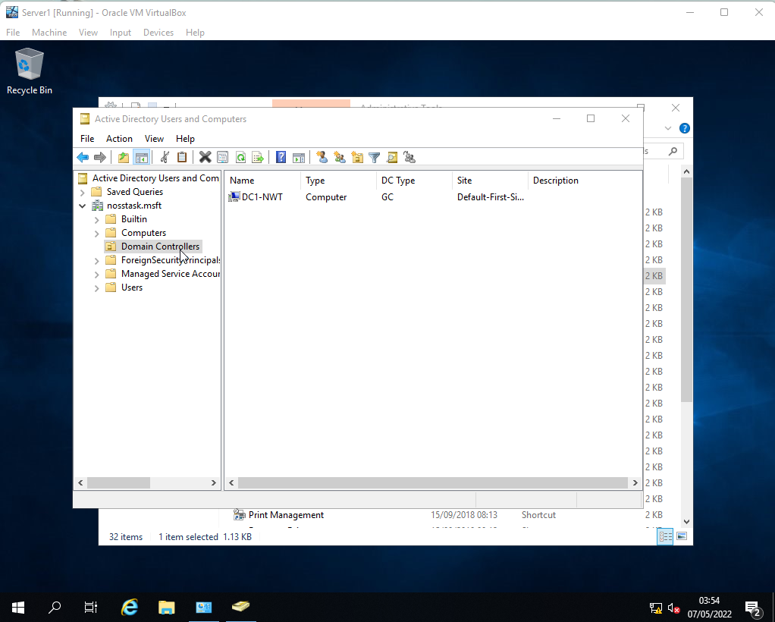
Figure J. Server1 listed in the Domain controllers area.
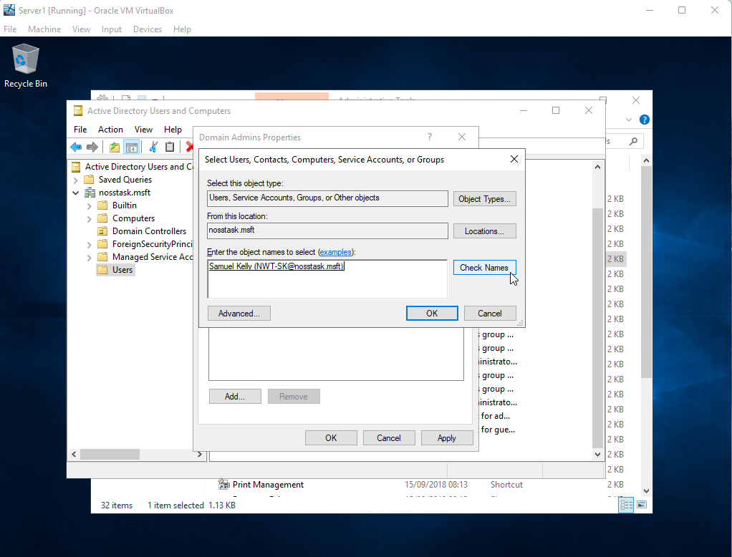
Figure K. New users being added as a domain admin
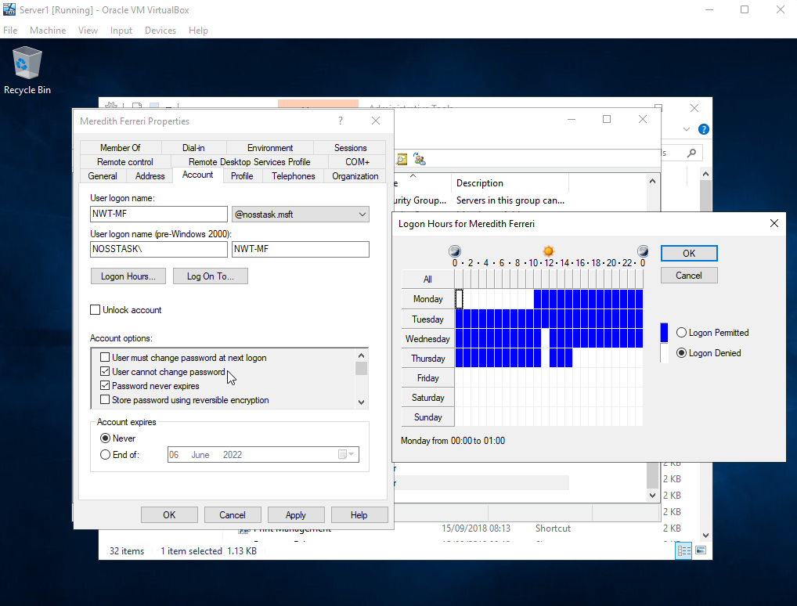
Figure L. Users logon hours being restricted on the network.
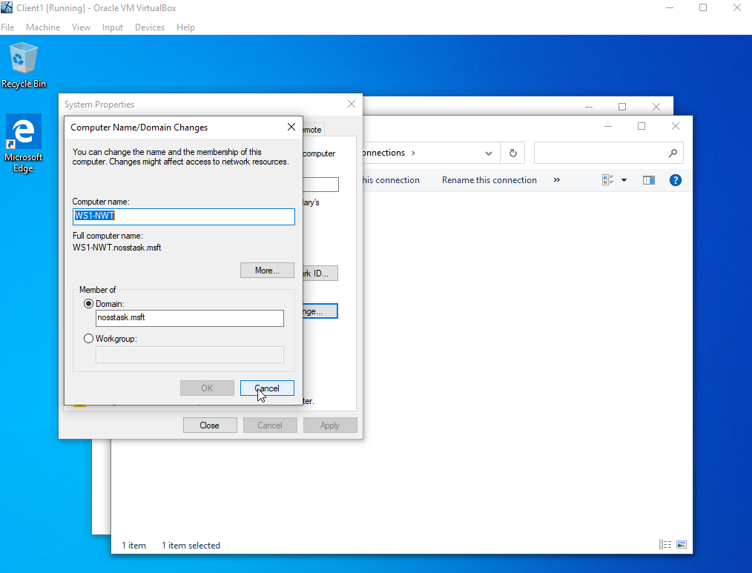
Figure M. Changing and logging into the domain on Client1.
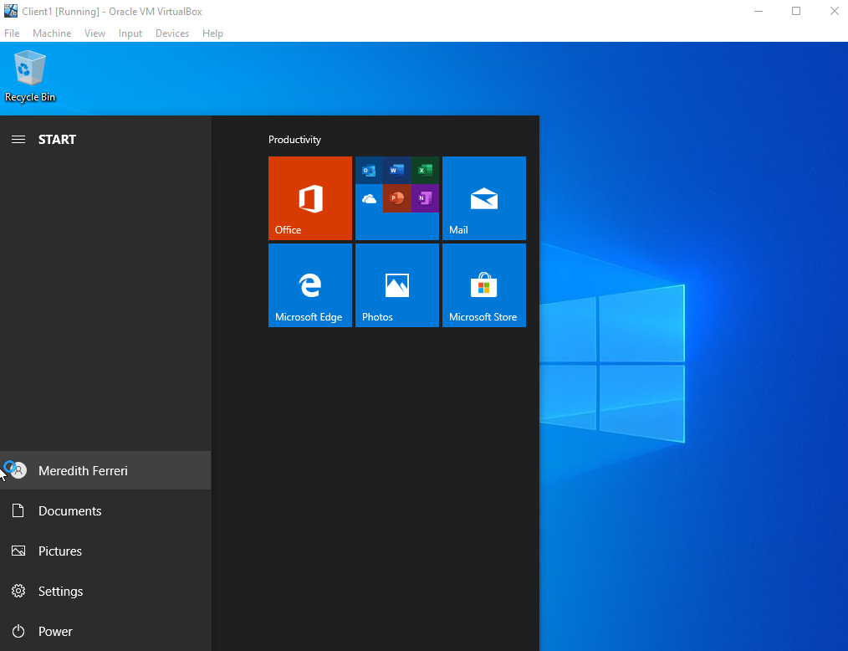
Figure N. User successfully logged on to Client1.

5.References
[1]K. Taylor, "What’s the Difference Between Type 1 and Type 2 Hypervisor?", HitechNectar, 2021. [Online]. Available: https://www.hitechnectar.com/blogs/hypervisor-type-1-vs-type-2/. [Accessed: 03- May- 2022].
[2]N. Romero, ""Cloud computing” in library automation: benefits and drawbacks", The Bottom Line, vol. 25, no. 3, 2012. [Accessed 8 May 2022].
[3]"What is DNS? | How DNS works", cloudflare, 2021. [Online]. Available: https://www.cloudflare.com/en-gb/learning/dns/what-is-dns/. [Accessed: 03- May- 2022].
[4]J. Gerend, "Dynamic Host Configuration Protocol (DHCP)", Docs.microsoft.com, 2021. [Online]. Available: https://docs.microsoft.com/en-us/windows-server/networking/technologies/dhcp/dhcp-top. [Accessed: 03- May- 2022].
[5]"What is Network File System? | Benefits, Accelerating NFS Performance", WEKA, 2021. [Online]. Available: https://www.weka.io/learn/what-is-network-file-system/. [Accessed: 03- May- 2022].

