
APPENDIX GA36b
58%

LEVEL 5 ASSESSMENT SPECIFICATION

Student name: | William Tomos John Bowen | Student ID number: | BOW16832669
Programme: | HND LEVEL 5
Module: | MECHANICAL PRINCIPLES
Module code: | M5X00926 | Contribution to Overall Module Assessment (%): | 50%
Lecturer: | EMILY NYATHI | Internal Verifier: | EDWARD HORNAGOLD
Assignment Title: | Power Transmission | Word count (or equivalent): | (NOMINAL 3000)
Submission deadline: | 24/01/2020 | Return date of provisional marks & written feedback: | 04/02/2020
Submission method: | All written assessments, where practical and possible, must be submitted via Turnitin unless otherwise instructed by the Lecturer. (Please DO NOT put this assessment specification into Turnitin or it will match many similarities with other students’ submissions.)  Alternative submission method (if applicable):  Late submission of the assessment will result in a late penalty mark. Penalties for late submission: Up to one-week late, maximum mark of 40%. Over one week late, 0%. Only the Extenuating Circumstances Panel may approve a change to submission dates.
Academic honesty / referencing: | Academic honesty is required. In the main body of your submission you must give credit to authors on whose research and ideas your work is based. Append to your submission a reference list that indicates the books, articles, etc. that you have used, cited or quoted in order to complete this assessment.

Student FEEDBACK FORM William Tomos john BOwen Assignment 3

.

Generic Assessment Criteria | Marks available | Marks  awarded
1. Engagement with Literature Skills
.
You did not complete your background research for Task 1. This has cost you some marks. However, for Task 2 you have engaged with a limited range of mostly relevant and credible sources. |  | 13
 | 25 | 13
2. Knowledge and Understanding Skills

You have worked had in the problem-solving section for ask 2. However, you dd not show your calculations in Task 1. This has cost you a few marks. |  | 19
 | 30 | 19
3. Cognitive and Intellectual Skills

You have used tables and graphs to analyse your findings in Task 1 making some valid arguments. However, you need to improve on giving credit to your sources of information on some of your findings. |  | 14
 | 25 | 14
4. Practical Application Skills

You have shown a good and appropriate application of established methods, materials, tools and/or techniques. |  | 9
 | 15 | 9
5. Transferable Skills for Life and Professional Practice

Demonstrates the skills for employment requiring the exercise of personal responsibility and decision-making, with some areas of minor errors. Some improvement noted I your presentation skills. | 5 | 3

Assessment Mark (Assessment marks are subject to ratification at the Exam Board. These comments and marks are to give feedback on module work and are for guidance only until they are confirmed. ) | Late Submission Penalties (tick if appropriate) |  | 58%
 | Up to 1 week late (40% Max) |  | 58%
 | Over 1 week late (0%) |  | 58%



(UWTSD, 2018)

Power Transmission Systems
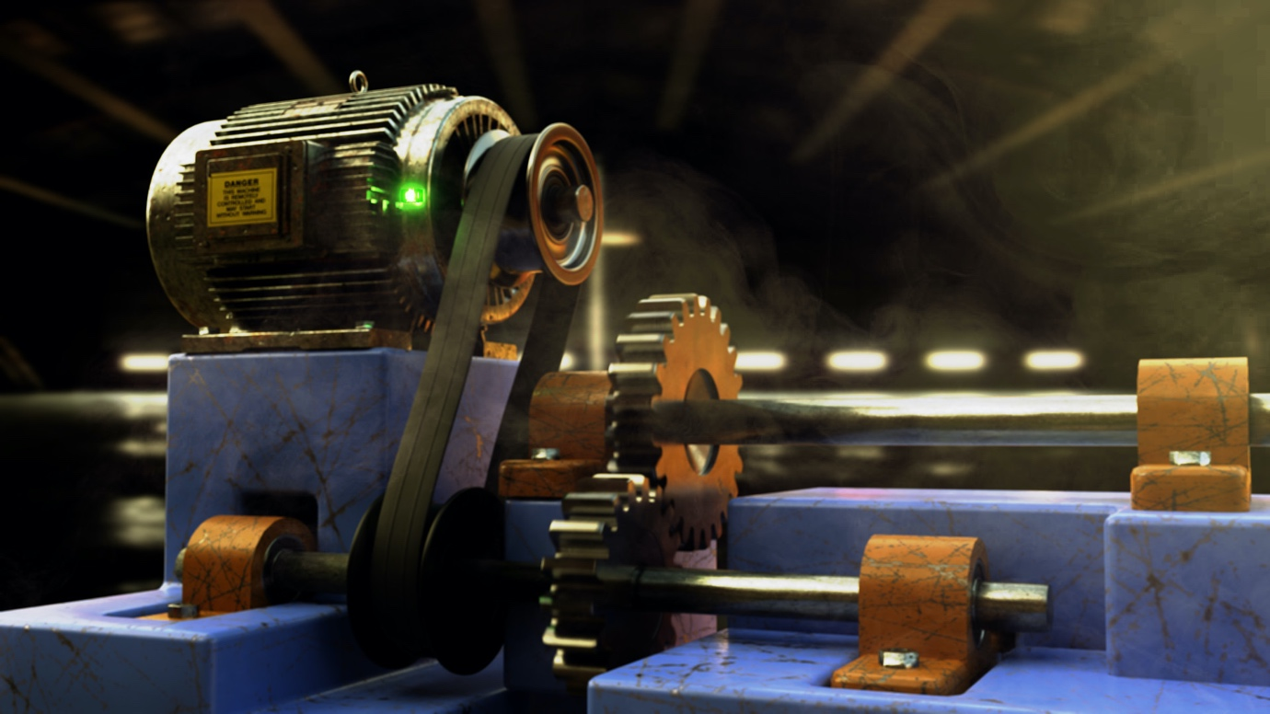

(F. Oliveia, 2018)
William Tomos John Bowen
BOW16832669
01/05/2020

Contents
1) Summary 3
2) Task 1 Introduction 4
3) Theory 5
4) Equipment 6
5) Procedure 7
6) Data, Analysis and Calculations 9
7) Conclusion 14
8) Reference List 15
9) Task 2 16
10) Reference List 35

Summary
This report will be split into two sections. In the first section will consist of varies types of pulley systems and will attempts to elaborate the effects of friction on a on belt drive. The experiment will illustrate the relationship between the constant angle and the constant tension ratio. This experiment will also verify the relationship between the constant tension ratio and friction. This report will also determine the friction between pulley and belt.

The second section of the report will elaborate the different types of gears and show varies types of calculations in order to design a gear using the speed ratio and the number of teeth required on a gear. The calculations will also demonstrate the revelations per minute on a gear system.

Task 1 Introduction
A small engineering manufacture company have requested for a small team to carry out a couple of experiments on their new belt drive system. The team that has been set the task of this objective is to carry out various types of experiments to discover the effects and relictions on a belt drive. During the experiment the team must illustrate the relationship between the constant angle and the constant tension ratio by request of the manufacturing company. The experiment that will be carried out must verify the relationship between the constant tension ratio and friction also. By carrying out these experiments, the friction between pulley and belt will be discovered; concluding the task set at hand.

For the objective to be meet the project team will require to carry out three different experiments to get the information needed. The team must also work in a safe, practical and efficient manor to ensure the manufacture is service with their requirements and desires meet.

Theory

equipment
Upon arriving at the selected experiment facility, a few objects we positioned in front of the group. The group began by amalgamating the equipment supplied to the group. One of the equipment supplied was a belt friction rig with a weighted carrier and weights already positioned on the rig. The weights positioned on the rig varied from 2 kg’s in weight up to 25 kg’s in weight. Another piece of apparatus was a dial test indicator which was correctly calibrated which was mentioned upon arriving. After the equipment had been accounted for the group then began to arrange the equipment ready for testing. However, prior to beginning the test roles were assigned to each member of a group and gathered a couple of other pieces of equipment such as goggles, pen, paper and a ruler to ensure the results could be collected.

Procudure
The project team began the experiment by arranging and recording all the equipment needed for the task at hand. A member of the team was tasked to record the data that will be collected during the experiments. Another member of the group was tasked to amend the equipment during the experiments when needed. In doing so insured that there was a consistent factor throughout. Another member of the team was tasked to measure and state the readings of the experiments ensuring the readings were all from their prospective.

After the roles of member was outlined, the experiments commenced. However prior be commencing with the first experiment, the team decided to create a table worth set data already in their rightful location as it would ensure the experiment ran as smooth as possible. The project team carrying out the experiments declared that the risk factor of the experiment was low; as it was low it was agreed by the group that minimum personal protective equipment was required such as goggles and gloves. However, a safe distance would be required whilst the experiment was commencing. In doing so would ensure that in likelihood of an accident occurring, the damage would be at a minimum.

The project team first experiment was the cantilever calibration experiment. The first step to the experiment for the cantilever calibration was to turn the angle of lap protractor to zero. After the angle of lap was set the belt was set to hang and the weight carrier was placed on the cantilever. Once this had been done the dial indicator was then required to be recalibrated to unit of zero. Since the indicator was set to zero the deflection of the cantilever was recorded every time a new load was placed upon it. These loading increased every 3kg started beginning at zero loading and increasing up to 24kg. Now that the data for each increasing load had been collected the project team now required to calculate T2 for each of the loadings. T2 was calculated by multiplying the load or mass in this instance by gravity. In doing so gave the result of T2 for each load. Now that all the data had been collected for the first experiment the team was then tasked to plot the data on a graph where the constant angle and the constant tension ratio relationship would be compared.

Once the first experiment had concluded the team then decided to carry out the second experiment. The second experiment must conclude the constant angle of lap. Therefore, the team began the experiment by setting the lap angle from 0 degrees to a 90 degrees angle. After the angle had been set the belt was attached and the dial was rest to a reading of zero. Once the dial was set to zero the pulley motor was witch on. Since the motor was activated the recording of the deflection could now commence. The data would be collected on the dial once the loading had been applied. These loading increased every 2kg started load beginning at zero and increasing up to 20kg. Now that all the data had been collected for the second experiment the team was then tasked to plot the data on a graph where the calibration curve T1 is plotted against T2. Since the graph has been created the first method of the theory can be used in order to calculate µ.

Once experiment 2 had concluded the team must then proceed to experiment 3, which was the record the results of the variable angles of lap. The first thing the team had to do was to attach the belt and reset the indicator back to 0. Now that the indicator had been set to 0 the team would require to secure a 20kg weighted load to the belt. After the weight had been placed the machine motor could be switched on. The engineering team would then be required to measure the deflection angle of lap when rotating from various angles; arranging from 240 degrees to 0 degrees in a anti-clockwise motion. The team was then required to determine T2 for each angle with the aid of the calibration curve. Once T2 was calculated T1 divided by T2 was needed to be plotted against the rad. After the results had been plotted the project team was then required to calculate µ from the slope of the curve to conclude the end of task set out by the small engineering manufacture company.

Data, Analysis & Calculations
Table below is the results collected from experiment 1.

m (kg) | 0 | 3 | 6 | 9 | 12 | 15 | 18 | 21 | 24
𝛿 | 0 | 15 | 30.5 | 45 | 60 | 75 | 90 | 104 | 118
T₂ = mg (N) | 0 | 29.43 | 58.86 | 88.29 | 117.72 | 147.15 | 176.58 | 206.01 | 235.44

Now that the data has been recorded, the results were then inputted into excel document in order to create a scatter graph chart where line of best fit was included. Also, the engineers were tasked on calculating the deflection of the cantilever for loads ranging from 0 to 24kg in increments of 3kg. The table above includes the result of each deflection at their respected loadings.

The results show that the experiment was an overall success as the results gathered from the experiment were rather close to the line of best fit and there were no out layers.

Table below is the results from experiment 2.

m (kg) | 0 | 2 | 4 | 6 | 8 | 10 | 12 | 14 | 16 | 18 | 20
𝛿 | 0 | 5 | 11 | 18 | 23 | 29 | 34 | 40 | 45 | 51 | 58
T₁ = mg (N) | 0 | 19.62 | 39.24 | 58.86 | 78.48 | 98.1 | 117.72 | 137.34 | 156.96 | 176.58 | 196.2
T₂ = k x δ | 0 | 9.94 | 21.868 | 35.784 | 45.724 | 57.652 | 67.592 | 79.52 | 89.46 | 101.388 | 115.304

As per the first experiment table and graph, the results were inputted into a excel document to create a scatter graph chart with a line of best fit was selected.

The results show that like experiment 1, experiment 2 was also an overall success as the results gathered from the experiment were close to the line of best fit and there were no out layers.

Table below is the results from experiment 3.

Θ, deg | 240 | 220 | 200 | 180 | 160 | 140 | 120 | 100 | 80 | 60 | 40 | 20 | 10
δ | 25 | 26 | 29 | 33 | 37 | 41 | 47 | 53 | 60 | 67 | 76 | 86 | 92
T_{2,} N | 49.7 | 51.69 | 57.65 | 65.6 | 73.56 | 81.51 | 93.44 | 105.36 | 119.28 | 133.2 | 151.09 | 170.97 | 182.9
 | 4.19 | 3.84 | 3.49 | 3.14 | 2.79 | 2.44 | 2.09 | 1.75 | 1.4 | 1.05 | 0.7 | 0.35 | 0.17
  Θ, rad
 | 3.95 | 3.8 | 3.4 | 2.99 | 2.67 | 2.4 | 2.1 | 1.86 | 1.64 | 1.47 | 1.3 | 1.15 | 1.07
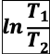 | 1.37 | 1.34 | 1.22 | 1.1 | 0.98 | 0.88 | 0.74 | 0.62 | 0.49 | 0.39 | 0.26 | 0.14 | 0.068

As per the first two experiments, results show that experiment 3, was also a overall success as the results gathered from the experiment were close to the line of best fit and there were no out layers. Both graphs have similar results and similar looks in terms of appearance.

Conclusion
The overall assignment was a success as the engineering project group found all the necessary results needed for the company. Whilst carrying out the experiments all members of the team worked safely and efficiently, in order to ensure the customer was satisfied with the professionalism of the team. The company conclude that all data received was beneficial for both parties. Upon calculating the results, the team decided to allow the customer to calculate the results that were tasked to them. The team decided that this was the best opposition as the team believed their inexperience and lack of judgement would have a profound effect and potentially cause the customer more harm if the team were to guess. However, if the project was to be carried out again, then assistance would be required to calculate the results the customer requested. Except for the minor objected not meet, both parties agreed that the overall task was a success.

Reference List
F. Oliveia, (2018). Mechanical – Pulley and Gear Drive System 1.5. [Image]. Available from: https://www.artstation.com/artwork/JoGom [Accessed: 01/05/20]

UWTSD, (2018). UWTSD Home/ University of Wales Trinity Saint David Logo. [Image]. Available from: http://www.uwtsd.ac.uk/ [Accessed: 01/05/20]

Task 2
When discussing pulley systems gears also are mentioned within the same sentence. “Gears are mechanisms that mesh together via teeth and are used to transmit rotary motion from one shaft to another. Gears are defined by two important items: radius and number of teeth. They are typically mounted, or connected to other parts, via a shaft or base.” (Creative Mechanics, 2020) There are two factors that are taken into accordance when designing a gear. These two factors are the radius and teeth of the gear. Creative Mechanics later goes onto explaining that there are two radiuses that are a factor for a gear these two radii are root and addendum. The addendum is the distance from the centre of the gear to the outside face of the teeth. The root radius is the distance from the centre of the gear to the base of the teeth.
The teeth on the gear is the section of the gear that interests with other gears teeth. For the gears to work correctly as intended the two gears must have a matching pitch and with to slot together. Once enough gears are interlocked with each other, the gears are referred as a gear train. There are many types of gear trains, however the for communally used gear trains are a simple gear train, compounded gear train, reverted gear train and epicyclic gear train.
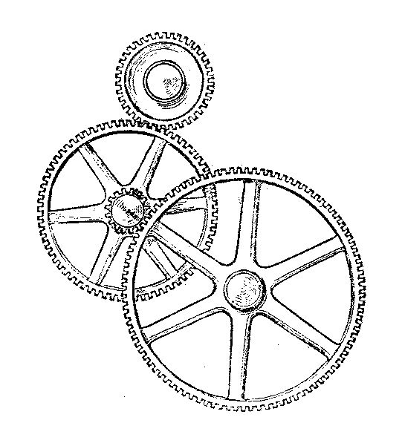
(Wikipedia, 2020)
As stated by its name a simple gear train is a train of gears that are amalgamated together in a way to maximise the torque produced without creating any slip on the gears. Slipping of gears will always happen due to wear and tear, however it is caused by the teeth not engaging with each other correctly causing the gears to become out of sync. This instance of the teeth on the gears not engaging properly is called slipping. A simple gear train is defined when a single gear is on a shaft and another gear is on a different shaft and the two are tangent with each other where they with react by rotating anti-clockwise to each other. Simple gear trains are widely used within today causality as they are used in everyday machines. These such machines are cars also known as automobiles. They are used in gear boxes and more specifically off-road and all-wheel drive vehicles. Simple gear trains are also used in the industrial industry machinery such as heavy-duty press machines and lathes. There are also many more instances and applications where simple gear trains are used in order to achieve the desired outcome. (D. Ghatt, 2016)
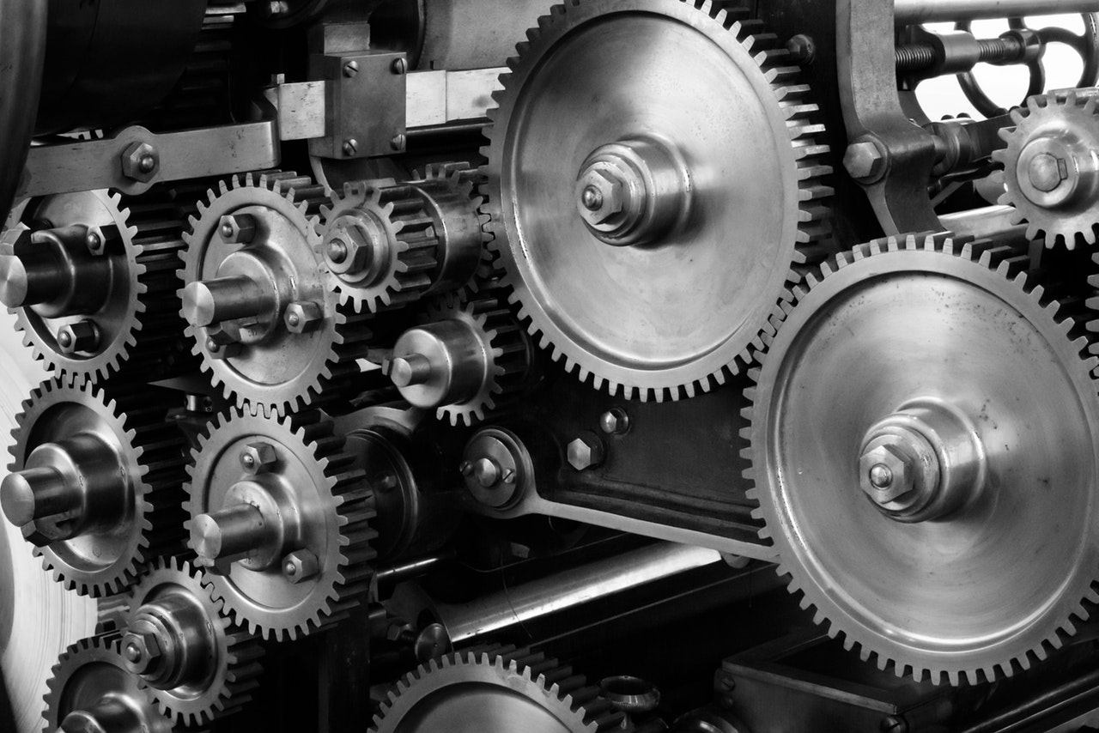
(SMLease Design, 2020)

Compound gear train is another typical gear train that is used within machinery across the world. Compound gears like the arrangement of a simple gear train; however, one or more can lay on a shaft. Due to gears being on the same shaft they will rotate at the same r.p.m. “The gears that make up a compound gear usually differ in size and have a different number of teeth.” (V. Ryan, 2010) Thus ensuring the speed can be decrease or increase depending on desired outcome for the final output. Compound gears are commonly used within car gear systems where each gear is represented by a gear on a gear box; depending on the desired outcome the gears, which will switch between high and low gear depending on the operator scenario. They can also be found in clocks and watches where the devices require a low rate of rotation and therefore ensure the rate is reduced to the required speed for the desired part such as seconds timer, hour and or moon phase. Typically, compound gears are located within machinery where the power requires regulating prior to use. (S. Sega, 2017)
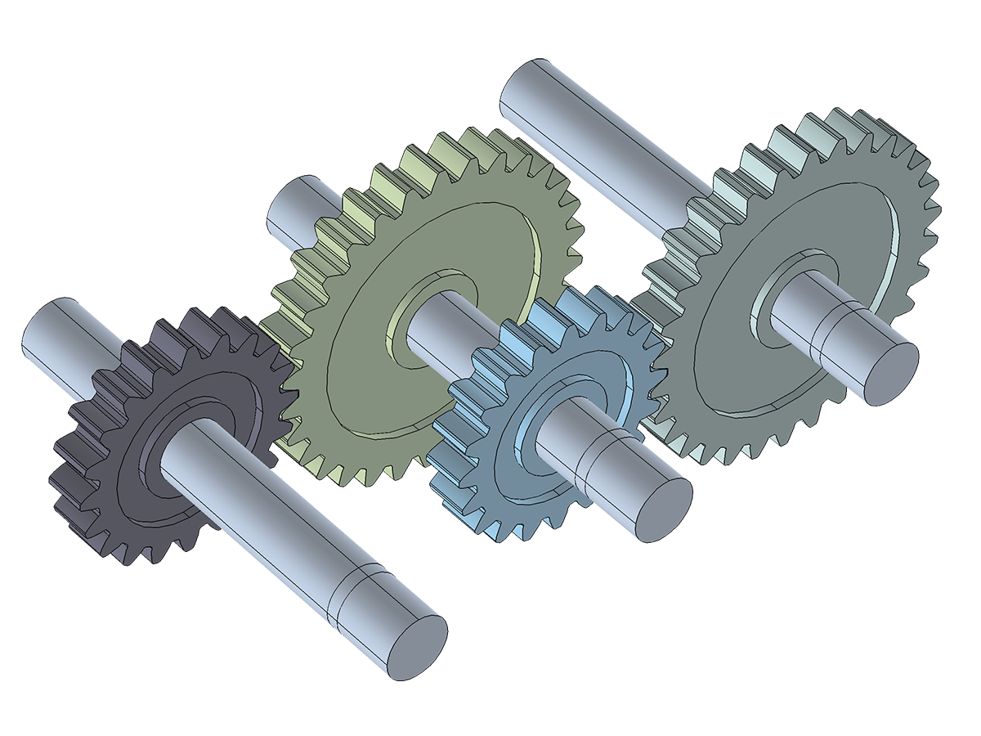
(COMSOL, 2020)
Another type of gear train is a Reverted gear train. Reverted gear trains are like a compound train as they have some gears on the same shaft. The purpose of a reverted gear train like the compound train is to regulate the power prior to use, where space within the machine is minimal. However, there are two major differences between the two of them. Unlike the compound train, the reverted train requires the input and output shaft to be on the same horizontal axis. Another different between the two gear trains is that the distance between gear centres of each pair (the gear connected to it) must be the same. Unlike the compound gear where they can be different. (Mechanical Maina, 2011) Reverted gear trains are used in many machines used across the world. One place they are used in is lathes where its used as part of the reverse function on the lathe. Reverted gears can also be pound in industrial speed reducers and in clocks like the compound gear trains. Reverted gear trains within watches can be typically be found operating the hour and second dial as they both are positioned on the same shaft.
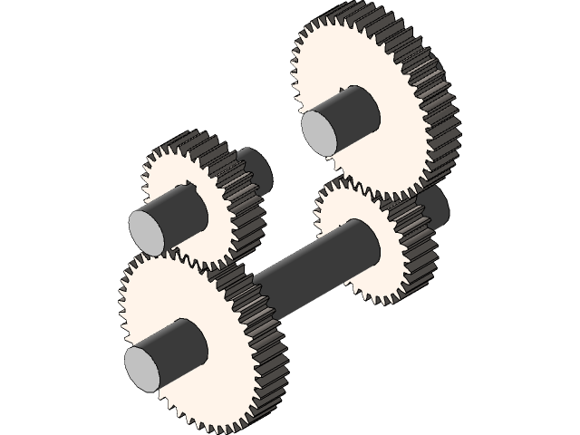
(A. Tyagi, 2019)

An epicyclic gear train is a gear that’s made up of two gears. The gears are mounted together so that the centre one gear can revolve around the centre of the other. Epicyclic gear trains are also known as a planetary gear train. Within the centre of the gears lays a component called a carrier. The purpose of this carrier is to “carry” one of the gears around the other gear. The gear that is being carried is commonly called the planet pinion and the gear that’s been revolved around is commonly known as the sun wheel. In doing will not allow them to slip. The planet gears within the gear train follow an infinite re-accruing curve called the epicycloid curve. Hence the name of the gear train. Therefore, the sun wheel is fixed and gears surrounding the sun wheel (gear), the planet pinions rotate around it. There are many different types of epicyclic gear trains such as they can be arranged where the planet pinions can be rotated on the inner face of the sun ring or the outer face of the sun ring. The epicyclic name come from the modelling movements of planets as planets are believed to move in perfect circular motion. The purpose of the epicyclic gear trains is to provide different r.p.m. outputs like. These are used on basically everything that has variable speed such as hoovers, remote control cars and 3D printers. (J. Karthik, 2017)
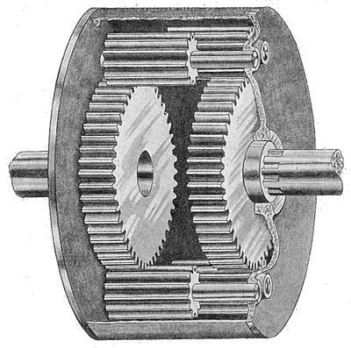
(Wikiwand, 2020)
Part 2:
Given information:
$N_{A}$ = 1000 R.P.M
$T_{A}$ = 20
$T_{B}$ = 50
$T_{C}$ = 25
$T_{D}$ = 85
$T_{E}$ = 28
$T_{F}$ = 65
Letter Index:
Speed of Driving Gear ($N_{1}$)
Number of Driving Gear Teeth ($T_{1}$)

The first thing I must do is to create a gear ratio for A to F. The equation below is a typical gear ratio.
$$Speed Ratio = \frac{Speed of First Driver}{Speed of Last Driven }= \frac{Number of Teeth on Drivens}{Number of Teeth on Drivers}$$
$$\frac{N_{1}}{N_{2}}= \frac{T_{2}}{T_{1}}$$
Therefore, the gear ratio for gears ‘A’ and ‘B’ is:
$$\frac{N_{A}}{N_{B}}= \frac{T_{B}}{T_{A}}$$
Now that the gears ratio for ‘A’ and ‘B’ as been created It can now be done for the rest of the gears.
$$\frac{N_{C}}{N_{D}}= \frac{T_{D}}{T_{C}}$$
And
$$\frac{N_{E}}{N_{F}}= \frac{T_{F}}{T_{E}}$$
Now that the gear ratios have been created for all the gear, I must now compound them together by multiplying the equation together. Therefore:
$$\frac{N_{A}}{N_{B}}×\frac{N_{C}}{N_{D}}×\frac{N_{E}}{N_{F}}= \frac{T_{B}}{T_{A}} × \frac{T_{D}}{T_{C}} × \frac{T_{F}}{T_{E}}$$
Since gears ‘B’ and ‘C’ are on the same shaft they are rotating at the same velocity therefore the same. Gears ‘D’ and ‘E’ are also on the same shaft therefore they are also rotating at the same velocity as each other. Now knowing this they are cancelling each other out resulting in the following:
$$\frac{N_{A}}{N_{F}}= \frac{T_{B} × T_{D} × T_{F}}{T_{A} × T_{C} × T_{E}}$$
Now that the Speed ration gear equation has been created, I can now input the information already obtained. Therefore:
$$\frac{1000}{N_{F}}= \frac{50 × 85 × 65}{20 × 25 × 28}$$
$$N_{F} = \frac{1000}{19.73214286}$$
$$N_{F} = 50.6787…$$
$$N_{F} = 50.679 R.P.M (3DP)$$

The motor shaft began with a 1000 R.P.M at gear ‘A’. However, the R.P.M decreased down to 50.679 R.P.M by the time it reached gear ‘F’.

Part 3A:
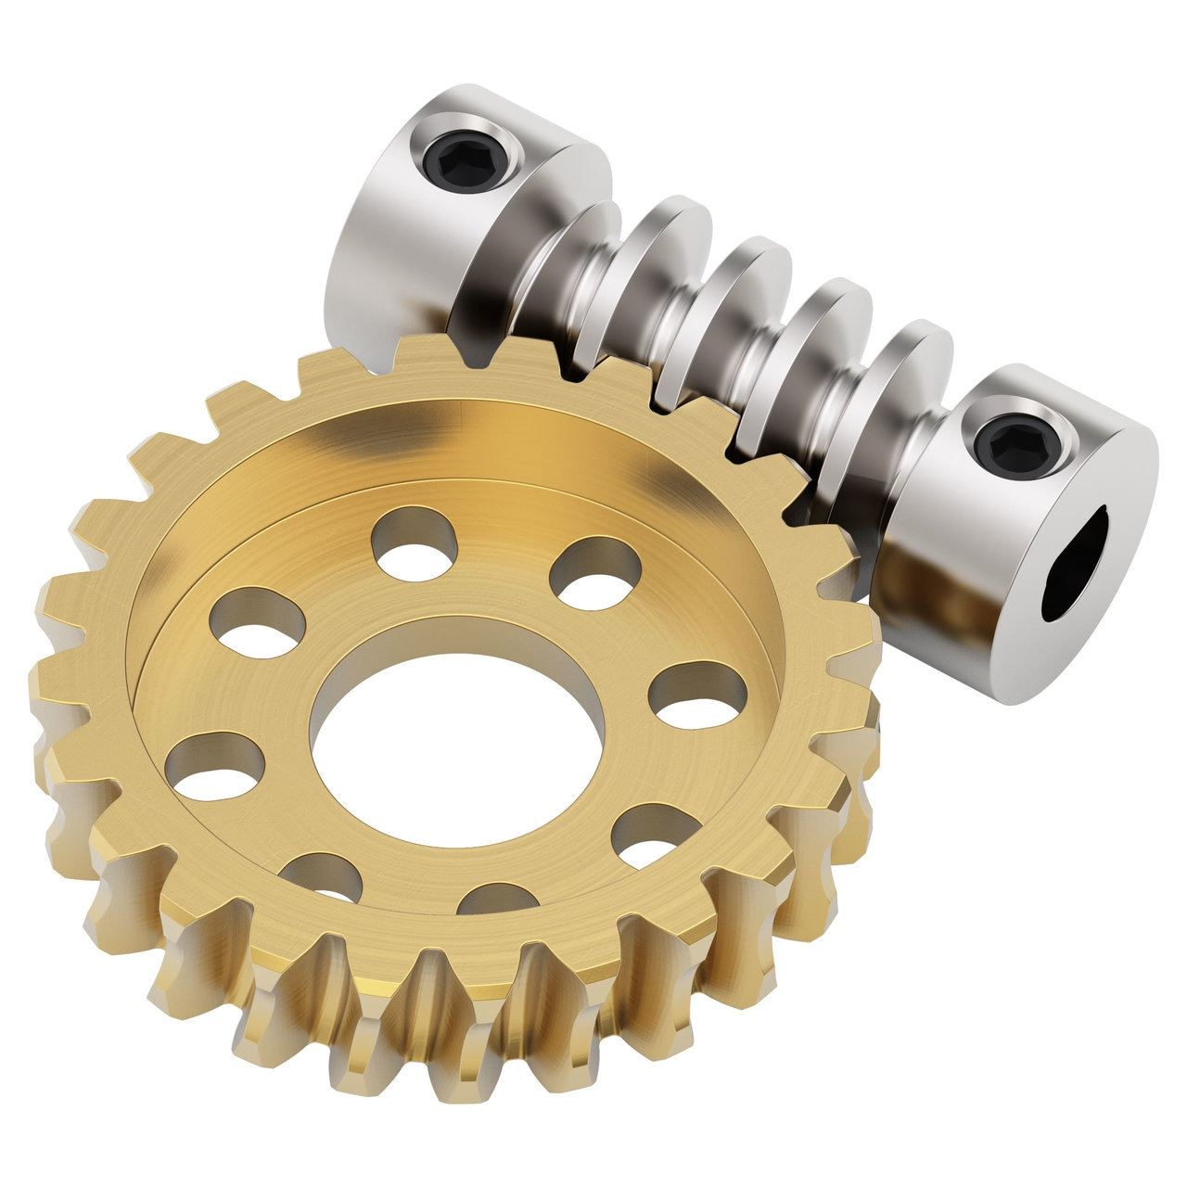
(goBILDA, 2020)
The best gear for speed reduction and torque multiplier is a worm gear. A worm gear is sometimes referred as a worm wheel. A worm gear is constructed from two components which are a worm and a gear. The “shaft has a spiral thread that engages.” (Machinery Lubrication, 2020) Worm gears are one of six old style gear designs for machinery. The gear aligns tangential to the shaft that has an angled shaped screw thread on it. The gears on a worm gear have curved shaped teeth also. By the gear being tangential to the shaft the rotational movement of the shaft is rotated by 90 degrees. The plane movement also changes as a result of the alignment. Typically, the gears on the worm gear are constructed out of brass and the shaft are fabricated out of steel. This is because it is easier to replace the gear than the worm shaft. (Machinery Lubrication, 2020)
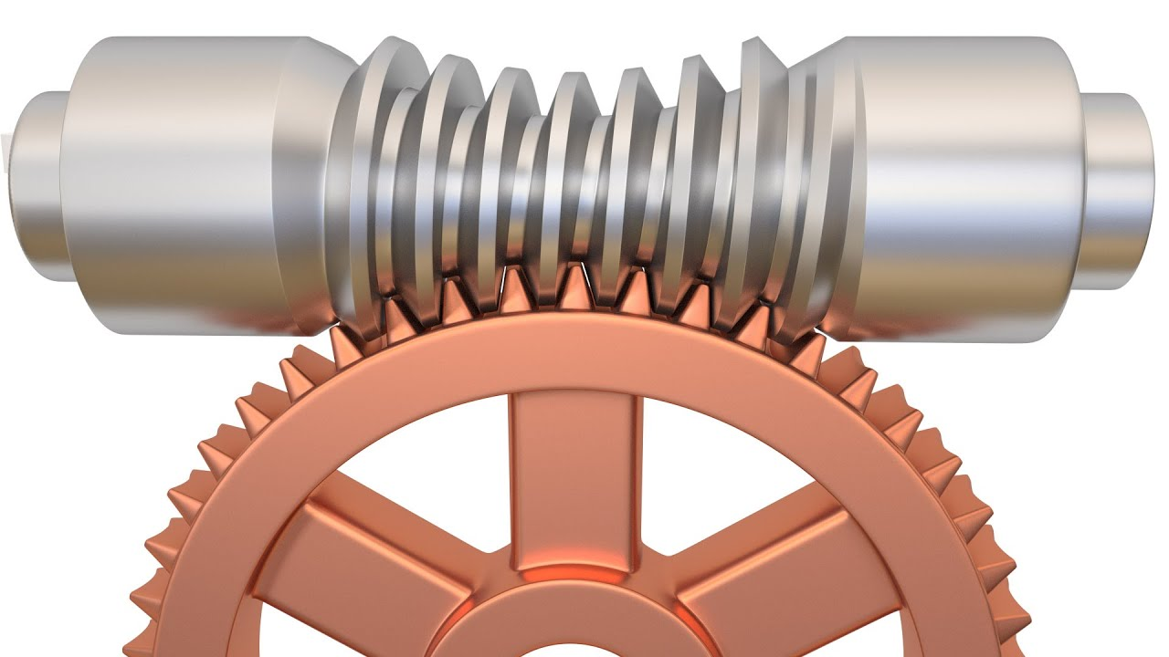
(O.T. Vinta, 2016)
The worm gears operate by the shaft rotating via a motor or power source. The rotation of the shaft rotates against the gear and the screw face pushes against the teeth of the wheel causing the gear to push against the force acting on it. There are many reasons why a worm gear is beneficial within machinery over a standard gear. One of these benefits is due to its high reduction ratio. “A worm gear can have a massive reduction ratio with little effort - all one must do is add circumference to the” gear. (Machinery Lubrication, 2020) Machinery Lubrication then go onto say that due to this the torque can be greatly increased or reduce the speed greatly. The result of this will result in significant reduction of conventual gear as the worm gear will achieve the desired outcome. Reducing conventual gear will result in decrease the likely hood of failures accruing in the machine as there be fewer components.

Part 3B:
Given information:
x = 800 mm
$N_{1}$ = 360 R.P.M
$N_{2}$ = 140 R.P.M
$P_{C}$ = 25 mm

Letter Index:
Distance Between Centres of Two Shafts (x)
Speed of the Driver ($N_{1}$)
Number of Teeth on the Driver ($T_{1}$)
Pitch Circle Diameter of the Driver ($D_{1}$)
Circular Pitch ($P_{C}$)

The first thing I must do is to create a gear ratio. The equation below is a typical gear ratio.
$$\frac{N_{1}}{N_{2}}= \frac{T_{2}}{T_{1}}$$
Due the number of teeth on each gear is unknown; I must substitute the pitch circle diameter of the driver in its place. Therefore:
$$\frac{N_{A}}{N_{B}}= \frac{D_{B}}{D_{A}}$$
$$\frac{360}{140}= \frac{D_{B}}{D_{A}}$$
$$D_{B} = 2.571428571 × D_{A}$$
Now knowing that the gear ‘B’ is approximately 2.6 times larger than gear ‘A’ I must now calculate the distance between shaft centres. The equation for this is as follows:
$$x = \frac{D_{A}+D_{B}}{2}$$
Therefore;
$$800 = \frac{D_{A}+D_{B}}{2}$$
$$1600= D_{A}+D_{B}$$
Now knowing this I can calculate the pitch for each gear.
$$D_{1}= \frac{x}{(\frac{N_{A}}{N_{B}}+1)}$$
$$D_{A}= \frac{1600}{(2.571428571+1)}$$
$$D_{A}= 448$$
$$D_{B} = 2.571428571 × D_{A}$$
$$D_{B} = 1152$$
Now that the pitch of each gear has been calculated I must now calculate the number of teeth on each gear. The equation to calculate this is as follows:
$$T_{1} = \frac{π ×D_{1}}{P_{C}}$$
Therefore, the number of teeth for gear ‘A’ is:
$$T_{A} = \frac{π × D_{A}}{P_{C}}$$
$$T_{A} = \frac{π × 448}{25}$$
$$T_{A} = 56.297…$$
$$T_{A} = 56$$
Number of teeth for gear ‘B’ is:
$$T_{B} = \frac{π × D_{B}}{P_{C}}$$
$$T_{B} = \frac{π × 1152}{25}$$
$$T_{B} = 144.764…$$
$$T_{B} = 145$$
Now that the pitch and teeth for both gears have been calculated I must now double deck my results by recalculating the pitch using the teeth calculated for each gear. I can do this by rearranging the number of teeth ratio.
$$D_{1} = \frac{T_{1} × P_{C}}{π}$$
Therefore:
$$D_{A} = \frac{T_{A} × P_{C}}{π}$$
$$D_{A} = \frac{56.29734035 × 25}{π}$$
$$D_{A} = 448 mm$$
$$D_{B} = \frac{T_{B} × P_{C}}{π}$$
$$D_{B} = \frac{144.7645895 × 25}{π}$$
$$D_{B} = 1152 mm$$
The check results have shown that I have correctly calculated the correct pitch and number of teeth for each gear. Now I must calculate the distance between shafts.
$$x = \frac{D_{A}+D_{B}}{2}$$
$$x = \frac{448 +1152}{2}$$
$$x = 800 mm$$
Gear ‘A’ has a pitch of 448mm and 56 teeth. Whereas gear ‘B’ has a pitch of 1152mm and 145 teeth. The distance between shafts centres is 800mm.

Part 4:
Given information:
x = 200 mm
$N_{A}/N_{D}$ = 12
$M_{A}=M_{B}$ = 3.13 mm
$M_{C}=M_{D}$ = 2.5 mm

Letter Index:
Distance Between Centres of Two Shafts (x)
Speed of the Driver ($N_{1}$)
Number of Teeth on the Driver ($T_{1}$)
Pitch Circle Radius of the Driver ($r_{1}$)

Using the information already in position it can be noted that the centres of the shafts from gears ‘A’ and ‘B’, as well as gears ‘C’ and ‘D’ are equal. Therefore:
$$r_{1}+r_{2} = r_{3}+r_{4}$$
It can also be assumed that the circular pitch is equal also.
$$T_{1}+T_{2} = T_{3}+T_{4}$$
Using known equations such as the speed ratio equation and the circular pitch equation, I can now begin calculating the pitch and number of teeth for all the gears.
However, before I begin, I must convert the circular pitch equation from diameter to radial.
$$T_{1} = \frac{π ×D_{1}}{P_{C}}$$
$$P_{C} = \frac{2π×r_{1}}{T_{1}}= πm$$
I can also make radius the subject, where ‘m’ is the module.
$$r_{1} = \frac{m_{1}× T_{1}}{2}$$
Therefore, I can now calculate the radius pitch for each gear as follows.
$$r_{A} = \frac{m_{A}× T_{A}}{2}$$
$$r_{B} = \frac{m_{B}× T_{B}}{2}$$
$$r_{C} = \frac{m_{C}× T_{C}}{2}$$
$$r_{D} = \frac{m_{D}× T_{D}}{2}$$
I must now transpos the new equations into the pitch equation calculated at the start during the assumptions.
$$r_{1}+r_{2} = r_{3}+r_{4}$$
$$\frac{m_{A}× T_{A}}{2}+ \frac{m_{B}× T_{B}}{2}= \frac{m_{C}× T_{C}}{2}+ \frac{m_{D}× T_{D}}{2}$$
Using the speed ratio, I can now calculate the speed of the gears and number of teeth.
$$\frac{N_{A}}{N_{B}}= \frac{N_{C}}{N_{D}}=\sqrt{12}$$
$$\frac{N_{A}}{N_{B}}= \frac{N_{C}}{N_{D}}=3.464101615$$
The number of teeth is the opposite of the speed ratio, therefore:
$$\frac{T_{B}}{T_{A}}= \frac{T_{D}}{T_{C}}=3.464101615$$
Using the information supplied it’s a known fact that the distance (x) between shafts is 200mm. Therefore:
$x = r_{1}+r_{2} = r_{3}+r_{4} = 200$
It can also be shown as
$$\frac{m_{A}× T_{A}}{2}+ \frac{m_{B}× T_{B}}{2}= \frac{m_{C}× T_{C}}{2}+ \frac{m_{D}× T_{D}}{2} =200$$
$$3.13 \left(T_{A} + T_{B}\right)= 2.5 \left(T_{C} + T_{D}\right) =400$$
Therefore:
$$T_{A}+ T_{B} =\frac{400}{3.13}$$
$$T_{A}+ T_{B} =127.7955272$$
And
$$T_{C}+ T_{D} =\frac{400}{2.5}$$
$$T_{C}+ T_{D} =160$$
Using the equation calculated earlier I must now make gear ‘B’ the subject of the equation by rearranging it.
$$\frac{T_{B}}{T_{A}}= 3.464101615$$
$$T_{B}= 3.464101615 × T_{A}$$
I must also make gear ‘D’ the subject of the equation also.
$$\frac{T_{D}}{T_{C}}= 3.464101615$$
$$T_{D}= 3.464101615 × T_{C}$$
Now that both sides of the shafts have been rearranged, I must now substitute them back into their individual equations.
$$T_{A}+ T_{B} =127.7955272$$
$$T_{A} =\frac{127.7955272}{3.464101615 +1}$$
$$T_{A} =28.62737864$$
Substitute the answer back into the equation to calculate the number of teeth in gear ‘B’.
$$T_{A}+ T_{B} =127.7955272$$
$$T_{B} =127.7955272 -T_{A}$$
$$T_{B} =127.7955272 -28.62737864$$
$$T_{B} =99.16814856$$
Now that the number of teeth for gears ‘A’ and ‘B’ have been calculated I must to the same for the remaining.
$$T_{C}+ T_{D} =160$$
$$T_{C} =\frac{160}{3.464101615 +1}$$
$$T_{C} =35.84147804$$
Substitute the answer back into the equation to calculate the number of teeth in gear ‘D’.
$$T_{C}+ T_{D} =160$$
$$T_{D} =160 - T_{C}$$
$$T_{D} =160 - 35.84147804$$
$$T_{D} =124.158522$$
Therefore gear ‘A’ requires 29 teeth, Gear ‘B’ requires 99 teeth, Gear ‘C’ requires 36 teeth and gear ‘D’ requires 124 teeth. Now that all the teeth have been calculated I now must place the required number of teeth into the speed ratio equation. Therefore:
$$\frac{N_{A}}{N_{D}}= \frac{T_{B} × T_{D}}{T_{A} × T_{C}}$$
$$\frac{N_{A}}{N_{D}}= \frac{99 × 124}{29 × 36}$$

Reference List
A. Tyagi, (2019). reverted gear train. [Image]. Available from: https://grabcad.com/library/reverted-gear-train-2 [Accessed: 02/05/20]

COMSOL, (2020). COMSOL MULTIPHYSICS 5.2a RELEASE HIGHLIGHTS. [Image]. Available from: https://www.comsol.com/release/5.2a/multibody-dynamics-module [Accessed: 02/05/20]

Creative Mechanics, (2020). What Are Gears. [Online]. Available from: https://www.creativemechanisms.com/gears
[Accessed: 02/05/20]

D. Ghatt, (2016). What are some applications of simple gear trains?. Quora. [Online] Available from: https://www.quora.com/What-are-some-applications-of-the-simple-gear-trains [Accessed: 01/05/20]

goBILDA, (2020). 24:1 Ratio Worm Gear Set. [Image]. Available from: https://www.gobilda.com/24-1-ratio-worm-gear-set/
[Accessed: 09/05/20]

J. Karthik, (2017). Where is the epicyclic gearing train used? [Online]. Available from: https://www.quora.com/Where-is-the-epicyclic-gearing-train-used [Accessed: 05/05/20]

Machinery Lubrication, (2020). Worm Gears Explained. [Online]. Available from: https://www.machinerylubrication.com/Read/1080/worm-gears
[Accessed: 07/05/20]

Mechanical Maina, (2011). Worm Gears Explained. [Online]. Available from: http://mechanicalmania.blogspot.com/2011/07/reverted-gear-train.html [Accessed: 01/05/20]

O.T. Vinta, (2016). Tutorial: How to Model Globoid (aka Throated) Worm Drive in Blender. [Image]. Available from: https://www.machinerylubrication.com/Read/1080/worm-gears
[Accessed: 07/05/20]

S. Sega, (2017). What is the applications of compound gear trains?. Quora. [Online] Available from: https://www.quora.com/What-is-the-application-of-compound-gear-train [Accessed: 01/05/20]

SMLease Design, (2020). Gear Train: Gear Ratio, Torque and Speed Calculations. [Image] Available from: https://www.smlease.com/entries/mechanism/gear-train-gear-ratio-torque-and-speed-calculation/
[Accessed: 01/05/20]

V. Ryan, (2010). Compound Gears [Online] Available from: http://www.technologystudent.com/gears1/gears3.htm [Accessed: 03/05/20]

Wikipedia, (2020). Gear Trains. [Image] Available from: https://en.wikipedia.org/wiki/Gear_train [Accessed: 02/05/20]

Wikiwand, (2020). Epicyclic gearing. [Image] Available from: https://www.wikiwand.com/en/Epicyclic_gearing [Accessed: 04/05/20]

