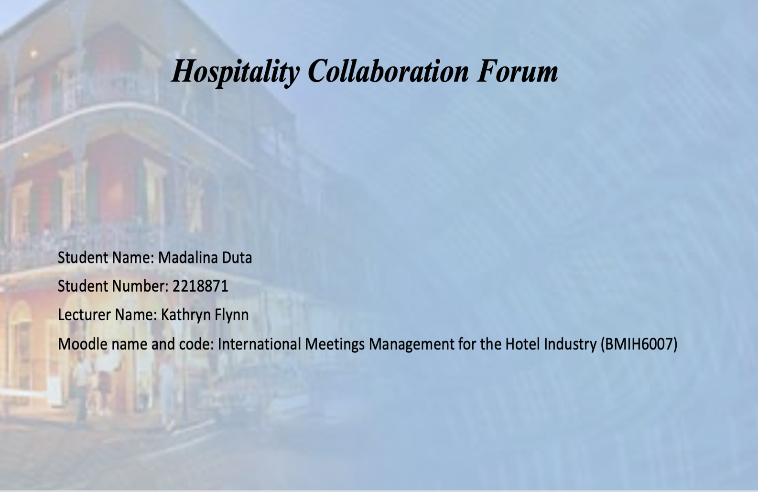
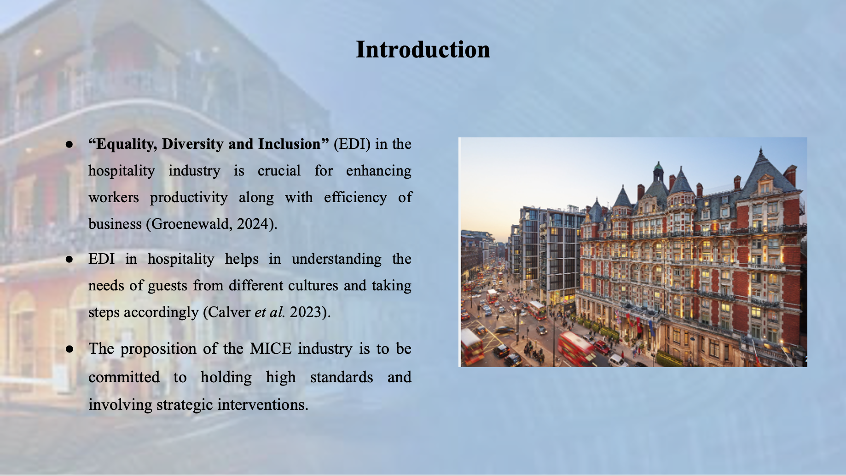
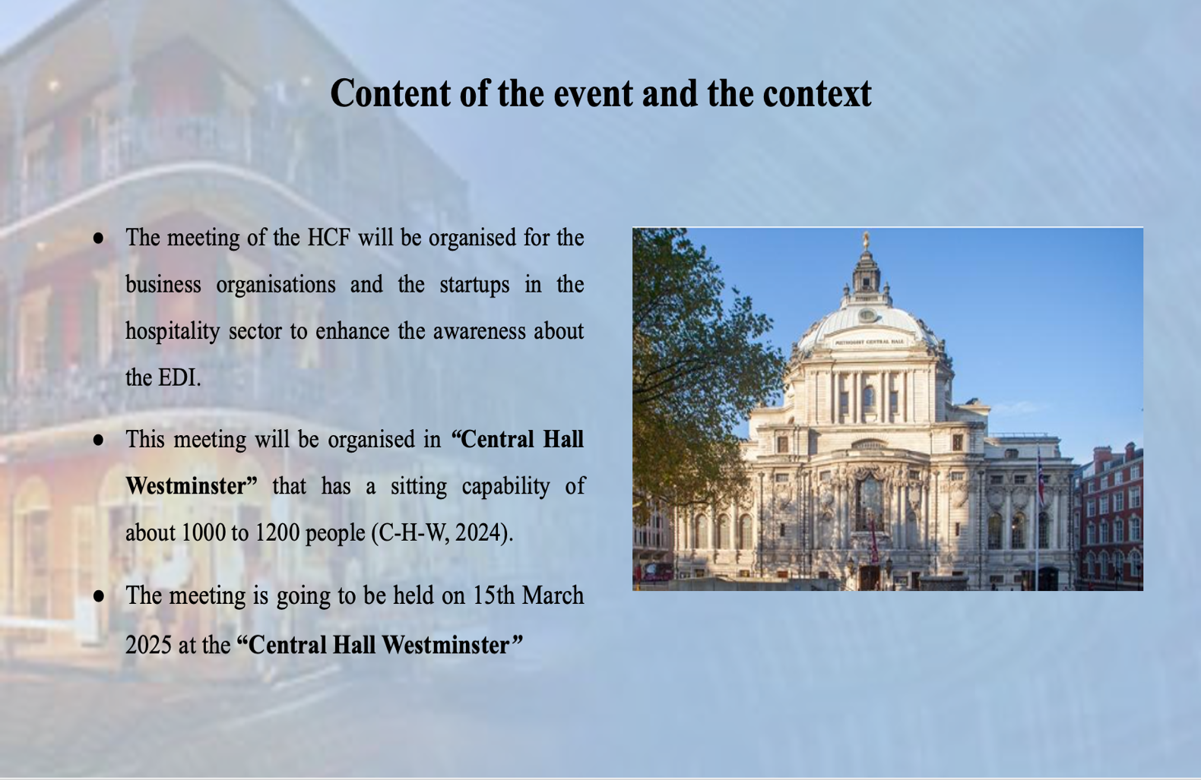
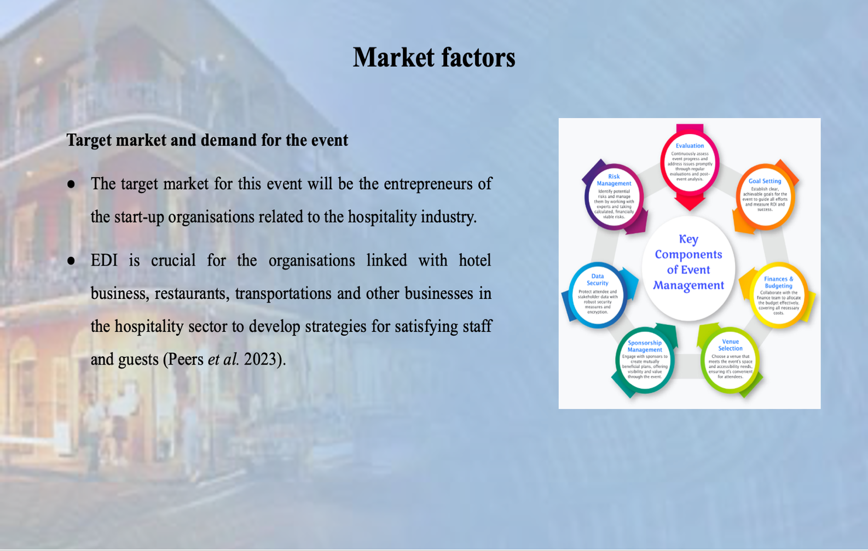
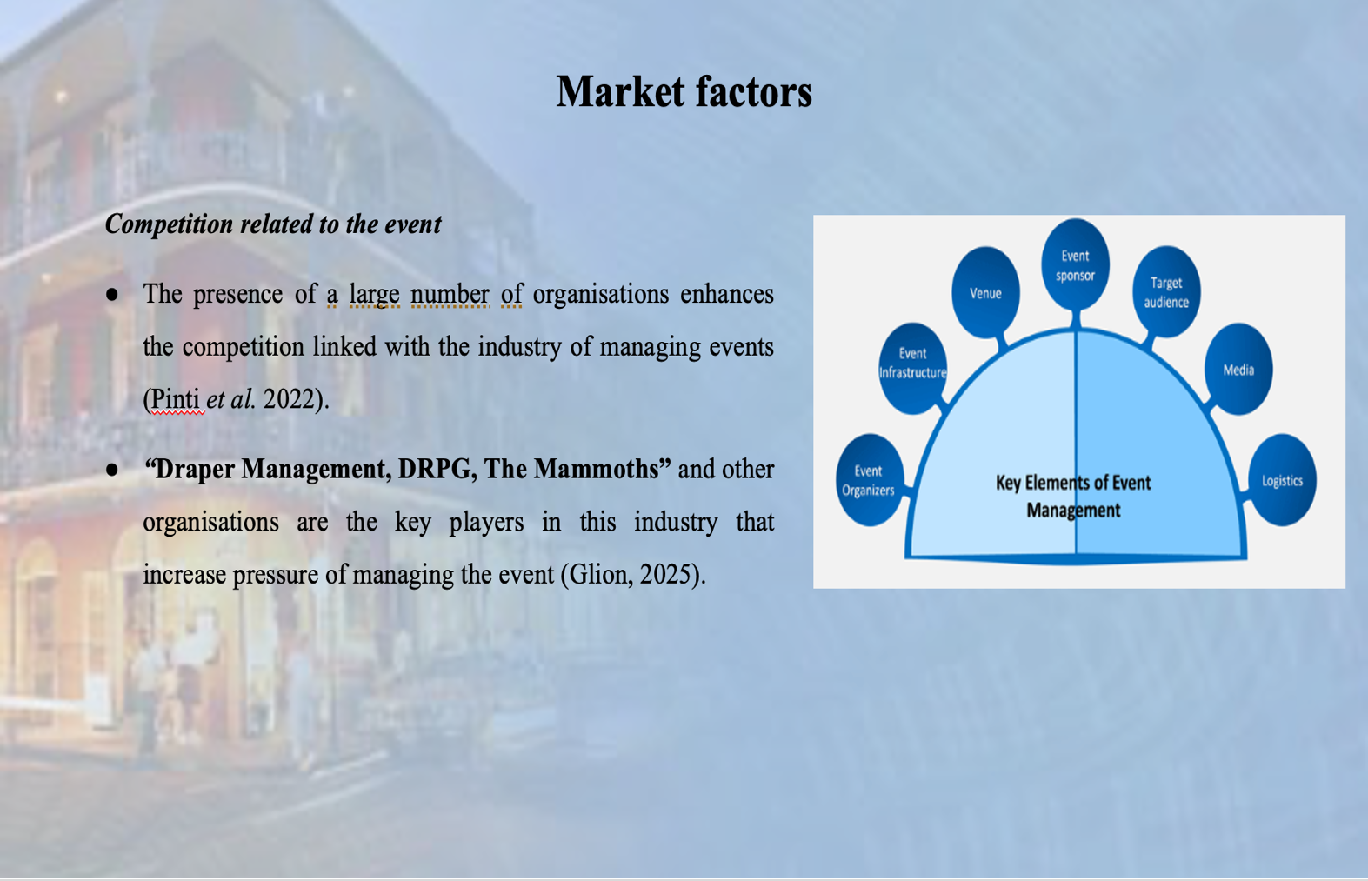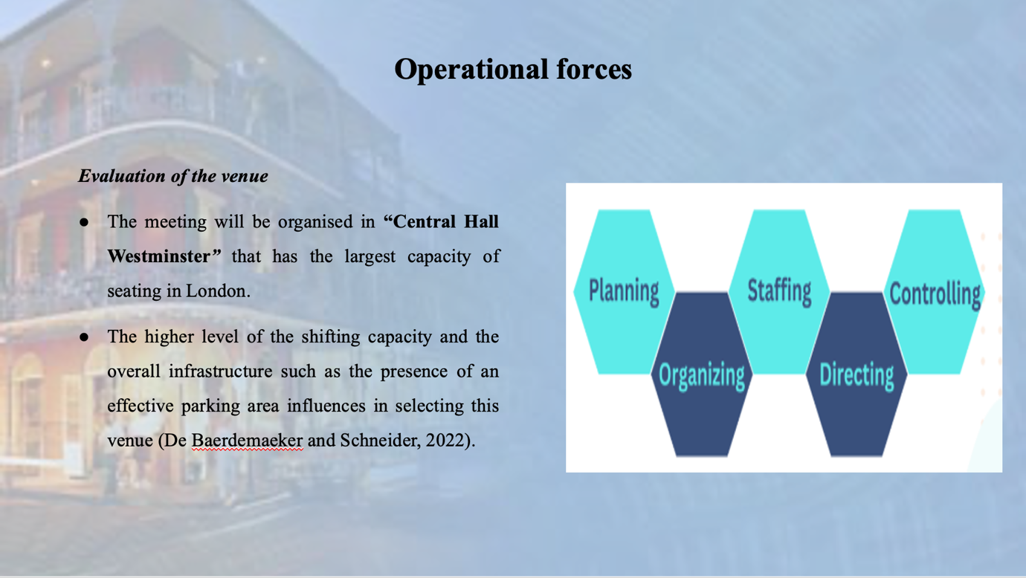
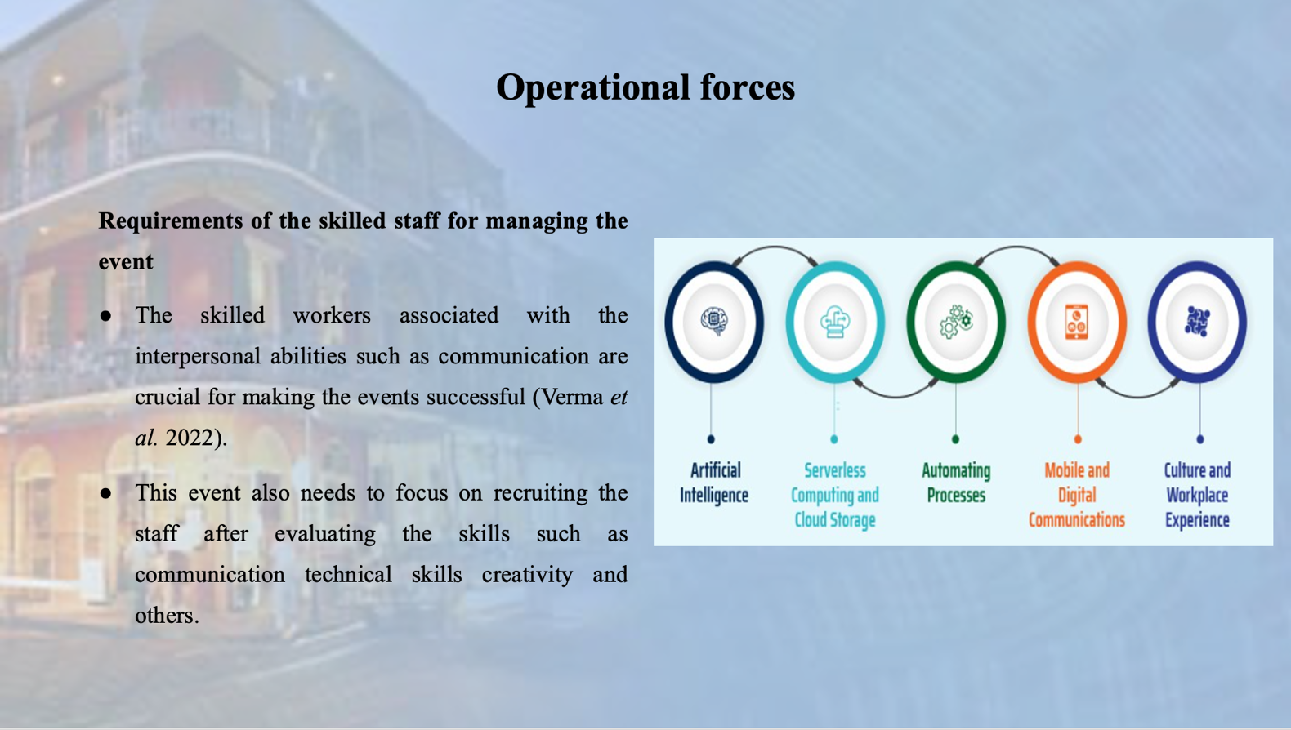
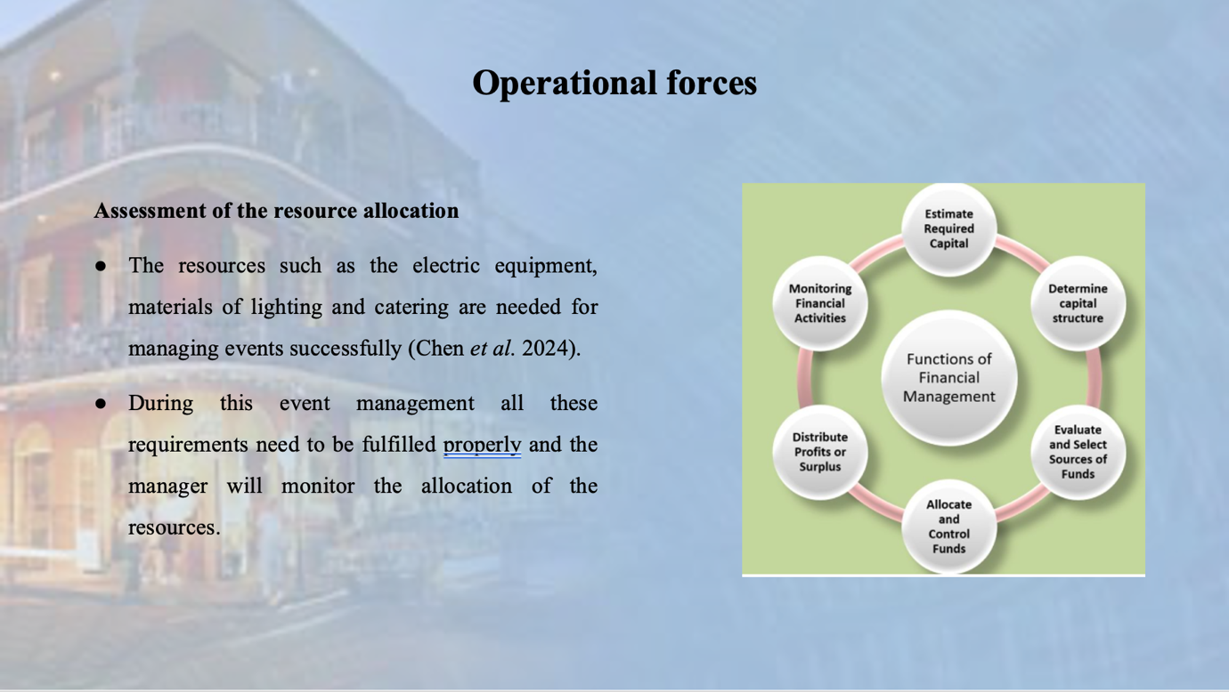
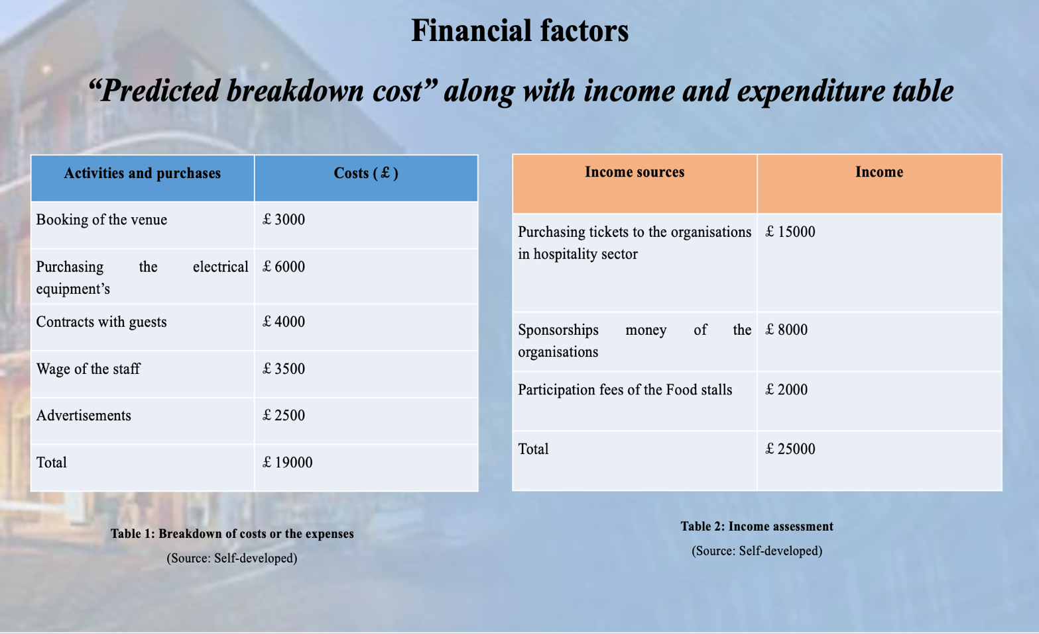
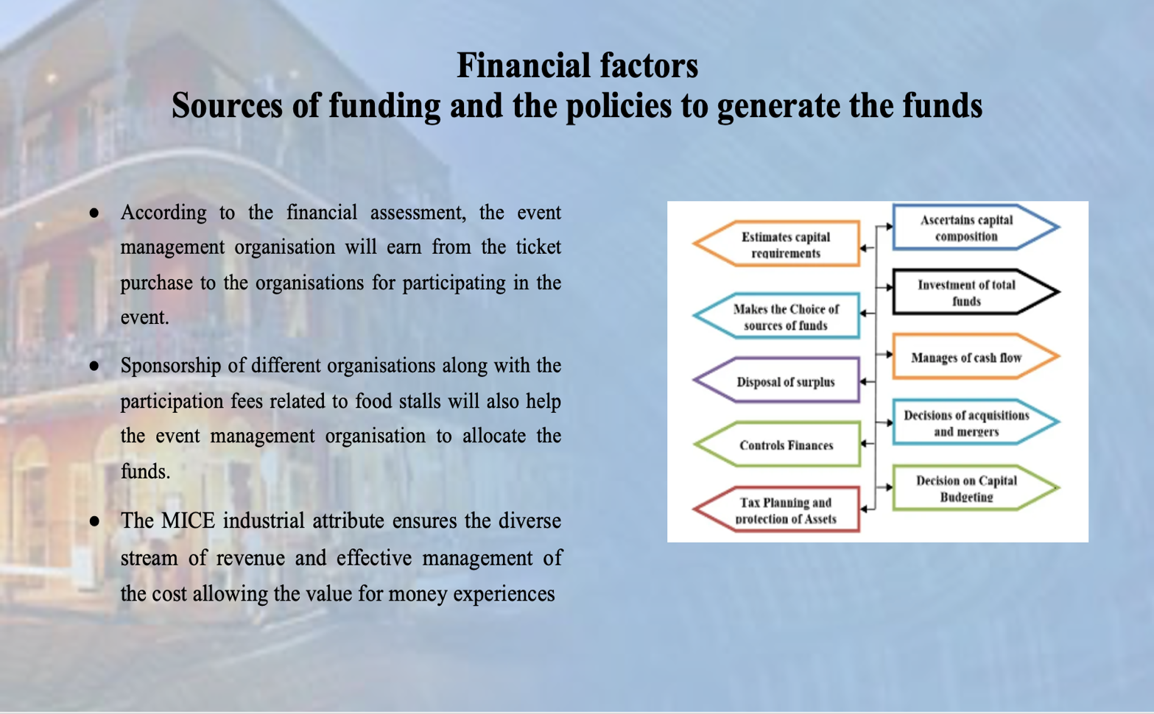

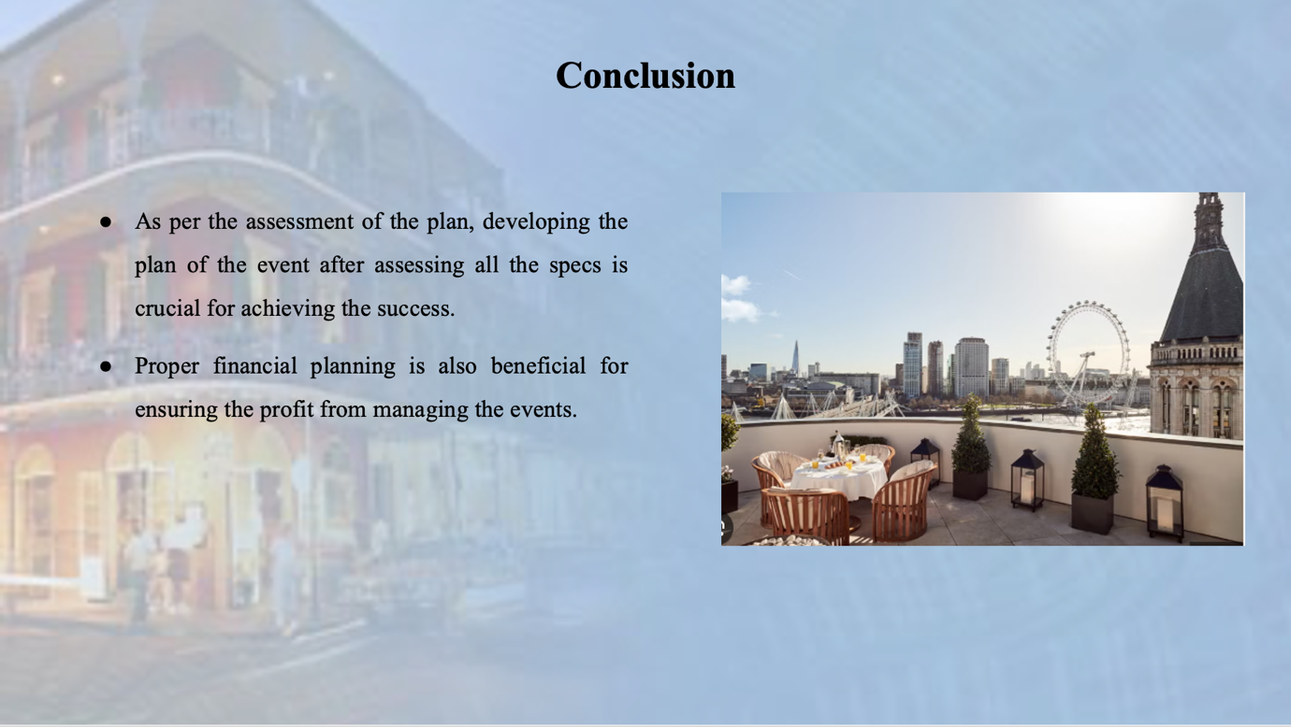
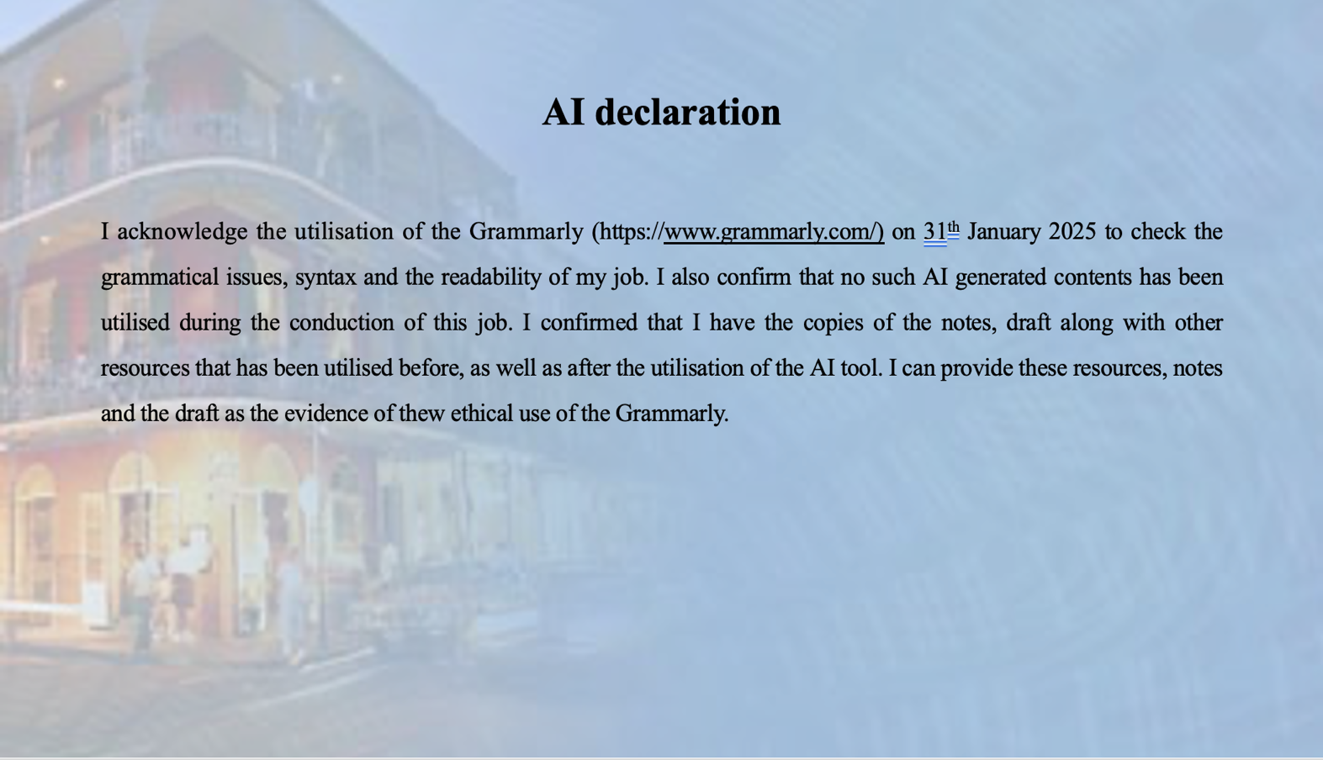
Reference

- Battaglia, (2024). Diversity in hospitality: how cultural inclusivity defines the industry. Available at: https://www.glion.edu/magazine/diversity-in-hospitality-how-cultural-inclusivity-defines-the-industry/
- Biggs, E., (2022). ‘A cloister of curious workmanship’: the patronage of St. Stephen’s cloisters within the Palace of Westminster in the early sixteenth century. Historical Research, 95(269), pp.309-333.
- Calver, J., Dashper, K., Finkel, R., Fletcher, T., Lamond, I.R., May, E., Ormerod, N., Platt, L. and Sharp, B., (2023). The (in) visibility of equality, diversity, and inclusion research in events management journals. Journal of Policy Research in Tourism, Leisure and Events, pp.1-25.
- Chen, G., Peachey, J.W. and Stodolska, M., (2024). Leveraging the cancellation of in-person sport events for sense of community: the case of the Illinois Marathon. Event Management, 28(1), pp.41-57.
- C-H-W, (2024). Space for 1000 to 2000 people. Available at: https://www.c-h-w.com/venue/1000-to-2400-people/#:~:text=Central%20Hall%20Westminster%20is%20central,1%2C000%20to%20over%202%2C000%20guests.
- De Baerdemaeker, S. and Schneider, M.D., (2022). Better Appreciating the Scale of It: Lemaître and de Sitter at the BAAS Centenary. HOPOS: The Journal of the International Society for the History of Philosophy of Science, 12(1), pp.170-188.
- Glion, (2025). The Top 25 Event Management Companies In The UK. Available at: https://www.table-art.co.uk/the-top-25-event-management-companies-in-the-uk/
- González-Granadillo, G., González-Zarzosa, S. and Diaz, R., (2021). Security information and event management (SIEM): analysis, trends, and usage in critical infrastructures. Sensors, 21(14), p.4759.
- Groenewald, E., (2024). Assessing the Role of Leadership in Shaping EDI Policies and Initiatives in Hospitality Industries: A Systematic Review and Meta-analysis Review. International Multidisciplinary Journal of Research for Innovation, Sustainability, and Excellence (IMJRISE), 1(1), pp.13-19.
- Jawabreh, O., Shniekat, N., Saleh, M.M.A. and Ali, B., (2022). The strategic deployment of information systems attributes and financial performance in the hospitality industry. Information Sciences Letters, 11(5), p.110504.
- Kelly, F.E., Frerk, C., Bailey, C.R., Cook, T.M., Ferguson, K., Flin, R., Fong, K., Groom, P., John, C., Lang, A.R. and Meek, T., (2023). Implementing human factors in anaesthesia: guidance for clinicians, departments and hospitals: guidelines from the Difficult Airway Society and the Association of Anaesthetists. Anaesthesia, 78(4), pp.458-478.
- Kornau, A., Knappert, L., Tatli, A. and Sieben, B., (2023). Contested fields of equality, diversity and inclusion at work: an institutional work lens on power relations and actors’ strategies in Germany and Turkey. The International Journal of Human Resource Management, 34(12), pp.2481-2515.
- Leta, S.D. and Chan, I.C.C., (2021). Learn from the past and prepare for the future: A critical assessment of crisis management research in hospitality. International Journal of Hospitality Management, 95, p.102915.
- Muzam, J., (2023). The challenges of modern economy on the competencies of knowledge workers. Journal of the Knowledge Economy, 14(2), pp.1635-1671.
- Noon, M. and Ogbonna, E., (2021). Controlling management to deliver diversity and inclusion: Prospects and limits. Human Resource Management Journal, 31(3), pp.619-638.
- Peers, D., Joseph, J., Chen, C., McGuire-Adams, T., Fawaz, N.V., Tink, L., Eales, L., Bridel, W., Hamdon, E., Carey, A. and Hall, L., (2023). An intersectional Foucauldian analysis of Canadian national sport organisations’‘equity, diversity, and inclusion’(EDI) policies and the reinscribing of injustice. International Journal of Sport Policy and Politics, 15(2), pp.193-209.
- Pinti, L., Codinhoto, R. and Bonelli, S., (2022). A review of building information modelling (BIM) for facility management (FM): Implementation in public organisations. Applied Sciences, 12(3), p.1540.
- Schislyaeva, E.R. and Saychenko, O.A., (2022). Labor market soft skills in the context of digitalization of the economy. Social Sciences, 11(3), p.91.
- Settembre-Blundo, D., González-Sánchez, R., Medina-Salgado, S. and García-Muiña, F.E., (2021). Flexibility and resilience in corporate decision making: a new sustainability-based risk management system in uncertain times. Global Journal of Flexible Systems Management, 22(Suppl 2), pp.107-132.
- Verma, A., Lamsal, K. and Verma, P., (2022). An investigation of skill requirements in artificial intelligence and machine learning job advertisements. Industry and Higher Education, 36(1), pp.63-73.
- Wang, R., (2021). [Retracted] Analysis of Sports Event Management Teaching from the Perspective of Multimedia considering Multiobjective Teaching Optimization Algorithm. Advances in Multimedia, 2021(1), p.3554715.
- Zarotis, G.F., (2021). Event management and marketing in tourism. Glob. Acad. J. Humanit. Soc. Sci, 3, pp.75-81.

