Elena Todorova (2124115)
bmhp5014-birm Robert Nartowski
Change makers: Creativity and value creation E-PORTFOLIO

Elaboration of flyer task.
Depression and anxiety are very cruel and a silent disorder, which can affect people from any ages and any walks of life. Many of us have suffered or no doubt know somebody that is suffered from this cruel disease. That's why it's very important everyone get involved and together we break the stigma around this disease. sometimes people feel they are judged or not being understand or being laughed at if they say they suffer from any of this disease, it makes it very hard for them to seek help. Often people who suffer from depression and mental illness experiencing feelings of devaluation, dehumanisation and feel dismissed even by professionals. That's why it is very important we gain enough knowledge on this disorder and make sure we can spot the signs and we can support anyone who needs help. WHO recommend targeting education campaigns to the general public to improve awareness of suicidal crises and, more broadly, to improve awareness of depression, which is a major risk factor for suicidal behaviour. Failing to do this will resolve to some people losing their life and many families being broken down because of this. According to (Mojtabai, Olfson, & Han, 2016)’’The prevalence of depression and the number of young people with untreated depression have increased in recent years.’’ However, there are many services and places where you can get help doesn't matter if it's anonymous; everything is private and confidential so you can get the support you need with dignity and respect. Visit our website or you can call our 24/7 helpline, also we have meetings every week you can join us and find all the information and knowledge you need. We have meditation meetings, well-being talk, group support, also one to one support and anything else which can help to fight the cruel disease. This brings the community together and helps many people. Sometime a smile is enough to make somebody's day better, or a simple question of’’ How are you today?’’
The purpose of the flyer is to encourage people to join and take part in mental health awareness as this is ongoing problem who affects all people directly or indirectly. Relevant picture is used to recreate the way people may feel. Included is information about the disorder as well as locations of where all the activities are hold. On the other hand, included also is contact information for anyone who may need it. Moreover, graphs are included to show the scale of this disorder. The logo of the campaign is a bright yellow sun with D in the middle and hands holding in beneath the sun. This symbolise there is always light in the end of the tunnel. Moreover, associating that the sun will shine again upon us and we should all give each other hand by supporting each other in hard times. This flyer is aimed for outreach to public and involve as many people as possible. Placed in community hubs, hospitals, universities, schools, spread as widely as possible publish in social media, newspapers as well; so more people can see and join the cause. It can be handed to people on the streets and in events as well.

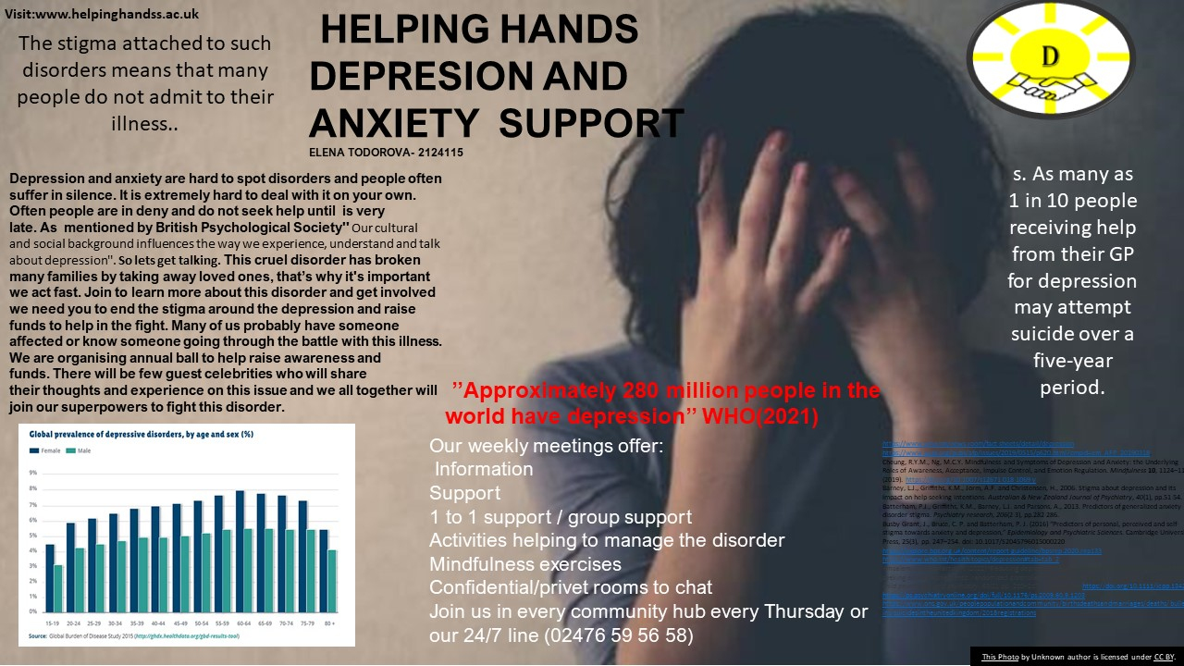

Speech
Good evening, ladies, and gentlemen. Good evening, everyone. Thank you for being brave and be here tonight. We are joining tonight to make a difference in many people lives. By raising awareness for depression and anxiety, and introducing the services provided by our organisation.
Have you ever got unbelievably nervous about something and wanted to back out, no matter how important it is? Can you remember that horrible feeling in the pit of your stomach that won’t go away?
Don’t wait for tomorrow, be the change we all need today.

Once Robin Williams said’’ All it takes is a beautiful fake smile to hide an injured soul and they will never notice how broken you really are.’’
Depression and anxiety are very cruel and at times silent disorder, which can affect people from any ages, any walks of life and any social status. This problem can affect anyone. Many of us have suffered or no doubt know somebody that is suffered from depression or anxiety. That's why it's extremely important everyone get involved and together we break the stigma around it.
Do you know that according to ONS’’ In 2018, there were 6,507 suicides registered in the UK.
- Males aged 45 to 49 years had the highest age-specific suicide rate (27.1 deaths per 100,000 males); for females, the age group with the highest rate was also 45 to 49 years, at 9.2 deaths per 100,000.
- In 2018, a total of 6,507 suicides were registered in the UK, 686 more deaths than in 2017 when there were 5,821 deaths (11.8% increase).

Sometimes people feel they are judged or not being understand or being laughed at if they say they suffer from any of this disease, and it makes it very hard for them to seek help. That's why by gaining enough knowledge on this disorder and making sure we can spot the signs we will be able to provide support to anyone who needs it. Failing to do this will resolve to some people losing their life and many families being broken down because of this.
However, is important to know there is many services and places where you can get help it can be anonymous; everything is private and confidential so you can get the support you need with dignity and respect. Our organisation provides regular and extensive training, support 24/7 for anyone, we have online platforms which are also very successful and can help. What makes us better and different is that we are dedicated and passionate to help and make difference in people lives. We do genuinely care for everyone. Sometime a smile is enough to make somebody's day better.
Our annual Ball has the aim to rase funds and be able to continue support all that have need of support.
Being part of it you are becoming a part of a change that can save many lives. By donating or volunteering you provide amazing support for the services we have to offer. So don’t hesitate and help us break the stigma together. Hand in hand we join to build support network that wont fail anyone who needs us. Just imagine been part of the change that so many people need and bring a smile to someone.
So, dig deep in your hearts and your pockets and be generous. Give all you can so we keep going forward. The feeling of been able to save a life or make a significant difference is amazing. Don’t wait for tomorrow, be the change we all need today.
Elaboration
The speech is created to be presented to fictious audience and help raise awareness on depression and anxiety disorder. Having a charity ball to raise funds and awareness is good idea as it can intwine fundraising, awareness and build network. Finding a place to host the ball is done by going to venues and persuade them to allow us to host there for free, also they can take part in donating to raise our funds. The flyer is helping to gain audience to attend the ball. Working in partnership with other organisations helps providing catering and entertainment. By collaborating with different businesses we are trying to spend less money on events, but alongside we get everyone involved. As many companies take pride in being part of great cause. Also, when getting celebrities to entertain they will have the chance to tell their story. This will result to attracting more people to join and donate. Being different will make people wanting to join and donate their money.

REFERENCE LIST

- https://www.who.int/news-room/fact-sheets/detail/depression
- https://www.aafp.org/pubs/afp/issues/2019/0515/p620.html?cmpid=em_AFP_20190318.
- Cheung, R.Y.M., Ng, M.C.Y. Mindfulness and Symptoms of Depression and Anxiety: The Underlying Roles of Awareness, Acceptance, Impulse Control, and Emotion Regulation. Mindfulness 10, 1124–1135 (2019). https://doi.org/10.1007/s12671-018-1069-y
- Barney, L.J., Griffiths, K.M., Jorm, A.F. and Christensen, H., 2006. Stigma about depression and its impact on help-seeking intentions. Australian & New Zealand Journal of Psychiatry, 40(1), pp.51-54.
- Batterham, P.J., Griffiths, K.M., Barney, L.J. and Parsons, A., 2013. Predictors of generalized anxiety disorder stigma. Psychiatry research, 206(2-3), pp.282-286.
- Busby Grant, J., Bruce, C. P. and Batterham, P. J. (2016) “Predictors of personal, perceived and self-stigma towards anxiety and depression,” Epidemiology and Psychiatric Sciences. Cambridge University Press, 25(3), pp. 247–254. doi: 10.1017/S2045796015000220
- https://explore.bps.org.uk/content/report-guideline/bpsrep.2020.rep133
- https://www.who.int/health-topics/depression#tab=tab_2
- Amsalem, D. and Martin, A. (2022) ‘Reducing depression‐related stigma and increasing treatment seeking among adolescents: randomized controlled trial of a brief video intervention’, Journal of child psychology and psychiatry, 63(2), pp. 210–217. Available at: https://doi.org/10.1111/jcpp.13427.
- https://ps.psychiatryonline.org/doi/full/10.1176/ps.2009.60.9.1203
- https://www.ons.gov.uk/peoplepopulationandcommunity/birthsdeathsandmarriages/deaths/bulletins/suicidesintheunitedkingdom/2018registrations

