

NAME: NIHITH KISHORE MEDURI
STUDENT NUMBER: 2212393

MODULE: LCMB7001

TITLE: MARKETING MANAGEMENT ASSESSMENT 2

LECTURER: TUSHARA BALENDRAN

WORD COUNT: 2000 WORDS OR EQUIVALENT

SUBMISSION DATE: 12/01/2023

Executive summary
Business management refers to effective management of all the business activities that help the company to achieve its strategic business objectives. This report gives an overview of the business management procedure of the reputed multinational retail company Tesco. In this context, “PESTLE analysis” and “SWOT analysis” has been used to examine the external and internal business factors. Furthermore, “Porter’s Five Forces Model” has been used to figure out the main competitive forces of the retail industry. The “4Ps Marketing mix strategy” has been used to identify the product, promotion styles, place and pricing styles followed by Tesco. Along with this, the market position of Tesco has been included in this report. The finding shows that the financial stability, good market position and brand reputation of Tesco help the company to make the business sustainable. Finally, a set of recommendations such as following a “competitive pricing strategy” and choosing an effective supplier has been included that help the company to improve business performance.

Table of Contents
Question A 4
Introduction 4
Company background 4
PESTLE Factors 5
Porters 5 Forces model 12
SWOT analysis 13
Segmentation, targeting and positioning 14
4Ps Marketing mix strategy 14
Conclusion 15
Question B 16
Recommendations 16
References 17
Appendices 19
Appendix 1: Market competition 19

Question A

Introduction
Tesco PLC is a reputed multinational retail company that manages its business operations through online and multi-format stores. The company has the largest grocery retailer in the UK and provides services to millions of customers worldwide. The good brand reputation of the company helps to attract customers and improves the customer base. In this report, the “PESTLE analysis” has been used to determine the external factors and the “SWOT analysis” has been used to examine the internal factors. Furthermore, the segmentation, positioning and target market of the company has also been addressed. Along with this, the “4Ps Marketing mix strategy” has been taken to determine the product, place, promotional style, and pricing style of Tesco.

Company background
The retail company Tesco PLC provides a wide range of products including clothing, furniture, toys, books, electronics, telecom services, financial services, internet services and so on. The company is mainly famous for providing quality products at affordable prices to customers. The company has more than 345,000 colleagues that help the company to manage its business operations (Tescoplc.com, 2022). The good brand reputation of the company is work as one of its strong points and it helps the company to enhance revenue growth.
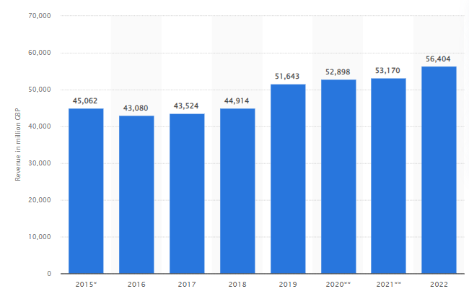
Figure 1: Revenue of Tesco
(Source: Statista.com, 2022a)
The statistical graph shows the annual revenue of the retail company Tesco in the UK. In the year 2021/2022, the annual revenue of the retail company Tesco is more than 56 billion British pounds (Statista.com, 2022a). It shows that from the previous year the annual revenue of Tesco has been enhanced by more than 3 billion British pounds. The strong financial position of the company creates a positive impact on the business and helps the company to manage its business operations properly.

PESTLE Factors
The PESTLE analysis has been taken to examine the external factors and their impacts on real business.
Factor | Analysis | Impact
Political | - The higher tax rate in the UK is 40% and 20% is the lowest tax rate (Gov.uk, 2022a)  - In 2021/22, criminal offences are more than 6.3 million have been recorded (Statista.com, 2022b). | Negative
Economic | - In 2019, near about 1.67% of the GDP has been increased (Statista.com, 2022c).  - In the year 2022, the unemployment rate is 3.7 % in the UK (Ons.gov.uk, 2022a). | positive
Social | - In the UK retail sales have been enhanced by 0.6% in October 2022 (Ons.gov.uk, 2022b).  - The online retail sales rate is 26.1% in October 2022 (Ons.gov.uk, 2022b).  - The literacy rate in the UK is 99% (Una.org.uk, 2022) | positive
Technological | - In the year 2019, website sales are near about 356.4 billion British pounds. (Statista.com, 2022d)  - Technologically advanced country | Positive
Environmental | - “Environmental Protection Act 1990” (Gov.uk, 2022b)  - “Control of Pollution Act 1974” | Positive
Legal | - “Labour relation Act”  - “Equality Act 2010” has been maintained (Gov.uk, 2022c)  - “Employment act” | Positive
Table 1: PESTLE Analysis
(Source: Self-developed)
Analysis
Political factor
The higher tax rate is 40% and 20% is the lower tax rate in the UK; therefore, the retail company Tesco is required to pay a high amount of tax that decreases the profit rate of the business. In 2021/22-year, criminal offences are more than 6.3 million have been recorded (Statista.com, 2022b). In this case, the high criminal offences make a negative impact on the business and damage the business environment.
Economic factor
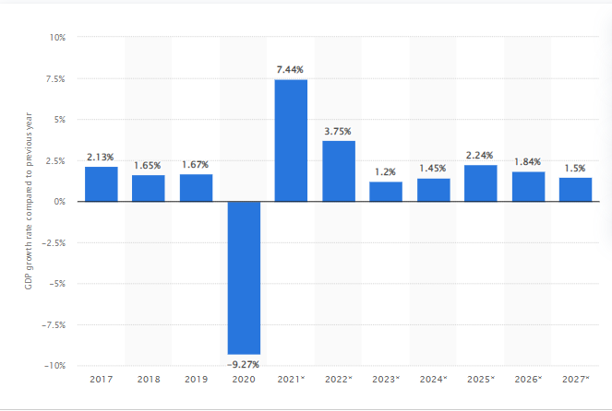
Figure 2: GDP rate in the UK
(Source: Statista.com, 2022c)
The above statistical graph depicts the GDP rate of the UK. In the year 2019, in the UK nearly about 1.67% of the GDP increased (Statista.com, 2022c). The good GDP rate of the country makes a positive impact on the business therefore the retail company Tesco can get financial help from the country.
Social factor
Retail sales in the UK have been enhanced by 0.6% in October 2022 (Ons.gov.uk, 2022b). Therefore, it helps the company increase retail sales and improves the financial performance of the business. In terms of literacy, the literacy rate in the UK is 99% (Una.org.uk, 2022). Therefore, the retail company can get sufficiently knowledgeable and skilled employees from the UK country and the company can manage its business operations properly.
Technological factor
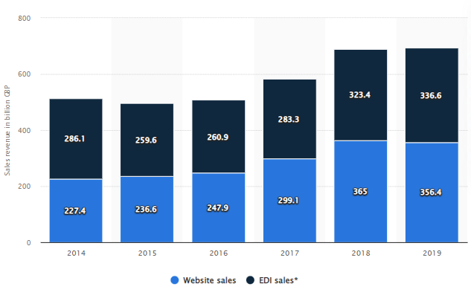
Figure 3: E-commerce sales in the UK
(Source: Statista.com, 2022d)
The UK country is considered a technologically advanced country that helps the retail company Tesco to use suitable technology for improving business operations. In the year 2019, website sales are nearly about 356.4 billion British pounds (Statista.com, 2022d). Therefore, the use of the website in the UK is high therefore the retail company Tesco can use the website to sell product and increases sales growth.
Environmental factor
The UK government has focused on improving environmental sustainability and multiple rules and legislation has been launched to keep the environment pollution free. The “Environmental Protection Act of 1990” has been launched to keep the environment pollution-free (Gov.uk, 2022b). Along with this, the UK government has also launched the “Control of Pollution Act 1974” to control pollution and improve environmental sustainability
Legal factor
The UK government launches one of the most effective acts “The equality Act 2010” that is used in all businesses to overcome discrimination issues and maintains equality among the staff at the workplace (Gov.uk, 2022c). Along with this, the UK government has also launched “The Labour relation Act”, “Employment act” and so on therefore the legal system makes a positive impact on the business

Porters 5 Forces model
Porter's Five Forces Model is one of the most effective tools that help the company to figure out the main competitive forces of the specific industry.
Factors | Impact
“Competitive rivalry” | High
“The bargaining power of suppliers” | Low
“The bargaining power of customers” | Moderate
“The threat of new entrants” | High
“The threat of substitute products” | Low
Table 2: Porter’s Five Forces
(Source: Self-developed)
Competitive rivalry
In the UK retail industry, “competitive rivalry” is identified as high makes a negative impact on the retail business. In the UK, Tesco is one of the largest retailers, however, the company has many competitors including ASDA, Sainsbury's, Morrison's and so on [Refer to Appendix 1]. In this context, Tesco can follow a Competitive Pricing Strategy to overcome the market competition and establish a sustainable market position.
The bargaining power of suppliers
In the UK retail industry, suppliers' bargaining power is low that creates a positive impact on the business of Tesco. In this context, the company has many suppliers that hamper the business and increases the cost structure. As opined by Sodhi and Tang (2021), effective management of the supply chain is very important for the retail business to enhance business growth. Therefore, the retail company Tesco is required to select an effective supplier and properly manage its supply chain.
The bargaining power of customers
The customer negotiation power in the UK retail industry is moderate that makes a negative impact on the retail company Tesco. As opined by Galera‐Zarco et al. (2020), the high bargaining power of the customer damages the business performance. In this case, the company is required to maintain customer satisfaction to make the business sustainable by maximising the business revenue.
The threat of new entrants
The new companies can easily start a business in the retail industry as it requires low cost that shows the new entrants' threat is high. However, establishing a brand reputation is difficult for a startup company that creates benefits for Tesco Company. Furthermore, the company has more than 345,000 colleagues that also make benefit Tesco Company (Tescoplc.com, 2022).
The threat of substitute products
Tesco makes uniqueness to its product therefore the chances of substituting the product is low that creates a positive impact on the business of Tesco. In this context, Tesco is required to make innovations in the product to draw consumers' attention and increase sales growth. Furthermore, the high increase in sales helps the company to improve revenue growth.

SWOT analysis
Strength | Weakness
- Tesco has more than 345,000 colleagues (Tescoplc.com, 2022).  - The revenue of the retail company Tesco is more than 56 billion British pounds (Statista.com, 2022a).  - Geographically diversified  - In the year 2022, the total number of stores in Tesco is 4,752 (Statista.com, 2022e) | - High market competition  - The main competitor of Tesco includes ASDA, Sainsbury's, Morrison's and so on (Keiningham et al. 2020).  - The company follows a “Low-cost strategy” that decreases the business revenue
Opportunities | Threat
- Tesco can expand its business operation in the foreign market  - Tesco can follow the "One Hour Delivery” procedure that helps to enhance sales growth | - Tesco faces “Supply chain issues” that hamper the business performance  - Rising costs of the raw material
Table 3: SWOT analysis
(Source: Self-developed)
Analysis
The above tables show the main strength of the retail company Tesco a strong financial ability, a sufficient number of human resources and stores. The main weakness of the company is its high market competition and the main competitor of Tesco includes ASDA, Sainsbury's, Morrison's and so on (Keiningham et al. 2020). Tesco can follow the “One Hour Delivery” procedure that works as an opportunity for the business and help the business to improve sales growth. Tesco faces “supply chain issues” that hamper the flow of product procedure and damages the business performance.

Segmentation, targeting and positioning
Tesco follows four segments “Geographic”, “Psychographic”, “Behavioural”, “Demographic” segmentation. Tesco keeps the availability of the product for all all-ages people with low and middle-income families. The occupation of people can be students, professionals, employees and unemployed. The company provides the products to the UK to 11 other countries. In terms of lifestyle, lifestyles can contend conformers, Traditionalists or anything. The benefit sought is cost advantages, variety, and the user status as an active user. Tesco is positioned as a multinational retail company that provides products at affordable prices (Tescoplc.com, 2022). The target market of Tesco is all-ages people with low and middle-income families in the UK.

4Ps Marketing mix strategy
The “4Ps Marketing mix strategy” has been taken to determine the product, place, promotional style, and pricing style of Tesco.
Tesco Product Strategy
Tesco keeps a wide range of products including clothing, furniture, toys, books, electronics, telecom services, financial services, internet services and so on (Tescoplc.com, 2022). The company keeps the availability of multiple types of products that influences the consumers to purchase a variety of types of products from one shop.
Tesco Pricing Strategy
Tesco follows a Low-cost strategy to sell the product and provides the product to consumers at affordable prices. This strategy is very beneficial for the company to increase sales growth and improves business revenue.
Tesco Place Strategy
The company sells the product to the UK to 11 other countries. In the year 2022, the total number of stores in Tesco is 4,752 (Statista.com, 2022e). The company sells its product online and in multi-format stores therefore the customer can purchase the product from multi-format stores and online.
Tesco Promotion Strategy
Tesco makes the promotion of the product through media and print to send messages to a huge range of customers. The effective promotion of the product is very beneficial for the organisation to enhance sales growth and business revenue

Conclusion
The reputed multinational retail company Tesco sells the product through online and multi-format stores. In this report, the “PESTLE analysis” and “SWOT analysis” have been used to examine the external factors and internal factors. In addition, “Porter's Five Forces Model” has been used to figure out the main competitive forces of the retail industry. Furthermore, the segmentation, positioning and target market of the company has also been addressed. The finding shows, Tesco has established a good marketing position in the UK marketplaces that help the company to achieve strategic business objectives. The “4Ps Marketing mix strategy” has been taken to determine the product, place, promotional style, and pricing style of Tesco. It can be concluded that the brand reputation and good marketing position of the retail company Tesco help the company to achieve its long-term business goal.

Question B

Recommendations
Tesco company to overcome the market competition and improves the financial performance of the business required following a “competitive pricing strategy”. As opined by Faith (2018), a “competitive pricing strategy” is very effective for the business to enhance sales growth in a minimal time. The company is required to focus on proper “supply chain management”, that helps the company to keep the availability of the product and the company can effectively maintain customer satisfaction. According to Sodhi and Tang (2021), proper “supply chain management” is very important for the retail business to enhance business growth. Therefore, the retail company Tesco is required to maintain proper management of the supply chain to properly meet customer requirements.

References
Faith, D.O., 2018. A review of the effect of pricing strategies on the purchase of consumer goods. International Journal of Research in Management, Science & Technology (E-ISSN: 2321-3264) Vol, 2. https://papers.ssrn.com/sol3/papers.cfm?abstract_id=3122351
Galera‐Zarco, C., Opazo‐Basáez, M., Marić, J. and García‐Feijoo, M., 2020. Digitalization and the inception of concentric strategic alliances: A case study in the retailing sector. Strategic Change, 29(2), pp.165-177. https://doi.org/10.1002/jsc.2319
Gov.uk (2022a). Income Tax rates and Personal Allowances. Available from https://www.gov.uk/income-tax-rates. Accessed on 16.12.2022
Gov.uk (2022b). Environmental Protection Act 1990. Available from https://www.legislation.gov.uk/ukpga/1990/43/contents. Accessed on 16.12.2022
Gov.uk (2022c). Equality Act 2010. Available from https://www.gov.uk/guidance/equality-act-2010-guidance#:~:text=The%20Equality%20Act%202010%20legally,strengthening%20protection%20in%20some%20situations. Accessed on 16.12.2022
Keiningham, T., Aksoy, L., Bruce, H.L., Cadet, F., Clennell, N., Hodgkinson, I.R. and Kearney, T., 2020. Customer experience driven business model innovation. Journal of Business Research, 116, pp.431-440. https://www.sciencedirect.com/science/article/pii/S014829631930462X
Ons.gov.uk (2022a). Unemployment rate (aged 16 and over, seasonally adjusted): %. Available from https://www.ons.gov.uk/employmentandlabourmarket/peoplenotinwork/unemployment#:~:text=Labour%20market%20overview%2C%20UK%3A%20December%202022&text=The%20unemployment%20rate%20for%20August,seen%20across%20all%20age%20groups. Accessed on 16.12.2022
Ons.gov.uk (2022b). Retail sales, Great Britain: October 2022. Available from https://www.ons.gov.uk/businessindustryandtrade/retailindustry/bulletins/retailsales/october2022 Accessed on 16.12.2022
Sodhi, M.S. and Tang, C.S., 2021. Supply chain management for extreme conditions: research opportunities. Journal of Supply Chain Management, 57(1), pp.7-16. https://doi.org/10.1111/jscm.12255
Statista.com (2022a). Annual revenue of Tesco Group in the United Kingdom (UK) and the Republic of Ireland from financial year 2015 to 2022. Available from https://www.statista.com/statistics/490931/tesco-group-finance-revenue-united-kingdom-uk/. Accessed on 16.12.2022
Statista.com (2022b). Crime in the UK - Statistics & Facts. Available from https://www.statista.com/topics/3793/crime-in-the-uk/#topicOverview. Accessed on 16.12.2022
Statista.com (2022c). Gross domestic product (GDP) growth rate in the United Kingdom 2027. Available from https://www.statista.com/statistics/263613/gross-domestic-product-gdp-growth-rate-in-the-united-kingdom/. Accessed on 16.12.2022
Statista.com (2022d). E-commerce sales in the United Kingdom (UK) from 2014 to 2019, by technology. Available from https://www.statista.com/statistics/282164/e-commerce-annual-sales-in-the-united-kingdom-uk-by-technology/. Accessed on 16.12.2022
Statista.com (2022e). Tesco's number of stores worldwide 2008-2022. Available from https://www.statista.com/statistics/238667/tesco-plc-number-of-outlets-worldwide/. Accessed on 16.12.2022
Tescoplc.com (2022). About Us. Available from https://www.tescoplc.com/about/. Accessed on 16.12.2022
Tescoplc.com (2022). About Us. Available from https://www.tescoplc.com/about/. Accessed on 16.12.2022
Una.org.uk (2022). International Literacy Day. Available from https://una.org.uk/international-literacy-day-factsheet. Accessed on 16.12.2022

Appendices

Appendix 1: Market competition

(Source: Self-developed)

