6/10/2019
Reflective Review of Learning Journey
Personal Development Plan
Viorel Melinteanu (1815993)

UNIVERSITY OF WALES TRINITY SAINT DAVID

Introduction

Life is a journey that changes ourselves, every day, through a personal and continuous personal development process. We were not born perfect or taught, but we can make an effort to gain self-knowledge, skills and new behaviours, so that our personal and professional lives can be improved. Each of us should know best what his goals are. (Personal Development, 2015, p1)
This year I decided it was time to take a step forward in my life, so I decided to continue studying and I became a student at University of Wales Trinity Saint David.

Objectives

Some people make plans for the next year, long-term plans or moment plans. Like everyone, I have also made plans for my future and I will do my best to get where I dream.
At my personal level, I propose to complete the course started this year with good results and to provide a better life for my family in the long term.
I professionally intend to become an event photographer in Wales.

In a world of individualism, as Tom Peters said in his article, ‘The Brand Called You’ published in 1997, ‘everyone has the chance to be a brand worthy of being noticed’(Fast Company, 1997).
Your personal brand is about identifying and communicating what makes you unique and relevant and different for the group you are addressing. If you understand what your strengths are, your passions and personal values, you can use this information to differentiate you from others.
Before becoming a brand, we need to know yourself

According Myers Briggs personality profiling test I am Extrovert, Intuitive, Thinking and Judging.
According The VARK Questionnaire I got 6 Vs, 5 Rs, 2 Ks and 1 A.

SMART

I have to analyse my objective from the SMART perspective:
- Is my objective Specific? Yes, because I want to make wedding photography and to address especially to the Romanian community in Swansea, Cardiff and the surrounding area.
- Is my objective Measurable? Yes, because I have over 10 years of experience, I know the steps I have to follow and know when and if I have achieved my goals. Meeting the goal involves money and time that are units of measurement.
- Is my objective Achievable? Yes, because I have the ability and resources to do it. I have the ability to motivate myself.
- Is my objective Realistic? Yes, because I know how to split the objective in smaller goals, according to priorities. Their achievement requires a natural order.
- Is my goal in time? Yes, I want to start my business in the summer of 2020. Each intermediate goal has a specific implementation time.

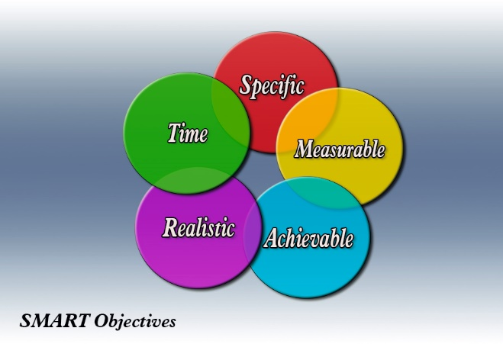

SWOT Analysis

A first step in personal development is self-knowledge. A SWOT Analysis can support a better understanding of the current state of mine.
According Ivorschi R, SWOT analysis is the most important management technique for understanding the strategic position of an organization and aims to choose the right strategies for reducing risks, removing weaknesses and take the best advantages of the opportunities.

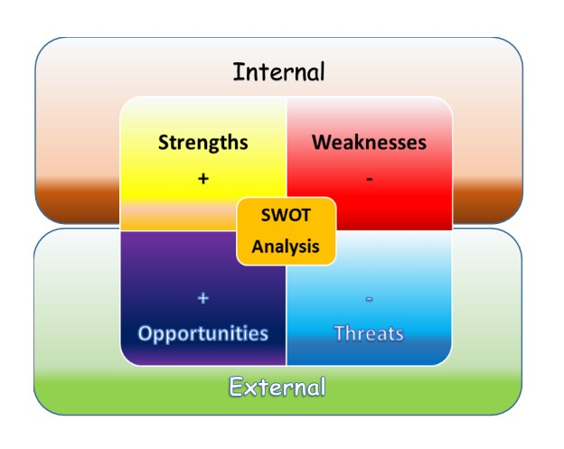

- Strengths
- experience in the event photo (I have worked in Romania for more than 10 years),
- experience working with people,
- marketing experience,
- the ability to listen and understand people and their needs,
- adaptability,
- ability to work under stress,
- the ability to observe,
- experience in using photo technique,
- permanent opening to renew and improvement,
- solid photo editing knowledge,
- knowledge of computer usage and modern technology,
- trust, respect, loyalty for business partners;

- Weaknesses:
- gaps in local legislation,
- lack of experience in local customs,
- poor relationships with local suppliers of photo equipment and supplies;

- Opportunities:
- social media sites offer the opportunity to make you known,
- specific local events like The Welsh National Wedding Fayre,
- local media like Your South Wales Wedding,
- the growing Christian community in the South of Wales of Romanian people,
- Skills for the Workplace course;

- Threats
- local competitors
- legal
- political (Brexit)

To increase law-related knowledge I will consult the university library and a lawyer.
By participating in local fairs with specifics, I seek to know local habits, suppliers of equipment and supplies, know local competition and convince other photographers to use my print services.

Personal development strategies

1. The Johari Window Model
A good tool for self-awareness and make you known is The Johari Window Model ‘developed by American psychologists, Joseph Luft and Harry Ingham in the 1950's, and named as 'JOHARI' by combining their first names’ (Saxena P, 2015, p.135)
In the open area are introduced attributes and features that I know, use or express them as they are: calm, complex, rational, sensible, well organised, dynamic, spontaneous, intuitive and adaptable. I know as well that I am a careful person. I have confidence in myself due experience and good feedback. I show a positive attitude and motivation in all I do. I developed skills to manage stress, to use time efficiently.
In the hidden area I keep adjectives as: tense, dignified, modest, wise, prudent or quiet.
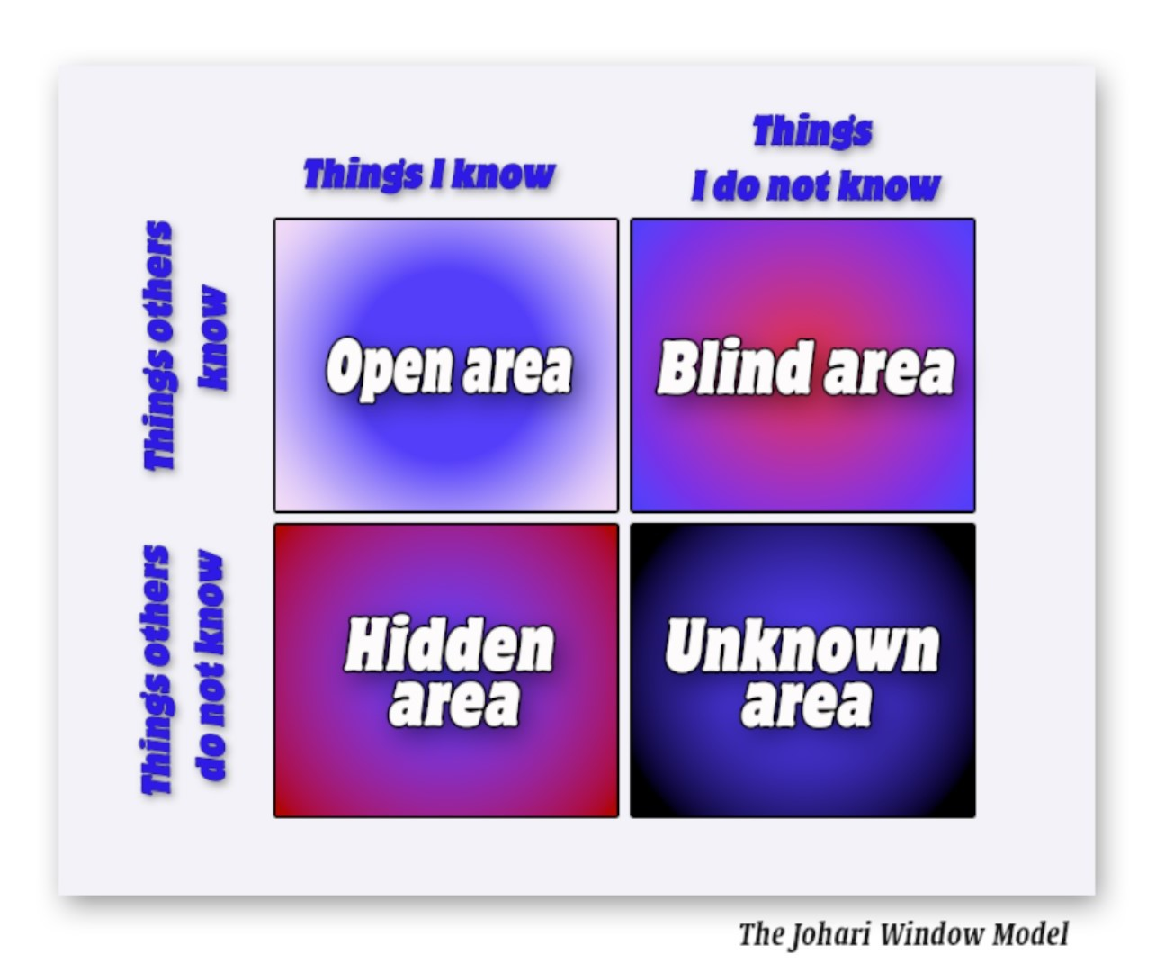
As a photographer I send emotions, breath, live, exist through photography. This is my ID, my profile picture. To express my open area I use, presentation site, Photobooks, print photos, booklets, DVDs and social media. To enlarge the open area I try new editing styles and different types of composition. For informed and objective feedback I use specialized forums, courses, and participate in photo contests.
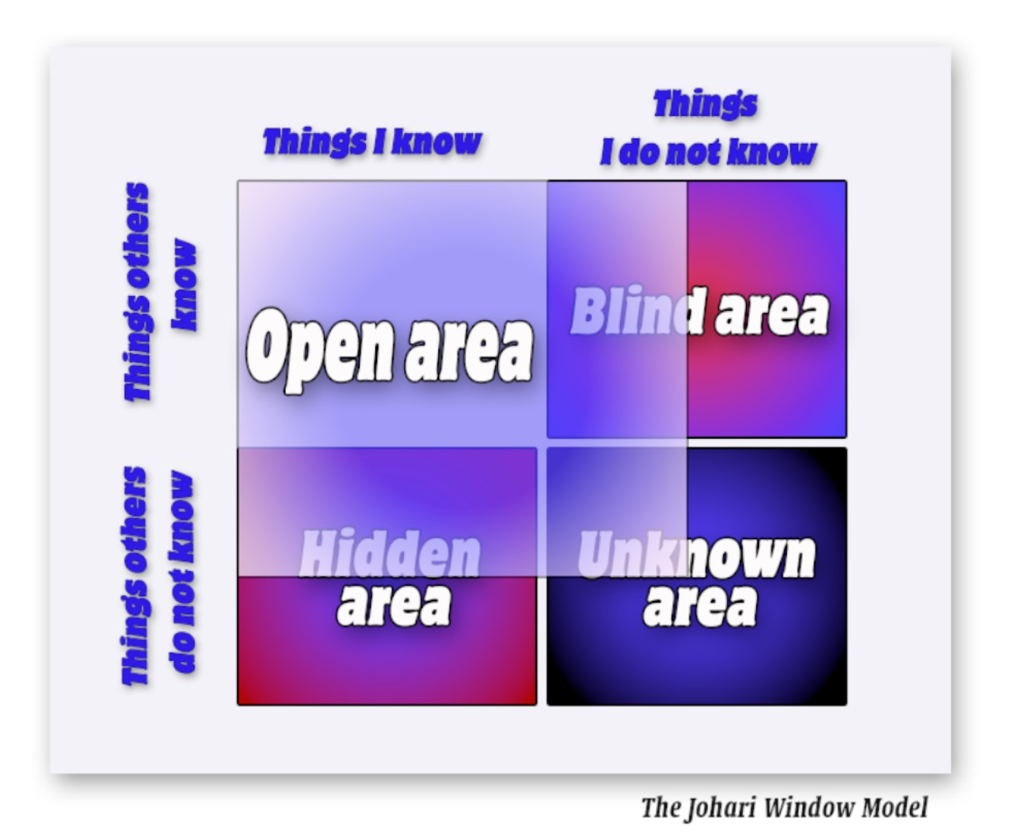

In this way, I improve myself.

Learning using The Kolb’s theory

In Romania it is said that the smart learns from the mistakes of others and the stupid does not learn even from his own mistakes.
‘Learning is the process whereby knowledge is created through the transformation of experience’ (Kolb, 1984, p. 38).
According Saul McLeod, The Kolb’s theory is internal cognitive processes based on four-stage learning cycle. (McLeod, 2017)
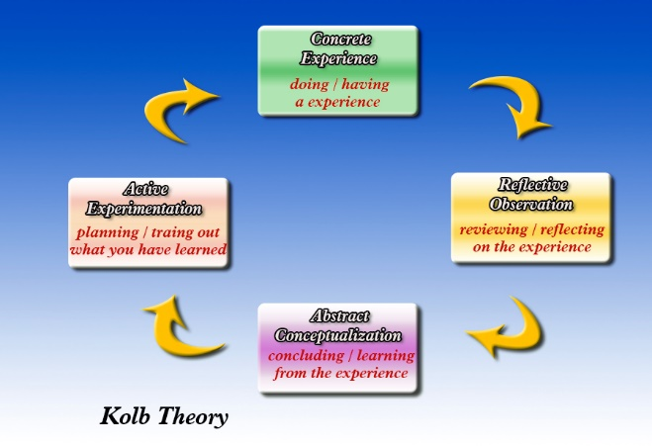

To find out what is new in the field of photography, I attended The Societies of Photographers Roadshows (The new experience)
During the ten years of experience in the event photo I have gained extensive knowledge of the use of Dslr devices. In recent years, new mirrorless has emerged in the camera market. They are lighter, smaller in size, have enhanced performance and give new ways to approach photography. Contact with this new concept opens new opportunities (Reflection on the new experience).
For their high potential, I decide that I need to buy a mirrorless camera and a set of lenses. (Conclusion from the experience).
As a SMART goal, I have developed a buying action plan. With the new device I will work my new photo albums that I will introduce to Welsh National Wedding Fayre (The next steps).

Go MAD Model

I applied the Go MAD Model to my objectives for more efficiency

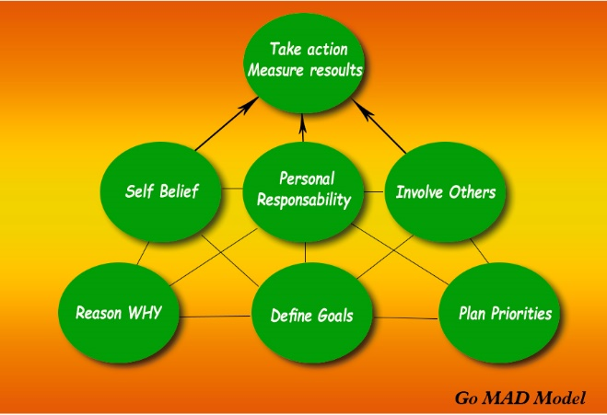

Step 1

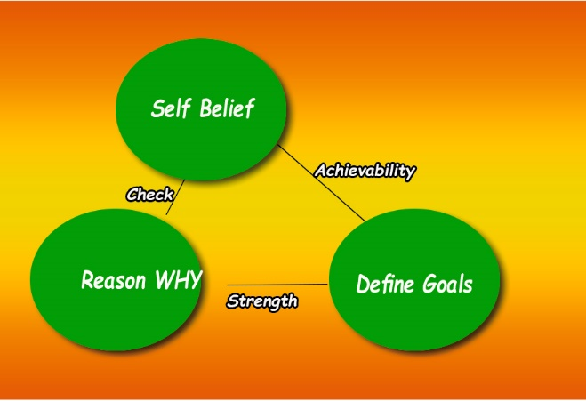

- Reason Why

- I want to improve live of my family,
- I want to turn my passion into my career

The number that best indicates my over rating is 9

- Define Goal

- The goal is to become a wedding photographer in Wales

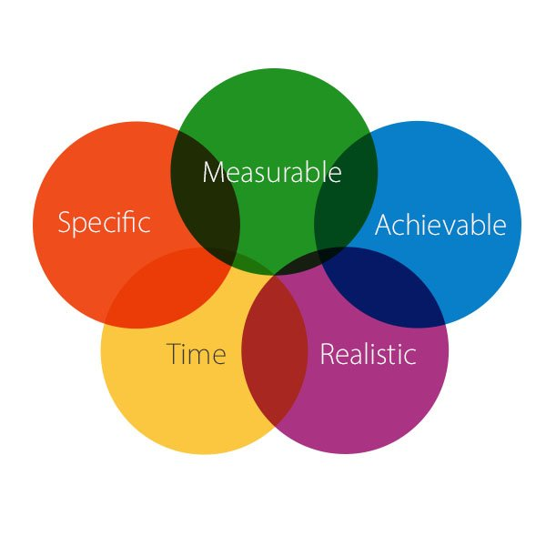
I already know my goal is SMART

- Self Belief

- I can do it

- Strenght:
- I know how do do it and I can
    - I have the necessary resources and know how to use them
- Achievability
    - Yes, in 19 months

My goal is achievable on a scale of 1 -10 at 9
Considering everything I know about myself on a scale of 1 to 10, my self belief is 9.
- Check
- Money
- Time
- Motivation

Step 2 External Triangle

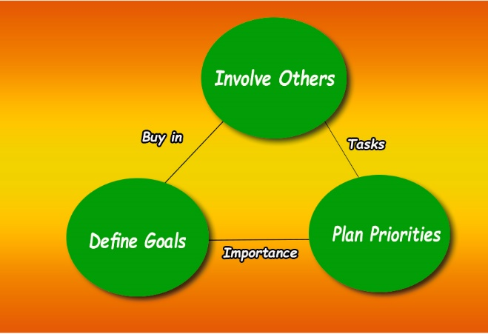

- Plans & Priorities
  - To Graduate course: Certificate of Higher Education Skill for the Workplace
  - To improve my photographer skills
  - Buy the photographic equipment
  - Create the studio
  - To make me known on the local market
- Involve others
  - lecturers and colleagues
  - local suppliers and not only
  - rental agencies
  - people working in media, advertising or involved in organizing weddings or related events

- Task
- to attend courses and promote
- to analyse the best purchasing options, the best services
- to contact and contract service providers

- Buy in
- Cameras and dedicate lenses
- Computer and editing software
- Studio equipment
- Printers
- Presentation site

Step 3 Personal Responsibility

I am responsible for making things happen.
I am motivated because I have a well-defined goal and I am aware of the benefits of achieving the goal.

Step 4 Take Action, Measure Results & Celebrate

I act proactively
I build in the necessary steps and potential strategies to achieve the stated objective
I measure my progress by counting the actions in the plan
I adapt future actions based on results
I learn from my own mistakes
And I act to reach my goal

PERSONAL DEVELOPMENT PLAN

Name: Viorel Melinteanu
Covering the period from: 01 March 2019 to: 30 September 2020
Planned Outcome: Become a wedding photographer in Wales

Development objective | Specific actions | Blockers and how they will be removed | Resources and Support required | How I will know when I have achieved the objective
Graduation course:  Certificate of Higher Education Skill for the Workplace | - attendance at the course  - individual study  - making assessments | - lack of time due to work schedule (holidays and swap shift) | - lecturers  - managers and workteam  - time  - laptop, printer, Internet access  - books | - Graduation diploma
New photographic equipment:  - cameras  - Lenses  - Computers and editing software  - Studio equipment  - Printers | - site research  - equipment testing | - some equipment is sold online only and can not be tested, and the return process is difficult or unavailable (I only buy what can be tested and has post-sales support) | - time  - money  - suppliers | - getting the equipment
Photo studio | - finding the right space  - preparing the space in accordance with the purpose | - expensive rent (finding the right space under the right conditions) | - time  - money  - rental companies  - advisor and solicitor | - getting the studio
Site preparation | - Individual research and consulting design companies | - | - time  - money | - getting the site
To become wedding photographer | - to attend photo classes to improve my skills  - to draw up a portfolio  - to promote myself on social media sites | - | - time  - money | - start work

Conclusion

The road to success is full of obstacles that we can overcome

if we are properly prepared with:

Planning;

Strategy;

Motivation;

Self-confidence

Interest in the development of skills;

Personal self-knowledge.

Personal development refers to an evolution at a personal improvement. Personal development is a cyclical process. Start with self-knowledge, continue with planning and developing a strategy to achieve fixed goals, then continue with improving permanent skills that will help you reach your ultimate goal, and ultimately ... self-confidence. All these steps are defining your way to success!

Appendices

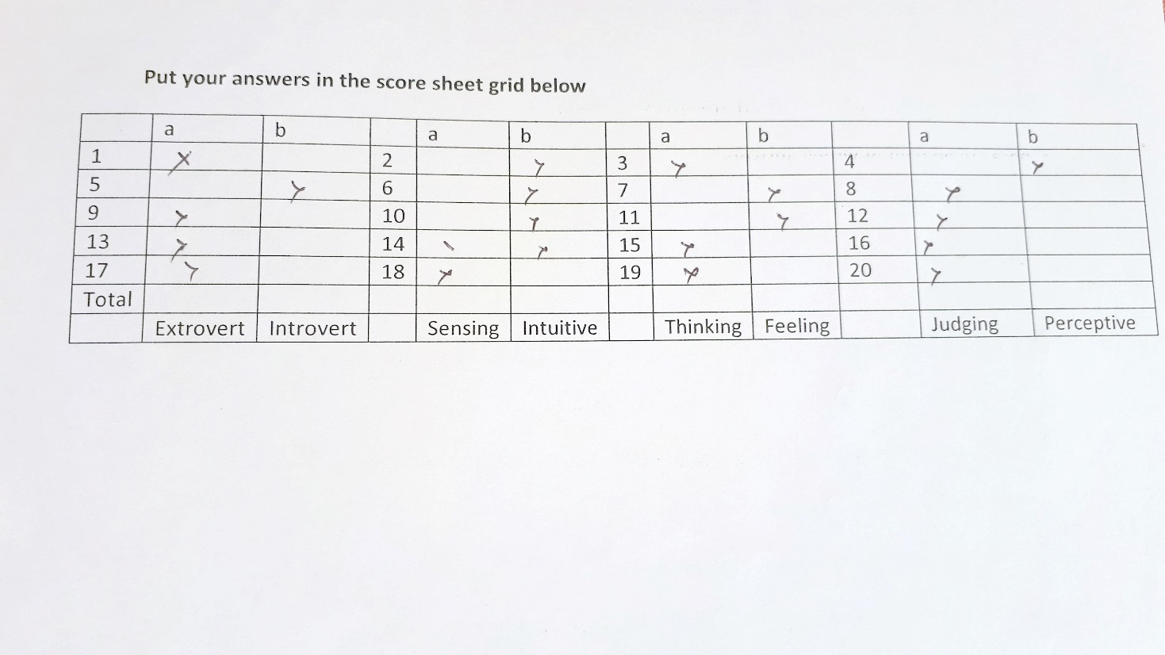

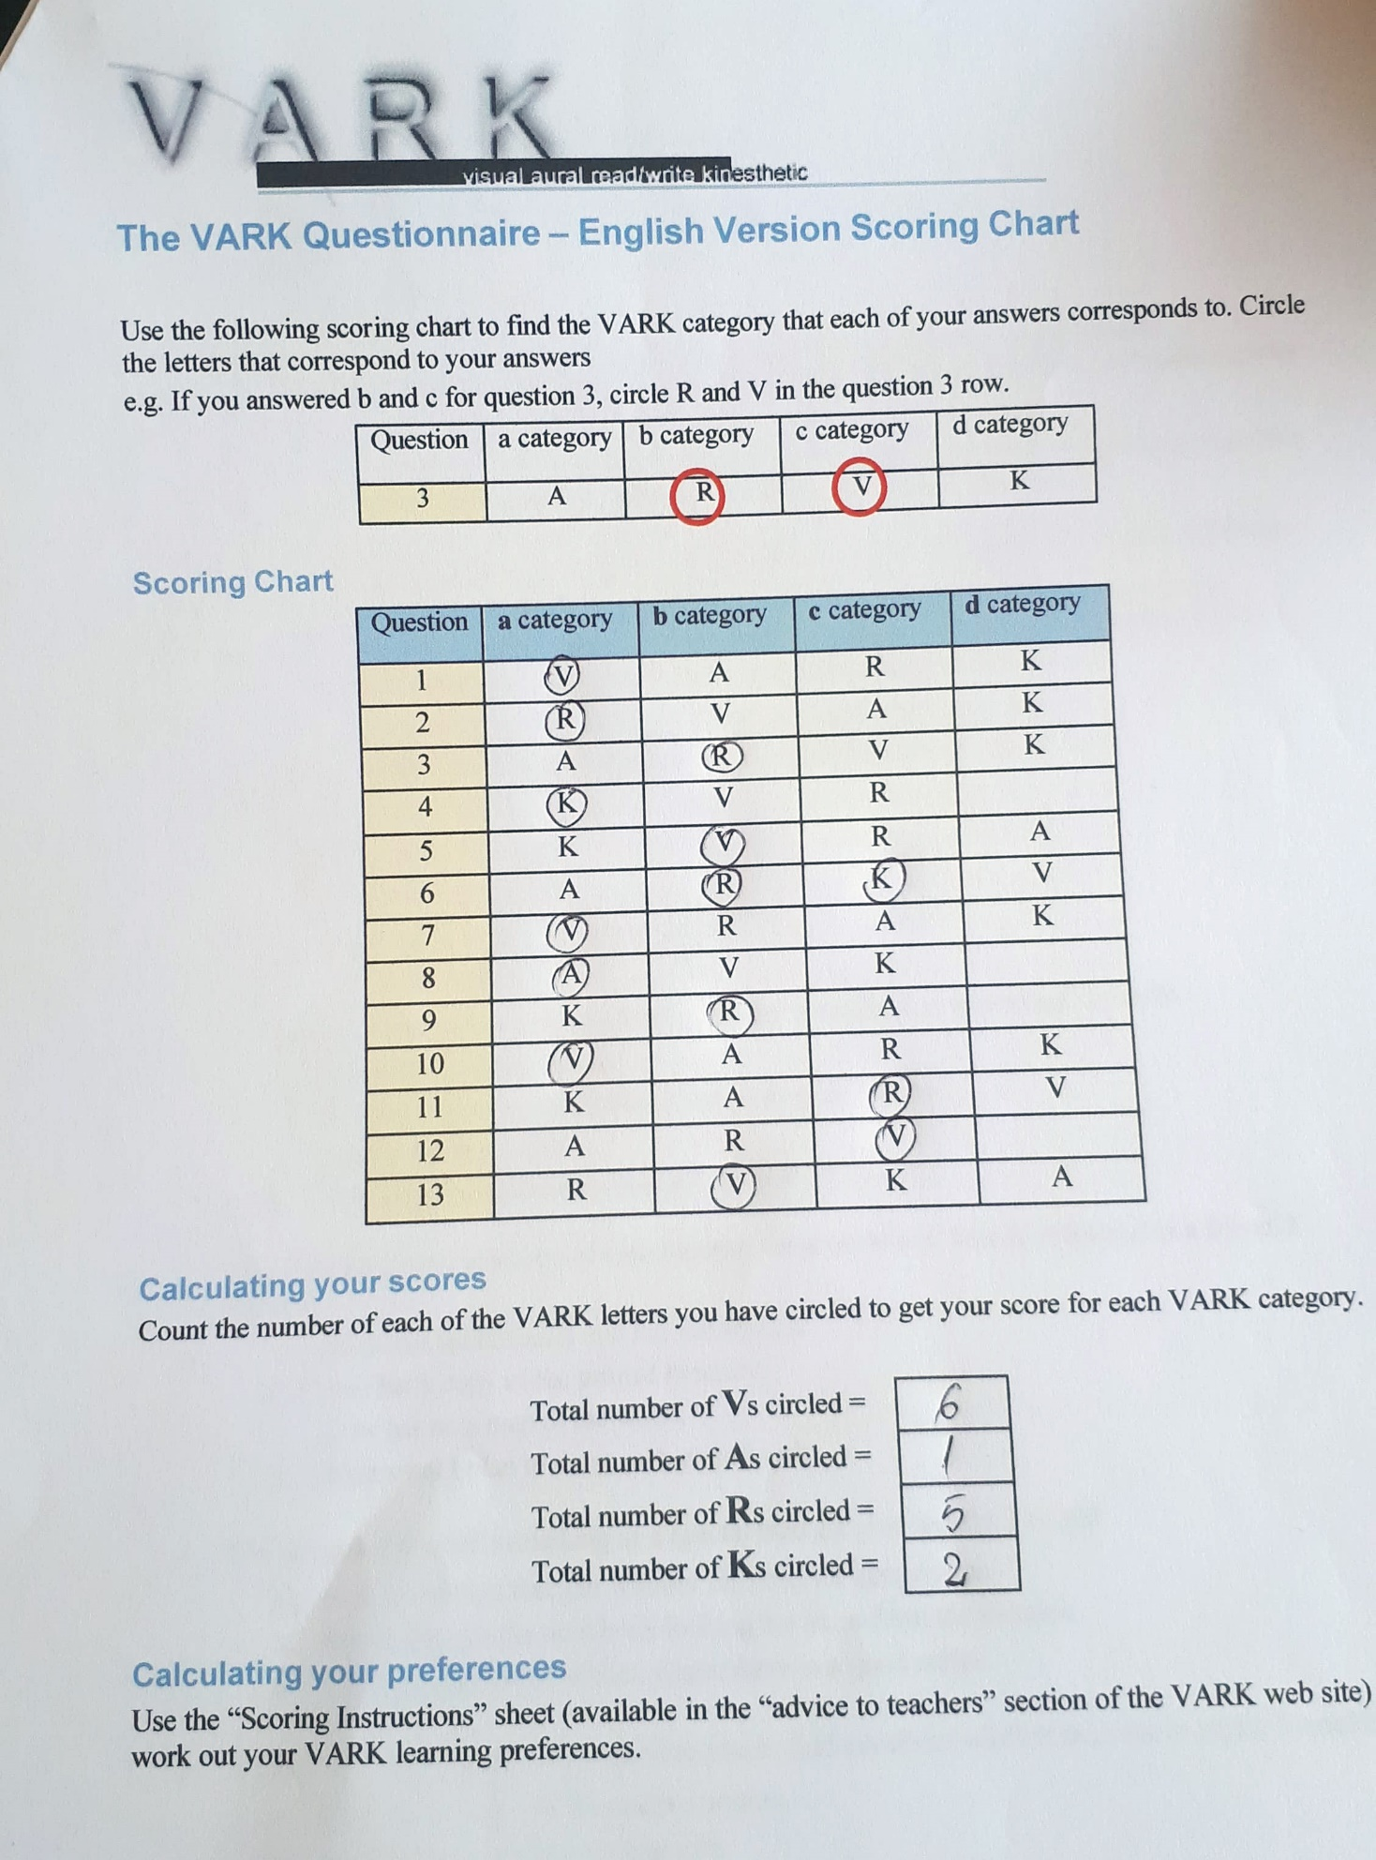

References

Dr. Sexana Parul (2015), ‘JOHARI WINDOW: An Effective Model for Improving Interpersonal Communication and Managerial Effectiveness’ SIT Journal of Management Vol. 5. No. 2. December 2015. Pp. 135 Available at: https://pdfs.semanticscholar.org/2903/839d86e4350fd16cd45517ceff4699e82318.pdf (Accessed at 11.06.2019)

FastCompany (1997) ‘A Brand Called You’, Available at: https://www.fastcompany.com/28905/brand-called-you/ (Accessed at 11.06.2019)

Ivorschi Rodica, (2012)’ The SWOT analysis - managerial tool for improving activity’, Romanian Statistical Review nr. 5

Kolb, D. A. (1984). Experiential learning: Experience as the source of learning and development (Vol. 1). Englewood Cliffs, NJ: Prentice-Hall.

McLeod Saul (2017) ‘Kolb's Learning Styles and Experiential Learning Cycle’, Simply Phychology
Available at: https://www.simplypsychology.org/learning-kolb.html#ref (Accessed at 15.06.2019)
Personal Development (2015) Bucuresti: Universitatea POLITEHNICA

Table of Contents
Introduction 1
Objectives 2
SMART 3
SWOT Analysis 4
Personal development strategies 6
Learning using The Kolb’s theory 9
Go MAD Model 10
PERSONAL DEVELOPMENT PLAN 15
Conclusion 17
Appendices 18
References 20

