P Number: 150524
Julia Lockhart
Word count:1819

In this essay I aim to address three key words, colour, light and history with artists that support my dissertation proposal. I aim to explore these artists and chosen words in depth and how they can relate to a chosen question for my dissertation in the future. The aim for this proposal is to discern what I want to delve into more fully with my chosen field of glass and the relationship my work and interests have together whilst learning the functionality and other uses of techniques and application of glass in a space and how these changes have manifested through time.
The first word that I think has a connection with glass, especially stained glass is colour. A great stained-glass artist by the name of Christopher Whall once wrote about colour in stained glass in his book ‘Stained Glass Work’. He wrote that it was “hopeless to deal with it by way of words in a book where actual colour cannot be shown!” (Whall, p 198) This book and text is a source that I would hope to use in my dissertation as It has many useful chapters to draw from such as the chapter on colour it also has chapters on … that all relate to my interest In glass work as a medium. Whall wrote that “the practise of stained glass is a very good way to learn colour, or as much of it as can come from learning.” (Whall, p 199) From this I have gathered that as glass is such a solid medium to work with it cannot be easily blended together and that you must understand colour in glass to harmonise assorted colours together in pieces or to make a statement or emphasis a specific area on the panel with clashing colour. One way in which colour has been understood is from the colour wheel, Moses Harris created the first colour wheel classifying red, yellow and blue as the primary colours, these colours cannot be created by mixing any other colours together. This diagram of colour was later given addition by Johannes Itten when he introduced secondary and tertiary colours. (Mcnee, 2009) Understanding colour in glass is essential, as the colour would change in relation to the light and to the background it was being viewed from, depending on the hues it casts through with light influences the feeling of the space in my opinion, the warm radiance of orange and reds in contrast to the cold tones of blue can significantly change the feeling of the space and the stained glass artwork as I think oranges and reds create a more warm atmosphere and blues and light greens can be cold colours.
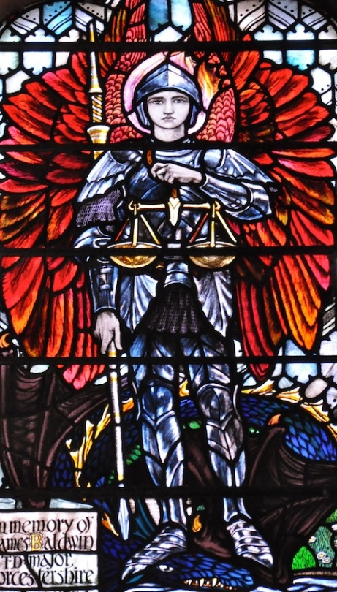
Christopher Whall design in Worcester Cathedral of St Michael and the dragon
(Blosslyns Fotorama. 2014)

This Christopher Whall design uses primary colours as the dominant luminosity, the bold use of red washed with tinges of pink and orange for the wings outlines the figure drawing your eyes up the panel. The blue dragon under his feet also corelates to Whalls teachings on colour in his ‘stained Glass Work’ book, that “when colour light and shade, and design are all fusing together into a harmony” (Whall, p222). A different artist who refined his art form by working alongside a variety of materials and skills such as quilt making and illustration and other artists like David Hornung was Michael James, he wrote in his second edition of colours that “looking at an unfinished or not quite right colour arrangement, I automatically ask myself what its thirsty for.”(James, M. p9) Although Whall and James are using two different materials they both agree in their statements that colour and the harmony between them is important to the design, This can also apply to other work and how colour is understand in numerous materials to best showcase the chosen field of work.
The second key word that is going to be explored is light. The word Light is essential to all art forms but in my opinion, light is especially important in working with glass as a medium, the way glass interacts with the space around it is dependent on how the piece is illuminated and how that glass reacts to the intensity and positioning of the light. Lighting on stained glass can change the appearance of the colour you would like to achieve if the light is natural from the sun or artificial from light bulbs, “Because sunlight has a wide color spectrum, it renders the colors of an object or artwork accurately. Visually, colors look more natural to us when illuminated with sunlight.” (Bernard Katz. 2018) But artificial lighting however “are great for highlighting certain areas of a sculpture. “Floods” are great for lighting paintings and larger areas” (Bernard Katz. 2018).
Light can reflect glass differently in numerous ways such as the density of the colour on stained panels or how thick and textured the glass is can mean that a stronger light is needed to achieve the full effect of the piece to fully understand and see it in site more accurately, working in architecture with glass pieces can be challenging, Catrin Jones a practising glass artist once stated;
‘Architectural glass is unique among the arts of the world because of the relationship that exists between glass and light. Essentially a dynamic, daylight art, architectural glass is energised through its relationship with light, and changes according to the time of day, the seasons and the weather.’(Catrin jones. 2018.)
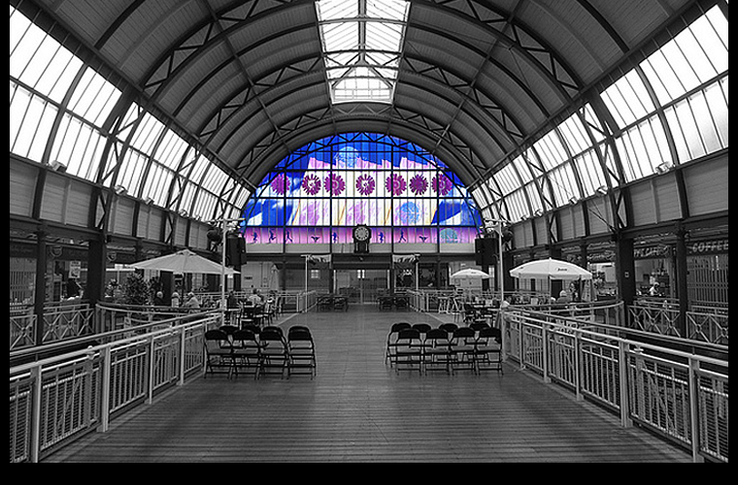
Catrins work in Newport Market (Catrin jones. 2018.)
Catrin is saying in my opinion is that glass as an art is always changing due to lighting conditions, I think that light is integral to glass, and this is one of the reasons I have chosen it to be one of my key words due to its importance in glass work. Her work centres around using mostly natural light to illuminate spaces whilst not compromising on creating a piece that will blend well with the surroundings but also stand out individually. Another artist that I researched that had a great interest in light and how it could change a space was Jan Butterfield, her book on the art of light and space gave me great insight into her view and perception of both, an extract of the book said “I could shape the walls where they joined. I could control how close they were, so that if I had a wall at one angle, the light from that angle would fall on another wall.” ( Butterfield, J.,p.70). Jan Butterfield and her perception of light and how she could physically change the shape and feeling of the space around her and the art involved showed me that this could be applied to my field of glass to great effect with glass being a reflective surface would greatly distort the space around the object and made me appreciate the positioning of my glass to achieve the greatest visual element.

My final word that I would like to develop and explore is history. There are many aspects to glass history, such as some of the first naturally occurring glass objects made from obsidian glass, the potential sharpness to “Obsidian was used to make knives, arrowheads, spear points, scrapers, and many other weapons and tools” it was also observed that ”they could see a reflection in obsidian and used it as a mirror.”(Hobart M.King. 2018.) this first discovery of a reflective material was the first form of glass, later developments into glass came from manmade techniques, ancient Egyptians used glass to create beads and amulets as far back as 2500BC (Emily sohn. 2005). I think glass as an art form is best recognised in British history through stained glass windows in churches though, they are mostly centred around religious values. The history and development of glass painting and the new methods of applying techniques intrigues me such as the discovery of silver stain and that it leaves a yellow hue once heated to a temperature like 610 degrees and the development of using an oil layer on to of an existent water layer, so more detail can be added without using so many firings. The History of glass has also lead to the development in architectural layouts, “There was a time not so long ago that glass was a precious material, so highly valued that only the wealthiest homes had glass in their windows” (Anna Hoffman. 2012). The new developments such as float glass meant that most houses could afford to brighten there interiors, it wasn’t just for the wealthy, This history of glass and the easier availability of glass as a material to work from may have inspired a greater number of glass artists to express and showcase their talents.

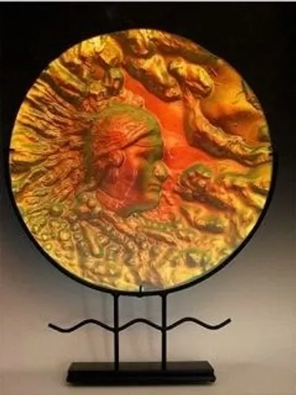
“one of the early pioneers working with Float glass. Considered a master at fusing, casting, kiln sculpting.” (Peggy Pettigrew Steward. 2017.)

In conclusion the purpose of this proposal has been to identify three key words colour, light and history and to understand their meanings in relation to my field of study in glass, how these have been represented in similar work and what I would like to learn from them in relation to myself. The aim of my proposal for a dissertation and the question I would like to develop with further investigation would be ‘How does glass work as an art form feature in modern day living’. I have chosen this question to investigate further as it is a broad topic that can have many avenues that are intriguing, the three words that I have chosen to study in this essay colour, light and history all feature around this topic in my opinion.

References

Anna Hoffman. 2012. Quick History: Window Glass. [ONLINE] Available at: https://www.apartmenttherapy.com/quick-history-windowsretrospect-165008. [Accessed 1 May 2018].
Bernard Katz. 2018. How to light art glass. [ONLINE] Available at: https://bernardkatz.com/how-to-light-art-glass-lighting-guide/. [Accessed 3 April 2018].
Blosslyns Fotorama. 2014. Echoes of the past. [ONLINE] Available at: https://blosslynspage.wordpress.com/2014/02/23/christopher-whalls-st-michael-in-worcester-cathedral/. [Accessed 3 April 2018].
Butterfield, J., 1996. The Art Of Light And Space. 1st ed. Na: Library of Congress.
Catrin jones. 2018. Architectural & Stained Glass. [ONLINE] Available at: http://www.catrinjones.co.uk/techniques.html. [Accessed 16 April 2018].
Catrin jones. 2018. Business. [ONLINE] Available at: http://www.catrinjones.co.uk/portfolio.html. [Accessed 1 May 2018].
Emily sohn. 2005. Glassworks in ancient Egypt. [ONLINE] Available at: https://www.sciencenewsforstudents.org/article/glassworks-ancient-egypt. [Accessed 17 April 2018].
Hobart M.King. 2018. Obsidian. [ONLINE] Available at: https://geology.com/rocks/obsidian.shtml. [Accessed 17 April 2018].
James, M. Hornung, D., 2012. Colour: A Workshop For Artists And Designers. 2nd ed. London: Laurence King Publishing
Lori Mcnee. 2009. Art and Fine Art Tips. [ONLINE] Available at: https://www.finearttips.com/2009/08/use-the-hidden-meaning-of-color-in-your-art/. [Accessed 3 April 2018].
Peggy Pettigrew Steward. 2017. The Glass Art Of Peggy Pettigrew Steward. [ONLINE] Available at: https://peggypettigrewstewart.com/. [Accessed 1 May 2018]
Whall, C., 1905. Stained Glass Work. 1st ed. 13 Paternoster Row London: John Hogg.
Whall, C., 1905. Stained Glass Work. 1st ed. 13 Paternoster Row London: John Hogg.

