University of Wales Trinity Saint David.
School of Engineering.

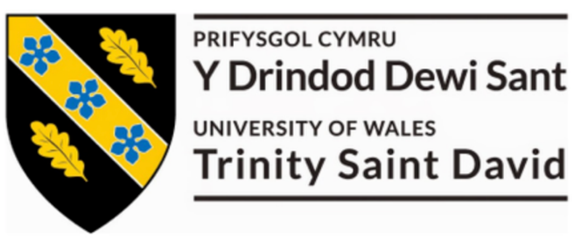
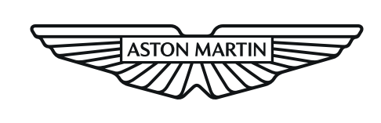

Name: Matthew Dewhurst

Student Number: 2113040

Date: 24/05/23

Subject: Manufacturing Design & Technology
ACMA5002

Title: Design for X Project

Degree: BEng Manufacturing Systems

Contents page:

Task 1

1.0 Introduction. ~ Page 3

2.0 Additive Manufacturing at AML. ~ Page 4

3.0 DFMEA & FMEA. ~ Page 8

4.0 Improvements. ~ Page 9

Task 2

5.0 Concept Design Appraisal. ~ Page 11

6.0 Design & Development. ~ Page 13

7.0 Manufacturing Process. ~ Page 15

8.0 References. ~ Page 17

Task 1
1.0 Introduction.

Additive manufacturing is a layer based automated manufacturing process and is also known as 3D printing. Design software can be used to develop complex structures, which can then be created with the use of additive manufacturing equipment as an alternative to traditional methods such as CNC machines and laser cutting. This newly innovated type of manufacturing can be utilized in a range of different sectors, to create or improve products using various materials. Materials that can be used in additive manufacturing range from alloys to plastics, which makes this type of manufacturing extremely versatile. Many companies have invested in additive manufacturing equipment and techniques to create new products or improve upon existing ones, one example of this is companies that specialize in rapid prototyping. The use of additive manufacturing is beneficial to rapid prototype companies as it allows them to create specialized products for customers fast and effectively.

Another reason that additive manufacturing is beneficial to rapid prototype companies is due to the ability of creating small production runs of a prototype and bespoke applications more cost effectively. There are many other benefits to the use of additive manufacturing such as reducing the amount of material and improving the efficiency of material use, as this type of manufacturing creates a final product that only requires a small amount of finishing. The reduction in the need for post-production finishing processes also means that the business can save time that is usually required to create a finish that is acceptable for delivery to customer, therefore reducing the labor time per product too. This means that companies can become less reliant on manual methods of machining and product monitoring, which could also help reduce running costs. Another benefit of the use of additive manufacturing is the ability to create complex designs that contain detail within enclosed geometries, this can be achieved by utilizing software to create precise designs which can then be executed by additive machinery that manufactures the product in layers. One source also says that “The cost of entry for AM has consistently been falling. Industrial-quality printers are affordable and so are the common materials.” (Gayette, M. (2022)) which makes additive manufacturing an effective alternative to traditional manufacturing methods which can be costly to set up.

On the other hand, there is several disadvantages to the use of additive manufacturing such as the production time taken to produce large components as one source demonstrates, “Depending on your desired final shape and size, it can take 2-3 hours to produce a shape that conventional powder metallurgy could make in 5-10 seconds.” (Horizon Technology (2021)) this highlights a constraint of additive manufacturing as it could slow down the production rate of some businesses and is therefore not a viable option. Another disadvantage is the modification and fine tuning of the equipment that is required to create a repeatable and efficient production process. Some complex designs created for additive manufacturing utilise support material, the supports are then discarded so refining of the designs must be carried out to reduce the amount of waste created. Linking into this, extensive training is needed to unlock the full potential of the design software for additive manufacturing. This can be time consuming and also expensive, especially for small businesses with limited budgets.
2.0 Additive Manufacturing at AML.

Within the manufacturing engineering department at Aston Martin, there are many uses for additive manufacturing to help aid the production processes. One example of this is the creation of bespoke tooling for special vehicle projects, which has been a regular requirement for the production of Aston Martin’s first hyper car. In this particular example, the new Valkyrie Spider variant design included a unique ring fixing for the headphone harness, the headphones are an important piece of safety equipment and must be used by the customer when driving the vehicle to protect their hearing from the extreme high volumes of the V12 engine. Additive manufacturing is beneficial for this application as it can be utilized to design tooling around unique components of the vehicle at hand, as existing tooling cannot be used as it does not meet the requirements of the application. The image below demonstrates the headphone harness fixing within the vehicle, a bespoke socket will be required to secure the fixing to the rear console panel. Another requirement of the bespoke socket is the need for compatibility with standard tooling that is used within Aston Martin production facilities, in this case a torque wrench will be used to secure the fixing so the socket will need to be designed around an existing wrench used by the company.

Figure 1: Valkyrie spider headphone harness. (M. Dewhurst (2023))
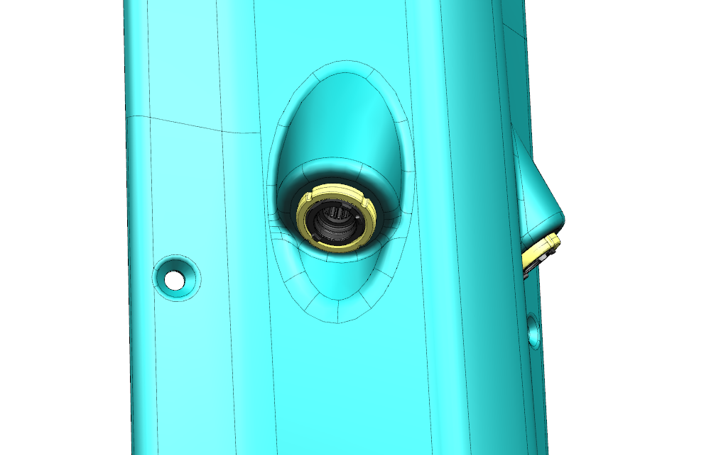

To create a design for additive manufacturing, a range of 3D design software’s can be used, in this example Solid works was utilized to create a design of the bespoke socket. Within this software package, the user is able to create a precise design with the vast range of tools at hand to create a product that will meet the demands of the customer. As shown by the diagram below, additive manufacturing allows the user to tailor the design of a bespoke product to any application, this flexibility in design means that the socket could be manufactured so that it is compatible with a range of different sized torque wrenches. Other design features that have been implemented using the design software include a hole in the side of the socket for the use of a quick release adaptor on the socket, as well as chamfers in the bottom section of the socket which will allow ease of fitment and removal of the socket. 3D design software also generates precise details in design, this is demonstrated by the socket head which has small notches, these have been designed to fit the small dimensions of the ring fixing.

Figure 2: Headphone harness ring socket design top section. (M. Dewhurst (2023))
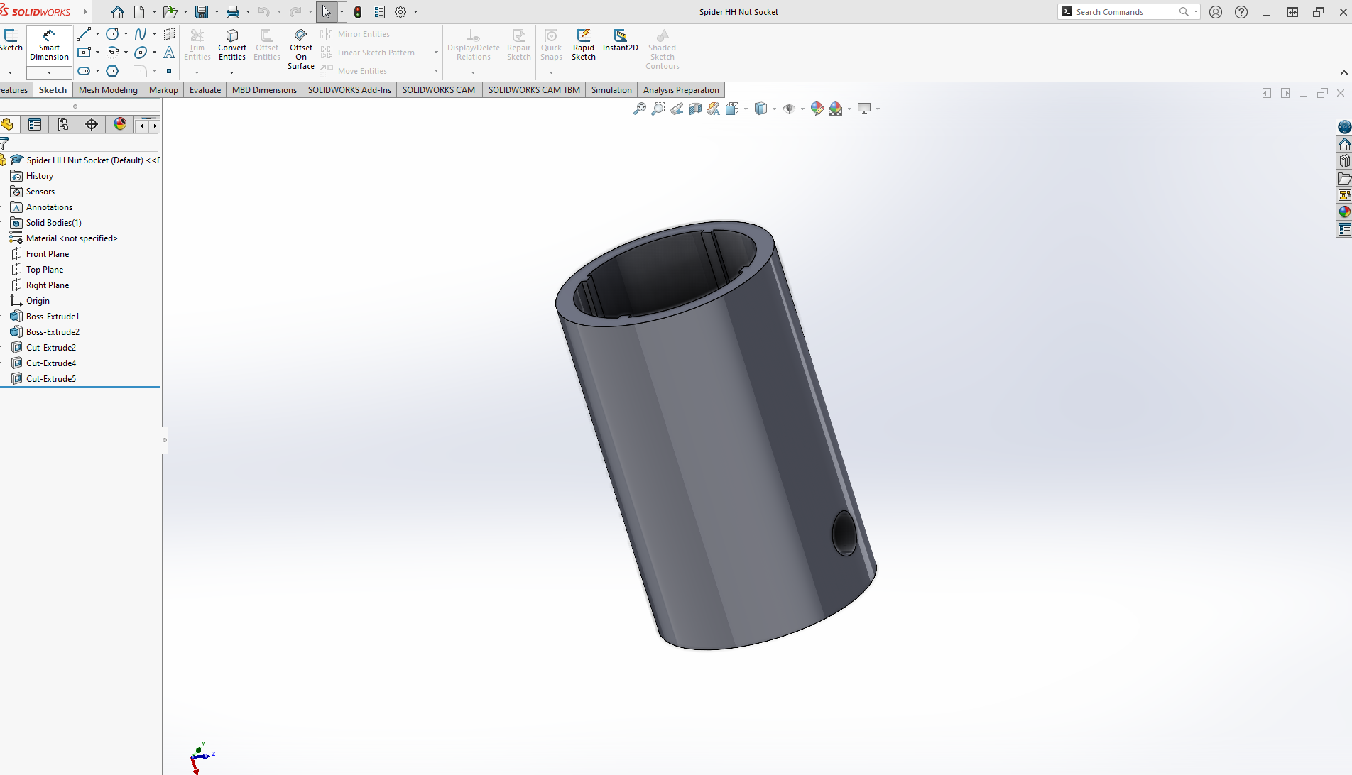
Figure 3: Headphone harness ring socket design bottom section. (M. Dewhurst (2023))
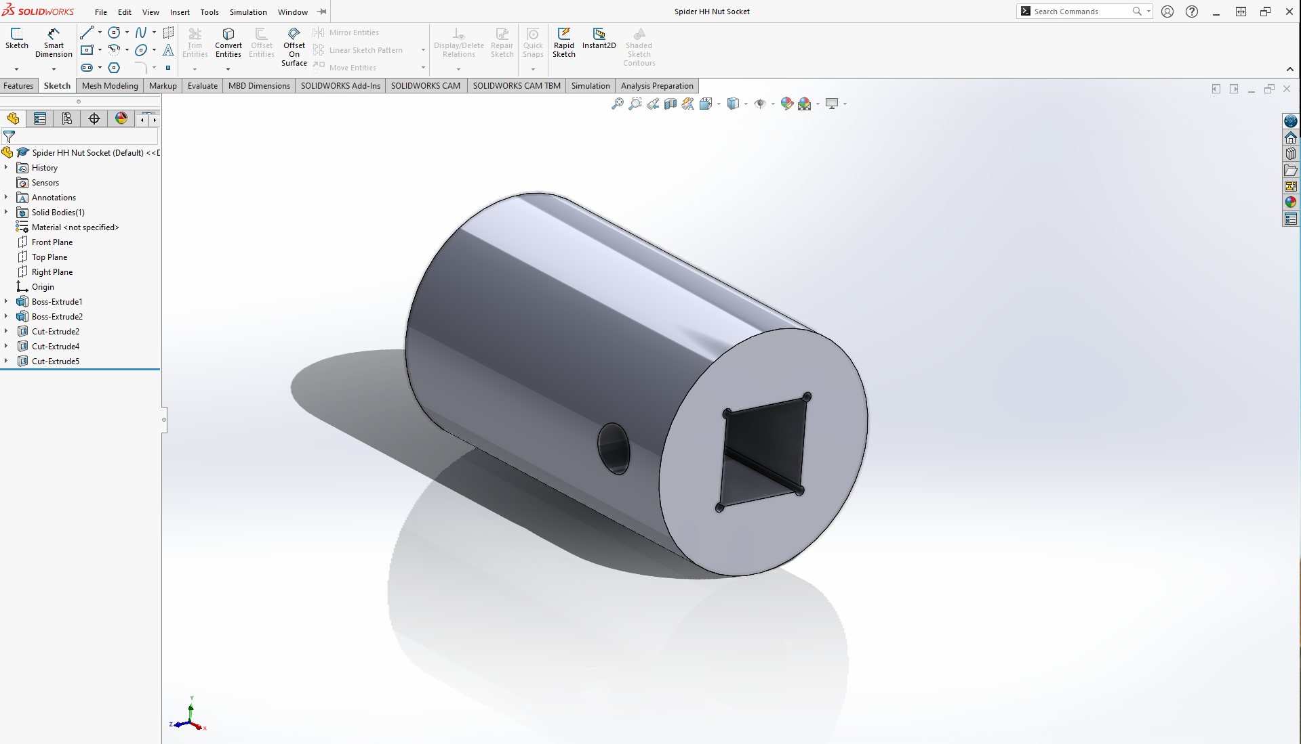

There are several considerations that must be made when using design for additive manufacturing, or otherwise known as DFAM. One consideration is the use of supports when printing the product, which aid the manufacturing of overhangs and complex designs. Once the production of the design has been completed, support material is removed, and the surrounding surface will require finishing to achieve satisfactory quality for the customer. Therefore, when designing the socket, placement of the design on the bed of the machinery is important as this will determine the amount of support material needed. To limit the amount of support material required, the socket was placed in an upright orientation which therefore meant that support material waste was reduced as it was only needed internally. Linking into the orientation and placement of the design on the bed of the machinery, optimization of the volume that can be manufactured per manufacturing run should be considered. The number of components that can fit on the bed can be optimized by carrying out refinement of the orientation and placement of the design, which can ultimately help reduce the running costs of production. From this example, the sockets could be stacked in the ‘Z’ axis to maximize the number of sockets produced per production run. In addition, additive manufacturing also creates the opportunity to consolidate parts, this means that a company can reduce the number of parts that need to be designed and produced for an assembly. One source says that the benefits of consolidating parts are, “reducing the number of fixings, less inventory required, reduced risk on delivery or part obsolescence and ultimately reduced assembly time and costs.” (Gen3DAdmin (2022))

Figure 4: Optimized orientation of design on 3D printing bed. (M. Dewhurst (2023))
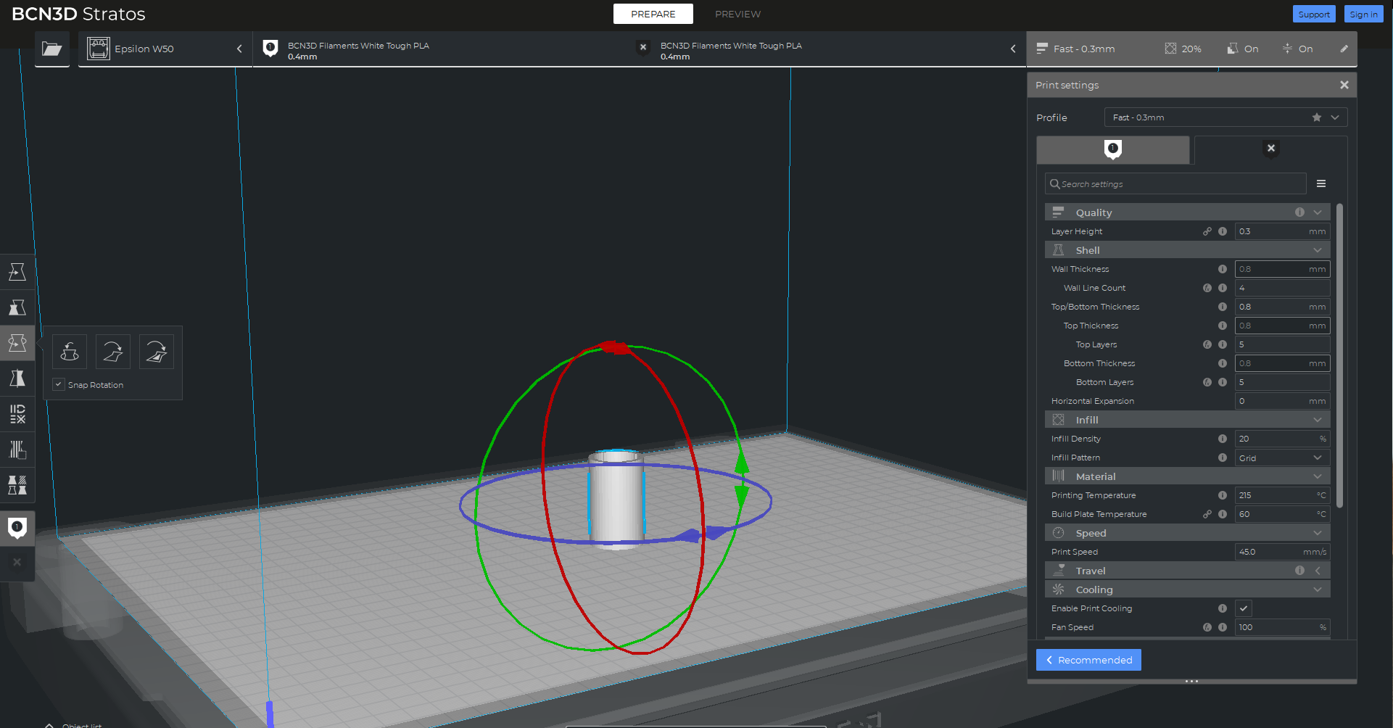

Figure 5: Demonstration of support material used to product the socket. (M. Dewhurst (2023))
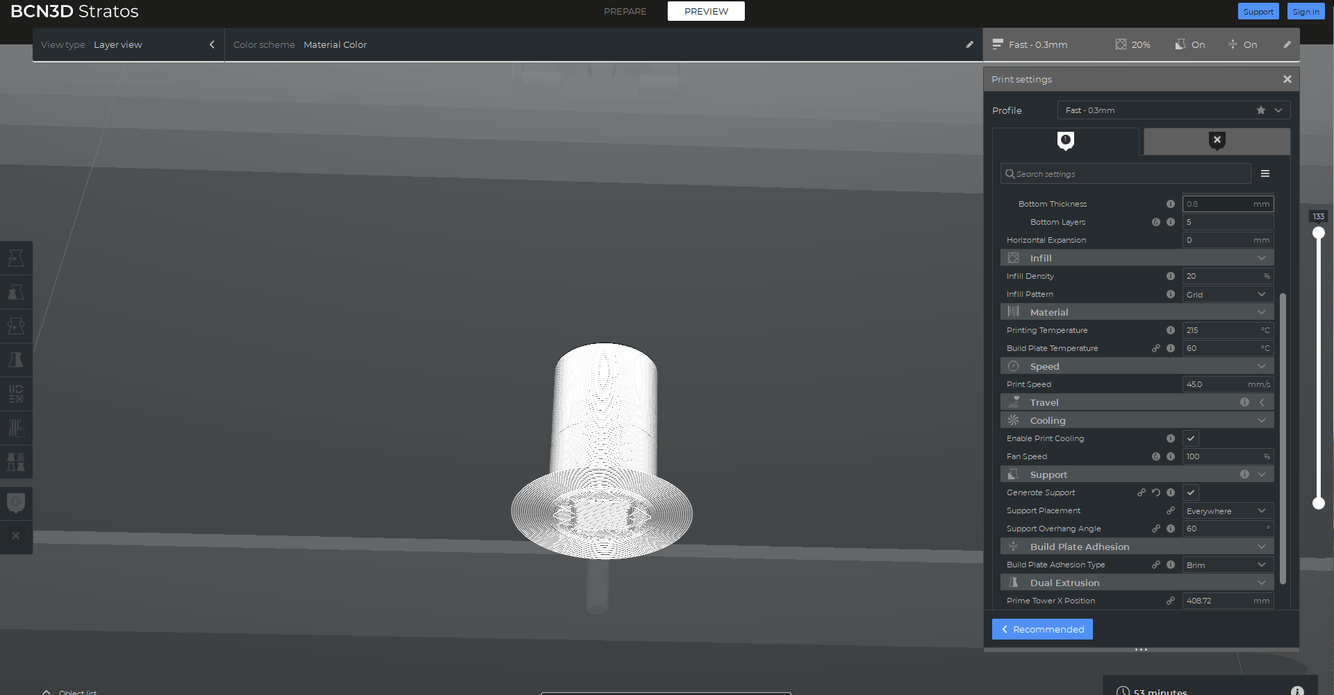

Once the design for additive manufacturing considerations have been implemented, the production of the design can be carried out. The choice of material for this application must be investigated as the ring fixing is black powder coated and is visible to the customer, a commonly used chrome socket would potentially cause damage to the fixing so an alternative material must be considered. As the socket will also have to tighten and secure the fixing, it will also need to be tough and able to endure the torque applied to the fixing on a regular basis. With both of these influences considered, carbon infused nylon was identified as a suitable material as it offers properties such as high inter layer strength and stiffness. Another advantage of the use of carbon infused nylon is that it has low warpage when compared to unfilled nylon, which results in less wastage during production. The images below demonstrate the end product of additive manufacturing, the socket was created with only a small amount of inner supports and therefore limited material wastage. Another benefit that can be taken from the use of additive manufacturing for this application is that the product was designed and produced within the space of 6 hours, if a standard socket was ordered for this application it may have taken up to 3 weeks to arrive.

Figure 6: Images demonstrating finished product of headphone harness ring socket design. (M. Dewhurst (2023))
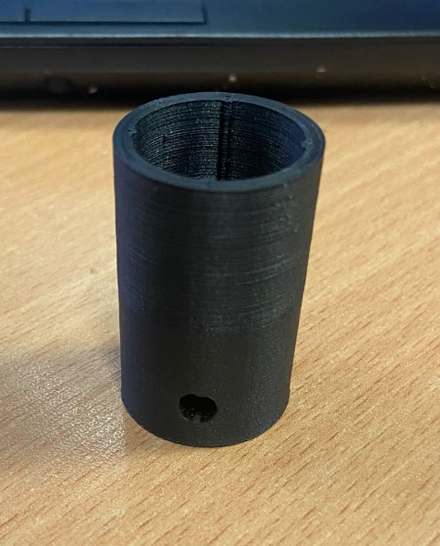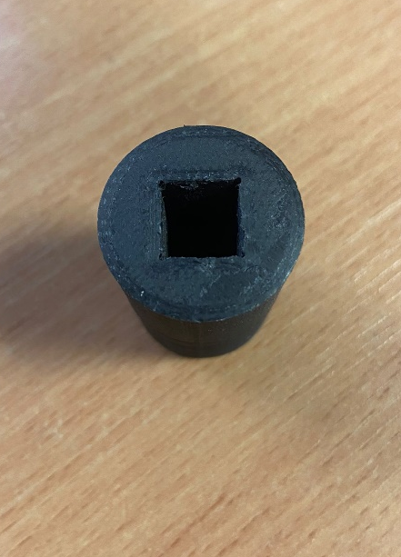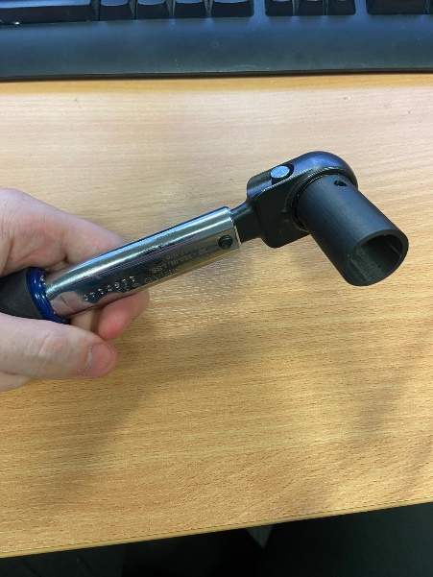

3.0 DFMEA & FMEA.

When manufacturing a new product, process control must be created to prevent potential failures that can affect the safety of both the production team and the end user. Failure mode and effect analysis or otherwise known as FMEA, is a tool that can be applied to both the design and production processes of a product to ensure that all potential failures are identified. One source says that, “Failure Mode and Effects Analysis (FMEA) is a structured approach to discovering potential failures that may exist within the design of a product or process. Failure modes are the ways in which a process can fail. Effects are the ways that these failures can lead to waste, defects or harmful outcomes for the customer.” (Quality One (2022)) From this tool, containments and counter measures can be implemented to protect the product and process from the identified failures.

There are many advantages to the use of the FMEA tool, firstly it offers an improvement to the quality and reliability of a product as well as the processes that are used to create it. This will ultimately improve the safety of both the product and processes, which is of paramount importance from both an ethical and legal point of view. Another benefit of this tool is the creation of a structured system for identifying potential failures, this will allow the areas of concerns to be tracked in addition to the counter measures so that they can be dealt with effectively. A structured process to track and document the risks that have been identified will also ensure that any colleagues within the team are also aligned, it is the responsibility of all members within the team to ensure that the design and production of a component is safe. To add to this, production process time and cost can be reduced with the use of FMEA’s as it can identify issues before they materialize, issues can be prevented from occurring which will create a more successful product launch.

During the design stages of any product, there is an opportunity to carry out a design failure mode and effects analysis or otherwise known as DMFEA. The purpose of this tool is to examine the functions of a component or product during the design stage to identify potential failures. There are many potential failures that can be identified at this stage and it will depend on the chosen product, some examples are material properties and inappropriate specifications. The table below shows an example of a DFMEA for the design of the ring socket, this demonstrates the tracking and risk rating of various potential failures in the design of the socket.

Figure 7: Headphone harness ring socket DFMEA. (M. Dewhurst (2023))
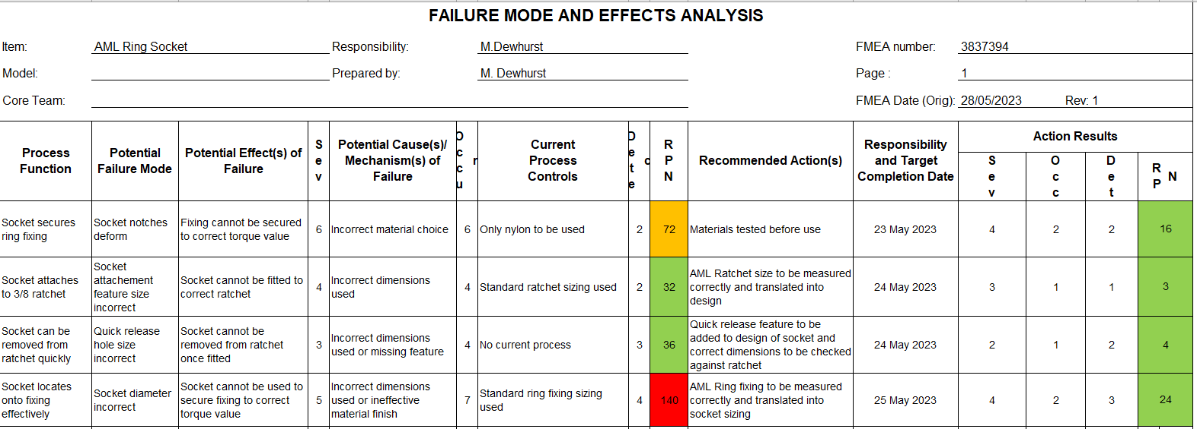
4.0 Improvements.

To improve upon the outcome of the ring socket additive manufacturing, there are several tools that can help reduce the cost and improve the quality of the product. One tool can that be used through 3D design software is finite element analysis, one source describes this tool as, “a computerized method for predicting how a product reacts to real-world forces, vibration, heat, fluid flow, and other physical effects. Finite element analysis shows whether a product will break, wear out, or work the way it was designed.” (Autodesk (2022)) This will ultimately contribute to improving the quality and life span of the product, by identifying areas that are at risk under loads that would be applied during the use of the product. A variety of different companies and sectors use FEA to design and manufacture their products, as it can be tailored to the use of different environments with the wide range of tools available. The image below shows the use of FEA for the ring socket, as the load will be applied from the inside of the shaft by the ratchet attached. The torque value that is required to secure the ring fixing is 1Nm, therefore this torque value is applied to the inner section of the socket during the setup of the FEA software.

Figure 8: Stress FEA of socket design with nylon. (M. Dewhurst (2023))
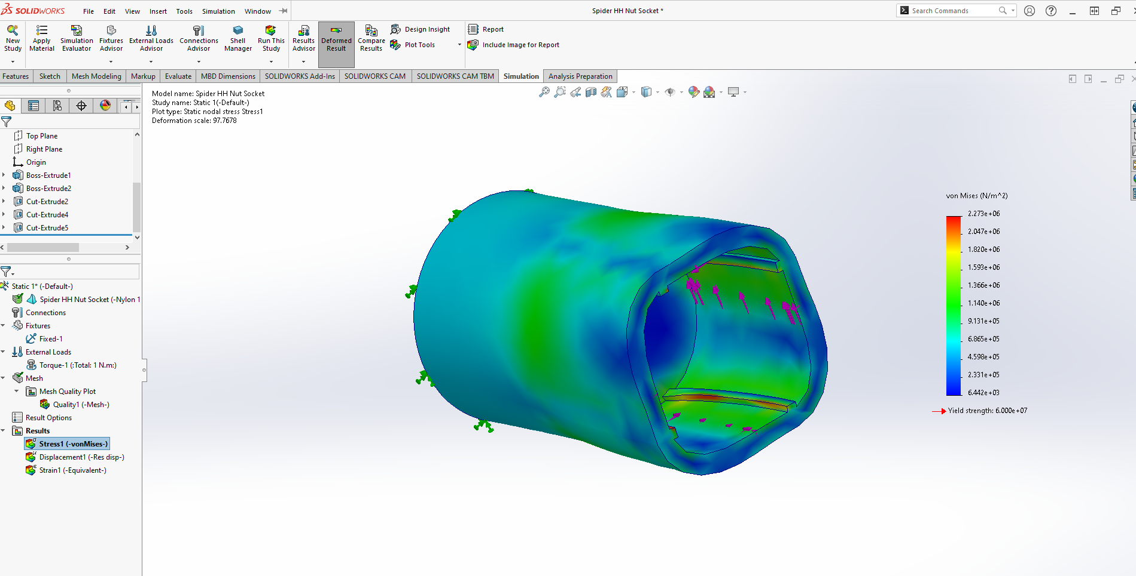
Figure 9: Displacement FEA of socket design with nylon. (M. Dewhurst (2023))
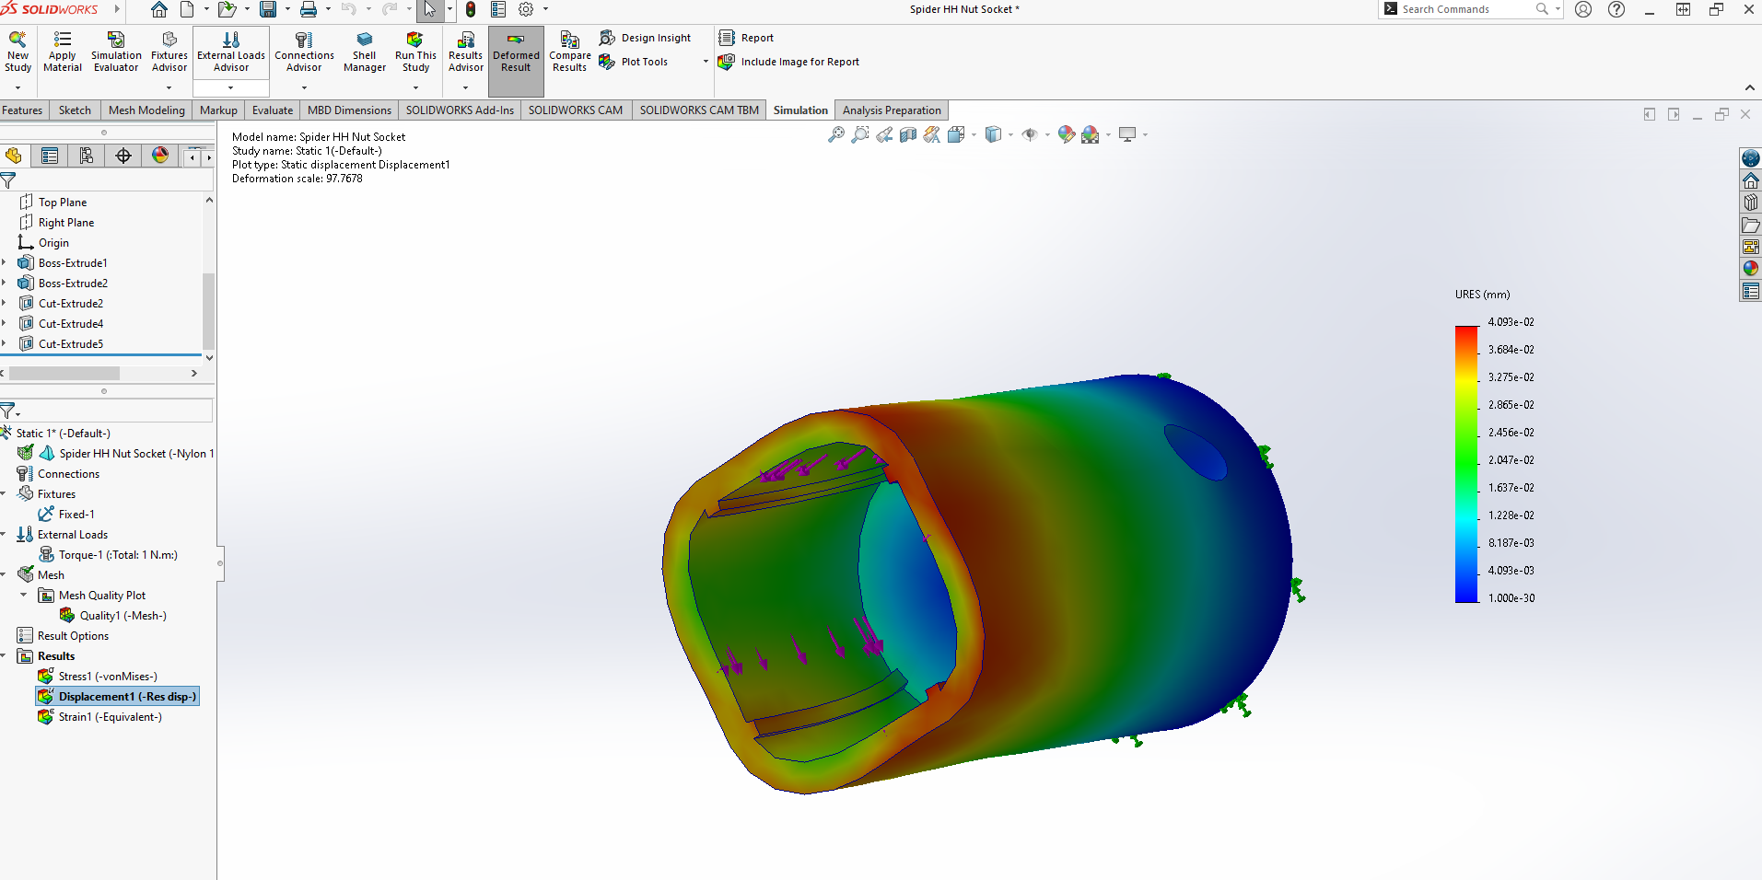
From the first study, a change of material to POM acetal could offer an improvement to the stress and displacement displayed by the nylon example. This is demonstrated by the study shown in figures 10 and 11.

Figure 10: Displacement FEA of socket design with POM Acetal. (M. Dewhurst (2023))
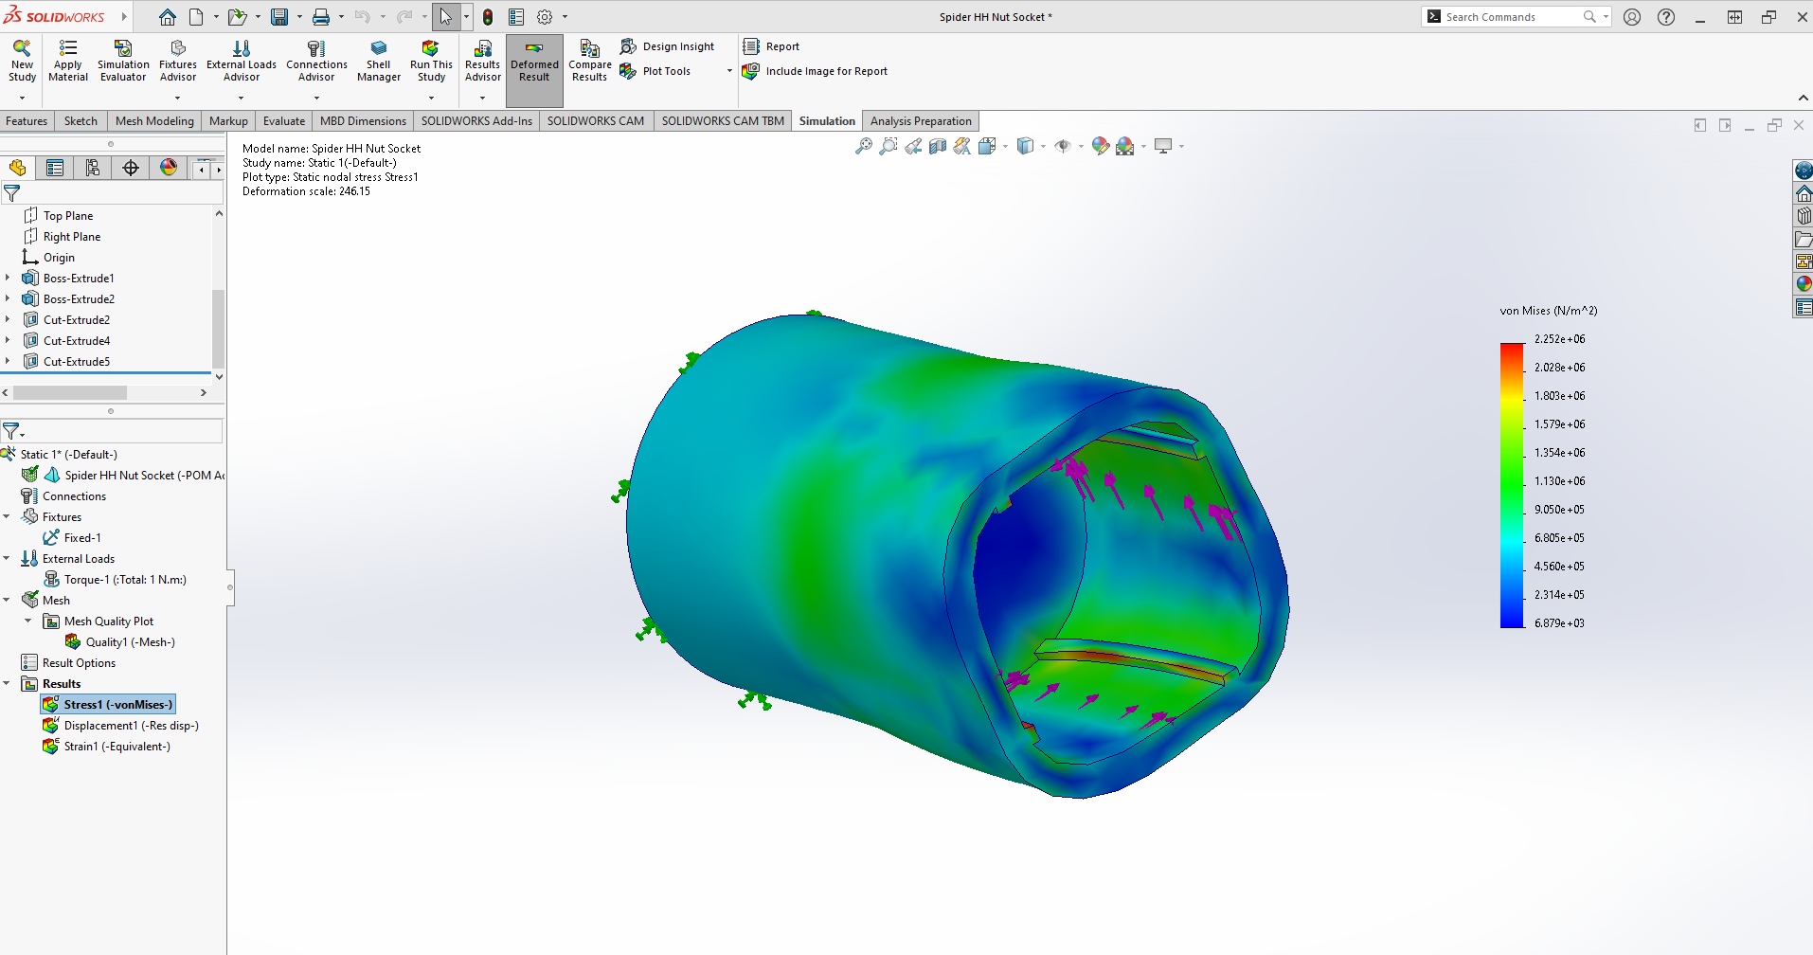
Figure 11: Displacement FEA of socket design with POM Acetal. (M. Dewhurst (2023))
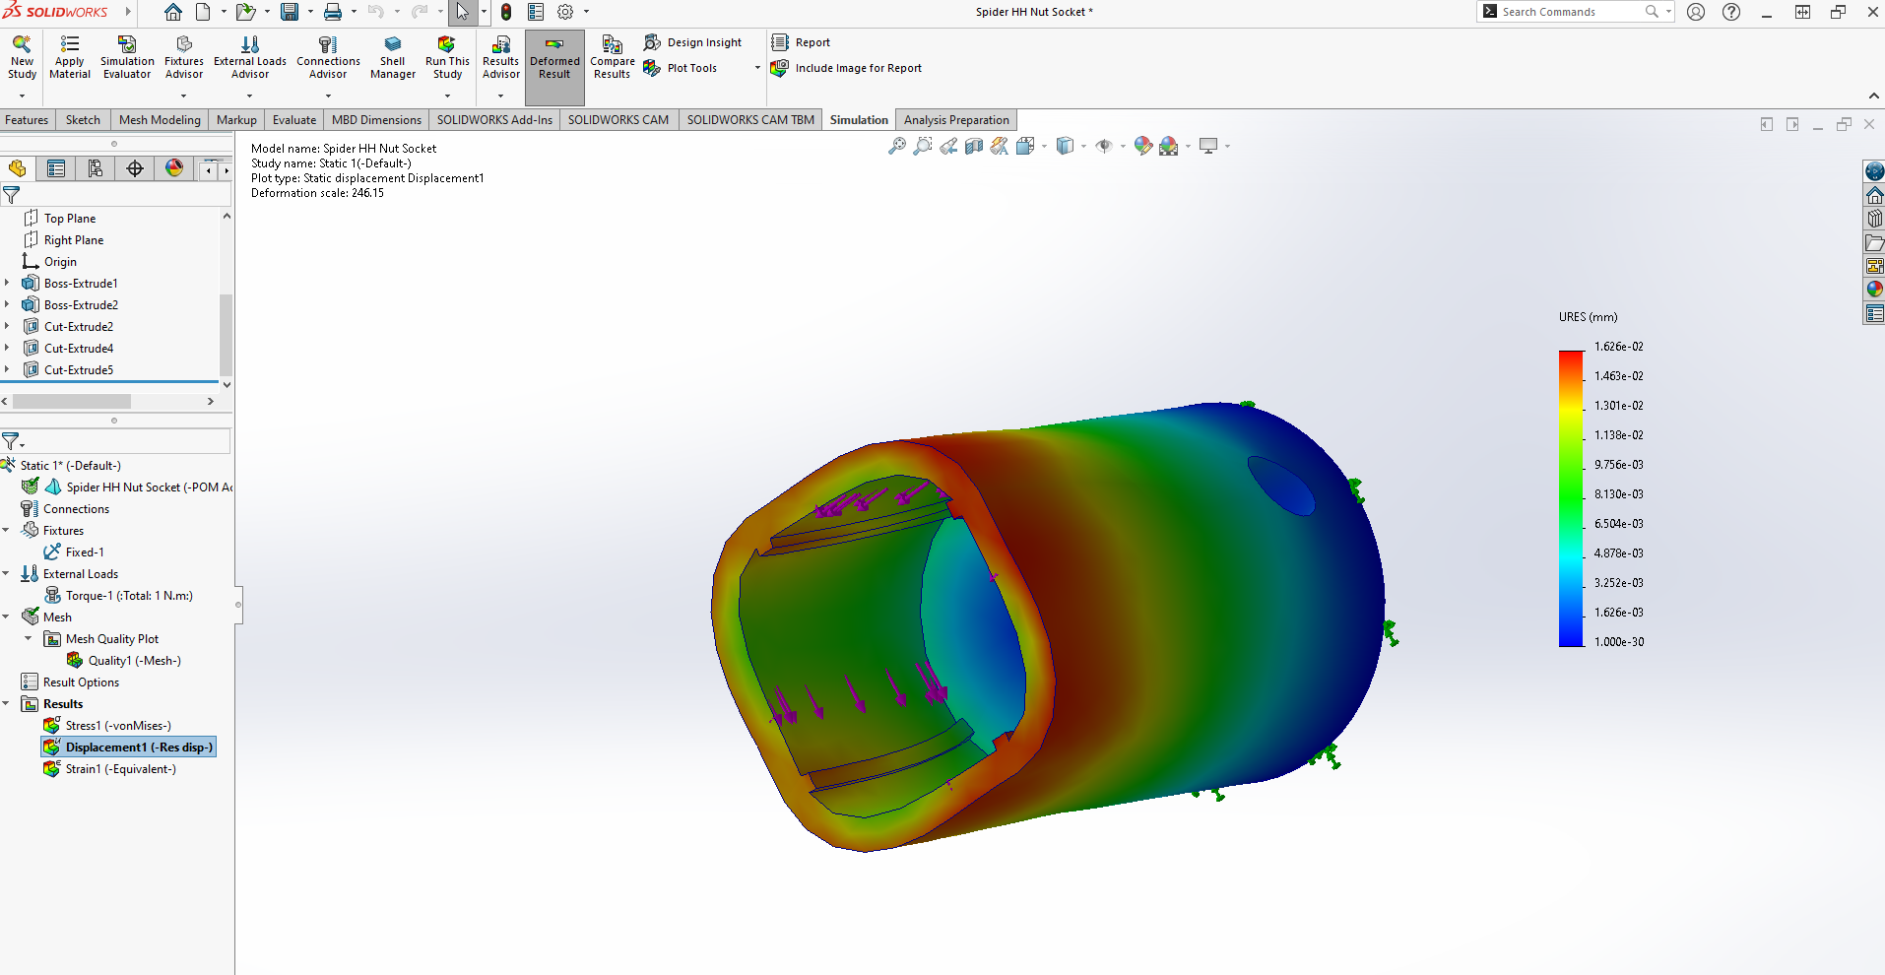

The benefits of the use of FEA are that it can help improve the robustness of the product by highlighting areas that would potentially fail under stress or strain, from this the design can be changed to reduce the risk of failure. The design can be changed to reduce this risk by amending the shape, dimensions, or the material of the product. On the other hand, FEA can be used to reduce the cost of producing the product, by reducing the amount of material used. This can be achieved by utilized the topology tool to remove areas of a product that are not required from stress and strain analysis. FEA can also be modified to suit the use and environment of any product, this can be carried out by adjusting the parameters of the analysis such as stress and temperature. This means that FEA is a tool that can be applied to a variety of sectors, it allows any engineering company to apply the analysis to their product.
Task 2
5.0 Concept Design Appraisal.
There are many considerations that must be made when investigating the end user needs of a wind turbine, it is important that these considerations are utilized during the design stage of the product. A tool that can be used to identify the end user needs effectively is the quality functional deployment model, which was first developed in Japan by Yoji Akao in the late 1960’s while working for Mitsubishi. This tool is commonly used within the engineering industry to ensure that the products and services being created will satisfy the needs of the user, by ranking identified requirements of the user and effectively tailoring the product to suit those needs. QFD was developed to create competitive edge over competitors in many areas, this includes cost, quality, and timing. This is as a result of using the model to identify design issues at the earliest point of product development, to achieve a stable and robust product before the launch to market. Figure 12 below demonstrates the use of the QFD model for the wind turbine.

Figure 12: Wind turbine QFD (M. Dewhurst (2023))
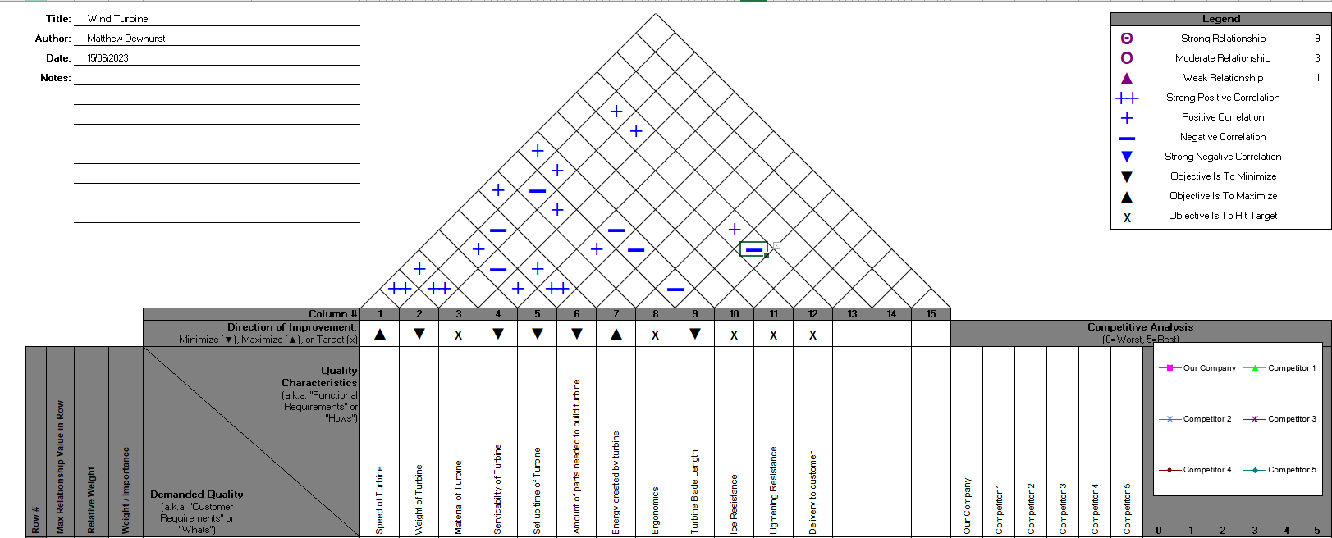
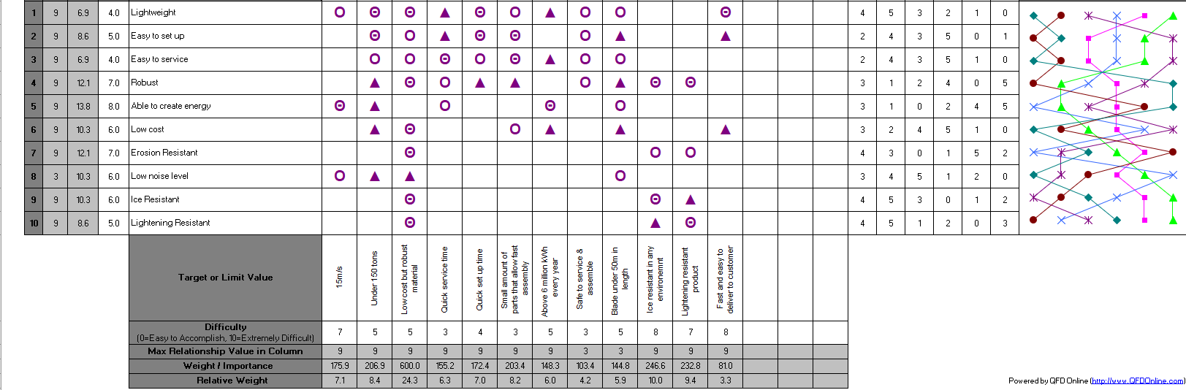

There are many benefits to the use of the QFD tool, such as the ability to identify issues earlier on in the development stages of the product which leads to fewer and earlier changes. As a result of these changes, the development time that is needed to create the product will be shortened, as the company will have fewer issues to overcome. Developing and launching new products can sometimes take many years, so the quality functional deployment model is useful to ensure that the company is developing the product as efficiently and effectively as possible. Leading on from the development stages of the product, QFD can also benefit the launch of the product as the company will experience fewer startup problems. The application of the QFD model in the early stages of a products development will ultimately lead to an improvement in the later stages of its introduction to market. This will also result in lower startup costs as less investment is needed to resolve problems and create late changes to the product. Once the product has been introduced to the market, the company could also see further benefits of the use of QFD as the customer is more likely to be satisfied with their purchase. As the QFD tool uses the customers’ requirements and desires, this creates a product that is tailored to fulfil the end users’ needs and improves customer satisfaction. Another benefit that can be highlighted once the product has been launched is a reduction in warranty claims, as potential problems are identified and resolved prior to the product reaching the customer and this will also improve their satisfaction.

When analyzing the results of the QFD, there are some quality characteristics that could be improved such as the ease of set up and ease of service. From this, improvements can be made to further increase customer satisfaction, as the needs of the customer will be better achieved. An aspect of the QFD model demonstrates the comparison of the product against competitors, this can also help improve qualities such as the serviceability and set up by matching or exceeding the standard set by competitors. From the foundation level of the house of quality model, the relative weight calculation creates a level of importance for the company to prioritize areas. This ensures that the company does not abandon the qualities that the customer perceives to be most important, therefore customer satisfaction can be assured.

6.0 Design & Development.
From the QFD analysis there are several design improvements that can be made to the wind turbine to increase the customers satisfaction with the product and make it more competitive within the market. One of the elements that was highlighted as an area for improvement is the ease of set up, which had a low score on the QFD when compared with competitors. The ease of setting up the wind turbine can be improved by reducing the amount of parts that are required to build the turbine or changing the fixing strategy to simplify fitments. To investigate these opportunities, the Lucas DFA method can be utilized to identify areas of the design that could be improved for ease of manufacturing. The Lucas DFA method was introduced to investigate complexity within assembly designs and how they can be simplified, one source says that “Lucas-DFA proposed an assembly evaluation method based on values scale, the values are given as relative measure of assembly difficulties of each component.” (Sinaga1, A.T. and Wangsaputra1, R. (2018)). The Lucas DFA model can be applied to a collection of components as an alternative to the assembly as a whole, from the wind turbine model it is evident that the propeller assembly contains several parts and has potential to be reduced. Figure 13 demonstrates the use of the Lucas DFA model in an attempt to identify parts of the assembly which are ‘non-essential’ and could be removed to reduce both assembly time and costs.

Figure 13: Wind turbine Lucas DFA method (M. Dewhurst (2023))

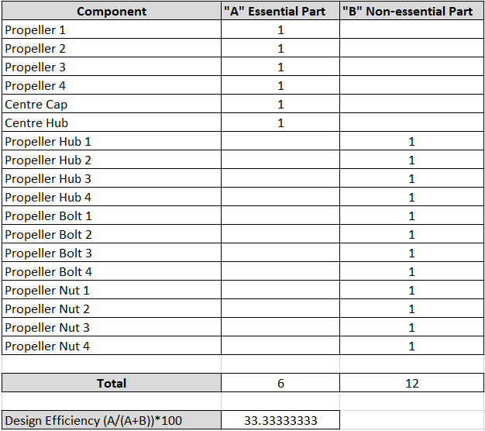

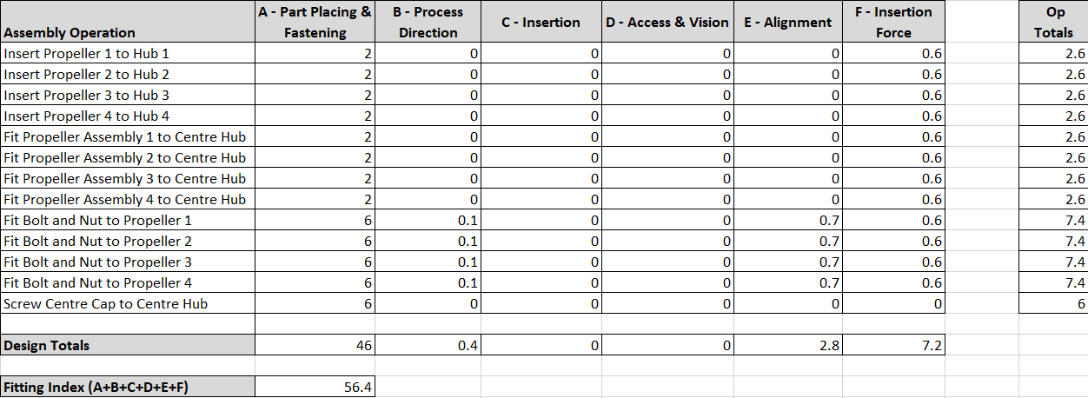

From the Lucas DFA method, a revised design can be produced to improve the areas of the design that are perceived to be difficult to manufacture. In the case of the wind turbine, the propellers and hub in the proposed design were components that had an abundance of fixings. This complexity in the design is then highlighted in the Lucas DFA study, as the fitting index accumulated to a substantial figure. As a result, the design of the wind turbine should be re-considered in an effort to reduce the complexity of the assembly and this can be demonstrated with the use of CAD software such as Solidworks. By reducing the complexity of the design, this can reduce the manufacturing time needed to produce the turbine and therefore allowing the company to increase the production volumes. As the company aims to create between 1000 and 2000 units per week, reducing the amount of fixings and unnecessary components is of paramount importance to ensure that the increase in volume is feasible. Therefore, when re-designing the propeller hub with reducing the amount of fixings and components in mind, a new design could be created that incorporated several components into a singular hub. The new design which is demonstrated in figure 14 will improve the fitting index of the wind turbines propeller components, therefore improving the efficiency of manufacturing to meet the supply targets set by the company.

Figure 14: Wind turbine propeller hub re-design (M. Dewhurst (2023))
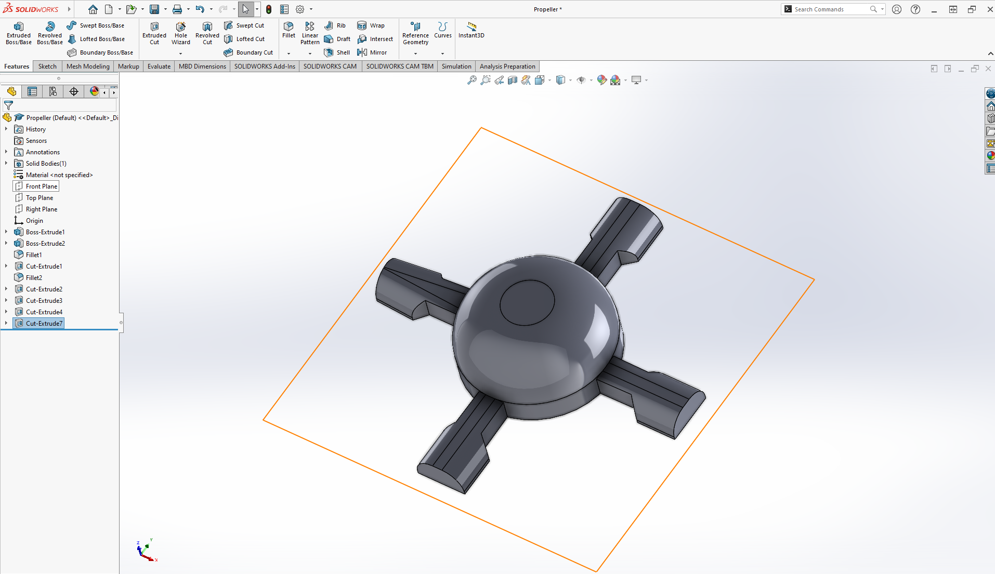

7.0 Manufacturing Process.
From the re-design of the wind turbine, the manufacturing processes that are needed to produce the components must be considered with mass production targets in mind. An efficient and effective manufacturing process must be created to ensure that the company can achieve their mass production targets per week. Many of the components of the wind turbine were designed to be produced using additive manufacturing, due to the many benefits of the equipment. One of the benefits of additive manufacturing in the case of the wind turbine would be the reduction in the finishing that is required to create a suitable finish for the customer. This would therefore reduce the amount of manufacturing time needed per product, enabling the company to reach the supply targets. However, another manufacturing method that must be considered is injection molding, which is the injection of molten material into casts to create complex shapes and designs. The new design of the propeller hub would benefit from the use of injection molding as it is a large complex design, and this production method offers many benefits for this particular application with the utilization of a range of plastics. One source says, “Plastic injection molding advantages center around great precision and high repeatability, combined with speed, a low cost per part and a huge choice of available plastics.” (Toolcraft Plastics (2022)). A manufacturing process that will offer an increase in the speed of production, will improve the company’s ability to reach the supply of 1000 to 2000 units per week. Also, a reduction in cost of production will help the company increase their profit margin, enabling them to fund further improvements to their production tooling and facilities.

Once the components of the wind turbine have been produced, manufacturing processes must be created to assemble the turbine efficiently and effectively. The components of the wind turbine must be analyzed to identify the need for tooling and fixtures, so that the technicians can build the turbines efficiently and ergonomically as possible. By reducing the amount of fixings needed to produce the wind turbine, both costs and assembly time can be reduced. This is one of the main advantages of the re-design, as the new propeller hub has reduced the amount of fixings required. In addition, the new design allows the propellers to simply be clipped into the hub which is more efficient when compared against the initial proposed bolt and nut fixing strategy. The assembly of both the propellers and hub can then be screwed onto the battery and rotary assembly as demonstrated in figure 16. These processes result in an efficient assembly which will allow the company to achieve the mass production targets that have been set, with potential to further increase if required. By utilizing clips and push fit parts, the company can also reduce the amount of tooling needed to produce the wind turbines. This can also be considered a cost saving as the company will not need to purchase tooling but may require technicians to aid the locating and push fitments of large parts such as the propellers.

Figure 15: Propeller Installment Manufacturing Process (M. Dewhurst (2023))
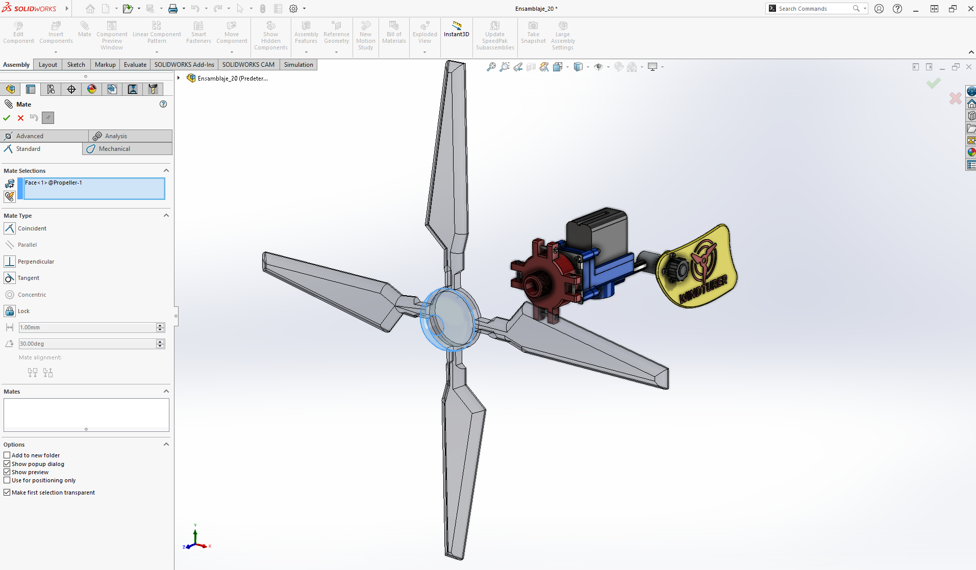

When introducing the production of new products, the use of PFMEA documents can aid the application of preventative measures that will ensure that manufacturing processes are completed safely and effectively. Similar to the DFMEA, a PFMEA helps identify areas of risk to production and from this, measures can be implemented to reduce or remove the risk. There are many benefits to the use of PFMEA, such as the ability to rank the severity of risks so that the most severe risks can be prioritized and resolved most effectively. This can be applied to the production of the wind turbine, by assessing the manufacturing processes to identify potential risks to both the technicians and the end user. This is demonstrated in figure 15, with the investigation into the assembly of the propellers to the re-designed hub.

Figure 15: Wind Turbine Manufacturing PFMEA (M.Dewhurst (2023))
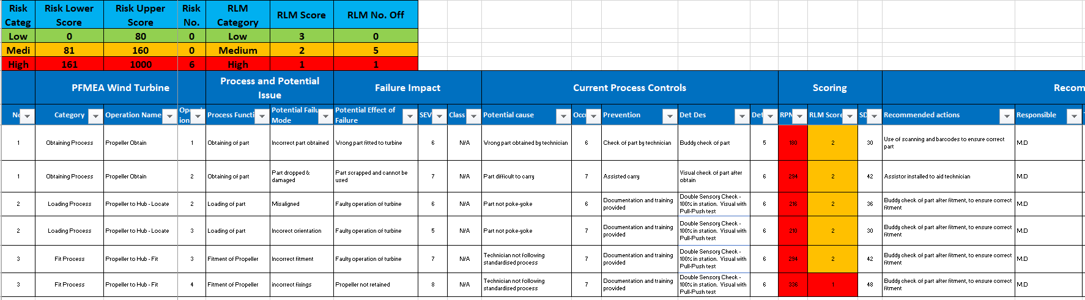

8.0 References.

Gayette, M. (2022) Top 10 advantages of additive manufacturing, PTC. Available at: https://www.ptc.com/en/blogs/cad/10-additive-manufacturing-advantages (Accessed: 26 May 2023).

Horizon Technology (2021) Advantages &amp; disadvantages of Additive Manufacturing Process, Advantages &amp; Disadvantages of Additive Manufacturing Process. Available at: https://www.horizontechnology.biz/blog/advantages-and-disadvantages-of-additive-manufacturing-process-vs-powder-metallurgy (Accessed: 26 May 2023).

Triditive (2023) Four great benefits of Additive Manufacturing Software, Triditive. Available at: https://triditive.com/four-great-benefits-of-additive-manufacturing-software/#:~:text=The%20software%20also%20allows%20digitize,part%20from%20the%20same%20platform.&amp;text=Additive%20manufacturing%20software%20enables%20independence,all%20work%20and%20optimizing%20designs. (Accessed: 27 May 2023).

Gen3DAdmin (2022) 4 key principles of Design for Additive Manufacturing, Gen3D. Available at: https://gen3d.com/news-and-articles/4-key-principles-of-design-for-additive-manufacturing/ (Accessed: 27 May 2023).

Quality One (2022) FMEA: Failure Mode and Effects Analysis: Quality-one, Failure Mode and Effects Analysis (FMEA). Available at: https://quality-one.com/fmea/#:~:text=Failure%20Mode%20and%20Effects%20Analysis%20(FMEA)%20is%20a%20structured%20approach,harmful%20outcomes%20for%20the%20customer. (Accessed: 27 May 2023).

Autodesk (2022) Finite Element Analysis Software, Autodesk. Available at: https://www.autodesk.com/solutions/finite-element-analysis#:~:text=What%20is%20finite%20element%20analysis,the%20way%20it%20was%20designed. (Accessed: 28 May 2023).

Sinaga1, A.T. and Wangsaputra1, R. (2018) IOPscience, A Framework for the Development of Automatic DFA Method to Minimize the Number of Components and Assembly Reorientations. Available at: https://iopscience.iop.org/article/10.1088/1757-899X/319/1/012058 (Accessed: 17 June 2023).

Plastics, T. (2022) What are plastic injection moulding advantages and disadvantages ?, Plastic Injection Moulding Advantages &amp; Disadvantages. Available at: https://www.toolcraft.co.uk/plastic-injection-moulding/advice/advice-plastic-injection-moulding-advantages-disadvantages.htm#:~:text=Plastic%20injection%20moulding%20advantages%20centre,time%20than%20some%20other%20processes. (Accessed: 24 June 2023).

