

Module – Materials Science and Building Services

Assignment Title - Construction Materials

Lecturer - Allan Nantel

Blaine Cunningham
(1908060)

- Empire State Building New York
The Empire State Building, a famous skyscraper in Manhattan, New York City. It may in fact be the most famous building in New York with the building having a total amount of 102 stories. This masterclass building was designed by 3 gentlemen called Lamb, Harmon and Shreve and was completed in the year 1931.
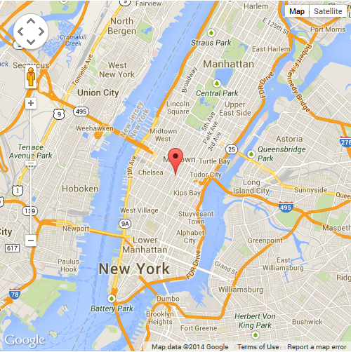
http://www.edpatekstil.com/images/map_us.png
As you can see from the above picture The Empire State Building is located In Midtown Manhattan.
1.1 This building has a certain amount of height records these include-
- The Empire State building was the tallest man-made structure recorded in the world before it was surpassed by the Griffin Television Tower in the year of 1954
- Also, the second tallest building in the America, surpassed only by Chicago’s finest the Willis Tower
- The Empire State Building is the 28th tallest in the world , this is an impressive record to have, but the tallest being Burj Khalifa in Dubai, which I will also be diving into next.
- Holding the record for being the tallest skyscraper in the world for over 40 years.
Then we also have the details of the building heights, the roofs recorded height is 1,250 feet. The height the building stands tall, is an amazing total of 1,454 feet. The Empire State Building held an incredible record for nearly a whole 40 years for being the largest skyscraper. If you didn’t know the production of the famous World Trade Centre took the title of the tallest skyscraper in the late 1970.

- Information about the Buildings Frame/ Durability
You couldn’t imagine the scale of the project, it was massive, my research has educated me through this building. Every day without fail trucks would be delivering tens upon thousands of materials. These include around roughly 300m3 of sand each day, also 5,000 bag of cement, even more on some production days. The one that I couldn’t believe is that the Empire State Building contains 60,000 tons of steel in the buildings frame. The building also contains 730 tons of aluminium , 10 million bricks and 200,000 cubic feet of I believe Indiana limestone.
Steel is an amazing material and this is why it was chosen to be used for this buildings structure. It is environmentally friendly and can support weight in all different areas needed, this was obviously a very important reason as to why Steel was the material that was made to create such a spectacular building. As the Empire State Building is so large Steel was thought of also for its incredible durability. This building will be around for many many more years to come as it has done for over 80+ years.

3.0 Health and Safety
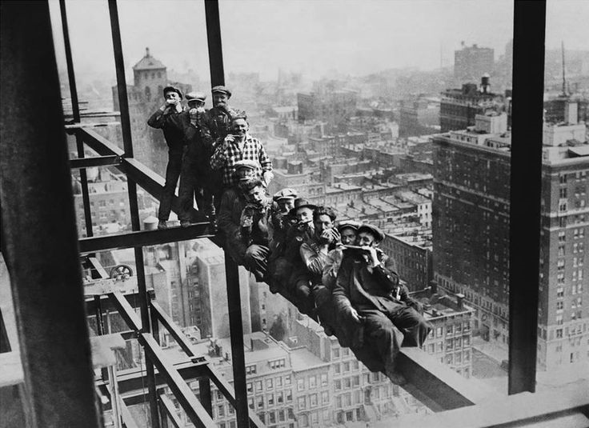
https://i.pinimg.com/736x/24/82/03/2482032561c4f072ad0cd8dc2fe76ca7.jpg
Health and Safety as you can see was a completely different world away to what it is now. There were no Health and Safety Officers you would just have a site “foreman” as we call it today who would ensure the work was proceeding correctly. In the picture above is men working on the Empire State Building making sure the work gets done. There were no canteen or break rooms, so they made there own lunch space and then continued working. Remarkable really, not a care in the world for these men.

4.0 Planning Process and Design Changes
The official plan of the famous building was 50 stories, but after later consulting this was soon increased to 60 stories then after that was increased to 80 stories. The plans were changed one last and final time in the year of 1929 of the month December. This was to include a 16 story , 200 foot metal crown. If that wasn’t enough more was added, an additional 200+ foot mooring mast. Finally the roofs overall height was now 1.250 feet and still stands this height to this very day. At the time the Empire State Building was the most tallest building in the world by a long way.
Smith, who also owned more famous buildings announced the updated plans for the skyscraper. People were very surprised by this as it already reached such an amazing height. The idea was to include an observation deck on the 86th-floor roof at a height of 1,050 feet .
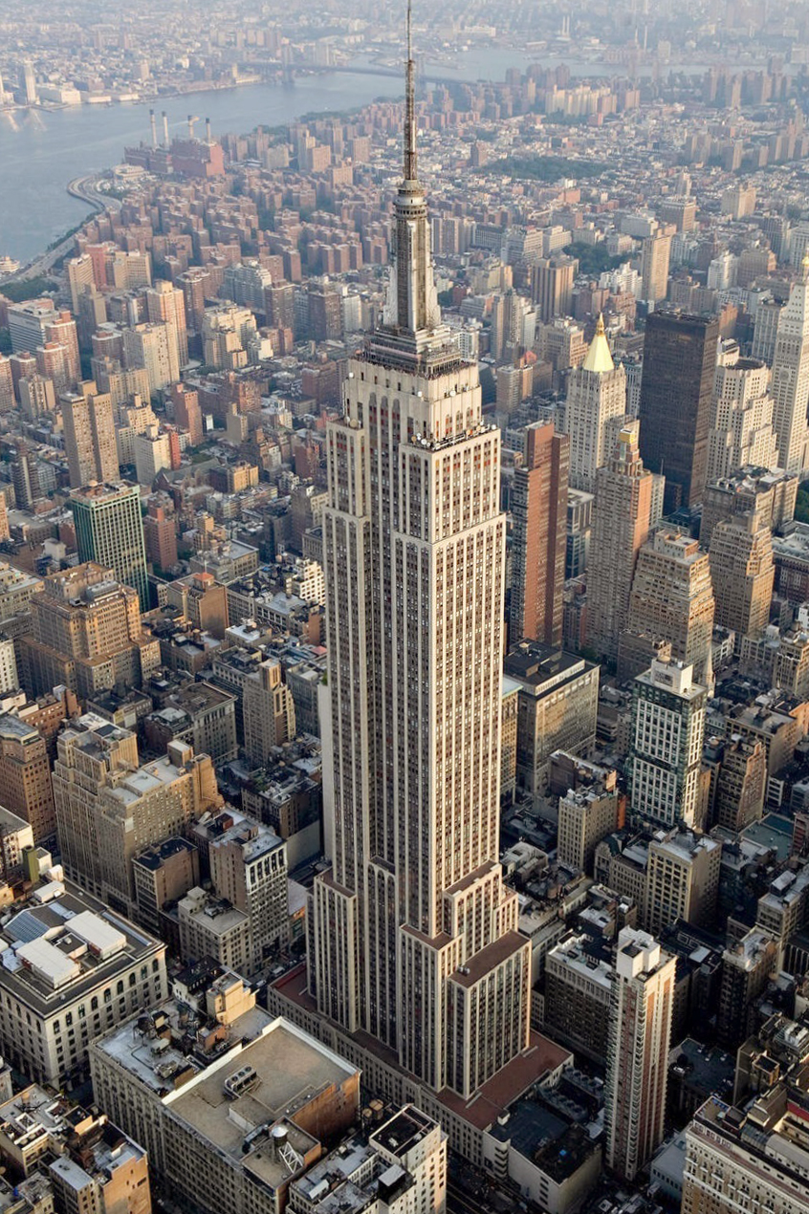
https://upload.wikimedia.org/wikipedia/commons/1/10/Empire_State_Building_(aerial_view).jpg

- Completion of the Empire State Building Project
Let’s dive in to when the Empire State Building Structure was completed. My research has shown provided me with information regarding this. The building was officially completed in the year 1931, the date of this was April 11, 410 days after construction of the building commenced and twelve days ahead of schedule which is very impressive. The pricing for this job was huge, The Empire State cost a total of 40+ Million, I believe the exact figure is 40,948,900 to build. The money back in the 1930s was obviously different to now. If this wonderful building was built now that 40 million would be equivalent to 554,644,100, which Is scary to look at. The budget was under $60 million.

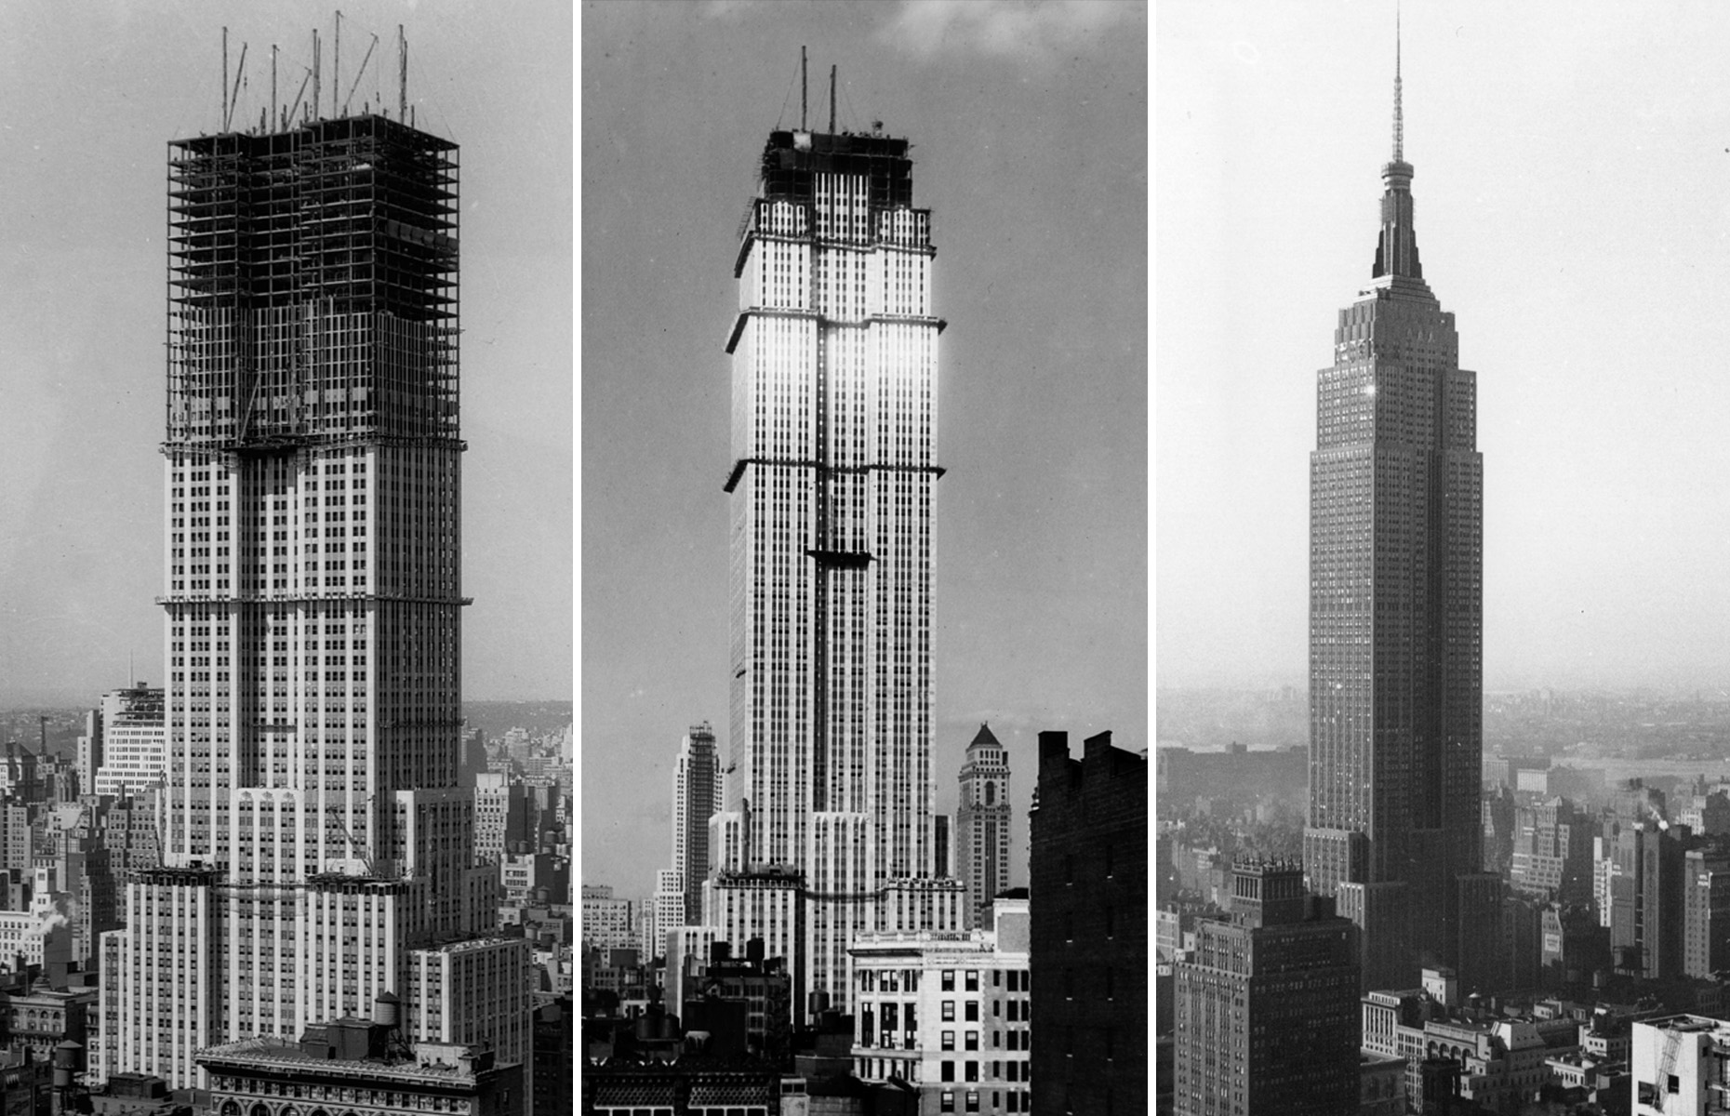
http://img-s-msn-com.akamaized.net/tenant/amp/entityid/BBAvYQR.img

- Accidents and Faults with the building

During the year of 1945 a bomber who was on its way to Newark Airport in New Jersey, the pilot crashed into the 79th floor of the Empire State Building. Shockingly after this crazy situation which occurred only a small minor damage affected the building.
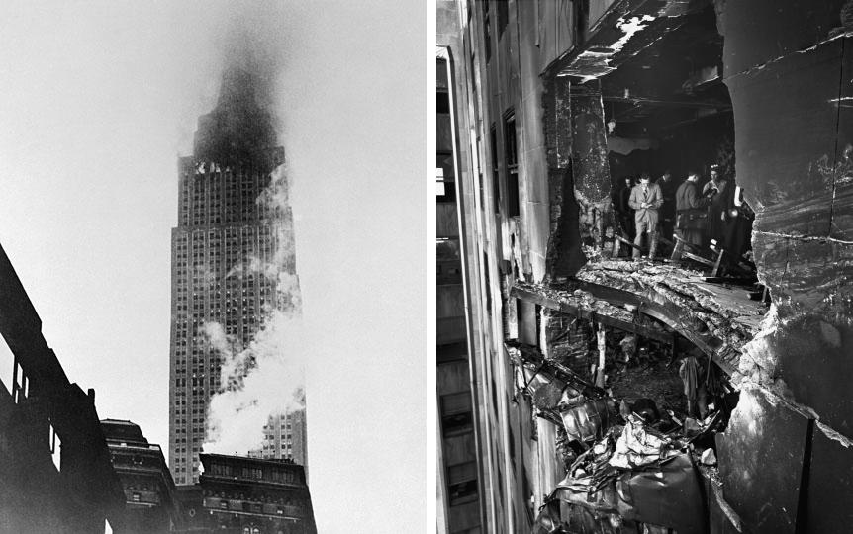
http://1.bp.blogspot.com/-ttWCK8GCuEU/UbUzyWZQ1lI/AAAAAAAAAKs/cMwK-9FxxFU/s1600/1.jpg

With such a large building at hand, there was one thing that could of been expected. Suicides were a real issue and still are to this day. The first suicide was recorded in the year 1931 and the date of April 7th. A carpenter who had been laid off after his hard work went to the 58th floor and leaped to his death. Yes it is as crazy as it sounds.

- Burj Khalifa
Construction of the world famous Burj Khalifa begun in the year 2004. The exterior of the building was completed five years later in 2009. If you didn’t know already the primary structure is reinforced concrete. This material was chosen as it is extremely reliable and can be manipulated to what best suits the building. The Building was officially opened in 2010 as part of a new development called Downtown Dubai or this was the idea anyway. With many ifs and buts the decision finally given the go ahead by the government. The decision was agreed to diversify from an oil based economy, so that Dubai could gain recognition from the whole world. The Burj Khalifa was designed by Adrian Smith sound familiar? You would know him from Skidmore , Merrill and Owings whose firm also designed one worlds trades centre and the famous Chicago Wills Tower.
It was predicted that the reception to the Burj Khalifa could of went each way of being negative or positive, but happily the reception it received was mostly positive after all! The building obviously received many upon many awards from its spectacular design. But throughout my research I have found there for concerning complaints regarding migrant workers who were primary building labour force.
7.1 Record heights set by Burj Khalifa
- Tallest skyscraper to top of antenna: 829.8 m (2,722 ft) (previously the Willis (formerly Sears) Tower – 527 m or 1,729 ft)
- Building with most floors: 163 (previously World Trade Center – 110)[18]
- World's highest elevator installation (situated inside a rod at the very top of the building)[19]
- World's longest travel distance elevators: 504 m (1,654 ft)[19][20]
- Highest vertical concrete pumping (for a building): 606 m (1,988 ft)[21]
- World's tallest structure that includes residential space[22]
- World's highest installation of an aluminium and glass façade: 512 m (1,680 ft)[23]
- World's highest nightclub, this nightclub is in the 144th floor
- World's highest restaurant
- I didn’t realise this could be a record but the World's highest New Year display of fireworks.
- Also the World's largest light and sound show staged on a single building.

- Climate Resistance and the buildings Durability
Through my research I have learnt that regarding the climate analysis a total of 40 wind tunnel tests were taken on the famous Burj Khalifa to test the effects the wind would have most importantly the occupants in the building and on the tower itself to effect its durability. The test were as follows, verify the wind climate of Dubai, analyse the large structure and before pressure test, this is so also analyse micro climate. The effects of the terrace and all around the tower base is very important.
The Empire State Building structure is an amazing 828m tall, the whole system that was initially designed is a reinforced concrete structure. This was the first attempt in world history to have such a large height for structures. This means the buildings durability is unbelievably advanced and this building is extremely durable. The Burj Khalifa was designed to also contain Steel as well as possessing over extreme amount of concrete. This building has been developed by the best architects and strucal engineers in the world.
The picture below is the construction phase of the Burj Khalifa
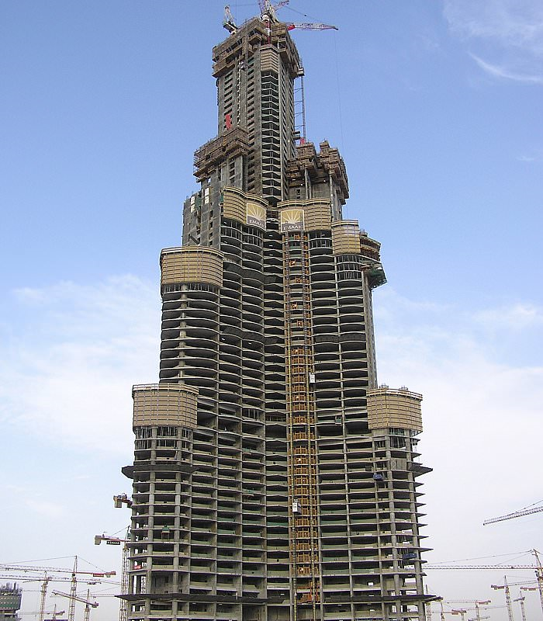
http://www.usasom.com/data/upload/image/201603/2bc2e9e0aaac1e2a76ee90b918ec8ebc.jpg

- Information about the Buildings Frame
Now let’s get in to the building frame the numbers everything like that, a total amount of 45,000m3 of concrete was used for this masterpiece. This resulted in the building using more than 110,000 tonnes, to construct the steel and concrete. that is unbelievable. The building weight is 450,000 tones the initial idea for the building was made sure this weight could be supported. Concrete works perfectly for this design. The building also features 192 piles, to put into understanding each pile is 1.5 meter in diameter by 43 meter in L , these numbers are scary.
This construction project took 22 million man hours which is absolutely incredible. Hard work pays off. While this project being a lot of reinforced concrete that is a very important factor. If you were unaware Burj Khalifa’s used 330,000m3 of concrete, just read that figure crazy, and also 55,000 tonnes of steel rebar.
My research has led me to know that special mixes of concrete were requested to be made and were made to withstand the extreme amounts of pressure of the building gigantic weight. It is very common for reinforced concrete in construction. Many tests were under gone to see if the building could in fact withstand the buildings pressure.
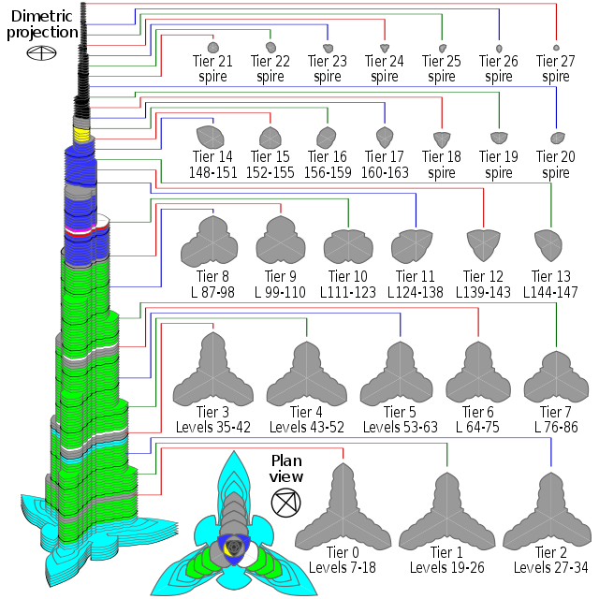
https://en.wikipedia.org/wiki/Burj_Khalifa#Construction_and_structure

- Planning/ Design

The idea of this amazing design came from an Islamic architecture. That is no surprise as Islam is a popular religion in Dubai. As the tower rises from the flat desert base, there are a total of 27 setbacks in a spiral pattern. You can see this from the diagram below. I have discovered that the tower is made of three elements arranged around a central core in the building. The structure is a Y shaped, with again as I have stated setbacks of its each three wings provided. This was just an idea to begin with but after lot of planning and in an extremely short amount of time this masterclass building was created with hard work and exceptional planning.
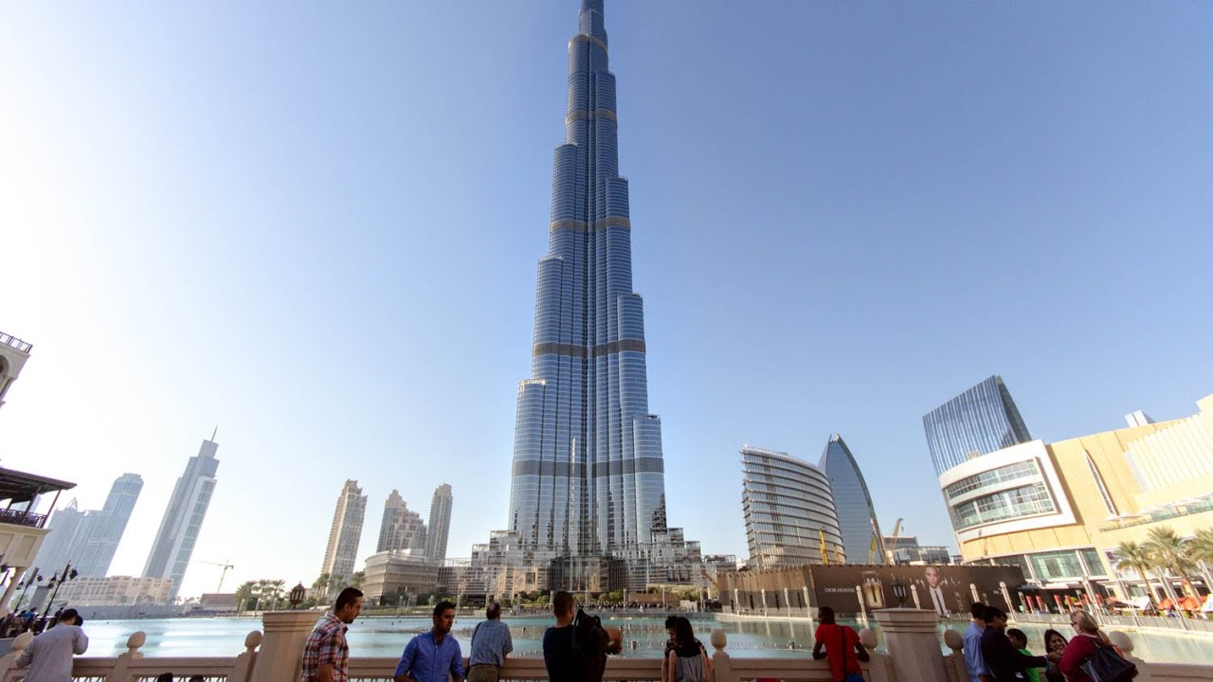
https://i.ytimg.com/vi/dLemK1zuh7I/maxresdefault.jpg
- Accidents and faults with the building
Incidents
Fatalities
Accidents are excepted with such huge building, but before the Burj Khalifa reached 2 years of its production a young man in his 30s who actually worked there for one of the massive companies sadly committed suicide by jumping from the 147th floor which is just terrible. The date this was recorded was the year 2011 the date May the 10th. The young man fell 39 floors, then landing on the deck on the 108th floor. I have read a report that the police confirmed it was indeed a suicide. It involved the companies as they refused to grant the young man annual leave.
It was also reported on the year 2014 which is quiet recent, the date being 16th of November a Portuguese tourist actually fell to her death on the very top floor of the observation deck. 148 floors high.
12.0 Comparing Frames
Steel Positives
- Speed efficacy, using steel frame can finish production faster
- Minimal Rework, steel can be manipulated to many things
- Waste is massively minimised
- Recycling is a massive positive which helps the world

12.1 Concrete Positives
- Concrete moves faster than other materials to proceed to final occupancy
- Great Flexibility in meeting a wide range of load and requirements
- Material of choice for many Architects and structural designers
- Shorter overall schedule and on time record of concrete major interest and and income advantages

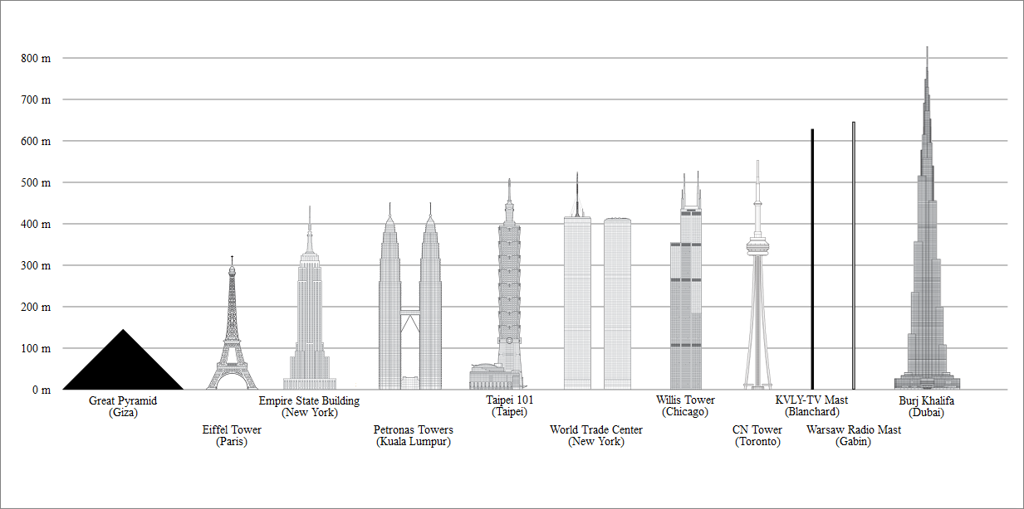

The diagram above is the heights of both the Empire State Building and the Burj Khalifa in a chart form. These two building are globally known around the world. They are massive tourists’ attractions and from my research true masterclass buildings. From the design stage to completing the buildings is amazing to learn. The amount of materials needed to create such a masterpiece is unimaginable as I have never witnessed such a large scale. The amount of planning that must have been undertaken is scary to think about, the most brilliant minds were used true experts of their work.

13.0 Biography
https://www.burjkhalifa.ae/en/the-tower/design-construction/
https://en.wikipedia.org/wiki/Burj_Khalifa#Architecture_and_design
https://www.bing.com/search?q=Steel+postives&FORM=EDGNCT&PC=LCTS&refig=4787f43205ae47b0b80be3085e32c1a5
https://en.wikipedia.org/wiki/Empire_State_Building#Planning_process

