Paul Davies
P151993

ENGINEERING DESIGN
Drill Press Group Redesign and Reflective Report

Executive Summary

This report looks at a design of a drill press assembly and critically appraises the concept of the design and identifies the functional requirements. It then looks at the main sliding unit (DPMSU) and states a manufacturing process and polymeric material for the main that could be used to suit a production run of a quantity of 500 units per week. Advantages of using this process are identified as talked about by a polymer injection moulding manufacturer “Reduced costs – plastic injection moulding allows for mass production on a very cost-effective scale. The majority of the process is controlled by computerised equipment and machinery, which can be managed by a single operator, meaning overheads, such as labour costs are kept to a minimum. This, in turn, means the overall cost of manufacturing parts is reduced – allowing us to pass this cost saving onto our customer. “……. ” Speed of production – plastic injection moulding is a fast production method, another factor that helps to reduce costs. Production cycle times can be as short as a few seconds depending upon the component being moulded.” (Skar Precision Moulding, 2016). Polyoxymethylene (POM) a suitable polymeric material is also talked about for why it could be used in this process. Different features would have to be added and changed to the original design Bayer (2000). A computer aided design program called Solid works 2017-2018 is identified and changes are discussed in what changes would be made in the part that is being made for Polymer Injection Molding.

Table of Contents
Executive Summary 1
Introduction 3
Findings Error! Bookmark not defined.
Sub Headings Error! Bookmark not defined.
Further Sub Headings 4
Conclusion 7
Recommendations 10
Reference List 11
Appendix Error! Bookmark not defined.

Introduction

A drill press can deliver much more accuracy than a standard hand drill. “Drill press is one of the best tools that are used to provide efficient services to the people. Unlike hand drill, the orientation and the location of the holes are considered accurately. All the functions and the features of the drill press are performed well, if all the parts of the tools are in the right condition and working properly.” (Power Tools Experts, 2015).

The image below is a design of a drill press assembly.

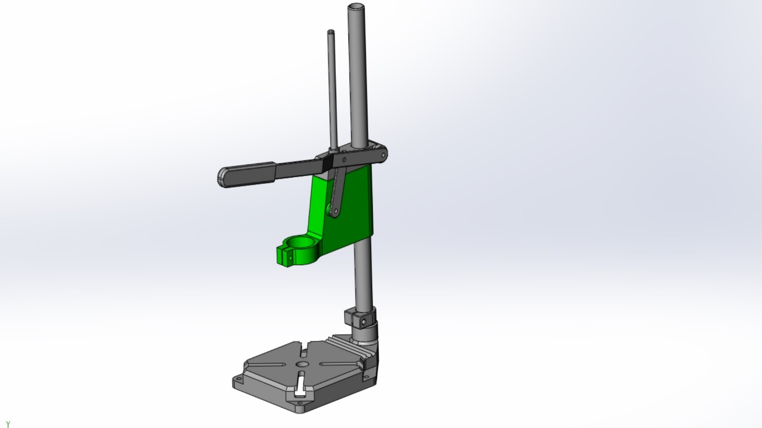
Fig 1.

This design has a base, guide shaft, lever arm, link arm, main shaft, main sliding unit, support clamp and top base clamp which would hold the drill mechanism in place. Looking at this drawing it determines that the top base clamp is part of the main sliding unit which is fixed to the lever arm and has a tunnel for the column (main shaft) that passes through it to slide up and down which is essential for when pressing down and then raising on an object when being drilled.
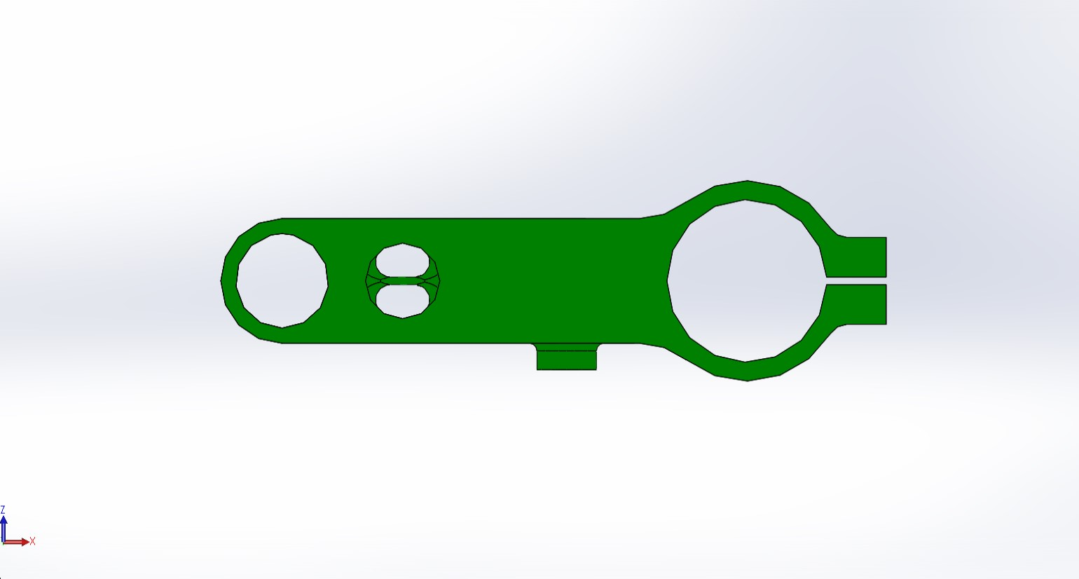
Fig 2.

Looking at a Birdseye view of the clamp part there is also another hole next to the main shaft that allows guidance for the drill press part when sliding through the column also on the side there is an extruded cylinder boss which connects the link arm to the lever arm.

If the (DPMSU) which is shown in green needed to be produced at a production run of a quantity of 500 units per week an ideal manufacturing process would be polymer injection moulding with the use of Computer Aided Design (CAD), but some alteration to the design would have to be made to suit this process because it must be strong and applicable for when pressure is applied to the arm when the drilling tool is penetrating through the object being drilled. In this report we will determine why this manufacturing method and a polymeric material would be suitable for this task, also what changes of the original design would need to be made.

Findings

3.1 Advantages of Using Polymer Injection Moulding

The advantages of using polymer injection moulding are reduced cost, speed of production, quality of production, efficient production process, simplified production process, simplified process and versatility of materials as stated below by the manufacturer (Skar Precision Moulding, 2016).
“Reduced costs – plastic injection moulding allows for mass production on a very cost-effective scale. The majority of the process is controlled by computerised equipment and machinery, which can be managed by a single operator, meaning overheads, such as labour costs are kept to a minimum. This, in turn, means the overall cost of manufacturing parts is reduced – allowing us to pass this cost saving onto our customers.
Speed of production – plastic injection moulding is a fast production method, another factor that helps to reduce costs. Production cycle times can be as short as a few seconds depending upon the component being moulded.”
Quality of production – at Skar our injection moulded components are produced to the highest levels of precision and where relevant require minimal finishing.
Our moulds are custom-made meaning they are specifically designed for the exact requirements of each individual customer while the use of automation, such as computer aided design (CAD) and computer aided manufacturing (CAM), ensures the risk of error during manufacturing is minimised and allows close tolerances during the making of the molds.
Efficient production process – the plastic injection moulding process is extremely efficient as very little of the raw material is scrapped or wasted. Any plastic that is left over from a previous job can be recollected, melted and recycled for use in the next job or if this is not appropriate then it can be sold and reprocessed by specialist companies. This allows us to optimise the use of raw materials and to have control over stock.
Simplified process – the injection moulding process can often reduce the number of components required to make a product, and therefore reduce assembly time.
Versatility of materials – advances in plastic materials and additives mean that increasingly plastic moulded components can be used as a replacement for metal components in engineering applications. Standard materials such as polystyrene, ABS, polycarbonate, polypropylene, nylon & PVC can be supplied reinforced with various materials and additives to modify their properties.” (Skar Precision Moulding, 2016).
Here it is easy to see why this choice of manufacturing process would be most suitable for the task of completing high production runs per week.

3.11 Suitable Polymeric Materials

Polyoxymethylene(POM), Acetal. Acetal Resin are among the strongest and stiffest of all thermoplastics but are high in cost. This is justified for when the requirements needed are good mould ability, fatigue resistance and stiffness. They are used such as in Automotive, industrial, plumbing, and FDA approved grades applications. They often compete with Nylon in making parts but show more creep resistance which would make this a better choice of material in some cases. (Alexandris, 2005).

Polyamide (Nylon) is used in a range of applications such as medical, automotive, sport, and industrial. Electrical, toughness, wear resistant and chemical properties are quite impressive which gives it high stability. (Mold, 2017).

Plastics used instead of metal can be beneficial in manufacturing “ Plastics now offer similar tensile strengths of metal, can be thermally conductive, resistant to heat and chemicals, and offer many other properties once thought of to be unique to metals. Certainly there will always be a need for metal, but for many industrial and consumer markets, plastic is becoming the material of choice for many convincing reasons, and the most important of which is cost reduction.” (Phillips, 2017).

3.111 Alterations to the Structure of the Design

Products made from polymer injection moulding must consider the filling of the cavities of the mould. The wall design and thickness size are essential to consider for avoiding trouble will filling the mould such as gaps or short shots. Also keeping walls from being to thick which could affect the cooling process causing inconsistencies and sink mark defects. It would necessitate a uniformed thickness. (Rogers, 2016). Looking at Fig 1. Some features in the new manufacturing process discussed the side walls could be curved instead of being sharp. This enhances stiffness, and appearance. It also reduces the hourglass-shaped warpage that is common in box-shape parts which is caused by long unsupported edges which exhibit low stiffness.

Most products made from polymer injection molding are usually assembled by more than one part. “An assembly operation joins two or more components in order to create a new entity….”(Groover, 2007). If the new design discussed were to be made from more than one part, then suitable bosses must be put in to the new design. These are holes that are positioned away from the side walls sometimes with the use of connecting ribs which add support to the structure. Ribs add stiffness and strength in the molded part without increasing overall wall thickness, other uses include; locating and captivating components of an assembly, providing alignment in mating parts and acts as stops or guides for a mechanism. Gussets are other features that could be added to support structures but are prone to ejection problems. Most of these features also must avoid sharpness to be able to perform sufficiently. Bosses that merge into the side walls can form thick sections and lead to sink. By also specifying smaller screws or inserts prevents overly thick bosses and the small screws attain high retention forces.” The most common variety consists of cylindrical projections with holes designed to receive screws, threaded inserts, or other types of fastening hardware.” (Bayer, 2000).

3.1V Example of Drill Press Assembly Made by Injection Moulding

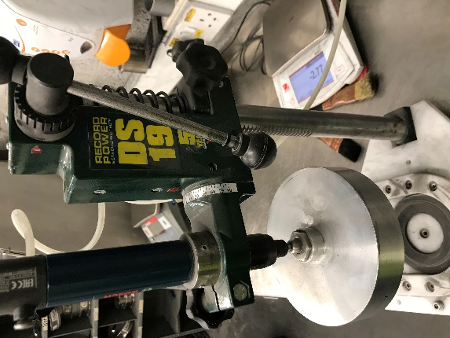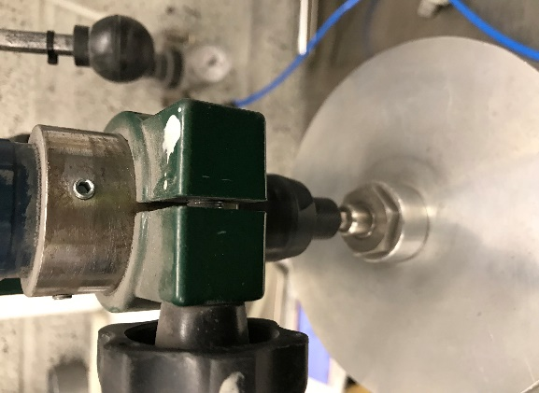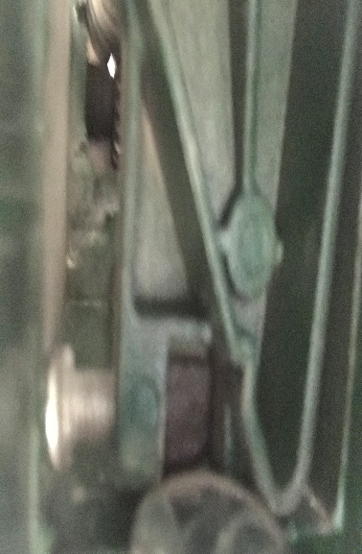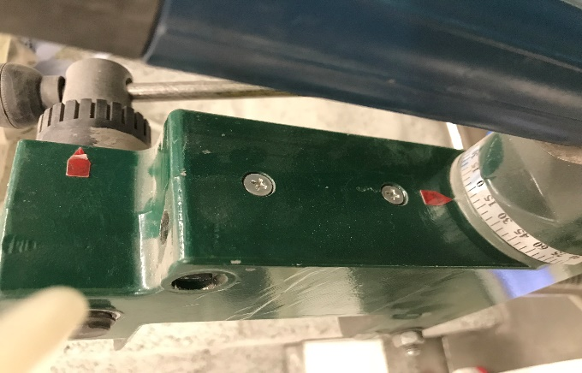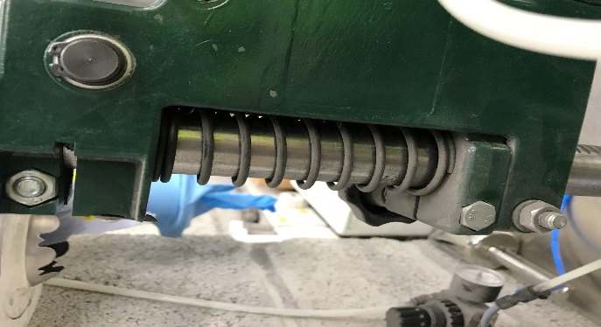
Fig 3.

Although this is made from a different material but a similar process of injection moulding the same functions could be used to consider in the new design when using a polymer material.

3.V Could a Structure be made from using the same mould?

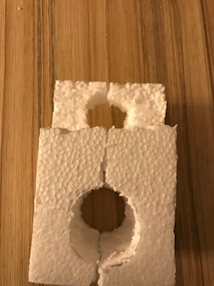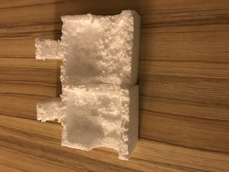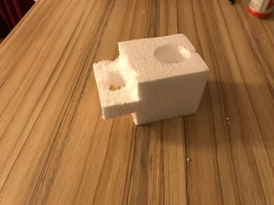
Fig 4.

These images of a polystyrene block are to show that if two parts that were made identical could both be used together to form a solid part. The problem however would be when joining the parts, the same way for polymer injection moulding the structure would lose strength because the functions in the mould would not mate up and would have to be joint in a different way which would end up not being fit for purpose when being made for a drill clamp part made of a polymer material, because it could break when force is being applied. If it was possible it could save cost of the mould tool because this is an expensive part in the process of injection moulding. “The material used for the part, the desired shape and features of the part, the material and design of the mould, and the properties of the moulding machine must all be taken into account. It is essential to consider the quantity of parts required and the life of the tooling. This is because injection tooling and presses are more complex, and therefore more expensive to set up and run, than other moulding techniques. Therefore, small batches of parts may not be cost-effective if manufactured by injection moulding.” (Martin's Rubber Company, 2018).

Conclusion

By looking at the findings the manufacturing process of Polymer Injection Moulding and CAD would be most suitable when wanting to produce a high production run of the DPMSU (quantity 500 units per week). There are so many benefits of using this process mainly being the cost all around, manufacturing versatility and the speed in which this process can achieve such a high number of mass production in a shorter space of time than other methods. A Plastic would also be an ideal choice over metal because it could still deliver the requirements if the correct implements and features are placed in the designs made when wanting to make a part that needs to be strong and sturdy because they still exhibit excellent properties that are needed. With the use of CAD, it also adds more accuracy, precision and better surface finishes in the final product.

Recommendations

To redesign the part again a suitable software programme called Solid works 2017-2018 because it would give the opportunity to do so by using the tools and features it has built in the system to make it possible for the new design of achieving a design assembly for Polymer Injection Moulding.

Looking at the original design of the part a method could be used by splitting it in half using the tools on the software and making the assembly in two parts. Changes would be made then to the shell of this design. Wall thicknesses would be altered so they are uniform and outer wall edges would be chamfered, the addition of suitable bosses and ribs would be added in the structure of the design to add strength.

Measurement of the original design would be taken to account for the other features of the Drill Press Assembly to make sure it could be still used on the same device but the “green part” made a different method of manufacturing. The cylinder boss on one of the original sides, the holes for the column and guide shaft would all stay in the same places.

The polymeric material used for the process would be (POM) because of the beneficial applicability it would show for the task for the function of a drill press assembly.

Reference List

Alexandris, A. (2005). Polyoxymethylene(POM), Acetal. [online] Wwwcourses.sens.buffalo.edu. Available at: http://wwwcourses.sens.buffalo.edu/ce435/POM_AE [Accessed 5 Jan. 2018].

Bayer (2000). Part and Mold Design. Pittsburgh: Bayer Corporation, pp.24-32.

Bayer (2000). Part and Mold design. Pittsburgh: Bayer Corporation, p.68.

Groover, M. (2007). Fundamentals Of Modern Manufacturing. 3rd ed. Lehigh University: John Wiley & Sons. Inc., p.10.

Martin's Rubber Company (2018). Advantages and disadvantages of injection moulding - Martin's Rubber Company. [online] Martin's Rubber Company. Available at: http://www.martins-rubber.co.uk/blog/advantages-and-disadvantages-of-injection-moulding/ [Accessed 5 Jan. 2018].

Phillips, R. (2017). Advantages of Plastic over Metal - Custom Plastics, Inc.. [online] Customplasticsinc.com. Available at: https://www.customplasticsinc.com/index.php/about-us/news/100-advantages-of-plastic-over-metal [Accessed 5 Jan. 2018].

Power Tools Experts (2015). drill press parts diagram and functions. [online] Available at: .” http://powertoolsexperts.com/drill-press-parts-diagram-and-their-functions/ [Accessed 4 Jan. 2018].

Rogers, T. (2016). Everything You Need To Know About Injection Molding. [online] Creativemechanisms.com. Available at: https://www.creativemechanisms.com/blog/everything-you-need-to-know-about-injection-molding [Accessed 4 Jan. 2018].

Skar Precision Moulding (2016). The advantages of plastic injection moulding. [online] Available at: http://www.skar.co.uk/advantages-plastic-injection-moulding/ [Accessed 3 Jan. 2018].

Skar Precision Moulding (2016). The advantages of plastic injection moulding. [online] Available at: http://www.skar.co.uk/advantages-plastic-injection-moulding/ [Accessed 3 Jan. 2018].

