Project Initiation Document (PID)
Ddraig Coch Enterprise

Background
The ‘Cark-E’ smart car key was proposed originally to improve safety on the roads around the world by preventing dangerous drivers, thieves and other unwanted people on the road using vehicles when not permitted by law. It would do this in several ways by trying to determine if the individual using the vehicle has access to it and all the legal requirements to drive on public roads. We envisioned a future where all cars come with the Cark-E provided as standard with all vehicles across the world, also potentially create availability for older vehicles to be migrated to the Cark-E system so current vehicles can still be used safely on the roads.

Aims
Main aims of the Cark-E are:
- Security
- Safety
- Convenience
The security of the vehicle would be improved with the use of Biometrics to enable the vehicle and prevent unauthorised/illegal use of the vehicle. Safety is improved as only permitted and legal drivers will have permission to enable the vehicle. Finally, it would be convenient as it would be easy to use.

Scope
Must Have | Should Have | Could Have | Wont Have
Biometrics  Bluetooth  App/Webpage  Database | LCD  GPS  Indicator of Operation  Charging | Medical Records  Security Features  Alcohol Content Reader  SoS Feature  Voice Recognition  Insurance Purposes  DVLA Connection  Police Accessibility  Wifi | Not Universal  No Data input features

Constraints
The first main constraint of the Cark-E is technological capabilities. With one of the goals being to prevent drunk drivers the key would need to be able to determine weather the user is intoxicated or not, there is no reliable way to carry out a test of this kind without taking blood. Until technology advances to the point that alcohol or substances in the body can be measured via fingerprint or sweat for example, this would not be possible. The amount of knowledge in specific areas, such as electrical engineering, will also be a constraint as there is no one on the team with a strong knowledge or background in this area or studying this stream.

Authority
The team that has been selected is responsible for the delivery of this product and using their knowledge to complete the assigned tasks. Although, some aspects of the project may need input from a third party with more specialised knowledge. Also, as with any new product, feedback from trial runs/testing periods will play a major roll in the development of this product.

Project Manager: Martin Dunn
Responsibilities:
Ensure all tasks are being completed on time and by the selected member of the team, reassign workloads where needed to ensure the most efficient working process has been applied.
Planning and organisation.
Identify strengths and weaknesses of team members to ensure tasks are being assigned correctly.

Project Team:
Martin Dunn – Software Engineer / Electronic Engineer / Marketing / Project Manager
Dan Algie- Web Development / Database Management / Marketing.
Ryan Morgan – Web Development / Database Management / Printing Engineer
Nathan Morgan- Software Engineer / Electronic Engineer / Marketing
Anthony Smith – Web Development / Database Management / Printing Engineer
The team can be reassigned at any point to meet the needs of the project and complete the workload that will need to be completed. Also if tasks are completed in less time then expected then members of the team can be reassigned to different areas to provide support in completing other tasks.

Stakeholder
There are many people who would be stakeholders of this project, including but not limited to the project team, James William and Sue Maw as they are teaching the module, The Dean of the School Of Applied Computing University Of Wales Trinity Saint David Swansea Campus as they are the main instigators of this project.
Resources
There are many different resources that will be needed to complete this project that will be listed below:
- Finance
- Components
- Lectures
- Research
- Programming Software
- Computers
- 3D Printer
- Arduino
These are the main resources that are needed to make this project possible. Financial support is coming from the University along with programming software, computers, Arduino, 3d printer and many components. Without these facilities provided this project would not be possible.

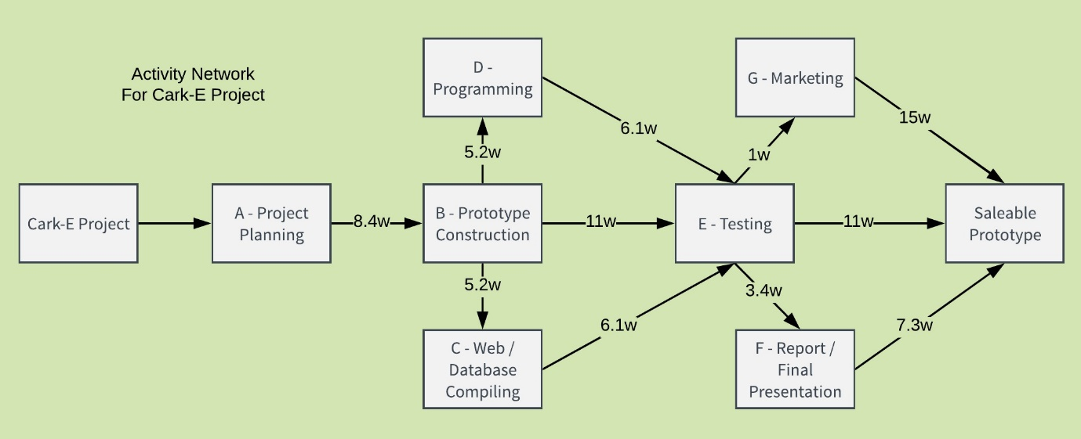
Appendix


