Table of Contents
1. Introduction
2. Project Concept and Business Case
2.1 Project Objectives
3. Evaluation of Project Management Approaches
3.1 Waterfall
3.2 Agile
3.3 PRINCE2 and PMBOK
3.4 Recommended Approach
4. Project Lifecycle and Initiation
5. Stakeholder and Environmental Analysis
6. Project Planning
6.1 Scope and Work Breakdown Structure
6.2 Scheduling and Critical Path
6.3 Resources and Budget
7. Communication and Responsibility
8. Risk, Data Protection and Health and Safety
9. Execution, Monitoring and Control
10. Project Closure and Benefits Realisation
11. Project Manager Attributes
12. Self-Audit and Personal Development Plan
13. Conclusion
References

1. Introduction
Maples Hair & Beauty Salon is an independent UK business employing approximately ten staff members. The salon has developed a loyal client base through personalised service, technical expertise and strong customer relationships. However, continued growth has exposed weaknesses in the way appointments and customer information are managed. Treatments sometimes exceed their allocated time, delaying later clients and increasing pressure on employees. Consultation information is not always recorded consistently, while customer records are divided between paper notes and digital systems.
These problems affect efficiency, customer experience and safety. An incomplete allergy or treatment record could put a client at risk, while repeated waiting may weaken trust even when the technical result is satisfactory. Employees may also waste time searching for colour formulas, previous treatment details and customer preferences.
This report proposes a six-month project to implement an integrated appointment-scheduling and customer relationship management (CRM) improvement. Booksy and supporting digital processes would be configured so that appointment durations, consultation records, reminders, follow-ups and management information operate as a coordinated system. Technology would support, rather than replace, the personal service that distinguishes Maples.
The report evaluates Waterfall, Agile, PRINCE2 and the Project Management Body of Knowledge (PMBOK) before recommending a tailored hybrid approach. It then examines initiation, stakeholder engagement, planning, scheduling, communication, risk, monitoring and closure. A final self-audit evaluates the skills required to manage the project successfully.
2. Project Concept and Business Case
A project is a temporary endeavour undertaken to create a unique product, service or result (Project Management Institute [PMI], 2021). The proposed CRM improvement meets this definition because it has a specific purpose, agreed scope, six-month duration and measurable deliverables. Following acceptance, responsibility for the system would transfer into routine salon operations.
The business case is based primarily on appointment overruns and fragmented customer information. Hair and beauty appointments can vary based on hair length, colour correction, consultation complexity, and unexpected client requirements. The existing booking process does not always translate these differences into realistic durations. One delay can affect the rest of the day, creating customer wait times and employee stress.
Fragmented records create a connected problem. Employees may need to repeat questions or search different systems for allergies, previous colours and treatment preferences. This reduces efficiency and may affect consistency and safety. The proposed solution is therefore more than purchasing software. It combines technology, data, staff training and redesigned working practices.
The principal project deliverables are:
A configured appointment-scheduling and CRM platform
Cleansed and centralised customer records
Standardised digital consultation forms
Realistic appointment durations
Automated reminders and follow-ups
Management reporting and performance measures
Staff training and competency assessment
Pilot testing, go-live and post-implementation review
Salon refurbishment, premises expansion and staff recruitment are excluded. Defining these boundaries reduces scope creep and keeps resources focused on the agreed problem (Kerzner, 2022).
2.1 Project Objectives
The project is intended to generate direct and indirect value. Direct benefits include fewer missed appointments, more repeat bookings and reduced administrative time. Indirect benefits include stronger confidence in records, lower employee pressure and a more consistent customer experience. Continued business justification should therefore be reviewed throughout delivery rather than considered only at approval (AXELOS, 2023).
Table 1
SMART objectives for the Maples CRM improvement project
Objective | Target
Reduce appointment overruns | 30% reduction within three months of go-live
Reduce customer waiting | 25% reduction within three months
Standardise customer records | 100% digital consultation completion for relevant treatments
Develop staff competence | 100% trained and assessed before full launch
Strengthen customer retention | 15% increase in repeat bookings within six months
Protect customer satisfaction | Maintain a minimum average rating of 4.8 out of 5

3. Evaluation of Project Management Approaches
The project methodology should fit the organisation rather than become an administrative burden. Maples requires sufficient structure to protect customer data and control costs, but excessive documentation would be unsuitable for a ten-person salon. The selected approach must also recognise that staff will learn more about their needs during testing.
3.1 Waterfall
Waterfall follows a sequential process in which requirements are established before configuration, testing, training and implementation. Royce (1970) demonstrated the logic of staged development but also recognised the risk of relying on a simple one-directional process.
Waterfall is relevant because many CRM activities have clear dependencies. The system must be configured before final testing, migrated records must be checked before go-live, and employees should be trained on a stable version. Its defined stages support budget control, accountability and quality reviews.
Its limitation is inflexibility. Requirements agreed at initiation may prove impractical in daily salon use. For example, a consultation form could appear suitable during planning but take too long to complete between appointments. Applying Waterfall without opportunities for feedback could therefore produce a technically complete system that employees find difficult to use.
3.2 Agile
Agile prioritises customer collaboration, working solutions and responsiveness to change (Beck et al., 2001). Short iterations would allow Maples employees to test consultation questions, appointment durations and reminder wording before providing feedback. Scrum similarly promotes regular inspection and adaptation (Schwaber & Sutherland, 2020).
This flexibility is useful because salon employees have practical knowledge that a software supplier may not. An experienced stylist may identify that balayage requires different timing according to hair length, while a beauty therapist may recognise that some treatments need more detailed consultation records.
However, a completely Agile approach could make costs and completion dates less predictable. Frequent meetings may also be difficult during busy trading periods. Data migration, privacy controls and final acceptance require structured approval rather than continuous informal change. Agile is therefore useful for testing and refinement but would not provide sufficient governance on its own.
3.3 PRINCE2 and PMBOK
PRINCE2 provides principles and processes that support continued business justification, defined responsibilities, and management by stages (AXELOS, 2023). Its governance and approval arrangements are valuable, but applying the entire method would create disproportionate paperwork. It must therefore be tailored.
PMBOK is a body of knowledge rather than a single delivery methodology. It provides adaptable guidance on stakeholder engagement, planning, delivery, uncertainty and measurement (PMI, 2021). Its breadth is valuable, although the project manager must select practices appropriate to the project.
Table 2
Comparison of project management approaches
Approach | Main Value | Limitation | Proposed Use
Waterfall | Clear stages and dependencies | Difficult to accommodate late changes | Overall project sequence
Agile | Rapid feedback and learning | Lower predictability if used alone | Configuration and pilot testing
PRINCE2 | Governance and business justification | Potentially excessive documentation | Roles, approval gates and closure
PMBOK | Adaptable management practices | Does not prescribe one process | Stakeholder, risk and control tools
3.4 Recommended Approach
A tailored hybrid approach is recommended. Waterfall would provide the overall six-month structure; PRINCE2 would support accountability and continued justification; PMBOK would provide planning, stakeholder, risk and monitoring practices; and Agile feedback would be used during configuration and pilot testing.
This approach combines control with flexibility. However, it should remain proportionate. A concise project charter, practical registers and short weekly meetings would be more beneficial than extensive documentation created only to demonstrate compliance.

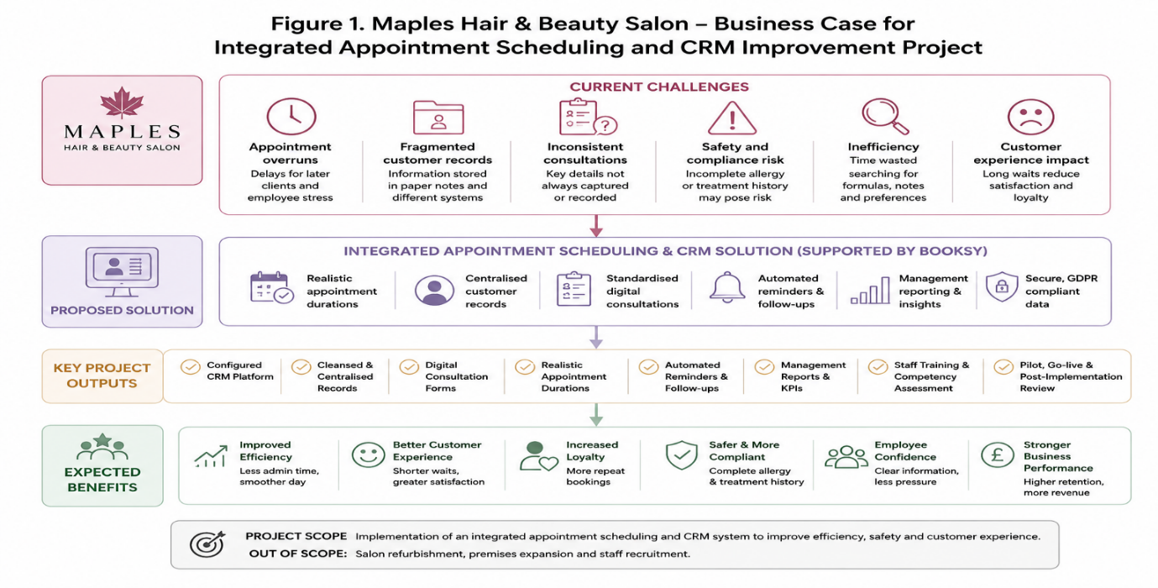
Note. Created by the author and adapted from AXELOS (2023), PMI (2021), and Schwaber and Sutherland (2020)
.

4. Project Lifecycle and Initiation
The project lifecycle provides a structured route from a recognised business need to an accepted operational improvement. Initiation confirms the business case, objectives, stakeholders and authority. Planning establishes scope, schedule, budget and responsibilities. Execution includes configuration, migration, training and pilot testing. Monitoring and control compare actual performance with the approved plan, while closure confirms acceptance and operational handover (Westland, 2021).
Although the lifecycle is often displayed sequentially, monitoring and control occur throughout planning and execution, not only near the end.

Note. 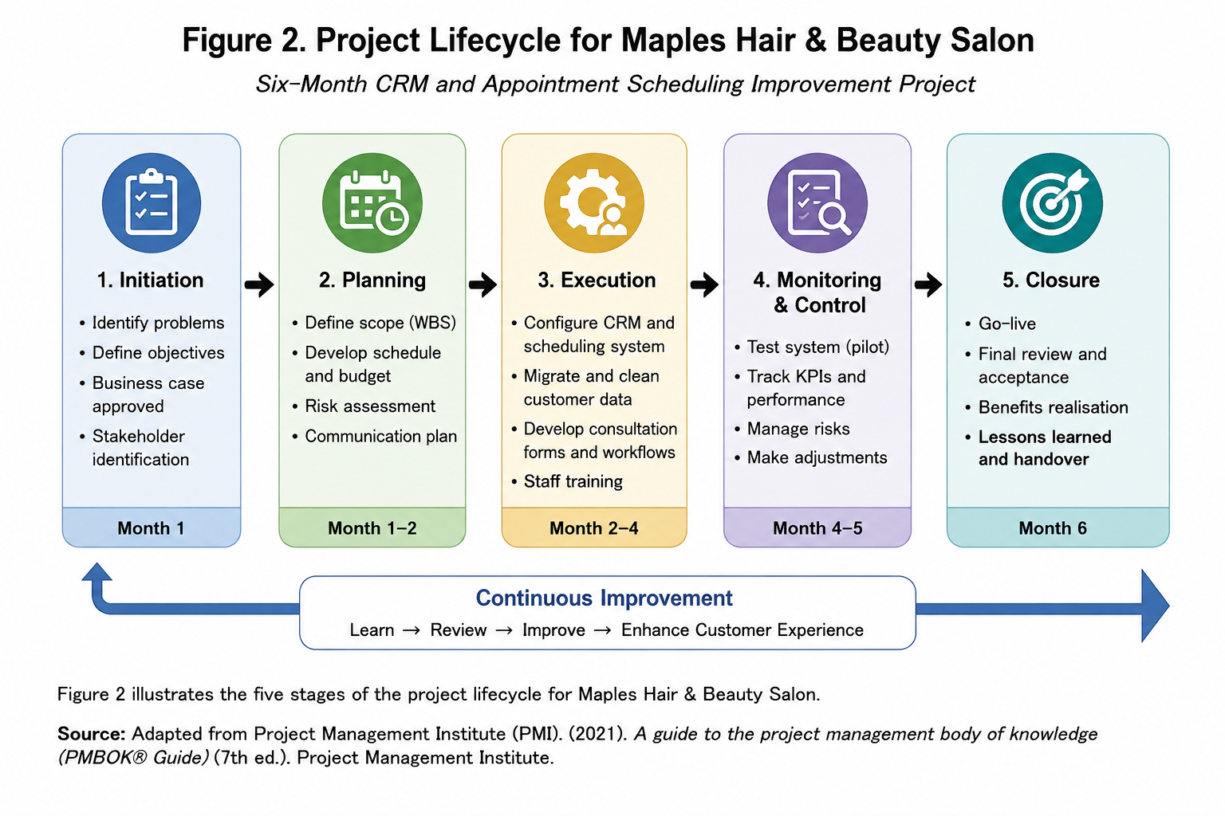
Created by the author and adapted from PMI (2021) and Westland (2021).
During initiation, the salon owner acts as project sponsor and approves the project charter. The charter should define the problem, scope, project manager’s authority, expected duration, budget tolerance and success criteria.
Approval should depend on baseline information concerning appointment overruns, waiting times, consultation completion and repeat bookings. Without baseline data, Maples would be unable to demonstrate whether performance had improved.
5. Stakeholder and Environmental Analysis
Stakeholder theory recognises that sustainable value depends on considering all groups affected by organisational decisions (Freeman, 1984). The salon owner has high power and interest because she approves expenditure and accepts the completed system. Employees have less formal power but considerable practical influence. If they find the system disruptive or time-consuming, adoption will fail.
Clients have limited direct authority but collectively affect reputation and retention. The software supplier has technical influence, while regulatory organisations shape data-protection expectations.
Staff should be involved in requirements discussions, form design, testing and lessons learned. Clients should receive clear communication if booking or privacy arrangements change. The supplier should receive documented requirements and acceptance criteria. Staff resistance should not automatically be viewed negatively because it may reveal legitimate concerns. Kotter (1996) similarly emphasises explaining the need for change and enabling participation.

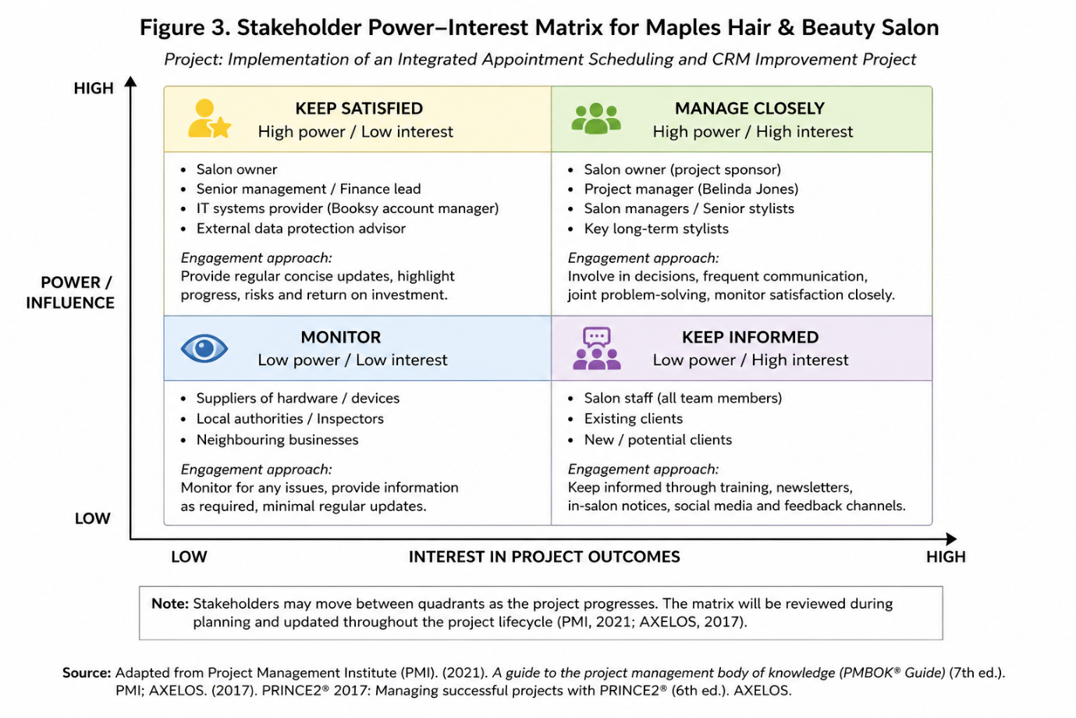
Note. Created by the author and adapted from Freeman (1984) and PMI (2021).
A PESTLE analysis provides additional context. Legally, Maples must comply with data protection and health and safety requirements. Economically, Maples must control subscription and training costs. Socially, clients expect convenience without losing personal contact. Technologically, cloud systems increase access but create dependence on connectivity and supplier security. Digital records may reduce paper use but still create energy and equipment impacts.
SWOT analysis can become a superficial list if factors are not connected to actions (Hill & Westbrook, 1997). Every identified issue should therefore influence a project decision, risk or control.

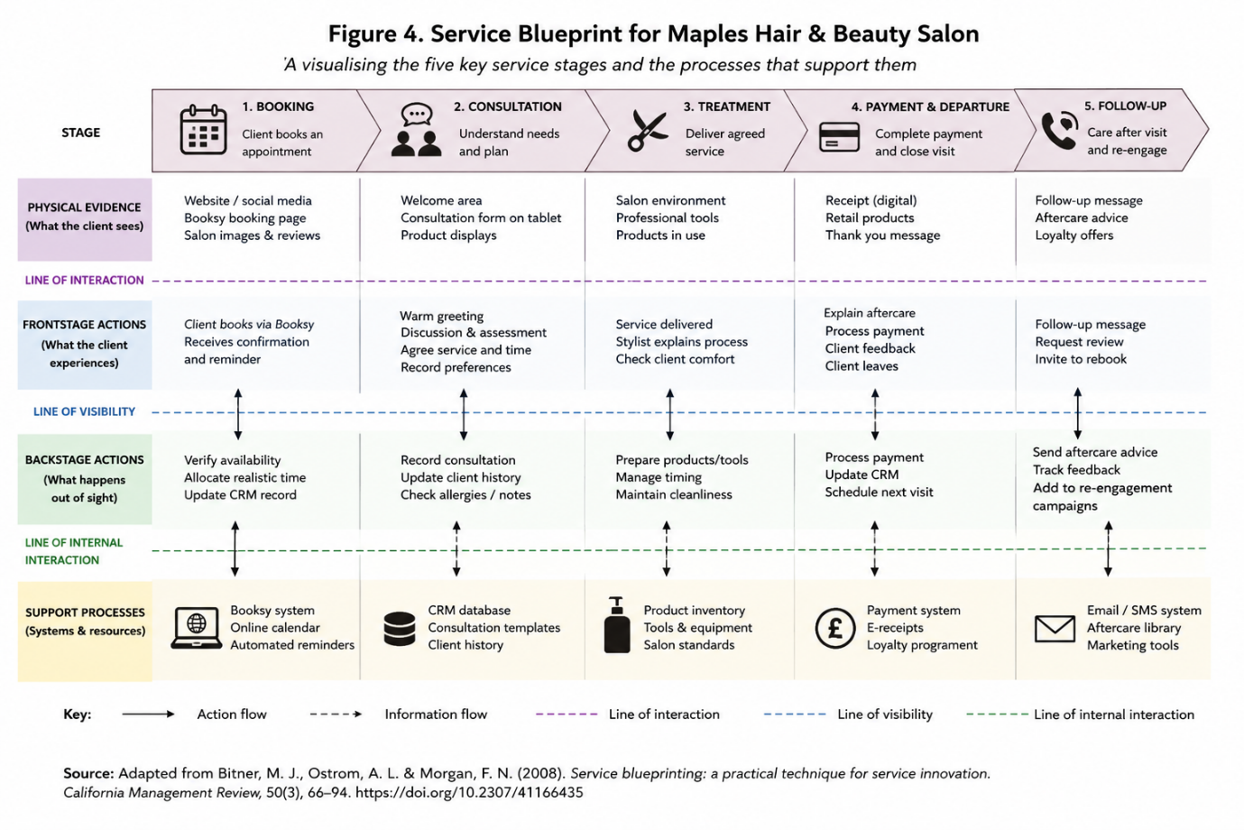
Note. Created by the author and adapted from Hill and Westbrook (1997) and Johnson et al. (2020).

6. Project Planning
Planning converts the approved idea into controlled activities. It reduces uncertainty but does not eliminate it, meaning plans should be reviewed when evidence changes (Maylor, 2019). Maples must also protect normal salon operations by staggering training and avoiding high-risk changes during peak periods.

6.1 Scope and Work Breakdown Structure
The project scope includes platform configuration, data cleansing, migration, consultation forms, appointment-duration rules, reminders, reporting, training, testing, pilot implementation and evaluation. Recruitment, refurbishment and unrelated marketing are excluded.
A Work Breakdown Structure (WBS) divides the deliverables into manageable work packages, supporting estimation, ownership and monitoring (Meredith et al., 2022). It should be based on deliverables rather than functioning as an informal task list.
Although the WBS improves clarity by decomposing the CRM project into manageable deliverables, its usefulness depends on the accuracy of the original scope. For Maples, an overly detailed WBS could create unnecessary administration, whereas insufficient detail could hide dependencies. Its value therefore lies in proportionate application rather than complexity.

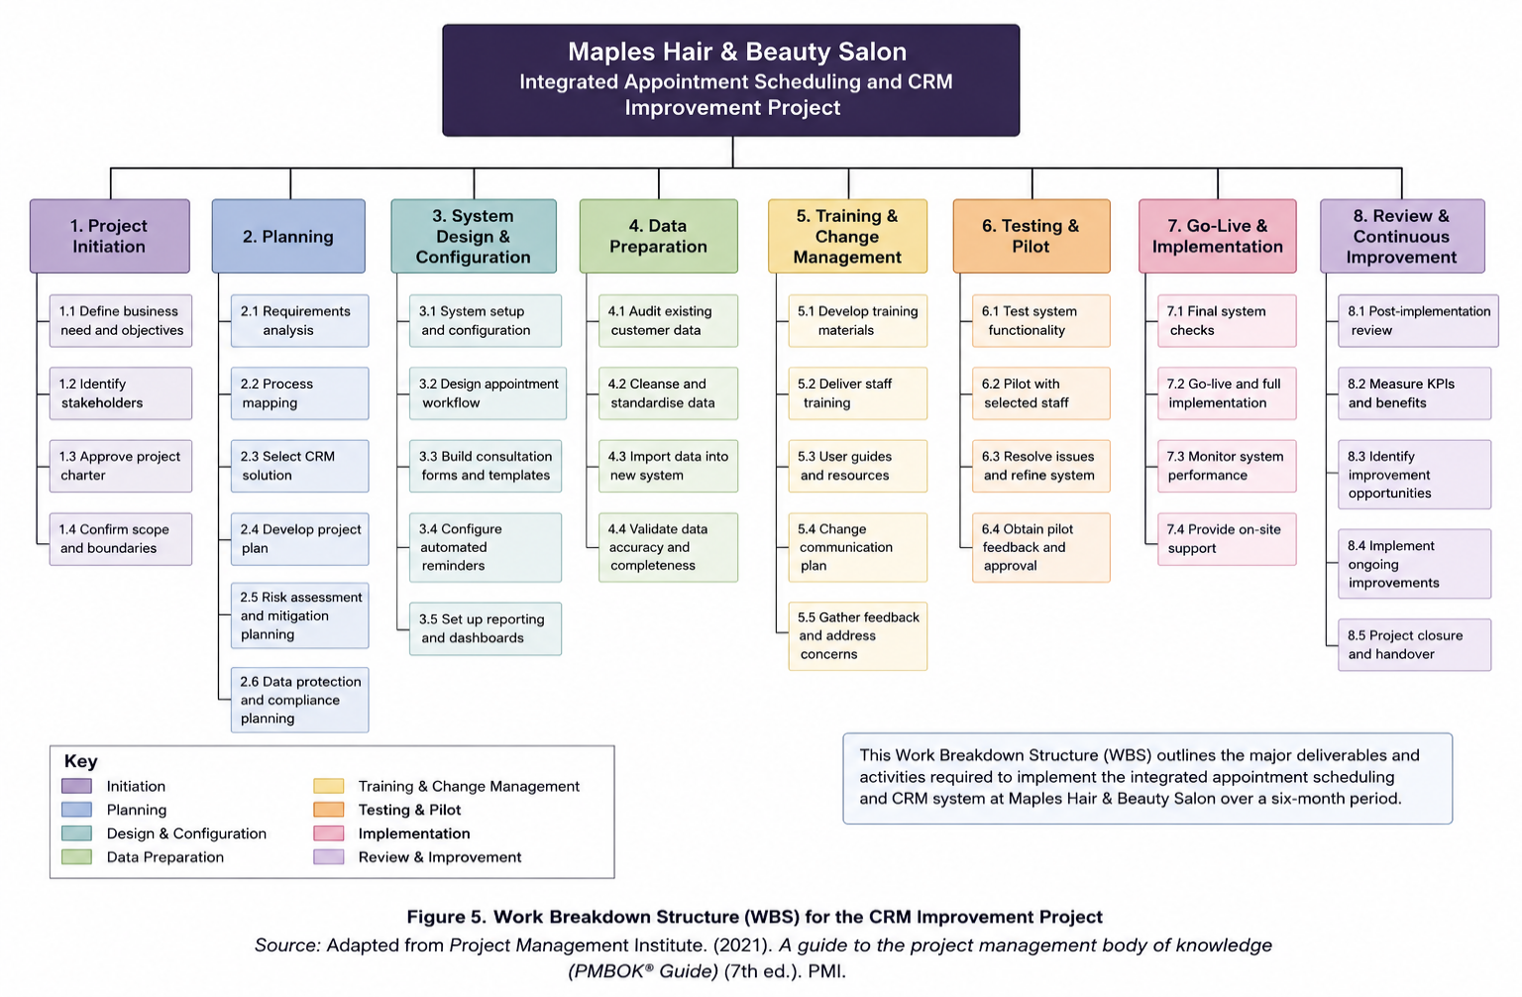
Work Breakdown Structure for the Maples CRM Project
Note. Created by the author and adapted from Meredith et al. (2022) and PMI (2021).
6.2 Scheduling and Critical Path
The proposed duration is six months:
Month 1: Approval, requirements and supplier confirmation
Months 2–3: Configuration, data preparation and form development
Month 4: System testing and staff training
Month 5: Pilot implementation
Month 6: Full deployment, evaluation and closure
Dependencies must be explicit. Employees should train on a stable configuration, customer records must be verified before go-live, and full deployment depends on pilot acceptance.
The Gantt chart provides Maples with a clear visual representation of activities, dependencies and deadlines, making it particularly useful for coordinating training with normal salon operations. However, it may imply greater scheduling certainty than actually exists. Supplier delays, staff absence, or changing salon demand mean the schedule must be reviewed regularly rather than treated as fixed.

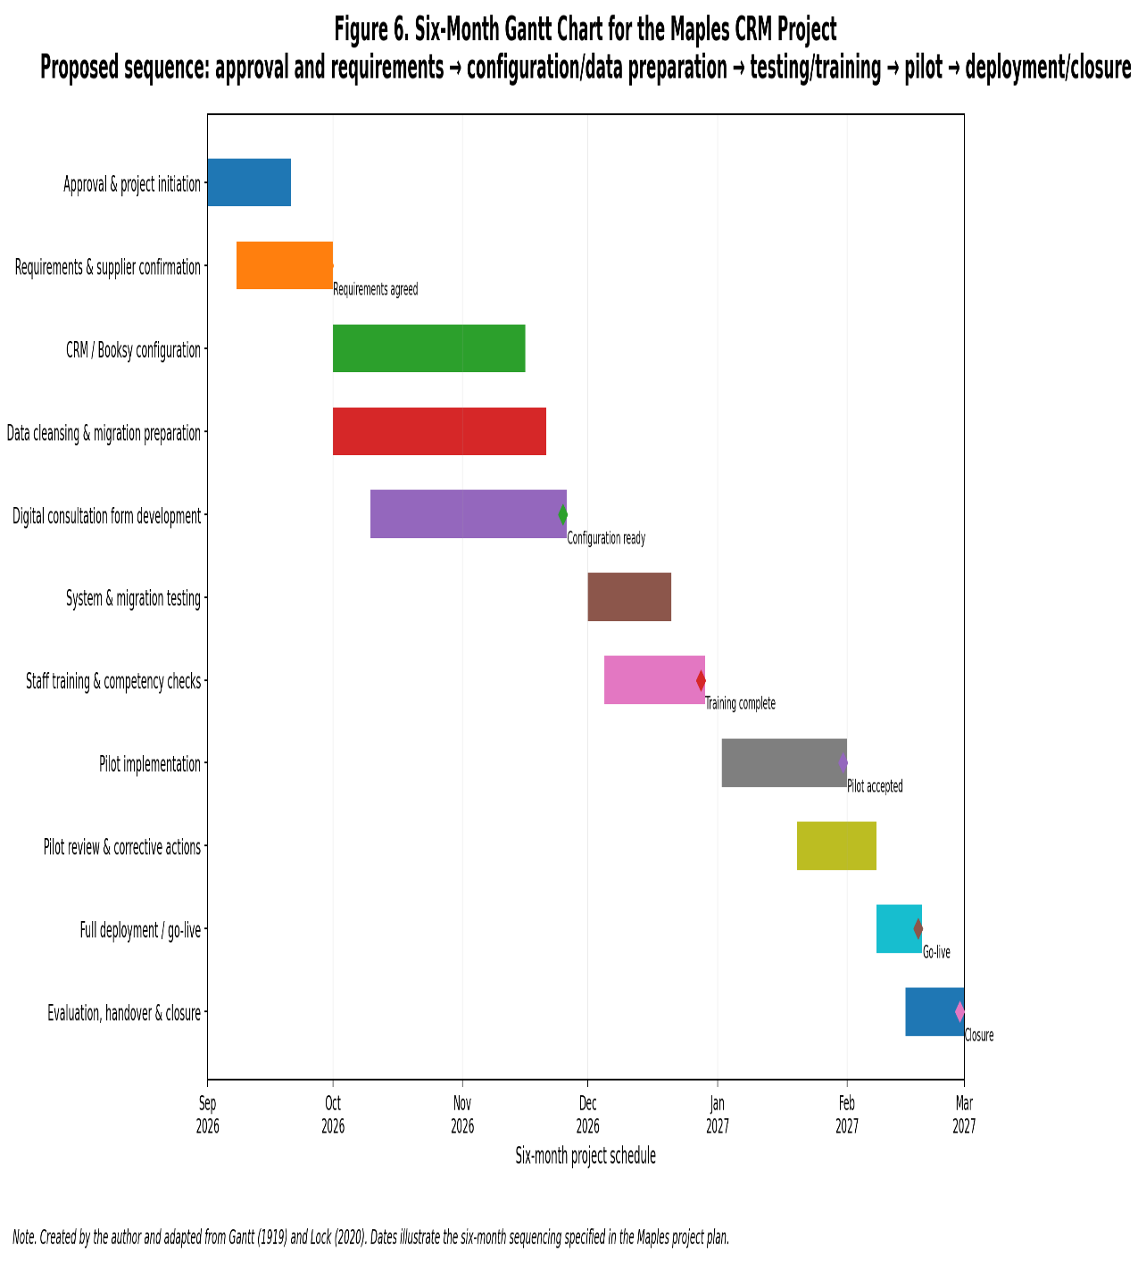
Note. Created by the author and adapted from Gantt (1919) and Lock (2020).
Critical Path Analysis identifies the longest sequence of dependent activities and therefore the earliest possible completion date (Lock, 2020). The likely critical sequence is approval, requirements, configuration, migration, testing, pilot acceptance and go-live. A delay to any of these activities would threaten completion unless time could be recovered elsewhere.
Critical Path Analysis strengthens scheduling by identifying activities where delay would directly affect completion. However, its accuracy depends on reliable duration estimates. This is a limitation for Maples because staff availability and operational pressures can vary. CPA should therefore support managerial judgement rather than replace it.

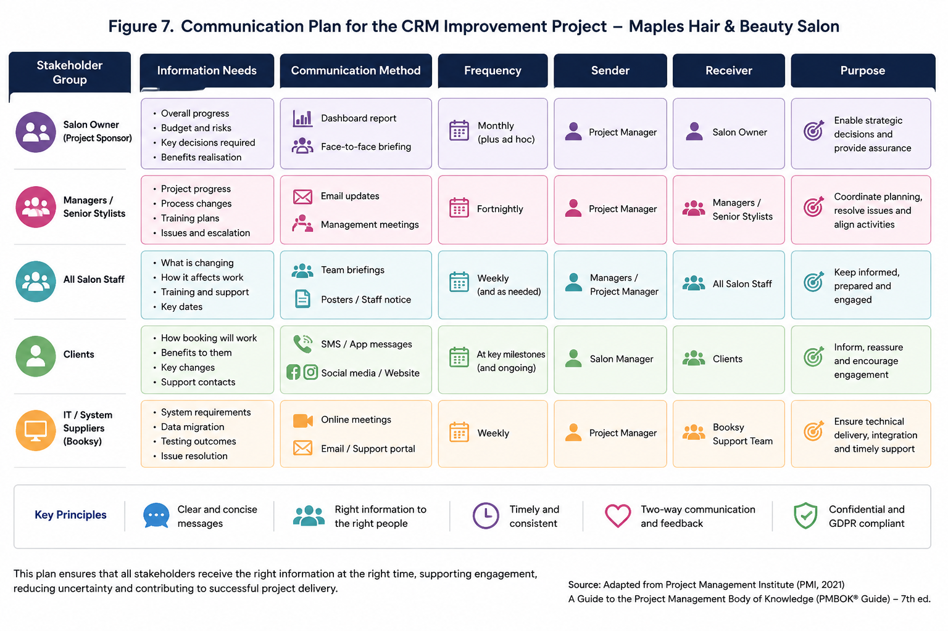
Note. Created by the author and adapted from Lock (2020) and PMI (2021).
6.3 Resources and Budget
Human resources include the sponsor, project manager, salon employees and software supplier. Financial costs include licences, configuration, training time, hardware, temporary productivity reductions and contingency.
A 10% contingency may be appropriate, but it cannot replace accurate cost estimation. Expected benefits include reduced administration, fewer missed appointments, improved use of capacity and stronger retention. Benefits must not be counted twice; increased repeat booking and increased revenue may reflect the same underlying improvement.
Table 3
Indicative Project Costs
Cost Category | Estimation Basis | Control
Software licences | Supplier quotation and user numbers | Sponsor approval
Configuration and migration | Fixed quotation or agreed hours | Acceptance criteria
Staff training | Training hours and employee cost | Staggered attendance
Hardware and connectivity | Gap assessment | Essential purchases only
Contingency | 10% of approved baseline | Sponsor authorisation
7. Communication and Responsibility
Communication should enable dialogue rather than simply distribute information. Stakeholders require different information and levels of detail (PMI, 2021). The salon owner needs concise information on progress, costs, risks and decisions. Employees need practical guidance and opportunities to raise concerns. Clients require relevant information where booking or privacy arrangements change.
Table 4
Communication Plan
Audience | Information | Method | Frequency
Sponsor | Progress, expenditure and risks | Review meeting and dashboard | Weekly
Salon staff | Changes, training and feedback | Team briefing | Fortnightly
Supplier | Requirements and defects | Implementation meeting | Weekly during configuration
Clients | Booking changes and benefits | Email, SMS or social media | Before pilot and go-live
Project team | Actions and dependencies | Short project meeting | Weekly
A RACI matrix will define who is Responsible, Accountable, Consulted and Informed. Each major activity should have one accountable owner. Assigning responsibility without sufficient time or authority would create only apparent accountability.
RACI provides useful role clarity, particularly where the salon owner, employees and supplier share responsibility. Its limitation is that formal allocation does not guarantee engagement or competence. At Maples, responsibility must therefore be supported by communication, adequate time and appropriate authority.

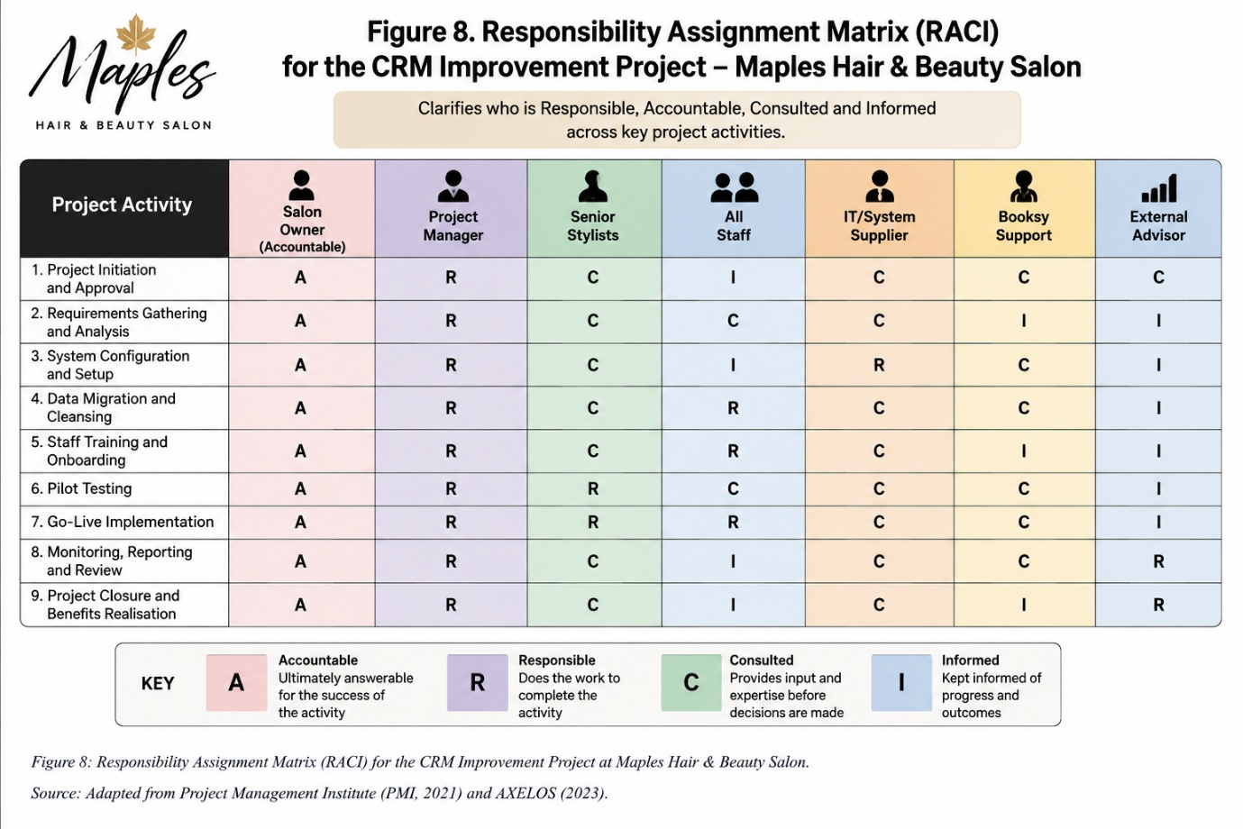
Note. Created by the author and adapted from PMI (2021).

8. Risk, Data Protection and Health and Safety
Risk is uncertainty that may affect objectives positively or negatively (International Organisation for Standardisation [ISO], 2018; PMI, 2021). Risks should have named owners, consistent scores and regular review. Significant threats include data-migration errors, resistance, disruption, cybersecurity incidents, supplier delays and cost escalation. Opportunities should also be recognised, including improved customer segmentation and more realistic service durations.
Customer records may contain contact information, colour formulas, allergies, contraindications and treatment histories. Under the UK GDPR, this information must be processed lawfully, fairly, transparently and securely (Data Protection Act 2018; Information Commissioner’s Office, 2024).
Maples should:
Identify and document its lawful basis
Provide an updated privacy notice
Restrict access according to job roles
Use secure passwords and multi-factor authentication
Maintain backups
Test migrated records
Review supplier data-processing terms
Using a software supplier does not transfer accountability away from Maples.
Health and safety also require attention. Training should consider screen position, seating, breaks and accessibility. Equipment must be installed safely, cables must not create hazards, and manual handling must be appropriate. These controls support the Health and Safety at Work etc. Act 1974 and display-screen guidance (Health & Safety Executive, 2024). Accurate allergy and contraindication records also contribute directly to client safety.
Table 5
Priority Risk Register
Risk | Likelihood | Impact | Response
Staff resistance | 3 | 4 | Co-design, training and pilot feedback
Inaccurate migration | 3 | 5 | Backup, staged transfer and testing
Data breach | 2 | 5 | Multi-factor authentication and controlled access
Appointment disruption | 3 | 4 | Staggered training during quieter periods
Supplier delay | 3 | 4 | Milestones and contingency dates
Cost overrun | 2 | 4 | Change control and sponsor approval

The risk matrix enables Maples to prioritise threats using a simple and accessible scoring system. However, likelihood and impact scores remain partly subjective and may create false precision. Regular review and discussion are therefore more important than the numerical score alone.
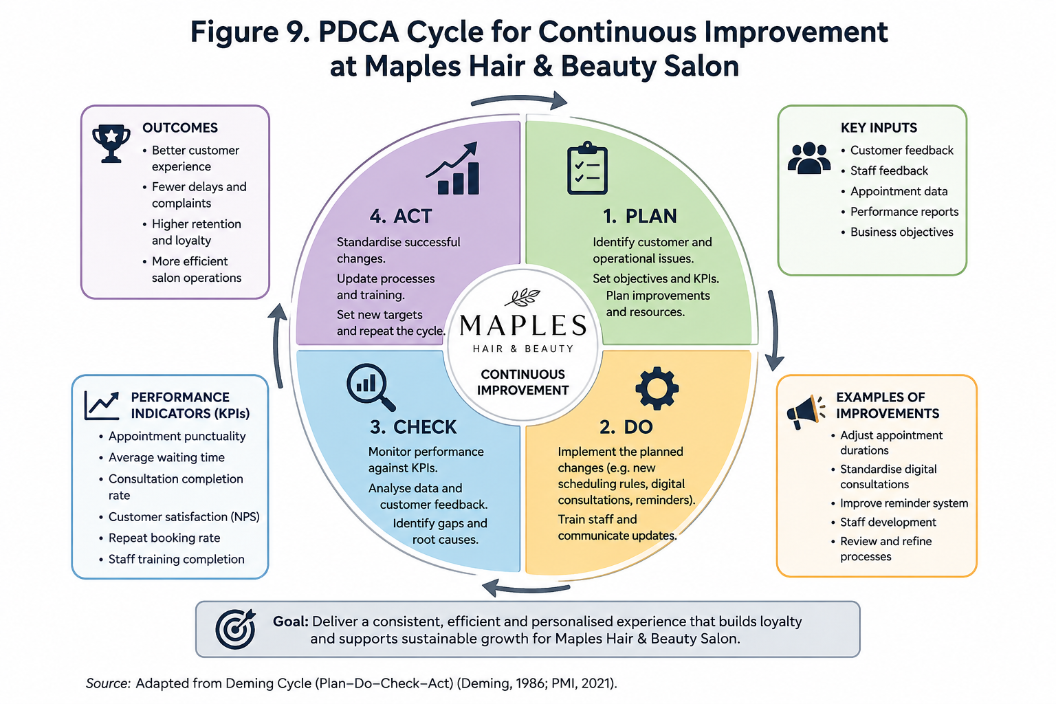
Note: Created by the author and adapted from ISO (2018) and PMI (2021).
9. Execution, Monitoring and Control
Execution includes system configuration, data cleansing, form development, testing and training. A small group of employees should test representative hair and beauty services before the pilot.
User Acceptance Testing should confirm that:
Customer records are accurate
Appointment durations reflect practice
User permissions are appropriate
Safety information is visible
The process does not undermine the client conversation
Monitoring compares actual performance with the approved baseline. Schedule performance, expenditure, open defects, training completion and migration accuracy measure delivery. Appointment overruns, waiting time, consultation completion, customer satisfaction and repeat booking measure benefits. Delivering the system on time would not constitute success if the original problems continued.
Table 6
Monitoring and Benefits Dashboard
Measure | Target | Frequency
Milestones completed on time | At least 90% | Weekly
Migration accuracy | At least 99% verified | Each migration test
Staff training | 100% before go-live | Weekly
Appointment overruns | 30% reduction | Monthly
Waiting time | 25% reduction | Monthly
Consultation completion | 100% where required | Weekly, then monthly
Repeat booking | 15% improvement | Monthly
Customer rating | At least 4.8 out of 5 | Monthly
The project manager could approve minor configuration changes within scope. Changes affecting cost, completion date, compliance or major deliverables require sponsor approval.
Quality can be managed through Plan-Do-Check-Act: plan the improvement, test it, evaluate evidence and then standardise or revise it (Deming, 1986). Juran (1988) similarly distinguishes between quality planning, control and improvement.

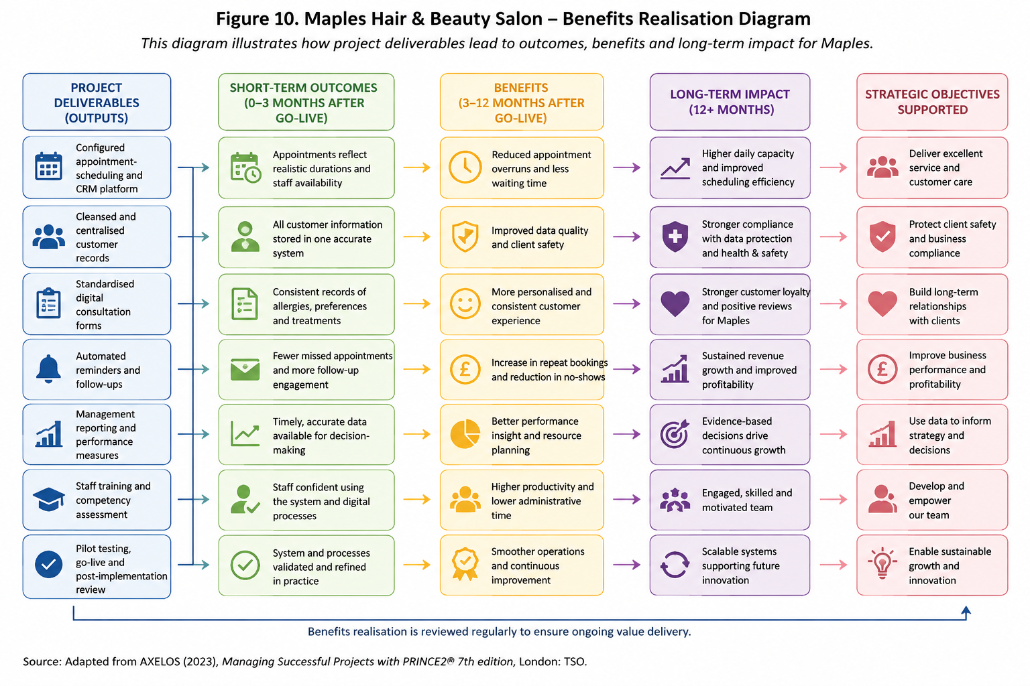
Note. Created by the author and adapted from Deming (1986).
10. Project Closure and Benefits Realisation
Closure should occur only when deliverables satisfy the acceptance criteria and the operational team is ready to assume responsibility. Activities include final acceptance, financial reconciliation, documentation, access review, lessons learned, stakeholder feedback and handover.
Closing too early may leave unresolved defects, while leaving the project open indefinitely weakens accountability. The sponsor should approve a closure report recording delivered outcomes, approved exceptions and outstanding actions.
Benefits may emerge after the project team has disbanded. The salon owner should therefore review performance after one, three and six months. If waiting time improves but satisfaction does not, Maples should investigate consultation and communication rather than automatically blaming the system. If repeat bookings increase but workloads become unsustainable, capacity and appointment durations should be reconsidered.
Lessons learned should record both positive and uncomfortable evidence so future projects benefit from experience (Turner, 2022).

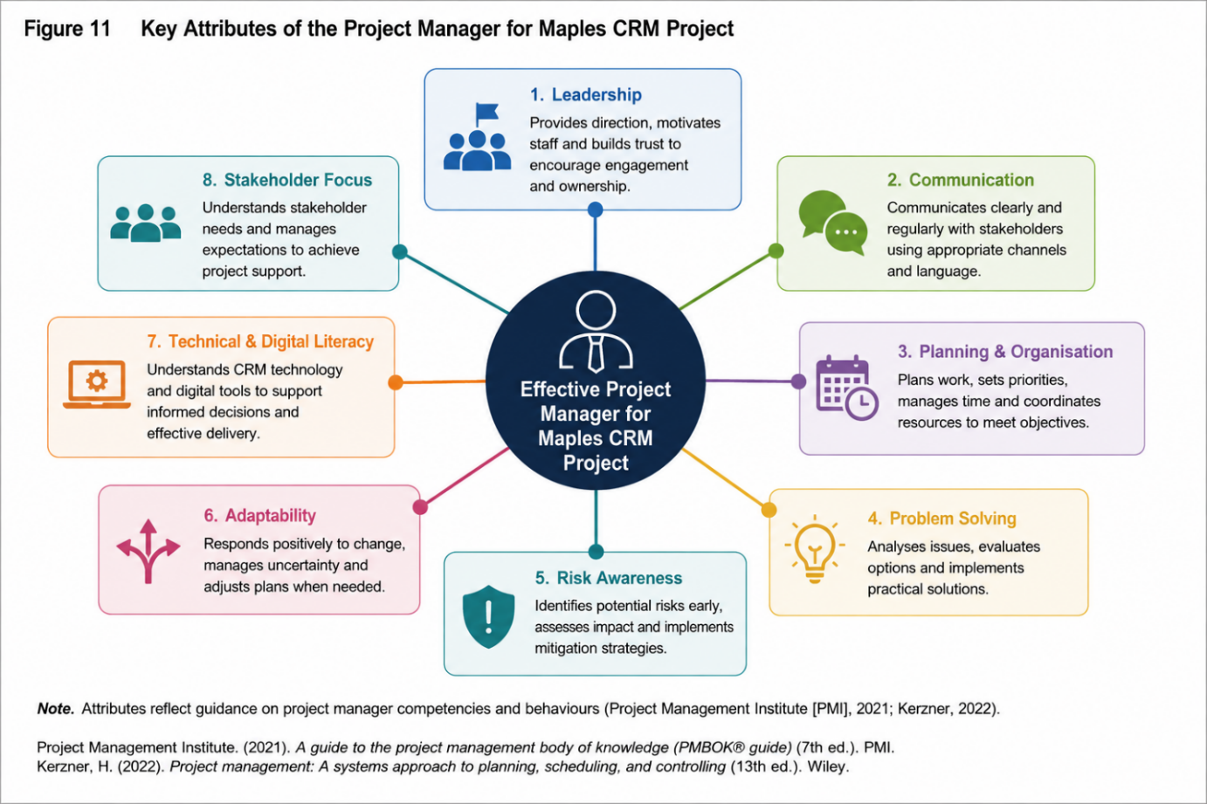
Note. Created by the author and adapted from PMI (2021) and Turner (2022).
11. Project Manager Attributes
The project manager requires technical knowledge and interpersonal capability. Emotional intelligence supports empathy, self-awareness and constructive responses to resistance (Goleman, 1998). Clear communication is necessary when translating between technical suppliers and salon employees. Ethical judgement is also required because customer and employee information must be handled appropriately.
Planning, decision-making and problem-solving help the manager distinguish between urgent defects and desirable improvements, protect the critical path and escalate decisions when tolerances are threatened.
Belbin (2010) highlights the value of complementary team contributions. Detail-focused employees may assist with data testing, confident communicators may support training, and experienced stylists may define realistic service durations. Tuckman (1965) also suggests that early disagreement is not necessarily a sign of project failure; if managed properly, it can improve decisions.
For Maples, credibility will depend on combining project discipline with salon knowledge. A plan that ignores peak demand or colour-processing requirements will lose staff confidence. However, relying only on experience may leave risks and decisions undocumented.
12. Self-Audit and Personal Development Plan
My salon experience gives me a strong understanding of customer expectations, appointment pressures, and personalised service. I am organised, attentive to detail and confident communicating with clients and colleagues. These strengths would help me identify practical issues a technical supplier might overlook.
However, familiarity may also create assumptions. I must test my judgement against evidence and actively seek staff perspectives. My principal development areas are formal scheduling, financial forecasting, digital risk and delegation. Although I understand project principles, I require more experience with network diagrams, variance analysis and technical supplier discussions.
I can become personally involved when quality is important, which may cause me to retain tasks that should be delegated. Reflective practice should therefore produce observable behavioural change rather than a general intention to improve (Schön, 1983).
Overall, my operational knowledge of the salon would be an advantage because I understand customer expectations, treatment timings and staff pressures. However, this familiarity could also create overconfidence and confirmation bias, particularly if I assume employees share my interpretation of a problem. Effective project management would therefore require me to separate my roles as salon practitioner and project manager, use evidence when making decisions and actively invite challenge from other stakeholders.
Table 7
Personal Development Plan
Objective | Action | Measure | Timescale
Strengthen project knowledge | Complete recognised project-management training | Qualification or certificate completed | Six months
Improve scheduling | Produce two practice Gantt and CPA schedules | Dependencies and critical path verified | Three months
Develop digital-risk knowledge | Complete GDPR and cybersecurity training | Due-diligence checklist used | Four months
Improve delegation | Apply RACI and review outcomes | Reduced unnecessary reassignment | Quarterly
Build reflective leadership | Maintain a learning log and seek feedback | Six documented reflections | Six months
13. Conclusion
The proposed project provides Maples Hair & Beauty Salon with a practical way to improve appointment reliability, customer records and follow-up communication without sacrificing personalised service. The analysis demonstrates that technology alone will not solve the problem. Benefits depend on accurate data, realistic appointment durations, staff participation and appropriate training.
A tailored hybrid approach is recommended. Waterfall provides the six-month sequence, PRINCE2 supports governance, PMBOK contributes adaptable management practices, and Agile feedback supports learning during testing.
The WBS, Gantt chart, critical path, communication plan, RACI matrix, risk register and performance dashboard each support different decisions. Their value is in improving accountability and control rather than producing unnecessary paperwork.
Overall, the analysis demonstrates that no individual project-management tool is sufficient in isolation; effectiveness depends on selecting and tailoring complementary techniques to Maples' scale, risk, and organisational context.
Success should be judged both by delivery of an accepted system and by whether that system reduces overruns, waiting and fragmented records while improving customer relationships. Formal closure, post-implementation reviews and continued PDCA cycles will help Maples maintain progress. With proportionate governance and empathetic leadership, the project can strengthen operational performance and support sustainable salon growth.

References
AXELOS (2023) Managing successful projects with PRINCE2®. 7th edn. London: The Stationery Office.
Beck, K., Beedle, M., van Bennekum, A., Cockburn, A., Cunningham, W., Fowler, M., Grenning, J., Highsmith, J., Hunt, A., Jeffries, R., Kern, J., Marick, B., Martin, R. C., Mellor, S., Schwaber, K., Sutherland, J., & Thomas, D (2001). Manifesto for Agile software development. Agile Alliance.
Belbin, R.M. (2010). Team roles at work. 2nd edn. London: Routledge.
Chapman, C., & Ward, S. (2011). How to manage project opportunity and risk (3rd ed.). Wiley.
Data Protection Act 2018, c. 12 (UK).
Deming, W.E. (1986). Out of the crisis. Cambridge, MA: MIT Press.
Freeman, R.E. (1984). Strategic management: A stakeholder approach. Boston, MA: Pitman.
Gantt, H. L (1919). Organising for work. Harcourt, Brace and Howe.
Goleman, D. (1998). Working with emotional intelligence. New York: Bantam Books.
Health and Safety at Work etc. Act 1974, c. 37 (UK).
Health and Safety Executive (2024) Working safely with display screen equipment.
Hill, T., & Westbrook, R (1997). SWOT analysis: It is time for a product recall. Long Range Planning, 30(1), 46–52. https://doi.org/10.1016/S0024-6301(96)00095-7
Information Commissioner’s Office (2024) A guide to the UK GDPR.
International Organisation for Standardisation (2018) ISO 31000:2018 risk management—Guidelines.
Johnson, G., Whittington, R., Scholes, K., Angwin, D., & Regnér, P (2020). Exploring strategy (12th ed.). Pearson.
Juran, J.M. (1988). Juran on planning for quality. New York: Free Press.
Kerzner, H (2022). Project management: A systems approach to planning, scheduling, and controlling (13th ed.). Wiley.
Kotter, J.P. (1996). Leading change. Boston, MA: Harvard Business School Press.
Lock, D. (2020). Project management (11th ed.). Routledge.
Maylor, H. (2019). Project management (5th ed.). Pearson.
Meredith, J. R., Shafer, S. M., & Mantel, S. J., Jr (2022). Project management: A managerial approach (10th ed.). Wiley.
Project Management Institute (2021). A guide to the project management body of knowledge (PMBOK® guide) (7th ed.) and the standard for project management.
Royce, W. W (1970). Managing the development of large software systems. Proceedings of IEEE WESCON, 26, 1–9.
Schön, D.A. (1983). The reflective practitioner. New York: Basic Books.
Schwaber, K., & Sutherland, J (2020). The Scrum Guide.
Turner, J. R (2022). The handbook of project-based management (5th ed.). McGraw-Hill.
Tuckman, B. W. (1965). Developmental sequence in small groups. Psychological Bulletin, 63(6), 384–399. https://doi.org/10.1037/h0022100
Westland, J. (2021). The project management life cycle. Kogan Page.

