Name: Richmal Eden
Student Number: 2502622
Course title: BA Surface Pattern and Textiles
Module: Ways of Perceiving (ADDA4023)
Tutor: Menna Buss

“It is not women’s inferiority that has determined their historical insignificance, it is their historical insignificance that has doomed them to inferiority” - Simone De Beauvoir (De Beauvoir, 1949, p. 184). This exhibition on embroidery as a form of self-expression, resistance and power for women over the last century aims to break the narrative that women’s work is not important. Throughout history, women’s contributions have been wrongly cast aside as irrelevant, resulting in ongoing oppression. These same mistakes cannot be continued, and work must be done to change the status quo. This exhibition puts the spotlight on four artworks, highlighting bold strength in the softness of textile art. On show in the white walled canvas of Bucks Museum’s Embroidery Gallery, the exhibition will tell the story of how women fight back, challenge and protest for their rights.
Simone De Beauvoir, 1908-1986, was a pioneering French philosopher and key figure in Existentialism and modern feminist theory. She argues that women’s behaviours are not biologically predisposed but a product of patriarchal society, famously saying “one is not born, but rather becomes, woman” (De Beauvoir, 1949, p. 330). The result of this social construct is that women become the Other, second to men. It is crucially important that the work of women artists is seen and heard to enable them to advocate for change.
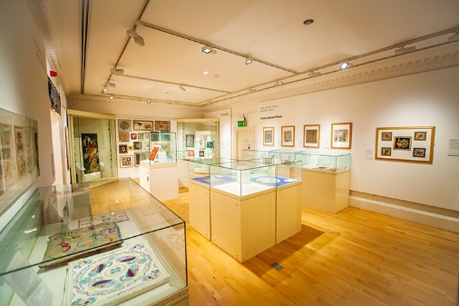
Fig.1: Embroidery Gallery, Bucks Museum, n.d.
Home to the national collection of the Embroiderers’ Guild, Bucks Museum’s Embroidery Gallery is a fitting place for this exhibition as the Guild aims to build awareness of stitch and textile art and educate in the history of embroidery. The intention is to take the viewer on a journey through four powerful embroidered artworks, all created within just over 100 years of each other, to experience how themes of desperation, protest, defiance, feminism and social commentary run through them all in contrasting ways.
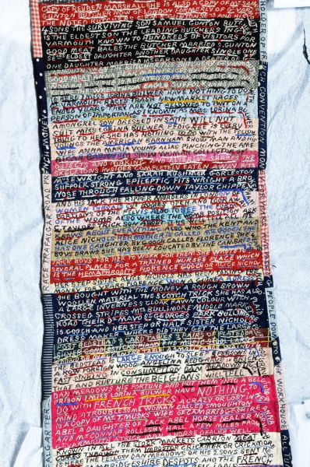
Fig.2: Patchwork embroidered scroll, Bulwer, 1904
This figure shows a section of a 12 foot long embroidered patchwork scroll stitched by Lorina Bulwer, and is the oldest artefact in this exhibition collection. Her unique work consists of “embroidered long strings of text that are full of protest and outrage” (Rosner, 2020) documenting her desperation during her time in the lunatic wards of Great Yarmouth Workhouse. Made out of cotton fabric with wool threads, the all-capitalised text is part diary and part tirade; a “desperate attempt to gain attention … to convey her palpable anguish and anger at her abandonment” (Hunter, 2019).
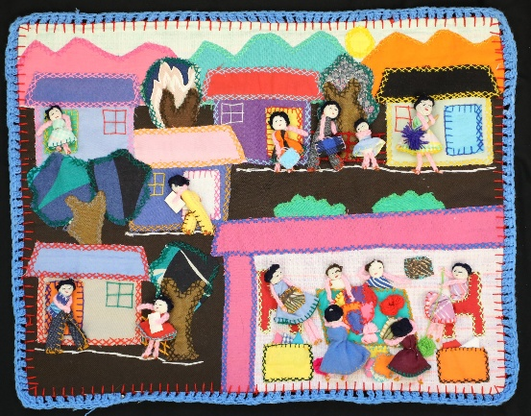
Fig.3: Community Arpillera Workshop, unknown, 1976
This colourful patchwork tapestry with doll figures is known as an arpillera. Thousands of these pictorial records were made by groups of anonymous working class women in Chile, known as arpilleristas during the Augusto Pinochet authoritarian regime between 1973-1990. Depicting life in Chile, they were made out of found material such as burlap potato sacks, scraps of cloth and sometimes clothing belonging to disappeared family members (Johnson, Pinath, and Wells, 2024). Arpilleras were an important form of protest, as well as a way of letting the world know about their situation as they were able to smuggle them out of the country.
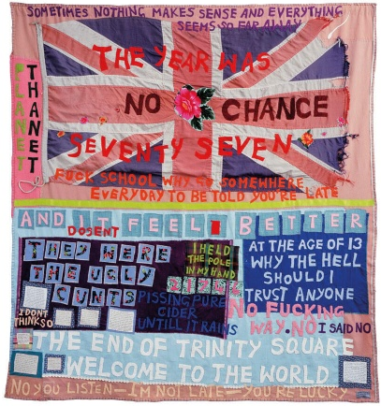
Fig.4: No Chance, Emin, 1999
A powerful theme throughout Tracey Emin’s work is how she represents both a private and internal monologue alongside a version of herself which is more detached and commentary (Brown and Emin, 2006, p. 7). Her textile work with applique blankets shows this brilliantly, demonstrating her defiance and antagonism towards both society and the state (Elkin, 2024). The use of cloth and bold text is akin to political protest banners, while the colours draw the viewer in to the text, which is unexpectedly harsh and explicit, juxtaposing the softness of the first impression.
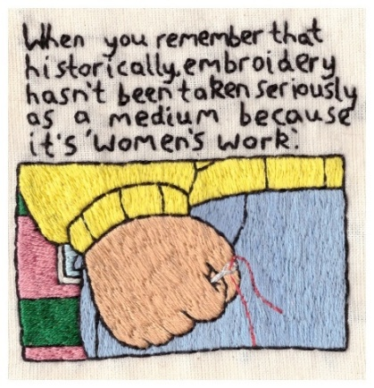
Fig.5: Feminist Arthur Meme, Hill, 2016
“The art of embroidery has been a means of educating women into the feminine ideal… but has also provided a weapon of resistance to the constraints of femininity” (Parker, 1996, p. vi). The work of contemporary embroidery artist Hannah ‘Hanecdote’ Hill demonstrates this resistance eloquently. Her work features bold illustrative motifs, covering a range of themes including prominent current issues around social media, data protection and environmental concerns. This hand embroidery on calico is a strong modern statement, capturing a fury around still not being taken seriously in the medium of embroidery. Taking the format of a digital meme and flipping that to create something analogue and often considered old fashioned results in a piece of art which gives the viewer reason to pause for thought.

Bulwer’s and Emin’s work notably share a similar aesthetic despite being made almost 100 years apart. It is possible that Emin knew of Bulwer’s work and took inspiration from her, which could explain what appears to be a shared visual language. The capital letters in both pieces are used to document facts that contrast with deep inner thought dialogues. The colour scheme of each features rosy pinks and a variety of blues. Pink has an interesting history, having originally been considered a colour for boys, it evolved into representing a feminine gentle beauty. More recently it has become notable for its use within the political activism landscape, revamping pink into an eye-catching feminist power symbol (Windsor and Newton, 2016).
Emin has a current major Tate Modern exhibition titled A Second Life, receiving great praise from art critics such as Eddy Frankel, who profoundly notes that “she lives, she feels, she loves and she suffers, and then she turns it all into art” (Frankel, 2026). This observation highlights why Emin fits so well in this exhibition. She is a living embodiment of women who came before her and an inspiration for future artists to have the courage to live their lives deeply and continue to change the landscape of art history.
Arpilleras tell the story of such an important part of Chile’s history and the arpilleristas rebellion against the dictatorship. Violeta Morales, one of the women who started making arpilleras, said “for us, an arpillera is an open book, a blank page where we can write to the world and tell them everything that is happening in this country” (Common Threads Press, 2026). Arpilleristas used the fact that textiles were considered merely unimportant women’s work to their advantage, allowing them to smuggle their pieces out of the country. 40 years after this arpillera was created, Hannah Hill stitched her small but poignant statement that, historically, embroidery hasn’t been taken seriously simply because it is women’s work. Positioning these two pieces together in the exhibition creates a powerful duo, with the modern piece speaking to the injustice of the historic piece not originally commanding the respect it deserved.

Setting up an exhibition can be described as “connecting different people and practices and causing the conditions for triggering sparks between them” (Obrist, 2014). A study visit to the Women in Print: 150 Years of Liberty Textiles at the William Morris Gallery gave useful insights into how textiles could be displayed in a gallery setting. Key takeaways from this visit included the importance of spotlights on individual works to highlight them within a larger space, the use of Perspex boxes to display delicate artefacts such as sketchbooks, both for protection as well as the implied reverence it brings, the impact of having a domestic scene ‘dressed’ in the textiles, and how pieces within a theme sit together to create a bigger impact together than they would as standalone pieces.
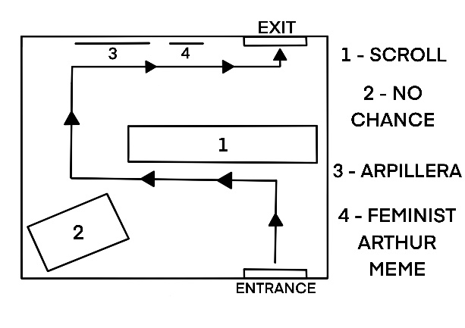
Fig. 6: Map of Proposed Embroidery Exhibition, Eden, 2026
The first piece that the viewer will experience upon entering the exhibition gallery is the 12 foot long embroidered scroll by Lorina Bulworth. Displayed on a tabletop height white box plinth and encased in a Perspex case showing a respect for the work that the creator would likely never have expected, this piece will set the tone for the rest of the exhibition.
The viewer will then be presented with a domestic bed set up in the corner of the room. Laying on top will be the No Chance appliqué blanket by Tracey Emin. Whilst her blankets are usually displayed hanging like a painting, the display of this piece will encourage the viewer to see this work in a more intimate environment, with the intention of highlighting the strength and power that can be demonstrated through the delicateness of an object intended for warmth and comfort.
Moving along, spectators will be invited to view the final two pieces - the arpillera and the embroidery by Hannah Hill - as a pair, both framed on the last wall, with the Arthur Meme being the last piece on the exhibition journey. By positioning the work in this way, the exhibition is summarised by this powerful duo, leaving a lasting impression with spectators as they leave.
Artist Hannah Hill will also be involved in community engagement activity events during the exhibitions timeframe. Hill is passionate about human stories and states “I want people to learn from my art, feel validated and seen” (Hill, 2026), making her an ideal figure to host stitching workshops with community groups, involving them in self-expression through embroidery, exploring a key theme of the exhibition.
It is the intention that viewers will have gained an awareness of the historical significance of women’s work in embroidery, and an appreciation for the versatility of this art form for self-expression, feminist power and overcoming oppression. In raising awareness of how women’s work has been forgotten, the exhibition can affect change for future generations.

Reference list:
Brown, N. and Emin, T. (2006). Tate Modern Artists. Tate.
Common Threads Press. (2026). Craft Roundtables: Collective Textile Resistance in Latin America. [Zoom]. Available at: https://www.eventbrite.co.uk/e/craft-roundtables-collective-textile-resistance-in-latin-america-tickets-1984622682869. [Accessed 28th March 2026].
De Beauvoir, S. (1949). The Second Sex. [online]. Vintage Books. Available at: https://uberty.org/wp-content/uploads/2015/09/1949_simone-de-beauvoir-the-second-sex.pdf. [Accessed 1st April 2026].
Elkin, L. (2024). Textiles as a Form of Feminist Dissent. [online]. Frieze. Available at: https://www.frieze.com/article/lauren-elkin-thread-of-dissent-241. [Accessed 1st April 2026].
Frankel, E. (2026). Tracey Emin: A Second Life review – this show of undiluted love, heartache and pain left me a teary wreck. [online]. The Guardian. Available at: https://www.theguardian.com/artanddesign/2026/feb/25/tracey-emin-review-tate-modern-london. [Accessed 6th April 2026].
Obrist, H. U. and Raza, A. (2014). Ways of Curating. New York: Farrar, Straus And Giroux.
Hill, H. (2026). Outside in, Artist: Hanecdote. [online]. Available at: https://outsidein.org.uk/galleries/hanecdote/. [Accessed 7th April 2026].
Hunter, C. (2019). Threads of Life: A history of the World Through the Eye of a Needle. S.L.: Sceptre.
Johnson, L., Pinath, A. and Wells Fray-Smith. (2024). Unravel. Prestel Publishing.
Parker, R. (1996). The Subversive Stitch.
Rosner, I. (2020). Sew What?: Stitching While Imprisoned. Part 1. [Podcast]. 20th August 2020. Available at: https://open.spotify.com/episode/49pHFRL3wzinQfc7K6SLPd?si=GXprOyEJTI-uzbyudlCYlA&nd=1&dlsi=765ad9849e3e4ab0. [Accessed 1st April 2026].
Winsor & Newton UK. (2016). Pink: a colour journey from the peaceful to the political. [online]. Available at: https://uk.winsornewton.com/blogs/articles/pink?srsltid=AfmBOooIE8o4iB78l4r595aYvbmnepOBalgf39pDIQgblXT7W40OXKAU. [Accessed 6 April 2026].

List of figures:
Figure 1. Discover Bucks Museum. No date. Available at: https://www.discoverbucksmuseum.org/whats-on/embroidery-gallery-previous-exhibitions/. [Accessed 1st April 2026].
Figure 2. Bulwer, L. (1904). Available at: https://collections.thackraymuseum.co.uk/object-598-001. [Accessed 1st April 2026].
Figure 3. Unknown. (1976). Available at: https://molaa.org/arpilleras-online-resistance. [Accessed 1st April 2026].
Figure 4. Emin, T. (1999). Available at: https://www.frieze.com/article/lauren-elkin-thread-of-dissent-241. [Accessed 1st April 2026].
Figure 5. Hill, H. (2016). Available at: https://www.hanecdote.co.uk/hanecdote-work/feminist-arthur-meme-2016. [Accessed 1st April 2026].
Figure 6. Eden, R. (2026). Map of Proposed Embroidery Exhibition.

Bibliography:
Brown, N. and Emin, T. (2006). Tate Modern Artists. Tate.
Bulwer, L. (1904). Available at: https://collections.thackraymuseum.co.uk/object-598-001. [Accessed 1st April 2026].
Common Threads Press. (2026). Craft Roundtables: Collective Textile Resistance in Latin America. [Zoom]. Available at: https://www.eventbrite.co.uk/e/craft-roundtables-collective-textile-resistance-in-latin-america-tickets-1984622682869. [Accessed 28th March 2026].
De Beauvoir, S. (1949). The Second Sex. [online]. Vintage Books. Available at: https://uberty.org/wp-content/uploads/2015/09/1949_simone-de-beauvoir-the-second-sex.pdf. [Accessed 1st April 2026].
Discover Bucks. (2021). The Embroiderers’ Guild - Discover Bucks. [online] Available at: https://www.discoverbucksmuseum.org/partners/the-embroiderer-guild/. [Accessed 1st April 2026].
Discover Bucks Museum. No date. Available at: https://www.discoverbucksmuseum.org/whats-on/embroidery-gallery-previous-exhibitions/. [Accessed 1st April 2026].
Eden, R. (2026). Map of Proposed Embroidery Exhibition.
Elkin, L. (2024). Textiles as a Form of Feminist Dissent. [online]. Frieze. Available at: https://www.frieze.com/article/lauren-elkin-thread-of-dissent-241. [Accessed 1st April 2026].
Embroiderers’ Guild. (2023). About the Guild - Embroiderers’ Guild. [online] Available at: https://embroiderersguild.com/about-the-guild/. [Accessed 1st April 2026].
Emin, T. (1999). Available at: https://www.frieze.com/article/lauren-elkin-thread-of-dissent-241. [Accessed 1st April 2026].
Frankel, E. (2026). Tracey Emin: A Second Life review – this show of undiluted love, heartache and pain left me a teary wreck. [online]. The Guardian. Available at: https://www.theguardian.com/artanddesign/2026/feb/25/tracey-emin-review-tate-modern-london. [Accessed 6th April 2026].
Hill, H. (2016). Available at: https://www.hanecdote.co.uk/hanecdote-work/feminist-arthur-meme-2016. [Accessed 1st April 2026].
Obrist, H. U. and Raza, A. (2014). Ways of Curating. New York: Farrar, Straus And Giroux.
Hill, H. (2026). Outside in, Artist: Hanecdote. [online]. Available at: https://outsidein.org.uk/galleries/hanecdote/. [Accessed 7th April 2026].
Hunter, C. (2019). Threads of Life: A history of the World Through the Eye of a Needle. S.L.: Sceptre.
Johnson, L., Pinath, A. and Wells Fray-Smith. (2024). Unravel. Prestel Publishing.
Parker, R. (1996). The Subversive Stitch.
Rosner, I. (2020). Sew What?: Stitching While Imprisoned. Part 1. [Podcast]. 20th August 2020. Available at: https://open.spotify.com/episode/49pHFRL3wzinQfc7K6SLPd?si=GXprOyEJTI-uzbyudlCYlA&nd=1&dlsi=765ad9849e3e4ab0. [Accessed 1st April 2026].
Smarthistory (2024). Arpilleras. [online] YouTube. Available at: https://www.youtube.com/watch?v=70KwXdOM6t8. [Accessed 6th April 2026].
Unknown. (1976). Available at: https://molaa.org/arpilleras-online-resistance. [Accessed 1st April 2026].
Wellesley-Smith, C. (2015). Slow stitch: mindful and contemplative textile art. London: Batsford, An Imprint Of Pavilion Books Company.
Winsor & Newton UK. (2016). Pink: a colour journey from the peaceful to the political. [online]. Available at: https://uk.winsornewton.com/blogs/articles/pink?srsltid=AfmBOooIE8o4iB78l4r595aYvbmnepOBalgf39pDIQgblXT7W40OXKAU. [Accessed 6 April 2026].

