

DATA HANDLING AND BUSINESS INTELLIGENCE
ASSESSMENT COMPONENT 2: DATA ANALYSIS AND VISUALISATION

Name: Nicolae Alexandru Voinea
Student’s ID: 2119833
Lecturer : Xavier Matieni
Deadline: 03/09/2023

Table of Contents
PART 1: 2
Introduction 2
1.1 Use of Excel for pre-processing the data 2
1.2 Use of Excel for analysing the data 2
1.3 Use of Excel for visualising the data 3
1.4 Pivot table analysis for the determination of declination or increment in the average room reservation price 3
1.5 IF function for the determination of declination or increment in the average room reservation price 6
1.6 Appropriate charts of the data set Analysis 7
Conclusion 7
PART 2 7
Introduction 7
1. How many students are male and female? 8
2. How many students qualify and do not qualify for reduced/free lunch? 9
3. What are the mean and median of students who qualify and do not qualify for reduced/free lunch? 10
4. What are the mean and median differences of students' pre-test and post-test scores? 10
5. Using the dataset Student_Score.csv provided in conjunction with SPSS, give a specific example of Clustering (ex. K-Means Clustering). Show your workings with screenshots and clearly explain your results. 11
6. With real-world (practical) examples, explain a minimum of 5 most common data mining and text mining methods for each that can be used in contemporary business. 13
7. Discuss the advantages and disadvantages of using SPSS and Excel using relevant practical examples and present your discussions in a table. 14
Table 7.1: Advantages and disadvantages of SPSS and Excel 15
Conclusion 16
References 17
Bibliography 20

PART 1:

Introduction
This essay would evaluate the benefits of using Excel for pre-processing, analysing and visualising data. Furthermore, this essay would also analyse data using a pivot table for evaluating the increment and decline of the average room reservation price of the hotel. Additionally, the essay would also produce a graphical presentation of the data using Excel.
Thesis Statement: This essay would interpret, analyse and graphically present data with the statistical interpretation of the data of the hotel.

1.1 Use of Excel for pre-processing the data
Data pre-processing is claimed as the raw data which is converted into a format data which is understandable. The raw data holds missing data, many errors, and noisy data, each of the issues which will be solved through the utilisation of the data pre-processing methods (Medium, 2020). Other than this Microsoft Excel is considered as a great tool for handling and pre-processing of the structure data. Excel also has a lot of functions and techniques which act out to be a lot more helpful for cleaning out structured data (Towardsdatascience, 2021). Prior to proceeding with the work, there is a need to understand basic functions that will be a part of solving and using a huge article. MS Excel also does enable the users in formatting, organise and compute the data within a spreadsheet. By organising data utilising software such as in excel, other users and data analysts can make data easier for viewing as data is being changed or added. For instance: In the hotel reservation dataset, as in for the understanding of things like data cleaning and, the two needed columns Average year and price are carried in a new spreadsheet. It is done for finding find the column Average Decrease and Increase, by using the IF function.

1.2 Use of Excel for analysing the data
Excel is most commonly utilised within business analysis, performance reporting, operation management and human resource management. It is because Excel is quite helpful in utilising a large collected cell formatted for organising and manipulating data and solving out mathematical features and functions. Users are able to arrange data with spreadsheets using pivot tables, formulas and so on (Techtarget, 2020). The spreadsheet application also seems to have a macro programming language called for visual basic applications.
With the help of the Hotel Reservation dataset, it was stated that there needs to be a determination of the rise or decrease in the average over-year range from the year 2017-2021. So, being a data analyst, it was stated that to evaluate the utilisation of the pre-processing of the data and to analyse the data and visualisation of the data. Thus, here are the features of Excel that are put to use are Pivot Table and IF Function. The pivot table is quite a powerful tool for computing, summarising and analysing the data which lets in seeing the patterns, trends and compression in the data (Microsoft, 2022). On the other hand, the IF function depicts whether the condition is met and then assists in returning 1 value if one and the other value if it gets false.

1.3 Use of Excel for visualising the data
Within Excel charts are being utilised for making a graphical representation of any set of the data. A chart can be stated as a visual representation of the data in which the data is reposed with the utilisation of symbols as in Lines or Bar Charts within Line Charts. Excel does provide a person with a lot of chart types and then selects one which suits the provided data. Other than this one can utilise the Excel recommendation chart options for viewing charts which are customised to the provided data and select one among those (refer to bibliography 1).
As discussed above, property in the case of the hotel reservation dataset, for analysis of the data set with appropriate charts. The chart which is utilised in this case scenario is the pivot table chart, for which the variables which are taken into consideration are Booking status, Arrival tear, Market type and Average price. Also, the chart is considered eligible to be used for the given dataset, but other than this there are different kinds of charts which can be utilised. The charts are pie charts, bar charts, bar graphs, column charts, line graph, scatter plots and so on.

1.4 Pivot table analysis for the determination of declination or increment in the average room reservation price
Sum of Average price |  | Booking status
Arrival year | Market type | Cancelled | Not Cancelled | Grand Total
2017 | Complementary |  | 340.93 | 340.93
 | Corporate | 3623.4 | 34798.74 | 38422.14
 | Offline | 40533.3 | 217872.96 | 258406.26
 | Online | 45764.59 | 243161.98 | 288926.57
2017 Total |  | 89921.29 | 496174.61 | 586095.9
2018 | Aviation | 3783 | 8805 | 12588
 | Complementary |  | 887.5 | 887.5
 | Corporate | 17386.59 | 111357.25 | 128743.84
 | Offline | 277497.18 | 428591.4 | 706088.58
 | Online | 925736.36 | 1390481.32 | 2316217.68
2018 Total |  | 1224403.13 | 1940122.47 | 3164525.6
2019 | Corporate |  | 67 | 67
 | Offline |  | 139 | 139
 | Online | 37.33 | 182.45 | 219.78
2019 Total |  | 37.33 | 388.45 | 425.78
2020 | Offline |  | 75 | 75
 | Online |  | 250.6 | 250.6
2020 Total |  |  | 325.6 | 325.6
2021 | Online |  | 316 | 316
2021 Total |  |  | 316 | 316
Grand Total |  | 1314361.75 | 2437327.13 | 3751688.88
Table 1.1: Use of Pivot table
(Source: Created by author)
The table provided depicts the Pivot table analysis for determining the declination or increment in terms of the average room reservation price. Here the 5 years’ details are provided. The core points of understanding are arrival years, the market type, and the booking status, which is divided under non-cancelled and cancelled. In the year 2017, the complementary market types booking status was like it had 0 cancellations and the lowest non-cancelled ones. The online market type had the most cancelled ticket which was at 45764.59 and non-cancelled were at none. Among each of the years 2021 had no cancellation which means a decrease, where no cancel also declined as the years deceased.

1.5 IF function for the determination of declination or increment in the average room reservation price
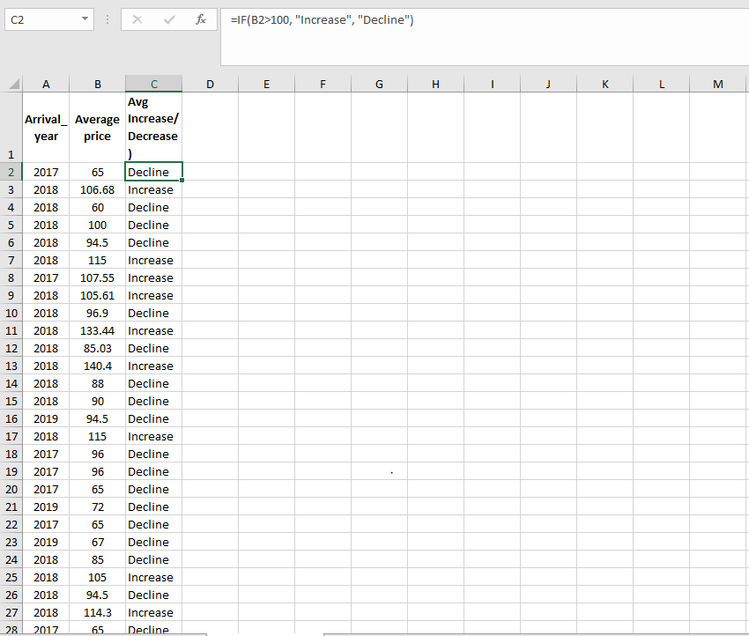Figure 1.1: Use of If function
(Source: Created by author)
In the case of the above-provided figure it can be seen that the use of the IF function is done, it mostly satisfies the need of average increase/decrease of the average price. It can be seen that the IF function, can be used “IF(B2>100, “Increased”, “Decline”)”, which allowed in showering within this year either there is a rise or a decrease.

1.6 Appropriate charts of the data set Analysis
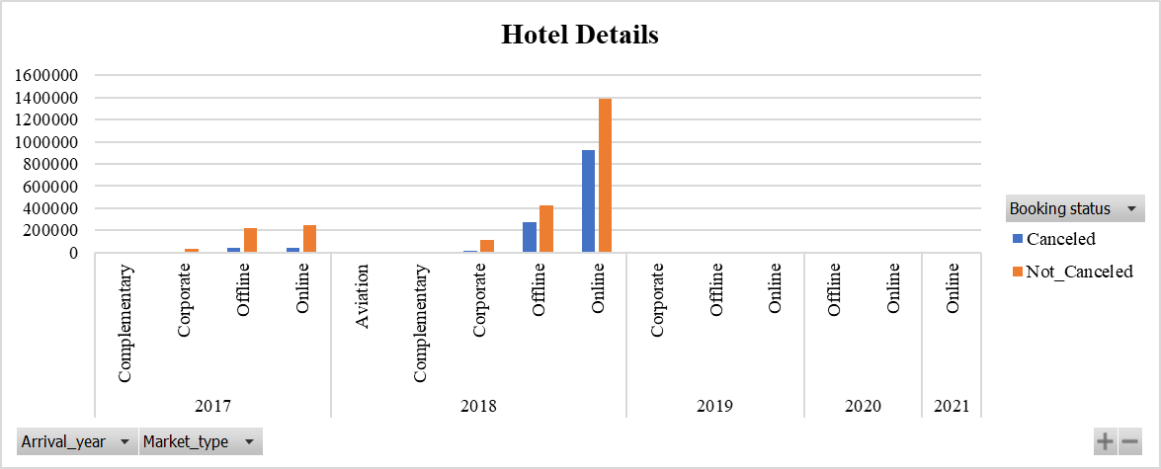
Figure 1.2: Hotel Reservation
(Source: Created by author)
The figure given above has been developed on the basis of the table presented above in section 1.4. The pivot graph has been utilised in the study as it contributes to the analysis of the data from different perspectives. For the analysis, arrival year, market type, and booking status for the study as it contributes to effectively analysing the objective. Moreover, the pivot table could help in making changes at any point in time and could help in critically determining the data for the study. The graphical representation helps in effectively understanding the reservation status of the rooms.

Conclusion
From the above discussions it can be concluded that the study effectively helps in analysing the data in statistical form for effective interpretation and understanding of complex data. The study contributes to an analysis of pre-processing data and visualisation of data with the help of a pivot table that helps in analysing the hotel reservation process and analysing the number of cancellations with respect to the market type and arrival year and booking status. Hence, the study is critical for efficiently analysing the data of the hotel.

PART 2

Introduction
This essay would analyse the dataset of 2133 school students for critically analysing the large set of data through SPSS. As a data analyst of the school, the shift from Microsoft Excel to SPSS has eased out the process of data mining. This essay would evaluate the total number of males and females as well as the qualifying students for reduced and free lunch. Furthermore, this essay would evaluate the mean and median of the gender and lunch qualification of the school students and develop knowledge regarding contemporary data mining methods as well as the use of SPSS.
Thesis Statement: This essay would analyse, interpret and visualise the data set of the school students using SPSS and also develop knowledge regarding data mining and text methods.

1. How many students are male and female?
Out of the total of 2133 school students, it has been evaluated that 1077 students are male and 1056 students are female.
Gender
 |  | Frequency | Percent | Valid Percent | Cumulative Percent
Valid | Female | 1056 | 49.5 | 49.5 | 49.5
Valid | Male | 1077 | 50.5 | 50.5 | 100.0
Valid | Total | 2133 | 100.0 | 100.0
Table 2.1: Gender Distribution of the school students
(Source: Developed by Author)
As shown in the above figure, 49.5% of the school students constitutes female and 50.5% constitutes male.
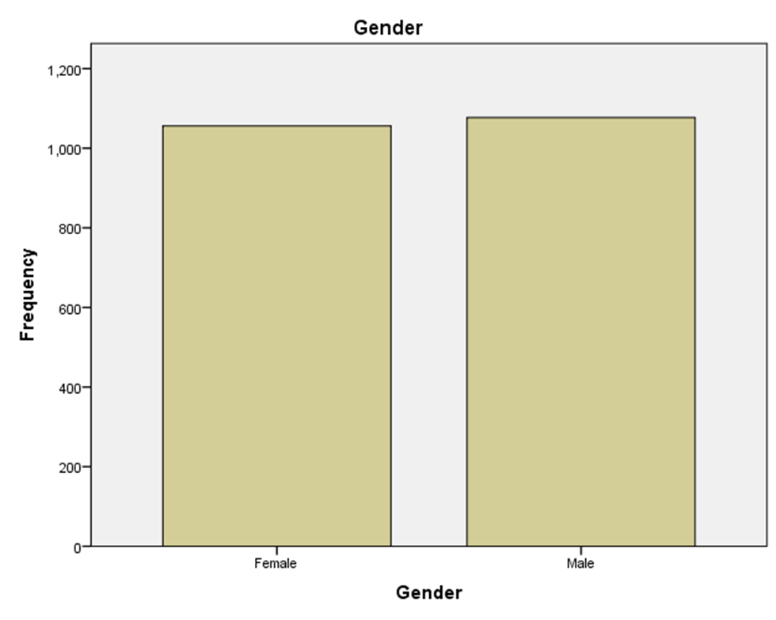
Figure 2.1: Bar Graph
(Source: Developed by Author)
As shown in the above figure, the bar graph depicts the gender distribution of the school students. In the views of Abdul et al. (2020), the use of bar graphical presentation ensures the understanding of the trend of two variables. Therefore, the bar graph effectively shows the difference between the total number of male students and the total number of female students.

2. How many students qualify and do not qualify for reduced/free lunch?
Out of the total of 2133 school students, it has been analysed that 918 students qualify for reduced or free lunch. However, 1215 students do not qualify for reduced or free lunch.
Gender * Lunch Crosstabulation
 |  | Lunch |  | Total
 |  | Does not qualify | Qualifies for reduced/free lunch | Total
Gender | Female | 593 | 463 | 1056
Gender | Male | 622 | 455 | 1077
Total |  | 1215 | 918 | 2133
Table 2.2: Analysis of the students qualify and do not qualify for reduced/free lunch
(Source: Developed by Author)
As shown in the above table, it can be evaluated that out of total 1056 female students, 593 female students do not qualify for lunch and 463 female students qualify for reduced/free lunch. Moreover, out of 1077 male students, 622 male students do not qualify for lunch and 455 male students qualify for reduced/free lunch. As stated by Alsaad et al. (2022), the cross-tabulation in SPSS ensures the effective understanding of the relationship between two variables. Therefore, the cross-tabulation has ensured the effective analysis of the variables of gender and lunch of the school students.

3. What are the mean and median of students who qualify and do not qualify for reduced/free lunch?
Does not qualify |  | Qualifies for reduced/free lunch
Mean | 1215 | Mean | 918
Median | 1215 | Median | 918
Table 2.3: Mean and Median numbers of students qualified for lunch
(Source: Developed by Author)
The above-portrayed table 2.3 is essential to differentiate the mean and median data regarding the students that are qualified and not qualified for the lunch in the school. The data is presented in the Table regarding the mean data. Mean data consider the variables of the data set. Through analysing this, it has been found that the average mean data for the students is 1215. The Median data for the students that are not qualified for the lunch is 1215. The median data is evidential toward the average value of the data set. Similarly, in consideration of the qualified for reduced or free lunch, the mean data is portrayed to be 918. The median data for the qualified for reduced and free lunch is 918.

4. What are the mean and median differences of students' pre-test and post-test scores?
Statistics
 |  | Pretest | Posttest
N | Valid | 2133 | 2133
N | Missing | 0 | 0
Mean |  | 54.96 | 67.10
Median |  | 56.00 | 68.00
Table 2.4: Mean and Median differences between pre-test and post-test scores
(Source: Developed by Author)
The above Table 2.4 has been elaborative to determine the mean and median statistics for the students' pre-test and post-test scores. Through the evaluation of the data set, 2133 students' scores were analysed to determine appropriate data. The missing statistics for both data is 0. The mean data for the pre-test score is 54.96 and the post-test score is 67.10. This has been evident towards the average used number in the data set. Thus, the post-test score has a higher mean data. While on the other hand, the median statistics for the pre-test data is 56.00 and for post-test data 68.00. The median data refers to the numbers that are used mostly in a data set. Thus, it has been effective to determine the post-test data scores is 68.00. This signifies that the post-test scores have been better for the student's performance. Thus, positive change has been portrayed through the evaluation.

5. Using the dataset Student_Score.csv provided in conjunction with SPSS, give a specific example of Clustering (ex. K-Means Clustering). Show your workings with screenshots and clearly explain your results.
Initial Cluster Centers
 | Cluster
 | 1 | 2
Pre-test | 23 | 93
Post-test | 35 | 100
Table 2.5: Initial Clusters Centres
(Source: Developed by Author)
The above table is essential for the depiction of Initial Clusters Centres; In the first cluster the pre-test score is 23 while the post-test score is 35. For the second cluster, the pre-test score is 93 and the Post-test score is 100. Thus, it was evident that the students improved in the post-score.
Iteration Historyª
Iteration | Change in Cluster Centers
Iteration | 1 | 2
1 | 30.191 | 33.606
2 | .885 | .791
3 | .611 | .532
4 | .212 | .181
5 | .227 | .200
6 | .150 | .128
7 | .000 | .000
a. Convergence achieved due to no or small change in cluster centres. The maximum absolute coordinate change for any centre is .000. The current iteration is 7. The minimum distance between initial centres is 95.525.
Table 2.6: Iteration History
(Source: Developed by Author)
As portrayed in the above table, the convergence has helped to determine the alteration in cluster centres. Through the analysis, it has been determined that 7 is the current iteration for the statistics.
Final Cluster Centers
 | Cluster
 | 1 | 2
Pre-test | 43 | 65
Post-test | 55 | 78
Table 2.7: Final Clusters Centres
(Source: Developed by Author)
Regarding the final cluster centres, the findings have been essential for determining the Cluster 1 score in the pre-test is 43 and post-test is 55. While on the other hand, for cluster 2 the pre-test score is 65 and the post-test is 78.
Number of Cases in each Cluster
Cluster | 1 | 993.000
Cluster | 2 | 1140.000
Valid |  | 2133.000
Missing |  | .000
Table 2.8: Number of Cases in Each Cluster
(Source: Developed by Author)
In terms of clusters the number regarding cluster 1 is 993.000 and Cluster 2 is 1140. This signifies the validation of cluster 2.

6. With real-world (practical) examples, explain a minimum of 5 most common data mining and text mining methods for each that can be used in contemporary business.
1. Data Mining Method
1.1 Regression Analysis
The regression analysis enables the evaluation of the relationship between the two variables of the study. As stated by Kohli et al. (2020), the use of regression analysis enables forecasting the sales of an organisation. For example, TESCO uses predictive analytics with the utilisation of regression analysis in evaluating the relationship between customer preference of the mode of order and logistics requirement (Analyticssteps, 2020).
1.2 Association Rule Learning
The association rule learning (ARL) within the data mining and text mining method enables the evaluation of the interesting or hidden behaviour of particular data within an entire data set. In the views of Santoso (2021), the utilisation of association rule learning enables a business in analysing the change in the customer behaviour pattern. For instance, the use of ARL has enabled WalmartLabs to data mining of customer expectations from 2.5 petabytes of customer data every hour (Linkedin, 2023b).
1.3 Classification Analysis
Classification analysis ensures the segregation of the data into various sets from a large data set. For example, the inclusion of artificial intelligence (AI) for classification analysis in Sainsbury has enabled effective analysis of the big data regarding the purchasing behaviour of various classes of customers (Techerati, 2019).
2. Text Mining Methods
2.1 Clustering Analysis
The clustering analysis within text mining is used to evaluate the similarity of the texts within a complete dataset. For example, the use of clustering analysis within the big data of TESCO has enabled the real-time controlling of the stock availability from the understanding of the customer purchase pattern (Analyticssteps, 2020).
2.2 Outlier Detection
Outlier detection for text mining benefits the data analyst in depicting such data within a dataset which does not qualify the expected behaviour or pattern of the analysis. For example, the use of outlier detection with the inclusion of machine learning (ML) in NHS UK has ensured digital diagnostics of the patients (Linkedin, 2023a).

7. Discuss the advantages and disadvantages of using SPSS and Excel using relevant practical examples and present your discussions in a table.
 | SPSS | EXCEL
Advantages | - SPSS ensures effective analysis of a huge dataset with the dynamic depiction of the analysis using graphs and charts (Trustradius, 2022).  - SPSS is beneficial for analysing both qualitative and quantitative data (Rahman and Muktadir, 2021). Thereby, ensuring the understanding of a wider array of data.  - For example, Eircom uses SPSS for data analysis for predictive analytics (SPSSanalyticspartner, 2023). | - Excel is user-friendly which enables effective analysis of the data using Functions, Formulas and Graphical Representation (Javatpoint, 2023).  - For example, Barclays plc in the UK uses Microsoft Excel for data analysis, chart and report preparation (Payscale, 2023).
Disadvantages | - SPSS lacks advanced analytics including multivariate decomposition which limits the adaptability within the business organisations (Trustradius, 2022).  - The functions of multi-level analyses or structural equation modelling with SPSS are not as fast or accurate as other data analytics software’s such as Tableau or Power-BI (Rippey, 2021). | - Analysing big data in Excel is cumbersome which increases the possibilities of errors (Javatpoint, 2023).  - The data analysis using Excel limits the automation process (Qasim, 2020). Therefore, it increases the reliance on human efforts.

Table 2.9: Advantages and disadvantages of SPSS and Excel
(Source: Self-made)

Conclusion
On a concluding note, the part of the study has been essential for identifying the data from the data set regarding the students. The main trends in the study have been the number of students that are available for free lunch, similarly the pre-test scores and the post-test score has been elaborated with the use of mean and median statistics. The use of SPSS analytical tools can be effective to determine the different variables.

References
Abdul, A., von der Weth, C., Kankanhalli, M. and Lim, B.Y., 2020, April. COGAM: measuring and moderating cognitive load in machine learning model explanations. In Proceedings of the 2020 CHI Conference on Human Factors in Computing Systems (pp. 1-14).
Alsaad, H.A., Almahdi, J.S., Alsalameen, N.A., Alomar, F.A. and Islam, M.A., 2022. Assessment of self-medication practice and the potential to use a mobile app to ensure safe and effective self-medication among the public in Saudi Arabia. Saudi Pharmaceutical Journal, 30(7), pp.927-933.
Analyticssteps, 2020. 5 ways Tesco uses Big data Analytics. Available at: https://www.analyticssteps.com/5-ways-tesco-uses-big-data-analytics (Accessed: 2 August 2023)
Javatpoint, 2023. Advantages and Disadvantages of MS Excel. Available at: https://www.javatpoint.com/advantages-and-disadvantages-of-ms-excel (Accessed: 1 August 2023)
Kohli, S., Godwin, G.T. and Urolagin, S., 2020. Sales prediction using linear and KNN regression. In Advances in Machine Learning and Computational Intelligence: Proceedings of ICMLCI 2019 (pp. 321-329). Singapore: Springer Singapore.
Linkedin, 2023a. NHS Unleashing the power of Machine Learning with the UK Government's NHS AI fund. Available at: https://www.linkedin.com/pulse/nhs-unleashing-power-machine-learning-uk-governments-ai-chris-suter (Accessed: 1 August 2023)
Linkedin, 2023b. Walmart's Big Data Strategy: Analyzing When People Crave Pop-Tarts. Available at: https://www.linkedin.com/pulse/how-does-walmart-drive-sales-from-data-reagan-charles-cook (Accessed: 2 August 2023)
Medium, 2020. Data Preprocessing in Machine Learning Model. Available at: https://medium.com/analytics-vidhya/data-preprocessing-in-machine-learning-model-3af34d0f3ceb (Accessed: 20 July 2023)
Microsoft, 2022. Create a PivotTable to analyze worksheet data. Available at: https://support.microsoft.com/en-gb/office/create-a-pivottable-to-analyze-worksheet-data-a9a84538-bfe9-40a9-a8e9-f99134456576 (Accessed: 22 July 2023)
Payscale, 2023. Average Data Analyst with Microsoft Excel Skills Salary at Barclays Bank PLC in United Kingdom. Available at: https://www.payscale.com/research/UK/Job=Data_Analyst/Salary/256bbb02/Barclays-Bank-PLC-Microsoft-Excel (Accessed: 2 August 2023)
Qasim, A., Issa, H., El Refae, G.A. and Sannella, A.J., 2020. A model to integrate data analytics in the undergraduate accounting curriculum. Journal of emerging technologies in accounting, 17(2), pp.31-44.
Rahman, A. and Muktadir, M.G., 2021. SPSS: An imperative quantitative data analysis tool for social science research. International Journal of Research and Innovation in Social Science, 5(10), pp.300-302.
Rippey, 2021. Pros & Cons of SPSS. Available at: https://doingsocialresearch.com/pros-cons-of-spss/ (Accessed: 2 August 2023)
Santoso, M.H., 2021. Application of Association Rule Method Using Apriori Algorithm to Find Sales Patterns Case Study of Indomaret Tanjung Anom. Brilliance: Research of Artificial Intelligence, 1(2), pp.54-66.
SPSSanalyticspartner, 2023. Industries & Case Studies. Available at: https://www.spssanalyticspartner.com/industries-case-studies/ (Accessed: 2 August 2023)
Techerati, 2019. Sainsbury’s is using machine learning on Google Cloud to predict food trends. Available at: https://www.techerati.com/news-hub/sainsburys-ai-machine-learning-cloud-google-analytics-2019/ (Accessed: 2 August 2023)
Techtarget, 2020. Excel. Available at: https://www.techtarget.com/searchenterprisedesktop/definition/Excel (Accessed: 21 July 2023)
Towardsdatascience, 2021. Excel for Data Pre-processing. Available at: https://towardsdatascience.com/essential-functions-in-excel-for-data-preprocessing-140f002f3ca (Accessed: 20 July 2023)

Bibliography
[1] Tutorialspoint, 2022. Excel Data Analysis - Data Visualization. Available at: https://www.tutorialspoint.com/excel_data_analysis/excel_data_analysis_visualization.htm (Accessed: 23 July 2023)

