University of Wales Trinity Saint David



Walkabout, Swansea

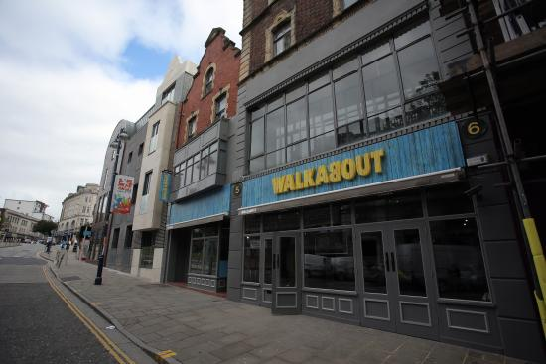

Consultancy Project Report
Project Consultant: Norbert Kondor
Clients: Robert Nangalia – Deputy Manager: walkabout.swansea@stonegatepubs.com
Matthew Cassidy – General Manager: bookings.wbswansea@stonegatepubs.com
Module: Consultancy Project
Level: 6
Lecturer: Michael Davies
Executive Summary

The following report analyses the two different primary research methods that have been used by the consultant in order to understand Walkabout’s competitors and consumer trends and preferences. Based on the data that have been gathered by using an online survey the consultant was able to cross-tabulate answers using SPSS which allowed him to write up a list of recommendations that would be financially beneficial for the business (based off the survey results).
Secondly, a ‘mystery shopper’ experiment was also included as a primary research method which helped the consultant to better understand the tangible differences between Walkabout and two of its main competitors: Fiction and Sin City. Both of these competitors attract the same age group although it was interesting to realize how the priorities of those who visit Fiction and Sin City are different from those that frequent Walkabout. Based on the data gathered Walkabout is too expansive for the students and the younger generation (Fiction and Sin City are both cheaper) and also the inconsistency in Walkabout’s customer numbers are confusing and unattractive from a consumer point of view.
By taking into consideration all of the comments left on the survey and the responses on the questions, it became clear that in order for Walkabout to draw in those people who would normally go to Sin City or Fiction, they would be required to negotiate with the Headquarters for some deals/discounts approvals which was definitely the number one motivator amongst the younger people when it came to choosing a venue for a night out. Furthermore, a stronger marketing strategy would definitely help people understand the venue and its offers better as currently many customers are confused when it comes to the ‘mates rates’ card and current deals.

Table of Contents
Introduction ……………………………………....………….Page 4
Walkabout Situational Details……………………………...Page 4
Research Methods………………………………...………..Page 5
Findings……………………………………….……..……….Page 6
Primary Research – Survey……………………….….……Page 6
Gender Table……………………………….……….……….Page 6
Age Table…………………………………….………………Page 7
Frequent Walkabout Customers Age Group…….……….Page 7
Frequent Fiction Customers Age Group……….…………Page 8
Frequent Sin City Customers Age Group…….…………..Page 10
Customers Priorities In Night-Club Venues….….………..Page 11
Customers Priorities In Night-Club Venues 2…….……...Page 12
Walkabout Customers………………………………………Page 13
Returning Customers Rate in Walkabout…………………Page 14
Walkabout Average Rating…………………………………Page 15
Main Reasons For Visiting Walkabout…………………….Page 17
Main Reasons For Visiting Walkabout 2………………….Page 18
Walkabout Improvements…………………………………..Page 18
Fiction Customer Priorities…………………………………Page 19
Sin City Customer Priorities………………………………..Page 21
Walkabout Opening Hours…………………………………Page 23
Primary Research – Mystery Shopper …………………...Page 24
Walkabout Mystery Shopper……………………………….Page 25
Fiction Mystery Shopper……………………………………Page 25
Sin City Mystery Shopper…………………………………..Page 26
Discussion & Analysis………………………………………Page 28
Conclusions…………………………………………………..Page 29
Aims And Objectives Outcome…………………………….Page 29
Recommendations…………………………………………..Page 30
Appendices…………………………………………………..Page 31
References…………………………………………………..Page 34
- Introduction

The main purpose of the Consultancy Project Report is to provide Walkabout Swansea with a set of recommendations and conclusions based off the results from a survey and from visits to competitor venues such as Fiction and Sin City. With the use of the recommendations Walkabout could potentially increase their turnover and draw in more people during the whole week.

Walkabout is an Australian themed sports bar located on Wind Street, Swansea which is a highly popular location amongst the students and locals so it has a great potential to be a successful profitable business. On the other hand, many other clubs and pubs are to be found on Wind Street which makes it challenging to keep people in Walkabout. In order to overcome the challenges, it was crucial to understand the competitors marketing techniques and also to realize the student’s preferences and trends when it comes to choosing a night club venue. The consultant has visited Fiction and Sin City as a ‘mystery shopper’ to identify the main differences between the venues taking into account the student’s priorities; a survey was also created in order to analyze student preferences and a total of 55 anonymous answers were collected.

  - Walkabout Situational Details

In the Project Initiation Document Marios Yiannou was mentioned as the General Manager of Walkabout Swansea but recently there has been a change and the new General Manager is Matthew Cassidy. Previously Matthew was the General Manager for another Stonegate venue: Popworld and before Popworld he spent numerous years working for Walkabout and he progressed from a glass collector to a General Manager.

With a change to the General Manager, Stonegate headquarters introduced another change to the venue: the withdrawal of a highly popular deal, the happy hour which offered guests 50% of savings on each drink.

- Research Methods

With the main motive of providing quality and professional recommendations the consultant has undertaken two separate primary research methods.

Firstly, a survey was created on Surveymonkey (Surveymonkey.co.uk) with 10 questions focusing on the respondent’s gender, age, and their preferences when it comes to choosing a venue for the night. A survey was chosen as a research method as it can be answered by a larger audience and the nature of the questions allowed the respondents to finish the survey in an average of 2 minutes. Most of the questions were multiple choice with the scope of allowing the respondents to be flexible with their answers as it is known that students going on Wind Street like to experience a variety of options and they tend to frequent several venues with different expectations, priorities, etc.
A total of 55 anonymous answers were recorded on the survey and with the use of SPSS the consultant was able to thoroughly analyze the data contrasting and comparing the answers from different points of view. Ex number 1: Filtering out those respondents who have already been to walkabout, the consultant was able to look at the potential improvements that the visitors suggested which could ultimately make Walkabout a more attractive venue. Example number 2: Looking into the customer priorities when arriving at a venue by filtering out only those respondents who prefer Fiction the most – this allows the consultant to identify the reasons on why they prefer Fiction and as a result Walkabout could potentially use the information for future projects to reach out to a wider audience and draw in more people.

Secondly, the consultant reviewed the current deals/atmosphere/customer engagement/marketing strategies of Walkabout and compared them to two main competitors: Fiction and Sin City. These two venues were identified as the main competitors by using the survey respondent’s most preferred venues between the ages of 18 to 24. The comparison was executed by visiting Fiction and Sin City in order to gain first hand experience on the main differences. The consultant has specifically looked at constant/daily/weekly deals at the venue, size, use of space, use of marketing materials, customer service, music type and the demographics that frequent the said venue.

- Findings

  - Primary Research – Survey

A survey was used as the first method of primary research which consisted of 10 short questions. The answers were used to identify the preferences and trends amongst the students or any person who visits Wind Street for late-night socializing purposes. The survey was created on Surveymonkey, although the actual data was interpreted by using SPSS in order to maximize the potential of the data. The survey format and all of its questions/answer options can be seen at the Appendices 1.

    - Gender Table

By looking at the basic analysis below, the number of male (38) and female (17) respondents were identified between the total number of respondents which is 55. Most of the respondents (69.1%) were male.
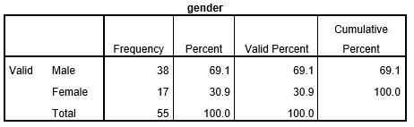

    - Age Table

As one of the most important tables there is (to accurately identify the target market in the following questions), looking at the results it is clear that most of the survey respondents were between the ages of 18-29. The ‘Cumulative Percent’ shows that the before mentioned age group provided most of the responses with 78.2%.
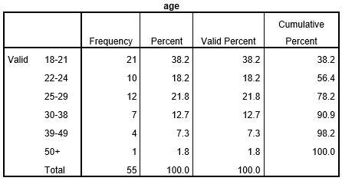

    - Frequent Walkabout Customers Age Group

The cross tabulation below clearly shows each age group separately and more importantly it identifies how many people normally choose Walkabout as a venue when they feel like socializing on a night out (out of 11 different venues that were shown on the survey). By looking at the table it is obvious that the highest number of people that normally choose Walkabout are between the ages of 18 to 21 with nine respondents and the least people that visit are above 39 with one answer.

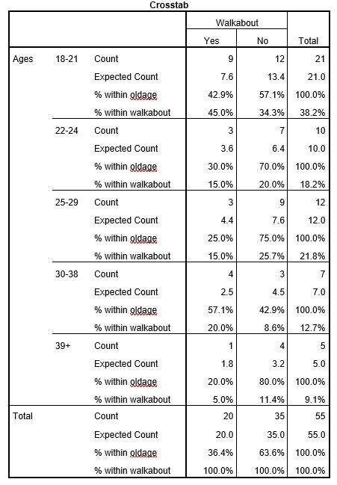

    - Frequent Fiction Customers Age Group

Similarly to the table 3.1.3, the next step was to analyze the same age groups but focusing on all of the other venues on Wind Street instead of Walkabout in order to identify the main competitors (taking into account Walkabout’s target market the consultant was looking at venues with high visitor numbers from the same age group). Fiction was the number one venue where people between the ages of 18 to 21 visited, although the numbers drop quickly in the older age groups, as it is seen on the table below.
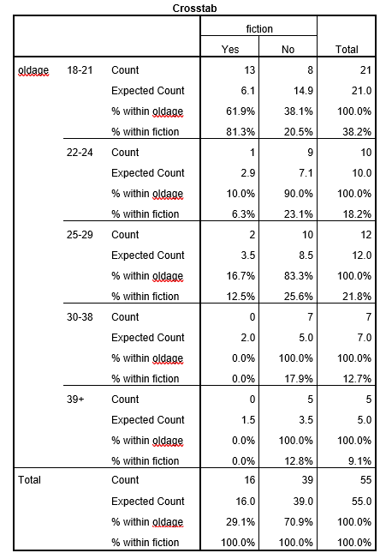

    - Frequent Sin City Customers Age Group

A third analysis was done using the same age groups but this time focusing on Sin City, the second biggest Walkabout competitor (based off the survey results). Closely following Fiction’s numbers, 11 people between the ages of 18 to 21 normally goes to Sin City for a night out, although Sin City’s numbers do not drop as rapidly as it did for Fiction when it came to the older age groups.

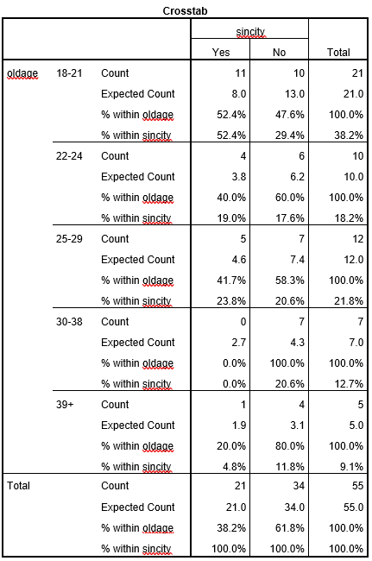
    - Customer Priorities In Night-Club Venues

The next analysis included the priorities that customers have when visiting a night-club. The highest rated priority out of 6 different options was definitely the low drink prices – 17 out of 21 voted for it in the 18 to 21 age group, similarly 9 out of 10 voted for it between the 22 to 24 age group.

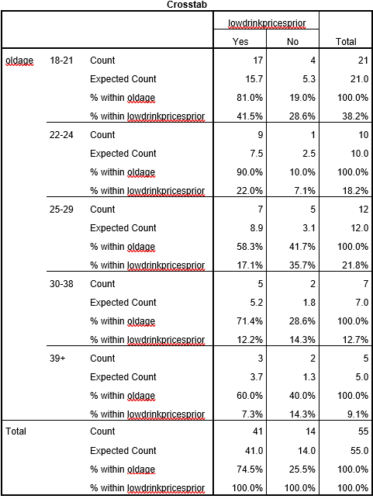
    - Customer Priorities In Night-Club Venues 2

Similarly, the lowest rated priority out of the 6 options presented on the survey was karaoke. Out of the total number of 55 respondents, 0% voted for karaoke as a priority when visiting a night-club venue, as it is seen on the table below.

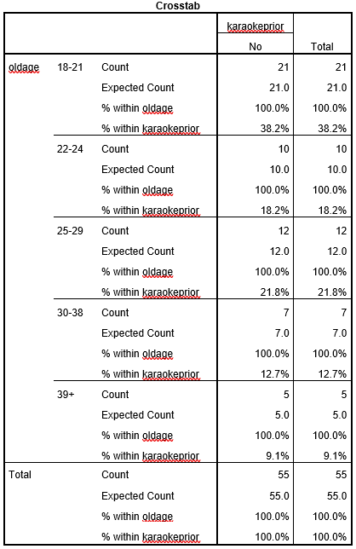

    - Walkabout Customers

The next analysis was crucial in order to measure the validity of the respondent’s answers as most of the questions in the survey refers to the Walkabout venue. As the table shows, according to the respondents 87% of them have already visited Walkabout.
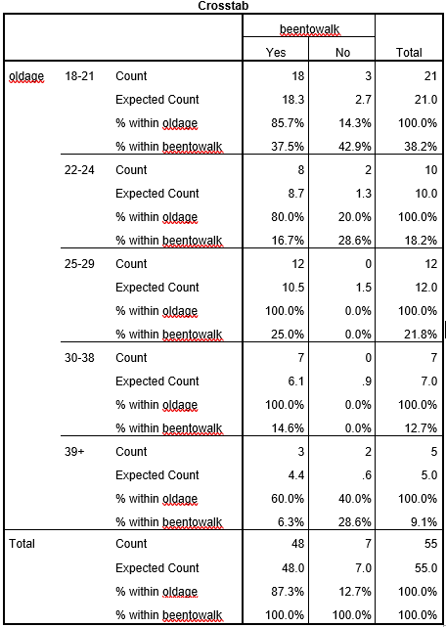

    - Returning Customer Rate In Walkabout

The table below shows the data gathered from the respondents who have selected that they have already been to Walkabout (48) – this data was cross matched with the same respondent’s answers but to a different question which was whether they would return there on a regular basis. Out of the 48 respondents who have already been in Walkabout normally goes back there regularly, on the other hand the remaining 28 (58%) did not choose Walkabout as a venue they normally visit. A pie chart visual representation can be seen as well below.
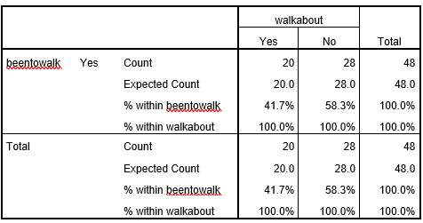

    - Walkabout Average Rating

The following data was collected with the use of a scale where the respondents had to rate Walkabout from 1, being the worst, to 10, being the best. Out of 48 respondents who have been already in Walkabout (it was important to only take them into consideration as the rest could make the analysis less valid) the average rating turned out to be 7.
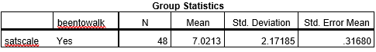

After the respondents rated Walkabout, they had the chance to justify their ratings in a comment section. The comments have been selected into two groups: Positive and Negative. Customer feedback is invaluable and a successful business should always take them seriously if they are looking for different ways to improve their product. The following comments have been pre-selected in order to use only thoughtful and real comments in the report.

Positive Comments:

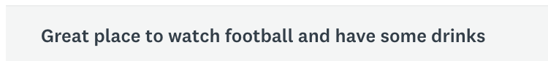

Negative comments:



    - Main Reasons For Visiting Walkabout

The respondents were asked to choose from a range of reasons on why they have visited the venue. Out of the 6 options, the most popular was the ‘Music’ with 16 votes or 33.3% (Out of the total 48 who have already been in Walkabout).

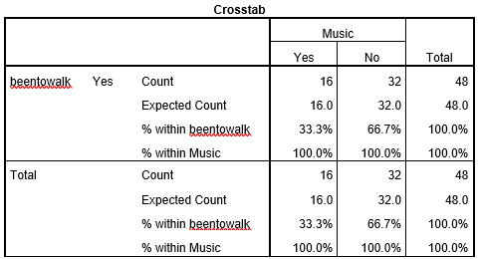

    - Main Reasons For Visiting Walkabout 2

Furthermore, out of the 6 options, the second most popular one was the ‘Sport’ with 13 answers, or 27%. (out of the 48 respondents who have already been in Walkabout).
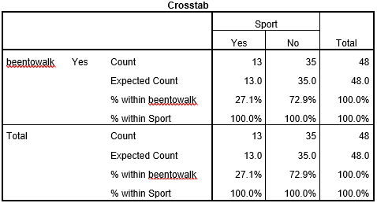

    - Walkabout Improvements

The survey-takers were also asked on their opinion if Walkabout needed to work on some improvements regarding certain aspects of the business. Out of 9 options, the most sought-after improvement Walkabout needs to improve on is its current drink prices. Out of the total 48 respondents who have visited Walkabout in the past 33.3% would like to see cheaper drink prices.
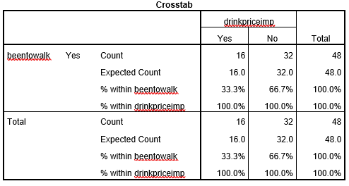
Furthermore, the second most popular improvement needed in the venue (based off the survey) was the Hygiene, with a 25% answer rate out of 48 respondents, and a total of 12 votes.

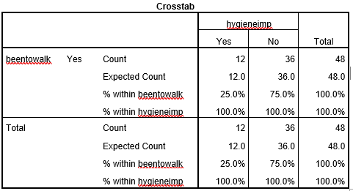

    - Fiction Customer Priorities

On the next analysis it is visible that out of the 13 people who normally go to Fiction (one of the main Walkabout competitor),11 has chosen the ‘low drink prices’ options when asked about their priorities when visiting a night-club venue.
Secondly, out of the respondents who have chosen another venue as their regular one (the remaining 35), 26 has also chosen that one of their main priorities are the low drink prices. The total respondents who have answered with ‘Low Drink Prices’ are 37 out of 48, or 77%.
Interestingly, the number one improvement that was voted for Walkabout was their drink prices and the table below makes it obvious that one of the main motivators when it comes to a night-club venue are the prices.
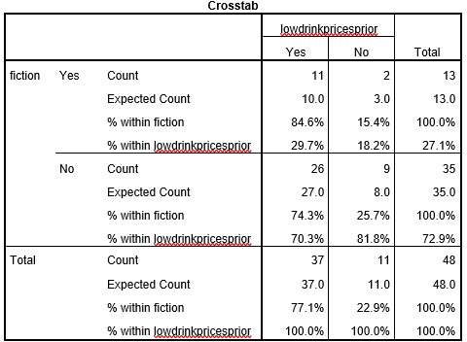

Moreover, the second most popular priority amongst the people who regularly go to Fiction is a busy dance floor. The total number of votes on this option was 10 out of 13. However, when taken into account all of the respondents, almost 46% said they prefer a busy dance floor.
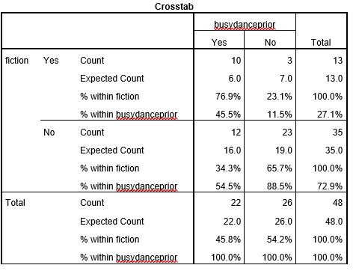

    - Sin City Customer Priorities

As Walkabout’s second biggest competitor (based off the survey results), the consultant analyzed Sin City as well when it came to the priorities of consumers visiting night-club venues; this was crucial as understanding competitor trends and techniques can be extremely beneficial. Out of the 18 people that regularly visit Sin City, 15, or 83% have voted for the ‘Low Drink Prices’ option when asked about priorities.
The table proves that two relevant Walkabout competitors draw in the bulk of their audience by providing them with low drink prices.
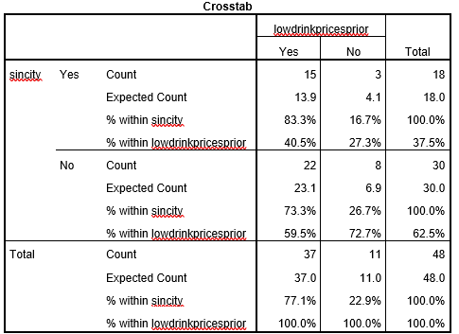

Furthermore, the second most voted for priority for those who frequent Sin City is the ‘Music’. On the table below it is clear that out of 18 people who regularly visit Sin City, 12 prioritizes the music that is being played in the venue.
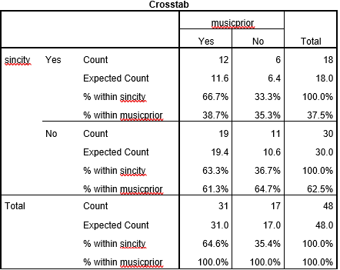

Lastly, the third most voted for priority for those who normally visit Sin City is the busy dance floor; 11 out of 18 people have the music as one of their main priorities as it is seen on the table below.
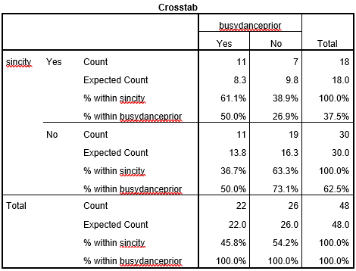

    - Walkabout opening hours

The last question on the survey was whether the respondents would prefer Walkabout to close at 4 am instead of the usual 3 am. By looking at the table below the younger age groups (from 18 to 29) would prefer to stay until 4 am while the older age groups prefer an earlier close. Overall, out of the 55 respondents 24 voted for a 4 am close and 20 voted for a 3 am close (one respondent skipped).

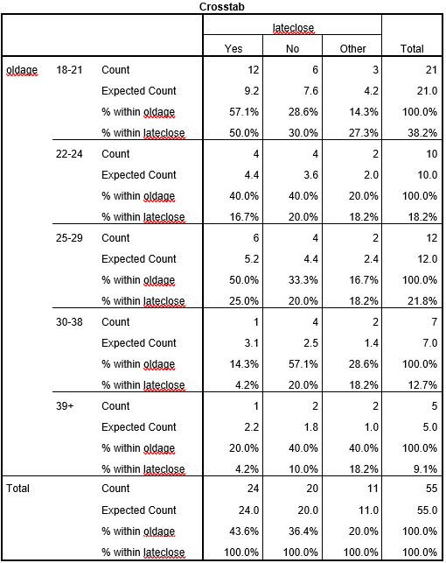

  - Primary Research - Mystery Shopper

In order to compare Walkabout to two of its competitors: Fiction and Sin City, the consultant visited all 3 locations in order to realize their main differences and identify each venue’s key selling points.

    - Walkabout Mystery Shopper

Walkabout is an Australian themed sports bar and just by looking at its brand it is obvious that it is different from a regular night-club. The dance floor and the music events are just one way they can motivate people to visit them. During the day and early evenings, people mostly visit the venue to watch sports with their screen-filled rooms and private sections. The fact that the venue is able to draw in a different audience certainly serves as an advantage.
Walkabout is one of the first venues found on Wind Street (from the northern entrance) which also gives them an opportunity to grab the customers attention with posters/stands/flyers/screens/etc.
The venue normally closes at 3 am on Wednesdays, Fridays and Saturdays, although if there is a special event it will stay open longer. Depending on the beverage a pint costs anything from 3.65 pounds to 4.75 (regular pricing). A single Smirnoff Vodka with a mixer costs 4.05 pounds (or 5.55 for a double). Customers can purchase a ‘mates rates’ card however in the venue, which offers them great deals. With the card the prices go down to 2 pounds for specific pints and half priced spirits (the most popular ones).
As the consultant works in Walkabout, it became obvious that most of the customers did not know how to obtain the cards even though it is clearly explained on the website.

    - Fiction Mystery Shopper

Fiction is located on the opposite side of the Wind Street compared to Walkabout. The venue in itself is entirely different as it is designed to be a solely a night-club venue and has no other purpose to it. Due to this nature, Fiction is closed on Tuesdays, Thursdays and Sundays. On the consultants visit on a Wednesday, the venue was almost full, and people were queued up constantly at their doors. There are three different dancing areas in Fiction with different music styles.
The drink prices were slightly different to the ones in Walkabout, surprisingly, even though the venue feels slightly more exclusive a double vodka’s cost was only 3.10 pounds (this is subject to change on different days) and a pint of Coors was 2.30 pounds. When it came to the deals and offers that they had it was not exactly obvious what was discounted but the servers were happy to let the consumers know if asked. Overall the queues were slightly long at the door and at the bar due to all the people being there, but the atmosphere was great and the customers were obviously enjoying themselves.

    - Sin City Mystery Shopper

Sin City is located on a different street in the City Center in front of a popular pub, Potter’s Wheel. The venue is notorious of its long queues on Thursdays as it is one of the most popular venues to go. Its popularity is potentially due to the fact that their drink prices are probably the lowest in the city (1.80 pounds for a double vodka + mixer). Sin City also has multiple rooms with different styles of music (Hip Hop, Electronic, Old-school) to suit everybody’s preferences.
The Sin City opening hours are 10pm till 3 am on most days, except on Saturday when its open until 4 am and on Wednesdays and Sundays its closed.
The venue feels old, worn down, the floor is usually is not cleaned up properly and customers sometimes can spot mold spots on the ceiling but ultimately on most Thursdays the venue is packed with students who enjoy the drink discounts and the good music they put on.

- Discussion & Analysis

The first primary research method the consultant has used was an online survey in order to target a larger audience and the actual survey was done in an average of 2 minutes so anybody could answer it in a fast manner resulting in more answers that the consultant has expected. The total number of answers were 55, 38 of them were male and 21 of those respondents were between the age of 18 to 21. The main reason the consultant got mostly answers from the younger age bracket is because the online survey was shared on facebook by university students who mostly have other similarly aged friends online. Secondly, the younger generation tends to use the internet much more than the older groups.
Looking at the tables listed in the findings section it is possible to identify weaknesses, strengths, opportunities to improve and the actual direction the business needs to take to improve. With the help of the survey analysis the consultant identified that the main audience that visits Walkabout are between the age of 18 to 21. It is also clear by looking at the numbers that as older the age group gets number of people preferring Walkabout goes down.
The consultant identified the two main competitors based off the survey respondents by looking at the age groups 18-21, 22-24, 25-29 which is the main target market for Walkabout; between these age groups the two most popular venues they visit regularly were Fiction and Sin City. Afterwards, it was crucial to know the main priorities of the customers that visit night-clubs in order to have the opportunity the tailor the venue for a wider audience. The ‘low drink prices’ was the most popular option as out of 21 people between the age of 18 to 21, 17 voted for it. Furthermore, 90% of the people in the 22-24 age group also supported the option. On the other hand, as karaoke is a popular pub/club entertainment, surprisingly out of the total of 55 respondents 0% voted for it as a priority when visiting a venue.
It was also important to understand how many people have already been to Walkabout as later on in the questionnaire it was crucial to use the data from those people who have already visited, in order to ensure valid data (this was used every time that Walkabout specific questions were asked). Out of the 55 respondents 48 have visited Walkabout which proves to be a great number and shows that it is an attractive venue in a perfect location although the venue struggles to keep its customers there due to numerous reasons. Out of these 48 people 20 would visit the venue again although 28 have chosen different clubs/pubs.
Interestingly, when asked for a reason of their visit, most people responded with ‘Sport’ or ‘Music’ for Walkabout (27% and 33%) which proves that there are 2 main audiences that are targeted with the sports bar theme. During the day the venue offers sports, food and a more relaxed atmosphere but after 10pm the venue can turn into a dance floor. In relation with drink prices, all of the data that can be related to it shows that the majority of the respondents have low drink prices as their number one priority when choosing a venue. When asked to choose from different options on what Walkabout can improve on, 33% answered with drink prices, and 25% answered with hygiene. Similarly, when asked about their priorities, 41 people out of 55 answered with low drink prices which ultimately proves that price is what matters most to the younger generation especially for students. It is also a possibility that most of the people are not aware that they are eligible of purchasing a ‘mates rates’ card from Walkabout which would enable them to enjoy the same beverages (specific drinks) on a discounted rate.
The last comparison that has been created between Walkabout and two of its competitors was to look at the respondent’s priorities when it came to Sin City and Fiction and compare that result with the improvements that have been suggested. It is clear that both Fiction and Sin City attract people who prioritize low drink prices and this serves as one of the main reasons of their visit. Also both of these places had high number of votes on the ‘busy dance floor’ option which was also one of the things that have been lacking in Walkabout. The comments that the consultant has received regarding the customer experiences in Walkabout also suggest that people think of the venue as a ‘hit or miss’ night-club: sometimes it is completely empty and other times people find themselves surrounded by hundreds of other customers.

- Conclusions

By the analysis that has been done on the data gathered from the survey and the ‘mystery shopper’ visits, the consultant can conclude that Walkabout is indeed a known venue around the Swansea area and amongst the students. It is also a great venue where people can watch sports and have drinks/food, but it is also great for late night parties on certain days. The main target market for the venue are mainly the people between the ages of 18 to 29 but the older generation is extremely important as well because even though they did not answer the survey in great numbers due to a number of reasons, there are regular visitors who come in for the sport or after work to meet with their friends. By analyzing the preferences amongst the larger age group (18-29) it became clear that the most important aspect of a night out for them is the low drink prices and a busy dace floor. Based off the numbers in the survey Walkabout does not have consistent, quality parties each night they are open and if customers experience the atmosphere when it is almost empty, they might not return due to the bad first experience. Secondly, students and respondents thought that the drink prices are too high – both in Fiction and Sin City, the drink prices were significantly cheaper when compared to Walkabout.

  - Aims And Objectives Outcome

As it was initially stated in the Project Initiation Document one of the main aims of the report was to prove the importance of deals and different periods when the beverages are cheaper in order to bring in a whole new audience (who would otherwise go to another venue such as Fiction or Sin City) and keep them there as well. With the removal of ‘Happy Hour’ on Saturdays this became much more needed at this stage and the consultant would be happy to follow up with a new project which would focus on the deals specifically and find a way to satisfy the needs of those people, who prioritize low drink prices. It is also understandable that this might be complicated due to Walkabout being part of a franchise and in most cases the processes/strategies can not be as flexible as they could be.

The mystery shopper experiment also turned out to be supportive of the fact that those places that are full usually involve great discounts on drinks and a variety of music genres. Conversely, due to the nature of the venue (Walkabout) it is obvious that there are certain limitations the venue can and can not do or change, which is absolutely understandable (especially if said venue is part of a franchise).

- Recommendations

Based on the facts that have been concluded, the consultant prepared a list of recommendations that he believes would ultimately benefit the Walkabout Swansea venue:
- Strengthen current marketing strategies, focus more on the people aged between 18 and 29. (VIP Package/Drink Tab giveaways on social media to increase awareness and number of likes on social media outlets)
- Better use of marketing materials in and outside of venue – when sports are not shown, use the screens to play a slideshow of the latest deals, events, offers, club cards that are available for anybody.
- Communicate with Headquarters and try to push for more deals that could replace ‘Happy Hour’ (good deals are a great excuse for advertising)

- Appendices

- Blank Survey Example

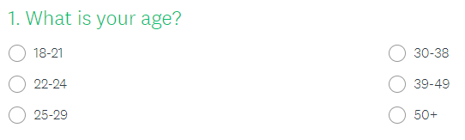.
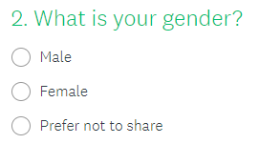
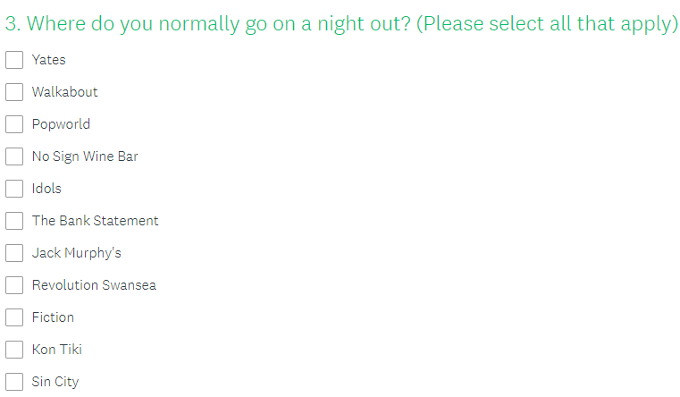
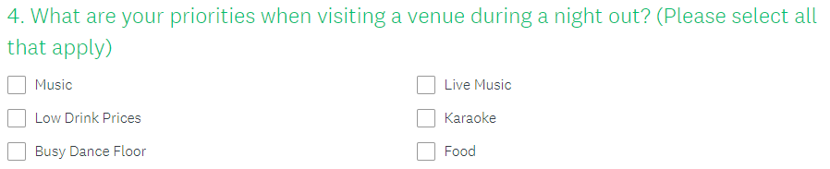

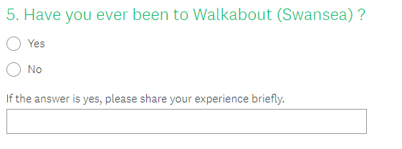
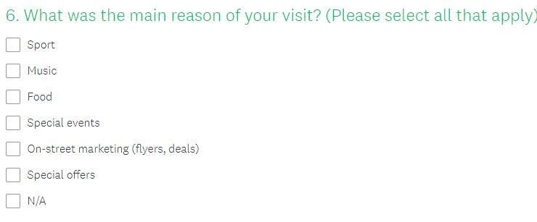
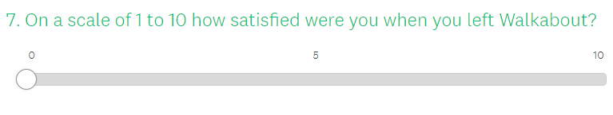


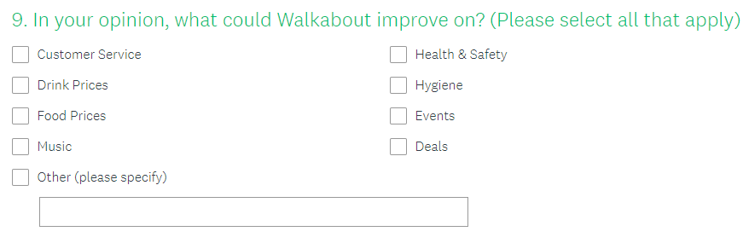

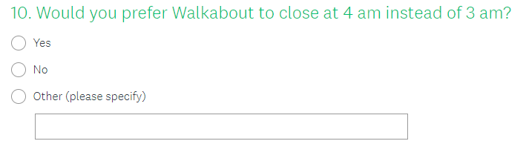
- Meetings

4th of March, 17:00, Rob Nangalia (Deputy Manager) & Marios Yiannou (General Manager)
25th of March, 18:00, Rob Nangalia & Matthew Cassidy (General Manager)
27th of April, 21:00, Rob Nangalia & Matthew Cassidy

- References
No academic literature was used to create the Consultancy Project Report.

