Assignment 2
Menu Engineering (Practical Task)

Student Name: Silvia Daniela Grecu
ID number: 2245642
Lecturer: Antoinette Milne, Ka Po Chong, Philippa Fitzgerald
BMIH4002
Food & Beverage Operations

PART 1: Restaurant Concept

Explaining the new restaurant concept, the target audience, and is very important in choosing the menu for the consumers.
The restaurant's concept is "Hotel Trinity," which is a conventional hotel that offers a variety of food to patrons. In the United Kingdom, Hotel Trinity is a four-star city center hotel that is a member of the Trinity Hotel group (Franceschelli et al., 2017). In addition to a variety of guest services including security, concierge, and room services, it provides lodging amenities like air conditioning, plumbing, elevators, and lighting. The Christmas Party idea serves as the foundation for the new hotel. (J. and HOPKINS, 2015) Venturing outside the conventional hotel industry, it will provide London's hotel services enthusiasts with some distinctive menu options. (CHADWICK, 2016) The primary asset of this hotel will be its public relations, which will enable it to expand quickly within the well-established UK hotel services and beverage sector. This hotel will not cut corners on the quality of its offerings (Hegde et al., 2017).
Since "Hotel Trinity" is a new company, it will carefully choose its target market and then concentrate on this market segment to win them over as devoted clients. The young between the ages of 16 and 40 are the new hotel's primary target market (Salamin et al., 2019). This target market is ideal for this company since they are always experimenting with new products and varieties. To understand the preferences and tastes of its guests, the hotel's management will collect a lot of consumer data. It will mainly provide the patrons with various hotel services products and beverages. (BUTTLE, 2016) However, the hotel will make sure that its guests feel so welcome that they will return time and time again. (P and BOWEN, et al, 2016) After that, segment marketing will be conducted with this target group in mind. Even though guests of all ages will get the standard hotel amenities, segment marketing will enable this establishment to cultivate a devoted clientele within its intended market (Jung et al., 2019).

The "Hotel Trinity" menu will have a variety of food and drink selections suitable for all age groups, with a focus on the intended market. The Christmas Party idea serves as the foundation for the new hotel. This hotel will get its raw materials from nearby farmers and choose the highest-quality veggies. (BLYTHE and MARTIN, 2016) It will thus be able to provide clients with freshly prepared hotel service meals. Additionally, this hotel will provide conventional hotel fare from many countries, giving guests a chance to experience new flavors. Customer satisfaction will rise as a result of the attractive decoration of the hotel services products. For guests of various economic levels to experience a variety of hotel amenities, "Hotel Trinity" also makes sure that the rates are fair (Lu et al., 2017).

Part 2: Menu Design
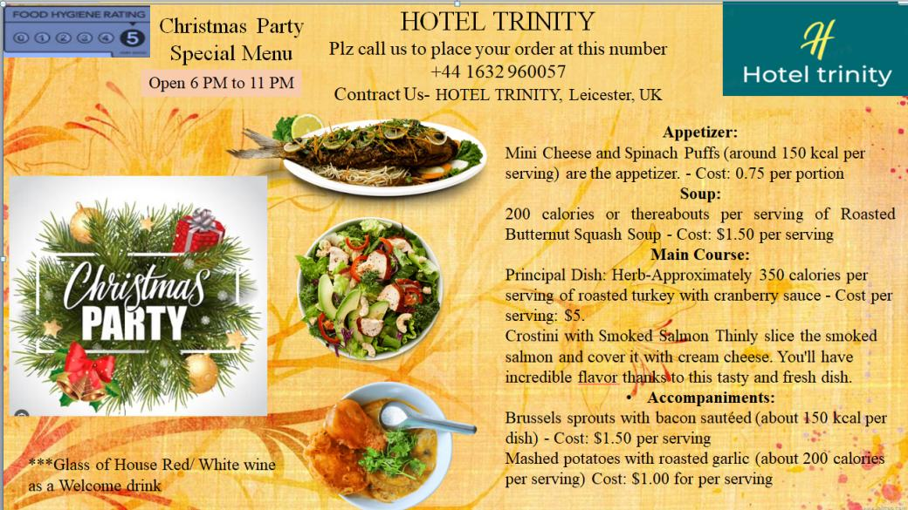
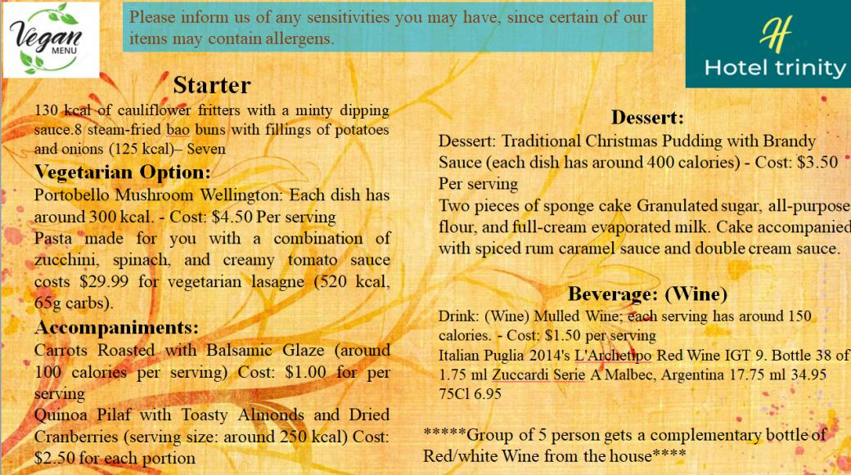

References
BLYTHE, J. and MARTIN, J. (2016) Essentials of Marketing. 3rd ed. Harlow: Pearson. BOWIE, D
BUTTLE, F. (2016) Hospitality Marketing: Principles and Practice. 3rd ed. Oxford: Routledge. GROUCUTT,
CHADWICK, F. (2016) Principles and Practice of Marketing. 8th ed. Maidenhead: McGraw-Hill. KOTLER
Franceschelli, M. V., Santoro, G., & Candelo, E. (2018). Business model innovation for sustainability: a food start-up case study. British Food Journal.
Hegde, S., Satyappanavar, S., & Setty, S. (2017, September). Restaurant setup business analysis using Yelp dataset. In 2017 International Conference on Advances in Computing, Communications and Informatics (ICACCI) (pp. 2342-2348). IEEE.
J. and HOPKINS, C. (2015) Marketing (Business Briefings). London: Palgrave Macmillan. JOBBER, D.
Jung, S. S., & Jang, S. S. (2019). To cluster or not to cluster? Understanding geographic clustering by restaurant segment. International Journal of Hospitality Management, 77, 448-457. FB
Lu, L., & Gursoy, D. (2017). Does offering an organic food menu help restaurants excel in competition? An examination of diners’ decision-making. International Journal of Hospitality Management, 63, 72-81.
P. and BOWEN, J. et al. (2016) Marketing for Hospitality and Tourism. 7th ed. Harlow: Pearson.
Salamin, P. P., & Hermawan, F. (2019). Financial Planning Model for Establishing a New Business a Case Study on “Blue Ocean” Restaurant. Jurnal Manajemen Bisnis, 10(2), 246-255.

