

Programme: MSc Public Health and Social Care in Practice

Module: Community Care and Management of Longer-term

Conditions

Module Code: LCHS7003

Evidence-Based Management and Person-Centred Care within the NHS

Assessment Title: Component 1 Information Booklet of Long-term Condition Management

Long-Term Condition Selected: Living With Chronic Kidney Disease (Ckd): An Information Booklet For Service Users And Healthcare Professionals In The Uk

Student Name: Dhruvisha Prajapati

Student Number:2542085

Lecturer: Muhammad Khan

Submission Date: 17-07-2026

Word Count: 3201

Executive Summary
Chronic Kidney Disease (CKD) is a progressive progressive disorder that impacts millions of individuals around the world and poses an increasing challenge to the health of the population of the United Kingdom. This evidence-based booklet will give an overview of CKD, its definition, prevalence, causes and key risk factors, as well as the physical, psychological and social consequences of the illness on individuals, families and carers. It defines existing NHS evidence-based practice, such as pharmacological intervention, lifestyle change, dialysis, kidney transplant and psychological support.
The booklet looks at how the NHS House of Care Framework and the World Health Organization approach to Innovative Care for Chronic Conditions (ICCC) Framework can be used to enhance long-term CKD management, as well. National and regional policy options, such as the NHS Long Term Plan, 10-Year Health Plan, NICE guidelines, Integrated Care Systems and Renal Networks are critically addressed alongside current implementation issues. Lastly, suggestions are given to enhance person centred, culturally aware and multidisciplinary care, augment self-management and encourage use of conservative kidney management where necessary. The booklet in general, emphasizes the need to diagnose early, to coordinate healthcare and equal access to renal services as a measure of enhancing patient outcome and ensuring long term CKD care in the UK.
Table of Contents
Executive Summary 2
1. Introduction 5
Purpose and Scope of the Booklet 5
Target Audience and Rationale for Topic Selection 5
2. Understanding Chronic Kidney Disease (CKD): Definition, Burden and Aetiology 5
Definition and Clinical Features (KDIGO Classification) 5
Global Prevalence and Burden 6
UK Prevalence and Burden (NHS Data 2025–2026) 6
Risk Factors and Aetiology 7
Genetic and Biological Factors 7
Lifestyle and Metabolic Factors 7
Ethnicity and Sociodemographic Considerations 7
3. Impact of CKD and Evidence-Based NHS Treatments 8
Physical Impact on the Individual 8
Psychological Impact on the Individual 8
Social Impact on the Individual 8
Wider Implications for Families and Carers 9
Evidence-Based NHS Treatments 9
Pharmacological Management 9
Lifestyle and Behavioural Interventions 9
Dialysis, Kidney Transplantation and Specialist Services 10
Mental Health Support Pathways 10
4. Theoretical Perspectives and Models for Improved Outcomes 11
UK Model: NHS House of Care Framework 11
International Model: WHO Innovative Care for Chronic Conditions (ICCC) Framework 11
Critical Comparison and Application to CKD Care 12
5. Local and National Policy Agendas 13
National Agendas 13
NHS Long Term Plan and 10-Year Health Plan 13
NICE Guidance Relevant to CKD 13
Local Agendas 13
Critical Examination of Policy Implementation Gaps 14
6. Recommendations for Person-Centred Care 14
Person-Centred and Culturally Sensitive Approaches 14
Self-Management Support Strategies 15
Multidisciplinary and Lifelong Care Considerations 15
End-of-Life and Conservative Kidney Management 15
7. Conclusion 16
Reference List 17

1. Introduction

Purpose and Scope of the Booklet
The booklet is evidence-based information about Chronic Kidney Disease (CKD), a long-term progressive disease, which involves a gradual loss in kidney activity. It describes CKD definition, co-morbidities, risk factors, physical, psychological and social effects, evidence-based NHS treatment pathways, theoretical models of care, UK health policies and person-centred advice in a bid to help people improve disease prevention and management.

Target Audience and Rationale for Topic Selection
The target audience of the booklet is UK service users, carers and healthcare professionals. The choice of CKD is based on the fact that it is an expanding health issue in the population where an estimated 7.2 million individuals in the UK will have CKD in 2025 and WHO reported that there are 674 million individuals with CKD and multidisciplinary care and effective long-term management are required (National Kidney Federation, 2025).

2. Understanding Chronic Kidney Disease (CKD): Definition, Burden and Aetiology

Definition and Clinical Features (KDIGO Classification)
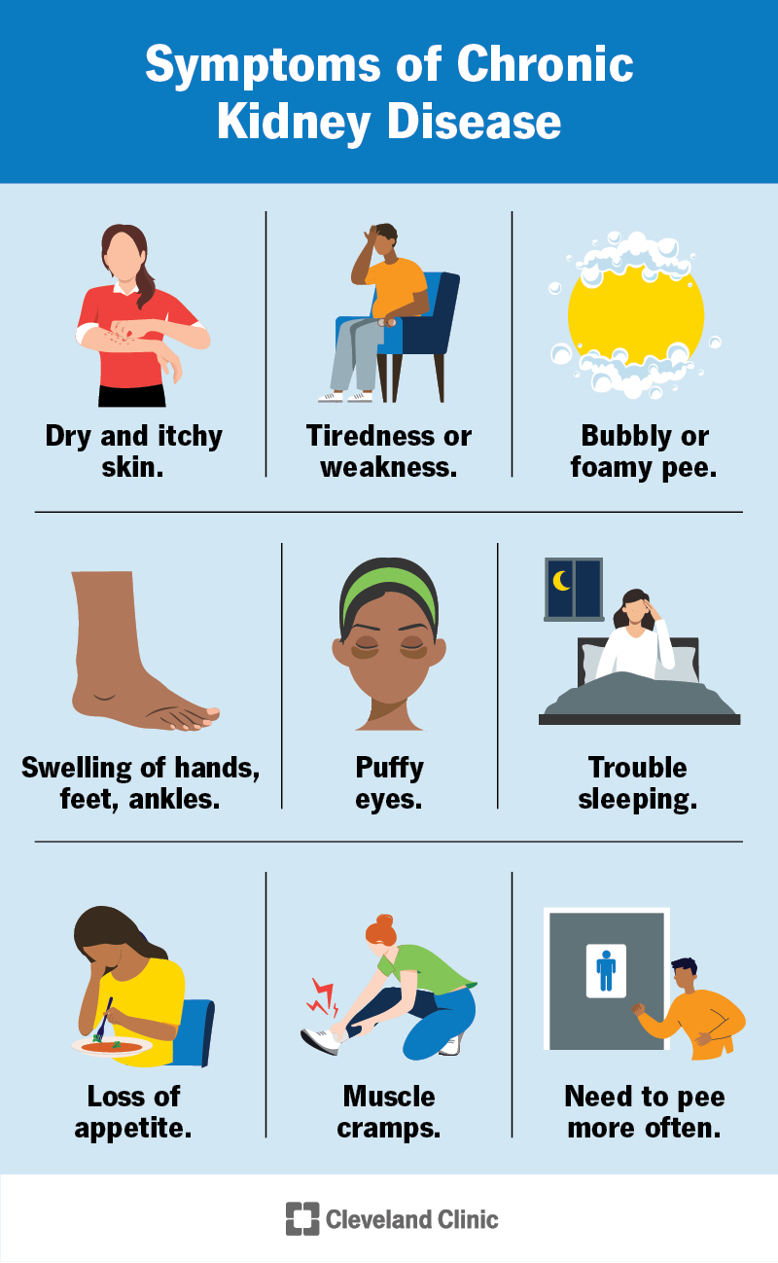
Figure 1: Symptoms of CKD
(Source: Cleveland Clinic, 2023)
Chronic Kidney Disease (CKD) is a progressive disorder, which is diagnosed by disruption in kidney structure or performance and continuing at least three months with detrimental effect on health. The Kidney Disease: Improving Global Outcomes (KDIGO) classification include stages of CKD based on template glomerular filtration rate (eGFR) (G1–G5) and albuminuria (A1–A3) that allow clinicians anticipate disease progression and cardiovascular risk (Aeddula and Vaidya, 2024). The initial stages of CKD often do not lead to any symptoms, but the CKD when in its advanced condition creates symptoms such as fatigue, oedema, hypertension, anaemia, electrolyte unbalance and decreased urine output (Cleveland Clinic, 2023).

Global Prevalence and Burden
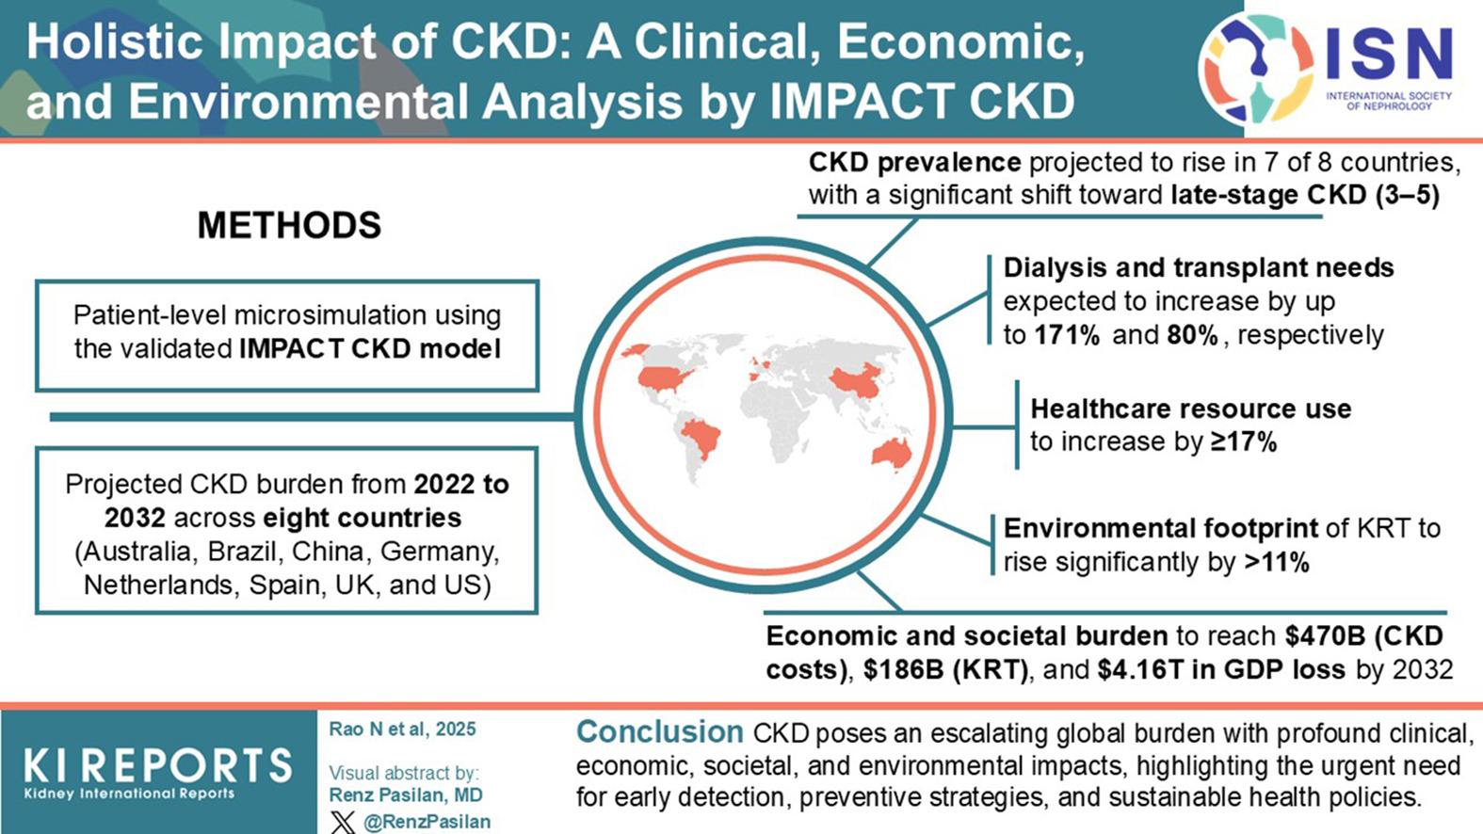
Figure 2: Global Burden of CKD
(Source: Brown et al., 2024)
CKD has come to be a considerable international health issue. The most recent estimates have suggested that CKD impacts around 13 percent of the global population with current evidence also released in 2026 estimating that, globally 850 million individuals are living with kidney disease of which 4.6 million are undergoing kidney replacement therapy (Brown et al., 2024). The global burden of CKD is estimated to be about 1.5 million deaths per year with the disease becoming the fifth cause of premature death by the year 2040 due to ageing of the population, diabetes, hypertension and obesity (Wang et al., 2025).

UK Prevalence and Burden (NHS Data 2025–2026)
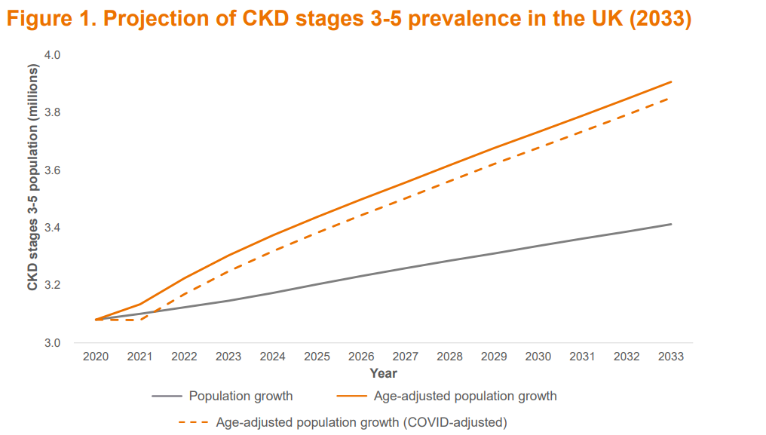
Figure 3: Projection of CKD stages 3-5 prevalence in the UK (2033)
(Source: Agathangelou et al., 2025)
The incidence of CKD in the United Kingdom is still on the rise. By 2025, approximately 7.2 million individuals in the UK had CKD, which is over ten per cent of the population, and NHS spending is estimated to be over 6.4 billion each year. Recent forecasts show that the direct NHS expenditures may rise to over 10.9 billion by 2033 unless disease development is averted. CKD is known to increase hospital admissions, cardiovascular morbidity and worse quality of life and constitutes a significant burden on NHS renal services and Integrated Care Systems (Agathangelou et al., 2025).

Risk Factors and Aetiology
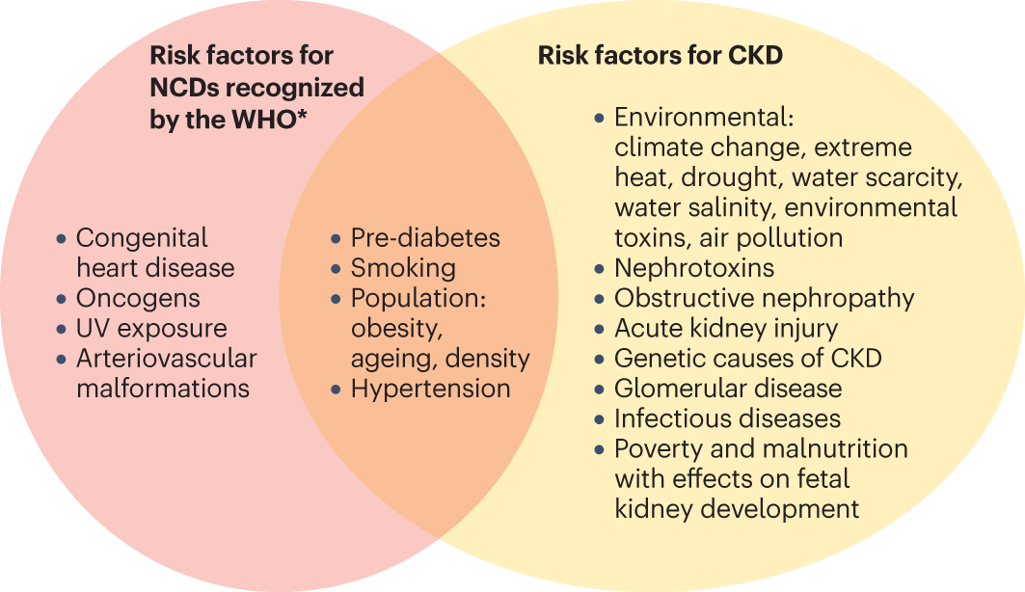
Figure 4: Risk Factors and Aetiology of CKD
(Source: Francis et al., 2024)

Genetic and Biological Factors
CKD is predisposed by inherited diseases like polycystic kidney disease, congenital kidney abnormalities and a family history of kidney disease. Biological ageing also causes a lower kidney performance, whereas diabetes mellitus, hypertension and autoimmune conditions are the main medical factors of the progressive kidney damage.

Lifestyle and Metabolic Factors
Among the risk factors are lifestyle variables such as obesity, smoking, inactivity, poor diets that contain high amounts of salt, and alcoholism. Nephrons damage and accelerate progression to kidney failure due to poor glycemic regulation, unregulated hypertension and metabolic syndrome (Francis et al., 2024).

Ethnicity and Sociodemographic Considerations
People of low income and socioeconomic status, South Asian and black communities are disproportionately affected by CKD due to increased rates of diabetes and high blood pressure and inequalities in access to healthcare. It is always observed that social deprivation correlates with increased prevalence of CKD and adverse clinical outcomes indicating the need to address the issue of CKD early and with cultural awareness and equitable access to preventive renal service throughout the UK (Mancini et al., 2026).

3. Impact of CKD and Evidence-Based NHS Treatments

Physical Impact on the Individual
Kidney disease (CKD) leads to the gradual deterioration of the kidney, impacting many other systems of the body and considerably lowering the quality of life. The initial CKD may be asymptomatic, so most individuals are only diagnosed when their kidney has sustained considerable irreparably damage. When the disease progresses, people usually feel tiresome, hypertensives, inflammation, anaemia, nausea, muscle dysfunctioning and reduced physical activity, which limits their performance in daily activities (Mayo Clinic, 2023). According to Kidney Care UK (2026), over 70 000 individuals in the UK have access to kidney replacement therapy, and just over 20 individuals are diagnosed with kidney failure each day, which states that the impact of CKD on people and the NHS has been increasing (Kidney Care UK, 2026).

Psychological Impact on the Individual
A high psychological impact of CKD is the fact that due to this disease, a person must deal with it all their lives and doubts about the progression of the disease. Patients undergoing dialysis or awaiting kidney transplantation are particularly prone to anxiety, depression, stress and emotional distress (Marin et al., 2023). These psychological problems tend to decrease adherence to treatment, compliance to medication and follow up visits, which may speed up the disease process and deteriorate the locations of the clinical results. Psychological support and patient education are therefore significant towards enhancing overall wellbeing and self-management (American Kidney Fund, 2022).

Social Impact on the Individual
CKD may limit work and education and social activities because of frequent hospital visits, dialysis regimes and deteriorating health. Some of the patients get economically stranded by their decreased workability and higher costs associated with healthcare (Alma et al., 2022). According to Borden et al., (2023), Black people have a higher chance of needing kidney replacement therapy approximately five times in comparison with White people, which echoed inequalities in health and unequal access to preventive healthcare services. Such inequalities are contributory factors of the worst long-term performance of the disadvantaged groups.

Wider Implications for Families and Carers
Families and carers play a vital role in offering necessary emotional, practical and financial care by helping to manage medications, as well as dietary needs, transport and home dialysis. Nonetheless, the outcomes of long-term care giving are often caregiver burden, stress, fatigue and financial pressure. Education of carers, psychological support and access to community services can enhance patient outcomes and wellbeing of caregivers (Marin et al., 2023).

Evidence-Based NHS Treatments

Pharmacological Management
NHS treatment is to slow the progression of CKD, manage the complications and decrease cardiovascular risk. Angiotensin receptor blockers (ARBs) and ACE inhibitors continue to be the preferred treatment to manage blood pressure and albuminuria (Murray et al., 2026). Recent NICE recommendations still recommend the use of SGLT2 inhibitors (such as dapagliflozin) in eligible patients since they considerably lower CKD fluctuations and cardiovascular incidents. Other medications consist of cardiovascular protection with statins, anaemia with erythropoiesis-stimulating drugs, mineral and bone disorders with phosphate binders and vitamin D supplementation (Anjali Avula et al., 2025). Consistently checking the condition of kidneys, blood pressure, electrolyte levels allows to make timely changes to treatment and minimize the complications.

Lifestyle and Behavioural Interventions
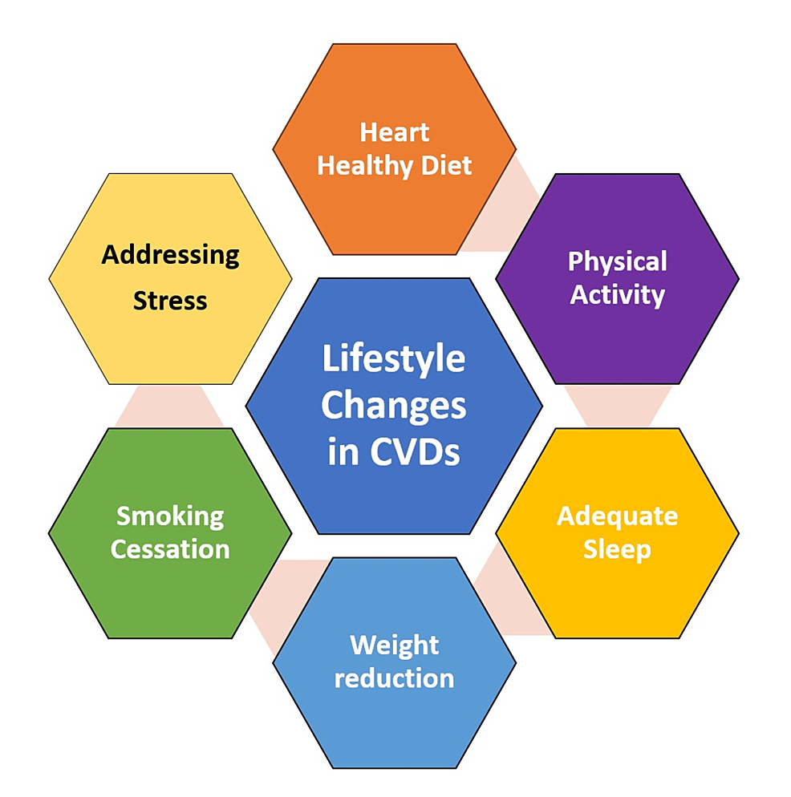
Figure 5: Lifestyle Management of CKD
(Source: Ghodeshwar, Dube and Khobragade, 2023)
Changes in lifestyle continue to be core to management of CKDs. The NHS recommends cessation of smoking, exercising, healthy weight, a decrease in salt in the diet and optimal management of diabetes and high blood pressure. Specialist renal dietitians provide individualized dietary recommendations to control protein, potassium and phosphate levels based on CKD stage. Early detection and treatment by regular screening of high-risk groups and NHS Health Checks can be made routine. Under NHS programmes of prevention that will be implemented during 2025-2026, prevention efforts remain focused on early detection and self-management of long-term conditions, such as CKD (Ghodeshwar, Dube and Khobragade, 2023).

Dialysis, Kidney Transplantation and Specialist Services
End-stage kidney disease is a condition of kidney failure that needs to be replaced by dialysis or transplantation. When the kidney functions cannot adequately work, waste products and excess fluid are eliminated through haemodialysis and peritoneal dialysis. The preferred treatment is kidney transplantation though because it is better survival and surpasses long-term dialysis that is independent and has a higher quality of life. Kidney Care UK (2026) claims that about 3,300 kidney transplants are carried out in the UK every year, but almost 6,939 individuals still stand on the list of patients waiting for transplantation, and according to this case, the lack of donor organs is still observed (Earl, 2025).

Mental Health Support Pathways
Increasingly, psychological services receive important focus in the renal services of the NHS so that the emotional burden of CKD can be relieved. NHS Talking Therapies, counselling and cognitive behavioural therapy are available to patients via primary care or renal psychology specialist team friends (NHS website, 2025). Regular psychological screening is recommended in renal checkups especially in patients that have just started dialysis or undergoing transplantation. There are also charitable organizations like Kidney Care UK that offer education, peer support groups and helplines which supplement services by the NHS (Kidney Care UK, 2026).

4. Theoretical Perspectives and Models for Improved Outcomes

UK Model: NHS House of Care Framework
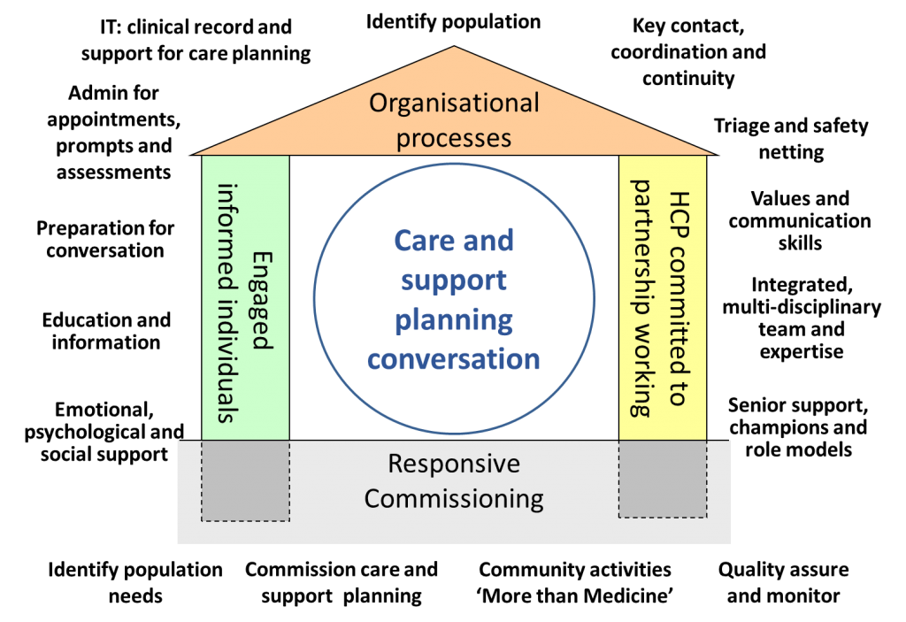
Figure 6: NHS house of Care Framework
(Source: NHS England, 2024)
The NHS House of Care Framework encourages individual management of long-term conditions by promoting shared decision-making and multidisciplinary coordinated care. It is made up of four inter-related components, namely, informed patients, collaborative healthcare professionals, supportive organizational systems and effective commissioning (NHS England, 2024). In the case of CKD, the framework fosters individual care planning, regular monitoring of kidney functionality, medication adherence, lifestyle education and multicolored collaboration of the general practitioner, nephrologist, nurse, dietician and pharmacist. This combined method enhances self-management, treatment compliance and continuity. The framework is concise with the NHS 10-Year Health Plan (2025), which focuses more on prevention, digital innovation and community-based management of chronic conditions, and assisting in earlier intervention and decrease in avoidable hospital readmission (NHS Scotland, 2026).

International Model: WHO Innovative Care for Chronic Conditions (ICCC) Framework
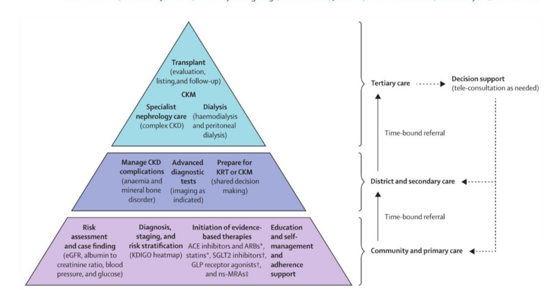
Figure 7: ICCC Framework for CKD (Source: Boris, 2026)
The WHO Innovative Care for Chronic Conditions (ICCC) Framework is a framework that fosters integrated management of chronic diseases by ensuring that governments, healthcare organizations, communities and patients work together. It is a framework working at the macro, meso and micro levels to enhance the health policy, service delivery and patient interaction. In the case of CKD, it promotes early screening, equal access to care, multidisciplinary care and community engagement (Marshall, Virdun and Phillips, 2025). At the World Health Association (May 2025), the first global resolution on kidney health was adopted and included a list of countries recognizing kidney disease as a primary element of public health and proposing countries take actions to strengthen prevention and integrated care (Parmar, 2025). Kidney disease encompasses acute kidney injury (AKI) and chronic kidney disease (CKD) where CKD affects an estimated 674 million individuals around the world the majority of whom are in the low- and middle-income countries (WHO, 2026). Simple blood tests, serum creatinine and urine tests of albuminuria can easily be used to detect chronic kidney disease at an early stage by primary healthcare services. The kidney failure is the most progressive form of CKD that needs dialysis or kidney transplantation to keep the patient alive, and the global burden of acute kidney injury (AKI) is still uncertain (American Kidney Fund, 2021).

Critical Comparison and Application to CKD Care
Both models pay more attention to a person-centered approach to multidisciplinary care, yet they are different regarding the focus. Building on works of Chang et al. (2024), the NHS House of Care provides guidance on the practical implementations of coordinated CKD services in the UK primary and secondary care, but the WHO ICCC framework focuses on health system-wide reform, policy formulation and community collaboration. A combination of both solutions creates a holistic approach of combining individualized clinical management with population prevention and health equity measures. Gandhi (2025) in her reports states that this unified model is specifically significant since in the UK, some 7.2 million individuals were living with CKD in 2025, which poses significant pressure on NHS services. Combination of both frameworks can be used to enhance early early diagnosis, patient engagement, continuity of care and long-term clinical outcomes as well as contribute to an equitable access to renal healthcare. Moreover, the combination of these frameworks will promote closer interactions among healthcare professionals, community organizations, and patients and result in more coordinated and sustainable CKD management (Hirsch et al., 2024). Finally, the use of the NHS House of Care as well as the WHO ICCC paradigm will help to elevate clinical outcomes, better the quality of life for patients, and contribute to the overall sustainability of renal healthcare in the UK.

5. Local and National Policy Agendas

National Agendas

NHS Long Term Plan and 10-Year Health Plan
The NHS Long Term Plan and 10-Year Health Plan for England (2025) focus on three significant changes in healthcare delivery: the shift to preventive care rather than treatment, the shift to community care rather than hospital care and the shift to digital care rather than analogue care (Taggar, Carson and Patel, 2025). These priorities help detect and manage CKD earlier with the assistance of a regular check-up, combined care and enhanced digital access to patients records. Nonetheless, kidney organisations have pointed out that although over 7 million individuals in the UK are living with kidney disease, CKD is not explicitly covered in the national strategy. The UK Kidney Association has, in turn, urged the UK government to implement a national kidney plan in order to enhance prevention, labor force, and equal access to renal facilities (UK Kidney Association, 2026).

NICE Guidance Relevant to CKD
NICE offers evidence-based recommendations on the diagnosis, monitoring, and treatment of CKD, as well as suggestions to apply blood pressure management and the use of SGLT2 inhibitors, cardiovascular risks reduction, and intervention referral to specialist renal care. NICE introduced kidney disease as a healthcare priority in 2026, with a view to speeding up the creation of new guidance and maximising access to effective treatments and novel technologies with the NHS (Kidney Care UK, 2026a). This is indicative of increased awareness of CKD as a significant chronic illness that needs an earlier intervention and regular clinical practice.

Local Agendas
Integrated Care Systems (ICSs) are central coordinated prevention, early diagnosis and long-term management of CKD through coordination of primary, community and specialist services. RNWNs assist in the renal unit standardized clinical pathway, workforce development and quality improvement. In their turn, the London Kidney Network mentioned that in 2024-2025 there are going to be 35 kidney transformation projects running across five of the Integrated Care Boards, and NHS London has dedicated 15 million pounds in a span of three years in the establishment of kidney pathways and minimization of disease progression (London Kidney Network, 2025). Kidney Care services also offer multidisciplinary service, patient education, dialysis, transplantation and psychosocial services to enhance clinical outcomes and patient experience.

Critical Examination of Policy Implementation Gaps
In spite of robust national and domestic policies, there are still major implementation difficulties. CKD remains poorly diagnosed and in numerous instances patients are diagnosed when much damage has been done on the kidney (Borg et al., 2023). Access to specialist renal care, shortages and inequalities in workforce availability in deprived communities and ethnic minority populations all become a problem of regional inequality, as they still limit the effectiveness of services. The UK kidney organisations, although acknowledged as a global health priority by the World Health Assembly in 2025, still maintain a national kidney strategy in order to achieve consistency in implementation of key initiatives, sustainable funding and equitable access to high quality renal care by all in England (Kidney Research UK, 2025).

6. Recommendations for Person-Centred Care

Person-Centred and Culturally Sensitive Approaches
The care of CKD needs to be specific to the clinical state of a particular patient, his or her preferences, cultural background and health literacy. Shared decision-making helps patients to actively engage in treatment decisions, such as medication, dialysis and transplantation. To lower the inequalities among ethnic minorities, who are disproportionately impacted by CKD, culturally competent implementation, interpreter services and effective communication are needed. In 2025, kidney disease was officially identified as a global health priority by the World Health Assembly, solidifying the notion of fair and person-centred kidney care in health systems (Kidney Care UK, 2026b)

Self-Management Support Strategies
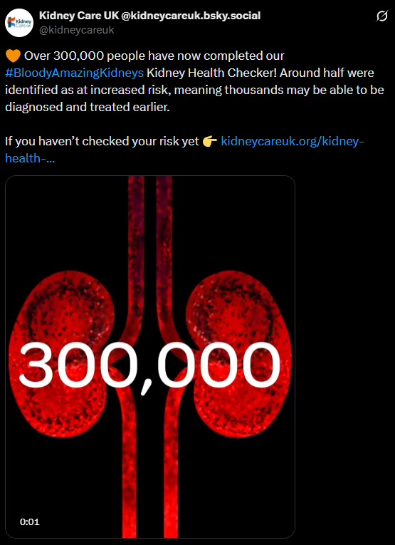
Figure 8: Bloody Amazing Kidneys Health Checker Usage
(Source: Kidney Care UK, 2026a)
The patients must be educated on medication compliance, blood pressure checks, nutritious diet, quitting smoking and physical exercise to manage CKD. Electronic measures like the NHS App, home blood pressure, telehealth visits can enhance self-management and enhance engagement. In a 2026 report, Kidney Care UK claimed that over 280,000 individuals had used its Bloody Amazing Kidneys Health Checker, showing greater engagement of the population in kidney health awareness campaigns and early diagnosis services (Kidney Care UK, 2026a).

Multidisciplinary and Lifelong Care Considerations
Lasting interaction with general practitioners, nephrologists, renal nurses, pharmacists, dietary therapists, psychologists and social care experts are necessary to control CKD effectively. Throughout the course of disease, multidisciplinary teams must offer combined follow-ups, medication checks and cardiovascular risk. As a guideline to kidney disease, the UK eCKD Guide, powered by NICE, suggests frequent monitoring of kidney functions, associated albuminuria and cardiovascular risk, as well as prompting referrals to specialized renal services as the means of postponing the progression and improving the outcome (UK Kidney Association, 2024).

End-of-Life and Conservative Kidney Management
In certain patients with end-stage CKD, conservative management of the kidney might prove suitable, rather than dialysis, especially when the burden of treatment surpasses the possible benefits. It is a symptom management approach that places emphasis on advance care planning, psychosocial care and sustaining quality of life via a coordinated renal and palliative care approach. Recent global recommendations released in 2026 propose a concept of the introduction of the conservative management system into the whole CKD pathway as the patients and their families should be provided with personalized support and informed decision-making when it comes to end-of-life care (Wong et al., 2026).

7. Conclusion
Chronic Kidney Disease is a prime example of a long-lasting illness that impacts heavily on physical, mental and social health and causes growing burdens to NHS health care. The disease needs to be slowed down and treatment methods minimise complications by diagnosis of the disease early in the disease progression and through effective self-management. ICC frameworks of the NHS House of Care and WHO, along with national policies, NICE guidance and integrated renal services, offers a solid ground on the enhancement of the outcomes. The enhancement of person-centred, culturally sensitive and multidisciplinary care will make the differences in health equity, overall quality of life and sustainability of kidney care in the United Kingdom.

Reference List
Aeddula, N. and Vaidya, S. (2024). Chronic kidney disease. [online] National Library of Medicine. Available at: https://www.ncbi.nlm.nih.gov/books/NBK535404/.
Agathangelou, G., Gofman, L., Kulkarni, R., Jaffe, J.N., Farrimond, B. and Sharma, S. (2025). EPH96 Projected Prevalence of Acute, Chronic, and End-Stage Kidney Disease in the UK From 2023 to 2033. Value in Health, [online] 26(12), p.S220. doi:https://doi.org/10.1016/j.jval.2023.09.1138.
Alma, M.A., van der Mei, S.F., Brouwer, S., Hilbrands, L.B., van der Boog, P.J.M., Uiterwijk, H., Waanders, F., Hengst, M., Gansevoort, R.T. and Visser, A. (2022) “Sustained employment, work disability and work functioning in CKD patients: A cross-sectional survey study,” Journal of Nephrology, 36(3), pp. 731–743. Available at: https://doi.org/10.1007/s40620-022-01476-w.
American Kidney Fund (2021) Tests for kidney disease, Www.kidneyfund.org. Available at: https://www.kidneyfund.org/all-about-kidneys/tests-kidney-disease
American Kidney Fund (2022) Mental health and kidney disease | American Kidney Fund, Www.kidneyfund.org. Available at: https://www.kidneyfund.org/living-kidney-disease/mental-health-and-kidney-disease
Anjali Avula, Johal, L.K., Ali, F., Amir, S., Yadav, S., Mohd Murtuza, Zia, U., Janjua, F.F., Raza, A., Lal, K., Abid, M. and Khan, R. (2025). ACE Inhibitors and ARBs in Chronic Kidney Disease: A Systematic Review of Randomized Controlled Trials on Albuminuria Reduction, eGFR Decline, and Safety. Cureus. doi:https://doi.org/10.7759/cureus.93707.
Borden, C., Xin Yee Tan, Roberts, M.-B., Mazzola, S., Zhao, F., Schenk, P., Simon, J.F., Gadegbeku, C., Sedor, J. and Wang, X. (2023). Black Patients Equally Benefit From Renal Genetics Evaluation but Substantial Barriers in Access Exist. Kidney international reports, 8(10), pp.2068–2076. doi:https://doi.org/10.1016/j.ekir.2023.07.007.
Borg, R., Carlson, N., Søndergaard, J. and Persson, F. (2023). The Growing Challenge of Chronic Kidney Disease: An Overview of Current Knowledge. International Journal of Nephrology, [online] 2023(1), pp.1–8. doi:https://doi.org/10.1155/2023/9609266.
Boris (2026). Implementing WHO global kidney health commitments could improve millions of lives - European Kidney Health Alliance. [online] European Kidney Health Alliance. Available at: https://ekha.eu/blog/implementing-who-global-kidney-health-commitments-could-improve-millions-of-lives/
Brown, S., Garcia, J.J., Guiang, H., Priest, S., Wheeler, D.C., Moura, A.F., Johnston-Webber, C. and Chen, J. (2024). IMPACT CKD: Holistic disease model projecting 10-year population burdens. Kidney International Reports. doi:https://doi.org/10.1016/j.ekir.2024.08.015.
Chang, J., Peysakhovich, F., Wang, W. and Zhu, J. (2024). The UK Health Care System. [online] Available at: http://assets.ce.columbia.edu/pdf/actu/actu-uk.pdf.
Cleveland Clinic (2023). Chronic Kidney Disease. [online] Cleveland Clinic. Available at: https://my.clevelandclinic.org/health/diseases/15096-chronic-kidney-disease.
Earl, R. (2025). More people are dying while waiting for a kidney - our response to new transplant data - Kidney Research UK. [online] Kidney Research UK. Available at: https://www.kidneyresearchuk.org/2025/07/09/more-people-dying-while-waiting-for-kidney-transplants/.
Francis, A., Harhay, M.N., Ong, A.C.M., Tummalapalli, S.L., Ortiz, A., Fogo, A.B., Fliser, D., Roy-Chaudhury, P., Fontana, M., Nangaku, M., Wanner, C., Malik, C., Hradsky, A., Adu, D., Bavanandan, S., Cusumano, A., Sola, L., Ulasi, I. and Jha, V. (2024). Chronic kidney disease and the global public health agenda: an international consensus. Nature Reviews Nephrology, [online] 20(20), pp.1–13. doi:https://doi.org/10.1038/s41581-024-00820-6.
Gandhi, T. (2025). Chronic kidney disease: impacts, challenges and pathways to improvement. [online] The Pharmaceutical Journal. Available at: https://pharmaceutical-journal.com/article/research/chronic-kidney-disease-impacts-challenges-and-pathways-to-improvement.
Ghodeshwar, G.K., Dube, A. and Khobragade, D. (2023). Impact of lifestyle modifications on cardiovascular health: A narrative review. Cureus, [online] 15(7), pp.1–8. doi:https://doi.org/10.7759/cureus.42616.
Hirsch, J.S., Danna, S.C., Desai, N., Gluckman, T.J., Jhamb, M., Newlin, K., Pellechio, B., Elbedewe, A. and Norfolk, E. (2024) “Optimizing Care Delivery in Patients with Chronic Kidney Disease in the United States: Proceedings of a Multidisciplinary Roundtable Discussion and Literature Review,” Journal of Clinical Medicine, 13(5), p. 1206. Available at: https://doi.org/10.3390/jcm13051206.
Kidney Care UK (2025). Facts about Kidneys. [online] Kidney Care UK. Available at: https://kidneycareuk.org/kidney-disease-information/about-kidney-health/facts-about-kidneys/.
Kidney Care UK (2026a). Over 300,000 people have now completed our #BloodyAmazingKidneys Kidney Health Checker! Around half were identified as at increased risk, meaning thousands may be able to be diagnosed and treated earlier. [online] X (formerly Twitter). Available at: https://x.com/kidneycareuk/status/2031054481564008764
Kidney Care UK. (2026b). Five reasons to be optimistic about kidney care in 2026. [online] Available at: https://kidneycareuk.org/news-from-kidney-care-uk/kidney-care-in-2026/.
Kidney Care UK. (2026c). Global declaration by the United Nations commits to tackling kidney disease alongside other noncommunicable disease and mental health. [online] Available at: https://kidneycareuk.org/about-us/policy-updates/global-declaration-commits-to-tackling-kidney-disease/
Kidney Care UK. (2026d). Homepage. [online] Available at: https://kidneycareuk.org.
Kidney Research UK (2025). WHO says Yes: Kidney health is a global priority - Kidney Research UK. [online] Kidney Research UK. Available at: https://www.kidneyresearchuk.org/2025/05/23/who-says-yes-kidney-health-is-a-global-priority/.
Lailatun Nimah, Nursalam Nursalam, Andri Setiya Wahyudi and Herdina Mariyanti (2024) “Quality of Life of Family Caregivers of Patients Undergoing Dialysis: A Literature Review,” SAGE open nursing, 10. Available at: https://doi.org/10.1177/23779608241240124.
London Kidney Network. (2025). Annual Report 2024-25 | London Kidney Network. [online] Available at: https://londonkidneynetwork.nhs.uk/annual-report-2024-25/
Mancini, R., Di Simone, E., Maria, A.D., Scichilone, L.M., Gavazzoli, E., Tedros, F. and Fabbian, F. (2026). Socioeconomic Status and Kidney Disease. Kidney and Dialysis, 6(2), p.25. doi:https://doi.org/10.3390/kidneydial6020025.
Marin, A.-E., Redolat, R., Gil-Gómez, J.-A. and Mesa-Gresa, P. (2023) “Addressing Cognitive Function and Psychological Well-Being in Chronic Kidney Disease: A Systematic Review on the Use of Technology-Based Interventions,” International Journal of Environmental Research and Public Health, 20(4), p. 3342. Available at: https://doi.org/10.3390/ijerph20043342.
Marshall, C., Virdun, C. and Phillips, J.L. (2025). Strengthening care for adults with palliative care needs in high-income rural communities: a global policy environmental scan. BMC Palliative Care, 24(1). doi:https://doi.org/10.1186/s12904-025-01797-0.
Mayo Clinic (2023) Chronic Kidney Disease, Mayo clinic. Available at: https://www.mayoclinic.org/diseases-conditions/chronic-kidney-disease/symptoms-causes/syc-20354521
Murray, J.S., Kalra, P.R., Anderson, L.J., Selby, N.M., Sawhney, S., McKane, W.S., Ostermann, M., Kolhe, N.V., McWilliam, S.J., Nagalingam, K., Bickerton, S., Lewington, A.J.P., Hinchliffe, W.T., Smith, S.J., Wise, M., Hancock, A., Kingdon, E., Cockwell, P., James, M.T., Blakeman, T., Dean, J.D., Morlidge, C., Tomlinson, L.A. and Green, D. (2026) “Renin–angiotensin system inhibitors (RASi) are not nephrotoxic – they protect the kidneys and the heart,” Clinical Medicine, 26(3), p. 100577. Available at: https://doi.org/10.1016/j.clinme.2026.100577.
National Kidney Federation. (2025). WHO says Yes: Kidney Health is a Global Priority. [online] Available at: https://www.kidney.org.uk/news/who-says-yes-kidney-health-is-a-global-priority.
National Kidney Foundation (2023) Chronic kidney disease (CKD), National Kidney Foundation. Available at: https://www.kidney.org/kidney-topics/chronic-kidney-disease-ckd
NHS England (2024). The Year of Care House – Year Of Care. [online] Yearofcare.co.uk. Available at: https://www.yearofcare.co.uk/implementation/the-year-of-care-house/.
NHS Scotland (2026). Chronic Kidney Disease | Right Decisions. [online] Scot.nhs.uk. Available at: https://www.rightdecisions.scot.nhs.uk/dgrefhelp-nhs-dumfries-galloway/renal/chronic-kidney-disease/
NHS website (2025). Talking therapies. [online] nhs.uk. Available at: https://www.nhs.uk/tests-and-treatments/talking-therapies/.
Parmar, R. (2025). Historic win for kidney health as WHO adopts global resolution - International Society of Nephrology. [online] International Society of Nephrology. Available at: https://www.theisn.org/blog/2025/05/23/historic-win-for-kidney-health-as-who-adopts-global-resolution/.
Taggar, J.S., Carson, J. and Patel, R. (2025). The NHS 10-year plan: rethinking the delivery of primary care medical education. British Journal of General Practice, 75(758), pp.390–391. doi:https://doi.org/10.3399/bjgp.2025.0349.
UK Kidney Association (2024). The UK eCKD Guide. [online] UK Kidney. Available at: https://www.ukkidney.org/health-professionals/information-resources/uk-eckd-guide.
UK Kidney Association (2026). UKKA Urges UK Government to Support WHO Resolution. [online] UK Kidney Association. Available at: https://www.ukkidney.org/about-us/news/ukka-urges-uk-government-support-who-resolution
Wang, L., He, Y., Han, C., Zhu, P., Zhou, Y., Tang, R. and He, W. (2025). Global burden of chronic kidney disease and risk factors, 1990–2021: an update from the global burden of disease study 2021. Frontiers in Public Health, 13. doi:https://doi.org/10.3389/fpubh.2025.1542329.
WHO (2026). Kidney disease. [online] Who.int. Available at: https://www.who.int/news-room/fact-sheets/detail/kidney-disease.
Wong, S.P.Y., Schell, J.O., Bursic, A.E., Butler, C.R., Callahan, M.B., Corbett, C., DeGraauw, J., Gazaway, S., Gelfand, S., Hall, R., Saeed, F., Scherer, J.S., Shaban, H., Stein, E.J. and Weiss, J.W. (2026). ASN Kidney Health Guidance on Conservative Management in People with Kidney Failure. Journal of the American Society of Nephrology. [online] doi:https://doi.org/10.1681/asn.0000001068.

