Title:Critically analyse the meaning of ‘vulnerability’ in the context of operational policing.
The Role of the Police has recently changed from focusing solely on criminal justice. Due to the perception shifts in the general public, the emergency services such as the police service are increasingly being called to respond to mental health and distress-related issues that can arise due to vulnerable people with mental health issues and learning disabilities. These calls are also associated with Public Health departments and Police Organisations accompanying Health officials to respond to these calls have become a norm (Chapman, et al., 2017). To work together to respond to the aid of vulnerable people Police Institutions which are accustomed to criminal justice and establishing law and order must understand the challenges of providing provisions for physical mental and social well-being for the vulnerable. They must be aware of how to operate, and understand the complex challenges of how to handle these issues. This requires an understanding of What is vulnerability, who is vulnerable, why should the police respond to issues related to vulnerability and how should the police respond to vulnerability requests (Asquith & Bartkowiak-Th'eron, 2021).
To better serve the public and handle the contemporary issues related to public welfare, in police procedure early intervention is the most prominent approach that is followed. Police forces are evaluated by his Majesty’s Inspectorate of Constabulary (HMIC) on how effective they are in protecting vulnerable people from harm to themselves and others (HMICFRS, 2019). In these cases, priority is given to identifying the incidents, assessing if there are vulnerable people affected, and managing the case to protect vulnerable victims and manage perpetrators of crime (College of Policing, 2022). The term vulnerability lacks a unified definite which makes it difficult to understand in terms of how policies and health policies are challenging to identify, assess and manage (Bartkowiak-Théron, et al., 2016). In the UK vulnerability is understood in a minimalist manner where vulnerability is Defined by the Ministry of Justice Code of Practice for Victims of Crime “A victim is vulnerable if they are under the age of 18 years or have a mental or physical disability, disorder or significant impairment.” (Ford, et al., 2020). It is important to define vulnerability as it enables police forces in the UK and understanding how they should tackle the issues related to Vulnerability. Therefore, term requires a common agreement and an appropriate standard (College of Polcing, 2020). With proper understanding, the police force can develop training procedures to develop expertise and learn good practices which enables them to offer consistency in approaching these issues. With proper understanding, police will also avoid mission load where other institutions are more appropriate to deal with the issues of vulnerability. Therefore, the proper understanding of vulnerability allows the police officer to have operational clarity on how they should respond (Keay & Kirby, 2018)
Vulnerability can be viewed as a universal concept where all people are somewhat vulnerable by being human. However, such views regarding this subject elude a precise or agreed understanding which can make protecting the vulnerable more difficult to protect by the police. It can also be argued that different humans have different vulnerabilities due to their particular experiences which makes it more complex to define (Wrigley & Dawson, 2016). Certain groups also avoid labelling people as vulnerable due to the negative effects and stigma it can generate, that vulnerable means weak. For this reason, people who want to challenge the label of vulnerable by the state to improve themselves such as when drug users want to overcome their addiction, feel wronged when labelled vulnerable (Bates, 2021). Vulnerability is derived from the Latin word “Vulnus, " which means a personas capacity to be harmed or at risk from psychological, emotional or physical causes, often associated with a lack of agency, weakness and dependency on their actions (Bartkowiak-Théron, et al., 2016). This vulnerability can be a universal trait where any human can become vulnerable and susceptible to harm due to their experience and conditions. Thus, vulnerability can be temporary, enduring, incremental, layered, apparent, hidden or permanent. The maximalist approach to Vulnerability allows police to respond to vulnerability with any ubiquity present and not see any case at face value. This approach improves the service delivery to vulnerable people and allows us to look at the vulnerability according to the situation and circumstances of the vulnerable (Bartkowiak-Théron, et al., 2016).
The importance of Police in understanding vulnerability is because most of the police work 84 % has little concern with crime and 75 % involves resolving the issue related to vulnerable people while also working with other service agencies (Bartkowiak-Théron, et al., 2016).
Therefore, a vulnerability in individuals can arise due to a variety of reasons where the individual may be a source of cause for vulnerability. There are four types of vulnerabilities. Vulnerability arises due to the fragile nature of humans where they are suspectable to harm from others, and environmental causes (College of Policing, 2022). This vulnerability can impact all individuals and Police exists in society mainly due to this vulnerability. The main role of the Police in society is to reduce the opportunities for humans due to their fragile nature to be harmed. Individual vulnerability is dependent on the experience and consequence of their circumstances such as age, ethnicity, race, illness, indigeneity, cognitive impairment, sexuality, gender, identity, addiction, disability, or homelessness (Naylor, et al., 2019). In current police procedures, these vulnerabilities are covered in how to approach with the participation of Public Health agencies, and NHS (College of Policing, 2022)
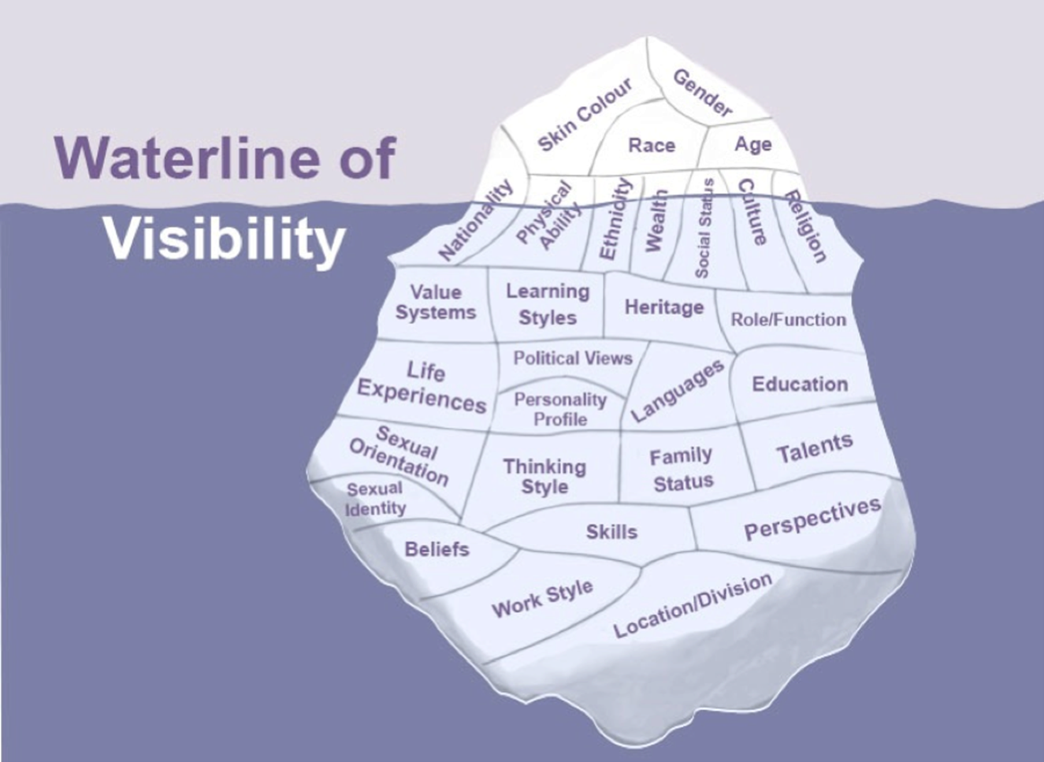
The situational vulnerability arises when an individual is a victim, witness or offender which creates circumstances to create vulnerability. Individuals who are dealing with the criminal justice system experience some sore of situational vulnerability, such as a victim of burglary experiencing vulnerability due to the invasion of privacy, stolen items, blackmail and unsafe from further attacks (Bartkowiak-Théron, et al., 2016). System-generated vulnerabilities are created due to policing processes such as detaining an individual from mental illness in a cell without performing diagnosis and treatment by partner agencies causing them to be vulnerable to harm. This has been observed in First Nations Peoples who are vulnerable to self-harm or suicide in isolation custody (Pandeya, et al., 2021). An individual can also suffer from the intersection of these vulnerabilities which can impact how police respond and which processes to follow to the issues (Ford, et al., 2020).
When responding to calls to resolve issues it must be understood that vulnerability is ubiquitous and is present everywhere. It means that its victims are not the only vulnerable in a situation. Offenders, witnesses and police and partners can be vulnerable in a situation. Due to media and cultural stereotypes police have to deal with hardened criminals and the attempts to recognise vulnerability in offenders are thought of as risky and naïve which can pose dangers to the police officers. But the reports have shown that most of the police work dealing with first-time victims and offenders who are vulnerable due to their naiveté, fragility, and individual vulnerabilities (Chapman, et al., 2017). Police officers themselves can be vulnerable due to injuries, trauma, and PTSD Post Traumatic Stress Disorder due to past or present causes. This vulnerability also affects how police processes are followed. Understanding this is important as a lack of support and training in managing people's grief and adversity can create situational vulnerabilities (Dehaghani, 2019).
Identifying vulnerability shapes how the encounter with the police can resolve and what processes they follow. Offenders can suffer from vulnerability from police officers such as obtaining convictions from individuals who suffer from mental illness, cognitive disability, immaturity or race/ ethnicity. If the police fail to identify vulnerability it can affect the further case resolution where judgements can be overturned due to a lack of due process and investigation of police actions (Dehaghani, 2017).
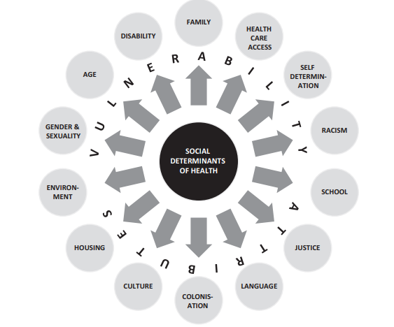
In the UK vulnerability police action is mandated by Care Act 2014 and the Safeguarding Vulnerable Groups Act 2006 where different agencies are linked together to work together in resolving issues with vulnerability. These legislations however lack the voice of vulnerable adults who lack a voice in this decision or raise concerns regarding policy changes, legislation and practices. Recognising the voice of the vulnerable and allowing the understanding of vulnerability Is not something that makes them different and is not just a negative experience. Vulnerability is a process that any person can go through and identifying the process will allow police officers to respond accordingly (Chapman, et al., 2017).

Police have a moral obligation to respond to issues related to vulnerability because by definition, the broad objective of policing in our society is to provide help in the times of difficulty (Kirby, 2021). Police are always expected to do the right thing and to ensure safety, support, and stability to all citizens. The definition of vulnerability itself is that the human being which is denied the agency or is incapable of self-actualization and therefore, can’t take care of their rights. Police are expected to be the first responders to variety of situations and normally are the first agency people call (Enang, et al., 2022). So, Police has a moral and legal obligation to protect those, who are susceptive to being subordinated or marginalized (Enang, et al., 2022). So, helping the vulnerable is an extension of the ethical mandate of policing and also of their duties and responsibilities.
From a humanistic perspective, Police must respond to vulnerability because vulnerability is universal problem. Every Human is fragile and therefore is prone to suffering. As a result, vulnerability is shared by all human beings (Wood, 2020). The human susceptibility to suffering is not only limited to special groups such as disabled, or those suffering from poverty, environment, or crime, but also those who have experienced inhumane and anti-social behaviour. A wide extent of people can be termed as vulnerable, some of which might face physical vulnerability (health-related) or others social (economic, political, political) or even emotional, situational, and incidental (Bates, 2021).
In the U.K over the past three decades have achieved significant social progress and at the same time have also become diverse, multi-cultural and multi-faceted. This cultural and social change has meant that socio-political inequalities have surfaced, and some sections have become politically and socially disadvantaged which have become persistent and embedded (Bates, 2021). So, vulnerability is the need for affirmative action by Police to positively adapt to the needs and expectations of these vulnerable people. Finally, there is also public expectations from Police to practice vulnerability and police official are under constant scrutiny from media, legislatures, special groups etc. to fulfil and quickly adapt to those expectations (Greig-Midlane, 2019).
Practicing vulnerability is difficult task as responding to it requires Police officials to have broad scope knowledge from physical aspects to socio-economic-cultural aspects. Vulnerability requires building a concerted broad based collaborative approach which requires multiple agencies working together (Brown, 2011). One of the failures of existent vulnerability practices has been the siloed approach and practicing siloed operational measures. It is not only unrealistic but also unfair to expect police to be aware of protocols to accord to vulnerable people. A more realistic solution is to have added departments and agencies to front-line police to help them cope better when dealing with specialized knowledge (College of Policing, 2022).
A practical first step towards practising vulnerability is to train and upgrade the cultural knowledge of police personnel. This process may involve building cultural competency, cultural knowledge. Further, providing opportunities where police officers can develop their knowledge and skills and determine the risk associated with vulnerability (College of Policing, 2022). With skills and knowledge on how to respond to respond effectively and recognised who are at risk of harm. The skills improve the ability of an individual to capture relevant information, assess and analyse it to learn how to respond in future scenarios.
Community engagement also plays a crucial rule in practising vulnerability where communities take part in soft negotiations by acting as community representation or be part of strategic committees where some part of policing power is given to them in remote and isolated areas to help vulnerable. Working with these community help in better service and support for the vulnerable (Keay & Kirby, 2018). With the communities help they can be alert and understand the clues which are resulted to vulnerability such as fear, disempowerment, bullying, coercion, abuse, lack of recognition, perception of authority, past experience, culture, trauma, feeling blame or net being believed (College of Policing, 2022). With skills recognising these clues the officers can overcome barriers to disclose the risks. The clues should be recognisable even if the individual is not disclosing their vulnerability and recognising the reason or are not seeing themselves as vulnerable (College of Policing, 2022).
College of Policing has a framework on how to practice identification of vulnerability where the training involves inspecting Appearance to recognize anything unusual such as injury, anxiousness, or unsettle, distress, demeanour, behaviour is manic, slow or furtive, communication of individual where they are showing concern, slurred speech, slow or fast, eyes are glazed, dilated, body language is showing stress or fear, danger in environment or due to physical condition are the elements which they should be able to recognise and assess vulnerability in an individual (College of Policing, 2022).
Communicating with vulnerable should also be learned such as offering them drinks, breaks in between talks, giving them time to think, offering interpreter or other officers, understanding the impact or sensitivity to police, using speech and dialogue which is easy to understand, and actively list to the vulnerable (College of Policing, 2022).

It is understood that police officers need to understand vulnerability so that they can provide assistance to individuals. If the police officers can recognise, they cannot provide assistance to vulnerable they can signpost to more experienced agencies and services such as NHS and Public Health agencies. To make this process smoother officers need proper training on how to identify vulnerability processes with increased knowledge and what are the effective systems to help these individuals. Police officers can provide triage care with individual interactions, social and environmental factors who are currently vulnerable.

References
Asquith, N. L. & Bartkowiak-Th'eron, I., 2021. Policing practices and vulnerable people. s.l.:Springer.
Bartkowiak-Théron, Asquith, I. &. & Nicole & Roberts, K., 2016. Vulnerability as a Contemporary Challenge for Policing. s.l.:s.n.
Bartkowiak-Théron, I. & Asquith, N., 2012. The extraordinary intricacies of policing vulnerability. Australian policing, 4(2).
Bates, C. F., 2021. Mitigation in discourse: Social, cognitive and affective motivations when exchanging advice. Journal of Pragmatics, Volume 173, pp. 119-133.
Brown, K., 2011. ‘“Vulnerability”: Handle with Care. Ethics and Social Welfare, 5(3), pp. 313-321.
Brown, K., 2014. Beyond protection:‘The vulnerable’in the age of austerity. Social policies and social control, pp. 39-52.
Chapman, J., Higgins, A. & Hales, G., 2017. Police Effectiveness in a Changing World: Slough site report. [Online]
Available at: https://www.police-foundation.org.uk/2017/wp-content/uploads/2017/12/slough_site_report.pdf
[Accessed 1 November 2022].
College of Polcing, 2020. National Vulnerability Action Plan (NVAP) Revised. [Online]
Available at: https://www.college.police.uk/guidance/vulnerability-related-risks/references
[Accessed 2 November 2022].
College of Policing, 2022. Clues. [Online]
Available at: https://www.college.police.uk/guidance/vulnerability-related-risks/clues
[Accessed 1 November 2022].
College of Policing, 2022. Communication. [Online]
Available at: https://www.college.police.uk/guidance/vulnerability-related-risks/communication
[Accessed 1 November 2022].
College of Policing, 2022. Mental vulnerability and illness. [Online]
Available at: https://www.college.police.uk/app/mental-health/mental-vulnerability-and-illness
[Accessed 2 Novemeber 2022].
College of Policing, 2022. Recognising and responding to vulnerability related risks. [Online]
Available at: file:///D:/November%202022/Vulnerability/Recognising-responding-vulnerability-related-risks-guidelines.pdf
[Accessed 2 November 2022].
College of Policing, 2022. Vulnerability and violent crime interventions. [Online]
Available at: https://www.college.police.uk/research/vulnerability-violent-crime-interventions
[Accessed 2 November 2022].
Dehaghani, R., 2017. Custody officers, Code C and Constructing Vulnerability: implications for policy and practice. Policing: A journal of policy and practice, 11(1), pp. 74-86.
Dehaghani, R., 2019. Vulnerability in police custody: police decision-making and the appropriate adult safeguard. s.l.:Routledge.
Enang, I. et al., 2022. Vulnerability assessment across the frontline of law enforcement and public health: a systematic review. Policing and Society, 32(4), pp. 540-559.
Ford, K. et al., 2020. Understanding the outcome of police safeguarding notifications to social services in South Wales. The Police Journal, 93(2), pp. 87-108.
Garland, J. & Chakraborti, N., 2012. Divided by a common concept? Assessing the implications of different conceptualizations of hate crime in the European Union. European Journal of Criminology, 9(1), pp. 38-51.
Gilson, E., 2014. The ethics of vulnerability: A feminist analysis of social life and practice. New York: Routledge.
Gilson, E., 2014. The Ethics of Vulnerability: A Feminist Analysis of Social Life and Practice. s.l.:Routledge.
GOV.UK, 2014. Multi-agency working and information sharing project. [Online]
Available at: https://www.gov.uk/government/publications/multi-agency-working-and-information-sharing-project
[Accessed 2 November 2022].
Greig-Midlane, J., 2019. An institutional perspective of neighbourhood policing reform in austerity era England and Wales. International Journal of Police Science & Management, 21(4), pp. 230-243.
HMICFRS, 2019. PEEL: Police effectiveness, efficiency and legitimacy 2018/19 – Metropolitan Police Service. [Online]
Available at: https://www.justiceinspectorates.gov.uk/hmicfrs/wp-content/uploads/peel-assessment-2018-19-metropolitan.pdf
[Accessed 1 November 2022].
Innes, M. & Fielding, N., 2002. From Community to Communicative Policing: ‘Signal Crimes’ and the Problem of Public Reassurance. Sociological Research Online, 7(2).
Keay, S. & Kirby, S., 2018. Defining Vulnerability: From the Conceptual to the Operational. Policing: A Journal of Policy and Practice, 12(4), pp. 428-438.
Kirby, S. a. K. S., 2021. Improving intelligence analysis in policing. s.l.:Routledge.
Luna, F., 2009. Elucidating the concept of vulnerability: Layers not labels. IJFAB: International Journal of Feminist Approaches to Bioethics, 2(1), pp. 121-139.
Luna, F., 2009. Elucidating the concept of vulnerability: Layers not labels. International Journal of Feminist Approaches to Bioethics, 2(1), p. 121–139.
Naylor, L. A. et al., 2019. A multiscale analysis of social-ecological system robustness and vulnerability in Cornwall, UK. Regional Environmental Change, 19(7), pp. 1835-1848.
Pandeya, N. A. et al., 2021. Factors Associated with Thoughts of Self-Harm or Suicide among Aboriginal and Torres Strait Islander People Presenting to Urban Primary Care: An Analysis of De-Identified Clinical Data. Int J Environ Res Public Health, 19(1), p. 153.
W. El Hage, J. F. P. S. A. S., 2009. Vulnerability to depression: what is the role of stress genes in gene × environment interaction?. Psychological Medicine, 39(9), pp. 1407-1411.
Wood, J. D., 2020. Private policing and public health: A neglected relationship. Journal of contemporary criminal justice, 36(1), pp. 19-38.
Wrigley, A. & Dawson, A., 2016. Vulnerability and marginalized populations. Public Health Ethics: Cases Spanning the Globe, pp. 203-240.

