Global Entrepreneurship Week: School of Design and Applied Arts

Tuesday 13 November, Unit 19, Little Wind Street, Swansea

10am Welcome and Intro, Sean Jenkins

10.10am – 11.00am Ben Reynolds, Urban Foundry

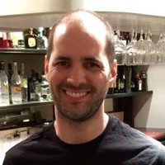
Ben is the founder and Director of Urban Foundry, a creative regeneration agency based in Swansea forging great ideas to change the world for the better by improving people’s lives, making better places, and creating a more sustainable prosperity. He has a Doctorate in the creative regeneration of cities and 20 years of experience of business and project development. He is a member of the Market Research Society, a Trustee of Swansea Council for Voluntary Services, and he has been both an executive and a non-executive director of a number of social enterprises. Ben also served as a Commissioner for the Welsh Government’s Cooperatives and Mutuals Commission.

Ben’s approach, is one that uses creative thinking combined with a strong theoretical understanding to solve a range of problems, from small community initiatives to nationwide schemes and programmes.

Over 20 years he has developed a detailed working knowledge of the third and public sectors in Wales, including cooperatives and social enterprises. That is coupled with his strong theoretical and research underpinning from his PhD study into the creative regeneration of cities.

Ben also has a sharp understanding of public funding – he has supported a wide range of groups in raising several million pounds for various regeneration projects, from public and private sources. He has also served on various funding panels, including those distributing European Structural Funds, and he has supported public funding projects that have allocated tens of millions of pounds of public funding.

11.00am – 12.45pm Alix Charles, founder of Alix Digital, Marketing Consultancy

Alix is a Freelance PPC Expert at Alix Digital which aims to help SMEs integrate digital marketing into their business and grow. With 10+ years marketing experience, she has worked in-house, freelance and for agencies which helps her understand what it's like to sit either side of the table. From one-off account audits, to training and day-to-day account management, there is one mission: Taking the complicated digital stuff and bringing it back to basics. https://alixdigital.com/

BREAK FOR LUNCH

2.00pm – 2.45pm Rhian Hâf, Independent Artist, Graduate from MA Glass, UWTSD


Rhian Hâf specialised in glass whilst studying for her BA (Hons) in Design and Applied Arts at Edinburgh College of Art. She gained a distinction in her MA in Glass from UWTSD Swansea in 2011. She received a Major Production Award from the Arts Council of Wales, which allowed her to develop her practice and visual research and create a new body of work, which has toured over Wales, the UK and most recent Venice as part of the Venice Glass Week. Artist in Residence placements include the Glass Department in Edinburgh College Art, Ruthin Craft Centre, and in Venice, as part of the Wales in Venice Programme. Exhibitions include the British Glass Biennale, National Museum of Scotland, National Glass Centre and twice her work has been selected for New Glass Review, Corning. In 2015 Rhian also received an Arts and Business Award for excellence in investment and skill sharing in partnership with Phoenix Optical Technologies, a precision optics manufacturer based in north Wales. In 2017 she has received a Creative Wales Award for a period of research and development, focusing on materiality, architecture and design. Rhian is looking at scale and limitations of glass within the potential of other applications; architecture and design through collaboration with individuals, organisations and industry partners.

2.45pm – 3.30pm Jo Ashburner, Red Dragon Flagmakers, Graduate from BA Surface Pattern Design, UWTSD

Jo is proud to lead a Welsh company manufacturing textile goods in the South Wales, UK – a social profit company born out of her family business established in 1969. The business’ portfolio includes flags, banners and bunting made across the board for every kind of customer. Jo also founded and developed the Noonoo range of eco ethical sustainable and organic children clothing and playthings in 2004. As a single parent, she graduated from UWTSD with a First in Surface Pattern Design and launched the brand four months later making product in her studio above the garage at home. Noonoo went on to win Gift of the Year Award in 2009 (UK), Sustainable Product of the Year (New York) and sold in the UK through 450 retailers including John Lewis and worldwide through eight distributors. Jo was awarded UK National Businesswoman of the year in 2006. https://www.reddragonflagmakers.co.uk/

3.30pm – 4.15pm Patrick Carton, McClaren, Graduate from MA Automotive Design, UWTSD


Now at McLaren and working as a designer, Patrick is helping to create new and innovative automotive products.

Since graduating in 2013, Patrick has received a number of awards and recognitions for his work. He was awarded the Pilkington Vehicle Design Award at the 2016 RCA Degree Show by judges from Audi, Jaguar and Pilkington NSG for a self-sustainable car that can generate electricity from rain, wind and sunlight in 2016. And in the same year, he was selected to exhibit his final MA project at the Global Grad Show in Dubai, during the Dubai Design Week 2016. In 2017 he was named in the Forbes 30 under 30 list. The list highlights 300 Young Disruptors, Entrepreneurs and Innovators from Europe across 10 industries who are changing our world.

Patrick demonstrated from the start of his course that he was destined for success, said Sergio Fontanarosa, UWTSD’s Programme Director Automotive Design.
"Patrick is another successful story from the Automotive Design course here at UWTSD. From the first day he showed great passion, a humble attitude, the willingness to learn and superb commitment. These are the perfect ingredients to succeed, not just in this trade but anywhere. It was no surprise to me that Patrick was selected by Forbes Magazine as the best 30 under 30 in Europe for 2017 and that he is going to shape some of the most prestigious British Dream cars of the future.”

Speaking about his time at UWTSD, Patrick said: "I loved every minute of my time at Swansea and I do miss the close knit community there. The thing I value the most from the course was the one to one tuition that I had - that is something that you just don't get anywhere else and it really gave me a head start when I graduated and I really wouldn't be where I am today without the expertise, time and effort put in by the staff on the course."

4.15pm - 5.00pm Andrew Langdon, Orangebox, Graduate of BA Product Design, UWTSD

Andrew Langdon is currently a Team Leader with Orangebox, a company that designs and manufactures office furniture, meeting spaces and Smart Working areas. Prior to this Andrew was a Team Leader for Panasonic Manufacturing UK Ltd based in Cardiff for nine years.

Having left school in 1983 with little in the way of academic qualifications Andrew has worked for several small private sector companies from building maintenance to working in the construction industry. Most significant for Andrew was the fifteen years spent working as a Boat Builder on Swansea Marina, it was during this time Andrew took the decision to give up full time employment and enrol as a full time mature student to study Industrial Design at the then Swansea Institute and subsequently graduating from Swansea Metropolitan University. Gaining his degree in 2008 has made it possible for Andrew to follow the career path he now leads. Being in his current position and as in his previous position has meant Andrew is able to mentor and develop graduate engineers and design engineers, something Andrew takes very seriously and is passionate about.

Andrew now splits his time between his native Swansea and Cardiff and has a keen interest in sailing, travel and rugby (Ospreys of course).

Wednesday 14 November, Reading Room, Alex

10am Welcome and Intro, Amanda Roberts

10.10am - 1.00pm Kieran Abbott, Co-founder | Creative Director, Big Lemon Creative Graduate MA Product Design UWTSD
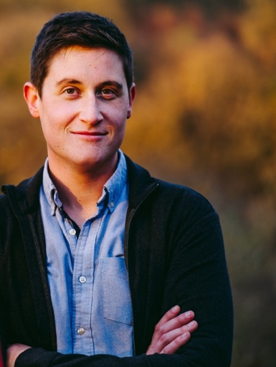
I started my freelancing career whilst completing my Masters in Product Design and Innovation at UWTSD, working on the odd job for businesses in and around the Swansea region. Since then I’ve worked in several different high profile design positions and most recently co-founded my own digital agency, Big Lemon. I’ve had experience in designing for, and managing clients within some of the UK’s most recognised brands, such as Harrods, Cunard, premier league football clubs, the NHS and Merlin Entertainments.

In the past four years Big Lemon has grown from an idea in the pub to an award-winning digital agency, servicing clients such as Admiral, the NHS, Bath Ales and UWTSD.

My role as creative director means I’m not only responsible for all things creative within the Big Lemon brand, but strategize the creativity within many of our clients’ organisations and their digital products. As a co-founder I’m held responsible for steering the company as we adapt and grow. Design, development and execution is what we’re about; as a means to scale, but also to solve our clients’ challenges.

Wednesday 14 November, Lecture Theatre 2, Dynevor

2pm - 4pm Jon and Heidi, Dirty Little Serifs, Branding, Design and Advertising Agency

Using creative thinking to develop businesses through brand awareness and marketing

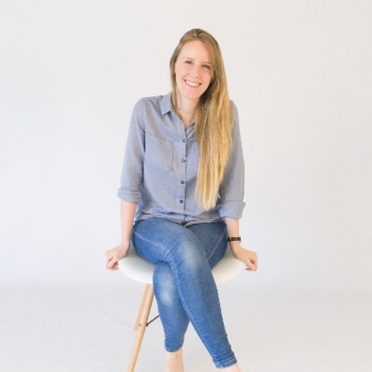
I’d always wanted to run my own business and after working in London I decided it was time to come back to Wales and take that big leap. My passion is design and creative solutions, and that’s what my company - Dirty Little Serifs - specialises in. We use creative thinking to develop businesses through brand awareness and marketing.

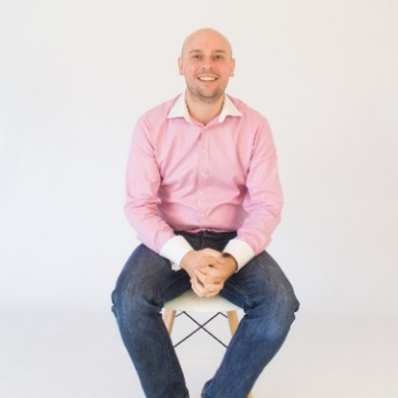
What are you waiting for? Go for it! Don’t be afraid to fail and ask as many questions as possible. Research is key within business.

Another thing I’d always wanted to do was travel, and my work has allowed me to do that - working for a wide range of brands across many sectors including travel, leisure, lifestyle, hospitality and medical. Jon Dawkins, Dirty Little Serifs

