Task 2 Build a basic Network
Equipment used
Wireless Router, Pc, Laptop, Server, switch and Printer
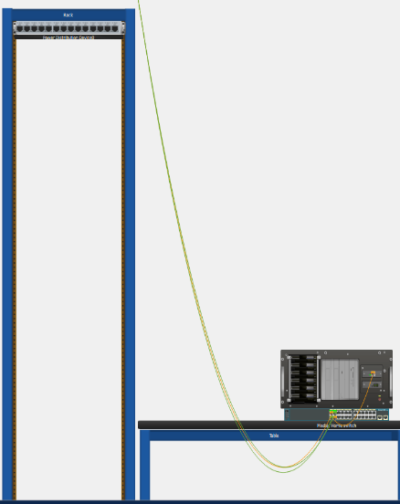
Fig 1 Physical Topology
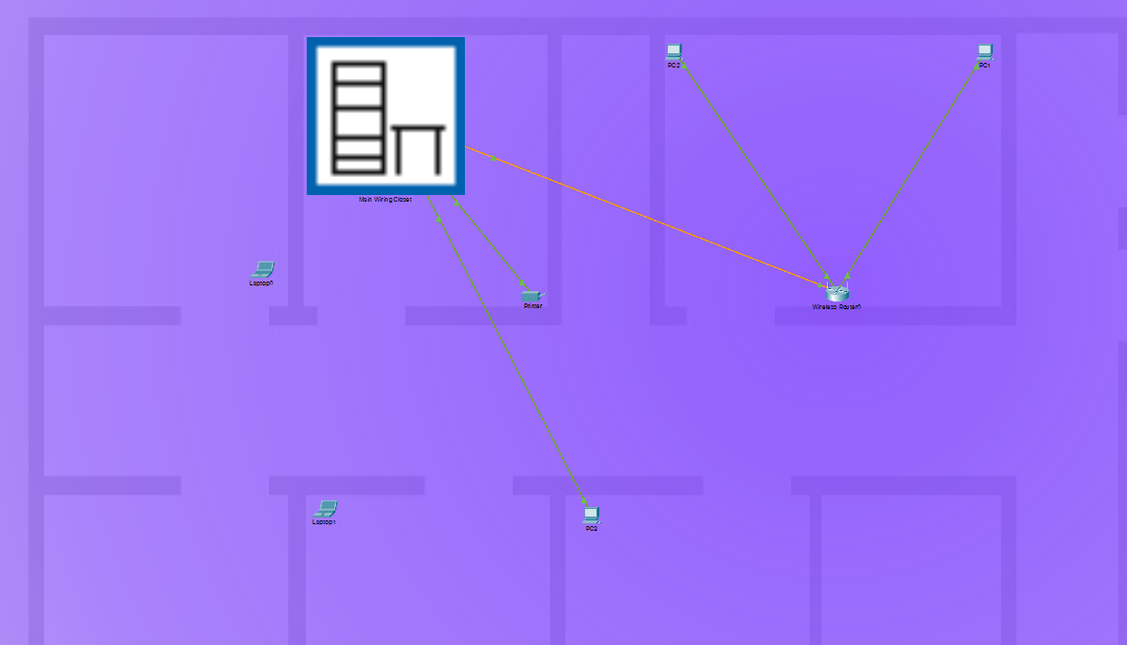

Device | Interface | IP Address | Subnet | Default Gateway
PC1 | Nic | 192.168.1.103 | 255.255.255.0 | 192.168.1.11
PC2 | Nic | 192.168.1.102 | 255.255.255.0 | 192.168.1.11
PC3 | Nic | 192.168.1.107 | 255.255.255.0 | 192.168.1.11
Laptop 0 | WIFI | 192.168.1.100 | 255.255.255.0 | 192.168.1.11
Laptop 1 | WIFI | 192.168.1.101 | 255.255.255.0 | 192.168.1.11
Printer | NIC | 192.168.1.108 | 255.255.255.0 | 192.168.1.11
Media | Nic | 192.168.1.109 | 255.255.255.0 | 192.168.1.11

Connection Test
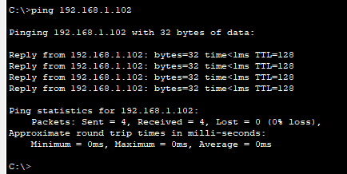
PC1 – PC2

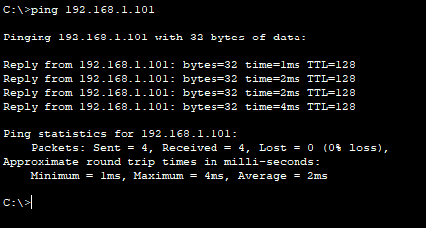
Laptop 0 – Laptop 1

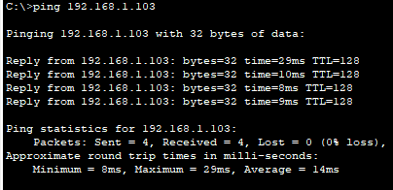
Laptop 0 – PC1

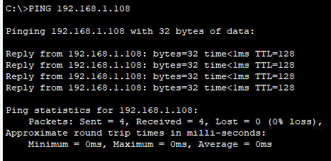
PC1 – Printer

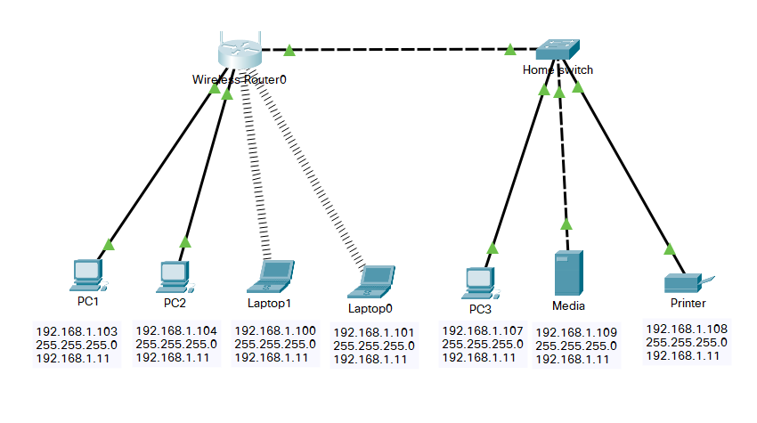
Fig 2 Logical Topology

PC1 => Router => PC2 Ping successful
Laptop 0 => Router => Laptop1 Ping successful
Laptop 0 => Router => PC1 Ping Successful
PC1 => Router => Switch => Printer Ping successful
Summery:
I created a small virtual network using Cisco Packet Tracer, added the device to the Logic Topology then assigned static IP address to each device then once I had connection, I then proceeded to ping to test the connectivity.

