Name: May Davies
Student Email: 1902699@student.uwtsd.ac.uk
Student Number: 1902699
Course: Computer Games Development
Module: Information Engineering
Module code: ACCB4013

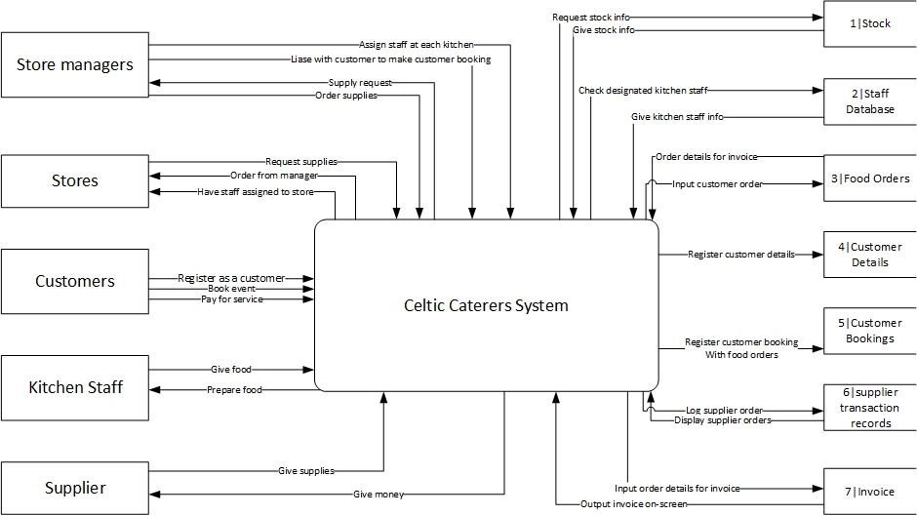
Level 0 DFD
The following DFD is a level 0 DFD that shows a very basic idea of how different parts of the celtic caterers system interacts with other parts, such as how the customer can book an event, which results in the food order database having another order made, the booking database registering the booking and the invoice database registering an invoice for example.

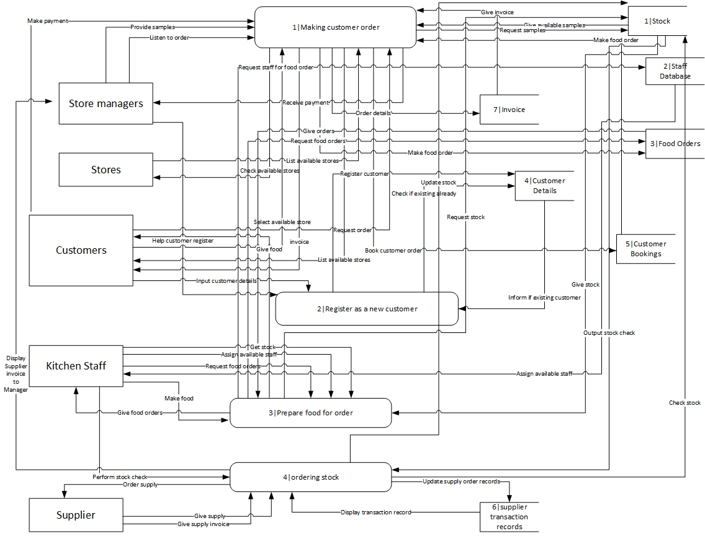
Level 1 DFD

Note: Zooming in to read this diagram is advised, it may be hard to read without getting a closer look due to how complicated the diagram is.

This diagram is a diagram of the level 1 diagram. This diagram is a lot more complicated than the level 0 diagram is it expands on the level 0 diagram in much more detail, breaking down each individual task as opposed to labelling the entire system as one process. An example of one of the processes here can be the prepare food for order process. In the prepare food for order process, firstly, the kitchen staff request food orders, which is grabbed from the food orders database, then, the kitchen get the necessary stock for the order. Once this is done, the kitchen assigns available staff from the staff database, the food is made, then given to the customer.

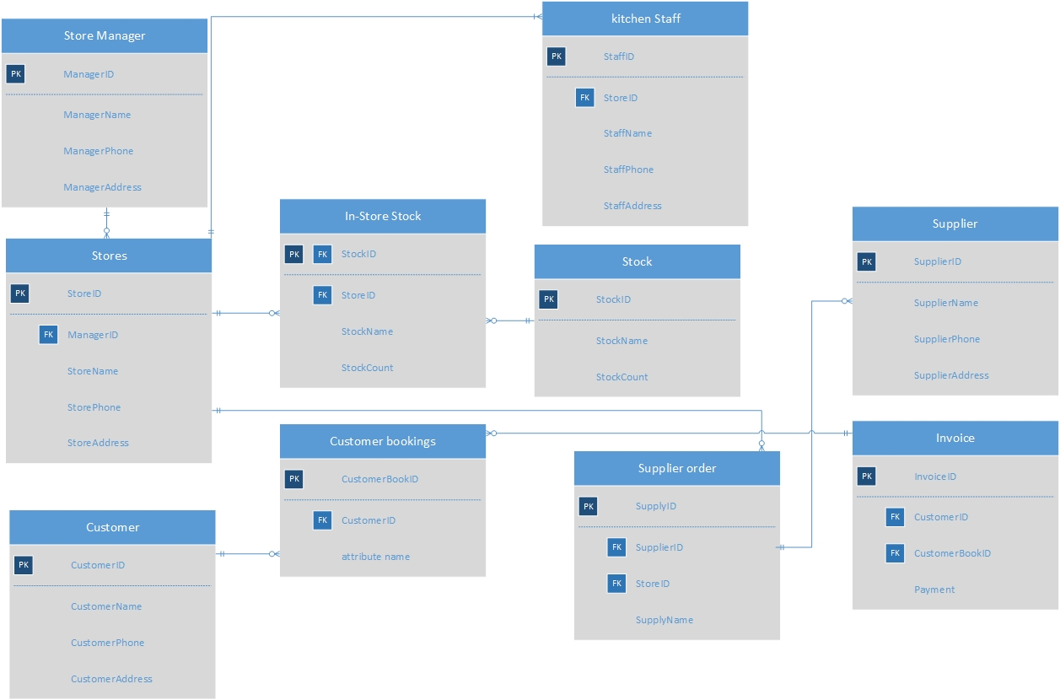
ERD

The following diagram is an Entity Relationship Diagram of the Celtic Caterers system. The relationships are as follows:

One store manager can manage many stores.
One store can have many in-store stock.
One stock can be found in many in-store stocks.
One store can have many supplier orders.
One supplier can be on many supplier orders.
One store can have many kitchen staff.
One customer can have many bookings.
One invoice can have many bookings registered to a customer.

