History and Theory 1
Architecture in your Hometown
My chosen buildings for this assignment are the Royal Welsh College of Music and Drama and the National Museum of Cardiff. The college, (Built by architects Bogle, Flanagan, Lawrence and Silver in 2011) in its modern architectural style sits on the boundaries of Bute Park and backs onto the dock feeder canal. The college lies both in the city being alongside the A470 whilst also amongst the limited countryside within Cardiff. This achieves a contrast between the wall of natural beauty and the hustle and bustle that comes with a city. (dcfw ,2008). The museum was designed and built in 1912 (opened in 1922) by the architects Smith and Brewer in a classical style, but modern at its time (Archiseek ,2009). The museum, located closely on the opposite side of the A470, is situated amongst a number of similar classical buildings. Although the college is a relatively new building it has to be able to continue to nurture the history of performing arts within Wales, whilst the museum has to preserve and showcase Welsh past.
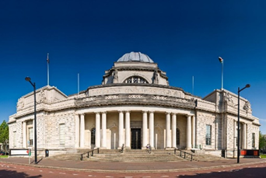
Figure 1 : National Museum of Wales (Matthew Dixon)

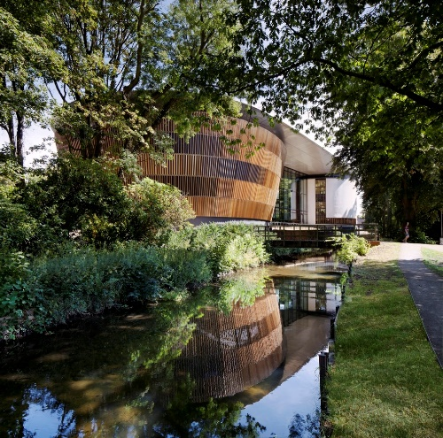
Figure 2 : Royal Welsh College of music and drama (archdaily (2011)

The plot of the Royal Welsh College of Music and Drama is located along a perpendicular setting with a plan including two main rooms, the Richard Burton Theatre and the Dora Stoutzker Hall. These rooms allow students to display their achievements and performances. The main entrance is located between these rooms which includes an elevated terrace for both movement and viewing. Figures 3 and 4 show how the building is stretched across the site, both from the road side and the side of the dock feeder canal.
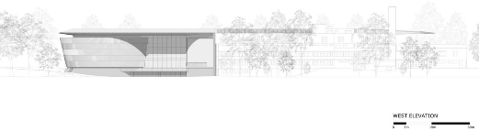
Figure 3 : Royal Welsh College of Music & Drama west elevation ( BFLS(2011)

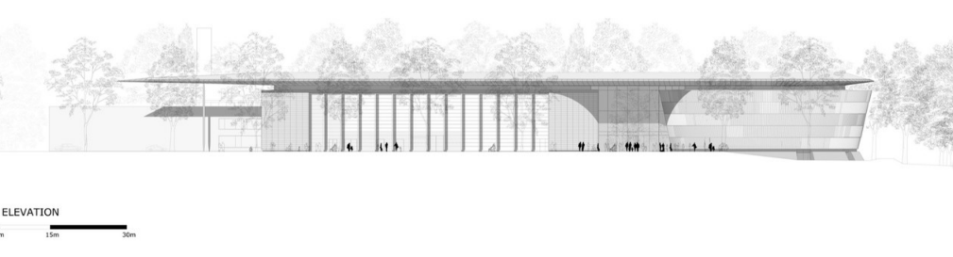
Figure 4 : Royal Welsh College of Music & Drama east elevation (BFLS (2011)

The layout enhances the environment from both sides, framing contrasting views of both nature and the city from the elevated viewing platform, including most of its immediate surrounding architecture where it does not stand out in any way.
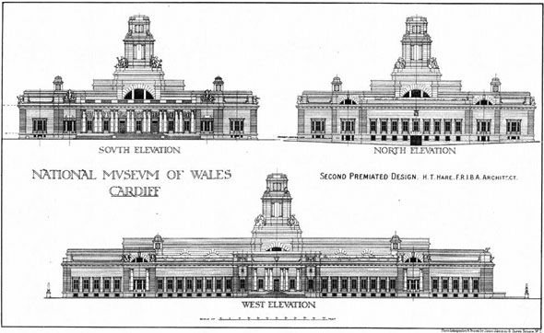
Figure 5 : Original Elevations of Museum (Hare (1910)

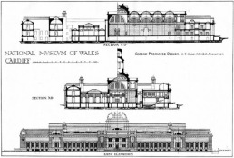
Figure 6 : Original Elevation and sections of Museum (Hare (1910)

Figure 5 and 6 show both elevations and sections of the museum. The layout starts with a large entrance hall where visitors view the interior of the building first, with an information centre and cafe. With the adaptation and additions throughout the years, the plans now allow for a fluid viewing of the museum which is simple but both enticing for the viewer.
The architects Bogle, Flanagan, Lawrence and Silver have used a small number of materials consistently in the college. Glass, timber and steel have been used in combination providing a light, airy and comfortable natural space for students and visitors. The curvature and use of timber both internally and externally allows the building to fit in to the area with the way it flows into its surroundings. Whereas, the spaces which are designed to hold performances are designed with very little natural light, but a large amount of stage lighting. Materials have also been used in these spaces which allow for a specific mood to be set during performances, enabling viewers to feel comfortable whilst emersed in the space. These spaces are in complete contrast to the entrance and communal spaces, providing an isolated space for viewers to focus on a performance with the guarantee of no disturbances and distractions. Steel has also been used in a soft way, not overpowering the space, and used in such a way where there are no straight lines. Therefore, allowing this industrial material to look soft and organic, wrapping itself around the space. On the other hand, the museum uses both marble and Portland stone (Kendall ,no date) in abundance, extending the vertical height of the space which was sort after during this time. Although from the exterior the museum looks to have a large amount of windows, the conversion to natural light in the interior of the museum is extremely disappointing. Unfortunately this has led to a large amount of interior lighting being used.
Figure 7 : Richard Burton Theatre (Archdaily (2011)

Figure 7: Richard Burton Theatre (BFLS (2011)
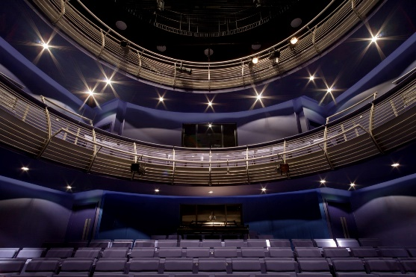

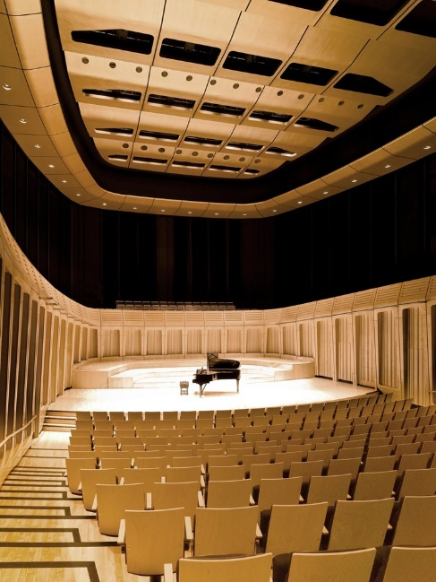
Figure 8 : Dora Stoutzker Hall (BFLS (2011)

The colleges main use is to provide “specialist practical and performance-based training in music and drama” (Royal Welsh College of Music & Drama,2021) allowing students to be prepared to enter the world of performing arts. The spaces throughout the college provide the possibility for a large number of uses including performance, learning and collaboration. There are also spaces designed for privacy and learning as well as for comfort and isolation from the problems and pressures that come with education. The performance zones can be both extremely quiet, but have the ability to amplify the sound of the performances with the use of curves and materials, enhancing the sound and therefore the quality of the performance. Both the theatre and the hall are situated as centres/hubs to the layout of the building, where the results of dedication and learning of both students and staff can be displayed. Whilst the museum has two simple uses. These are to attract a combination of tourists and local residents whilst also showcasing the wide array of historical artifacts which are found at the museum.
The purpose of the college was to provide a teaching and performing centre for the development of the performing arts in Wales. The facilities and environment provided through architecture do this to the utmost. There are facilities to showcase all of the combined achievements of the performers. Both the theatre and the hall express their purpose in the materials used to enhance the performance and the viewers experience. The interior holds a contrast to the exterior architecture in a way that unless you knew the building, you would not expect the contents which are held within. The museum is also successful in its role. The layout allows the display of the history within. Although the architecture seems to have been left in the past, and whilst the classical architecture is extremely fitting in places. The museum could learn from similar museums in how you successfully move forward with the time. If I were to repeat this study I would be interested in the emotional impact that is imposed on the users of both buildings. Also the impact of the construction on the surrounding nature, in particular the side of the canal and park of the college.

References
Archiseek (2009) National Museum and Library for Wales. Available at: https://www.archiseek.com/2009/1910-national-museum-of-Wales-cardiff/ (Accessed on: 11 January 2022)
BFLS. (2011) Available at: https://archdaily.com/178785/royal-welsh-college-of-music-drama-bfls/5016317328ba0d15800106b-royal-welsh-college-of-music-drama-bfls-image (Accessed : 17 January 2022) (A)
BFLS. (2011) Available at: https://archdaily.com/178785/royal-welsh-college-of-music-drama-bfls/5016317328ba0d15800106b-royal-welsh-college-of-music-drama-bfls-image (Accessed : 17 January 2022) (B)
BFLS. (2011) Available at: https://archdaily.com/178785/royal-welsh-college-of-music-drama-bfls/5016317328ba0d15800106b-royal-welsh-college-of-music-drama-bfls-image (Accessed : 17 January 2022) (C)
BFLS. (2011) Available at: https://archdaily.com/178785/royal-welsh-college-of-music-drama-bfls/5016317328ba0d15800106b-royal-welsh-college-of-music-drama-bfls-image (Accessed : 17 January 2022) (D)
BFLS. (2011) Available at: https://archdaily.com/178785/royal-welsh-college-of-music-drama-bfls/5016317328ba0d15800106b-royal-welsh-college-of-music-drama-bfls-image (Accessed : 17 January 2022) (E)
dcfw (2008) Royal Welsh College of Music and Drama. Available at: dcfw.org/royal-welah-college-of-music-and-drama-3/ (Accessed on: 16 January 2022)
Dixon, M. (2014) Available at: https://www.shutterstock.com/g/matthewdixon/sets/1609076/ (Accessed : 15 January 2022)
Hare, H, T. (1910) Available at: https://www.archiseek.com/2009/1910-national-museum-of-wales-cardiff/ (Accessed: 17 January 2022) (A)
Hare, H, T. (1910) Available at: https://www.archiseek.com/2009/1910-national-museum-of-wales-cardiff/ (Accessed: 17 January 2022) (B)
Kendall, R. (no date) A geological walk around BGS Wales in Cardiff. Available at: https://www.bgs.ac.uk/discovering-geology/maps-and-resources/office-geology/bgs-wales-office/ (Accessed at: 15 January 2022)
RWCMD (2021) National Conservative of Wales. Available at: https://www.rwcmd.ac.uk/node/1 (Accessed on: 10 January 2022)

