Contemporary Themes in the Hotel and Hospitality Sector
BMIH6001
Strategic Resilience: Hotel Industry Responses to Global Uncertainty in 2025
Student name: Alina Boestean
Student number: 2207646
Lecture name: Chris Wilkin
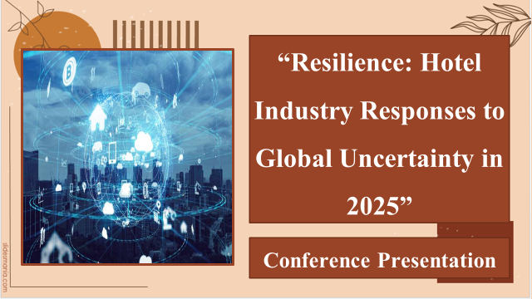
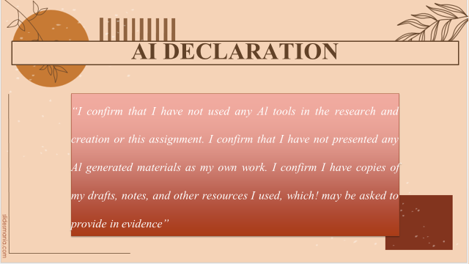
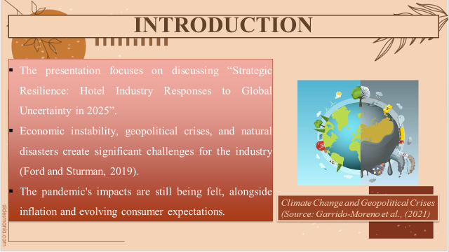
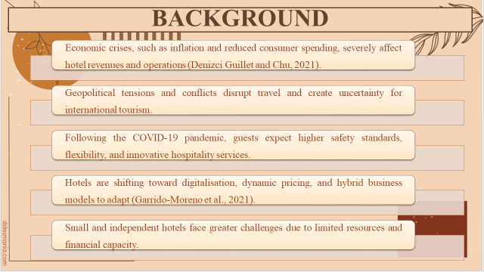
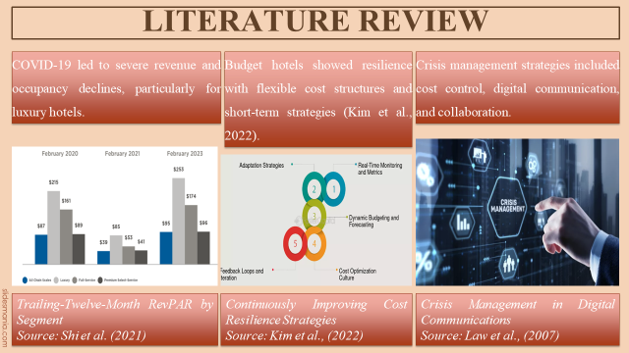
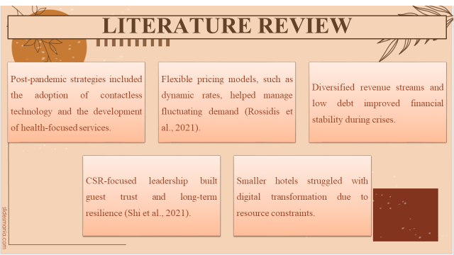
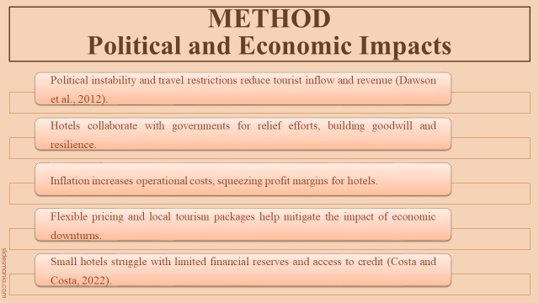
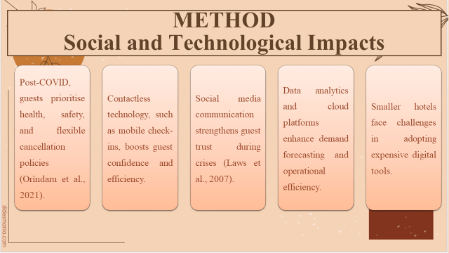
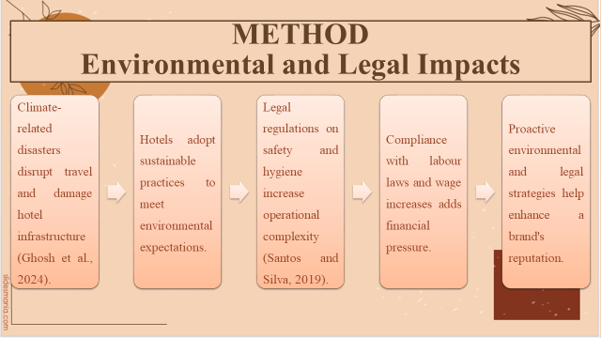
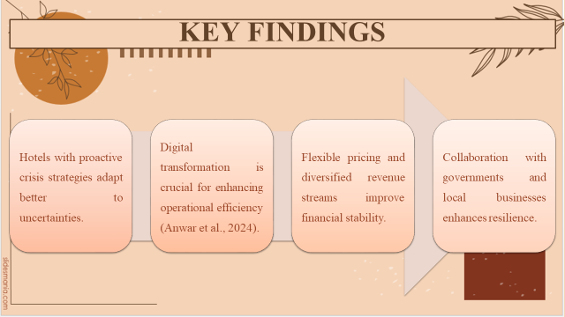
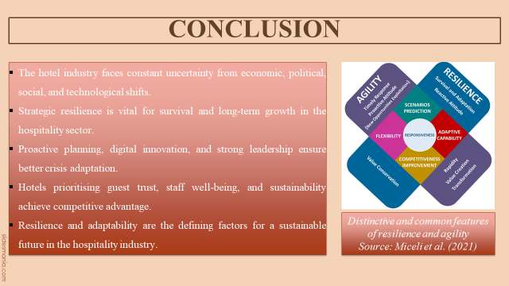
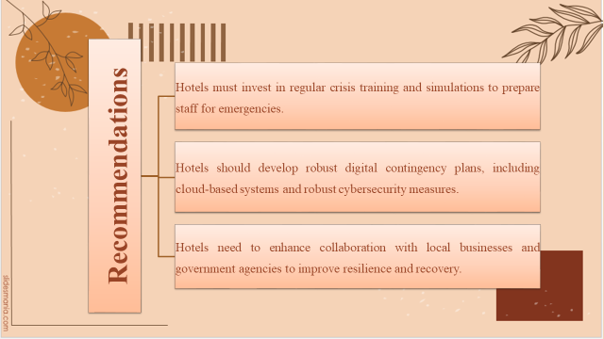
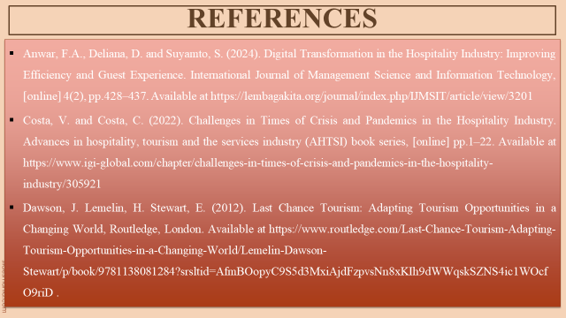
Anwar, F.A., Deliana, D. and Suyamto, S. (2024). Digital Transformation in the Hospitality Industry: Improving Efficiency and Guest Experience. International Journal of Management Science and Information Technology, [online] 4(2), pp.428–437. Available at https://lembagakita.org/journal/index.php/IJMSIT/article/view/3201
Costa, V. and Costa, C. (2022). Challenges in Times of Crisis and Pandemics in the Hospitality Industry. Advances in hospitality, tourism and the services industry (AHTSI) book series, [online] pp.1–22. Available at https://www.igi-global.com/chapter/challenges-in-times-of-crisis-and-pandemics-in-the-hospitality-industry/305921
Dawson, J. Lemelin, H. Stewart, E. (2012). Last Chance Tourism: Adapting Tourism Opportunities in a Changing World, Routledge, London. Available at https://www.routledge.com/Last-Chance-Tourism-Adapting-Tourism-Opportunities-in-a-Changing-World/Lemelin-Dawson-Stewart/p/book/9781138081284?srsltid=AfmBOopyC9S5d3MxiAjdFzpvsNn8xKIh9dWWqskSZNS4ic1WOcfO9riD
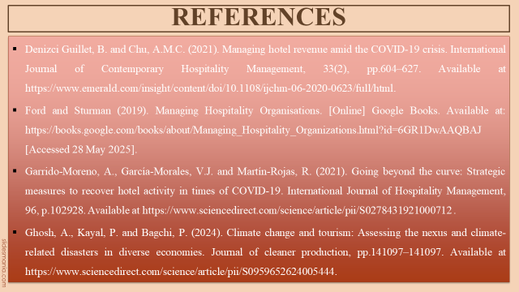
Denizci Guillet, B. and Chu, A.M.C. (2021). Managing hotel revenue amid the COVID-19 crisis. International Journal of Contemporary Hospitality Management, 33(2), pp.604–627. Available at https://www.emerald.com/insight/content/doi/10.1108/ijchm-06-2020-0623/full/html
Ford and Sturman (2019). Managing Hospitality Organisations. [Online] Google Books. Available at: https://books.google.com/books/about/Managing_Hospitality_Organizations.html?id=6GR1DwAAQBAJ [Accessed 28 May 2025].
Garrido-Moreno, A., García-Morales, V.J. and Martín-Rojas, R. (2021). Going beyond the curve: Strategic measures to recover hotel activity in times of COVID-19. International Journal of Hospitality Management, 96, p.102928. Available at https://www.sciencedirect.com/science/article/pii/S0278431921000712
Ghosh, A., Kayal, P. and Bagchi, P. (2024). Climate change and tourism: Assessing the nexus and climate-related disasters in diverse economies. Journal of cleaner production, pp.141097–141097. Available at https://www.sciencedirect.com/science/article/pii/S0959652624005444
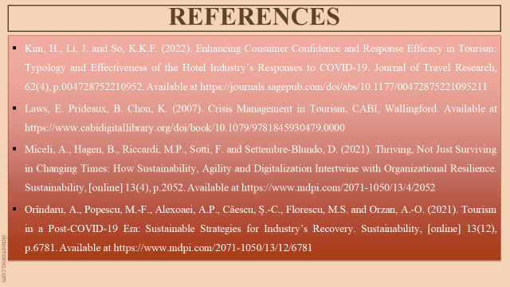
Kim, H., Li, J. and So, K.K.F. (2022). Enhancing Consumer Confidence and Response Efficacy in Tourism: Typology and Effectiveness of the Hotel Industry’s Responses to COVID-19. Journal of Travel Research, 62(4), p.004728752210952. Available at https://journals.sagepub.com/doi/abs/10.1177/00472875221095211
Laws, E. Prideaux, B. Chon, K. (2007). Crisis Management in Tourism, CABI, Wallingford. Available at https://www.cabidigitallibrary.org/doi/book/10.1079/9781845930479.0000
Miceli, A., Hagen, B., Riccardi, M.P., Sotti, F. and Settembre-Blundo, D. (2021). Thriving, Not Just Surviving in Changing Times: How Sustainability, Agility and Digitalization Intertwine with Organizational Resilience. Sustainability, [online] 13(4), p.2052. Available at https://www.mdpi.com/2071-1050/13/4/2052
Orîndaru, A., Popescu, M.-F., Alexoaei, A.P., Căescu, Ș.-C., Florescu, M.S. and Orzan, A.-O. (2021). Tourism in a Post-COVID-19 Era: Sustainable Strategies for Industry’s Recovery. Sustainability, [online] 13(12), p.6781. Available at https://www.mdpi.com/2071-1050/13/12/6781
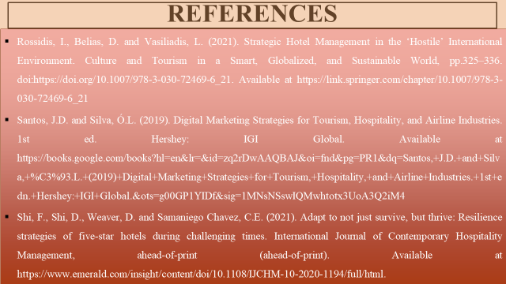
Rossidis, I., Belias, D. and Vasiliadis, L. (2021). Strategic Hotel Management in the ‘Hostile’ International Environment. Culture and Tourism in a Smart, Globalized, and Sustainable World, pp.325–336. doi:https://doi.org/10.1007/978-3-030-72469-6_21. Available at https://link.springer.com/chapter/10.1007/978-3-030-72469-6_21
Santos, J.D. and Silva, Ó.L. (2019). Digital Marketing Strategies for Tourism, Hospitality, and Airline Industries. 1st ed. Hershey: IGI Global. Available at https://books.google.com/books?hl=en&lr=&id=zq2rDwAAQBAJ&oi=fnd&pg=PR1&dq=Santos,+J.D.+and+Silva,+%C3%93.L.+(2019)+Digital+Marketing+Strategies+for+Tourism,+Hospitality,+and+Airline+Industries.+1st+edn.+Hershey:+IGI+Global.&ots=g00GP1YIDf&sig=1MNsNSswIQMwhtotx3UoA3Q2iM4
Shi, F., Shi, D., Weaver, D. and Samaniego Chavez, C.E. (2021). Adapt to not just survive, but thrive: Resilience strategies of five-star hotels during challenging times. International Journal of Contemporary Hospitality Management, ahead-of-print (ahead-of-print). Available at https://www.emerald.com/insight/content/doi/10.1108/IJCHM-10-2020-1194/full/html

