Scenario – Mr Movit (Transport Company).

As the owner, you would like to estimate how long a delivery will take based on 3 factors: 1) the total distance of the trip in miles and 2) the number of deliveries that must be made during the trip, and 3) the daily price of petrol in Wales in pounds.

In order to find out how much the predictor variables (Miles travelled, number of deliveries and daily petrol prices) predict the total travel time, we would need to carry out a multiple regression. Please open the Mr Movit SPSS File on Moodle.

Below is the data, as you can see this is from a total of 10 random travel runs and we have the three PVs (Predictor variables) and the 1 CV (Criterion Variable – Travel time) in the various rows.

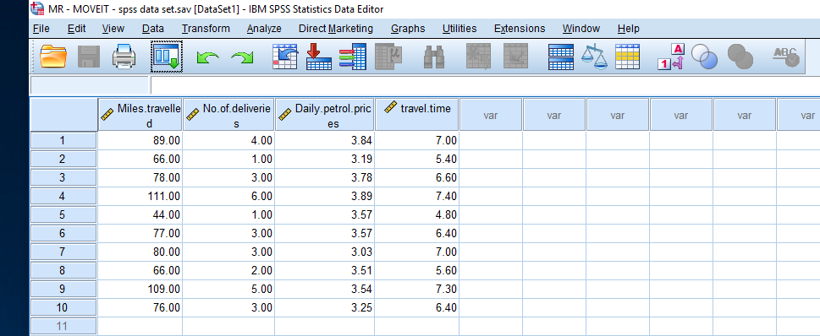

To perform the Multiple Regression you go.

Analyse……… Regression……….. Linear

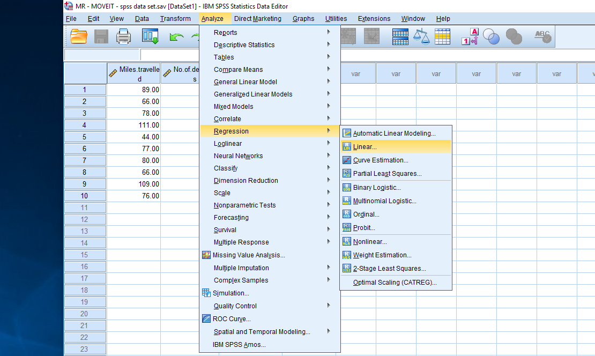

Place the Criterion Variable (Dependent Variable) of travel time into the Dependent box and the three predictor variables (Independent Variables) into the independent variable box. For this study you need the method as “enter”. If you were looking at making further predictions on which PV had the strongest relationship with the CV then you would use the “stepwise” method, but we are not, so stick with “enter”.

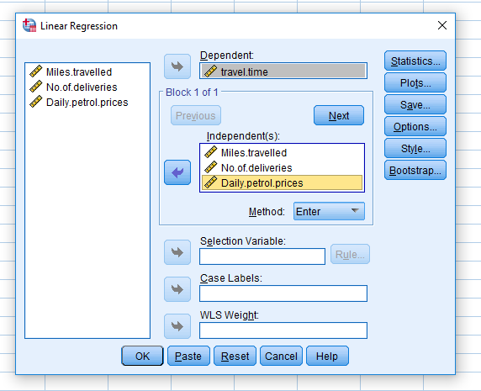
Then click statistics.
Make sure the following boxes are checked – Estimates, Model Fit, Part and Partial correlations and Collinearity diagnostics…… Then click continue.

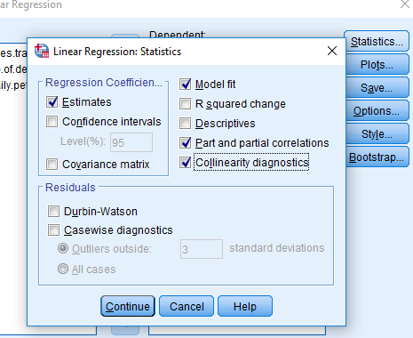

Then Click Plots.

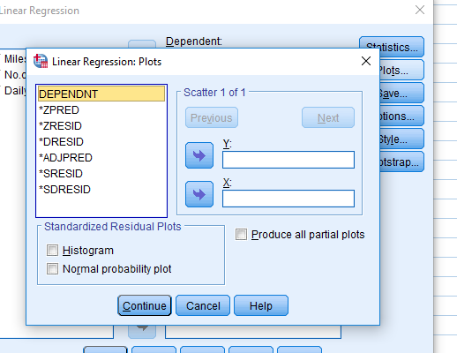
We want to do a plot of the Standardised Predictors – ZPRED and the Standardised Residuals – ZRESID. Place ZPRED into X and ZRESID into Y. We want this as a histogram, so check that box.

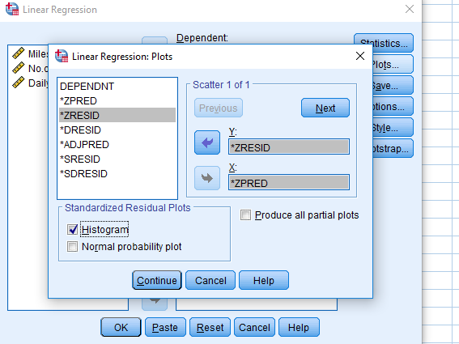

Then click continue and then ok….. and we should run our analysis.

Lets look at the tables (Important ones only).

Model Summary^{b}
Model | R | R Square | Adjusted R Square | Std. Error of the Estimate
1 | .946ª | .895 | .842 | .34469
a. Predictors: (Constant), Daily.petrol.prices, Miles.travelled, No.of.deliveries
b. Dependent Variable: travel.time

The adjusted R square is important – this measure the proportion of the variation of the CV explained by the PV (Predictors). Use the adjusted R square.
The adjusted R square can then be converted into a percentage (x 100) – so it is telling us that 84% of the total variability of the CV (time travelled) is explained by our Predictor variables. This would suggest a very strong model.

ANOVAª
Model |  |  |  | Sum of Squares |  |  | df |  | Mean Square |  |  |  | F |  | Sig.
1 |  | Regression |  | 6.056 |  |  | 3 |  | 2.019 |  |  |  | 16.991 |  | .002^{b}
 |  | Residual |  | .713 |  |  | 6 |  | .119
 |  | Total |  | 6.769 |  |  | 9
a. Dependent Variable: travel.time
b. Predictors: (Constant), Daily.petrol.prices, Miles.travelled, No.of.deliveries

Look at the F value and Significance Values here – again as with factorial Anova’s we are looking for a Sig value of less than .05. In this case P = .002 which is significant, therefore our hypotheses that the PVs could predict the CV is supported. However, it does not end there.

The next box is also very important, as this looks at the individual contribution of each PV.

Coefficientsa
Model |  |  | Unstandardized Coefficients |  |  | Standardized Coefficients |  | t |  | Sig. | Correlations |  |  |  |  | Collinearity Statistics
 |  |  | B |  | Std. Error | Beta |  |  |  | Sig. | Zero-order | Partial |  | Part |  | Tolerance | VIF
1 | (Constant) |  | 6.211 |  | 2.321 |  |  | 2.677 |  | .037
1 | Miles.travelled |  | .014 |  | .022 | .326 |  | .636 |  | .548 | .928 | .251 |  | .084 |  | .067 | 14.936
1 | No.of.deliveries |  | .383 |  | .300 | .705 |  | 1.277 |  | .249 | .916 | .462 |  | .169 |  | .058 | 17.353
1 | Daily.petrol.prices |  | -.607 |  | .527 | -.200 |  | -1.152 |  | .293 | .267 | -.426 |  | -.153 |  | .583 | 1.714
a. Dependent Variable: travel.time

Now if you look at the sig levels – it says that ALL of our individual PV do not make a significant contribution to the total model (as all P values are greater than 0.05). Yet in the model total we had a strong model (clearly significant) – so something is odd with this data. Remember back to the assumptions of Multiple Regression and multicollinarity and the VIF mentioned in the PowerPoint. Values of over 10 suggest high levels of multicollinearity and need to be removed from the data. As you can see Miles travelled and numbers of deliveries have very high values….. 14.93 and 17.35, suggesting that there is too strong a relationship between these two PV and consequently we have to re-run the analysis and without one of these PV as our regression has been violated.

So what you need to do is delete one of these variables from the model and re – run the analysis. It is best practice to delete the one with the highest VIF (unless you have a specific reason to keep it) – so lets re-run the analysis taking away number of deliveries from the model.

Please note as you have done this – there is now differences in box 1 and 2, but lets look at the coefficients box now.

Coefficientsª
Model |  | Unstandardized Coefficients |  | Standardized Coefficients | t | Sig. | Correlations |  |  | Collinearity Statistics
 |  | B | Std. Error | Beta | t | Sig. | Zero-order | Partial | Part | Tolerance | VIF
1 | (Constant) | 3.868 | 1.482 |  | 2.609 | .035
1 | Miles.travelled | .041 | .006 | .954 | 6.445 | .000 | .928 | .925 | .891 | .873 | 1.145
1 | Daily.petrol.prices | -.219 | .449 | -.072 | -.488 | .641 | .267 | -.181 | -.067 | .873 | 1.145
a. Dependent Variable: travel.time

