- Ahlam Bchini
- 2439423
- Professional Development within Health and Social Care (LCHS 4009)
- Hajira Mustasim
- Personal Development Portfolio

Task1

Job Title: Health Care Assistant (Band 2, Ref; 7584369)
Employer: Sandwell and West Birmingham NHS Trust
Location: Sandwell/Birmingham (Community inpatient)
Key Duties: Deliver basic nursing care (personal hygiene, nutrition, mobility support), assist multidisciplinary teams, maintain infection control standards, report patient condition changes.
Source: https://apps.trac.jobs/job-advert/7584369
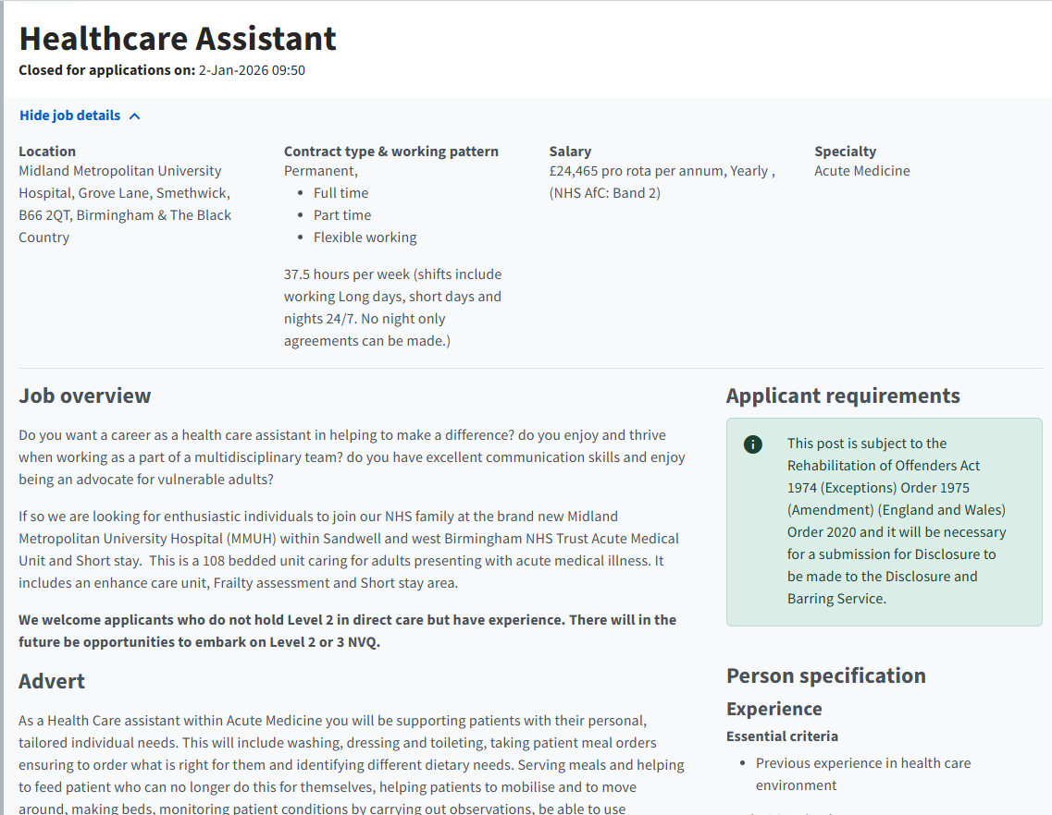
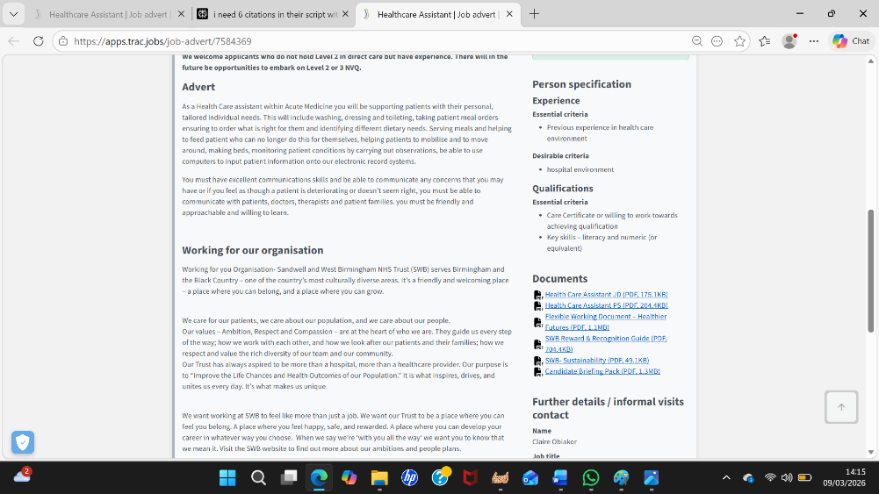

Task1/ Professional CV

Ahlam Bchini
Address: 17 Alexander way. Birmingham.B8 3BF
Mobile: 07988501781
Email: nourahlem82@gmail.com

Personal Profile
I am a dedicated Level 4 Health and Social Care student applying for Band 2 Health Care Assistant position at Sandwell & West Birmingham NHS Trust (Ref: 7584369). I am competent in childcare, providing personal care, safety supervision, and emotional support. Interspersing with a passion for individual- oriented care, I engage in infection prevention and control strategies, as well as interprofessional collaboration. I have a strong ambition to complete the Care Certificate training on my route to becoming a School Nurse.

Experiences
Family Childcare Support (2019-2023)
- Provided personal hygiene support, meal planning, and meal delivery while monitoring children aged 4–8 for offsite hazards.
- Facilitated mobility, emotional wellbeing and daily living activities.
- Reported changes in behaviour or health to parents promptly, with appropriate next steps.
- Fostered clean/safe environments (infection control equivalent).

Achievements
- Achieved excellent grades in health modules.
- Delivered health promotion research presentations.
- Demonstrated consistent punctuality and reliability.
- Successfully worked in group presentation about digital literacy in health care settings.
Education and Qualification
Level 4 Diploma in Health and Social Care (2025-2026)
GCSEs in English and Mathematics (2008)

Key Skills

- Person-centred care and empathy
- Multilingual communication: Fluent Arabic, French and English
- Organisation, time management and remaining calm under pressure
- Basic IT skills.

Other Details

Full driving licence
Able to work flexible shifts, including nights and weekends
Strong interest in providing compassionate care to support the wellbeing of others

Interests

Reading about health, wellbeing, and personal development.
Listening to music and relaxation activities.

References
Available upon request
Task 2: Personal Statement
I am writing to apply for the Band 2 Health Care Assistant role (Ref: 7584369) with Sandwell and West Birmingham NHS Trust. This position is my introduction to patient care within the NHS and, combined with my previous childcare experience, will help me develop academic skills to work towards my goal of becoming a School Nurse. Delivering person-centred care, especially in a community-focused inpatient setting, is something I am passionate about and will allow me to empower vulnerable communities with the respect, compassion, and professional competence they deserve at their time of need.

I have gained the essential knowledge for working in healthcare with a Level 4 Diploma in Health and Social Care (2025-2026). Modules on communication in care settings, equality, diversity and psychology gave me a deeper understanding of human behaviour, emotional wellbeing, and vulnerable people’s needs. In turn, this links to core HCA roles such as patient observation, reporting changes or concerns to qualified personnel, and promoting dignity using person-centred approaches. Research presentations on health promotion and digital literacy in healthcare helped me to develop organisation, teamwork, and problem-solving skills, which are crucial in multi-disciplinary teams. I received top marks for health modules and tutors often commented on my punctuality and good organisational skills.

I have also been offering family childcare support with children aged 4–8 for multiple years, like an HCA role. I coordinated personal hygiene, toileting, dressing, meal preparation, and delivery of healthy options (e.g., Margaret could not sit on a stool to eat), compound movement during gross motor play, following basic safety guidelines when out in the world, without imposing them unnecessary. This one to-one support proved highly effective, as I was able to keep track of signs of health and behaviour changes in each child and, if needed, follow-up with parents in real-time about what observed aspects led me to contact them along with the next steps. I also maintained clean, hygienic environments to prevent infection — skills that cross straight over into ward-based patient support, rehabilitation and infection control. I built resilience in myself, remained calm during pressure situations while building supportive and safe environment spaces through these experiences.

Combine with my strengths to make a great fit for this role. Fluent in Arabic, French, and English, I communicate accurately and empathetically with people from different backgrounds, inspiring trust and inclusivity at a time when Sandwell's growing diverse population needs it most. I am a reliable, punctual and organised individual with good time management skills and basic IT skills for any documentation. I have a full clean driving licence and I'm in good health and a non-smoker and can cover shifts on nights/weekends also.

This role dovetails beautifully with the Trust's values of empathy and lifelong learning. I am passionate about completing the Care Certificate and Level 2 training to formalise my competencies. I will add immediate value with high-quality, patient-focused care and simultaneously gain NHS experience to facilitate my progression towards School Nursing by bringing my education, practical childcare skills, and multilingual empathy. I look forward to supporting Sandwell & West Birmingham in its goal of improving population health outcomes and delivering great care.

Task 3/ Part A
SWOT Analysis
Strengths | Weaknesses
- Understanding of principles governing health and social care  - Strong communication, patience, and empathy  - Unpaid childcare experience nurturing children’s wellbeing  - Ability to remain calm in stressful environments | - Limited formal healthcare work experience  - Familiarity with the clinical environment  - Little exposure to practical aspects of healthcare  - building confidence in emotionally draining situations
Opportunities | Threats
- Healthcare Assistant position offers real-life experience  - opportunity to network with healthcare professionals  - Strengthening future nursing school applications  -Educational events and voluntary opportunities | - Workforce pressures within the NHS  - Emotionally demanding healthcare environments  - Heavy workload and workplace stress  - Potential burnout without proper coping mechanisms

A SWOT analysis on an individual focuses on personal strengths, weakness, opportunities, and threats around professional goals (International Journal for Innovative Research in Technology, 2025). It provides a reflective snapshot that converts self-assessment into targeted development actions. Using this framework, I can see what skills are needed to reach Healthcare Assistant and School Nursing roles, balanced with opportunities for external training and competing within the market; allowing me realistic career planning (what is required vs. sought-after), combined with a more self-aware sense of how to advance my presence in health and social care.

Part B

Personal Development Plan
Goals | List the actions to complete to achieve the goal | Support/resources needed | Target date | Review date
Gain hands-on patient care experience as a health care assistant in an NHS setting | -Apply for Health Care Assistant roles  -Volunteer in NHS/ local health care settings | - Job/volunteer opportunities  -Supervisor guidance | 6-12 months | 3 months  after placement start
Improve clinical and practice skills | -Complete care certificate+ NHS mandatory training (safeguarding, BLS)  -Shadow experienced health care staff | -Training courses  -staff mentorship | 6-12 months | Every 2 months  during training
Develop emotional resilience | -Attend wellbeing workshops  -Seek mentorship from senior or care assistants  -Keep reflective journal | -Well-being training  -Supervisor/mentor support  - Time for self-reflection | 12-14 months | Every 3 months  to monitor emotional  wellbeing  and coping strategies

A Personal Development Plan is a structured framework which details an individual’s learning and professional life targets, the actions needed to achieve goals by certain deadlines and dates for review (Embree, 2022). It offers a concise written structure for monitoring progress, gauging strengths and development needs, and tracking changes in competence over time, as (Jack et al, 2018) emphasises through reflective teacher- learner cycles. The PDP gives me a framework of my short to long term goals for the Healthcare Assistant role and future career in School Nursing, translating reflection into tangible, measurable steps.

This Personal Development Plan summarises my three goals over the span of two years, in which I will achieve hands on experience and training in year one, followed by the development of clinical skills and resilience in year two. Progress is tracked quarterly through certifications, reviews, and journal analysis with respect to competence baselines.

Task 4

Critical Reflection on LCHS4009 Component 1 Presentation

Introduction

Reflection supports learning and professional development by enabling individuals to examine experiences, recognise strengths and weaknesses, and plan improvements. Using Gibbs’ Reflective Cycle, this report reflects on my LCHS4009 Component 1 presentation, focusing on my thoughts, feelings, and performance. It describes the experience, explores feelings, evaluates strengths and weaknesses, analyses using theory, and concludes with an action plan for enhancing confidence, critical thinking, and effectiveness.

Description of the Experience

For Component 1, I delivered my presentation to my lecturer, explaining prepared key points while managing timing and speaking clearly. I relied heavily on notes. Occasionally, I spoke quickly which affected clarity and pacing. I felt anxious, as my lecturer noted that I had looked very nervous, which confirmed how obvious my anxiety was during my delivery. The presentation followed an organised sequence with slides supporting main points to keep me on track. This one-to-one delivery without a wider audience focused on conveying content coherently.

Feelings and Thoughts about the Experience

I felt anxious about timing, stressed, and lacking confidence in recalling points and speaking clearly. Performance anxiety commonly impairs communication and competence (Zhang and Ardasheva, 2019). I forgot some planned content and spoke rapidly, reducing clarity. As I progressed, focusing on the structure and slides slightly boosted my confidence, although nervousness and time pressure persisted. This showed how emotions influence performance, highlighting emotional regulation's role in professional competence (Health and Care Professions Council, 2024).

Evaluation of the Experience

Strengths included clear organisation, accurate content, and supportive slides, demonstrating effective preparation. Weaknesses were over-reliance on notes limiting clarity, rapid speech and forgetfulness reducing impact, and descriptive rather than analytical discussion. Content knowledge alone proved insufficient without confident delivery and critical engagement. Recognising these positives and negatives shows reflection's value in identifying improvement areas for future presentations.

Analysis

This experience demonstrates reflective practice's value in learning, as structured reflection fosters deeper learning and professional identity (Jasper, 2021). Gibbs’ Reflective Cycle enabled systematic examination of feelings, thoughts, and performance factors affecting delivery (University of Edinburgh, 2024). The model supports continuous improvement by transforming experience into actionable learning. This revealed reflection extends beyond description to understanding pressure responses and adaptation strategies. Reflecting on this has reminded me of how important it is to realise how anxiety and confidence are related to my professional identity and how I want to portray myself as a future healthcare professional.

Summary

Preparation and organisation were strengths while anxiety, time pressure, forgetfulness, reliance on notes, and limited critical evaluation were weaknesses. More analytical exploration and calmer delivery would have improved impact. The experience reinforced reflection, self-awareness, and planning's importance for academic and professional growth.

Action Plan

For future presentations, I will practise delivering material without relying heavily on notes to enhance confidence and engagement. I will focus on critical evaluation by comparing sources, discussing limitations, and rehearsing responses to potential gaps in memory. Practising time management and pacing will reduce stress, which is consistent with recommendations for improving oral presentation skills in higher education (Zhang and Ardasheva, 2019). Seeking peer feedback during rehearsals will help identify unclear areas and support ongoing reflective learning (Jasper, 2021). To combat the anxiety and nervousness highlighted by my lecturer, employing some breathing or relaxation exercises before presenting, as well as attempting to rehearse several times without notes, will help me to feel more confident in my voice.
Applying Gibbs’ Reflective Cycle (University of Edinburgh, 2024) will help me turn each experience into structured learning for future practice. I will also record some of my rehearsals to review my tone, pace, and body language more objectively. Implementing these strategies will strengthen analytical skills, build confidence, and ensure more structured, professional, and effective presentations.

Conclusion

Reflecting on my presentation using Gibbs’ Reflective Cycle has highlighted the importance of structured reflection in developing academic and professional skills. Recognising strengths, weaknesses, and the impact of anxiety, forgetfulness, and time stress enables targeted improvement. Gibbs’ model demonstrates how self-awareness, planning, and critical evaluation can transform experiences into actionable strategies for effective, confident, and reflective practice.

References

Embree, J.L. (2022) Teaching nurses how to create a personal and professional development plan. Journal of Continuing Education in Nursing, 53(10), pp. 438–441. Available at: https://pubmed.ncbi.nlm.nih.gov/36178758/ (Accessed: 10 March 2026).
Health and Care Professions Council (2024) Reflection and meeting your standards. Available at: https://www.hcpc-uk.org/standards/meeting-our-standards/reflective-practice/reflection-and-meeting-your-standards/ (Accessed: 7 March 2026).
International Journal for Innovative Research in Technology (2025) Importance of self SWOT analysis in career planning and mapping for students. Available at: https://ijirt.org/article?manuscript=186435 (Accessed: 10 March 2026).
Jack, K., Hamshire, C., Harris, W., Langan, M., Barrett, N. and Wibberley, C. (2018) ‘My mentor said I had a lot of potential’: perceived value of the teacher-learner relationship in nursing. Nurse Education Today, 59, pp. 54–58. Available at: https://doi.org/10.1016/j.nedt.2017.09.003 (Accessed: 8 March 2026).
Jasper, M. (2021) Reflective practice and developing professional identity: a qualitative longitudinal study of student nurses. Nurse Education Today, 105, p. 105015. Available at: https://doi.org/10.1016/j.nedt.2021.105015 (Accessed: 7 March 2026).
University of Edinburgh (2024) Gibbs’ reflective cycle. Available at: https://reflection.ed.ac.uk/reflectors-toolkit/reflecting-on-experience/gibbs-reflective-cycle (Accessed: 7 March 2026).
Zhang, X. and Ardasheva, Y. (2019) Sources of anxiety in foreign language public speaking: a qualitative study. System, 82, pp. 61–71. Available at: https://doi.org/10.1016/j.system.2019.03.002 (Accessed: 7 March 2026).

