Programme:
Certificate of Higher Education Skills for the Workplace (Health and Social Care)

Modul: Introduction to Public Health
Module code: LCHS4004

Title: Tuberculosis (TB)

Lector: Bianca Sanfilippo

Author: Petra Stankova (2216986)

TUBERCULOSIS (TB)
Tuberculosis Is a bacterial disease, which is caused by bacteria named Mycobacterium Tuberculosis.
Tuberculosis is communicable disease, highly infectious, which is transmitted by droplets, which one person spread and another one inhales them. This disease is spreads in community, usually, when people spend more time close to person, who has active pulmonary tuberculosis. (NHS,2022)
Tuberculosis can be primary, active or latent.
Primary TB is usually without any symptoms, or with symptoms typical for flu. Primary tuberculosis is recognized by the body and the bacteria that cause it are destroyed by immune system.
Latent version of the disease is not communicable, person, who has passive TB does not have any symptoms, latent TB can be in body many months, years.
Tuberculosis can attack another part of body too, not only lungs. Can attack joints, bones, lymph, stomach, glands or nervous system. This type of Tuberculosis we called extrapulmonary TB. This type of TB usually affects people with very weakened immunity.
Only active pulmonary Tuberculosis is communicable. (NHS,2022)
Symptoms typical for TB are:
Long term cough, can contain blood
Swelling at night
Weight loss
Fever
Tiredness
Loss of appetite
Lose weight. (NHS,2022)

Diagnosis
Diagnosis of TB can be confirmed by physical exam, when a doctor check lymph node if they are swelling and listen the sounds of lungs by stethoscope. The most commonly is skin test used for TB diagnostic, but blood test, which are more precisely is used increasingly frequent. If skin test is positive, doctor usually let make a chest X-ray or a CT scan. When chest X-ray has signs of tuberculosis, doctor can make samples of the sputum (comes from mouth with cough). This test shows, if TB bacteria is there. (Mayo Clinic, 2022)

Treatment of Tuberculosis
Tuberculosis is a very serious disease, which in the past often resulted in death.
Currently, tuberculosis is treatable and curable. When TB response well to medication, disease is treated 4 or 6-month with 4 antimicrobial medications (antibiotics). Patient is provided by a medical professional all the time. (WHO,2022) Active tuberculosis is hospitalized if it has a serious course, but usually hospitalization is not necessary. (NHS, 2022)
Because TB medicines have been used for many years, some strains of tuberculosis have become multidrug-resistant. Drug resistance arise when medicines are used incorrectly, when prescription is improper, drugs are poor quality or treatment was finished prematurely. MDR-TB is curable too by using second-line drugs. Treatment for MDR-TB is limited and includes large chemotherapy up to 20 months. This second-line treatment is expensive for NHS and toxic for person, who need it. (WHO,2022)

Strategies used in the UK to control the incidence of Tuberculosis.
- simplification of access to services, timely determination of diagnosis and initiation of treatment
- easy access to good quality diagnostics
- high quality of treatment and care
- make sure, that all contacts are tracing
- reduce drug resistant TB
- use screening to identify latent TB
- uptake BCG vaccination
- trace TB in under - served communities
- monitoring and control cases of TB – The Public Health, Act of 1984, Control of Disease says, it is mandatory to report all cases of Tuberculosis (NHS, 2022)

The BCG vaccine (Bacillus Calmette-Guérin vaccine)
BCG vaccine is developed from a weakened strain of Tuberculosis. It activates the immune system to protect body against the infection but doesn’t caused illness. The protection against the most severe forms of TB is consistent, such as TB meningitis in children. Vaccine is not so effective in preventing TB bacteria, that affects the lungs in adults, so has minimum impact on the spread of Tuberculosis, and is recommended for babies, children and adults under the age of 35 who are at higher risk of catching TB. The BCG vaccine shouldn’t be given more than once in lifetime. (Mayo, Clinic,)

Prevention
- Any visits of public space, no school, no work, no clubs, restaurants, no public traffic, when you have active TB.
- Stay at home in isolation.
- If you have a company, keep distance, cover mouth and nose always when you are coughing, sneezing, laughing.
- For tissue, which you used, use plastic bag.
and adults under the age of 35 who are at higher risk of catching TB. The BCG vaccine shouldn’t be given more than once in lifetime. (Mayo, Clinic,)

Treatment of Tuberculosis
Tuberculosis is a very serious disease, which in the past often resulted in death.
Currently, tuberculosis is treatable and curable. When TB response well to medication, disease is treated 4 or 6-month with 4 antimicrobial medications (antibiotics). Patient is provided by a medical professional all the time. (WHO,2022) Active tuberculosis is hospitalized if it has a serious course, but usually hospitalization is not necessary. (NHS, 2022)
Because TB medicines have been used for many years, some strains of tuberculosis have become multidrug-resistant. Drug resistance arise when medicines are used incorrectly, when prescription is improper, drugs are poor quality or treatment was finished prematurely. MDR-TB is curable too by using second-line drugs. Treatment for MDR-TB is limited and includes large chemotherapy up to 20 months. This second-line treatment is expensive for NHS and toxic for person, who need it. (WHO,2022)

The country with the highest incidence of tuberculosis in the world are:
Africa, particularly countries south of Sahara
South Asia
Russia
China
South America
The western Pacific region (WHO, 2022)

TB is dangerous for all age groups, but mostly affects adults of productive age. More than 80% of cases and deaths comes from low- and middle-income countries. In higher risk are people infected with HIV, people, who has lower condition of their immune system and people with undernutrition. Smoking and alcohol consumption also increase the risk of tuberculosis. ( WHO,2022)

Tuberculosis in England morbidity data:
In 2020 was 4,125 cases of TB recorded in England, what is rate of 7.3 per 100,000 population, what is by WHO definition of a low incidence country. 72.8% of notifications was people, who was not born in UK. (GOV UK, 2022)
Tuberculosis in England mortality data:
At the moment, we do not know of any deaths caused by tuberculosis in UK, but globally, tuberculosis is still very dangerous, it is 13th most common disease, which is a couse of death in the world and second infection disease after Covid 19, which caused death. Tuberculosis often causes a death in countries, where health care is poor and it is not available to everyone. In 2021 wordwide 1,6 milion people died from TB. (WHO, 2022)
2000–2020 shaded areas represent uncertainty intervals. The horizontal dashed line shows the 2020 milestone of the End TB Strategy.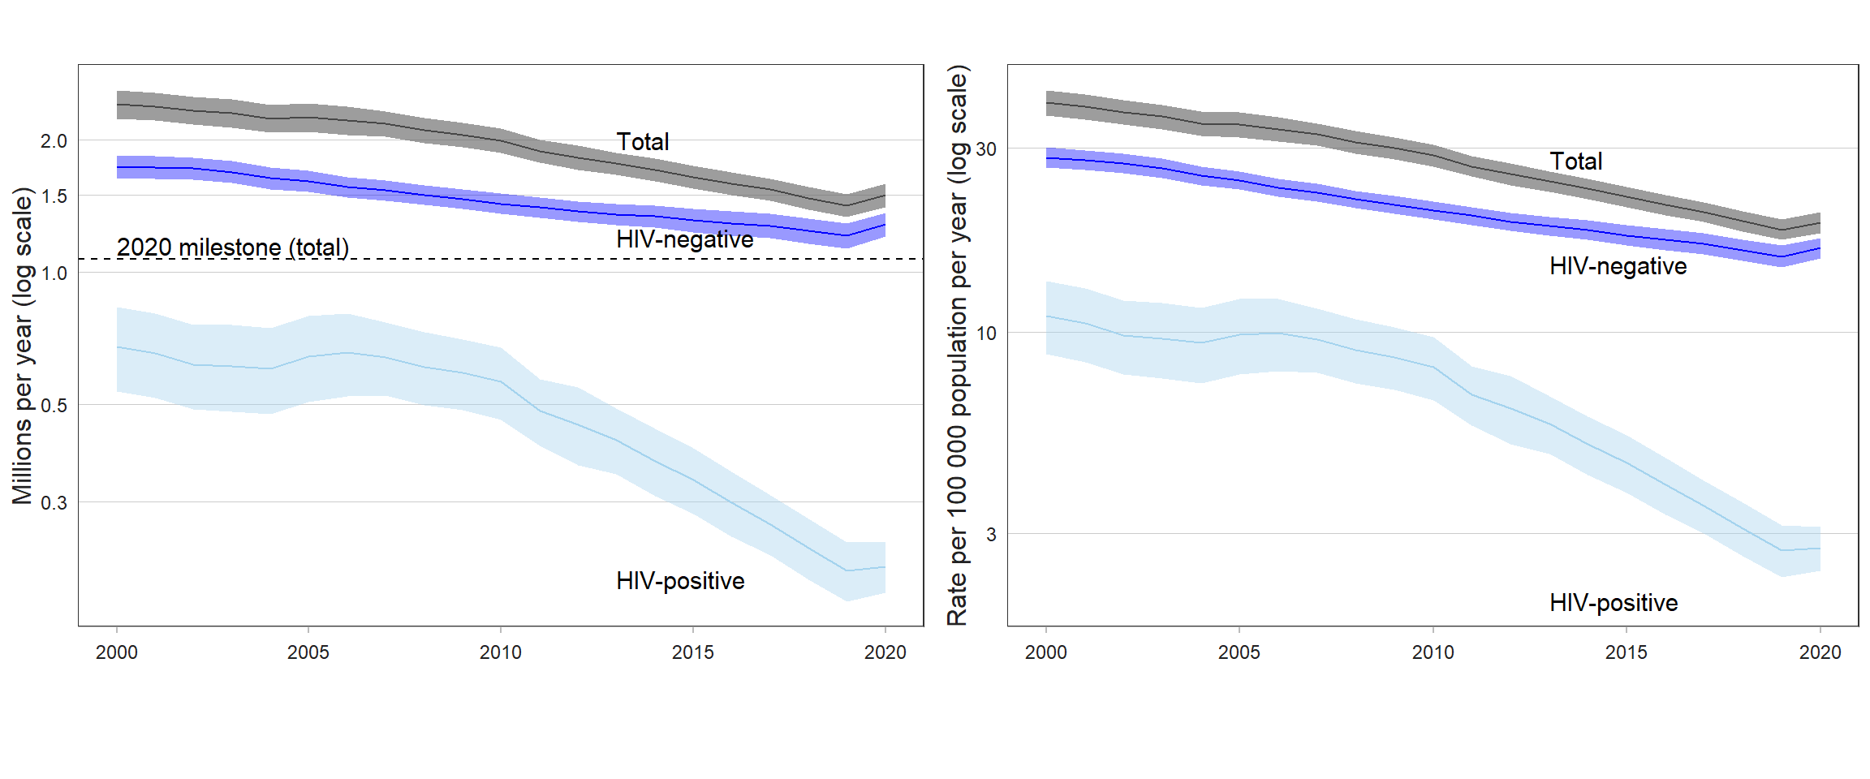

s of death worldwide in 2019
Deaths from TB among HIV-positive people are shown in grey.
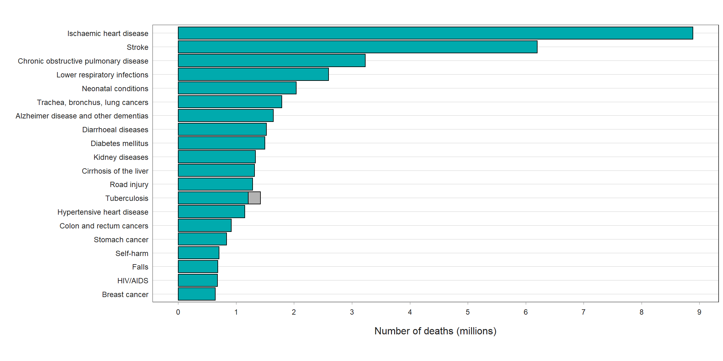

Fig. 2.2.8 Estimated TB mortality rates in HIV-negative people, 2020
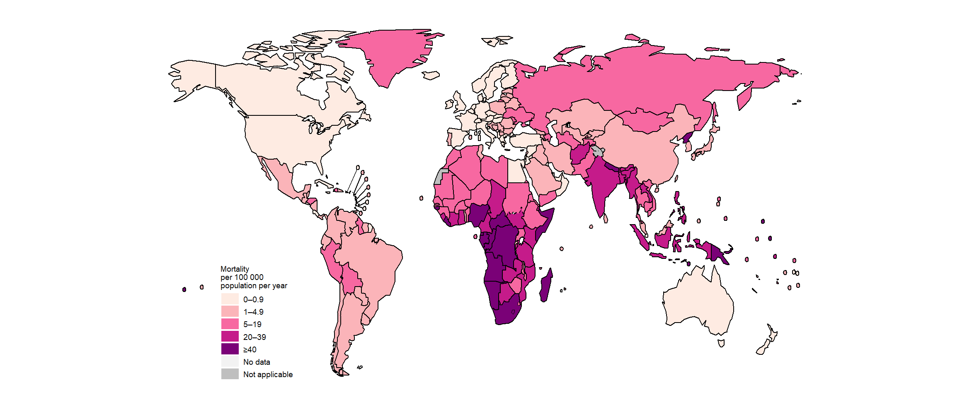

References:

BBC News(2018) Tuberculosis rates in England fall by third in six years. Accessed on Tuberculosis rates in England fall by third in six years - BBC News accessed 5.3.2023

UK Health security agency(2022) Tuberculosis in England. Accessed on Tuberculosis in England: 2021 report (publishing.service.gov.uk) accessed 19.3.2023
NHS (2022) Tuberculosis(TB). Accessed on https://www.nhs.uk/conditions/tuberculosis-tb accessed 1.4.2023.
Mayo Clinic(2023) Tuberculosis. Accessed on https://www.mayoclinic.org/diseases-conditions/tuberculosis/symptoms-causes/syc-20351250 accessed 19.3.2023.
World Health Organization(2022) Tuberculosis. Accessed on Tuberculosis (who.int), accessed 5.4.2023

