

LEVEL 4

SEMESTER 1

MODULE CODE: SHSS4077
Making Safety Personal
aSSESSMENT TYPE: Project
Assessment/Component: 2

COMPONENT WEIGHTING: 30 %

WORD COUNT: 1,500 WORDS

MODULE TUTOR: Graham Harvey

SUBMISSION DETAILS:
Work as part of a small team (between three and five people) to produce an interpretive brochure/ leaflet/ poster relating to a site that you have visited for outdoor pursuits.
Your publication MUST provide details of:
- the natural environment at the site (specific species, ecosystems etc.).
- how outdoor practitioners should behave at the site in order to minimise their environmental impact
- key safety considerations for individuals participating in specific activities at the site
Each team member will submit a copy of the completed leaflet AND a 500-word summary/ reflection of his or her personal contribution to the project. The summary must also include a full list of reference material used in preparing the leaflet.
Submit via Turnitin
6th December 2019

School of Sport, Health & Outdoor Education

Assessment Feedback Sheet

Student No./ Name: Andrew Jones 1902249

Personal Evaluation – to support your academic progress please complete the section below BEFORE submitting your work.
What do you consider to be the best aspects of this work? |  |  | I am considerably happy with the finished leaflet.
Which aspects do you consider could have been improved in this piece of work? |  |  | Having more of our own photos I feel would have enhanced the leaflet, this would have also extended to our knowledge of the area.
What have you found most satisfying whilst undertaking this submission? |  |  | Ironically, though not my initial contribution – the conservation aspect which I had to spend some time researching in order to fulfil the assignment brief.
ASSESSMENT CRITERIA | Learning  Outcomes |  | GRADE
ASSESSMENT CRITERIA |  |  | Poor  < 20% | Weak  20-29% | Unsatisfactory  30-39% |  | Satisfactory  40 – 49% | Good  50 – 59% | Very Good  60 – 69% | Excellent  70 – 84% |  | Exceptional  85– 100% | %
Identify the key natural features of the chosen site | 4 |  |  |  |  |  |  |  |  |  |  |  | 20%
Clearly outline a code of environmentally sensitive practice for outdoor practitioners s using the site | 1,4,5 |  |  |  |  |  |  |  |  |  |  |  | 20%
Clearly outline safety guidelines for individuals participating in outdoor activities SPECIIFCALLY at the site. | 1,2,3,4 |  |  |  |  |  |  |  |  |  |  |  | 20%
Reflection on personal contribution to the project | 1 |  |  |  |  |  |  |  |  |  |  |  | 20%
Evidence of research and reading relevant to both the activity and venue | 2,3, 4, 5 |  |  |  |  |  |  |  |  |  |  |  | 20%
It is expected that students will present work that is proof read, correctly referenced and adheres to the Assessment Checklist. Therefore a range of 0 – 10 marks will be deducted for non-completion of any of the points on the checklist below.
TUTOR COMMENTS:

Submission date:  via Turnitin |  | Return date:  (at least within 4 weeks) |  |  |  | Tutor: |  |  |  |  | Mark:

Assignment Checklist

- Please complete the Personal Evaluation section of the Assessment Feedback sheet, add your name and details, and paste the whole of this assignment document into the front of your assignment

- Submission is a single word file, clearly labelled with your name and module code
- Font style - Times New Roman, size -12 for text and 14 for headings
- Ink colour – black only
- Line spacing – 1.5 line spacing and 2cm- 2.5cm page margins
- Quotations more than three lines to be indented 1 line spacing
- One line space between paragraphs, paragraphs must be left aligned
- Pagination (your assignment should have page numbers)
- All tables and figures are internally referenced and have a title
- Word count checked and written at end of text (before references and any appendix)
- Assignment is within 10% of the word limit (excluding references and any appendices)
- All references in the text are included in the reference list
- Correct referencing following the Harvard style, as described in the Palgrave study skills book ‘Cite them Right’.
- Correct spelling using UK English
- Correct use of punctuation
- Grammar and syntax correct- double check anything that has a green line under it
- I have read my assignment out loud to myself and it makes sense and is easy to read
- Somebody else has read my work and it makes sense to him or her!
- I have checked and I have not plagiarised
Failure to follow these guidelines will cost you marks!
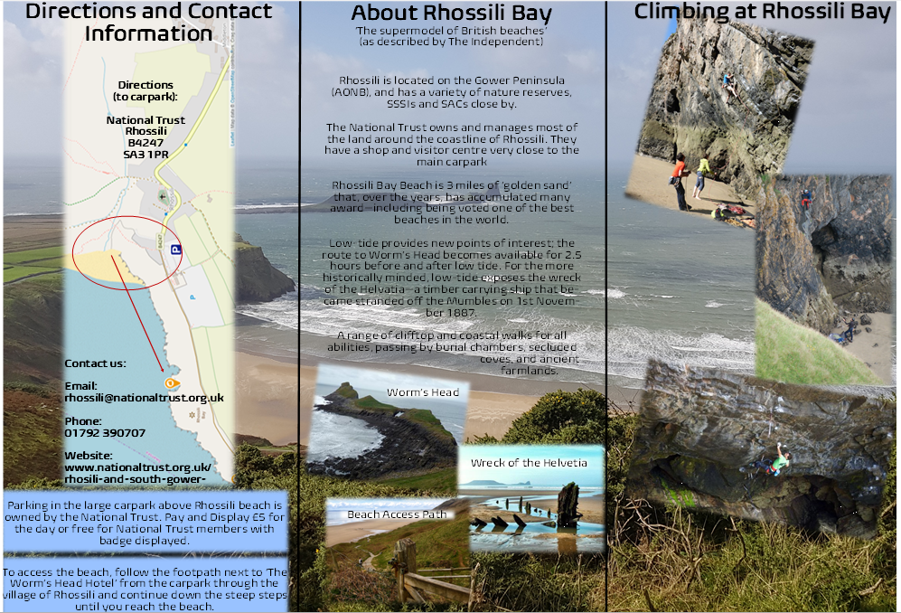
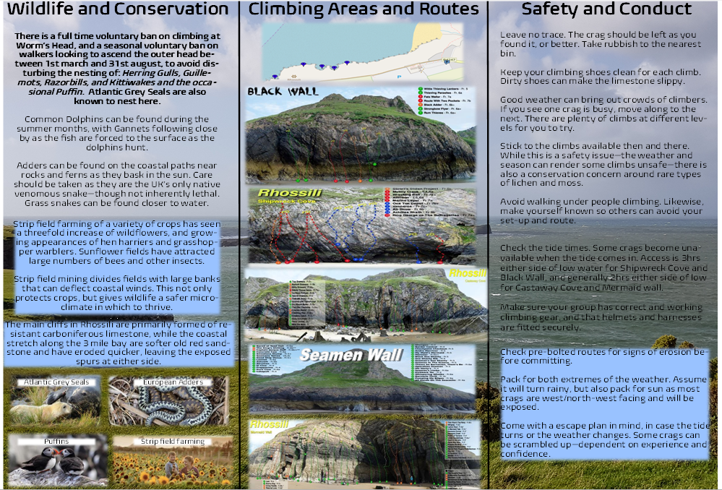
First picture represents front cover, back middle and back page of a tri-fold leaflet.
Second picture represents fully opened middle of a tri-fold leaflet.
Individual Reflection
I was part of a group of five who decided to base this leaflet on Rhossili Bay Beach and climbing as the activity. Though we knew there was access to climbing and abseiling after having done abseiling there ourselves, I’m not sure we knew how prevalent it is until we started researching for the leaflet. The discussion on what aspects of the leaflet we’d individually was relatively quick and without friction; having based what we wanted to put into it on other leaflets we’d seen through one of our ‘making safety personal’ workshops. At the time, each aspect seemed mostly as equally involved as the other aspects and so I was happy to be given whatever wasn’t taken by the other group members: activity and locational safety.
Once we’d agreed what aspect we’d focus on, I noted to the group that I was also happy to compile everyone’s contributions and create the leaflet, completely open to the groups input and happy to change it based on their recommendations. There didn’t seem to be a any opposition to this, and in reflection I am happy that I also took this aspect on as it gave me a chance to add and change any other aspects that I felt didn’t quite hit the assignment brief – specifically conservation and wildlife. Though the wildlife aspect was relatively conclusive, geological and conservation aspects were severely lacking and so I found myself out of necessity having to rewrite that section to ensure we hit the brief given to us.
Though we had every intention of returning to Rhossili Bay to research first hand, and to take some more first-hand photos of the areas and crags, we could never quite find the time to go down as a group. A few reasons presented – but the most frustrating was a lack of communication with some members of the group. In the end, those that had maintained contact throughout decided that the photos I had from our first trip would suffice and I ended up using them as the background for our leaflet. In hindsight, there is an argument to be made that I could have gone down by myself so we didn’t rely solely on internet sourced photos.
In terms of my own contribution to the safety aspect, I found that initially a lot of what I was putting was common sense and not necessarily area specific – this would have been remedied by having been to Rhossili again. Having coached climbing before, I was able to draw from my own experiences to create what I think is a concise and safe approach relevant for a leaflet. When the group started sending me their research, I was then able to make some of it more area specific and relevant and make the entire middle fold-out section of the leaflet flow and link in with each other. To the group’s credit, the volume and quality of what I was sent to compile was for the most part very good. The difficulty (though a pleasant one) was pulling apart what was ultimately relevant and wording it in such a fashion that the final product didn’t come across as disjointed.
(528)
References:
Country Life (2019) Country Life Today: The first Atlantic grey seal pups of the season, spotted on the Farne Islands. Available at: https://www.countrylife.co.uk/news/country-life-today-first-atlantic-grey-seal-pups-season-spotted-farne-islands-206424 (Accessed 2 Dec. 2019).
Earthstar (2019) I love Puffins!. Available at: https://earthstar.blog/2018/05/15/i-love-puffins/ (Accessed 2 Dec. 2019).
Explore Gower (2019) Gower Peninsula Geology. Available at: http://www.explore-gower.co.uk/gower-geology (Accessed 2 Dec. 2019).
Explore Gower (2019) Helvetia Shipwreck, Rhossili, Gower. Available at: http://www.explore-gower.co.uk/helvetia-shipwreck-rhossili (Accessed 2 Dec. 2019).
Explore Gower (2019) Worm's Head in Rhossili, Gower. Available at: http://www.explore-gower.co.uk/worms-head-rhossili [Accessed 3 Dec. 2019].
First Nature (2019) Gower Coast National Nature Reserve, Swansea, Southwest Wales. Available at: https://www.first-nature.com/waleswildlife/sw-nnr-gowercoast.php (Accessed 2 Dec. 2019).
Gower Coast Adventures (2019) Gower Coast Adventures. Available at: http://www.gowercoastadventures.co.uk/info/our-wildlife (Accessed 2 Dec. 2019).
Morris, S. (2019) Return of strip-field farming creates haven for rare species in south Wales. Available at: https://www.theguardian.com/environment/2018/aug/29/return-of-strip-field-farming-creates-haven-for-rare-species-in-south-wales (Accessed 2 Dec. 2019).
National Trust (2019) Rhosili and South Gower Coast. Available at: https://www.nationaltrust.org.uk/rhosili-and-south-gower-coast (Accessed 2 Dec. 2019).
QORF (2019) Rockclimbing Code of Conduct - QORF. Available at: https://qorf.org.au/resources/fact-sheets-master/caring-for-the-outdoors/rockclimbing-code-of-conduct/ [Accessed 5 Dec. 2019].
Scottish Natural Heritage (2019). Adder. Available at: https://www.nature.scot/plants-animals-and-fungi/amphibians-and-reptiles/adder (Accessed 2 Dec 2019).
South Wales Climbing Wiki (2019) Rhossili Sea Level Crags - South Wales Climbing Wiki (SWCW). Available at: https://swcw.org.uk/wiki/Category:Rhossili_Sea_Level_Crags [Accessed 3 Dec. 2019].
Swansea.gov.uk (2019). Swansea - Rhossili Down and Rhossili Cliffs. Available at: https://www.swansea.gov.uk/rhossili (Accessed 2 Dec. 2019).
UK Climbing (2019) ARTICLE: 10 Things to Do at a Sport Crag. Available at: https://www.ukclimbing.com/articles/skills/10_things_to_do_at_a_sport_crag-12236 [Accessed 5 Dec. 2019].
UK Climbing (2019) Worms Head. Available at: https://www.ukclimbing.com/logbook/crag.php?id=22508 (Accessed 2 Dec. 2019).
UK South West (2019) Worm's Head, Rhossili Bay, Swansea. Available at: https://www.uksouthwest.net/swansea/worms-head/ [Accessed 4 Dec. 2019].
Visit Swansea Bay (2019) Rhossili Bay beach. Available at: https://www.visitswanseabay.com/listings/rhossili-bay-beach/ (Accessed 2 Dec. 2019).

