OME INSTRUMENTATION AND CONTROL – YEAR 2

A report into the design of a control system to oversee a process and its transfer function.

BY JOSEPH MCNICHOLAS
Contents
Introduction 3
Method 4
Using Matlab and Simulink to design initial control system 4
Calculating the closed loop transfer function of the entire system 7
Results 10
Discussion 12
Conclusion 12
Appendix 12
References 14

Introduction
The author is to design a control system capable of controlling a process with a transfer function whose equation is: $$G\left(s\right)=\frac{1}{as^{2}+bs+c}$$
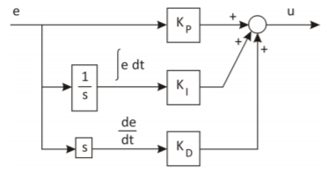
A system is a series of elements and parts acting together as a larger whole. A control system is a system where the output of that system is controlled by the input. The purpose of a control system is to govern the behaviour of other components and devices around it to achieve the desired result, an example would be a thermostat or cruise control on a car. There are two main types of control system, these are open loop and closed loop systems. A closed loop control system is more autonomous and requires “the use of a feedback signal to adjust the output of a system” [1]. The input controls the output of the system, but there is a feedback element whereby the output is measured and the input adjusted accordingly. Ibrahim et al describe this as an “actuating error signal, which is the calculated difference between the input signal and the feedback signal” [2] this signal is then fed to the controller to bring the output value close to the desired value and to minimise error. Ibrahim et al also describe open loop control systems as “Frameworks in which the control activity is unaffected by the yield” [2]. An example for both would be a modern kettle (closed loop) and an old kettle (open loop). A modern kettle has the ability to shut itself off once water temperature has reached a certain temperature, whereas an old kettle will continue to boil if left unchecked. The author will later use a Proportional – Integral – Derivative (PID) controller in MATLAB to answer the above problem. Each of these components can be broken down into K_{p}, K_{I}, K_{D}, Owen says that the name comes from “three different actions that the controller makes in responding to a non-zero input, the error” [3]. The controller will seek to correct any error and return the input to zero. It does this by taking proportional action, integral action and derivative action.

Figure 1 PID Controller configuration [3]

A transfer function is a description of a behaviour of a system in mathematical terms and “is defined as the ratio of the Laplace transform of the output variable to Laplace transform of the input variable assuming all initial conditions to be zero” [4]. It is a way of expressing how a part of a control system will behave in mathematical terms, although it assumes that the initial condition of the system is zero. Once a transfer function is known, the resulting equation can be used to determine the output of any input value. The laplace transform can be used to simplify the transfer function. If a differential equation is in the time domain then the laplace transform can be applied to turn it into an algebraic equation, this can then be solved and converted back to the time domain [5].
The author will use MATLAB and Simulink to design a control system for the equation above To do this predetermined values of 2, 1, 5 have been assigned for the a, b, c values to be used in the equation. Coupled with this is the need to control the process within two seconds and an overshoot of less than 5%.
The second task asked for the closed loop transfer function for the system as a whole using the settings and system created in MATLAB. These were to be compared with the results gained from the first simulation

Method

Using Matlab and Simulink to design initial control system
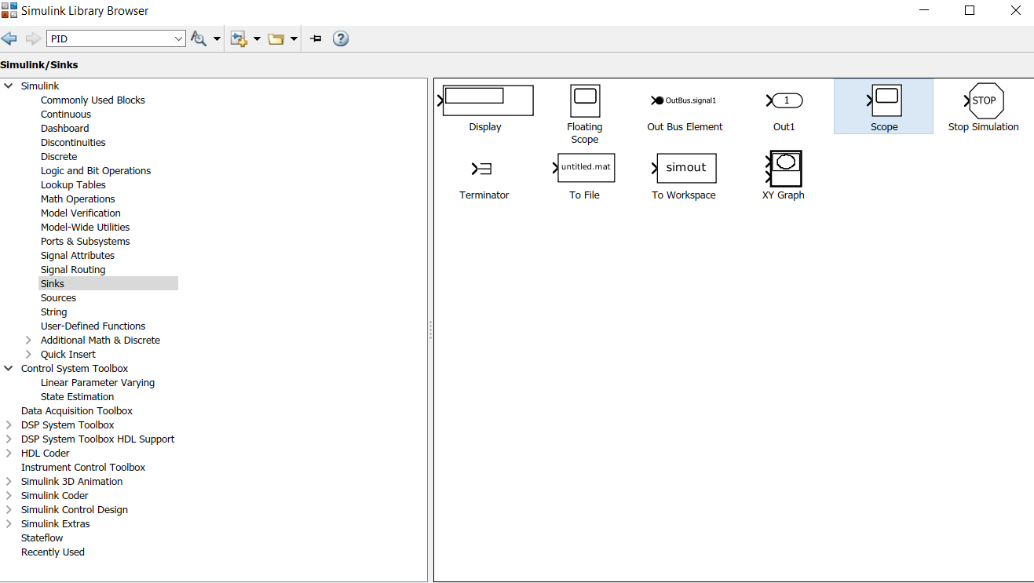
The system is built and simulated in MATLAB and Simulink. This requires the use of the library browser where all the parts to make the system can be found as seen in Figure 2.
Figure 2 - Library Browser for parts in Simulink
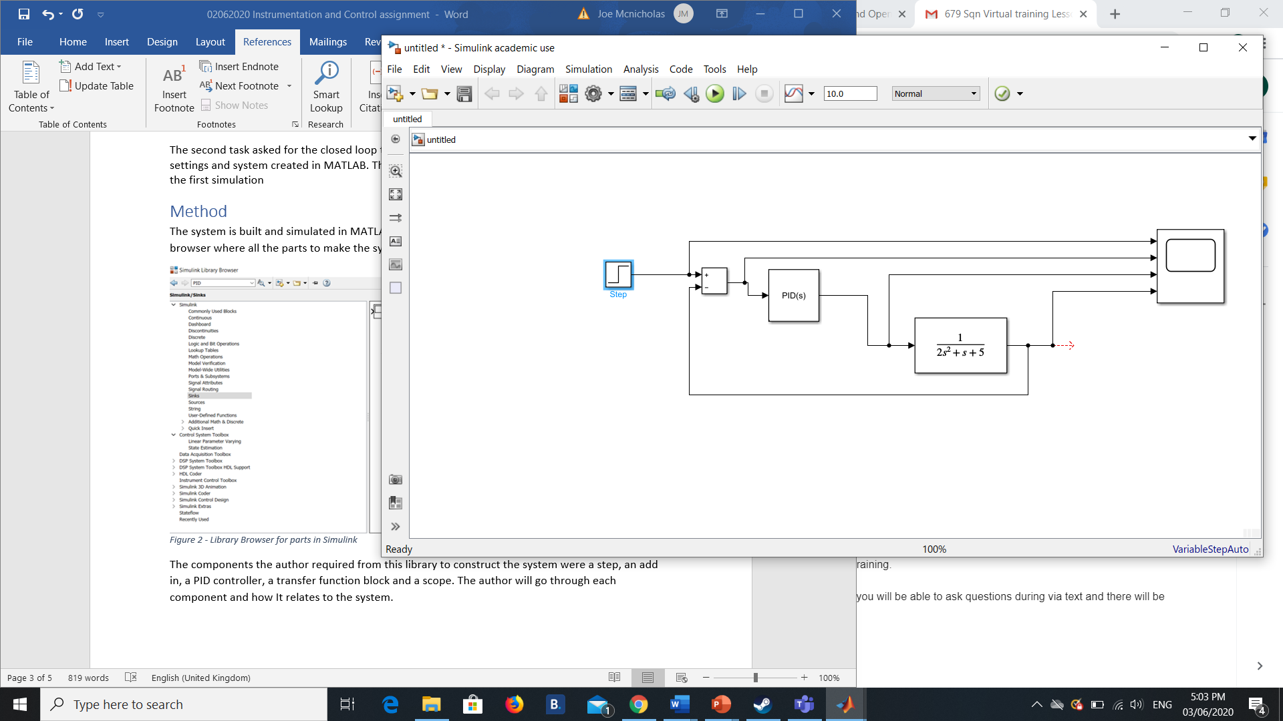
The components the author required from this library to construct the system were a step, an add in, a PID controller, a transfer function block and a scope. The author will go through each component and how It relates to the system.
In Figure 3 is the step component which provides a step between two definable levels, acting as the switch in a thermostat or kettle.

Figure 3 - Step component

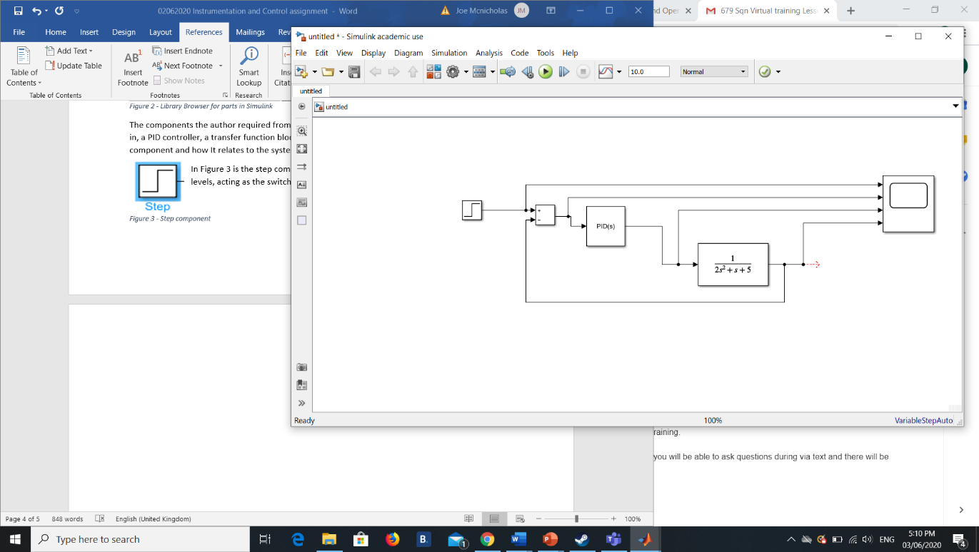
In Figure 4 is the sum box which calculates addition or subtraction on its inputs in this case. The input is added on to the value first and then the error generated by the system is subtracted from this value before being fed onto the next component.
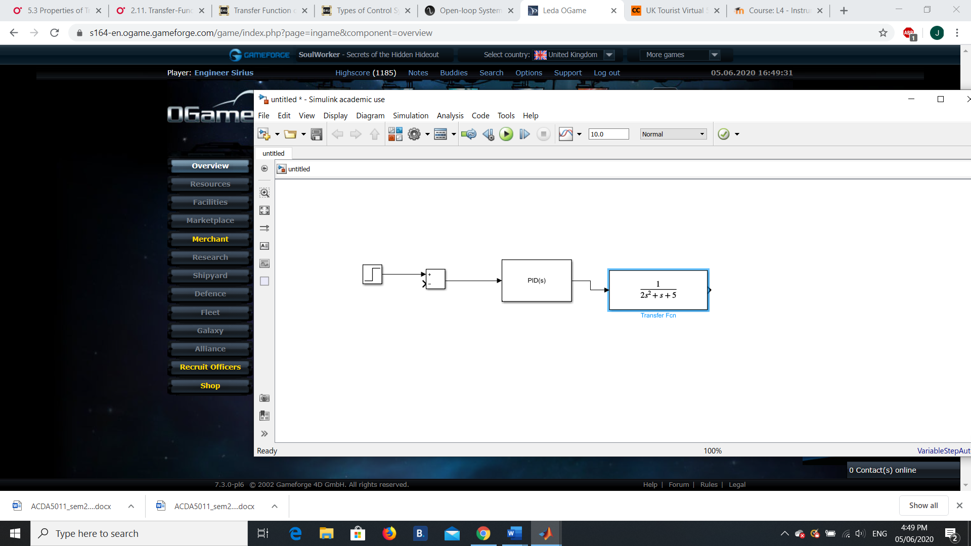
Figure 4 - Sum box
In Figure 5 is the PID controller which will control the process value using the feedback generated and calculated by the sum box. The PID controller will reduce this to zero with minimal overshoot of the set point
Figure 5 - PID controller
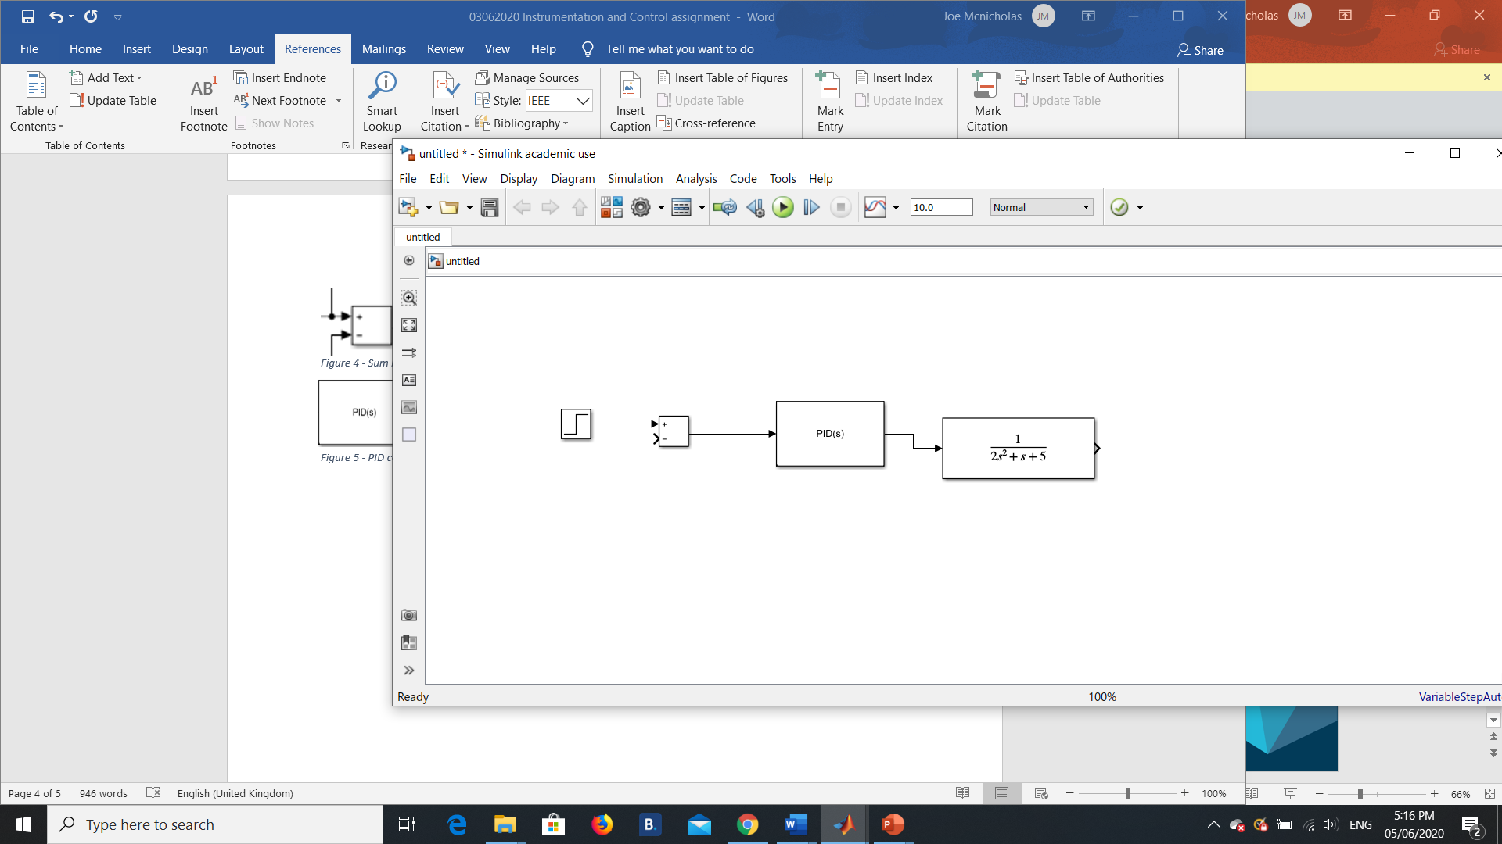
In Figure 6 is the Transfer function box with preassigned values for the system the author designed the control system for. It is the mathematical way of describing the behaviour of the system in mathematical terms.
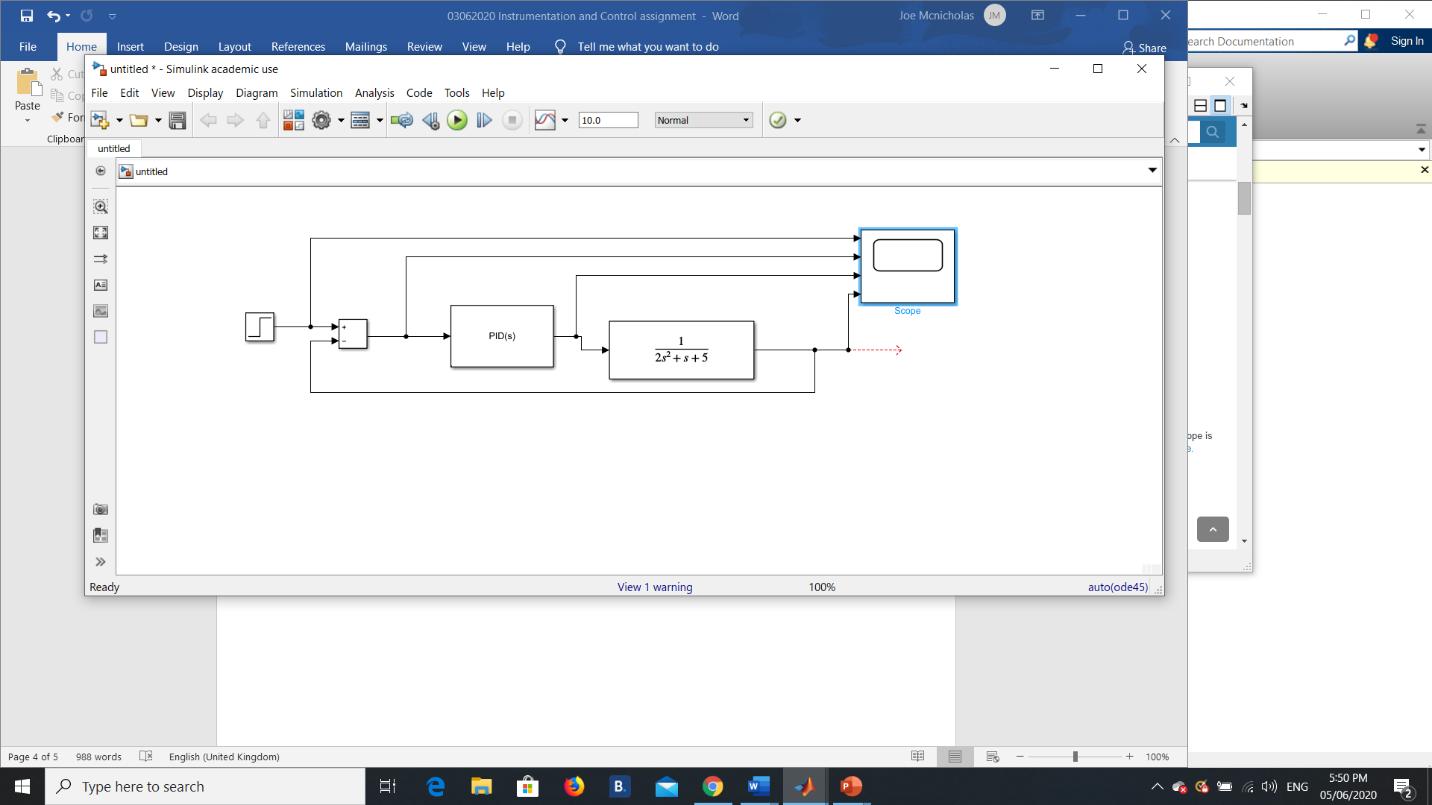
Figure 6 - Transfer function box
In Figure 7 is the scope which allowed the author to visualise the process. It has 4 inputs leading from the step input, the sum box input, the PID controller input and the overall plant output

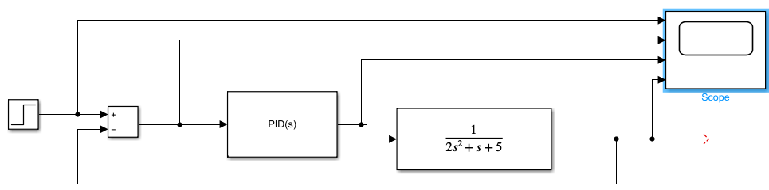
Figure 7 - Scope
Figure 8 - The overall system
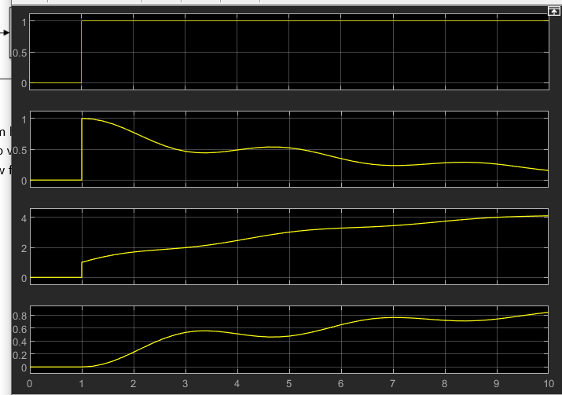
In Simulink, when the system had been set up in this manner, it was allowed to run to give the author the scope readings to visualise how the system was working. In Figure 9 the layout was simplified and the y axis scaled to allow for a clearer comparison between the different values.
The scale along the x axis is time in seconds. The Y axis is tied in with the set value and how the other components work to control the process value as a result. The top line is the step input, the second line is the error signal, the third line is the controller effort and the bottom line is the plant output. Initially as the set point was switched on the error was steadily reduced by the controller while the plant output increased to match the set point value.
Figure 9 - Scope showing relative effort values
After this step it was necessary to tune the PID controller to meet the parameters set in the assignment brief. These parameters being bringing the process under control within 2 seconds with an overshoot of no greater than five percent.
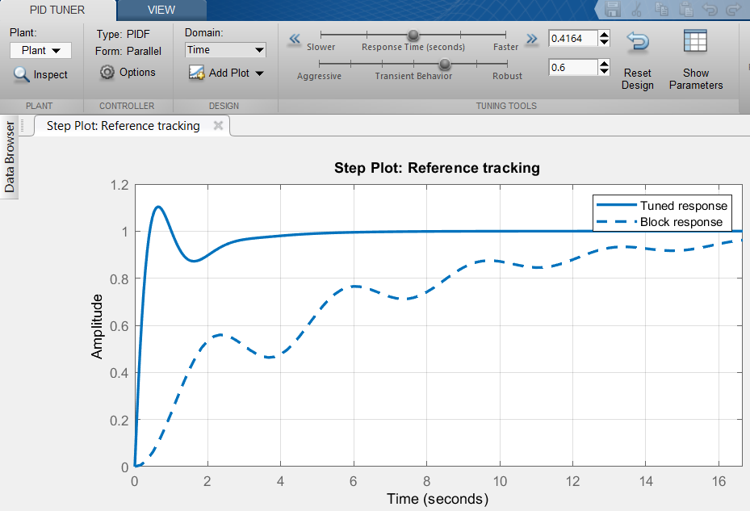
Figure 10 - Tuned and untuned responses of system
When tuning the PID controller the filter coefficient is set to 1. Figure 10 shows the responses given from the control system. The dotted line is the response as it currently is, the thick blue line is the current tuned response with the settings, the dotted line is similar to the plant output seen on the
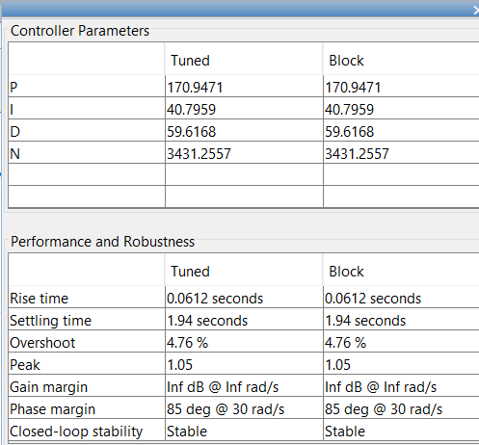
fourth line of Figure 9. The tuned response can be altered by the response time and transient behaviour sliders. The transient behaviour affects how aggressive or robust the rise will be, if this is too aggressive then the response will oscillate violently. The response time determines how quickly the response will reach 1. It is important to balance these to achieve control of the process in under two seconds with a less than five percent overshoot. In Figure 11 were the response time and transient behaviour values necessary to achieve the parameters set out in the brief.
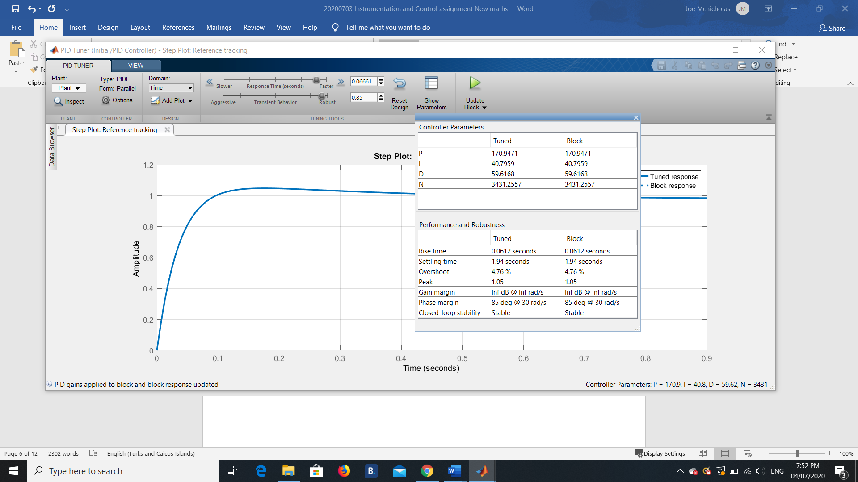

Figure 11 - Suitable control parameters
With these updated controller values Figure 9 was updated to reflect this with new relative effort values as seen in Figure 12.

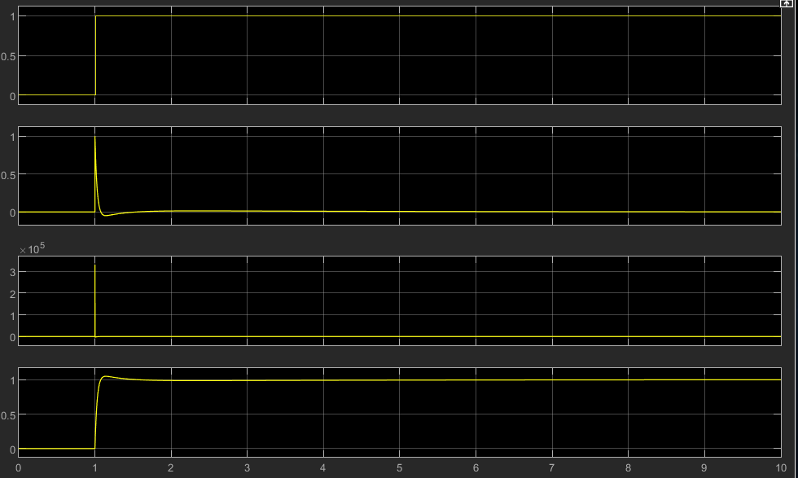

Figure 12 – Scope showing updated relative effort
The relative efforts of each of the components in Figure 12 compared with Figure 9 are now much different. The step input has not changed and the error input is quickly reduced to zero. The controller effort in line three was extremely short lived and served to maintain the plant output at a near constant value for the majority of the simulation.
The values gathered from the tuning of the PID controller are seen in Table 1.
K_{P} | 170.9471
K_{I} | 40.7959
K_{D} | 59.6168
N | 3431.2557
Table 1 - PID controller values for transfer function

Calculating the closed loop transfer function of the entire system
The second task was to find the closed loop transfer function (CTLF) for the entire system. This was done using the following calculations.
The transfer function assigned to the process in the brief was:$$G\left(s\right)=\frac{1}{as^{2}+bs+c}$$
When using the values assigned in the brief the transfer function of the process becomes:$$G\left(s\right)=\frac{1}{2s^{2}+s+5}$$
Using the values in Table 1 the formula for the transfer function for the PID controller is:$$K_{p}+K_{i}\frac{1}{s}+K_{d}\frac{s}{\frac{1}{N}s+1}$$

$$170.9471+\frac{40.7959}{s}+59.6168\frac{s}{\frac{1}{3431.2557}s+1}$$

Multiplying the transfer function of the process and the PID controller becomes necessary to calculate the forward path transfer function of the entire system:
$$\left(170.9471+\frac{40.7959}{s}+59.6168\frac{s}{\frac{s}{3431.2557}+1}\right)×\left(\frac{1}{2s^{2}+s+5}\right)$$

$$\left(170.9471+\frac{40.7959}{s}+59.6168\frac{s}{\frac{s+3431.2557}{3431.2557}+1}\right)×\left(\frac{1}{2s^{2}+s+5}\right)$$

$$\left(170.9471+\frac{40.7959}{s}+59.6168\left(s÷\frac{s+3431.2557}{3431.2557}\right)\right)×\left(\frac{1}{2s^{2}+s+5}\right)$$

$$\left(170.9471+\frac{40.7959}{s}+59.6168\left(s\left(\frac{3431.2557}{s+3431.2557}\right)\right)\right)×\left(\frac{1}{2s^{2}+s+5}\right)$$

$$\left(170.9471+\frac{40.7959}{s}+59.6168\left(\left(\frac{3431.2557s}{s+3431.2557}\right)\right)\right)×\left(\frac{1}{2s^{2}+s+5}\right)$$

$$\left(170.9471+\frac{40.7959}{s}+\left(\frac{204560.4848s}{s+3431.2557}\right)\right)×\left(\frac{1}{2s^{2}+s+5}\right)$$

$$\left(\frac{\left((s\left(s+3431.2557\right))×170.9471\right)+\left(s+3431.2557\right)40.7959+s\left(204560.4848s\right)}{s\left(s+3431.2557\right)}\right)×\left(\frac{1}{2s^{2}+s+5}\right)$$

$$\left(\frac{170.9471s^{2}+586563.2113s+40.7959s+139981.1644+204560.4848s^{2}}{s^{2}+3431.2557s}\right)×\left(\frac{1}{2s^{2}+s+5}\right)$$

$$\left(\frac{204731.4319s^{2}+586604.0072s+139981.1644}{s^{2}+3431.2557s}\right)×\left(\frac{1}{2s^{2}+s+5}\right)$$

$$\left(\frac{204731.4319s^{2}+586604.0072s+139981.1644}{\left(s^{2}+3431.2557s\right)(2s^{2}+s+5)}\right)$$

$$\left(\frac{204731.4319s^{2}+586604.0072s+139981.1644}{2s^{4}+s^{3}+5s^{2}+6862.5114s^{3}+ 3431.2557s^{2}+17156.2785s }\right)$$

$$\left(\frac{204731.4319s^{2}+586604.0072s+139981.1644}{2s^{4}+6863.5114s^{3}+ 3436.2557s^{2}+17156.2785s }\right)$$
With this formula the system can be drawn as this:

Output
$$\frac{204731.4319s^{2}+586604.0072s+139981.1644}{2s^{4}+6863.5114s^{3}+ 3436.2557s^{2}+17156.2785s }$$
Error calculator
Step Input
Controller and Process

Feedback

Figure 13 – Forward path transfer function of the system
The next step was to remove the feedback loop and calculate the transfer function of the entire system including the block that calculates the error. The formula for calculating this is: $$TF=\frac{G}{1+GH}$$
G is the forward path transfer function calculated in the previous step and H is the transfer function of the feedback loop.
$$\frac{(\frac{204731.4319s^{2}+586604.0072s+139981.1644}{2s^{4}+6863.5114s^{3}+ 3436.2557s^{2}+17156.2785s })}{1+\left(\frac{204731.4319s^{2}+586604.0072s+139981.1644}{2s^{4}+6863.5114s^{3}+ 3436.2557s^{2}+17156.2785s }\right)×1}$$

$$TF=\frac{\frac{204731.4319s^{2}+586604.0072s+139981.1644}{2s^{4}+6863.5114s^{3}+ 3436.2557s^{2}+17156.2785s }}{\frac{2s^{4}+6863.5114s^{3}+ 3436.2557s^{2}+17156.2785s }{2s^{4}+6863.5114s^{3}+ 3436.2557s^{2}+17156.2785s }+\frac{204731.4319s^{2}+586604.0072s+139981.1644}{2s^{4}+6863.5114s^{3}+ 3436.2557s^{2}+17156.2785s }}$$

$$TF=\frac{\frac{204731.4319s^{2}+586604.0072s+139981.1644}{2s^{4}+6863.5114s^{3}+ 3436.2557s^{2}+17156.2785s }}{\frac{2s^{4}+6863.5114s^{3}+ 208167.6876s^{2}+603760.2857s+139981.1644}{2s^{4}+6863.5114s^{3}+ 3436.2557s^{2}+17156.2785s }}$$

$$TF=\frac{204731.4319s^{2}+586604.0072s+139981.1644}{2s^{4}+6863.5114s^{3}+ 3436.2557s^{2}+17156.2785s}×\frac{2s^{4}+6863.5114s^{3}+ 3436.2557s^{2}+17156.2785s}{2s^{4}+6863.5114s^{3}+ 208167.6876s^{2}+603760.2857s+139981.1644}$$
$$TF=\frac{(204731.4319s^{2}+586604.0072s+139981.1644)(2s^{4}+6863.5114s^{3}+ 3436.2557s^{2}+17156.2785s)}{(2s^{4}+6863.5114s^{3}+ 3436.2557s^{2}+17156.2785s)(2s^{4}+6863.5114s^{3}+ 208167.6876s^{2}+603760.2857s+139981.1644)}$$

$TF=\frac{409462.8638s^{6}+1406349724.7938s^{5}+4729952802.8667s^{4}+6488913144.4086s^{3}+{10544952790.801s}^{2}+2401555841.2006s}{4s^{8}+27454.0456s^{7}+47524124.1132s^{6}+{1429968817.5256s}^{5}+{4977265282.2356s}^{4}+{6606819863.9814s}^{3}+{10839290682.77s}^{2}+2401555841.2006s}$

The system can now be redrawn as seen in Figure 14.
$$\frac{409462.8638s^{6}+1406349724.7938s^{5}+4729952802.8667s^{4}+6488913144.4086s^{3}+{10544952790.801s}^{2}+2401555841.2006s}{4s^{8}+27454.0456s^{7}+47524124.1132s^{6}+{1429968817.5256s}^{5}+{4977265282.2356s}^{4}+{6606819863.9814s}^{3}+{10839290682.77s}^{2}+2401555841.2006s}$$
Output
Step Input

Figure 14 - Closed loop Transfer function of system
Now there is a transfer function for the entire system and its controller including feedback. The mathematical formula derived in Figure 14 was compared with the computer simulation worked in Matlab.

Results
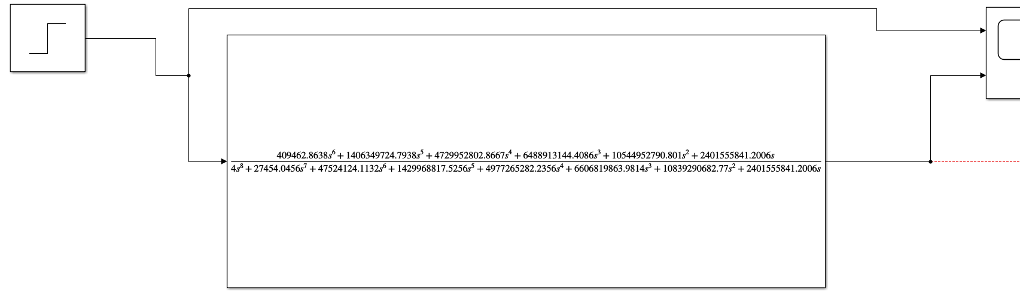
Once the calculation of the CLTF was completed it was compared to the PID controller simulation used in step 1. The closed loop transfer function was input into MATLAB - Figure 15, so that the scope reading of both could be compared. Initially the original input value was kept at 1.
Figure 15 - Closed Loop Transfer function in MATLAB

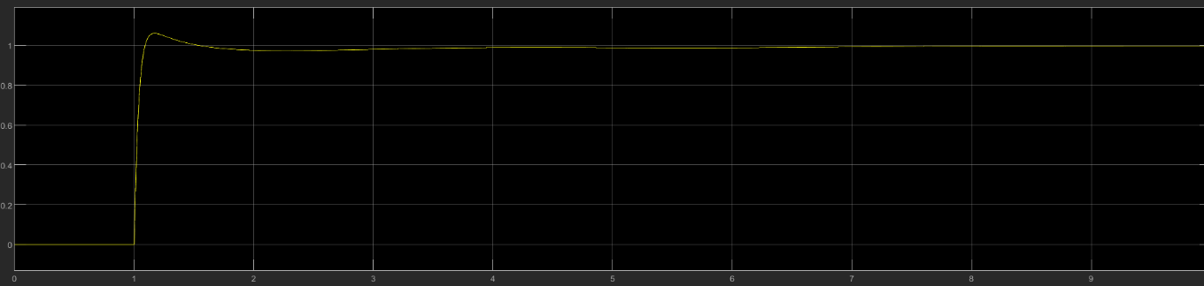
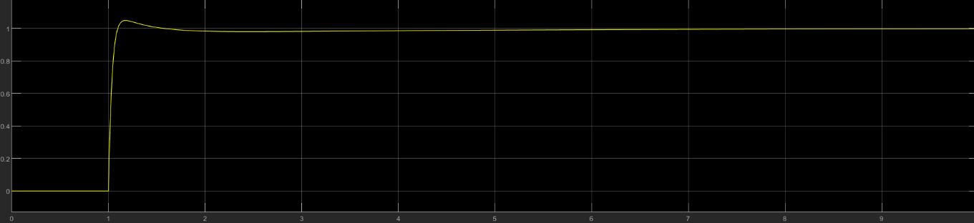
Figure 16 - Scope readings of PID Controlled system
Figure 17 - Scope reading of Closed Transfer Loop system
In Figure 16 is the scope reading of the PID controlled system designed on MATLAB, the effort adhered to the parameters set in the task. It comes under control within two seconds and does not overshoot past 5%. Around the two second mark there is a slight dip before the effort steadied at one. Figure 17, the mathematically calculated CTLF shows a similar trajectory to the MATLAB system with a few differences. These are the initial effort overshooting the 5% limit set out in the brief and the dip in the effort being more pronounced in the closed loop system. To see if the overshoot value of both systems remained consistent the author took the peak value of each system from the scope (example in Figure 18) and plotted them in Table 2.
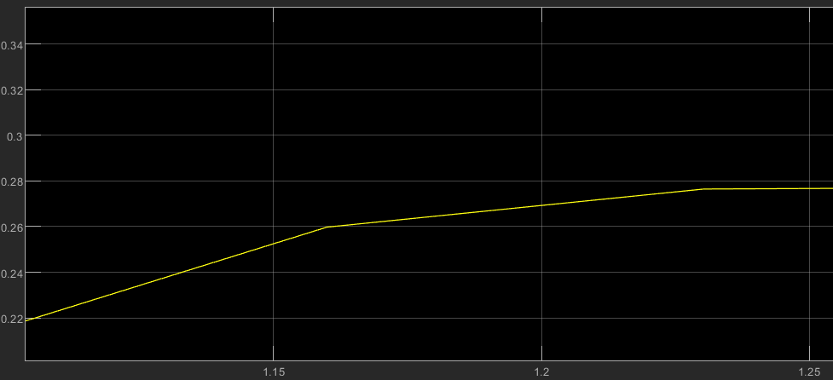

Figure 18 - Zoom in of scope graph on MATLAB
Set Final Value | PID Controlled System | CTLF system | PID Overshoot % | CTLF system Overshoot %
0.25 | 0.262 | 0.265 | 4.8 | 6
0.5 | 0.524 | 0.53 | 4.8 | 6
1 | 1.048 | 1.06 | 4.8 | 6
2 | 2.095 | 2.119 | 4.8 | 6
Table 2 - Overshoot Percentage of both systems at different system settings.

As seen in Table 2, the MATLAB designed PID system has a consistent overshoot at all settings of 4.8%. The CTL system had a marginally larger overshoot as a percentage of the final setting. The author has also generated a Nyquist diagram and a pole zero diagram as seen in the appendix. Electrical 4u states that as long as the roots of the system lie on the left-hand side of the s plane [6]. Jain goes on to give a stability criterion of Z = N + P with “Z equalling the number of roots of 1+G(s)H(s) on the right hand side of the s-plane, N = number of encirclement of critical point 1+j0 in clockwise direction and P = number of poles of open loop transfer function” [7], he also mentions that for a stable system Z must equal 0. As seen below in Figure 20, the system does not encircle 1+j0 and the number of poles of the open loop transfer function is also zero, as seen in Figure 21. Therefore the system is stable.

Discussion
As the scope readings from the output in Figure 16 and Figure 17 are almost similar we can assume that the transfer function calculated in part two of the methodology was done correctly, even if there is some slight variation. For the CLTF system though the output was brought under control within two seconds, the overshoot went up to 6%. The data gathered from the PID controller set was after the result of tuning the controller within MATLAB to attain the desired parameters from the system. The values used to calculate the CLTF were taken from this tuned version but rounded to 4.s.f for ease of calculation. It may be possible that the slight variation in the figures for calculating the transfer function were behind the slightly different trajectory the output effort was recorded at.

Conclusion
The author concludes that the mathematic equations used above have created a system that is almost stable with regards to meeting the parameters in the project brief. This may be due to the rounding of figures by the author creating slight imperfections. This was verified when inputting into MATLAB, and comparing with the pole zero and Nyquist plots done.

Appendix
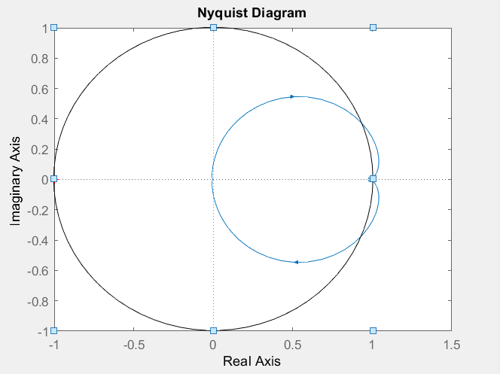

Figure 19 - Nyquist plot [8]
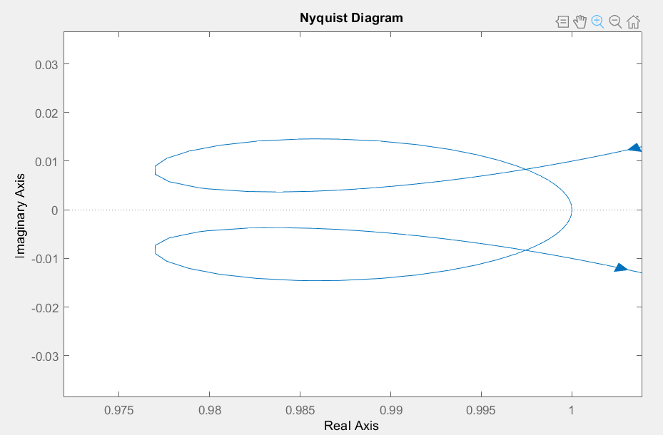

Figure 20 - Nyquist plot zoomed in
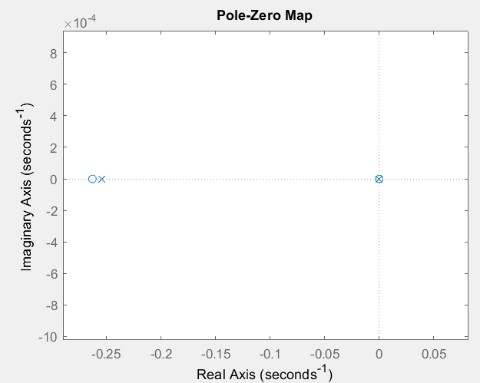

Figure 21 - Pole Zero Plot [9]

References

[1] | R. L. Chatburn and E. M. Cabodevila, "Closed Loop Control of Mechanical Ventilation: Description and Classification of Targeting Schemes," Respiratory Care, vol. I, no. 56, pp. 85-102, 2011.
[2] | A. Ibrahim, R. R. Alexander, M. S. U. Sanghar and R. D. D'Souza, "Control Systems in Robotics: A review," International Journal of Engineering Inventions, vol. V, no. 5, pp. 29-38, 2016.
[3] | F. Owen, "Introduction to Control Systems," in Control Systems Engineering A practical approach, San Luis Obispo, California Polytechnic State University, 2012, pp. 1-7.
[4] | Electrical 4U, "Transfer Function of Control System," 8 June 2019. [Online]. Available: https://www.electrical4u.com/transfer-function/. [Accessed 2 June 2020].
[5] | K. Webb, "Laplace transformas and transfer functions," [Online]. Available: http://web.engr.oregonstate.edu/~webbky/ESE499_files/Section%203%20Laplace%20Transforms%20&%20Transfer%20Functions.pdf. [Accessed 2 June 2020].
[6] | Electrical4U, "Nyquist Plot: What is it?," E4U, 21 July 2019. [Online]. Available: https://www.electrical4u.com/nyquist-plot/. [Accessed 14 July 2020].
[7] | V. Jain, "Nyquist Stability Criterion," E4U, 22 April 2020. [Online]. Available: https://www.electrical4u.com/nyquist-stability-criterion/. [Accessed 14 July 2020].
[8] | S. Mosey, "Nyquist Diagrams," University of Wales Trinity St David, Swansea, 2020.
[9] | S. Mosey, "Pole-Zero Plots s-plane diagrams," University of Wales Trinity St David, Swansea, 2020.

