
User-Centred Design and Usability Evaluation of a Mobile Forbidden Island Game


Student Name | Hazrat Usman
Student ID | 2324334
Programme | BSc Applied Computing
Module | Usability Engineering
Module Code | ACCA6026
Lecturer | Abiola Babatunde
Assignment Title | User-Centred Design and Usability Evaluation of a Mobile Forbidden Island Game
Submission Deadline | Friday 30th October, 2026
University | UWTSD – Birmingham Campus

Contents
1.0 Introduction 3
2.0 User Research and Persona Development 3
2.1 Research Method 3
2.2 Questionnaire Findings 4
2.3 Behavioural Patterns and Persona Development 4
3.0 User Personas and Scenarios 5
3.1 Persona One: Experienced Computing Student 5
3.2 Persona Two: Beginner Player 6
3.3 Persona Three: Accessibility-Focused Player 6
4.0 Input/Output Devices and Accessibility 7
4.1 Input Devices 7
4.2 Output Devices and Feedback 7
4.3 Accessibility and Assistive Technologies 8
5.0 Low-Fidelity Wireframes and Cognitive Walkthroughs 8
5.1 Wireframe Design and Navigation 9
5.2 Cognitive Walkthrough One: Creating a New Game 9
5.3 Cognitive Walkthrough Two: Completing a Player Turn 9
6.0 Peer Heuristic Evaluation 10
7.0 Conclusion 10
References 12
Appendices 13
Appendix A - User Research and Questionnaire Findings 13
A.1 Purpose of the Questionnaire 13
A.2 Questionnaire Questions 13
A.3 Summary of Participant Responses 13
A.4 Key Questionnaire Findings 14
A.5 Behavioural Groups 15
A.6 MoSCoW Prioritisation of User Requirements 16
Appendix B - Detailed User Personas and Scenarios 17
B.1 Overview of User Personas 17
B.2 Persona One — Adam: Experienced Computing Student 17
Table B2: Adam's User Journey 18
B.3 Persona Two - Sarah: Beginner Player 18
B.4 Persona Three - Daniel: Accessibility-Focused Player 19
B.5 Comparison of Persona Requirements 20
B.6 Influence of Personas on Interface Design 20
Appendix C - Low-Fidelity Wireframes and Navigation 22
C.1 Overview of the Wireframe Designs 22
C.2 Game Introduction and Creation 22
C.3 Joining and Preparing for Gameplay 23
C.4 Game Instructions and Player Interaction 24
C.5 Treasure Progress, Accessibility and Game Completion 25
C.6 Navigation and Design Consistency 25
Appendix D - Cognitive Walkthrough Records 27
D.1 Purpose and Evaluation Method 27
D.2 Cognitive Walkthrough One - Creating a New Game 27
D.2.1 Findings 28
D.2.2 Recommended Improvements 28
D.3 Cognitive Walkthrough Two - Completing a Player Turn 28
Table D2: Cognitive Walkthrough Two - Step-by-Step Assessment 29
D.3.1 Findings 29
D.3.2 Recommended Improvements 30
D.4 Summary of the Cognitive Walkthroughs 30
Appendix E - Heuristic Evaluation Records 31
E.1 Purpose and Evaluation Method 31
E.2 Evaluation One - Beginner Player Perspective 31
E.3 Evaluation Two - Experienced Player Perspective 31
E.4 Evaluation Three - Accessibility-Focused Perspective 32
E.5 Summary of Simulated Evaluation Findings 33
E.6 Genuine Peer Evaluation Findings 33
E.7 Summary and Analysis of Genuine Peer Feedback 34
E.8 Reflection on Classmates' Wireframe Designs 35

1.0 Introduction
Usability engineering plays an important role in designing interactive systems that are easy to learn, efficient to use and accessible to people with different abilities and levels of experience [1]. Effective interface design should support clear navigation, understandable instructions and appropriate feedback. These principles are particularly important in mobile games, where limited screen space, touchscreen controls and different levels of user experience can create usability challenges.
This report presents the initial interface design for a University of Wales Trinity Saint David (UWTSD) version of Forbidden Island. The original cooperative board game requires players to work together to collect four treasures and escape before the island sinks. The proposed mobile adaptation introduces a university-themed environment inspired by UWTSD campus locations, including Birmingham, Swansea, Carmarthen and London, while maintaining the original game's cooperative objectives. These locations are proposed as themed game-board tiles to create a stronger connection with the university.
The aim of this project is to develop a user-centred mobile interface that supports clear navigation, accessible gameplay and effective interaction. The report examines questionnaire findings, user personas, interface requirements, input and output methods, low-fidelity wireframes and usability evaluations. These activities help identify potential usability problems and guide improvements before developing a functional prototype.

2.0 User Research and Persona Development
User research helps designers understand how different people may interact with a system and what difficulties they might experience. Gathering information directly from potential users reduces reliance on assumptions and supports better design decisions [2]. For this project, questionnaire responses from five participants were examined to understand gaming experience, learning preferences and accessibility needs. The findings were used to identify behavioural patterns and develop three user personas.

2.1 Research Method
A questionnaire containing eleven questions was completed by five participants from different age groups and gaming backgrounds. Four participants were studying computing, while one was not currently studying. The questions explored mobile gaming habits, experience with cooperative games, confidence when using unfamiliar applications, preferred learning methods, game-board design and accessibility requirements.
The questionnaire included multiple-choice questions and an opportunity to provide additional comments. Responses were anonymized as P01 to P05 and compared to identify common preferences and potential usability difficulties. Due to the small sample size, the findings were used as initial evidence to guide interface design rather than being considered representative of all mobile game users. The questionnaire questions and a summary of responses are presented in Appendix A.

2.2 Questionnaire Findings
The findings revealed different levels of gaming experience and confidence. Two participants played mobile games daily, while the others played weekly, occasionally or never. Two were very confident using unfamiliar games, whereas the remaining three reported lower levels of confidence. This indicates the importance of supporting both experienced players and beginners.
Three participants preferred short interactive tutorials. Other preferences included written instructions, video tutorials and help tips during gameplay. Offering different learning options could therefore make the game easier to understand.
Accessibility was another important consideration. Three participants selected larger text, while two selected high contrast and screen reader support. Confusing navigation, lengthy instructions, small text and small buttons were also identified as potential difficulties.
These findings suggest that the interface should prioritise clear navigation, readable content, accessible controls and guidance that players can access when needed.

2.3 Behavioural Patterns and Persona Development
Comparing the responses revealed three provisional behavioural groups. P01 and P04 were frequent, confident mobile gamers who could benefit from efficient navigation and immediate access to gameplay information. P02 and P03 were less confident and indicated a greater need for clear instructions and learning support. P05 represented a moderately confident player who preferred straightforward navigation and concise information.
These patterns informed three personas representing an experienced computing student, a beginner and a player with additional accessibility requirements. Each persona was used to consider how different needs might influence the design of tutorials, controls, navigation and gameplay feedback [1].
The accessibility-related questionnaire responses informed the third persona's interface requirements. However, the character's individual circumstances are fictional and should not be treated as confirmed characteristics of any participant.

Table 1.Summary of Participant Gaming Behaviour and Interface Design Needs.
Participant | Gaming frequency | Confidence | Main design consideration
P01 | Daily | Very confident | Quick, simple gameplay
P02 | Occasionally | Not very confident | Clear navigation and written guidance
P03 | Never | Not confident at all | Step-by-step help and easy-to-understand controls
P04 | Daily | Very confident | Accessible controls and more gameplay challenges
P05 | Weekly | Somewhat confident | Simple navigation and concise instructions

3.0 User Personas and Scenarios
Three user personas were developed based on the questionnaire findings to represent different gaming experiences, confidence levels and accessibility requirements. The personas are fictional but informed by the responses of five participants. They provide realistic scenarios for understanding user goals, potential difficulties and interface requirements [3].
The three personas represent an experienced computing student, a beginner player and an accessibility-focused player. Their requirements informed decisions about game navigation, instructions, gameplay controls and accessibility features. Detailed persona profiles, scenarios and user journeys are presented in Appendix B.

3.1 Persona One: Experienced Computing Student
Adam, aged 22, is a computing student who regularly plays mobile games and confidently explores unfamiliar applications. He enjoys cooperative gameplay and prefers short tutorials that allow him to begin playing quickly.
Scenario: Adam wants to create an online game with friends, choose his character and start a session. During gameplay, he needs to identify his available actions and monitor the team's treasure progress without repeatedly opening separate menus.
User requirements: Create and join games, select a character, view available actions and monitor treasure progress.
Experience requirements: Fast navigation, clear information and minimal unnecessary interruptions.

3.2 Persona Two: Beginner Player
Sarah, aged 30, is a computing student who occasionally plays mobile games and has limited experience with cooperative board games. She prefers written guidance and can find unfamiliar navigation confusing.
Scenario: Sarah opens Forbidden Island for the first time and wants to understand the rules before joining a game. During her turn, she needs clear explanations of movement, flooded tiles and the actions available to her.
User requirements: Access beginner instructions, understand game objectives, identify available actions and receive clear feedback.
Experience requirements: Simple navigation, understandable language and reassurance that actions have been completed correctly.

3.3 Persona Three: Accessibility-Focused Player
Daniel, aged 46, is a fictional player with reduced vision who uses screen magnification. He enjoys cooperative games but may find small text, low-contrast elements and crowded screens difficult to use.
Scenario: Daniel joins a game with friends and needs to identify his position, available actions and changes to the island. He wants to increase text size and use clearly labelled controls without losing important gameplay information.
User requirements: Adjust text size, distinguish game elements, access clearly labelled controls and use compatible assistive technology.
Experience requirements: Comfortable reading, confidence when selecting actions and independence during gameplay.

4.0 Input/Output Devices and Accessibility
Input and output technologies are important in mobile game design because they determine how players interact with the interface and receive information. The proposed UWTSD-themed Forbidden Island game will use touchscreen controls, visual feedback and optional audio features. Accessibility will also be considered to ensure that players with different abilities and levels of experience can participate comfortably.

4.1 Input Devices
The main input method will be the smartphone touchscreen, allowing players to interact with the game through tapping and scrolling. Players will be able to select menu options, choose characters, move between island tiles and perform actions such as collecting treasures or protecting flooded locations.
Large, clearly labelled buttons will be used for important actions, including moving, exchanging cards and ending a turn. This approach responds to questionnaire feedback identifying small buttons and confusing navigation as potential difficulties. Important actions will also provide confirmation or clear feedback to reduce accidental selections [4].
Where supported by the device, alternative input methods such as voice control and external keyboards will be considered. These options could support players who experience difficulties using touchscreen controls.

4.2 Output Devices and Feedback
The smartphone screen will be the primary output device, displaying the game board, player positions, available actions, treasure progress and flooding information. Clear icons, readable text and consistent layouts will help players understand the game without repeatedly opening instructions [5].
Visual feedback will be provided when players complete an action, collect a treasure or encounter a flooded tile. For example, the selected tile could be highlighted and a short message displayed to confirm a successful move.
Optional sound effects may provide additional feedback for important events, while vibration could indicate changes during gameplay. However, essential information will not depend on sound, colour or vibration alone. Text messages and clearly labelled symbols will ensure that players can understand important events even when these features are unavailable or disabled.

4.3 Accessibility and Assistive Technologies
Accessibility will be considered throughout the initial design rather than added after the interface is completed. The questionnaire findings highlighted the importance of larger text, high contrast, screen reader support and clear navigation.
The proposed interface will therefore include readable text, sufficient colour contrast, clearly labelled buttons and a simple layout. Players should be able to distinguish flooded tiles and other important game elements using symbols and text rather than colour alone [6].
Compatibility with mobile screen readers, such as Voiceover and Talkback, will also be considered. Buttons and game elements should have meaningful labels so that players using assistive technology can understand their purpose.
Adjustable text size and reduced animation will be considered to support different visual and interaction preferences. These features would help Daniel, the accessibility-focused persona, while also improving usability for other players.
Table 2. Relationship Between User Research Findings and Proposed Accessibility Design Decisions.
Research evidence | Proposed design decision
P04 reported small text and buttons | Larger buttons and readable text
P02 and P05 reported confusing navigation | Simple menus and consistent navigation
P02 and P04 selected high contrast | High-contrast interface elements
P02 and P04 selected screen reader support | Meaningful labels for accessible controls
P01, P02 and P04 selected larger text | Adjustable text size
P04 selected reduced animation | Option to minimise animation

Overall, the selected input, output and accessibility features aim to create an interface that is understandable, inclusive and suitable for cooperative mobile gameplay.

5.0 Low-Fidelity Wireframes and Cognitive Walkthroughs
Low-fidelity wireframes provide an early representation of an interface, allowing designers to examine screen layouts, navigation and usability before developing a functional prototype [7]. For the proposed UWTSD Forbidden Island mobile game, twelve wireframes were created using Figma to demonstrate the main stages of gameplay.
The designs were informed by questionnaire findings and three user personas, with particular attention to clear navigation, readable information and accessible controls. Two author-led cognitive walkthroughs were also documented to identify potential usability difficulties in creating a game and completing a player turn. Cognitive walkthroughs are particularly useful for examining how users recognize and complete tasks within an interface [9].

5.1 Wireframe Design and Navigation
The proposed UWTSD Forbidden Island mobile interface consists of twelve low-fidelity wireframes covering the main stages of gameplay. These include the Welcome Screen, Main Menu, Create Game, Join Game, Character Selection, Game Lobby, How to Play, Game Board, Player Actions, Treasure Progress, Accessibility Settings and Game Results. The wireframes were organised in Figma using simple layouts, clearly labelled buttons and consistent navigation elements to support players with different levels of experience.
The proposed design introduces a university theme inspired by UWTSD campus locations, including Birmingham, Swansea, Carmarthen and London. These locations are intended to provide names for selected island tiles while preserving the cooperative gameplay and treasure-collection objectives of Forbidden Island. The campus-themed labels are proposed for further development of the Game Board and have not yet been incorporated into the current wireframes.
Research into mobile educational games highlights the importance of usability and wider user experience when evaluating game interfaces [8]. Although Forbidden Island is a cooperative game rather than an educational game, these principles remain relevant. The Game Board presents the island tiles, water level and treasure progress, while the Player Actions screen provides clearly labelled gameplay controls. These design decisions reflect the questionnaire findings, particularly the need for readable information, straightforward navigation and accessible interaction.
The navigation structure allows players to create or join games, select characters and access the Game Board. Additional screens provide gameplay instructions, accessibility options and information about treasured progress. The twelve wireframes are presented in Appendix C (Figures C1–C4), while Figure C5 illustrates the proposed navigation flow between screens.

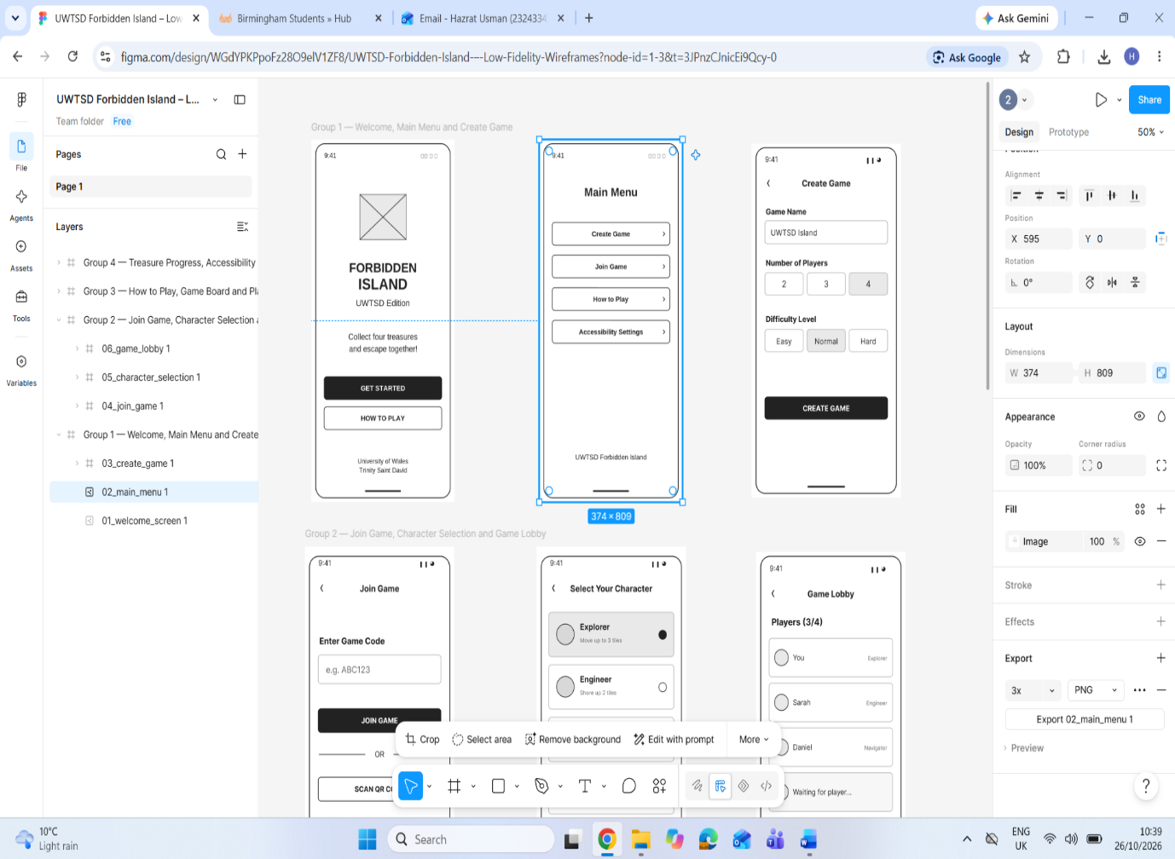
Figure 1.Low-Fidelity Interface Design in Figma – Main Navigation and Game Setup.
Figure 1 illustrates the initial development of the UWTSD Forbidden Island mobile interface using Figma. The screenshot shows the Welcome Screen, Main Menu and Create Game wireframes, representing the early stages of user interaction. The designs focus on simple layouts, clearly labelled buttons and straightforward navigation to help players understand how to begin the game. The Figma workspace also demonstrates how the screens and individual interface components were organised during the design process. The complete set of twelve low-fidelity wireframes is presented in Appendix C, Figures C1–C4.

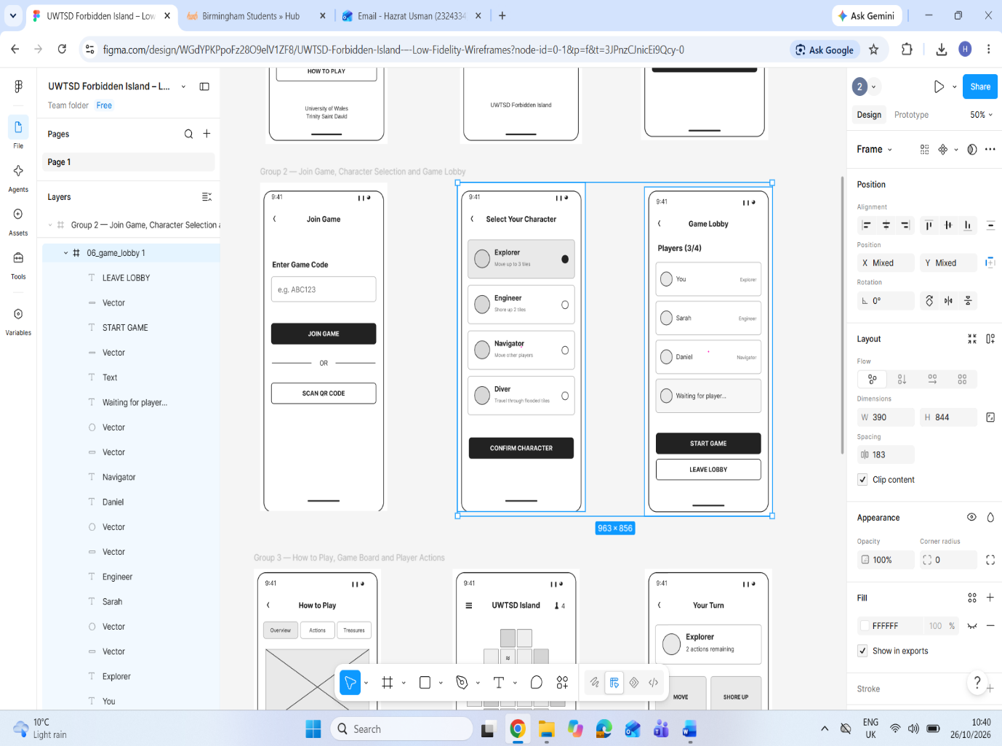
Figure 2. Low-Fidelity Interface Design in Figma – Character Selection and Game Lobby.
Figure 2 presents the next stage of interface development in Figma, including the Join Game, Character Selection and Game Lobby wireframes. These screens demonstrate how players can join an existing game, select a character and prepare for cooperative gameplay. Consistent button placement, readable labels and simple navigation elements were used to support usability. The visible Figma layers also provide evidence of how the interface components were structured during development. The remaining wireframes are presented in Appendix C, Figures C3–C4, while Figure C5 illustrates the complete navigation flow between screens.

5.2 Cognitive Walkthrough One: Creating a New Game
The first cognitive walkthrough examined the process of creating a multiplayer game, focusing on Sarah, the beginner persona. Cognitive walkthroughs assess whether users can identify appropriate actions, understand their purpose and recognise successful task completion [11].
The task involved seven steps, beginning with the Welcome Screen and progressing through the Main Menu, Create Game, Character Selection and Game Lobby. The inspection suggested that clearly labelled buttons and consistent screen layouts could help beginners understand the navigation process. However, potential usability issues were identified, including unclear input validation, insufficient confirmation messages and uncertainty about when a game could begin. These findings highlighted opportunities to improve system feedback, error prevention and user confidence. The detailed assessment is presented in Appendix D, Table D1.

5.3 Cognitive Walkthrough Two: Completing a Player Turn
The second cognitive walkthrough examined seven steps involved in completing a player turn, considering the requirements of Adam and Daniel. The task included viewing the Game Board, opening Player Actions, checking remaining actions, selecting movement and Shore Up options, reviewing treasure progress and ending the turn.
The inspection followed the cognitive walkthrough approach to examine whether players could recognize available actions and understand the feedback provided by the interface [9]. It identified useful features, including clearly labelled action buttons and a visible action counter. However, the static wireframes did not demonstrate how players select valid tiles or receive confirmation after completing actions.
Additional labels, highlighted destinations and clearer feedback were therefore recommended to improve usability and accessibility. The complete assessment is presented in Appendix D, Table D2.
Together, the two walkthroughs identified potential design improvements before the development of an interactive prototype. As the evaluations examined static wireframes, their findings represent an author-led inspection rather than observed user-testing results.

6.0 Peer Heuristic Evaluation
Heuristic evaluation is a usability inspection method used to identify potential interface problems by assessing a design against established usability principles. Nielsen's ten usability heuristics provide a framework for examining system feedback, consistency, user control and error prevention [10]. This approach helps identify usability weaknesses before developing a functional prototype [9].
Six classmates evaluated the twelve low-fidelity wireframes of the proposed UWTSD Forbidden Island mobile game. Their feedback was collected using five rating questions and three open-ended questions covering navigation, gameplay controls, readability, accessibility and potential improvements. The results were generally positive, particularly for the Main Menu and game creation process. However, the reviewers identified areas requiring improvement, including unclear Back buttons, lengthy instructions, small interface elements and limited feedback after gameplay actions.
The findings suggested that clearer navigation controls, simplified instructions, descriptive game-board symbols and confirmation messages could improve the user experience. An additional AI-assisted simulated heuristic inspection was conducted to explore potential usability issues, but its findings were kept separate from the genuine peer feedback. The evaluation records and detailed findings are presented in Appendix E.

7.0 Conclusion
This report has presented the usability engineering process used to design a mobile interface for the UWTSD version of Forbidden Island. The project focused on understanding user needs through questionnaire research, developing three user personas and creating twelve low-fidelity wireframes using Figma.
The research highlighted the importance of simple navigation, clear instructions, readable text and accessibility features for users with different levels of gaming experience. These findings influenced the interface design, particularly the game board, player actions and accessibility settings.
Two cognitive walkthroughs were conducted to examine important gameplay tasks, while an initial AI-assisted heuristic inspection identified potential usability problems. In addition, six classmates evaluated the proposed wireframes and provided feedback on navigation, readability, gameplay controls and accessibility. Their responses highlighted opportunities to improve Back buttons, simplify instructions, explain game-board symbols and provide clearer action confirmation. Further testing with an interactive prototype would be required to validate these proposed improvements.
Overall, the project demonstrates how user-centred design principles can support the development of an accessible and understandable mobile gaming interface. Future improvements should focus on usability testing and refining the design based on feedback.

References
[1] S. Fleury and N. Chaniaud, “Multi-user centered design: Acceptance, user experience, user research and user testing,” Theoretical Issues in Ergonomics Science, vol. 25, no. 2, pp. 209–224, 2024.
[2] B. A. Kumar, S. S. Chand, and M. S. Goundar, “Usability testing of mobile learning applications: A systematic mapping study,” International Journal of Information and Learning Technology, vol. 41, no. 2, pp. 113–129, 2024.
[3] E. Bjarnason, F. Lang, and A. Mjöberg, “An empirically based model of software prototyping: A mapping study and a multi-case study,” Empirical Software Engineering, vol. 28, art. no. 115, 2023.
[4] P. Weichbroth, “Usability testing of mobile applications: A methodological framework,” Applied Sciences, vol. 14, no. 5, art. no. 1792, 2024.
[5] P. Weichbroth, “Usability of mobile applications: A consolidated model,” IEEE Access, vol. 12, pp. 62378–62391, 2024.
[6] L. Hassan, “Accessibility of games and game-based applications: A systematic literature review and mapping of future directions,” New Media & Society, vol. 26, no. 4, 2024.
[7] K. Magylaitė, K. Kapočius, R. Butleris, and L. Čeponienė, “Towards high usability in gamified systems: A systematic review of key concepts and approaches,” Applied Sciences, vol. 12, no. 16, art. no. 8188, 2022.
[8] S. N. H. Syed Yasin and R. Ibrahim, “A review on user experience model in mobile educational games evaluation,” Open International Journal of Informatics, vol. 11, no. 2, pp. 165–178, 2023.
[9] O. Alhadreti, “Assessing the usability of M-health applications: A comparison of usability testing, heuristics evaluation and cognitive walkthrough methods,” International Journal of Advanced Computer Science and Applications, vol. 15, no. 11, 2024.
[10] Z. Galavi, S. Norouzi, and R. Khajouei, “Heuristics used for evaluating the usability of mobile health applications: A systematic literature review,” Digital Health, vol. 10, 2024.
[11] K. G. Tileng, L. Rosita, H. Mardhiana, and Christian, “Usability testing on student mobile application in university using cognitive walkthrough method,” in Proc. 2023 8th International Conference on Information Systems Engineering (ICISE '23), 2024.
[12] “Optimizing mobile game UI usability through HCI evaluation methods and emerging technologies,” in Proc. 2025 4th International Conference on Creative Communication and Innovative Technology (ICCIT), IEEE, 2025.

Appendices

Appendix A - User Research and Questionnaire Findings

A.1 Purpose of the Questionnaire
A questionnaire was used to gather initial information about potential users of the proposed UWTSD Forbidden Island mobile game. Five participants with different ages, gaming experiences and confidence levels contributed to the research. Their responses helped identify user preferences, potential usability difficulties and accessibility requirements.
Participants were anonymised using the identifiers P01–P05. Due to the small sample size, the findings were used to guide initial interface design decisions rather than represent the wider population.

A.2 Questionnaire Questions
The questionnaire covered the following topics:
- What is your age group?
- Are you currently studying computing or another subject?
- How often do you play games on your mobile phone?
- Have you played Forbidden Island or another cooperative board game before?
- How confident are you using unfamiliar mobile games?
- Would you prefer to play with friends online or together in the same location?
- How would you prefer to learn the rules of a new game?
- Which game-board design would be easiest for you to understand?
- What information would you prefer to see during your turn?
- What difficulties do you normally experience when using mobile games?
- Which accessibility features would you find helpful?

A.3 Summary of Participant Responses
Table A1: Participant Background and Gaming Experience
Participant | Age group | Study background | Gaming frequency | Confidence
P01 | 35–44 | Computing | Daily | Very confident
P02 | 25–34 | Computing | Occasionally | Not very confident
P03 | 45 or above | Not currently studying | Never | Not confident at all
P04 | 18–24 | Computing | Daily | Very confident
P05 | 45 or above | Computing | Weekly | Somewhat confident

Table A2: Main User Preferences
Participant | Learning preference | Board preference | Main design needs
P01 | Interactive tutorial | Simple 24-tile board | Fast gameplay, clear information and larger text
P02 | Written instructions | Campus-themed board | Simple navigation, readable text and accessible controls
P03 | Video tutorial and help tips | Unsure | Clear explanations and easy-to-understand controls
P04 | Interactive tutorial | Campus-themed board | Efficient gameplay, larger controls and accessibility options
P05 | Interactive tutorial | Simple board | Straightforward navigation and concise instructions

A.4 Key Questionnaire Findings
Table A3: Summary of Identified Patterns
Finding | Number of participants
Played mobile games daily | 2 out of 5
Very confident with unfamiliar games | 2 out of 5
Preferred interactive tutorials | 3 out of 5
Selected larger text | 3 out of 5
Selected high-contrast options | 2 out of 5
Selected screen reader support | 2 out of 5
Reported confusing navigation as a difficulty | 2 out of 5

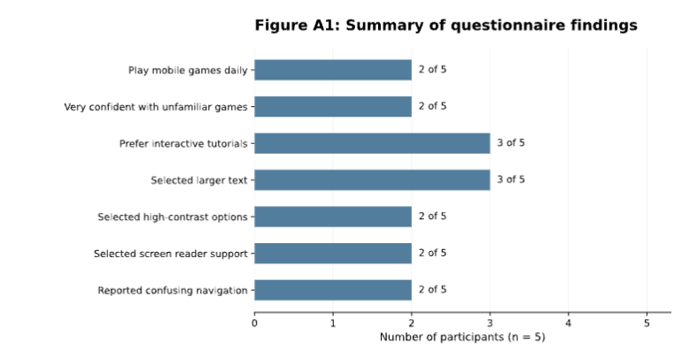
Figure A1: Summary of Questionnaire Findings from Five Participants.
Figure A1 presents the main findings from the questionnaire completed by five participants. Three participants preferred interactive tutorials, while three selected larger text as a helpful accessibility feature. Two participants selected high-contrast options and two selected screen reader support. These findings informed the proposed interface design, particularly the inclusion of clear instructions, readable text and accessible controls. Due to the small sample size, the results were used to guide initial design decisions rather than represent the wider population.

A.5 Behavioural Groups
Three provisional behavioural groups were identified from the questionnaire responses.
Group One - Experienced Players (P01 and P04): These participants regularly played mobile games and were confident exploring unfamiliar interfaces. Their preferences supported efficient navigation, visible gameplay information and accessible controls.
Group Two - Beginners (P02 and P03): These participants had lower confidence and preferred additional guidance. Their responses supported clear instructions, simple navigation and contextual help.
Group Three - Moderately Confident Player (P05): This participant preferred concise information and straightforward navigation, highlighting the need to balance usability for both beginners and experienced players.

A.6 MoSCoW Prioritisation of User Requirements
Table A4: Prioritised Interface Requirements
Priority | Requirement | Supporting evidence
Must Have | Clear navigation between the main screens | P02 and P05
Must Have | Readable text and clearly labelled buttons | P01, P02 and P04
Must Have | Visible player actions and treasure progress | Questionnaire findings
Must Have | Clear game instructions | P02 and P03
Should Have | Adjustable text size | P01, P02 and P04
Should Have | High-contrast display options | P02 and P04
Should Have | Meaningful labels for screen reader compatibility | P02 and P04
Should Have | Interactive tutorial | P01, P04 and P05
Could Have | QR-code game joining | Proposed design feature
Could Have | Reduced animation and optional sound controls | Accessibility considerations
Won't Have (Initial Prototype) | Fully functional multiplayer networking | Outside the low-fidelity interface design scope
The MoSCoW prioritisation method was used to organise the proposed interface requirements according to their importance. Essential features, including clear navigation, readable text, game instructions and visible gameplay information, were classified as Must Have. Additional features, such as adjustable text size, high-contrast options and interactive tutorials, were considered Should Have. Optional features, including QR-code joining and reduced animation, were placed in the Could Have category. Fully functional multiplayer networking was excluded from the initial low-fidelity design scope. This prioritisation helped ensure that the twelve wireframes focused on the main user needs identified through the questionnaire research.

Appendix B - Detailed User Personas and Scenarios

B.1 Overview of User Personas
Three user personas were developed to represent different needs identified through the questionnaire research. These personas are fictional representations informed by the responses of five participants (P01–P05). They were used to consider how different players might interact with the proposed UWTSD Forbidden Island mobile game.
The personas represent an experienced player, a beginner and a player with accessibility requirements. Each includes a background, goals, potential difficulties, gameplay scenario and user journey.

B.2 Persona One — Adam: Experienced Computing Student
Table B1: Adam's Persona Profile
Attribute | Description
Name | Adam
Age | 22
Occupation | Computing student
Gaming experience | Experienced mobile gamer
Technical confidence | High
Main goal | Create a cooperative game quickly and play with friends
Main frustration | Unnecessary navigation and repeatedly opening menus
Preferred learning method | Short interactive tutorial
Research basis | P01 and P04
Scenario
Adam wants to create an online Forbidden Island game with his university friends. He opens the application, creates a new session, chooses a character and waits for the other players to join. During gameplay, he wants to identify his available actions and monitor treasure progress without unnecessary interruptions.
User requirements: Create or join a game, select a character, view available actions and monitor treasure progress.
Experience requirements: Fast navigation, clear gameplay information and minimal interruptions.

Table B2: Adam's User Journey
Stage | User activity | Expected interface support
1 | Opens the application | Clear Welcome Screen
2 | Creates a game | Simple game creation form
3 | Selects a character | Clearly described character abilities
4 | Waits for friends | Visible lobby and player information
5 | Starts gameplay | Easy-to-understand game board
6 | Completes actions | Accessible action buttons and progress indicators

B.3 Persona Two - Sarah: Beginner Player
Table B3: Sarah's Persona Profile
Attribute | Description
Name | Sarah
Age | 30
Occupation | Computing student
Gaming experience | Limited experience with cooperative games
Technical confidence | Low
Main goal | Understand the game and participate confidently
Main frustration | Confusing navigation and lengthy instructions
Preferred learning method | Written instructions and clear guidance
Research basis | P02 and P03
Scenario
Sarah opens the UWTSD Forbidden Island application for the first time. She wants to understand the game rules before joining her friends. She accesses the instructions and learns how players move, protect flooded tiles and collect treasures. During her turn, she needs clear action labels and confirmation that her selections have been completed successfully.
User requirements: Access instructions, understand the objectives, identify available actions and receive feedback.
Experience requirements: Simple navigation, understandable language and confidence when completing tasks.

Table B4: Sarah's User Journey
Stage | User activity | Expected interface support
1 | Opens the game | Simple Welcome Screen
2 | Reads instructions | Accessible How to Play screen
3 | Joins a session | Clearly labelled Join Game option
4 | Chooses a character | Short descriptions of character abilities
5 | Begins a turn | Visible available actions
6 | Performs an action | Clear confirmation and feedback

B.4 Persona Three - Daniel: Accessibility-Focused Player
Table B5: Daniel's Persona Profile
Attribute | Description
Name | Daniel
Age | 46
Occupation | Not specified
Gaming experience | Interested in cooperative games
Accessibility consideration | Reduced vision and use of screen magnification
Main goal | Participate independently with accessible controls
Main frustration | Small text, low contrast and unclear symbols
Preferred interface features | Adjustable text, high contrast and descriptive labels
Research basis | Accessibility preferences from P01, P02 and P04
Important: Daniel's reduced vision and use of screen magnification are fictional persona characteristics. They are not presented as medical information disclosed by any questionnaire participant.
Scenario
Daniel wants to join a cooperative game with his friends. Before starting, he opens the Accessibility Settings screen and adjusts the text size and contrast. During gameplay, he needs to recognise his character's position, identify flooded tiles and understand the available actions without relying only on colours or small symbols.
User requirements: Adjust text size, distinguish game elements, access labelled controls and use compatible assistive technology.
Experience requirements: Comfortable reading, independent interaction and confidence when selecting actions.
Table B6: Daniel's User Journey
Stage | User activity | Expected interface support
1 | Opens the application | Readable Welcome Screen
2 | Changes accessibility settings | Text size and contrast options
3 | Joins a game | Clearly labelled controls
4 | Views the game board | Distinguishable tiles and symbols
5 | Selects an action | Large buttons with descriptive labels
6 | Reviews progress | Clear text and visual indicators

B.5 Comparison of Persona Requirements
Table B7: Comparison of the Three Personas
Design consideration | Adam | Sarah | Daniel
Simple navigation | Important | Essential | Essential
Game instructions | Short tutorial | Detailed guidance | Accessible instructions
Visible player actions | Essential | Essential | Essential
Treasure progress | Essential | Important | Important
Large readable text | Helpful | Helpful | Essential
High-contrast controls | Helpful | Helpful | Essential
Clear action feedback | Important | Essential | Essential

B.6 Influence of Personas on Interface Design
The three personas informed several decisions during the development of the twelve low-fidelity wireframes.
Adam's requirements influenced the Create Game, Game Board and Player Actions screens, where efficient navigation and visible gameplay information were prioritised.
Sarah's requirements influenced the How to Play screen, straightforward menu options and clearly labelled controls intended to support beginners.
Daniel's requirements influenced the Accessibility Settings screen, including adjustable text size, high-contrast options and consideration of screen reader compatibility.
Together, the personas helped connect the questionnaire findings to the proposed interface features. They also provided realistic scenarios for examining usability through the cognitive walkthrough activities described in Sections 5.2 and 5.3.

Appendix C - Low-Fidelity Wireframes and Navigation

C.1 Overview of the Wireframe Designs
This appendix presents the 12 low-fidelity mobile interface wireframes developed for the UWTSD version of Forbidden Island. The designs are organised into four groups, covering the main stages of the user journey, including game introduction, session creation, character selection, gameplay, accessibility settings and game completion.
The wireframes use a consistent black-and-white layout, clearly labelled buttons and simple navigation elements. These design choices were informed by the questionnaire findings, which highlighted the importance of straightforward navigation, accessible text and clear game instructions. The wireframes focus on the structure and usability of the proposed interface rather than its final visual appearance.

C.2 Game Introduction and Creation
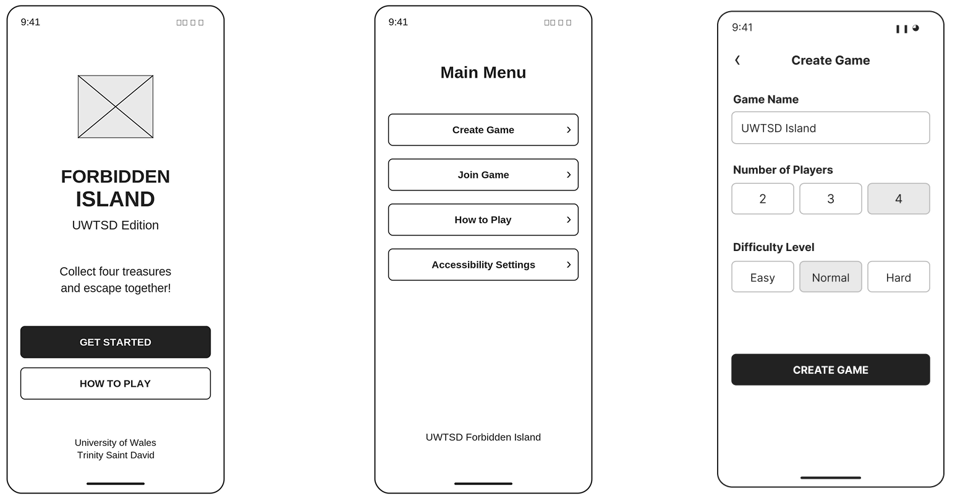
Figure C1: Low-Fidelity Wireframes Showing (a) Welcome Screen, (b) Main Menu and (c) Create Game.
Figure C1 presents the initial stages of the mobile game. The Welcome Screen introduces the game and provides options to get started or view instructions. The Main Menu displays four clearly labelled options, allowing players to create a game, join an existing session, access instructions or change accessibility settings.
The Create Game screen allows users to enter a game name, choose between two and four players and select a difficulty level. The simple arrangement of input fields and buttons aims to reduce unnecessary complexity, particularly for users who have limited experience with cooperative mobile games.

C.3 Joining and Preparing for Gameplay
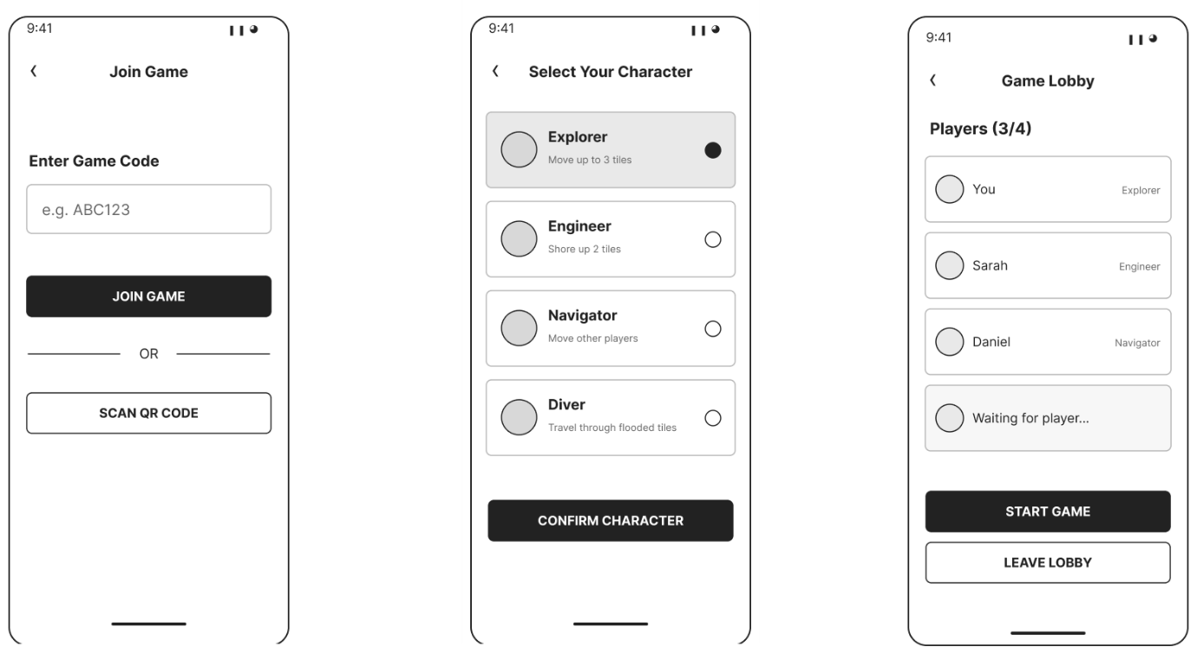
Figure C2: Low-Fidelity Wireframes Showing (a) Join Game, (b) Character Selection and (c) Game Lobby.
Figure C2 illustrates how players can join an existing game and prepare for cooperative gameplay. The Join Game screen provides a game-code input field and an alternative QR-code option, giving users two methods of accessing a session.
The Character Selection screen presents four available roles: Explorer, Engineer, Navigator and Diver. Each role includes a short description of its abilities to help players make an informed choice. The Game Lobby displays the participants and their selected roles, together with options to start the game or leave the session. These features aim to provide clear feedback and support communication before gameplay begins.

C.4 Game Instructions and Player Interaction
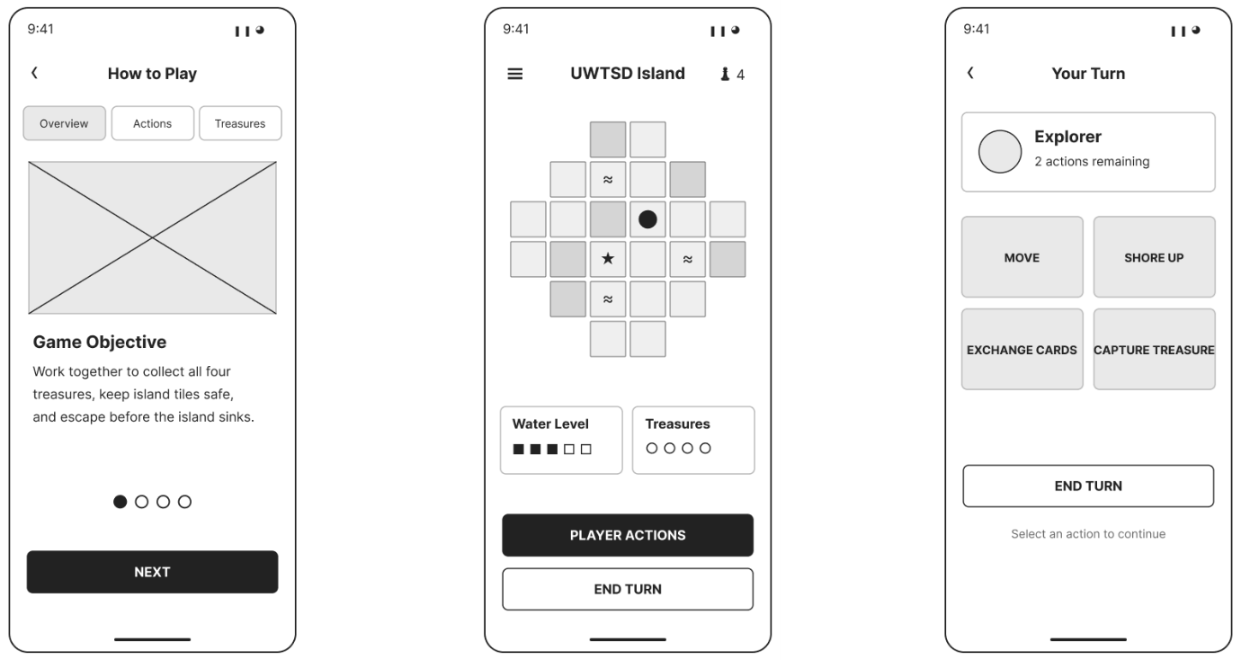
Figure C3: Low-Fidelity Wireframes Showing (a) How to Play, (b) Game Board and (c) Player Actions.
Figure C3 demonstrates the main learning and gameplay interfaces. The How to Play screen introduces the game objective and separates information into sections covering the overview, available actions and treasures. This approach allows new players to access instructions without presenting all the information at once.
The Game Board screen displays the island tiles alongside the water level, treasure indicators and navigation controls. The Player Actions screen provides clearly labelled buttons for movement, shoring up flooded tiles, exchanging cards and capturing treasures. An action counter helps players understand their remaining opportunities during a turn.
Together, these screens aim to improve the visibility of important game information and support users in completing gameplay tasks.

C.5 Treasure Progress, Accessibility and Game Completion
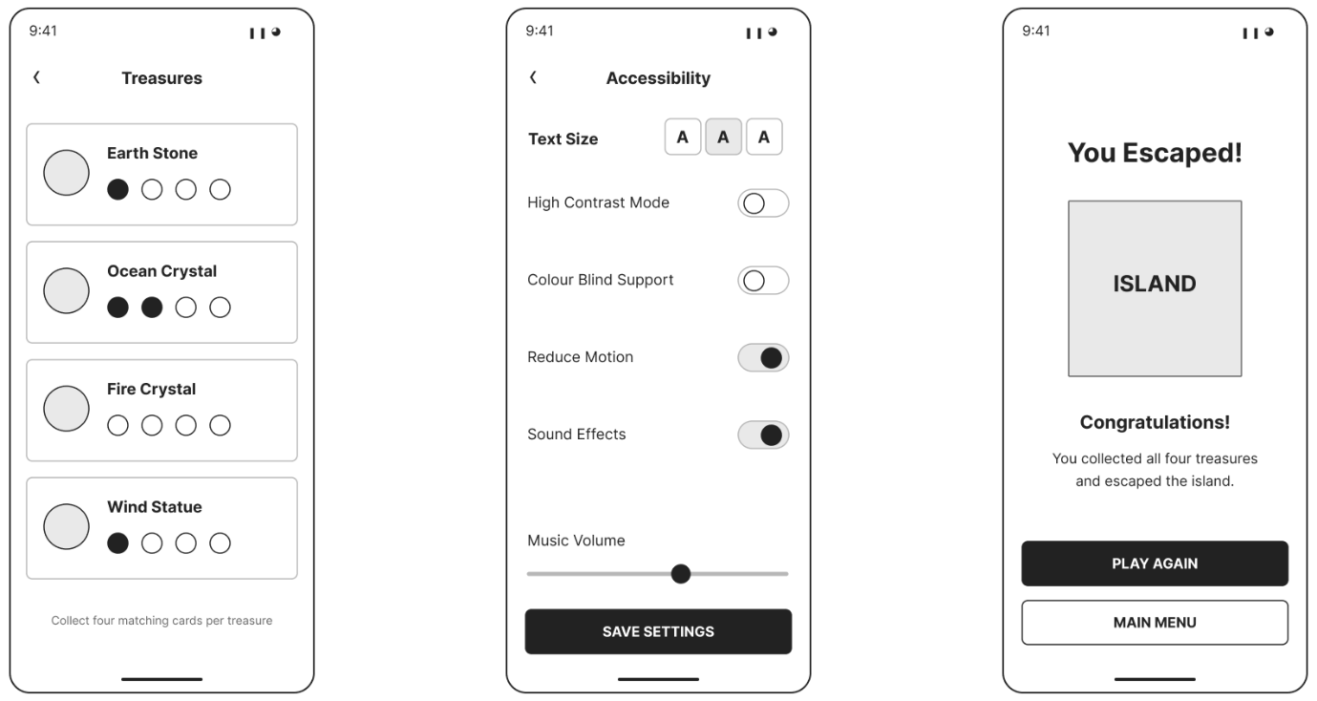
Figure C4: Low-Fidelity Wireframes Showing (a) Treasure Progress, (b) Accessibility Settings and (c) Game Results.
Figure C4 presents the supporting interfaces used during and after gameplay. The Treasure Progress screen displays the four treasures and their associated card indicators, allowing players to monitor collection progress.
The Accessibility Settings screen includes options for adjusting text size, enabling high contrast, supporting colour-blind users and reducing motion. Sound and music controls are also provided. These options reflect accessibility preferences identified during the questionnaire research and aim to support different user needs.
The Game Results screen provides clear feedback when the players successfully escape the island. It also offers options to play again or return to the main menu, allowing users to continue or finish their gaming experience.

C.6 Navigation and Design Consistency
The 12 wireframes demonstrate the proposed navigation structure of the mobile game. Users begin at the Welcome Screen and move to the Main Menu, where they can create or join a session. After selecting a character and entering the lobby, players proceed to the Game Board and access the available actions and treasure information during gameplay.
The design maintains consistent button styles, screen headings and navigation controls to help users recognise familiar interface elements. Accessibility settings and instructions are provided to support users with different levels of experience and accessibility preferences.
These wireframes provide the visual foundation for the two cognitive walkthroughs discussed in Sections 5.2 and 5.3. The walkthroughs examine how users would complete important tasks using the proposed interface.
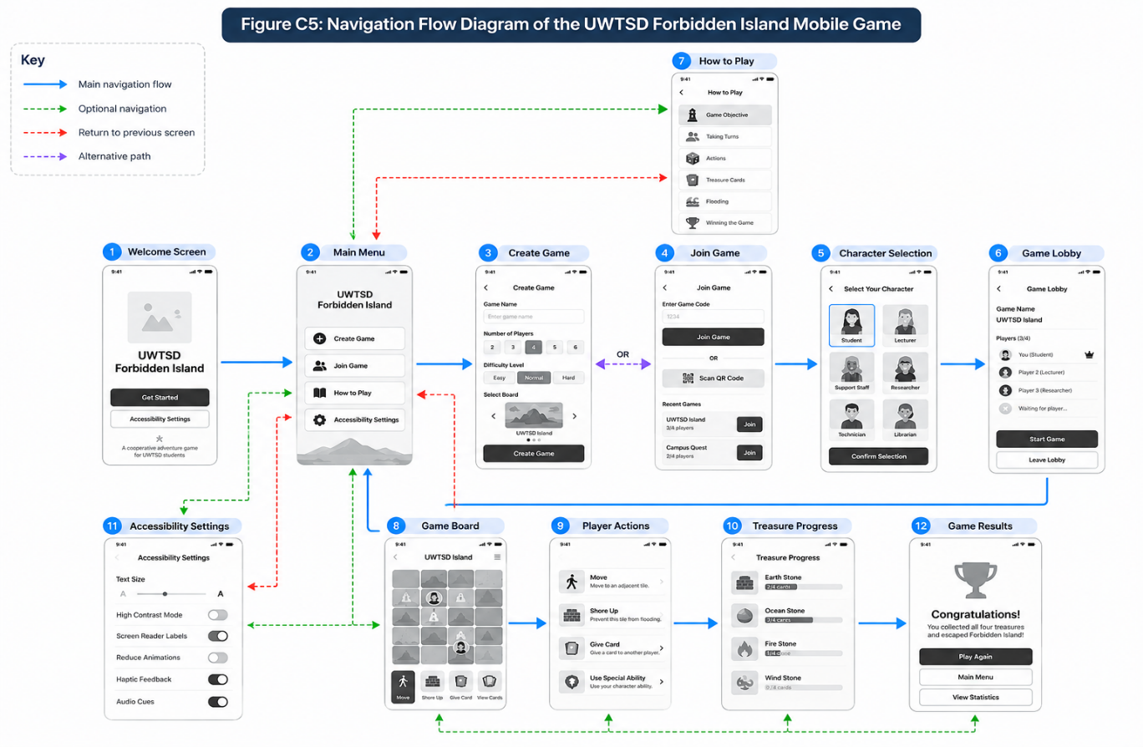
Figure C5: Proposed Navigation Flow of the UWTSD Forbidden Island Mobile Interface.
Figure C5 illustrates the navigation structure of the proposed UWTSD Forbidden Island mobile game. Players begin at the Welcome Screen and proceed to the Main Menu, where they can create or join a game. The diagram also shows access to character selection, gameplay instructions, accessibility settings and treasure progress. The directional arrows represent the main navigation routes, alternative options and return paths. This structure aims to support clear navigation, user control and ease of use.

Appendix D - Cognitive Walkthrough Records

D.1 Purpose and Evaluation Method
Cognitive walkthrough is a usability evaluation method that examines whether users can understand and complete tasks through an interface. It is particularly useful for identifying potential difficulties experienced by new or less confident users.
Two walkthrough scenarios were selected to examine the proposed UWTSD Forbidden Island mobile interface. The first focuses on creating a new game, while the second examines completing a player turn.
The walkthroughs use the low-fidelity wireframes presented in Appendix C. Each step is examined using four questions:
- Will the user understand what they need to achieve?
- Will the user notice the correct action or control?
- Will the user understand that the action will help achieve their goal?
- Will the user recognise whether the action was completed successfully?
The records below provide an initial author-led assessment of the proposed design. As the wireframes are static, screen transitions and feedback messages are assessed as design intentions rather than tested functionality.

D.2 Cognitive Walkthrough One - Creating a New Game
Task: Create a new multiplayer game, select a character and enter the game lobby.
Relevant persona: Sarah, the beginner player.
Starting point: Welcome Screen.
Expected outcome: The player creates a game and reaches the lobby, ready for other players to join.
Table D1: Cognitive Walkthrough One - Step-by-Step Assessment
Step | User action | Assessment and potential difficulty | Suggested improvement
1 | Open the application and select Get Started | The Welcome Screen presents a clearly labelled button. However, its destination is not demonstrated in the static wireframe. | Show the navigation connection to the Main Menu.
2 | Select Create Game | The Main Menu clearly displays this option, making it easy to recognise. | Maintain consistent button styling.
3 | Enter a game name | The Create Game screen provides a labelled input field. No validation or error message is shown. | Add guidance for missing or invalid names.
4 | Choose the number of players and difficulty | The available options are visible, but the selected state should remain clear. | Use a distinct selection indicator.
5 | Confirm Create Game | The main action button is prominent. Confirmation that the session has been created is not demonstrated. | Provide a success message or clear transition.
6 | Select and confirm a character | Character roles include short descriptions, supporting informed selection. | Clearly indicate the selected character before confirmation.
7 | Enter the Game Lobby | The lobby displays participating players and their roles. However, the example shows three of four players alongside a Start Game button. | Explain whether all players must join before starting and disable unavailable actions.

D.2.1 Findings
The proposed interface provides a straightforward sequence for creating a new game. Clearly labelled buttons, simple input fields and character descriptions support the beginner persona.
The inspection also identifies areas requiring further attention. These include input validation, confirmation messages and the conditions under which the game can begin.

D.2.2 Recommended Improvements
The Create Game screen should provide feedback when required information is missing. The Game Lobby should also communicate whether the session is ready to start. Clear transitions between screens would further support beginners.

D.3 Cognitive Walkthrough Two - Completing a Player Turn
Task: View the game board, move to a neighbouring tile, protect a flooded location, review treasure progress and end the turn.
Relevant personas: Adam, the experienced player, and Daniel, the accessibility-focused player.
Starting point: Game Board.
Expected outcome: The player understands the available actions and completes a turn with clear feedback.

Table D2: Cognitive Walkthrough Two - Step-by-Step Assessment
Step | User action | Assessment and potential difficulty | Suggested improvement
1 | View the Game Board | The board displays island tiles, water level and treasure indicators. Some symbols may be unclear without explanations. | Provide descriptive labels or a symbol legend.
2 | Open Player Actions | The Player Actions button is clearly visible on the Game Board. | Maintain consistent navigation between both screens.
3 | Check remaining actions | The Player Actions screen displays an action counter, helping the player understand their remaining opportunities. | Update the counter after each completed action.
4 | Select Move | The Move button is clearly labelled, but the process for selecting a destination is not shown. | Highlight valid destination tiles and provide a confirmation state.
5 | Select Shore Up | The Shore Up option is visible, but the method for choosing a flooded tile is not demonstrated. | Highlight eligible flooded tiles and confirm the action.
6 | Review treasure progress | The Treasure Progress screen displays four treasures and card indicators. | Provide a clear route back to gameplay and explain collection requirements.
7 | End the turn | End Turn is clearly labelled, but the resulting feedback or handover to another player is not shown. | Display confirmation and indicate the next player's turn.

D.3.1 Findings
The interface presents important gameplay actions through clearly labelled controls. The Game Board and Player Actions screens provide a useful starting structure for managing a player's turn.
However, the static wireframes do not demonstrate every interaction required to complete the task. Potential difficulties include selecting valid tiles, understanding symbols and recognising whether actions have been completed.
These issues may affect beginners and players using assistive technologies.

D.3.2 Recommended Improvements
Future design improvements should include clearer tile selection, visible action feedback, descriptive symbols and confirmation when a turn ends. Accessible labels should also be considered when developing an interactive prototype.

D.4 Summary of the Cognitive Walkthroughs
Table D3: Summary of Identified Usability Issues
Usability issue | Relevant screen | Priority | Proposed improvement
Unclear input validation | Create Game | Medium | Add validation messages
Unclear session readiness | Game Lobby | Medium | Explain start conditions
Limited explanation of board symbols | Game Board | High | Add symbol legend and labels
Unclear destination selection | Game Board / Player Actions | High | Highlight valid tiles
Limited action confirmation | Player Actions | High | Provide feedback after actions
Unclear turn completion feedback | Player Actions | Medium | Add turn confirmation and handover
The two walkthroughs identify potential usability improvements related to navigation, feedback, gameplay controls and accessibility.
The findings provide a basis for refining the low-fidelity wireframes before further development. However, because the walkthroughs are based on static designs, the identified issues require confirmation through an interactive prototype and genuine user testing.

Appendix E - Heuristic Evaluation Records

E.1 Purpose and Evaluation Method
Heuristic evaluation is a usability inspection method used to identify interface problems by examining a design against established usability principles. Nielsen's ten usability heuristics were selected as the evaluation framework for the proposed UWTSD Forbidden Island mobile interface.
An initial AI-assisted inspection considered three different user perspectives: a beginner player, an experienced player and a player with accessibility requirements. The inspection focused on the twelve low-fidelity wireframes presented in Appendix C.
The findings below represent potential usability issues identified from the proposed designs. They are not observations or feedback collected from actual classmates.

E.2 Evaluation One - Beginner Player Perspective
Reviewer: AI-assisted simulated reviewer A
Focus: Learnability, navigation and clarity of instructions.
Table E1: Beginner Perspective Evaluation
Heuristic | Screen | Identified issue | Suggested improvement | Severity
Recognition rather than recall | Game Board | Players may struggle to remember instructions while playing. | Add an accessible Help option during gameplay. | 2 - Minor
Visibility of system status | Player Actions | Feedback after completing actions is not demonstrated. | Display confirmation messages after actions. | 3 - Major
Consistency and standards | Main Menu / Gameplay | Navigation between different screens is not fully demonstrated. | Use consistent navigation controls and clearly defined transitions. | 2 - Minor
Evaluation summary
The proposed interface provides clearly labelled main menu options and a simple layout. However, beginners may require additional guidance during gameplay. Contextual instructions and clearer feedback could help users understand their actions and reduce uncertainty.

E.3 Evaluation Two - Experienced Player Perspective
Reviewer: AI-assisted simulated reviewer B
Focus: Gameplay efficiency, user control and error prevention.
Table E2: Experienced Player Perspective Evaluation
Heuristic | Screen | Identified issue | Suggested improvement | Severity
Flexibility and efficiency of use | Game Board / Treasure Progress | Players may need to navigate between screens to check detailed progress. | Display essential progress information directly on the Game Board. | 2 - Minor
User control and freedom | Player Actions | The wireframes do not demonstrate how to cancel a selected action. | Add a Cancel option before confirming important actions. | 3 - Major
Error prevention | Player Actions | Unavailable actions are not clearly distinguished from available actions. | Disable unavailable controls and explain why actions cannot be performed. | 3 - Major
Evaluation summary
The interface presents the main gameplay actions through understandable controls. However, experienced players may benefit from quicker access to information and fewer unnecessary navigation steps. Clear cancellation options and prevention of invalid actions would also improve usability.

E.4 Evaluation Three - Accessibility-Focused Perspective
Reviewer: AI-assisted simulated reviewer C
Focus: Readability, accessibility and clarity of game information.
Table E3: Accessibility Perspective Evaluation
Heuristic | Screen | Identified issue | Suggested improvement | Severity
Aesthetic and minimalist design | Game Board | Some symbols may be difficult to interpret at mobile screen size. | Provide a simple legend and readable labels. | 3 - Major
Recognition rather than recall | Game Board | Players may need to remember the meanings of different symbols. | Include descriptive labels and accessible explanations. | 2 - Minor
Help and documentation | Accessibility Settings | The wireframes show accessibility options but cannot demonstrate whether they work. | Test text scaling and assistive technology support in a functional prototype. | 3 - Major
Evaluation summary
The proposed Accessibility Settings screen includes useful options, such as adjustable text size, high contrast and reduced motion. However, the static designs cannot confirm that these features function correctly. Further testing would be necessary to evaluate their effectiveness.

E.5 Summary of Simulated Evaluation Findings
Table E4: Prioritised Usability Improvements
Identified issue | Priority | Proposed improvement
Limited feedback after gameplay actions | High | Add confirmation messages
Unclear cancellation of selected actions | High | Provide Cancel controls
Unavailable actions not clearly identified | High | Disable invalid actions
Game-board symbols may be unclear | High | Add descriptive labels and a legend
Limited help during gameplay | Medium | Add contextual guidance
Progress information spread across screens | Medium | Improve visibility of essential information
Accessibility functionality not yet tested | High for later testing | Test in an interactive prototype
The three simulated evaluations identified potential improvements in navigation, gameplay feedback, error prevention and accessibility. These findings can inform future revisions of the interface, but they should not be interpreted as evidence of completed peer testing.

E.6 Genuine Peer Evaluation Findings
Six classmates completed peer evaluations of the proposed UWTSD Forbidden Island mobile interface. The reviewers were Mihai Adrian Lungu, Rabia Naeem, Simret Manna, Yasser El Ouafai Ouafa, John Gabriel Kak Yomon and Nicolae Panait. Each reviewer assessed the twelve low-fidelity wireframes using five rating questions and three open-ended questions.
The findings showed positive feedback for the Welcome Screen, Main Menu and game creation process. However, several reviewers identified difficulties with navigation, particularly the lack of clear options for returning to previous screens. Other recommendations included simplifying instructions, adding a game-board symbol legend, improving the readability of interface elements and providing confirmation messages after gameplay actions.
Positive comments highlighted the Character Selection screen and Accessibility Settings. Overall, the peer feedback identified practical opportunities to improve navigation, learnability, gameplay feedback and accessibility. These findings provide useful evidence for future design improvements, although further testing with an interactive prototype would be needed to evaluate actual functionality.
Table E5: Peer Evaluation Evidence Checklist
Required activity | Evidence to include | Current status
Mihai evaluates your interface | Completed evaluation form | Completed
Rabia evaluates your interface | Completed evaluation form | Completed
Simret evaluates your interface | Completed evaluation form | Completed
Yasser evaluates your interface | Completed evaluation form | Completed
John evaluates your interface | Completed evaluation form | Completed
Nicolae Panait | Nicolae Panait | Nicolae Panait
The six completed peer evaluation forms are retained as supporting evidence for the findings presented in Sections E.6 and E.7.

E.7 Summary and Analysis of Genuine Peer Feedback
Six classmates evaluated the twelve low-fidelity wireframes of the proposed UWTSD Forbidden Island mobile game. Their feedback was collected using five rating questions and three open-ended questions covering navigation, gameplay controls, readability, accessibility and potential improvements.
The results were generally positive, particularly for the Welcome Screen, Main Menu and game creation process. However, the Game Board and Player Actions received comparatively lower ratings, suggesting that these screens may require further improvement.

Table E6: Summary of Peer Evaluation Findings
Usability area | Current draft | Correct average
Welcome Screen and Main Menu | 4.83 | 4.83
Creating or joining a game | 4.83 | 4.83
Game Board and Player Actions | 3.83 | 3.83
Instructions and navigation | 3.83 | 3.67
Text, buttons and symbols | 4.17 | 4.17

Several reviewers identified unclear navigation between screens, particularly the absence of clearly visible Back buttons. Other recommendations included simplifying the game instructions, adding a legend to explain game-board symbols, improving text readability and displaying confirmation messages after gameplay actions.
The feedback also highlighted positive aspects of the design, including character descriptions and accessibility settings. These findings suggest that the proposed interface provides a useful foundation but could benefit from further refinement.
Overall, the peer evaluations identified practical improvements that could enhance navigation, learnability and accessibility. The feedback will inform future design revisions, while an interactive prototype and further usability testing would be required to confirm the effectiveness of these improvements.

E.8 Reflection on Classmates' Wireframe Designs
As part of the peer review activity, wireframe designs developed by classmates were observed and informally discussed. The designs demonstrated different approaches to organising mobile game screens and presenting gameplay information. This provided an opportunity to reflect on the importance of clear navigation, readable interface elements and consistent screen layouts.
Although copies of the classmates' wireframes were not available for inclusion in the appendix, observing their designs provided a useful opportunity to consider alternative interface approaches. The six completed peer evaluations of the proposed UWTSD Forbidden Island interface provided additional feedback, including positive ratings and recommendations for improving navigation, instructions and gameplay feedback.

