KNOWLEDGE AND INFORMATION MANAGEMENT SKILLS FOR THE WORKPLACE

Student I.D: 1710683
Mohammed Abdul Basith Chowdhury
BMSK5006

Abstract
Importance of data, information and information for the business of TESCO has been mentioned in this study. Usage of data analytics and digital marketing in TESCO has been discussed in this study. Different techniques of modeling like KM process framework And KM Matrix in Tesco has been discussed in this study. Skills, knowledge and information are important within the organization TESCO PLC as they are helping them in storing essential details. They are also helping the organization in making effective business plans in order to achieve all their objectives. The intellectual properties, technologies and performance drives are important for the employees in increasing productivity and help the organization to grow in the competitive market. Recommendation has also been provided according to the simplified receiver based model has been discussed in this study.
Table of Contents

Introduction 3
Overview of the case study 3
Evaluation of the concept and importance of knowledge management 4
a. Explaining relationship between data, information and knowledge 4
b. Explaining the relationship between individual knowledge and organisational knowledge 4
c. Applying analysis and different modelling techniques to identify assets of knowledge 5
d. Evaluating actual and different potential for knowledge aspects 8
Understanding of important knowledge management processes 9
a. Explaining the need for creating, storing, applying and integrating knowledge 9
b. Considering importance of Intellectual property rights 10
Framework for establishing a knowledge management culture 11
a. Explaining the contribution in the assets of knowledge on an organization 11
Knowledge requirements 12
b. Evaluating the different requirements of knowledge in an organisation 12
c. Evaluating the organisation’s framework to enable the sharing of knowledge 13
d. Recommendations to improve current framework 14
References 16

Introduction
Skills of information management refer to the different cycle in the activities of an organization. This includes gaining of information from one person to another person. Importance of information management skills helps any organization to improve the quality of data in a company, increases efficiency and maintains security for a company’s data. At present, data plays an important resource in an organization to manage different information for the success of a company. Knowledge in any business is very important to understand different needs of the customer and also implementing different skills of every employee in an organization. This report sheds light on the different techniques and analysis to identify different organizational skills in an organization. TESCO PLC has been chosen for this study because it is the third largest retailing company across the world.

Overview of the case study
Tesco is considered as one of the largest retailer which is having around 6,784 stores in the year 2016 with 597,784 employees working in it. Recently it has been found that Tesco is having its outlets in 12 countries and it is growing globally with more than 27 million Clubcard holders. Tesco is not only having grocery business but they are also having a large presence of financial services, non-food items as well as telecommunication market. Tesco is also providing online services for the customer for the customers in the year 1996 which is a direct service. Tesco is having 72 stores in London as well as South East and they are proving 24*7 services for the customers. Tesco is using cloud computing and data analytic to improve as well as protect data and information which are related to employees and the production team. Tesco has launched its advanced mobile payment capabilities for the customers such as Pay+ which is considered as a advanced form of PayQwiq solutions. The main advantage of this technology is it directly links with the Clubcard loyalty programme. Some of the strategies that are used by Tesco are the cost saving which is sought from the management of the supply chains. Tesco has introduced ‘Scan as you ship’ and they made 1 million pound investment for the improvement of the stores. They have also introduced to Self Checkout system and new Scan while shopping of the equipment within the shop for the customers.

Evaluation of the concept and importance of knowledge management

a. Explaining relationship between data, information and knowledge
Importance of data and information is a crucial part for any business. As per Travis (2017), sharing the knowledge among the individuals plays an important role in any business to solve different problems related to the company. Data can be explained as the collection of facts related to the specific topic. Once data is collected from the relevant sources, the next step is to deduce information from the set of data which has been found out from relevant study. According to Collet et al. (2015), after getting data and information from the relevant sources, applying own knowledge and judgments for specific information can be used in TESCO to increase production in a large scale. Knowledge can be gathered when learning is done in a proper way. Knowledge can be used to understand subject in proper manner which can be gathered from the experience of certain people. In TESCO PLC, to produce any new brand of clothes in the market, it is important for marketers to get data which are collected with the help of analytics and it helps to improve the process of decision making in this industry (tescoplc.com, 2019). Once proper data is collected, marketers need to get accurate information to manage efficiency in TESCO. Usage of analytics in TESCO helps retailers to understand about the better preference for their customers. Proper knowledge in the retailing sector is important for the employees of TESCO PLC for improving the productivity in their business. However, Ritter et al. (2018) have mentioned that good quality data is important for marketers to predict the growth of TESCO according to the needs of customers. Sharing of data using new techniques like data analytics and cloud computing can help any business to improve efficiency in TESCO PLC. Knowledge is the process to make something specific related to the information, specific data and experience of different employee in an organization. In order to maintain good efficiency in the TESCO, it is important to maintain customer data in their database with proper security in the retail sector. Hence, it can be understood that proper data and information leads to implement the knowledge in a better manner.

b. Explaining the relationship between individual knowledge and organisational knowledge
Organizational knowledge can be explained as the company resource in which specific value cannot be changed in a business. As commented by Tong et al. (2015), different individuals working in an organization and implementing their own knowledge in a company helps any business to exchange specific skills, knowledge and information among group of people working in the organization. This benefits the business to improve productivity of a company. Using of individual knowledge in a business helps to create new ways for increasing productivity of a company. As opined by Lee et al. (2016), sharing of knowledge within an organization helps to improve cooperation and management skills between the different hierarchies working in a business. TESCO PLC plans to build new brand for their customers, in this case, employees can share their own techniques and planning among team members and implement new strategies to increase the revenue of the retail sector. It is important to use own learning methods for each individual to increase the economic development of UK. It has been found that TESCO operates about 7000 stores across the word, out of which 3739 stores are based in the UK (statista.com, 2018). Use of new strategies like data analytics can be implemented in TESCO PLC to attract more number of customers in the UK. To attract more number of customers in TESCO, marketers provide easy access to online based shopping and produce different brand of clothes in the market according to the choice of customers. It has been found that value of Tesco Brand in UK is approximately 10.81 billion USD (statista.com, 2019). It is important for any individual to implement their own learning and using creative ways to improve the benefit of an organization. Knowledge of an individual consists of two types of learning - operational and conceptual level of learning. In operational level learning, employees have to use their physical ability to produce proper action for the specified task. In conceptual level learning, employees have to make use of different concepts according to the experience gained by doing some research. TESCO PLC can make use of conceptual level of learning to motivate their employees to use different strategies by understanding the needs of the customer which helps to improve revenue of TESCO PLC.

c. Applying analysis and different modelling techniques to identify assets of knowledge
It is important to apply different management techniques to understand different resources of a company. As per Vasyutin et al. (2019), there are three kinds of management tools which have been mentioned in this study. Three knowledge based management tools can be classified as The KM Process Framework, The KM Matrixand The Knowledge Management Process Model.
- The KM Process Framework: Thisframework explains about the different processes which explain about the different strategies to improve knowledge in an organization. However, Bamel and Bamel (2018) have mentioned that the main strengths of this model are to understand about the main focus of the strategy which helps management to take specific action related to the specified tasks. TESCO focuses to maintain loyalty of the customer and develop new technologies including usage of data analytics to improve the experience of shopping for their customers.
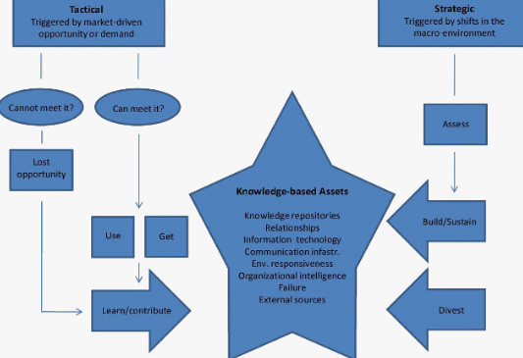
Figure 1: KM Process Framework
(Source: Bamel and Bamel , 2018)
- The KM Matrix:These model in general theoretical frameworks to understand about the specific guidelines and implementation of different strategies in a business. As commented by Abazov et al. (2016), there are four stages in the KM Matrix which includes sensing, organizing new events, socializing different plans and internalize. First of all management of TESCO PLC have to find out different sources from which they can collect information regarding the specific brand. After this stage it is important to organize the knowledge of different brand of products and understanding the strengths and weaknesses of TESCO PLC. Different techniques have to use in TESCO PLC to share the needs of the organization. After this stage, markets of TESCO have to use their knowledge to apply specific methods and decide accordingly to the needs of customers.
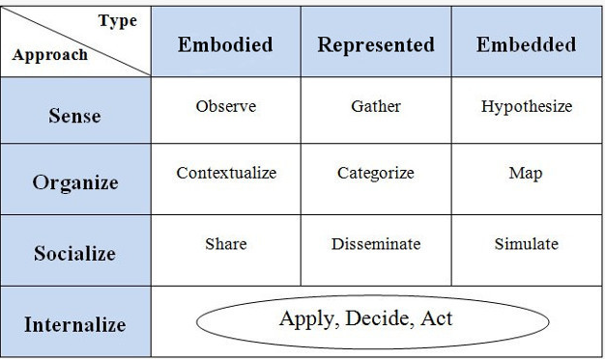
Figure 2:KM Matrix
(Source: Abazov et al. 2016)
- The Knowledge Management Process Model: This model focuses on the different initiatives of the management to improve production of an organization. TESCO PLC have to focus on the involvement of more employees in their business and using new technologies like digital marketing and cloud computing helps to improve the production in their business. Sharing of knowledge among the employees of TESCO helps to plan new strategies for increasing customer base in the market (Handfield et al. 2015).
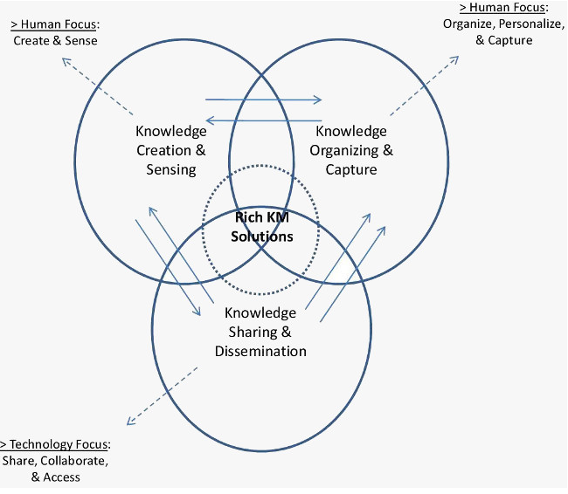
Figure 3: Knowledge Management Process Model
(Source: Handfield et al. 2015)
Analysis
The KM Process Framework, the KM Matrixand the Knowledge Management Process Model can be implied to understand the usage of new technologies like digital marketing and cloud computing which helps to attract more customers in TESCO. Proper strategies of TESCO and sharing of knowledge among different hierarchies in this organization helps to improve the communication skills and finding new ways to improve customer base in the market of Tesco.

d. Evaluating actual and different potential for knowledge aspects
The actual, as well as potential knowledge assets are including different types of data, innovative ideas that are created by the management of the organisation and the learning that are offered to the employees who are working within the organisation. These assets are also including cognitive as well as technical skills and the working capabilities of the employees. The knowledge of the organisation TESCO PLC is including the following:
Intellectual property rights: As per the view of de Beer et al. (2017), the properties provide the leaders of the organisation TESCO with incentives to create new innovative products and services. These services are important for the organisation as they are helping them in increasing the market share as well as make more profits. This also provides an opportunity for the business to grow within the international market. The protections to the intellectual properties are critically fostering innovations protection to the properties are helping the organisation to protect different types of ideas, business as well as protecting the business.
Technologies: As per the view of Hauge (2018), innovative technologies are important for the organisation TESCO as they are helping the employee counting of the stocks easily. New technologies are allowing all the products to get automatically counted as well as removing them while leaving off the store or after the purchase. TESCO PLC has been improving the offline as well as online shopping for the customers in order to attract the attention of more customers. These technologies have been helping the organisation in producing products that are satisfying the needs of the customers.
Industry performances drivers: According to Treem (2016), the performance drivers are important for the organisation TESCO PLC as they are helping in the making of effective decisions without any guidance or planning of a strategy or getting feedback from the higher authorities. These performance drivers are considered the leading factors that are having a positive effect on the employee performance of the organisation. With the help of the performance drivers, the organisation is successful in getting feedback about the effectiveness of all the strategies that are created within the organisation. These are providing an opportunity for the organisation to develop new strategies.

Understanding of important knowledge management processes

a. Explaining the need for creating, storing, applying and integrating knowledge
Creation of knowledge
It is important to create knowledge within the organisation TESCO as they are helping in increasing efficiency as well as the productivity of the employees who are working within the organisation. It is very essential for the company to maintain all the knowledge efficiently as they are helping the employees in sharing, accessing as well as updating of the business information. As per the view of Nonaka and Toyama (2015), the creation of knowledge is helping the organisation by promoting discipline for the employees. The knowledge management is helping the organisation in promoting an integrated approach that is including of identification of the data, capturing of the data and evaluating of the data. This also promotes the retrieving of the data as well as sharing of all the information assets of the organisation. The creation of knowledge is helping the organisation in solving different types of problems that are arising within the organisation as well as they are helping them by providing them with different benefits. The benefits are including improving the decision-making process as well as increasing productivity.
Storing of knowledge
Storing of the information is important within the organisation TESCO as they are helping them in retrieving of all the old data. According to the view of Argote and Guo (2016), storing of the data is important as they are securing the data from any kind of unwanted guest. A digital storage data within the organisation TESCO are helping the employees, the management as well as the leaders to access all the information in different ways. These are also making easier for them while searching of the information in their organizational database. It is important for the organisation to store the data in their online websites that are helping them in reducing the burden on the hard disk which is eventually saving the space on the disk.
Applying the knowledge
Applying the stored knowledge is important at the time of creating different business strategies (Donate and de Pablo, 2015). They are helping the organisation in targeting their new market as well as targeting new customers. They are helping the organisation in creating innovating marketing plans. Applying the knowledge within the new business plan are increasing productivity as well as the efficiency of the organisation. The knowledge is helping the organisation in learning the needs and requirements of the customers. This knowledge is helpful in shaping all the business activities that are going on within the organisation. Applying different knowledge about the market in the strategies within the business plan is helping the employee in developing the skill in creating the new plan.
Integrating knowledge
The organisation is integrating knowledge from different types of sources by exploring the information, identification of the knowledge, organisation of all the data as well as assessing experiences in order to develop the ability to solve various types of conflicts that are arising in the organisation. As per the views of Pan et al. (2015), knowledge is important for the organisation as it is helping the employees of the organisation in creating different new strategies that are important in surviving within the competitive market. The competition organisations are helping TESCO in providing information about the recent trends that is going on within the market. They are also helping the organisation providing the details of the needs and requirements of the customers. The organisation TESCO is collecting information about the market from different sources and creating a new business plan. The leaders of the organisation are collecting feedback from the employees, the management as well as the customers in order to build an effective strategy that is helping them in achieving their organizational goals and objectives. This has been motivating the employees in creating more innovative ideas as well as building effective communication within the employees who are working within the organisation. This enables the employees in effective growth within the organisation as well as helping the organisation to grow within the market.

b. Considering importance of Intellectual property rights
Intellectual property rights are those rights which are provided to the employees for using their own creative minds in any organization. Importance of this property rights in TESCO helps to improve economic growth of their business and using of new technologies to improve the target audience in TESCO market. Intellectual property rights motivate the employees of TESCO to perform better in their performance because management of TESCO have to reward bonus for using their own creative minds for the beneficial of TESCO. As per Davoudi et al. (2018), intellectual property rights helps the employees of TESCO to focus on clear goals and achieve the target set by TESCO.

Framework for establishing a knowledge management culture

a. Explaining the contribution in the assets of knowledge on an organization
Knowledge assets are useful for any business to manage different inventions effectively and looking for effective use of technologies in their company. According to Mudambi and Navarra (2015), knowledge assets focus on the specific goals and objectives, which are set by any business. There are few assets of knowledge, which are used in TESCO. These can be mentioned as follows:
- Patents
- Copyrights
- Intellectual Proprietary Rights
Analysis:
Role of patents is important in TESCO because it helps to protect specific processes regarding the design of products and to meet specific requirements as per the needs of the customers. Efficient protection in the patents encourages TESCO to increase their capital. Advantages of patents in TESCO provide right to stop other competitors of TESCO like ASDA and Sainsbury’s from copying without TESCO”s permission. Role of copyrights in TESCO is important because it helps to protect the original works which are created by marketers to increase revenue in their business. Copyrights helps to restrict the use of original designs and products which are made by TESCO, as a result competitors of TESCO like ASDA and Sainsbury’s cannot produce their products in the market. Role of Intellectual Proprietary Rights in TESCO helps to maintain their revenue for a longer period of time. This helps TESCO to increase the value of the stockholder. Intellectual proprietary rights helps TESCO to protect the invention of new technologies like advanced M-commerce and increases the competition in the market along with ASDA and Sainsbury’s. Best way to protect invention in new technologies is to file patents for the new invention in TESCO. Different strategies have to be implemented by TESCO for improving economic condition of their business.

Knowledge requirements

b. Evaluating the different requirements of knowledge in an organisation
Knowledge in a business of TESCO is very important for marketers to achieve more target customers in their business. According to Monios (2015), to improve the business knowledge in TESCO, retailers have to look for the needs of customers and use of specific skills and experience of employees for increasing the value of the products in the global market. Different strategic requirements in the knowledge management can be mentioned as follows:
- Reduced cost and risk
- Improving Productivity
- Faster development for different technical approaches
- Reducing cost of employee training
- Faster problem solving among team members
- Improving new plans for the strategy
Analysis
Basic requirements for the process of knowledge in TESCO consistof new development for technical processes in TESCO which includes usage of data analytics to focus on the needs of the customers. Implementationof digital technology and online shopping helps TESCO to attract more number of customers in their business. Looking for new plans in the strategy helps TESCO to gain more competition in the market which includes the participation of other competitors like ASDA and Sainsbury’s. Spending less money on the employee’s training and providing quality training to the employees of TESCO helps to increase efficiency in the global market. Collaboration among the employees in different teams of TESCO helps to solve complex problems regarding the design of new products and increase communication skills among team members. This helps team members of TESCO to share their own knowledge and implement that knowledge to increase growth of this retail sector. It has been found that approximately 43.05% of sale of groceries is done online and 25.04% of sale of groceries is done offline (tescoplc.com, 2019). Ability to adapt with new environment of TESCO can be applied in TESCO to increase workforce in their business. Installing CCTV cameras inside the store of TESCO can help their business for maintaining the customer’s security inside the mall. Providing discounts online and offers in the promotions help TESCO to retain their old customers in their business for a longer period of time. In future, TESCO is planning to implement smart phone technology to provide easy access for shopping to their customers.

c. Evaluating the organisation’s framework to enable the sharing of knowledge
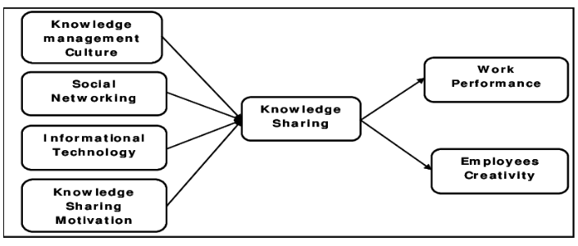
Figure 4: Simplified receiver -based model
(Source: ANIEBO, 2017)
Using of framework to explain about the sharing of knowledge in an organization is helpful to understand about different resources used in the business and influence of technology on retail sector. Proper knowledge of the work culture in TESCO helps the employees to stay in their company for a longer period of time. Positive work culture in the environment of
TESCO helps employees to understand their value and feel respect for different contribution in the work environment. According to ANIEBO (2017) use of social networking sites like Facebook helps to attract more number of customers in their business during a short span of time. Usage of digital marketing and data analytics in the business of TESCO helps marketers to know about the behaviour of target customers in their business. It is important for TESCO to maintain loyalty in their business so that old customers are retained in their organization and at the same time, new customers are attracted towards their business. Sharing knowledge among the team members of TESCO helps to increase confidence within themselves and create new technologies for the betterment of TESCO. Sharing of knowledge helps the business of TESCO to improve performance of their own work and motivation to create new technologies in their business for the efficiency in their organization. Use of Information technology in TESCO helps their business to manage different kinds of processes in their business. Implementation of different kinds of hardware and software devices in TESCO is important because of different range of processes in their business. Main focus of TESCO is to create value for their customers to maintain loyalty of their customers for a longer period of time. TESCO provides a wide variety of household items and clothing items for all the age group of people. TESCO makes use of computer networking which helps to share the information among the large group of hierarchies in their business. As a result, it increases the profit of TESCO for longer periods of time.

d. Recommendations to improve current framework
- It can be recommended from this simplified receiver based model that sharing of knowledge across the hierarchies of TESCO can help to increase work performance of each employee and motivates employees to perform better in the workplace. With the help of simplified receiver based model, senior leaders of TESCO needs to promote knowledge sharing culture in the organization.
- It can be recommended with the help of simplified receiver based model, top managers of TESCO plays an important role to manage all the responsibilities of the other employees. Setting deadlines for the specific projects helps employees of TESCO to focus on the clear goals of the organization and needs to work effectively in a team to solve complex problems in the workplace.
- It can be recommended with the help of simplified receiver based model, using social networking sites and digital technologies in TESCO needs to be implemented in their business to increase efficiency in the workplace.
Conclusion
It can be concluded that data, information and knowledge is important for the organisation TESCO PLC to understand about the important factors which are affecting their business. Good quality of data and information is important to implement knowledge in the specific topic in the workplace of TESCO. Digital technology and online shopping are helping TESCO to attract more number of customers in their business. Digital marketing as well as cloud computing are helping to attract more customers in TESCO. Motivating the employees of TESCO and sharing of knowledge across the team members helps to create new ideas and implementing those ideas in their business. Different techniques as well as business planning with the team members and implementing newstrategy increase revenue of the retail sector. Use of social networking sites such as Facebook helps in order to attract large number of customers in their business within a short span of time.
Proper work culture of the employees of TESCO helps to create positive impact in the mind of employees and stay in their organization for a longer period of time. Knowledge assets of TESCO like Patents and copyrights help the company to restrict copying of specific design and products from the competitors like ASDA and Sainsbury's. The organisation is creating different types of strategies that are helping the organisation to grow within the international market. These business plans are helping in attracting the attention of more customers as well as it enables the organization in creating more profits. Proper knowledge in the work culture in TESCO helps the employees to stay in their company for a longer period of time. Different models like the KM Process Network and KM matrix help to analyze about the strategies in business of TESCO and using new technologies to know about the future of their business.
Knowledge is used to understand subject in proper way which can be gathered from the experience of certain people. Intellectual property rights of TESCO help their business to create rewards for the efficient employees and providing bonus to those employees to focus on their aim with a clear mind. Providing quality training to the employees of TESCO with low cost in the training helps their business to improve the economic condition of their business. It is important for managers of TESCO to look after the different strategies and motivating their employees to achieve higher position within the organization.

References
Abazov, V.M., Abbott, B., Acharya, B.S., Adams, M., Adams, T., Agnew, J.P., Alexeev, G.D., Alkhazov, G., Alton, A., Askew, A. and Atkins, S., (2016). Measurement of the top quark mass using the matrix element technique in dilepton final states. Physical Review D, 94(3), p.032004.
ANIEBO, C.S., (2017). COMMUNICATION MODELS IN THE TEACHING PROCESS. International Journal of Communication: An Interdisciplinary Journal of Communication Studies, 9(1).
Argote, L. and Guo, J.M., (2016). Routines and transactive memory systems: Creating, coordinating, retaining, and transferring knowledge in organizations. Research in Organizational Behavior, 36, pp.65-84.
Bamel, U.K. and Bamel, N., (2018). Organizational resources, KM process capability and strategic flexibility: a dynamic resource-capability perspective. Journal of Knowledge Management, 22(7), pp.1555-1572.
Collet, C., Hine, D. and Du Plessis, K., (2015). Employability skills: perspectives from a knowledge-intensive industry. Education+ Training, 57(5), pp.532-559.
Davoudi, S.M.M., Fartash, K., Venera, G.Z., Asiya, M.B., Rashad, A.K., Anna, V.B. and Zhanna, M.S., (2018). Testing the Mediating Role of Open Innovation on the Relationship between Intellectual Property Rights and Organizational Performance: A Case of Science and Technology Park. EURASIA Journal of Mathematics Science and Technology Education, 14(4), pp.1359-1369.
de Beer, J., McCarthy, I.P., Soliman, A. and Treen, E., (2017). Click here to agree: Managing intellectual property when crowdsourcing solutions. Business Horizons, 60(2), pp.207-217.
digital.hbs.edu, (2016). Tesco: A digital transformation. Available at: https://digital.hbs.edu/platform-rctom/submission/tesco-a-digital-transformation/[Accessed on 04/07/2019]
Donate, M.J. and de Pablo, J.D.S., (2015). The role of knowledge-oriented leadership in knowledge management practices and innovation. Journal of Business Research, 68(2), pp.360-370.
Handfield, R.B., Cousins, P.D., Lawson, B. and Petersen, K.J., (2015). How can supply management really improve performance? A knowledge‐based model of alignment capabilities. Journal of Supply Chain Management, 51(3), pp.3-17.
Hauge, A.M., (2018). Situated valuations: Affordances of management technologies in organizations. Scandinavian Journal of Management, 34(3), pp.245-255.
Lee, J.C., Shiue, Y.C. and Chen, C.Y., (2016). Examining the impacts of organizational culture and top management support of knowledge sharing on the success of software process improvement. Computers in Human Behavior, 54, pp.462-474.
Monios, J., (2015). Integrating intermodal transport with logistics: a case study of the UK retail sector. Transportation Planning and Technology, 38(3), pp.347-374.
Mudambi, R. and Navarra, P., (2015). Is knowledge power? Knowledge flows, subsidiary power and rent-seeking within MNCs. In The Eclectic Paradigm (pp. 157-191). Palgrave Macmillan, London.
Nonaka, I. and Toyama, R., (2015). The knowledge-creating theory revisited: knowledge creation as a synthesizing process. In The essentials of knowledge management 30(1),(pp. 95-110).
Pan, Y., Xu, Y.C., Wang, X., Zhang, C., Ling, H. and Lin, J., (2015). Integrating social networking support for dyadic knowledge exchange: a study in a virtual community of practice. Information & Management, 52(1), pp.61-70.
Ritter, B.A., Small, E.E., Mortimer, J.W. and Doll, J.L., (2018). Designing management curriculum for workplace readiness: Developing students’ soft skills. Journal of Management Education, 42(1), pp.80-103.
statista.com , (2019). Tesco PLC - Statistics and Facts. Available at: https://www.statista.com/topics/3807/tesco-plc/[Accessed on 05/07/2019]
statista.com, (2018). Number of Tesco stores in the United Kingdom (UK) from financial year 2011 to 2018*. Available at: https://www.statista.com/statistics/490947/tesco-group-stores-united-kingdom-uk/[Accessed on 04/07/2019]
tescoplc.com, (2019). Our businesses.Available at: https://www.tescoplc.com/about-us/our-businesses/[Accessed on 05/07/2019]
Tong, C., Tak, W.I.W. and Wong, A., (2015). The impact of knowledge sharing on the relationship between organizational culture and job satisfaction: The perception of information communication and technology (ICT) practitioners in Hong Kong. International Journal of Human Resource Studies, 5(1), p.19.
Travis, T.A., (2017). From the classroom to the boardroom: The impact of information literacy instruction on workplace research skills. Education Libraries, 34(2), pp.19-31.
Treem, J.W., (2016). How organizations communicate expertise without experts: Practices and performances of knowledge-intensive firms. Management Communication Quarterly, 30(4), pp.503-531.
Vasyutin, I., Zerihun, L., Ivan, C. and Atala, A., (2019). Bladder organoids and spheroids: potential tools for normal and diseased tissue modelling. Anticancer research, 39(3), pp.1105-1118.

