Assessment-1
Blogging to communicate

NUME: Denisa Roxana Stoica
ID STUDENT: 2211503
MODULE: Marketing Fundamentals
CODE: LCBB4004
LECTURER: Tushara Balendra
DATE OF SUBMISION: 25-11-2022

Blog posts on Apple Inc.
Background of Apple Inc.
This business is a designer and manufacturer of personal computers, software, peripherals, networking solutions, and music players. It is one of the most well-known and successful businesses in the world and for this, this company has been providing robust technology goods and exceptional software services.
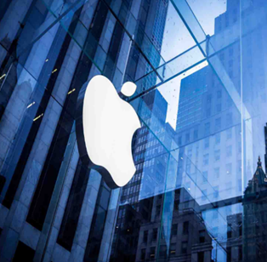
The headquarter of Apple Inc. is in California founded by later Steve Jobs. It was launched as an ‘Apple-1’ computer in 1976. After the launch, this business has become exponentially in terms of goods and services. Now, this has become the most reputed and successful business in terms of manufacturing premium products. Such products are quite popular across the globe and the product list includes Mac computers, iPods, iPads, and iPhones.
It is identified that as of September 2007, the company can operate 194 stores in the USA and more in the UK, Japan, Canada, and so many other countries. For a variety of reasons, ranging from its philosophy of comprehensive aesthetic design to its advertising campaigns. This business has also engendered and cultivated a customer base that is unusually devoted to the company and its brand.
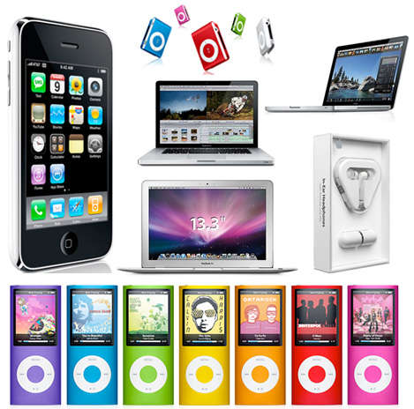

Source: (Nagamia, 2015)

Segmentation, targeting, and position of Apple
Apple is such a global brand that is not available for all because the company has specific market segmentation, targeted customers, and particular positioning in the market (Blythe, 2014). Based on the market conditions, the company’s internal capabilities, and strengths, Apple inc. has specified these issues before launching the products in the market.
It focuses on-
- Market segmentation: Geographic, demographic, behavioral, and psychographic.
- Targeting: Primary customers and secondary customers.
- Positioning: High-quality global brand and premium branding in the market.

Market segmentation of Apple Inc
It is considered the procedure of dividing a broad consumer or business market, normally consisting of existing and potential customers into sub-groups of consumers, envisaging shared traits (Blythe, 2014). Apple Inc. has segmented its entire market into some major categories which are geographic, demographic, behavioral, and psychographic segmentation.

Geographic market segmentation
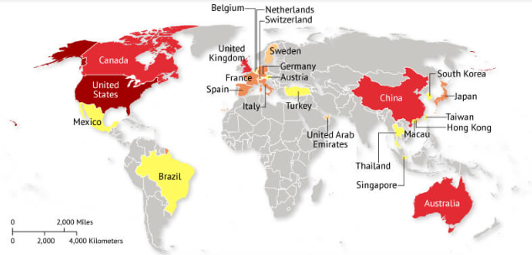
This is a multinational business that is founded in the USA but now indulges in serving the whole world through the presentation of its premium products. In the UK, it is quite popular not only among the British but also among immigrants. In this particular geographic market, Apple has a lucrative marketing positioning.


Apple stores in Regent Street, UK

That is why Apple always prioritizes urban areas as part of the geographic market segmentation so that it can have the targeted customers for itself who can easily get attracted and afford this kind of product (Greenspan, 2015). Still, it has some other relative market segmentation.

Demographic market segmentation
Demographic issues include age, gender, life cycle, income, and occupation of the customers (Blythe, 2014). Apple Inc. has segmented both men and women, especially those whose ages range between 18 to 45. But these ages vary considering the cases and conditions of the products. iPhone and iPad are for those whose ages range from 20 to 45 and iTunes store, Apple pay, and iCloud are for 18 to 30 but iOS, iLife Apple Watch, and Apple TV are for 20 to 35 ages people. People who are having a higher income, bachelor, newly married couples, professionals, managers, students, executives, etc.

Behavioral segmentation
Hardcore loyal and switchers are envisaged by Apple Inc who have also a sense of achievement, belongingness, self-expression, speed of service, advanced and unique features, and capabilities (Meyer, 2019). The speed of service, recreation, and efficiency are the major behavioral segmentation of Apple Inc.

Targeting of Apple Inc.
It is the process of having customers and this is an initial process before launching the products in the market. The target market is found in two categories and they are primary customers targets and secondary customers.
- Primary customer targets are middle-upper income professionals to support them coordinate with colleagues, friends, and family.
- Secondary customer targets are high school, college, and graduate and postgraduate students who need one portable multination device
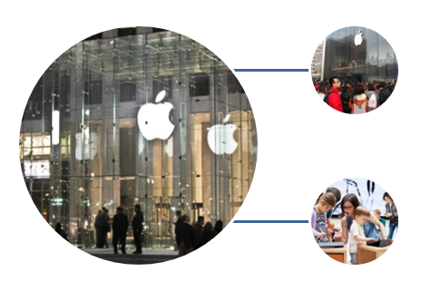

Market positioning of Apple Inc.
A strategic positioning map is used by businesses, like Apple Inc. that helps them how the competitive brands position is improving (Clow & Baack, 2022). Because of several factors of Apple Inc. that are reaching out to new segments through the diversification strategy, Apple Inc. has placed itself at the top of its competitors.
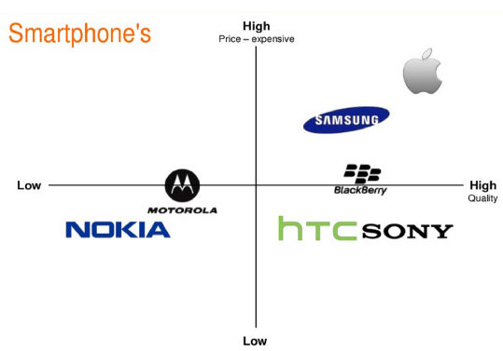
It is found that Apple is at the top because what makes this essential is that customers will more than ready to buy Apple products at a higher price (Greenspan, 2015). The reason is that Apple Inc. has established an interaction that helps the business to get interconnected and emotionally attached to the minds of the customers.
It has a high-value and high-price brand worth the money to be spent on. The customers of Apple Inc. will deem it a luxury brand due to its expensive prices (Foskett, 2015). The high positioning exhibits the perception of the users and the value of quality they associate the brand with compared to the business competitors.

Marketing Mix of Apple Inc.
Marketing mixes are the major strategies of businesses that need to be specific for having more customers for themselves. According to marketing concepts and theories, four major mixes are products and services, price, promotion, and place.
Each mix is interrelated with each other. So, the business needs to decide carefully. Like, Products’ quality can help determine the price.
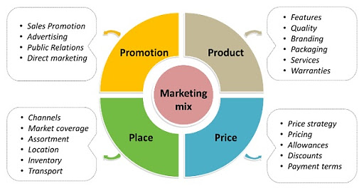
These mixes need to be effective in terms of fulfilling the demands of the customers. For obtaining success, these mixes need to be effective.
Figure 1: Marketing mix
Source:
Apple Inc. also specified these issues before launching the products and services within the business. Its products are electronic devices that have standard pricing strategies and products are distributed globally. Besides, it requires lots of promotional activities.

Products of Apple Inc.
This multinational company has a range of quality and premium products that make it unique in the market. Its products include portable computers, servers, accessories, Wi-Fi-based stations, developers, iPod, iPhone, iTunes, and peripheral products (Greenspan, 2015).

It has an iOS operating system that cannot be found on other
electronic devices. As a result, people have a desire for using this
kind of device for having an experience of using a unique device
that has a distinct and unique operating system. Besides, it has also
Apple App store from which the users need to install the relative
software applications that can be run on android phones only.
Apple Inc. has built high-quality in its products that require several unique android functions that have made the products’ quality and effectiveness unique and attractive to the targeted customers. These products are available in the market which represents the business’ diversification strategy. It indicates the representation of a new product in the new market (Nagamia, 2015). Steve Jobs brought the concept of Apple Inc. into the market as high premium quality products that are not available to the market competitors, like Samsung, Xiaomi, etc. Its products are also developed considering the concept of a product development-intensive growth strategy.

Source: (Armstrong et al., 2017)

Price of Apple Inc.
The choice of pricing strategies is dependent on the product’s quality and the efficiencies of the services. Pricing decision is the strategy that requires setting a price for a product or service (Meyer, 2019). Like others, Apple Inc. needs to envisage several costs for producing high-quality premium products for the targeted customers. Based on several costs and the percentage of profit, ultimate prices are determined. Its relative costs are:
- Fixed: There are some costs in the business that do not change. Apple Inc. needs to purchase equipment, machinery, and so many relative costs that are needed for long-term purposes.
- Variable: These costs rise or lower depending on the production level and these can be calculated in margin per item.
- Total: The combination of both, variable and fixed costs.

Premium pricing of Apple Inc.
Apple Inc. follows premium pricing strategies that are a premium brand approach that is on high pricing strategy. Premium pricing is such sort of strategy that is specified considering the high quality and conditions of the products (Greenspan, 2015).
Several products indulge in offering a small number of products to target a particular demographic of s customers. This kind of pricing helps customer acquisition costs be low and
appeal to price-sensitive customers but relies on a small margin. As the products have limited edition that requires a steady stream of new customers.

As the premium brand approach is on a high-price strategy, it
offers a small number of products to target specific customers.
By utilizing this kind of strategy, Apple Inc. can maintain the
High-end image of the business and its products (Foskett, 2015).
Apple products attract a smaller market share and this market is
composed of some targeted customers from the middle and upper
classes. It maintains profitability as the prices of Apple can help entail higher profit margins.

Place of Apple Inc.
As has already been said, this business is a multinational business with several stores worldwide. It has a headquarter that is located in the USA. It has placed its business in three major places and they are online stores, retail and third-party stores, and exclusive stores (Clow & Baack, 2022).

Online stores of Apple Inc.
These kinds of online stores are found on the particular websites of the business that indulges in distributing via the online stores. Besides, social media efforts are also essential nowadays.
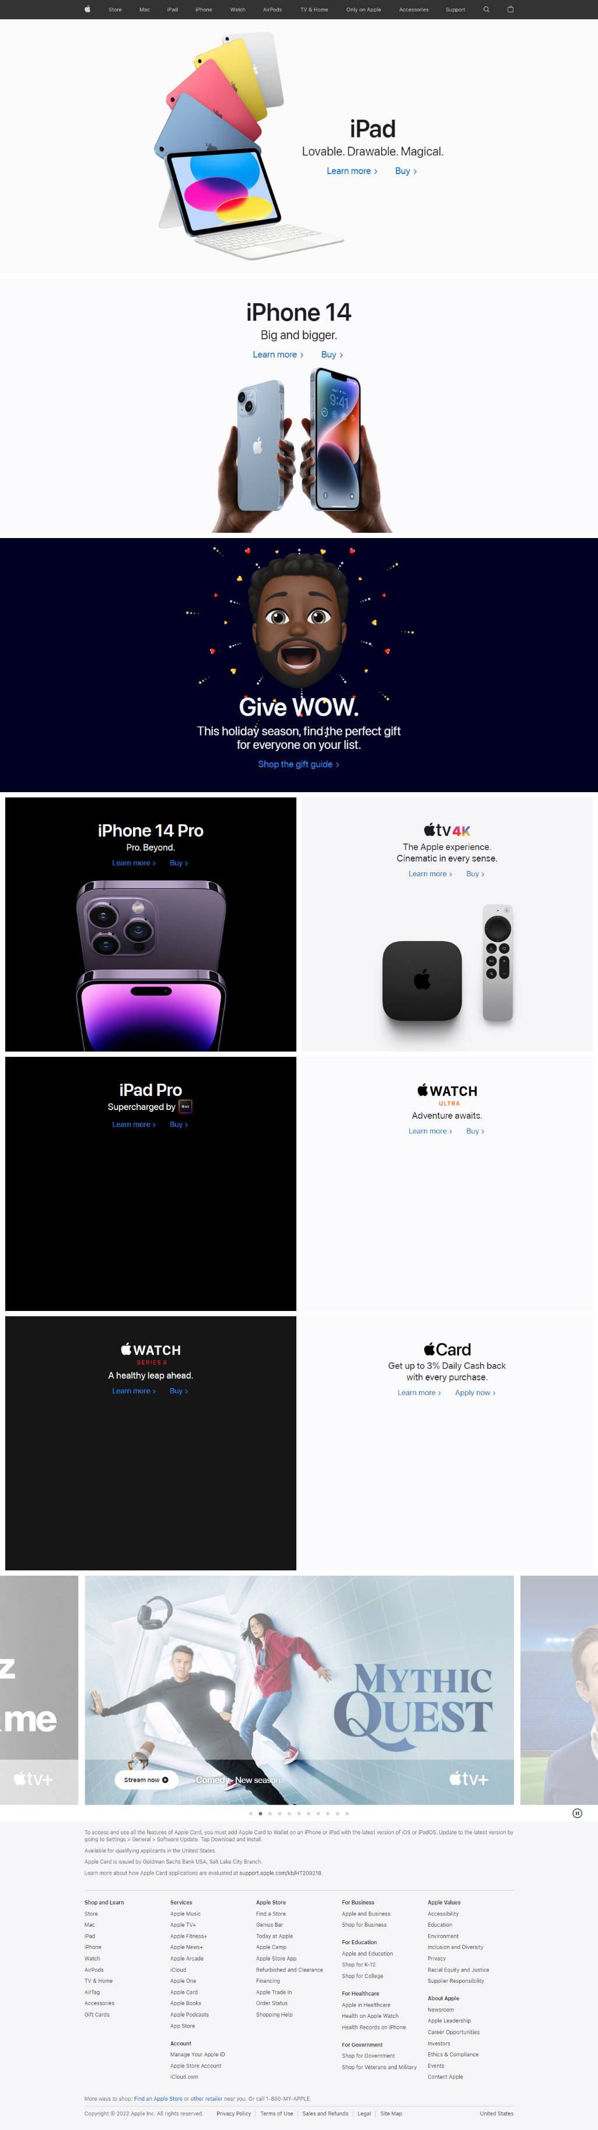
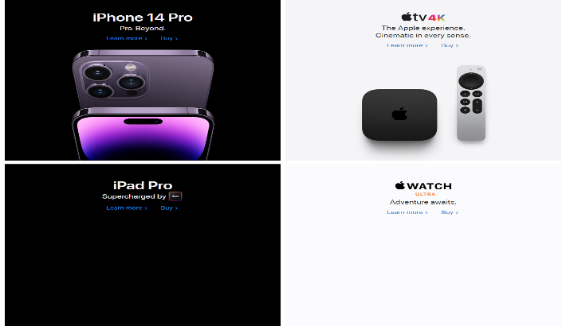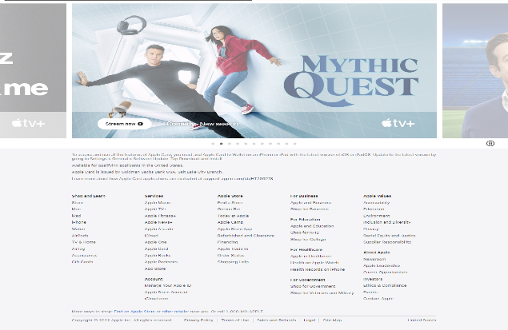
Source: (Home Apple Inc. 2022)

Retail and third-party stores
They have direct retail stores and the customers visit the stores for purchasing the core products directly from the retailers (Foskett, 2015). Besides, the third-parties are also found in many countries that indulge in selling the products of Apple Inc.

Exclusive stores
Apple has exclusive stores catering to divergent categories of products. For example, fifth avenue, New York, and Regent Street, UK.
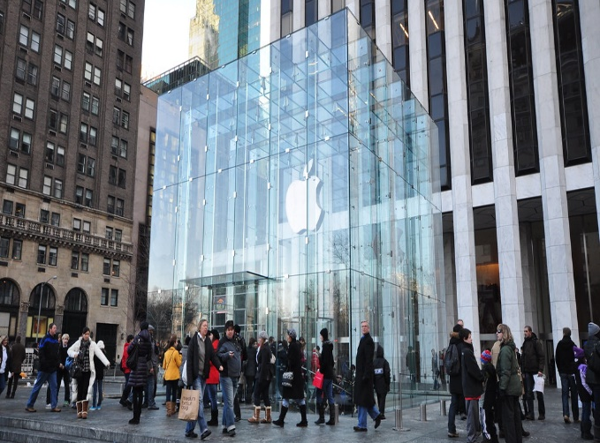

Promotion of Apple Inc.
Promotion is a marketing mix that helps the business reach the message of the products to the ultimate or targeted customers at the end of the day. In terms of promoting its products, it emphasized premium image and quality of the products and for this, the marketing communications mix supports the business position in reaching more targeted purchasers (Clow & Baack, 2022).
Advertising of Apple Inc.
This kind of promotional tool insists on the business utilizing billboards, magazines, newspapers, etc. In many countries, Apple Inc. uses billboards for promoting its products.


Celebrity endorsement of Apple Inc.
For building brand equity, different business envisages the concept of celebrity endorsement. At different times, businesses, especially well-known businesses, are seen in endorsing celebrities for promoting the products (Armstrong et al., 2017). As Apple Inc. has high worth value, it indulges in endorsing the most popular celebrities.

References
Armstrong, G. et al. (2017) Principles of Marketing. 7th . Harlow: Pearson Education Limited.
Baines , P.L., Fill, C. and Page, K. (2014) Marketing. 2nd edn. Oxford.
Blythe, J. (2014) Principles & Practice of Marketing. 3rd edn. Los Angeles: Sage.
Clow, K.E. and Baack, D. (2022) Integrated Advertising, Promotion, and Marketing Communications. 6th edn. Harlow, England: Pearson.
Foskett, J. (2015) Pricing strategies - apple inc.., prezi.com. Available at: https://prezi.com/ixod1br_ym2h/pricing-strategies-apple-inc/ (Accessed: November 14, 2022).
Greenspan, R. (2015) Apple Inc’s Marketing Mix (4P’s), 10(1), pp. 2–9. Available at: https://doi.org/https://www.academia.edu/24430395/Apple_marketing_mix.
Home Apple Inc. (2022) Apple. Apple Inc. Available at: https://www.apple.com/sitemap/ (Accessed: November 14, 2022).
Jobber, D. and Ellis-Chadwick, F. (2016) Principles and practice of Marketing / David Jobber and Fiona Ellis-Chadwick. 8th edn. -Hill Higher Education: McGraw.
Meyer, P. (2019) Apple Inc.'s Generic Strategy & Intensive Growth Strategies, Panmore Institute. Available at: https://panmore.com/apple-inc-generic-strategy-intensive-growth-strategies (Accessed: November 14, 2022).
Nagamia, N.K. (2015) “Apple Inc-A Marketing Analysis Case Study,” MacEwan University Student eJournal, 2(1). Available at: https://doi.org/10.31542/j.muse.216.
O’Regan, G. (2015) “Apple Inc..,” Pillars of Computing, pp. 25–30. Available at: https://doi.org/10.1007/978-3-319-21464-1_5.

