Learning and Collaboration for Global Citizenship (4003)
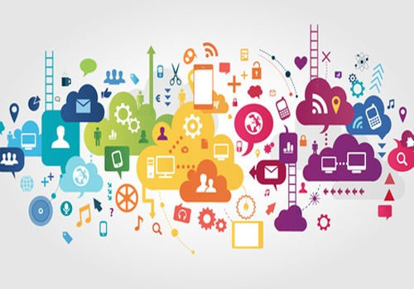
Flexibility And Digital Learning
Claire Davies
Tutor: Alex Bell

Introduction
How is digital technology used in learning? Has learning in the 21st century become more digital? How big a part does social media have on our digital learning? I am going to take a look at how digital learning is advancing and if it is the way forward with-in education, work and in everyday life. Not only will I be looking at my own use of digital learning, but also the use of digital learning as a whole throughout the world and how much we have all become very reliant on the use of digital technology and social media when it comes to learning.
How is digital technology used in learning?
Digital technology is massively used in education these days, not only is it the use of a computer but also the tools and resources that accompany using a computer or digital device. I feel that technology is definitely changing how we are learning with in education, digital technology is changing and improving all the time and making it easier to learn. There are many ways in which digital technology can be used through education to help us learn, some of these way are:
Moodle: Moodle is a basic structure that has been organised around educational courses. These are pages or areas within the Moodle application where tutors can upload their learning resources and activities for a student to be able to access. I have found that has helped me with my digital learning as it is an easy application to grasp and it holds all the information that I need for my course.
“Moodle is web-based and so can be accessed from anywhere in the world. With a default mobile-compatible interface and cross-browser compatibility, content on the Moodle platform is easily accessible and consistent across different web browsers and devices” (Moodle, 2018).
Online libraries: With the mass growth of the internet, e-learners have more access to a vast range of information sources available at the click of a mouse i.e.
library resources, government information, news sites, advertising, plus many more forms of resources. Librarians have traditionally selected and organized resources with great care. Librarians have the opportunity to provide e-learners with direction and to rescue them from information overload. A digital library can link e-learners to library catalogues, licensed journal databases, electronic book collections, selected internet resources, electronic course reserves, and tutorials, and to forums for communication and interaction with others. The digital library permits e-learners to access library and networked resources and services anytime and anywhere that an Internet connection and computing equipment are available. (Sharifabadi, 2006).
I have found that being able to access the digital/online library has helped me to be able to find information I needed to complete my assignment. Until this academic year I had never used the online library and I was a bit dubious about using it for the first time, but I found that it was far easier and convenient for me to do my research.
Has learning in the 21st century become more digital?
The 21st century has definitely become more digital!
Social media has seen a rise over the last decade, not only for the social side of it but it is also used more and more to help with learning within education.
Connective learning is dependent on learning networks. This makes learning a social enterprise. Connectivism is a learning theory that is specific to the digital age. In the 21st century, we must create a new understanding of learning due to of the fast innovation of the social digital world. Learning today occurs through connections within various networks. So this gives you mass sources available for learning in the 21st century. (Brady, 2017).
Digital learning has increased over the years due to better internet access, and the ability to research for anything you want at a click of a button. The world Wide Web gives you the ability gain information from various sources from all over the world. When I was first in education 25+ years ago, we had the use of computers, but we didn’t have access to the internet like there is today. I do feel that digital learning is the way forward, but I also feel that maybe some of the mature students going back into education may find it difficult to grasp as it’s a new and different concept to learning to what they were used to.
“The future isn’t solely digital, no matter how it may seem sometimes. As a publisher, we create both digital and print materials, and we don’t plan to change that anytime soon. We live in an inspiring time, when both of these mediums have an important role to play. How much space each of those parts occupies is up to each individual district, school, and classroom.” (Levine, 2017).
I find this to be true, as much as digital technology plays a big part in learning, it isn’t the only way to learn. Print is equally as useful as is digital to our learning.
How does social media factor into our learning?
Benefits to using social media in educational learning is the ability to work independently and collaboratively with others in the same learning environment. I found that the 4 weeks digital learning we did, meant that I working on it independently but also collaboratively within the group forum. It also gives you the opportunity to expand time also known as asynchronous communication. Being able to expand time gives flexibility to digital learning. Social media can be very beneficial to learning as various tools can be used to share information and to communicate with other students. As part of our group, we have started a group chat via social media on Facebook messenger, this has enabled me to interact with fellow classmates and vice versa. This is an instance where expanding time is used, as everyone communicates at different times.
“Social media allows students and teachers to communicate synchronously as well as asynchronously. The teachers and students can use different social media tools within the class as well as outside the class to interact with one another”. (Abraham, 2017).
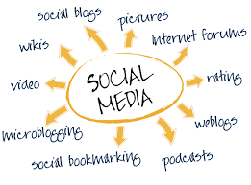

Another social media platform that I find myself using to help me with my learning is you tube, I use this to watch video tutorials which help me to understand and gain more information on the subjects I am learning about. I find this a great help as I can take down notes while watching the videos and also use them for referencing if I use them within my assignments. I find that Wikipedia is a good source of information, but being as it isn’t 100% trustworthy I wouldn’t use it to reference in my work but find it is a good starting point to source other information I may need.
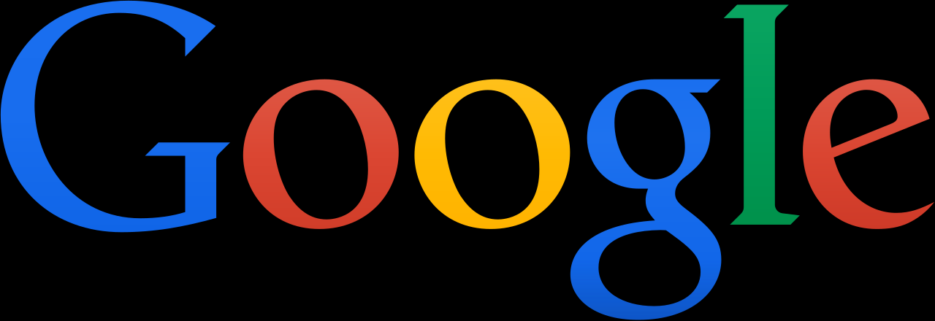
Google is a search engine I find very useful and have found myself using it on a daily basis, I have used it quite a bit since I started studying. I find it useful for searching for various information relating to the subjects I am studying. It is also good for finding pictures that I may need to use in my work.
(Google, 2013).
Netvibes is a social dashboard I used when doing our digital learning for 4 weeks, I created an account which allowed me to keep up to date with news, social media and my favourite websites such as Facebook, You Tube and Twitter as they are all stored in one place on the dashboard. Once I had created my Netvibes page I was able to share this in the forum that was created on Moodle for our group, this enabled other class member to be able to go and see what was on my dashboard. I didn’t find this very easy to set up or to use and will probably never use it outside of my education, but maybe in the future if I had a bit more time and understanding of it, there is a possibility I could use it again as it is a good way to store and share social media that I may need to refer back to at a later date as it is all stored in one place.
Social media is a great means to give everyone the ability to gain the information that is out there, this means giving everyone an equal opportunity to learn.
Personal Learning Environments
What is a Personal Learning Environment? A personal learning environment will differ from person to person, it can be a combination of many things: tools used, other people, services used. One of the tools many people use today is Social media. There are many tools and resources used in digital learning such as:
Google/Google Scholar, Online Library, Moodle, Twitter
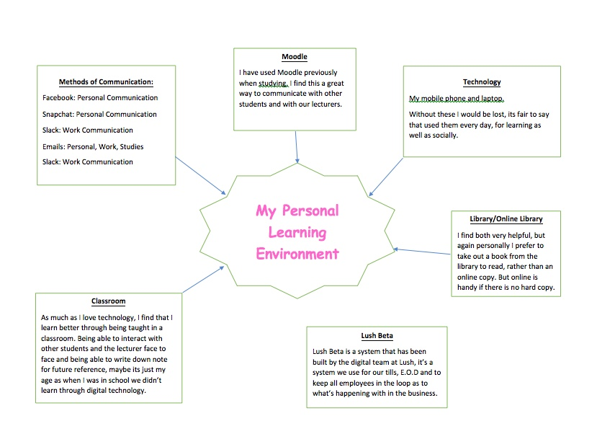

(Davies, 2019).
I found that these are many of the resources I use for learning, above is a diagram of my own PLE, this shows what digital technology I use and what I use them for:
Moodle: This is a great tool used by tutors to communicate with students, this gives us all the information we need for our course, we are able to access this wherever we are so it means that we are able to work outside of the classroom, so we are not restricted to only learning within a classroom environment.
Online library: Although I have only used this as a means to extend the time I have taken a book out for, it is also a great way to access books that you may not find in a library. Again being as you are able to access this from any technological device this doesn’t restrict you from acquiring the books, journals etc that you need if you aren’t able to get to a library and as this is an online service you have access to it at any time of the day or night.

“Students of UWTSD and Coleg Sir Gâr can access a wide range of resources from our online library, including e-books, e-journals, specialist databases, online newspapers and much more. We are also able to provide access to online resources for students at partner institutions.” (UWTSD, 2019).
Having all this technology and tools available to us has definitely made my own personal learning easier, at the start I was unsure about using so much digital technology but have come to realise that in this day and age it is the way forward. As scary as it was at the beginning, I feel I have found myself feeling more comfortable with digital learning.
Preparing to learn in the 21st Century
So what advice would I give to an undergraduate about to start studying in the 21st Century?
From my own personal experience I found that attending class has as much benefits as learning through digital means. Everyone learns in different ways, so the best advice I can give to a new student is for them to find what their Personal Learning Environment is, and to make the most of all the tools and resources that are available to them and to never be afraid to ask for help from tutors or fellow student. Everyone is in the same boat and as daunting as it may seem, there is always help out there.
Conclusion
Learning in the 21st Century has definitely become more digital and is advancing day by day. Digital learning has so much flexibility, the reason for this is because the internet holds so much information and it is available at the touch of a button. This allows people to learn from anywhere because of the many different portable devices available that can be used to help with learning. The benefits of digital technology is that the tools and resources are at hand for the use of everyone. As much as digital technology is used within a learning environment, there is still room for non-digital means of learning, like using books from a library. Social media is also used massively in digital learning, this giving students a means to communicate with fellow student. So it seems that digital learning could be the way forward in the learning process in the 21st Century.

Bibliography

Abraham, P. J. (2017). Promises of social media enabled learning in education.
Brady, G. (2017, March). Retrieved from https://medium.com/digital-learning/the-6-essential-elements-of-21st-century-learning-3cb89e5f6a33
Davies, C. (2019, March 5th). My PLE as a diagram. Retrieved from https://moodle.uwtsd.ac.uk/mod/forum/discuss.php?d=11027
Google. (2013). Retrieved from https://en.wikipedia.org/wiki/File:Logo_Google_2013_Official.svg
Levine, T. (2017, September 20th). eSchools News. Retrieved from https://www.eschoolnews.com/2017/09/20/learning-digital-print/
Moodle. (2018, December). Retrieved from https://docs.moodle.org/36/en/About_Moodle
Sharifabadi, S. R. (2006). Retrieved from https://www.researchgate.net/publication/220677207_How_digital_libraries_can_support_e-learning
UWTSD. (2019). Retrieved from https://www.uwtsd.ac.uk/library/online-library/

