Assignment on
Entrepreneurship
Module Code: M6X01926

Student Name: Nozmul Huda
Student ID: 1705289
Table of Contents
Introduction 3
About Dr Muhammad Yunus 3
About Grameen Bank 3
What is Microfinance? 4
Paradigms in Microfinance 5
Pros and Cons of Microfinance 5
Dr Muhammad Yunus’ Entrepreneurial Motivations 6
Conclusion 7
References 7

Introduction
Entrepreneurship is probably the hardest form of business where there is no guarantee for profit from the functions but the entrepreneur takes on all the financial risks associated with it. According to Merriam-Webster, an entrepreneur is the person who flinches a business from the scratch, taking on all the risks to meet a goal. Sometimes, that goal can be financial oriented. Also, the goal can be the benefit of human civilisation. Dr Muhammad Yunus is one of the most famous entrepreneurs in the world that led him to win a Nobel Peace Prize in 2006. In this assignment, we are going to describe the marvellous initiatives taken by the Peace Prize winner and see how his entrepreneurship has changed the life of many people.

About Dr Muhammad Yunus
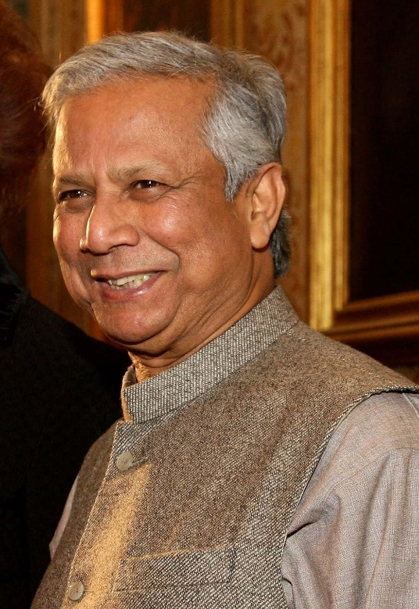
Dr Muhammad Yunus is altogether a social entrepreneur, an economist, a banker and a leader. He is the founder od ‘Grameen Bank’. With the establishment of this bank, he introduced the concept of Microcredit and Microfinance to the poor people who could not establish their businesses, firms, livelihood and so on because of not being eligible for old-style bank loans (Azim, 2019). Dr Muhammad Yunus identified the needs of these poor fated people and wanted to bring an initiative that will help them to stand up in life. He established the Grameen Bank where he gave loans and other financial facilities to the before mentioned peoples with the least bindings. Because of his contribution for the development of these people, he along with Grameen Banks were awarded with the Nobel Prize in Peace segment in the year of 2006. He was a leader for all the people he dreamed to lead and his practices were appreciated not only in Bangladesh but all over the globe (Yunus, 2007). Because providing loans to the poor people without having any kind of bindings and security was a tough idea for many. He took the initiative to help people stand from poverty.

About Grameen Bank
Grameen Bank is said to be the bank for the poor. It is microfinance-based organisation where small loans are provided to the people who cannot take the usual bank loans without any kind of security or bindings. It was established by Dr Muhammad Yunus from Bangladesh who later achieved Nobel Peace Prize Award for his brilliant feat for the development of the society. Currently the organisation has 2568 branches all over Bangladesh and the net income of the company around 75.73 Crore Taka (Around $9.00 million) as of late. The company has over 20,000 employees working for them. Most development of the bank was done between the years of 2003 to 2008. According to the bank website, Grameen Bank provided small and medium loans to almost 8.5 million people all over the country of Bangladesh and almost 95% of the borrowers are women (Azim, 2019). So, Grameen Bank is not only helping the people to overcome poverty, they are also contributing significantly for women empowerment in Bangladesh.

What is Microfinance?
Dr Muhammad Yunus and the Grameen Bank has changed the life of millions of people in Bangladesh because they brought the concept of Microfinancing to the poor people. Majority of the people in the country are living in poor condition. Because of the lack of money, they cannot arrange themselves any livelihood. The lack of money and other financial supports disable them to take any kind of financial facilities from the banks. Microfinance is such a service that helps the poor individuals and small businessmen to take small-scale loans. In order to take the loans, the do not have to provide any kind of mortgage. The facility of not having any mortgage has created a revolutionary change in the lifestyle of the people. Because of this unique facility, millions of facilities have got the opportunity to take micro loans to buy livestock, to grow crops, to start up a small-scale business and so on. The micro loan is more well known as micro-credit.
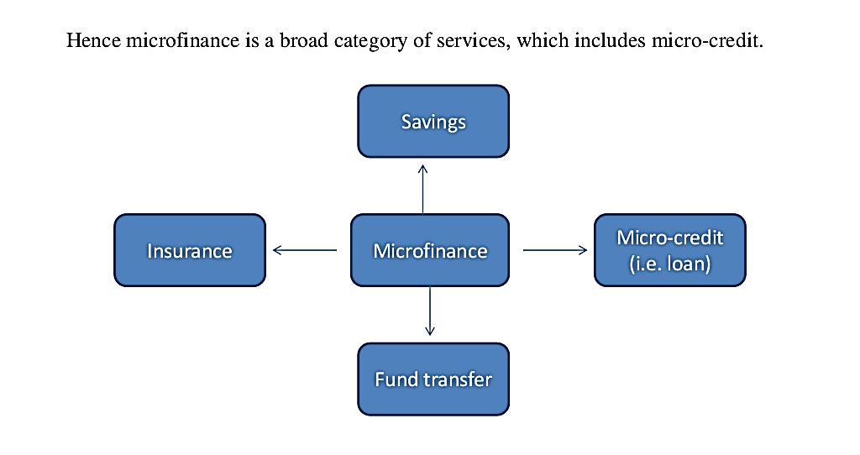
Figure 1 Microfinance (Counts, 2008)
The figure shows us various functions of Microfinance. It gives the poor people insurance, give them the unique feature to transfer their funds to dear ones, providing short loans and also give commercial bank opportunity like giving opportunity for savings account.

Paradigms in Microfinance
Microfinance was an impossible concept even few years back. But Dr Muhammad Yunus brought about a great shift in the ‘Paradigms in Microfinance’.
Features | Old Paradigms | New Standards
Defining Problem | Market was imperfect | The risk is minimal.  The cost is also low.
Roles of Financial Institutions | Implement the government plans.  Helping the deprived people. | Managing their resources in the most effective manner.
Subsidies | Subsidy dependence is created. | Creation of new independent financial institutions.
Sustainability | It was ignored before (Azim, 2019). | It is now a great concern.
Assessment | Positive changes for the beneficiaries. | Improvement of overall functions of the finance services.

Pros and Cons of Microfinance
Microfinance has not brought changes only in Bangladesh but also all over the world. Billions of people are benefited by this structure and system of financing that gives them hope to live a better life.
Microfinance has the following positive implications:
People of Bangladesh have been able to eradicate the extreme poverty problem. Because of micro-financing, they have been able to create solution for their hunger (Rahman, 2019). The kids can get access to primary education. Microfinance by Grameen Bank helped the women to stand for themselves. It has a great impact on the woman empowerment. Long term implications include: reduce in the child mortality. Because of the lack of nutrition, millions of children die every year in Bangladesh. But the opportunity of microfinance has contributed in reducing the rate over the years. Also, maternal health is much more improved over the years.
Constraints of Microfinance are as follows:
Still many people are not properly aware about the functions of microfinance. If a person has multiple loans and borrowings, it can have a negative impact over the financing organisation. As a result, the risk increases leading to unsustainable business model. The rates are also higher than any other traditional banks. It may risk the lives of many people borrowing the money. Also, there are some regularity issues. Microfinance organisations are prone to risks of credit, price risk, risks for liquidity, risk for legal issues and so on.

Dr Muhammad Yunus’ Entrepreneurial Motivations
In a face to face interview with The Guardian, Dr Muhammad Yunus said that we all are entrepreneurs and we all have the ability to bring a change in the society and a greater change in the nation. He did not only think of the poor people of Bangladesh (Yunus, 2007). He thought about all the poor people in the world. Poor homeless people living in Australia, poor people living in the Europe and so on. He always cherished himself to do something for the humanity that will meet the most vital need of the people: Hunger. Hunger is the worst experience a person can face. He believed that there are two types of businesses in the world. One type is the traditional type where the organisations can make billions of revenues and profits and so on. But the other type of business solves the problems of the people.
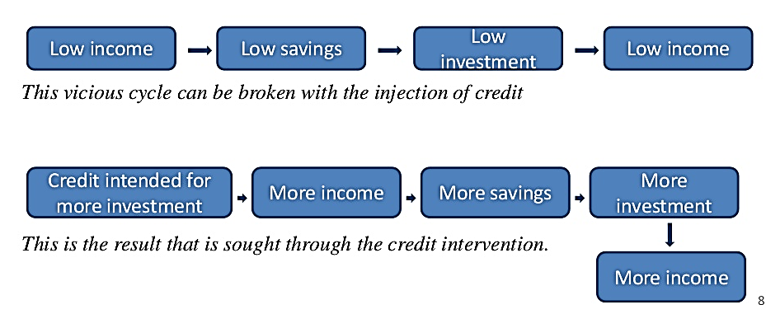
Figure 2 Models for Improving Life (Bateman, 2014)
Dr Muhammad Yunus saw that low income is the root of all problems. It leads to low savings; people are not able to invest for themselves and the vicious circle of low income carries on. It can be solved by introducing micro credit. The credit will help the people to invest that will generate more income. More income will lead to more savings and more investments. And that’s how the vicious cycle of low standard of living can be eradicated.
He wanted to develop a business model that will bring the people in a system. He did not want to bring the people. One of his beliefs is that the people are not bound to work for others but rather they need to work for themselves. So, he wanted to financially support them in establishing their own businesses. And this is how he innovated the concept of ‘Grameen Bank’. And the rest has come down to history. He did not only bring change in the lives of the people; he created a social change. His efforts for the society have awarded him the Nobel Peace Prize in 2006.

Conclusion
Dr Muhammad Yunus and his Grameen Bank have changed the lives of millions of people in Bangladesh. It helped the people to come out of extreme poverty condition, created opportunities for work, ensured women empowerment, facilitated the child health care and primary education and many more. The positive impact of the practices is many. Other countries are also inspired by the initiatives taken by Dr Muhammad Yunus. Now many organisations in the world, specially in the Africa are trying to develop the practice and improve the lives of millions of people. Microfinance can help the poor people to stand up in their life and hope for a better future.

References
Azim, M.I. and Kluvers, R., (2019). Resisting Corruption in Grameen Bank. Journal of Business Ethics, 156(3), pp.591-604.
Bateman, M., (2014). The rise and fall of Muhammad Yunus and the microcredit model.
Bhawuk, D.P., Mrazek, S. and Munusamy, V.P., (2017). From Social Engineering to Community Transformation: Amul, Grameen Bank, and Mondragon as Exemplar Organizations 1. In Ethical Transformations for a Sustainable Future (pp. 75-112). Routledge.
Counts, A., (2008). Small loans, big dreams: how Nobel prize winner Muhammad Yunus and microfinance are changing the world. John Wiley & Sons.
Rahman, A., (2019). Women and microcredit in rural Bangladesh: An anthropological study of Grameen Bank lending. Routledge.
Subba-Reddy, C.V., Yunus, M.A., Goodfellow, I.G. and Kao, C.C., (2017). Retraction for Subba-Reddy et al.,“norovirus RNA synthesis is modulated by an interaction between the viral RNA-dependent RNA polymerase and the major capsid protein, VP1”. Journal of virology, 91(24).
Yunus, M., (2007). Q&A with Muhammad Yunus. Interview on ‘NOW.’PBS. j. mp/oEeNni.
Yunus, M., (2017). Social business entrepreneurs are the solution. In The Future Makers (pp. 219-225). Routledge.

