
Assignment 2:
Operating Systems
CertHE Computing Skills for Workplace

Computer Architecture and Operating Systems. ACCA4022_LON
DR. Redhwan Al-Amri (Lecturer)
University of Wales Trinity Saint David
(London Campus)
Student Name: Mesfin Tezera
Student Number:2510889
Group: 02
Date: 03 August 2026

Table of Contents
Introduction 1
1. Key functions of general Operating Systems 1
Systems 1
1.1 Process and Processor Management 1
1.2 Memory Management 3
1.3 File System Management 4
1.4 Security and Protection 5
2. Use of Windows OS CLI commands. 7
3. Use of Linux OS CLI commands. 15
4. Use of Windows OS scripts. 20
Script: System Health Check 20
Key Features Demonstrated 22
5. Use of Linux OS scripts. 23
Script: Log File Analyzer 23
Key Features Demonstrated 25
Conclusion 26
References 27
Appendices 29
Tutorial Activity on OS Types from OS Tutorial 1 29
1. LinkedIn Learning course: 29
2. Cisco Network Academy: 30
3. Cisco Network Academy : Operating Systems Basics 32

Introduction
An Operating System (OS) is the most important software on a computer because it manages the hardware and allows other programs to run. It handles essential tasks like saving files, managing memory, and running the apps we use every day. This report looks at how popular systems like Windows and Linux work by exploring their key functions. It also shows how to use the Command Line Interface (CLI) to control these systems through specific commands and automated scripts. By studying these tools, we can better understand how a computer manages its resources and how to perform administrative tasks more efficiently.

1. Key functions of general Operating Systems

1.1 Process and Processor Management

Process and processor management is the system operating system used to organize and execute everything running on our computer. When we open an application, it leaves our storage drive and becomes an active process in the computer memory. The operating system handles process management by creating these tasks, tracking them as they shift through different lifecycle stages such as waiting for users input or being ready to run and closing them when they finish. At the same time, possessor management deals with the actual physical CPU by using scheduling strategies to distribute fraction of a second of processing power to all open applications. Because a single computer core can only execute one tiny instruction at a exact microsecond, the system switches between these takes millions of times per second, which lets us seamlessly multitask without our computer freezing or crashing [1].
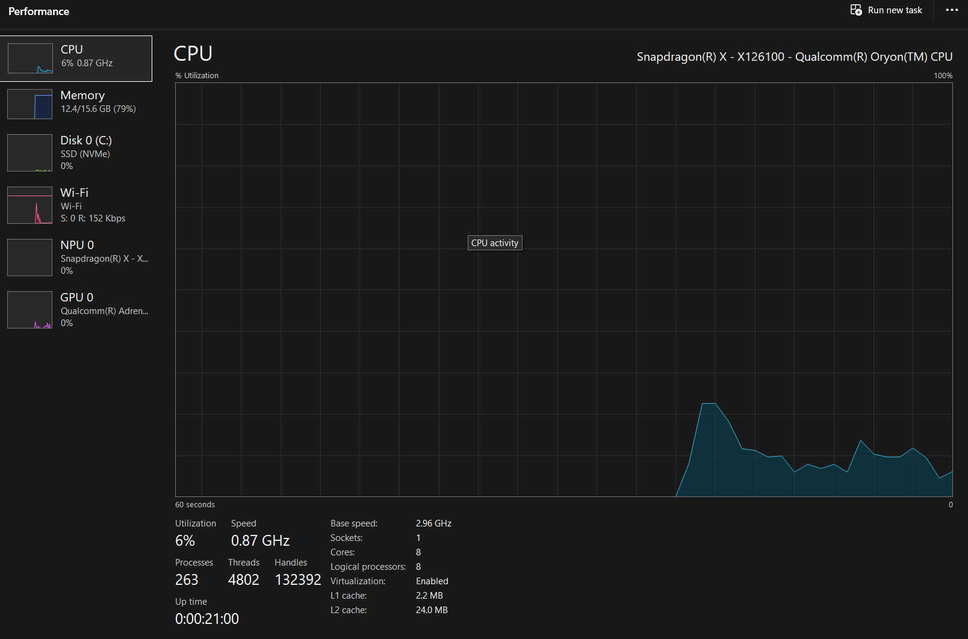

Figure 1: The screenshot displays File Explorer, which illustrates how the operating system organizes data into files and folders.

1.2 Memory Management

Memory management is the process by which a computer operating system controls and coordinates our computer’s main memory, commonly known as RAM, ensuring that there is always enough space for our active applications to run smoothly. When we open a program, the operating assigns is a specific black of memory, tracks exactly how much memory that program is using, and then safely reclaims that space to prevent waste once the program is closed. Because physical RAM is limited, memory management also uses a clever technique called virtual memory, which temporarily borrows space from our hard drive when our RAM gets full, so our computer does not crash [2].
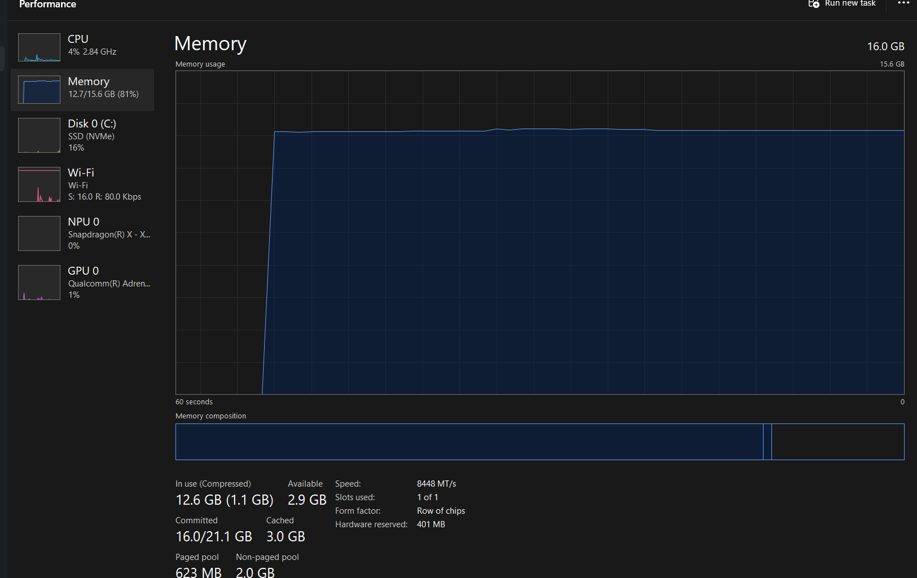
Figure 1: This screenshot illustrates the memory management system operating normally, displaying the real-time allocation and distribution of system resources.

1.3 File System Management

File Management is the method an operating system uses to organize, store, name, and retrieve digital files on our computer’s storage device, much like an electronic filing cabinet. Without a file system, all our data would exist as one massive, unreadable block of numbers, instead the operating system breaks this data down into distinct files, nests them inside directors or folders, and creates a master index to keep track of exactly where each file lives on the physical disk. File system management handles everything from saving a new document and renaming a folder to control users’ access permissions. [3].

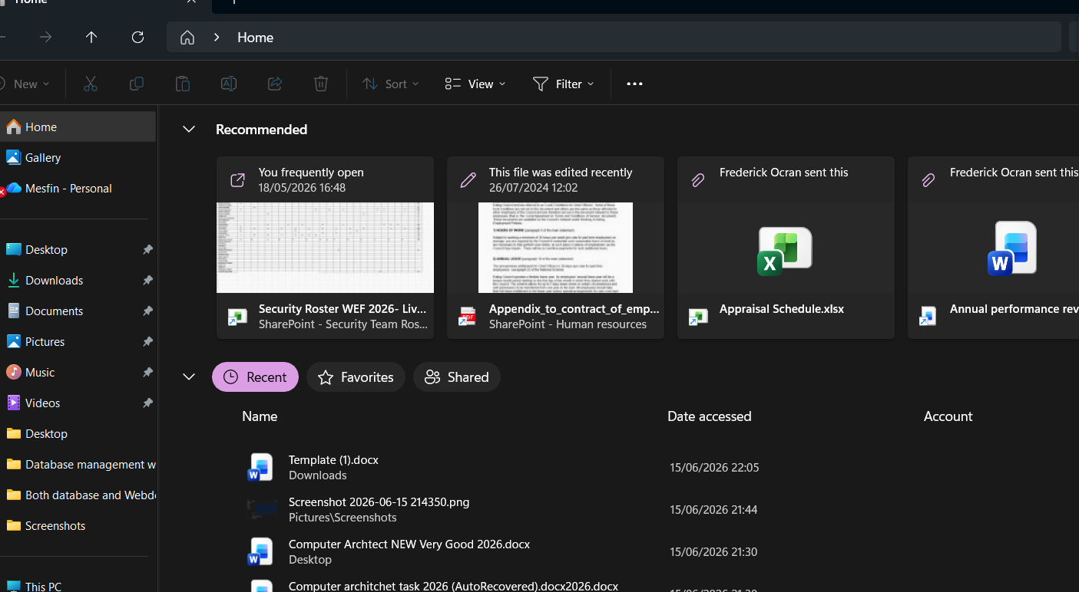
Figure 1: The interface demonstrates that file system management is operating normally, with all storage directories and data processes functioning within optimal parameters.

1.4 Security and Protection

Security and protection are the framework of an operating system user to defend a computer against both internal error and external threats. While protection focuses on internal control by ensuring that users and executing programs can only access specific files, memory block, and hardware resources they are explicitly authorized access, viruses, malware, and network attacks. Also, mechanics of protecting computer-stored information from unauthorized use or modification [4].
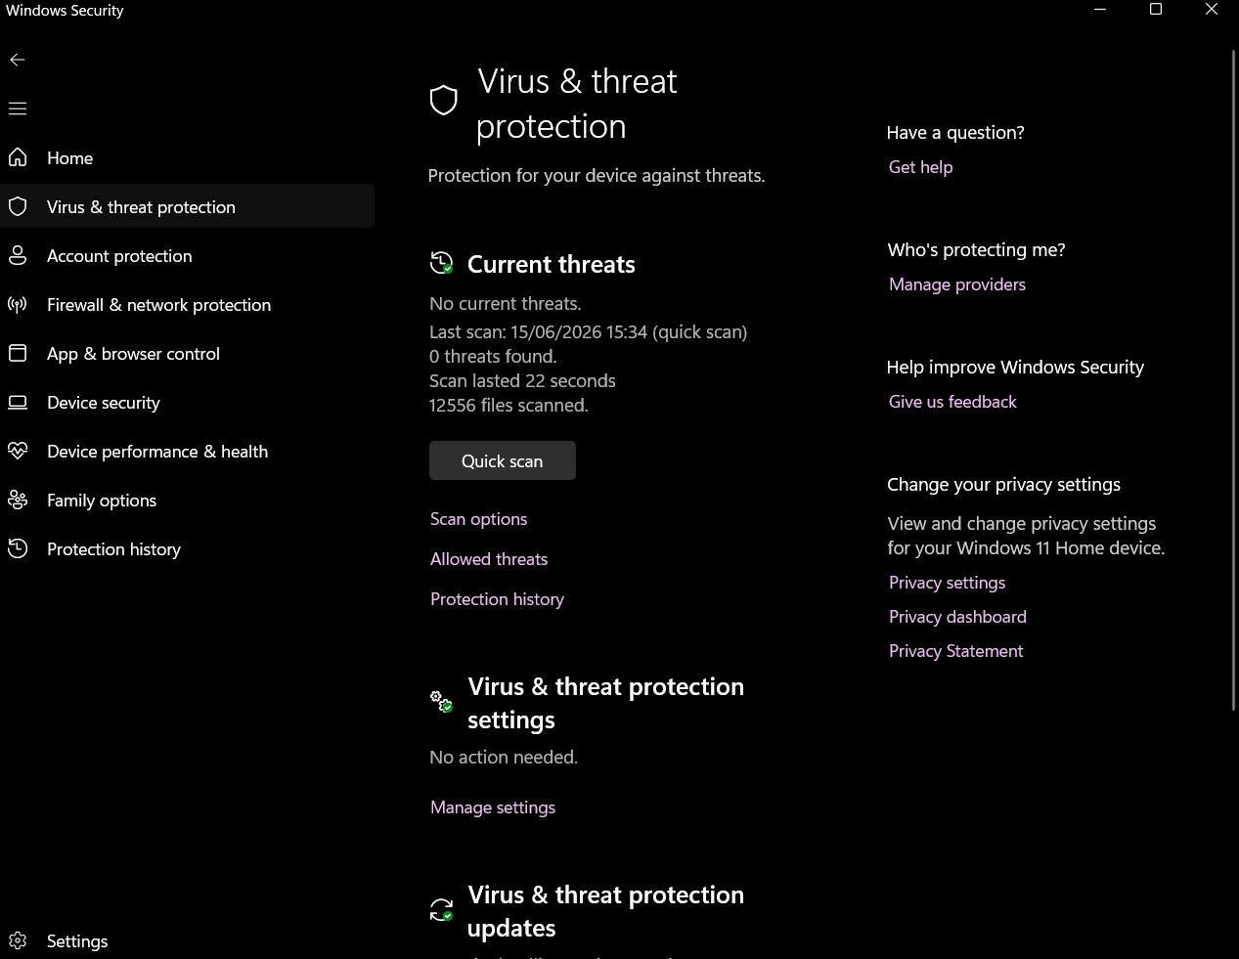

Figure 1: This image shows the Virus & threat protection screen in Windows Security, indicating that no threats were found during the last quick scan.

2. Use of Windows OS CLI commands.
Process management: -Windows OS CLI commands are highly effective for managing the active tasks and programs running on our computer. When software application freezes or stop responding; we can use a quick text command like task list to see a computer list of everything running in the background. If we need to shut down a frozen program immediately, typing the task kill command followed by the program’s name will force to close instantly.

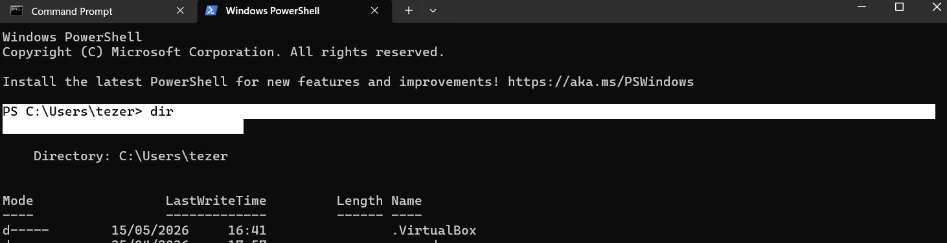
Figure 1: this is dir command input for folder system

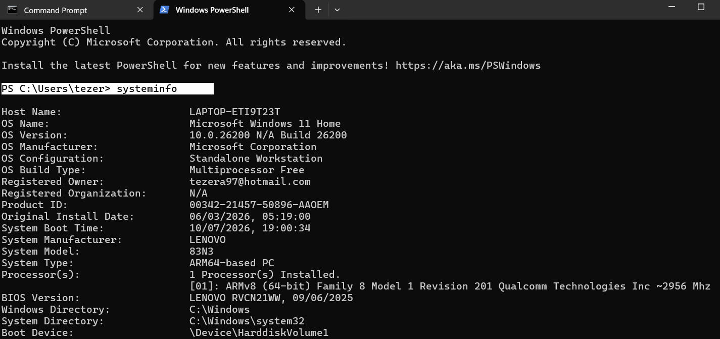
Figure 2: this is dir output result on command prompt 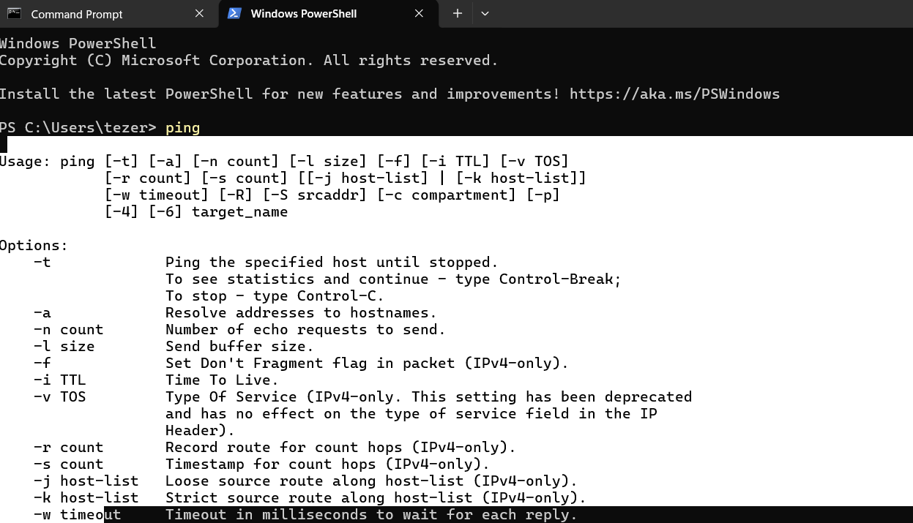
Figure 3: This is ping command prompt input

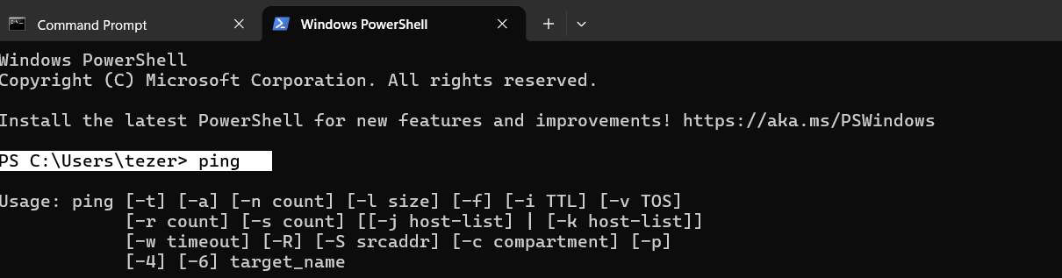Figure4: this is ping command prompt output

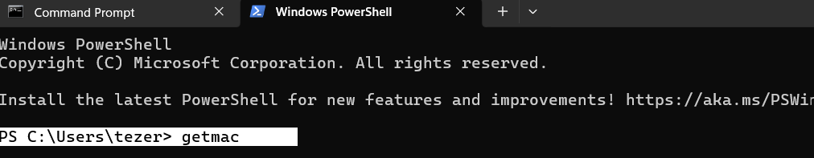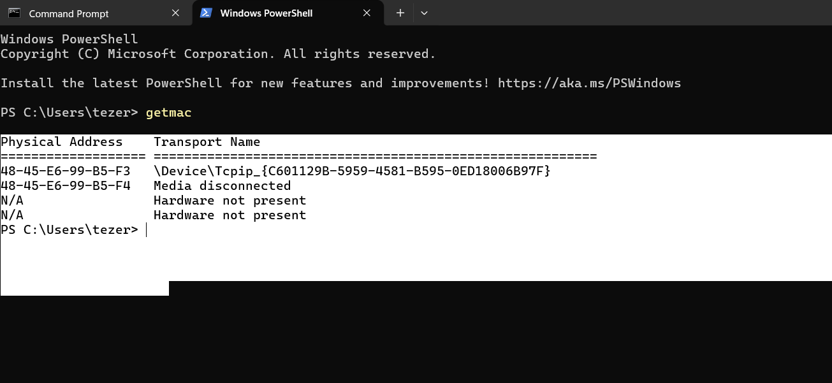
Figure 5: Is getmac command input and output command result together

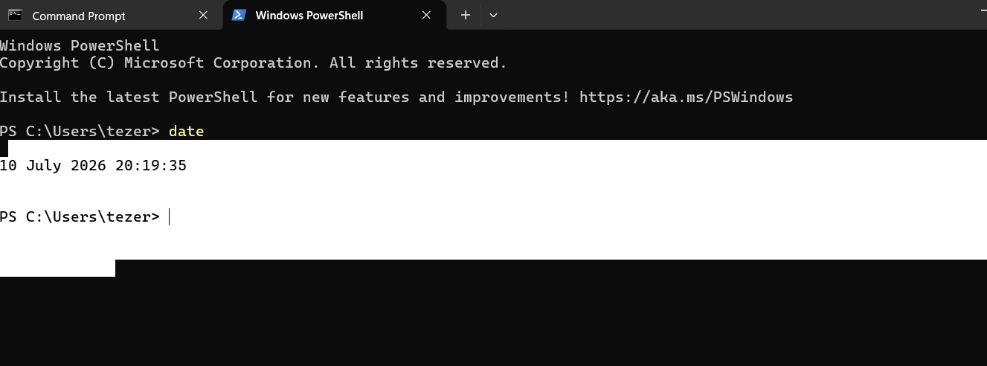
Figure 6: This is date command input and output command all together.

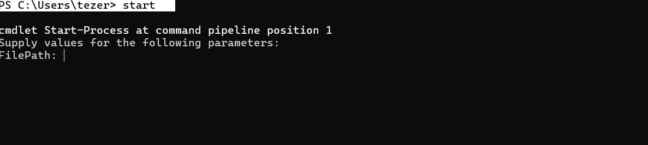
Figure 7: this is start command input
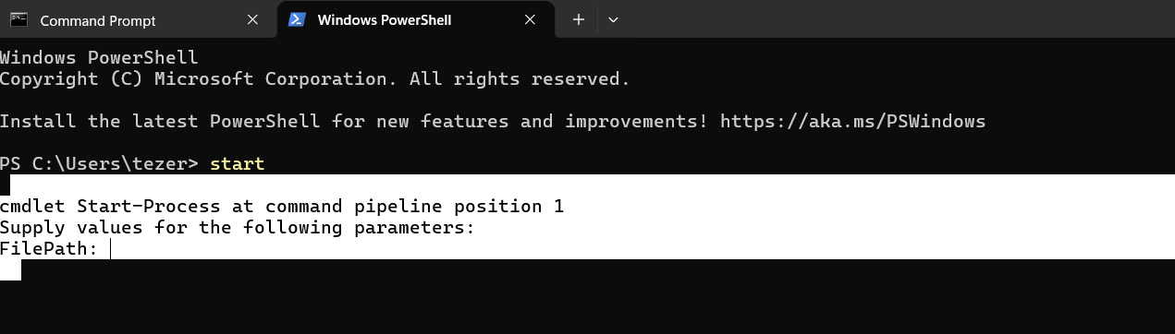
Figure 8: this is starting command output the result

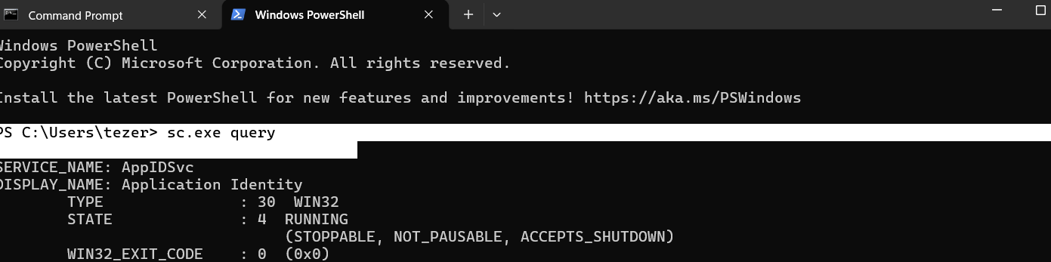
Figure 9: this sc.exe. query in put command

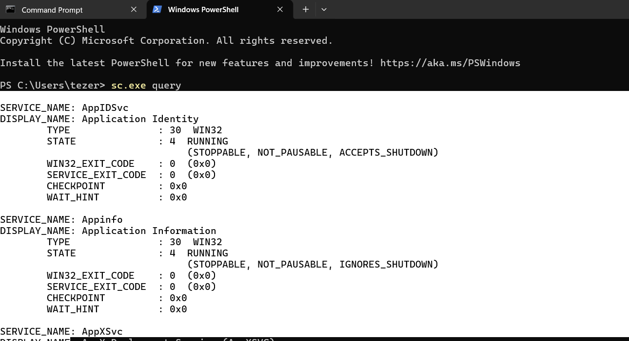
Figer 10 this is sc.exe. query output result:

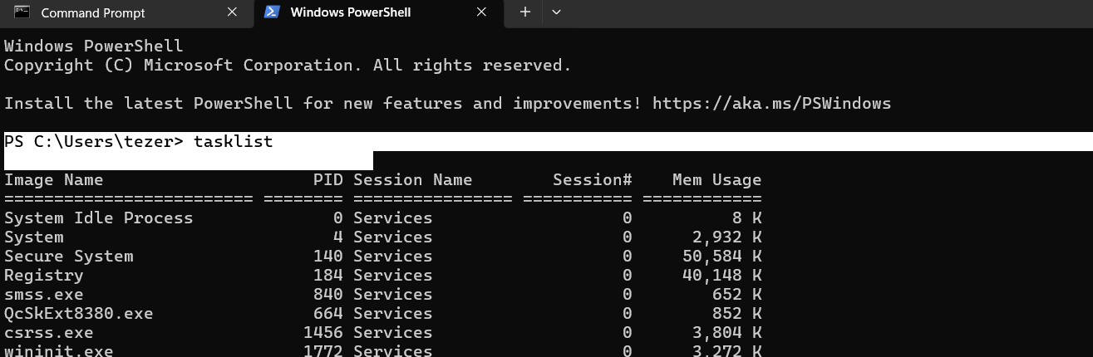
Figure 11: This is tasklist command input and output result.
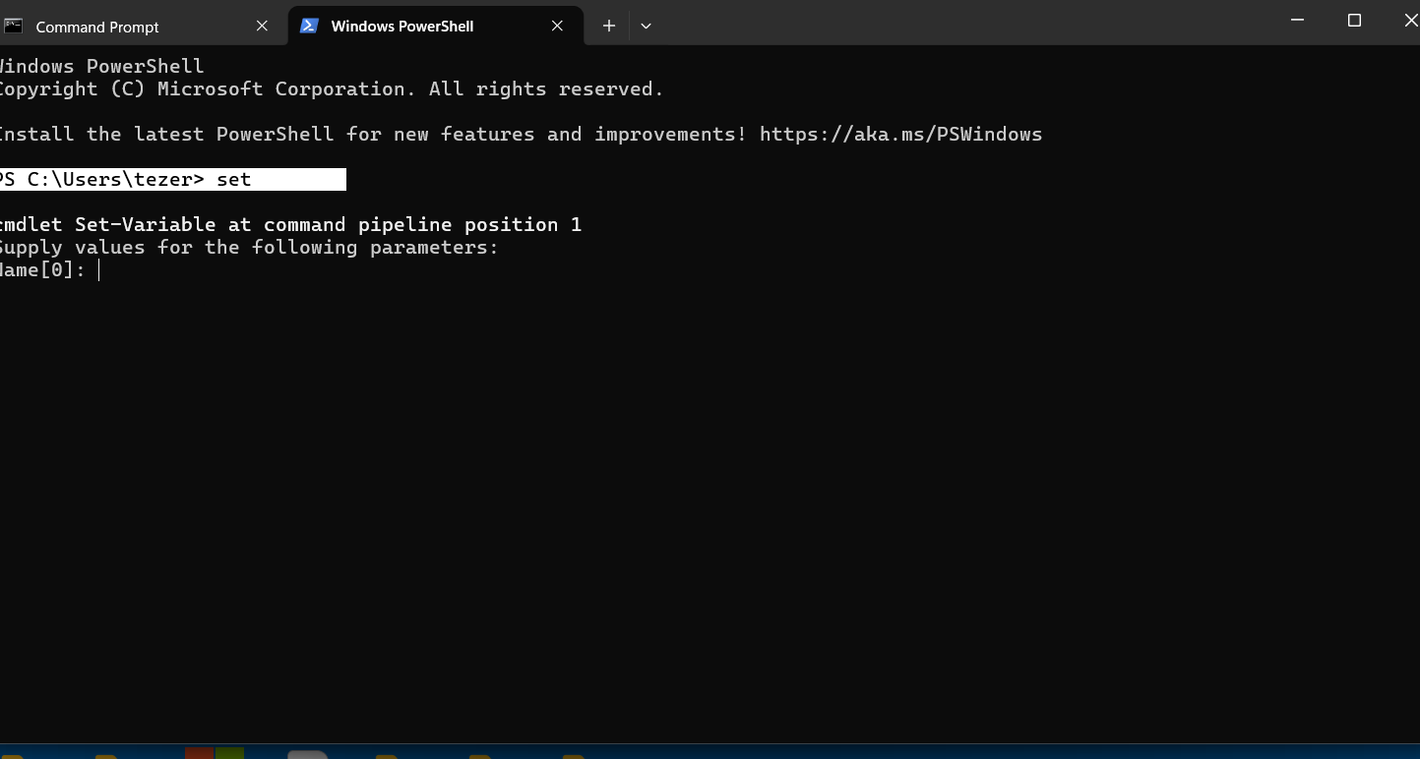
Figure 14: In this image I typed as input set command into window PowerShell windows which has automatically aliased it to the set-variable cmdlet.

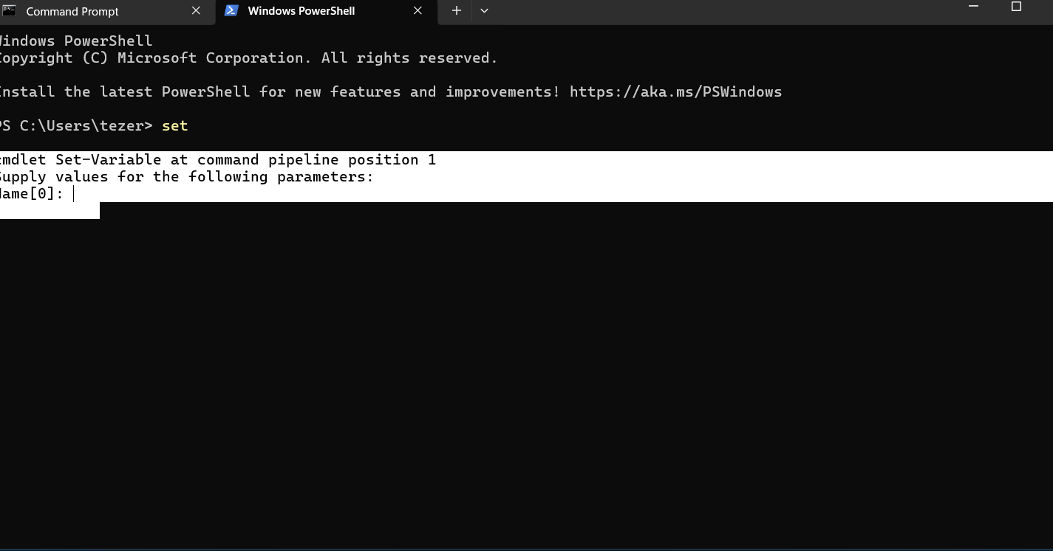
Figure 15: this image I typed as input set command into Window PowerShell windows which has automatically aliased it to the set-variable cmdlet.

This is mkdi my folder: This is Linux/unix command mk dir it is the command line -interference to create a new empty folder at our current location or specific path.
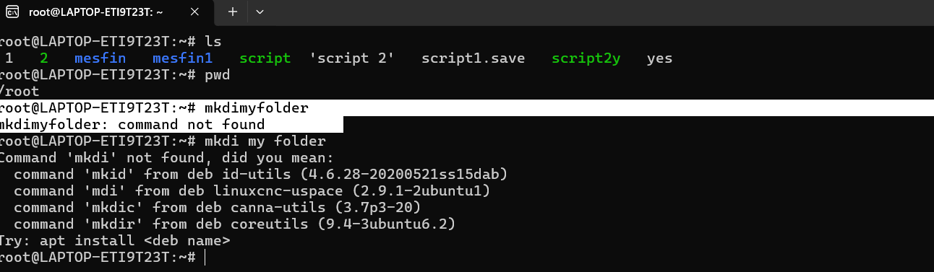
Figure 1: This is mkdi my folder command input

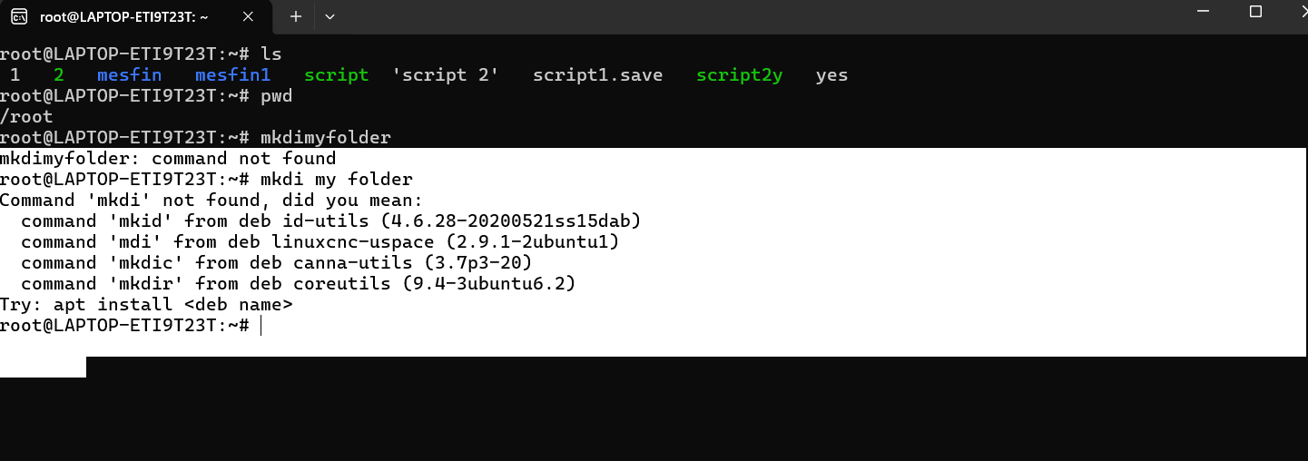

Figure 1B: this is mkdi my folder command output result.

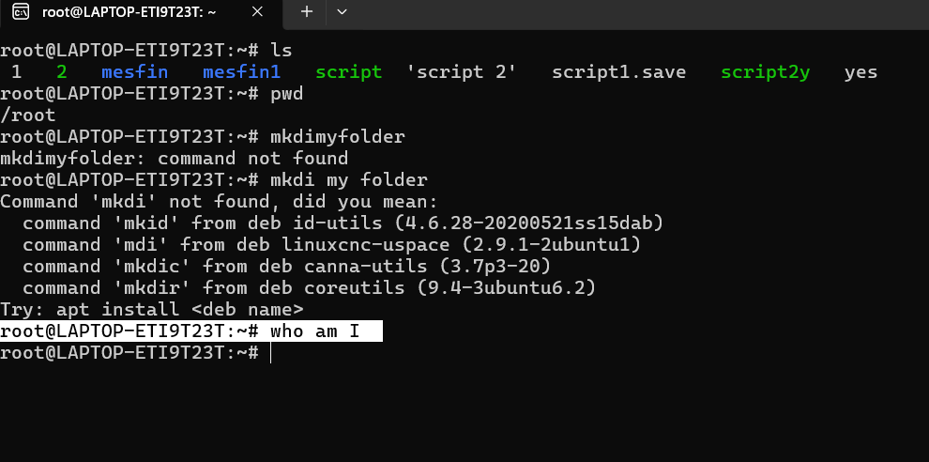
Figure 2: this is who am I command input
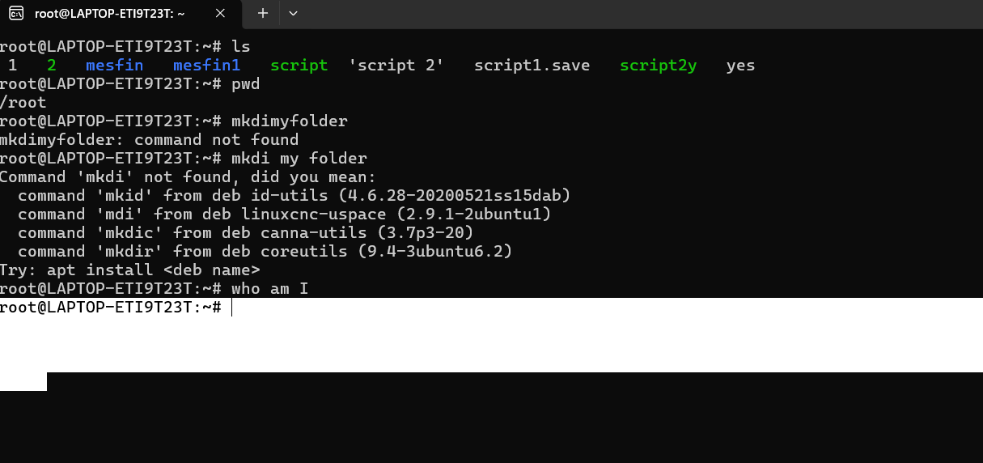
Figure 2B: this is root result of the command who am i

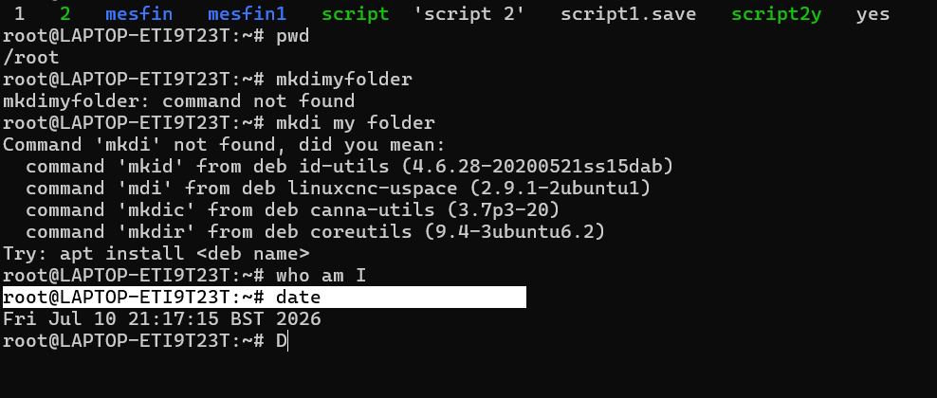
Figure 3: This is data Command input

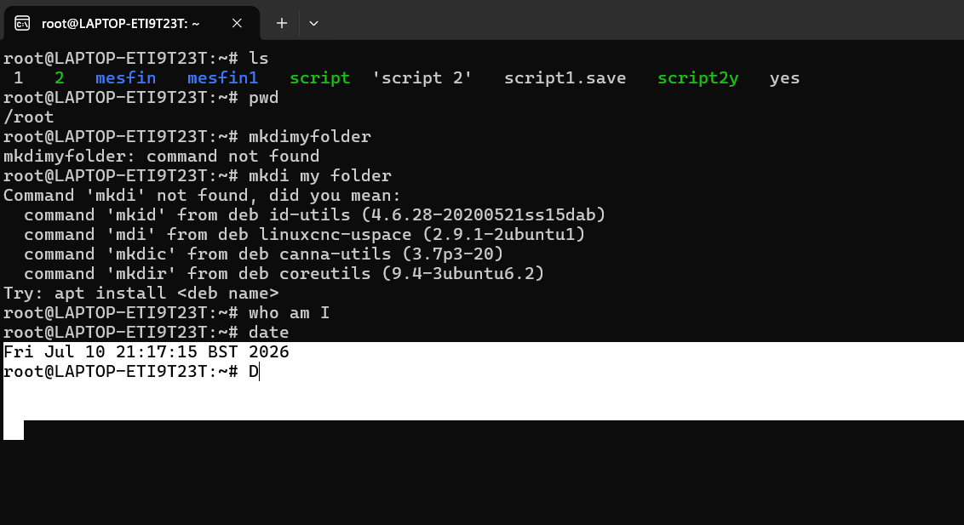
Figure3B: this is data command output result
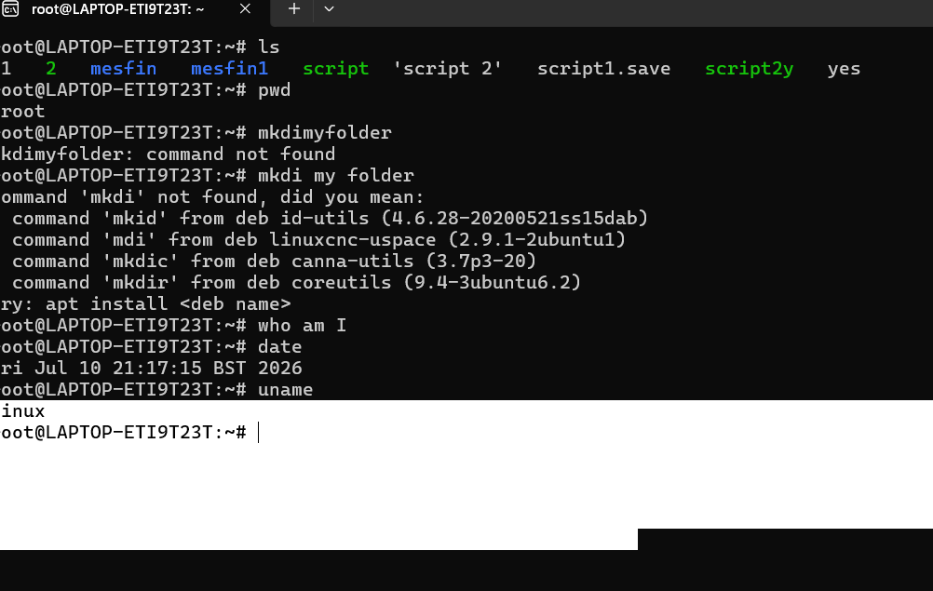
Figure4:folder command input
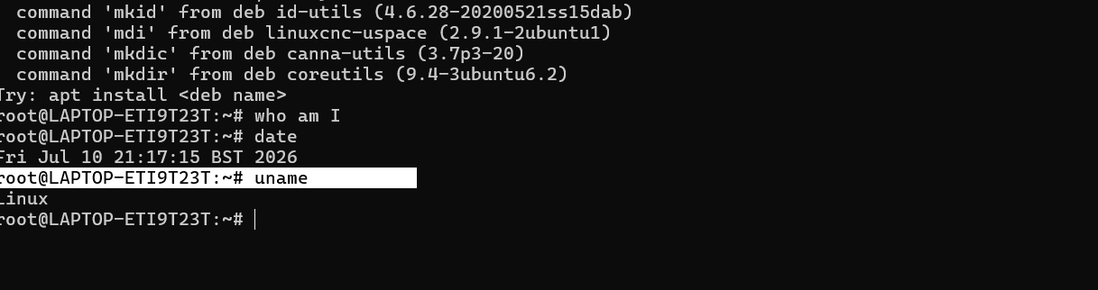
Figure 4: This is uname command input

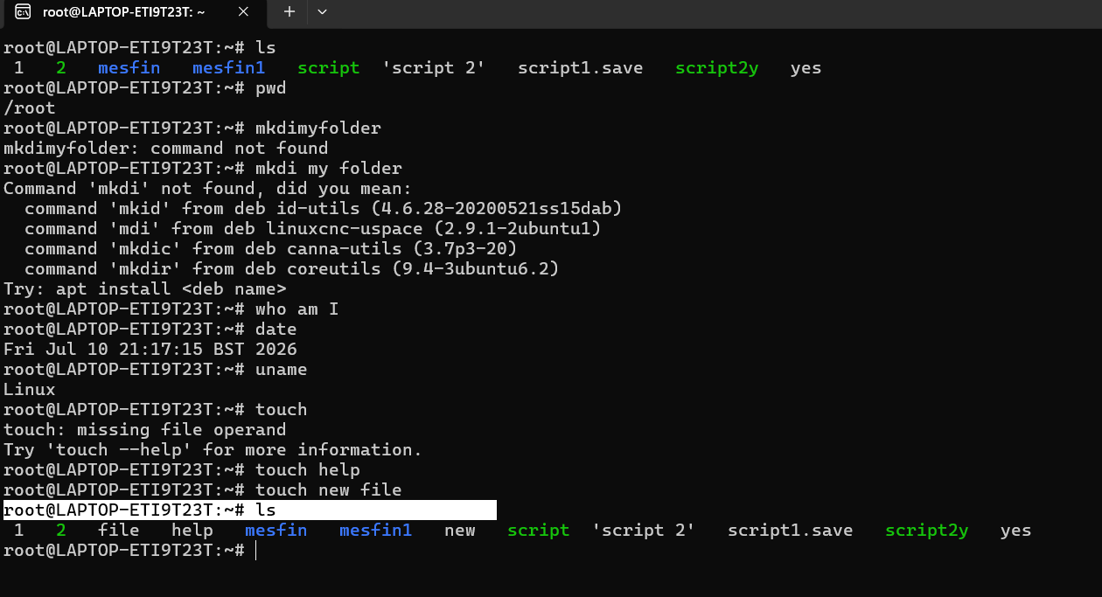
Figure 5: This is IS command input

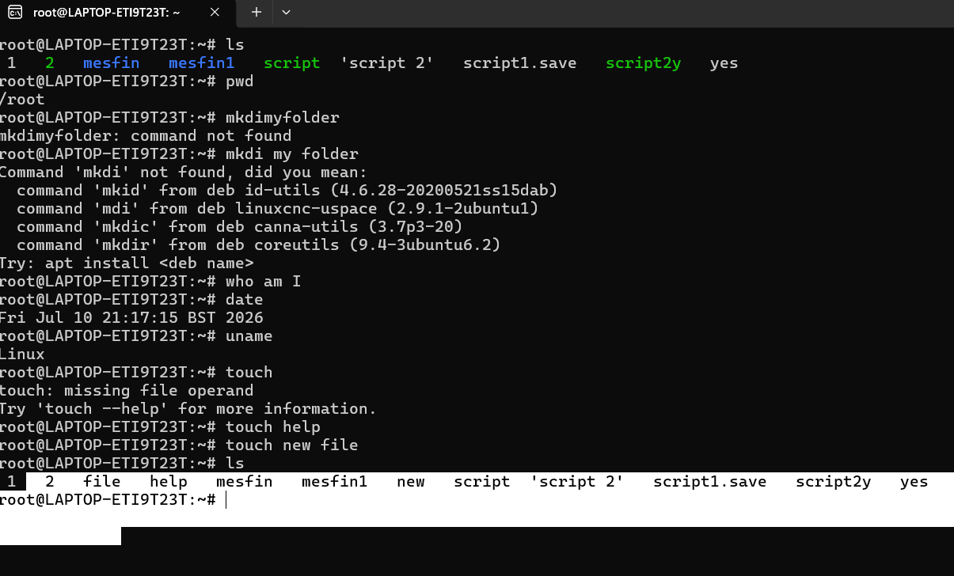
Figure 5 B: This is command IS output is displays a Linux terminal session demonstrating the execution of fundamental command -line utility tools, including directory listing (IS).printing the working directory (pwd) checking the system (data) and operating system identification (uname). Additionally, it illustrates common command -line syntax error- such as typos with (mkdir) and missing arguments for (touch) along with successful empty file creation using touch help and touch new file.

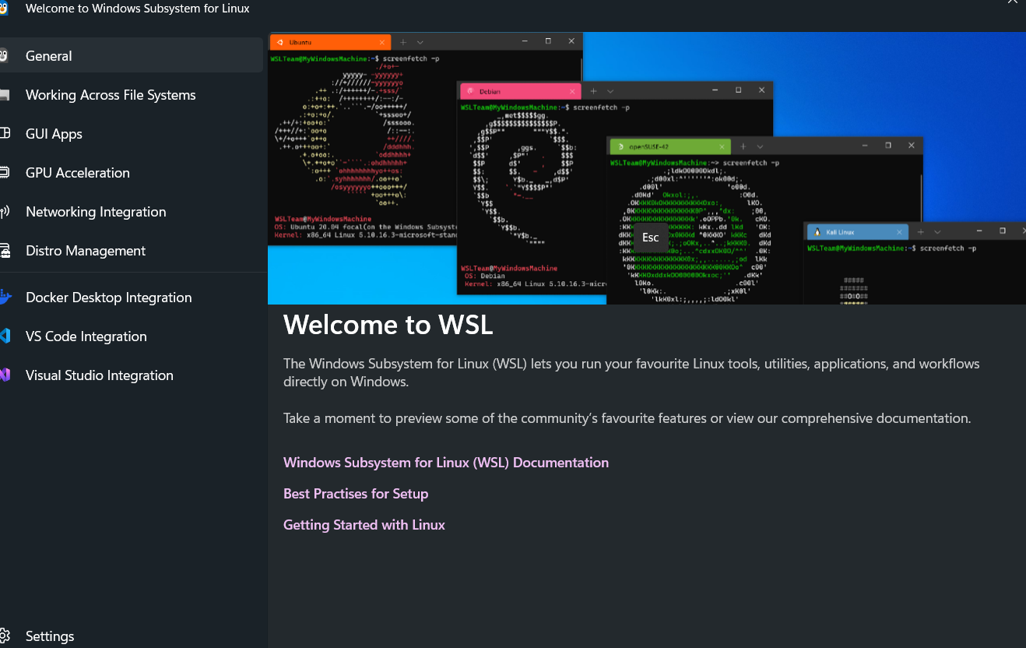

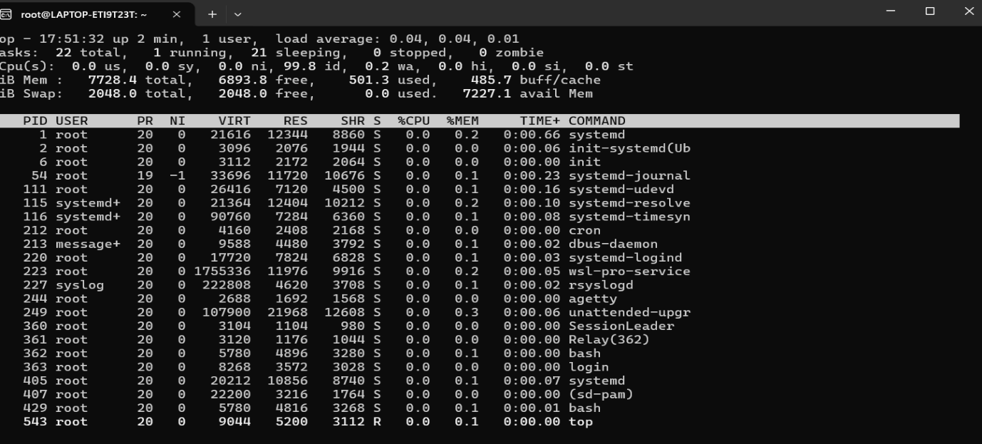
Figure 1 : The image shows terminal window with the prompt root@LAPTOP ETI923T it is displaying a real time system monitoring interface using the standard Linux utility TOP , running within a window subsystem for Linux (WSL) environment.
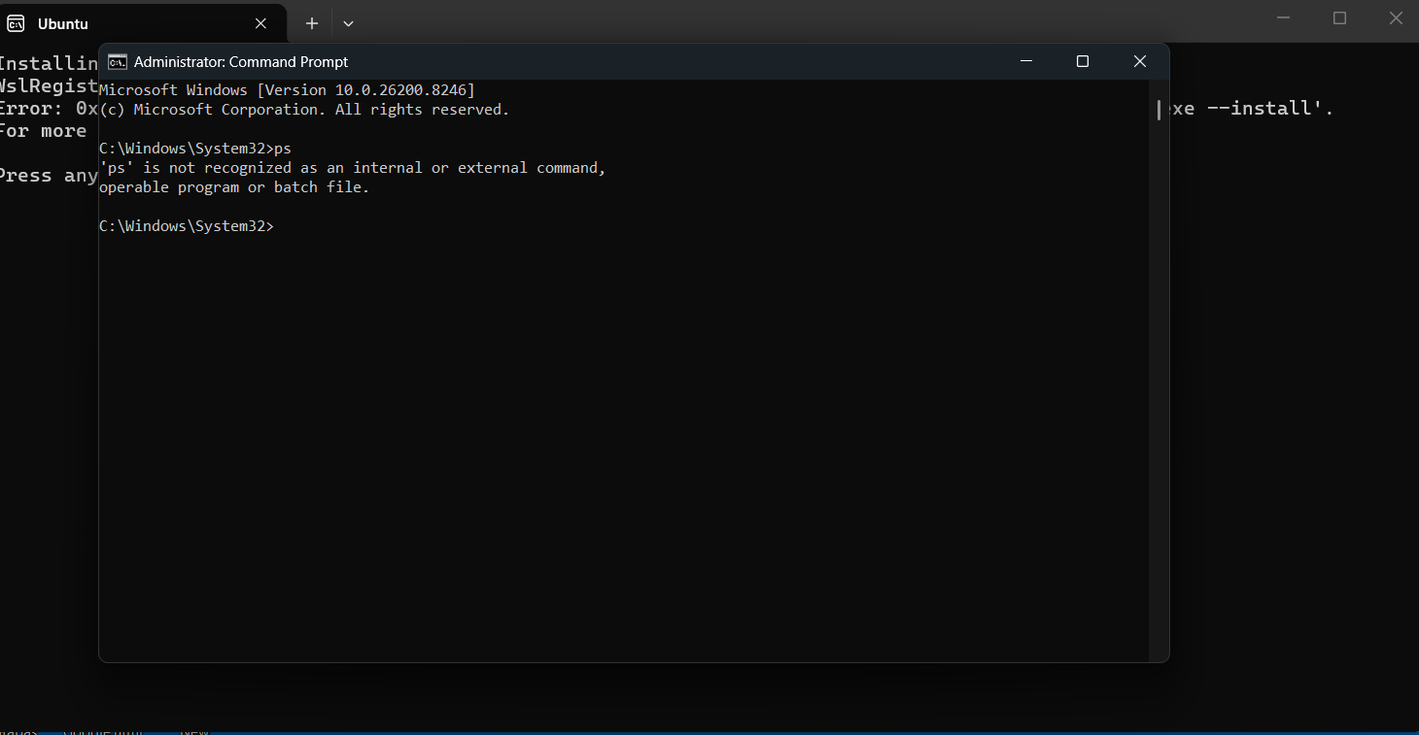

Figure 2: Process management interface, illustrating how commands like top display live system resource usage and active processes.

Task 3 Use of Linux OS CLI commands

Figure 1: Prosses management, this is how command like TOP show live system resource usage

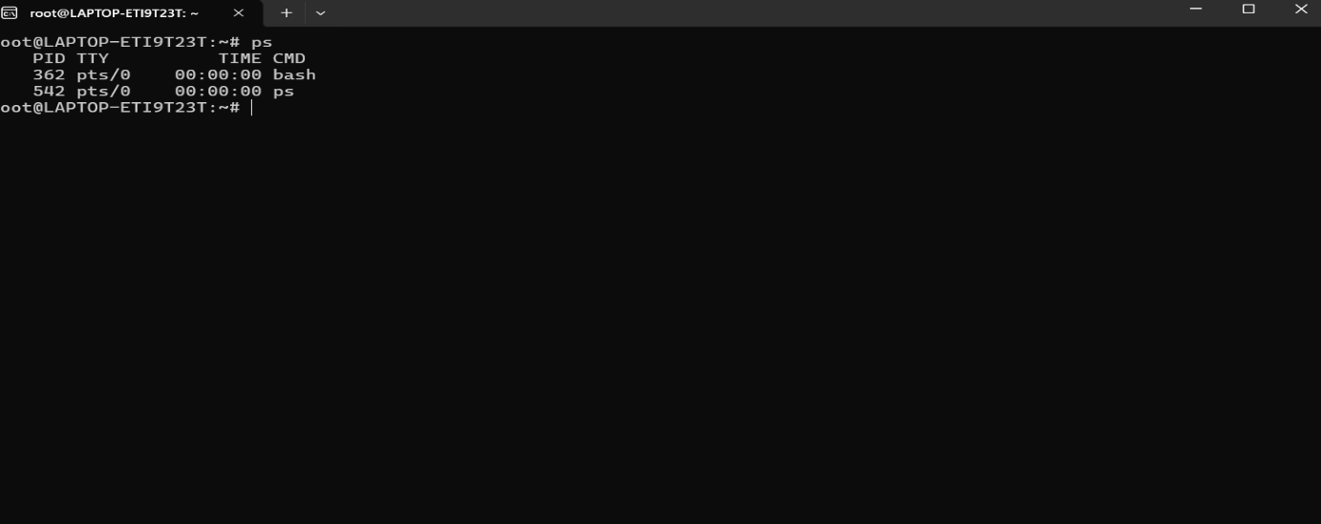

Figure 1: Prosses management, this is how command like TOP show live system resource usage

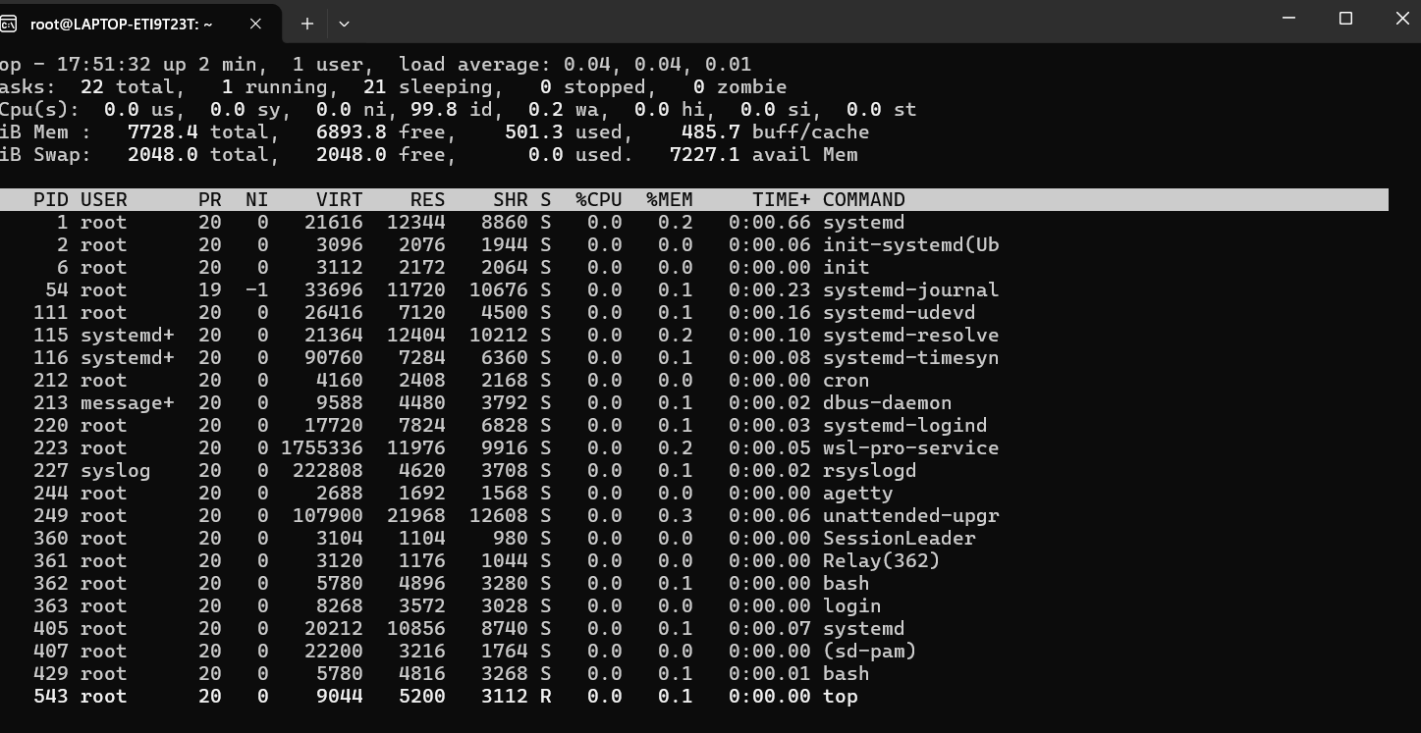

Figure 3: Network testing (ping) could be highlighted for checking connectivity

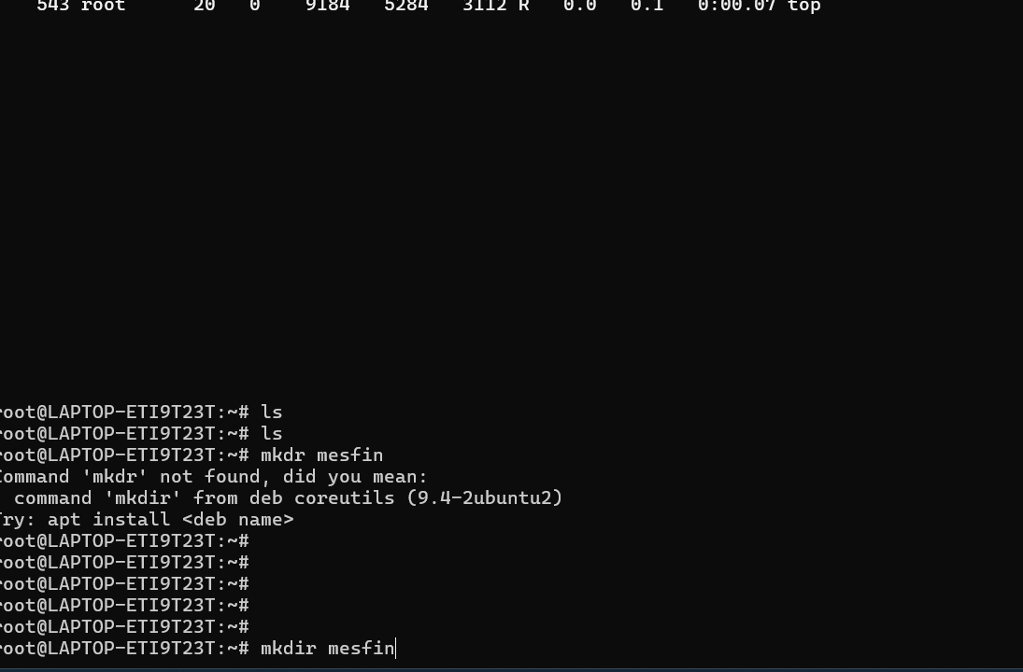

Figure 4: User Management this is how user read creates new user account

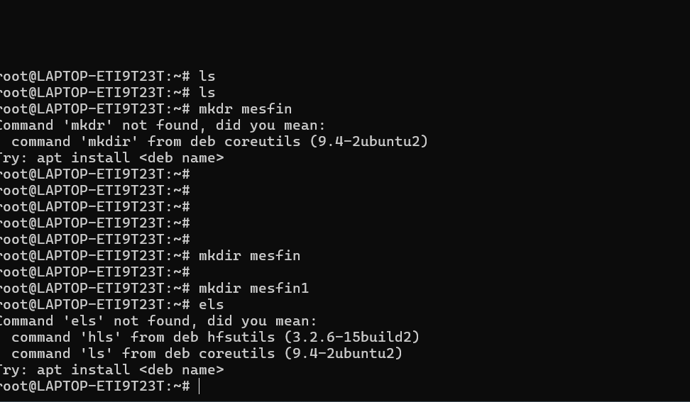

Figure 5: Task Scheduling emphasize that (cron) antumates recuring Actions

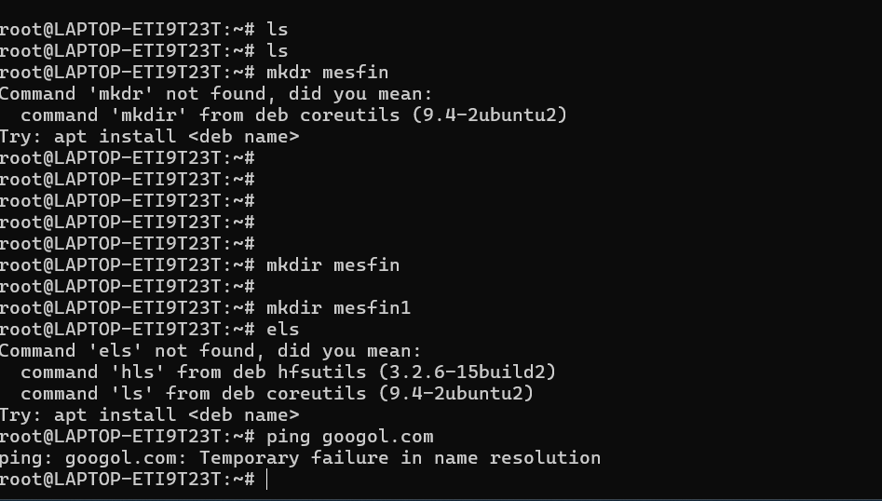

Figure 6: Task Scheduling emphasize that (cron) antumates recuring Actions

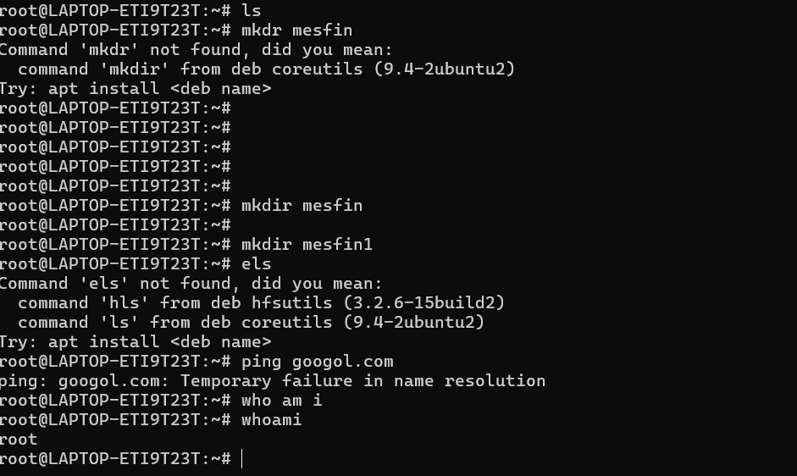

Figure 7: Task Scheduling emphasize that (cron) antumates recuring Actions

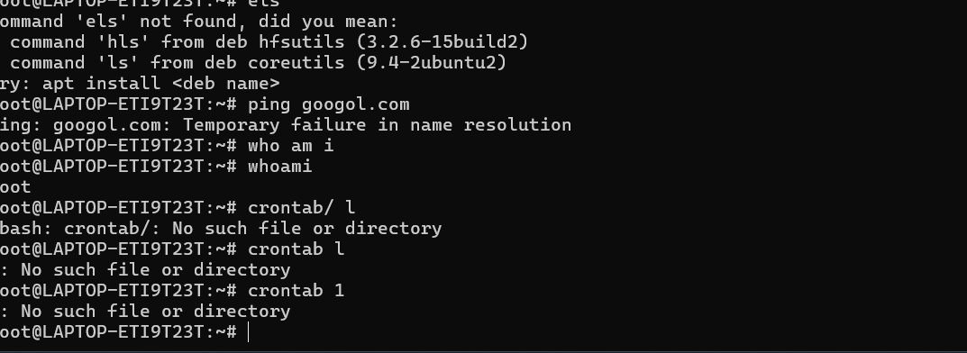

Figure 8: Command emphasize that (cron) antumates recuring Actions

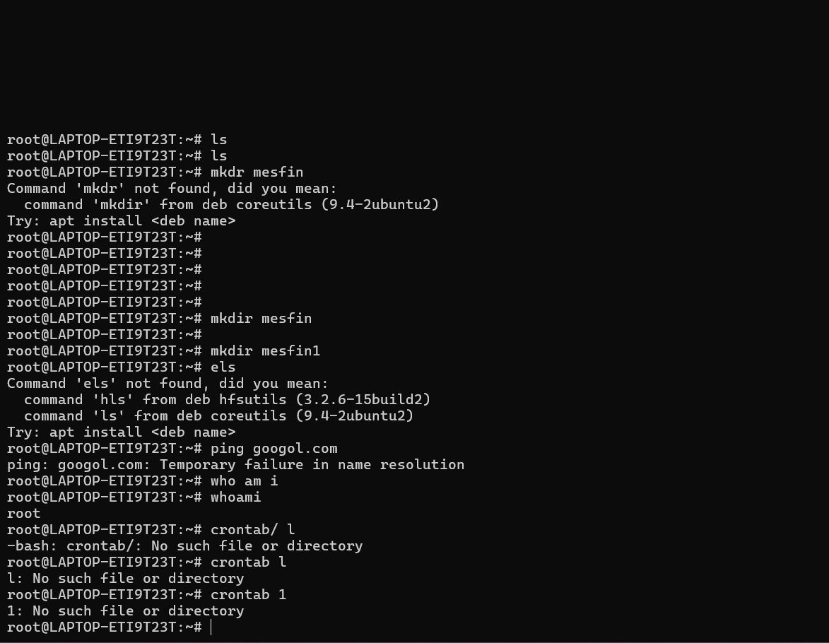

Figure 9: Command emphasize that (cron) antumates recuring Actions

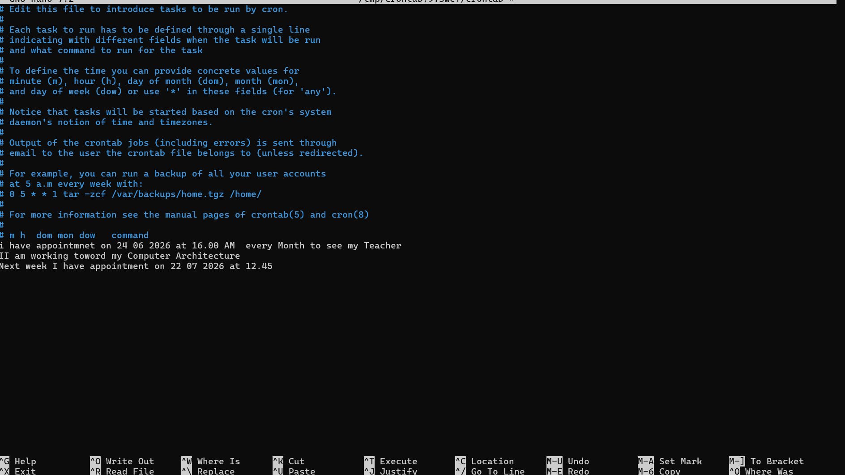

Figure 10: Command emphasize that (cron) antumates recuring Actions

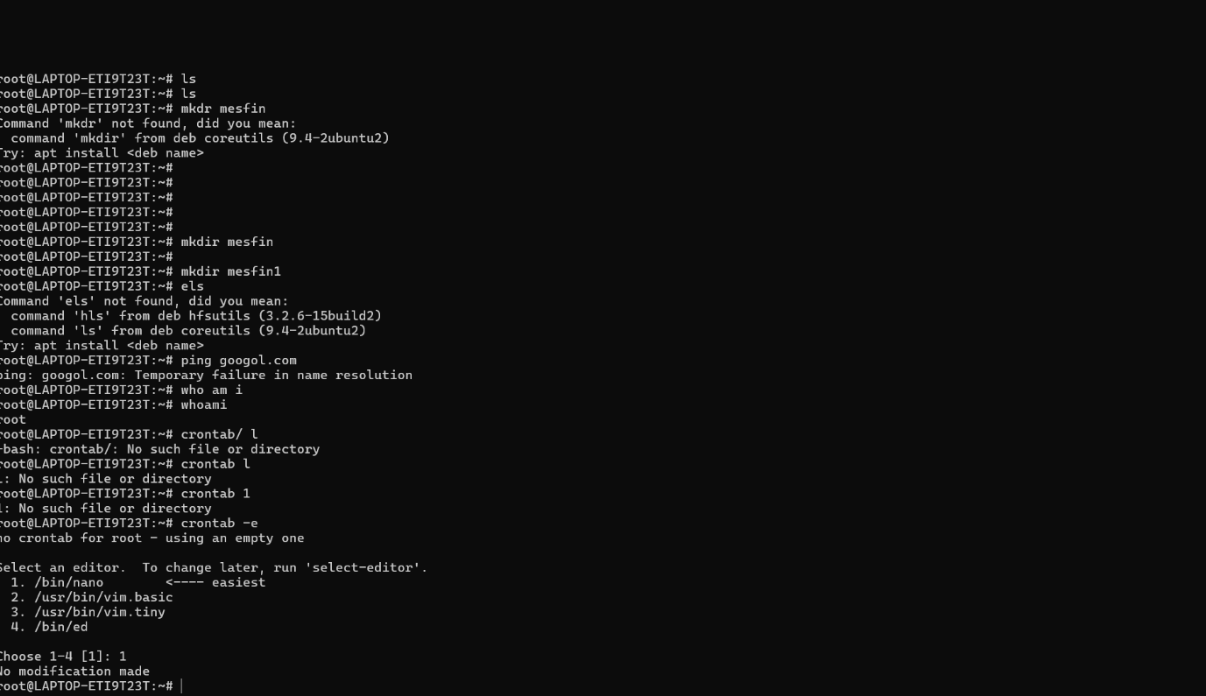

Figure 11: Command emphasize that (cron) antumates recuring Actions

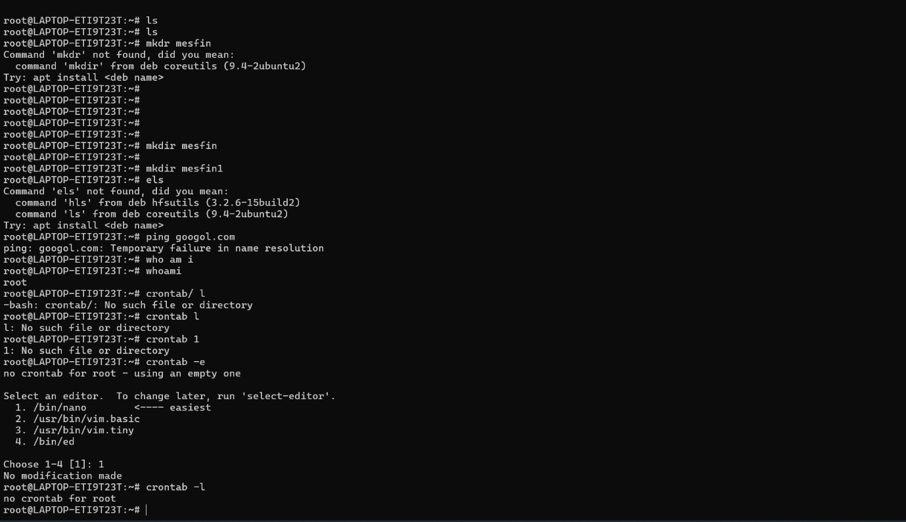

Figure 12: Command emphasize that (cron) antumates recuring Actions

Figure 13: User Management interface, demonstrating the step-by-step process used to create a new user account on the system.

4. Use of Windows OS scripts.
Window scripts are small, filled command -line instruction that help us automate repetitive tasks on our computer. Instead of typing the same command one by one every day, we can save them all onto a single script file that runs everything automatically with a single double -click. System administrators often use two main types of scripts; traditional batch files (ending in .bat) for simple tasks, and advanced PowerShell script (ending in .ps1) . By using this script, we can quickly backup filles,

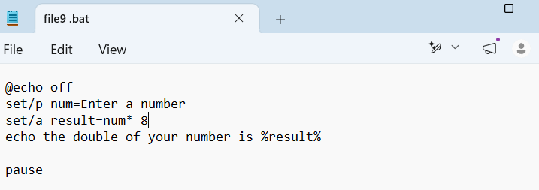
Figure1: displayas the batch script code which prompts the user for a number, performs a calculation and displays the input
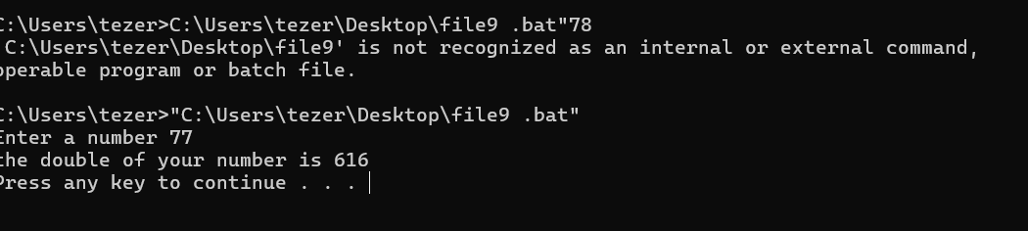
Figure 2: displays the batch script code which prompts the user for a number, performs a calculation and displays the output

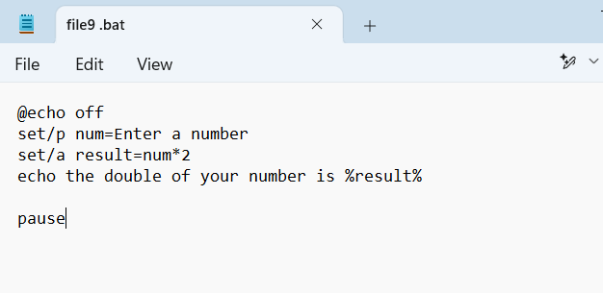
Figure3: displays the batch script code which prompts the user for a number, performs a calculation and displays the input

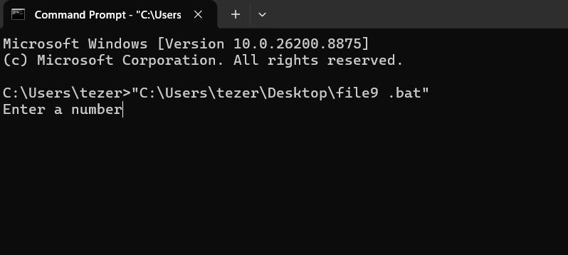
Figure4: displays the batch script code which prompts the user for a number, performs a calculation and displays the output

: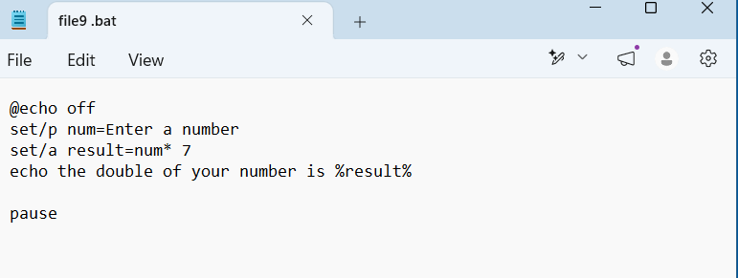
Figure 4: displays the batch script code which prompts the user for a number, performs a calculation and displays the input

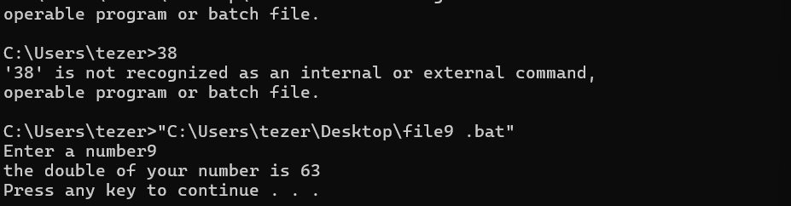

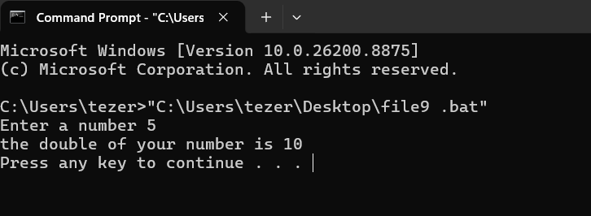
Figure 5: displays the batch script code which prompts the user for a number, performs a calculation and displays the output

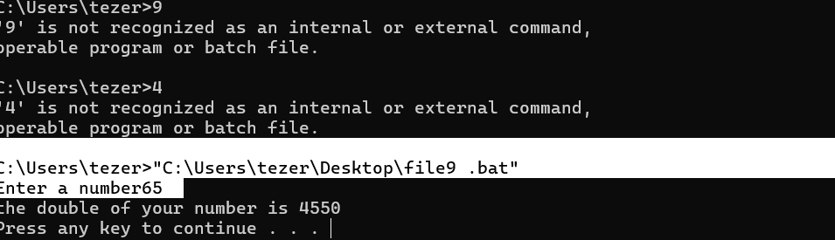
Figure 6: displays the batch script code which prompts the user for a number, performs a calculation and displays the output/input

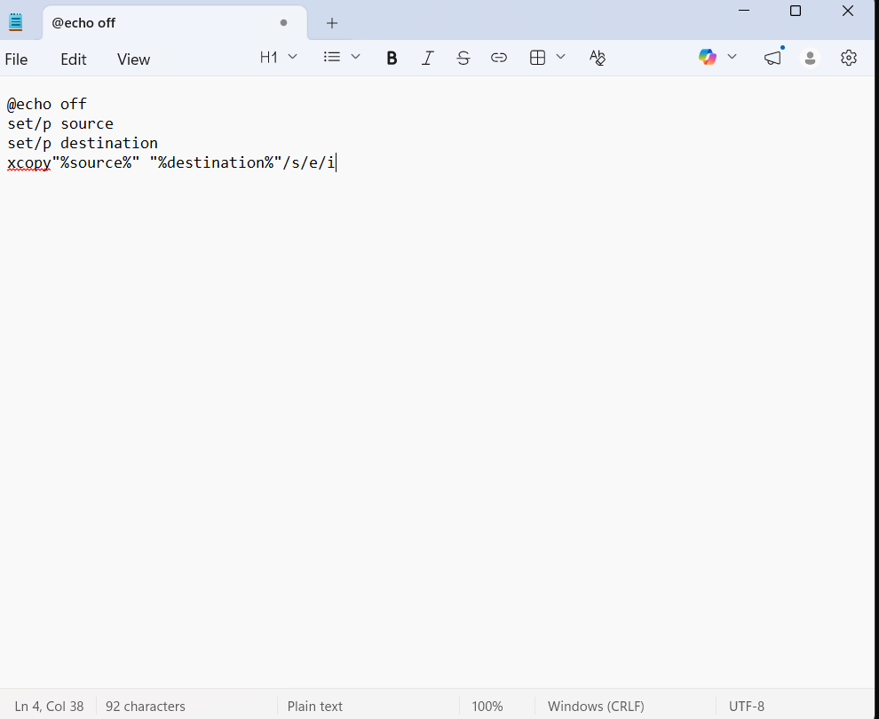

Figer 2: this screenshot displays the completed batch script in notepad, designed to automate the process of copying files from a source directory to a destination folder, it uses variables for user input and the xcopy command to perform the transfer.

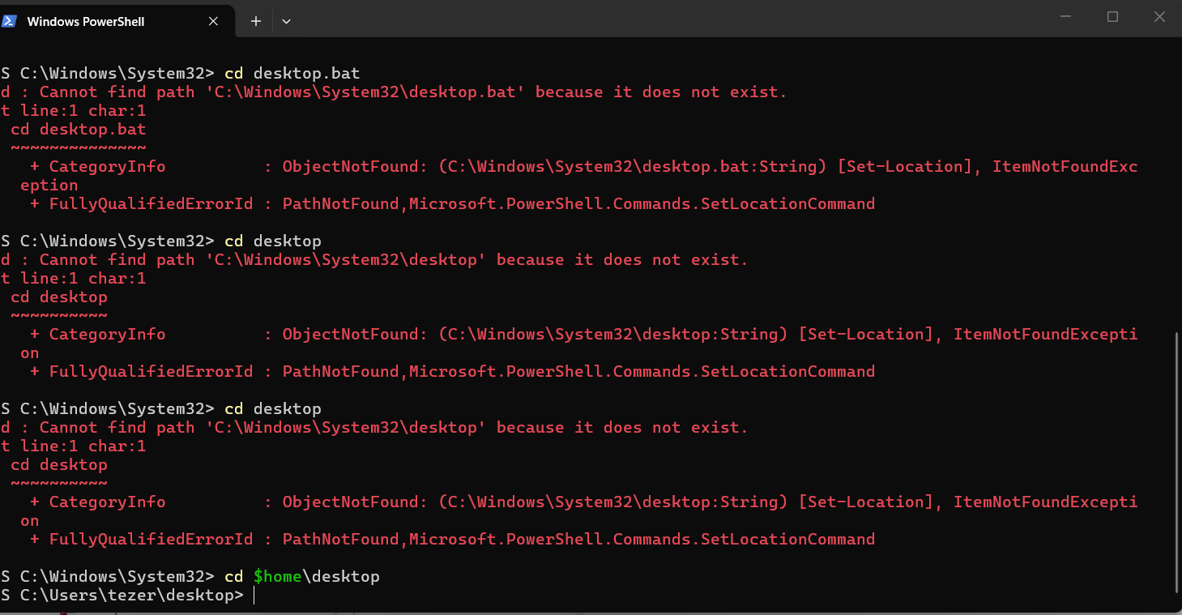

Figure 3: This screenshot shows that the current directory has been successfully changed to the Desktop folder, preparing the environment for command execution.

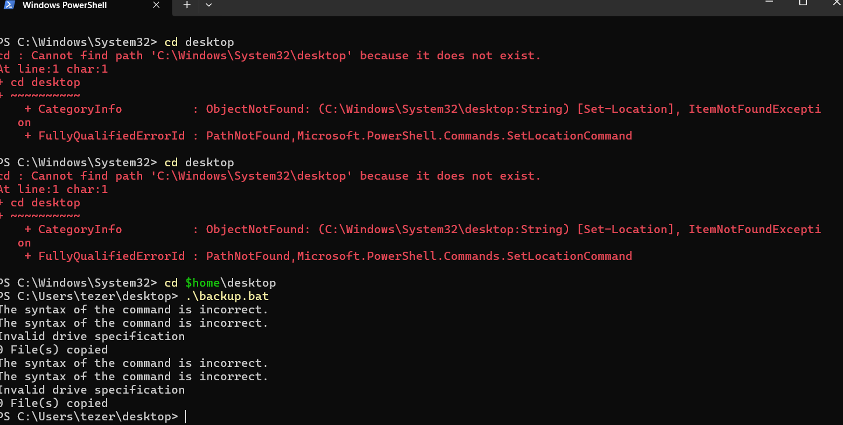

Figer 4: this screenshot captures the execution of the batch script, but indicates syntax error and an invalid drive specification showing that the code needs troubleshooting to fix the command structure

5. Use of Linux OS script
Linux scripts are small text packed with terminal command that allow us to automate everyday tasks instantly. Instead of typing out multiple commands one by one, you can save them into a single script file- usually written in a language called Bash-and run them all with a single action. System administrators and developers use these scripts to automate repetitive work. Like backup important data, updating system software, or managing user accounts. Because Linux is highly flexible, this script can easily handle complex conditions, such as running a specific toll only if a certain file exists.
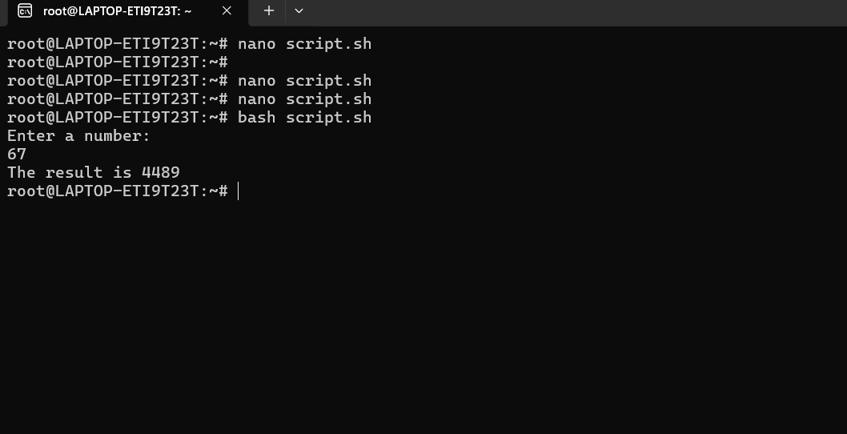
Figure 1: This is Linux OS script to check numbers if they are correct

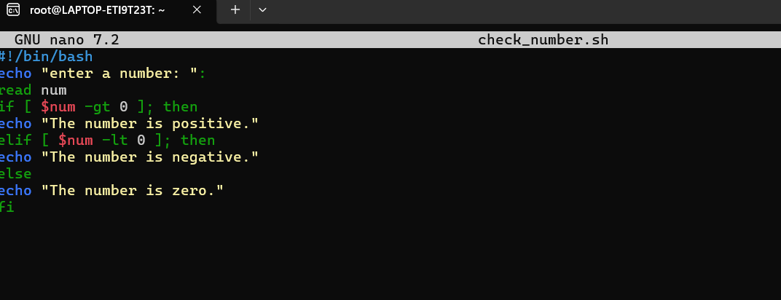
Figure 2: This is Linux OS script checking positive numbers if they are 0
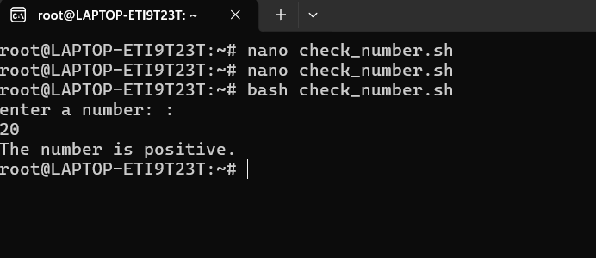
Figure 3: This is Linux OS script checking positive numbers if they are positive, it is positive.

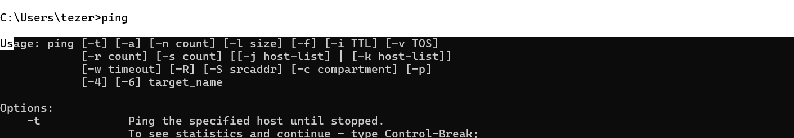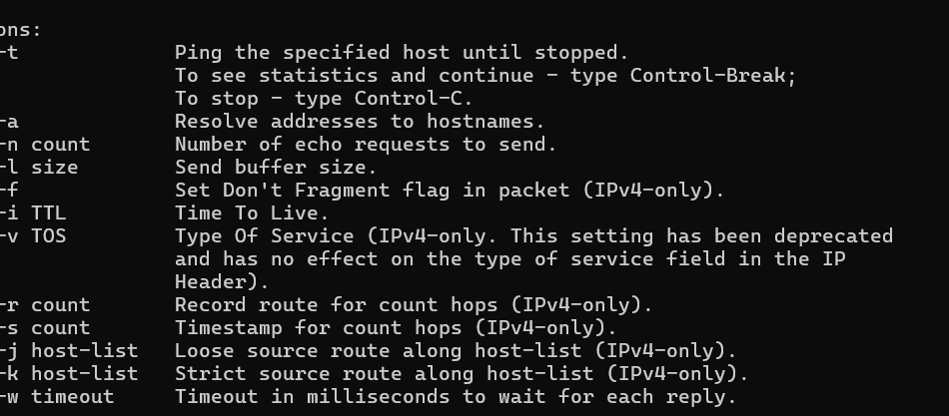
Figure 4: This tests connectivity to a host input and output result

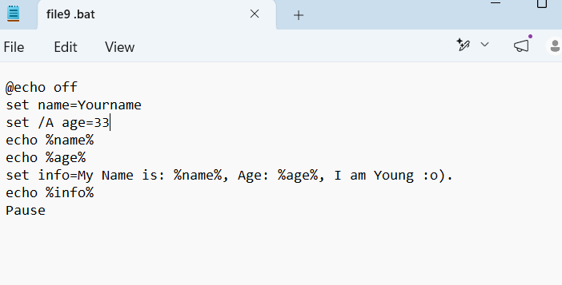
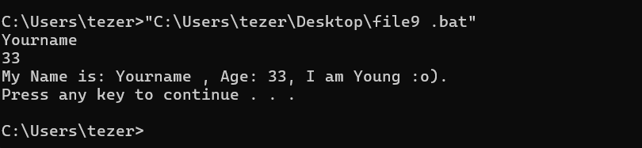
Figure 5: This tests connectivity to host input and output age 33 result

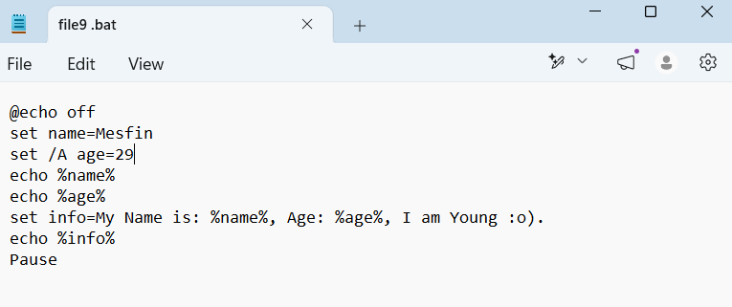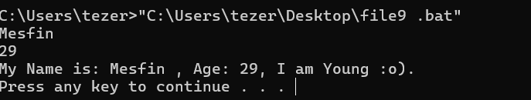
Figure 6: This tests connectivity to a host input and output age 29 result

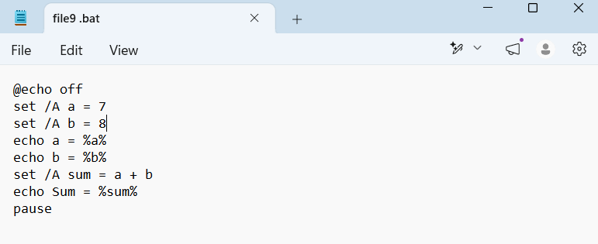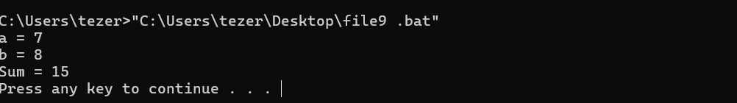
Figure 7: This tests connectivity to a host input and output 7+8 result

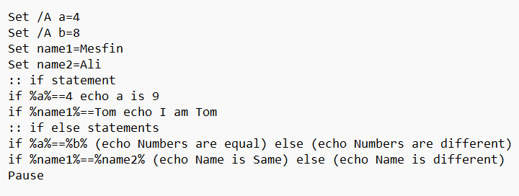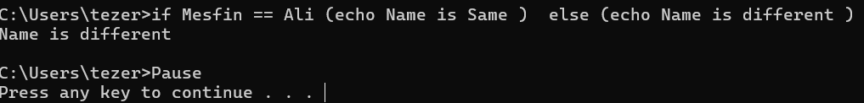
Figure 8: This tests connectivity to a host input and output Name similarity check result

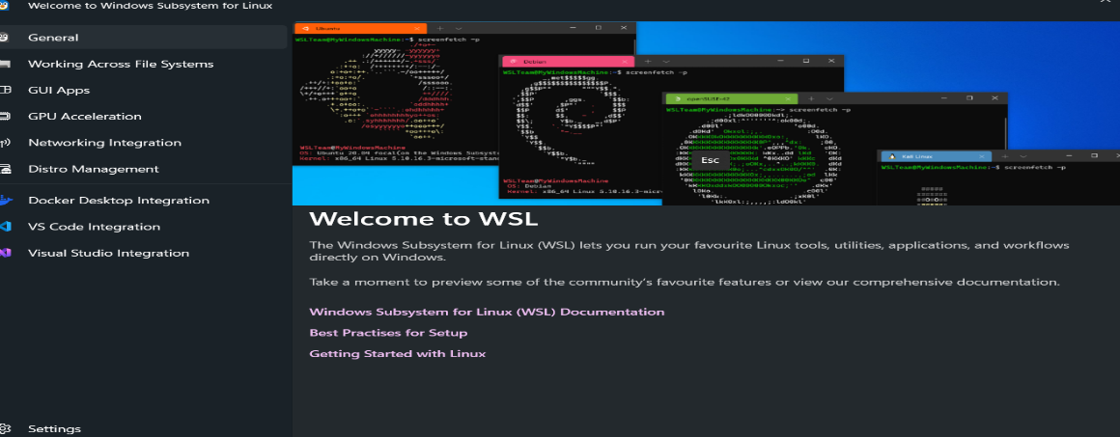
Figure 9: this image displays the “welcome to WSL” screen, which highlights the window subsystem for Linux, In the graphic section
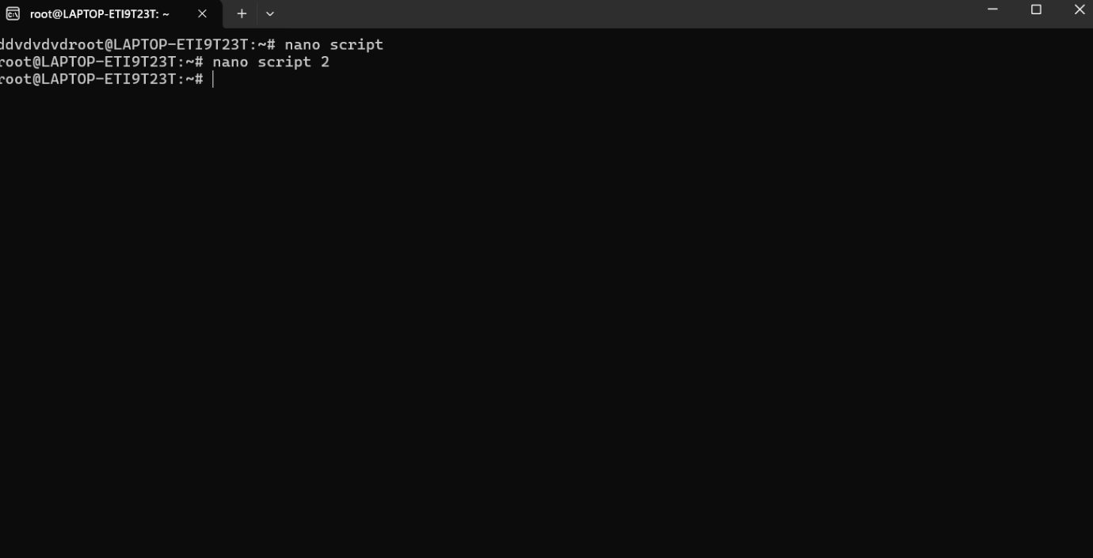
Figure 10: This image has a Linux command -line interface where the user is creating and managing script files. We can see the use of the nano text editor to edit script file.
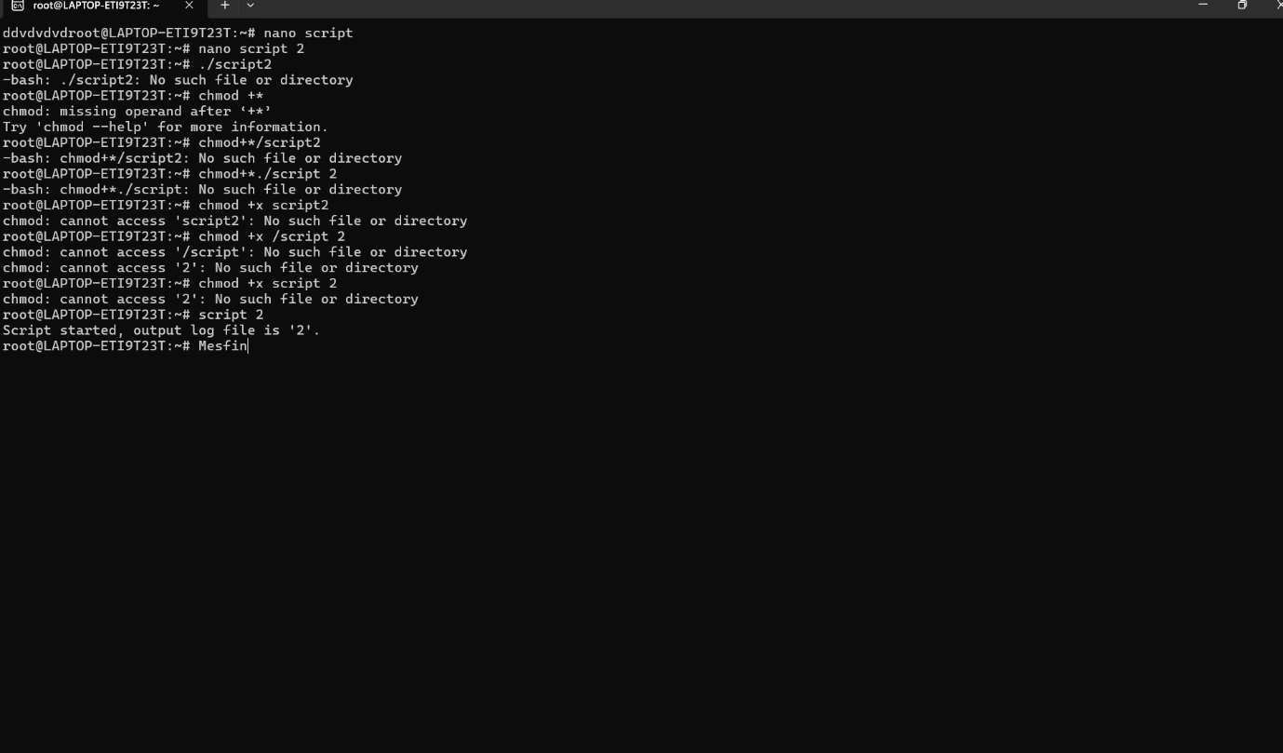
Figure 11: This image shows a bash script being edited with nano text editor in a Linux terminal. The script starts with the shebang line! /bin/bash. Which tells the system to use Bash shell to execute.

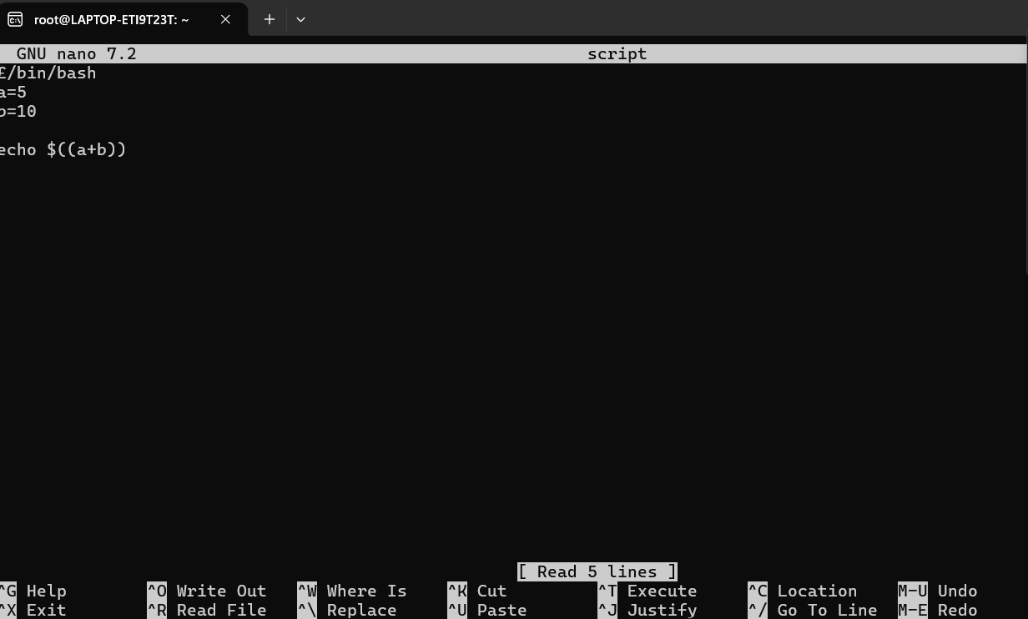
Figure 12: This image shows a bash script being edited with nano text editor in a Linux terminal. The script starts with the shebang line! /bin/bash. Which tells the system to use Bash shell to execute.
:
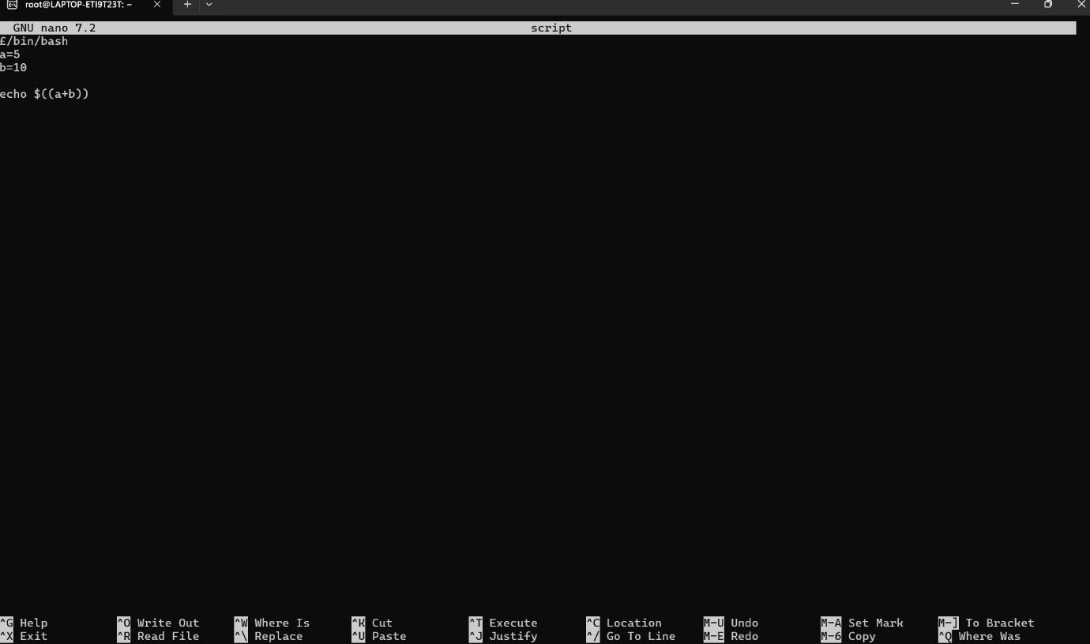
Figure 13: This image shows a bash script being eddied with the nano text editor in a Linux terminal. The script starts with the shebang line /bin/bash.

Conclusion
Process management serves as the essential traffic controller of the operating system-dynamically organizing active programs and dictating critical CPU time to keep the entire system running seamlessly. Working hand-to-hand, memory management strategically allocates and purges RAM space, ensuring that multiple high -demand applications can run simultaneously without ever crashing the system

References

[1] | W. Stallings, "Operating Systems. Internals and Design Principles," Operating Systems. Internals and Design Principles, vol. 1, no. 1, p. 1128 p., 2018. - .
[2] | A. SILBERSCHATZ, Operating system Concept, vol. 1, Yale University USA: 1, 2005, p. 1.
[3] | A. Silberschatz, Operating System Concepts, United States: 01 January 2001, January 2001.
[4] | "The protection of information in computer systems," The protection of information in computer systems, vol. Volume: 63, no. Issue: 9, p. 1, 2006-2009.

Evidence of engagement with 1 online certified course

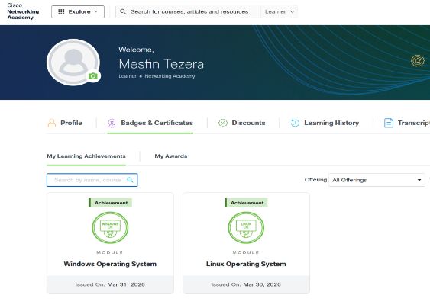


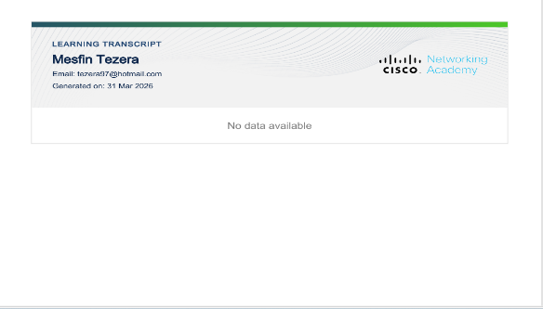

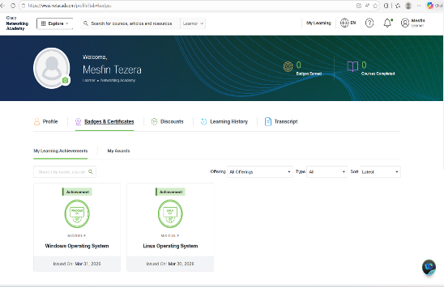

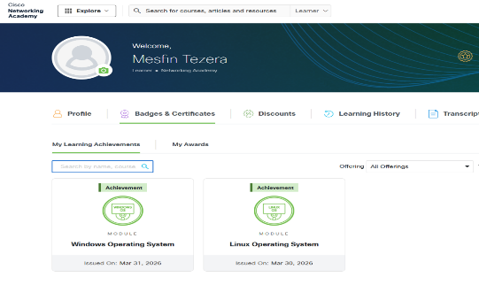

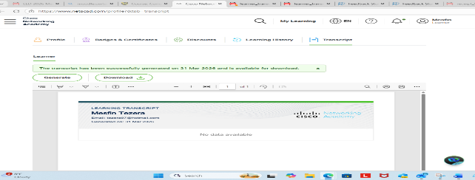
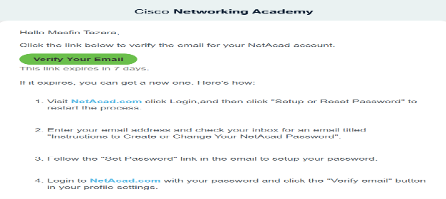

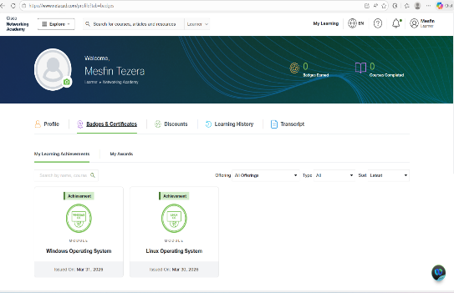

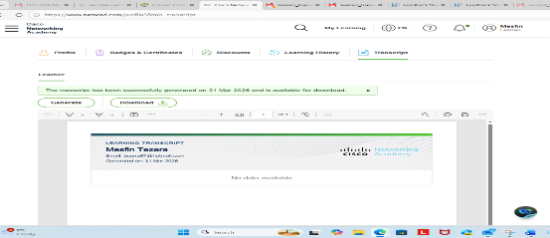

================================The End=============================

