Jolene Mann
STUDENT nO: 2011697

Strategic Management in Policing

BMPO 7004

Contents

Glossary of terms 2
Executive Summary 3
Introduction 4
Main findings 7
Strategic Position 7
Strategic Choices 19
Strategy in Action 22
Conclusion 27
Recommendations 28
Appendices 0
Appendix A - SWOT Analysis 0
Appendix B – PESTEL(O) Analysis 0
Appendix C – Stakeholder Mapping 0
Appendix D – Value Chain Analysis (VCA) 0
Appendix E - The Strategic Triangle 0
Appendix F – BSC Dyfed-Powys Police 0
Appendix G – Screenshot of Dyfed-Powys Power Bi Dashboard (PMF) 0
Appendix H – Strategic Performance Delivery Plan, Dyfed-Powys Police 0
Appendix I – Plan on a page 0
Appendix J – Governance structure for Dyfed-Powys Police 0
Appendix K – Visualisation of Performance Strategy Process 0
References 0

Glossary of terms

CDI Crime Data Integrity
DPP Dyfed-Powys Police
Force Dyfed-Powys Police
FMS Force Management Statement
HMICFRS Her Majesty’s Inspectorate of Constabulary and Fire & Rescue Service
MLT Motivating Language Theory
MTFP Medium Term Financial Plan
OPCC Office of Police Crime Commissioner
PCC Police Crime Commissioner
PESTEL Political, Economic, Sociological, Technological, Environmental, Legislative,
PMF Performance Management Framework
RBV Resource Based Value Theory
STM Strategic Triangle Model
SWOT Strengths, Weaknesses, Opportunities and Threats
VCA Value Chain Analysis
VIRO Valuable, inimitable, rare and organisational support framework

Executive Summary

This paper argues that in the complex environment in which policing operates, it is fundamental to plan ahead to meet future challenges, yet even with the best insights, these are pointless without a plan and a plan without a clear vision and purpose, of what the organisation are seeking to achieve, will fail. There is an abundance of research that offers credence to the notion that, strategic planning and clear visions help organisations accomplish greater success (Mayfield, Mayfield and Sharbrough, 2015 and George and Walker, 2019).
This paper concludes that strategic management is fundamental to improving police performance. Policing is faced with delivering services with less money, on a backdrop of rising public expectations and increased scrutiny, thus it is crucial for policing to govern its activities through a strategic plan to effectively manage its resources, finances, assets, people and objectives to deliver best value outcomes for the public and maintain legitimacy.

Introduction

Strategic planning became mandatory for policing 23-years-ago, yet, policing’s ability to do so, is held with scepticism over its increasingly fragmented approach to strategic management (Osborne, Radnor and Nasi, 2012) and its flawed history of implementation (Schafer, 2003).
To survive, policing needs to adapt (Biedenbacha and Soumlderholma, 2008) and whilst having a compelling strategy is a good start, alone its not enough (Ackoff, 1970). People are the driving force behind ensuring its success and how leaders execute strategic management, can either make or break an organisation.
Policing must build teams that are able to execute strategy and this relies on having a defined purpose that motivates people to act, an inspirational vision and an operating model that unlocks potential, along with integrated structures, systems and processes. Supporting delivery, a strategic plan acts as a guiding document (Rogers, McIntyre, and Caputo, 2020) that articulates the desired mission (Andreas, 2009) and ensures resources are aligned, capable and developed to deliver best public-service outcomes.
Strategy helps organisations shape their future, to move from where they currently are, to where they want to be (McKeown, 2020). Johnson, Scholes and Whittington (2005, p.6) agree, defining strategy as being ‘concerned with the long-term direction of an organisation’, with the ultimate aim of satisfying stakeholder expectations. Rumeldt (2012), goes a step further and frames strategy in terms of it being a flexible and coherent set of actions that address high-stake challenges.

Mintzberg, Ahlstrand and Lampel (2009) differentiate strategic management into ten schools of thought and within the literature, it strengthens the notion that strategic planning is not a single entity, it comprises a multitude of deliberate activities, concepts, tools, procedures and resources required to accomplish strategic objectives (Bryson, 2011). The schools are explored within the paper.
Research of Andrews, Boyne, Law and Walker (2012), shows that strategic management and strategic planning make a positive difference to organisational peformance (George and Walker, 2019), in this context, Johnson et al. (2005, p.16), define strategic management as underpinned by three interlinked areas; ‘strategic-position’, making ‘strategic-choices’ and turning ‘strategy-into-action’ (figure 1).
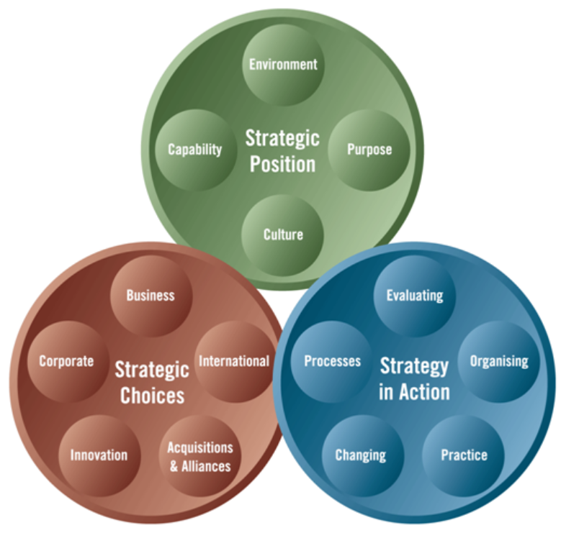

Figure 1 - Exploring Strategy Model (Johnson, Whittington and Scholes, 2012, p.10)

The purpose of this paper is to consider strategic management theories in development of a performance plan for Dyfed-Powys Police (DPP).
Herein, it has been constructive, to apply the exploring strategy model as subheading discussion points and to consider the key components, alongside the API Model (figure 2) (NPCC, 2019) and supporting literature.
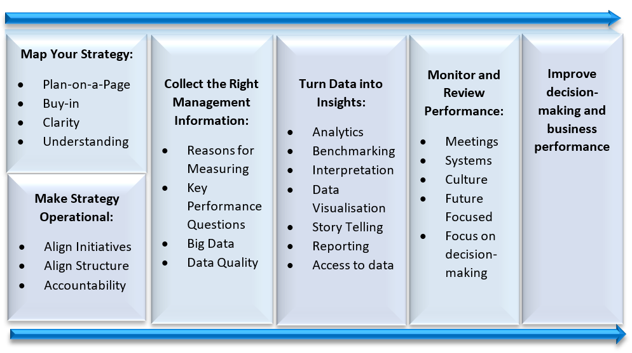

Figure 2 - API Model (NPCC, 2019, p.23)

Main findings

Strategic Position
People won’t embrace change unless they understand why they need to, by asking fundamental questions in the development of strategy, the answers will enable employees to understand the necessity for change (Kotter, 1995) and the organisations eyes are widened to consider the past, the present and the future, thus empowering intuitive learning to emerge (Mintzberg, 1987) and consequently, a sense of urgency is created, encouraging employees to take action (Kotter, 1995).
Findings from an inspection (HMICFRS , 2021a), identified a critical shortcoming in performance, DPP were recording 87.6% of all reported crime, meaning annually approximately 4,400 crimes were not recorded, worringly so, this included domestic abuse victims. This posed a signficant risk to the most vulnerable and DPPs reputation.
To fully understand the reason behind these issues, it is prudent to establish the root cause. McKeown (2020) sets out key questions (figure 3) for organisations to determine their environmental position and to diagnose barriers that could hinder the change pathway. McKeown (2020) cites when the questions are answered honestly it enables an organisation to look inward, outward and forward to see the bigger picture. Mintzberg, Ahlstrand and Lampel (2009) agree, yet go a step further, when making decisions, a predetermined course into unchartered waters could hide future risks, thus its crucial organisations correspondingly adopt a holistic view that also looks sideways.

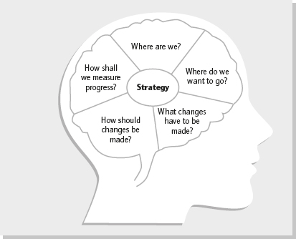

Figure 3 - Strategy questions (McKeown, 2020, p.176)
The first step for key stakeholders is to collectively evaluate DPPs current position in terms of analysing the validity of its vision, mission and values and through open questions, forge a shared understanding of DPPs internal and external environment and agree what future success looks like.
According to Ferlie and Ongaro (2015), organisational success is reliant on the achievement of a fit between its capabilities and the external environment. Thus, its prudent for DPP to draw on the ‘The Design School’ notion (Andrews, 1971) represented by Mintzberg et al. (2009, p.24), when developing a performance plan. The school implies that strategy governs structure and thus prior to the creation of strategy, it is cruical an appraisal is carried out, to understand the organisations internal and external position.

Applying theory, SWOT analysis enabled a thematic diagnosis of DPPs strengths, weaknesses, opportunities and threats to be completed (Johnson et al., 2012). The analysis yielded evidence, that DPP had no Performance Management Framework (PMF) and the governance structure was failing to ensure accountability, resulting in a loss of strategic direction (Appendix A). Analysis showed DPP, had aligned performance management solely against the Police and Crime Plan (P&CP) objectives which span over a four-year period, thereby strategy had become politically affiliated, it had remained largely unchanged and failed to adapt to the changing environment.
Consequently, ‘strategic drift’ had emerged (Johnson, 1987 cited in Mintzberg et al., 2009, p. 236), with DPP failing to keep up with the pace of change and it had settled into a state of flux (Johnson et al., 2005, p. 582). Thus, performance and morale had deteriorated, responsibilities were fragmented and there was no clear direction.
According to Espindola and Wright (2021) rapidly changing environments are unforgiving of slow-moving strategies. Johnson et al. (2005) agree, stagnant strategies that fail to adapt, result in uncertainty and derailment and one would argue this is true for DPP.
On reflection, SWOT analysis is rigid and omits to capture past and present learning. Johnson et al. (2005), support this notion, the listing of strengths and weaknesses can become over-generalised and provide meaningless analysis. Whilst there is cynicism, SWOT remains favoured within strategic management literature and worthy of consideration in the development of a plan.

Additionally, SWOT analysis showed historic policing practices had profound influence on the attitude towards performance management, resulting in nervousness around monitoring and targeting (Home Office, 2015). Historically, policing was target driven and performance was weighted against set indicators such as arrests and detections (Davies, 2012). The 1990s Public Service Agreements, introduced national targets and as a consequence, perverse cultures and incentivies emerged that caused distrust between the police and public (Eterno and Silverman, 2012). Consequently, targets were removed, yet recently national league tables are relaunched to measure the effectiveness of call-handling (Home Office, 2021a). Whittington, Regnér, Angwin, Johnson and Scholes (2021), cite the significance of learning from historical relationships, as they form an affiliation with strategy formation today. This notion is extremely pertinent for consideration in developing the performance plan.
In addition, the design-school endorses the PESTEL model (Ferlie and Ongaro, 2015) to scan the political, economic, sociological, technological, environmental and legislative influences that impact the organisation. Supporting this notion, Johnson et al. (2005) argue, in a climate of uncertainty, PESTEL encourages horizon scanning, which proves fruitful to determine a long-term view of strategy. Thus, PESTEL would be prudent to adopt when developing a plan (Appendix B).
The positioning school correlates the linking of strategic management and performance through the application of Porter’s Value Chain Analysis (VCA) (Mintzberg et al., 2009) of which proves advantageous for strategic planning across policing, to determine how well the organisation are doing, by analysing activities and the governance structure to determine how they interact with one another to deliver best public value outcomes (Ferlie and Ongaro, 2015).
Yet, Mintzberg (1994) argues to the contrary, strategic planning does not guarantee improved strategic thinking (Mintzberg, 1994) and raised scepticism about its effectiveness on improving peformance (Mintzberg and Waters, 1985).
Amongst the conflicting nuances, the notion of strategic planning is still very much alive (George and Walker, 2019). Supporting evidence appears in a study by Jung and Lee (2013), that when combined, goal-setting and strategic planning are central to driving organisational performance, supporting this notion, DuPont-morales and Harris (1994), argue that merging planning and performance strengthens the bond of answerability between public-bodies and the public and in support, research by Andrews et al. (2012) found organisations with strategic planning outperformed those without.
Furthermore, Elliot et al. (2020) provide research, strategic planning contributes to performance and one agrees, DPP have been operating without a performance strategy and evidently, the lack of strategic direction has resulted in inadequate performance, yet, cognisance is also given to arguments, that planning is not a singular determining factor, as legitimacy, transparency and accountability also contribute to good performance (Ferlie and Ongaro, 2015).
The need for change has resonated with the new chief constable and the pause button has been pressed. The next step is for Chief Officers and key stakeholders to form a guiding coalition to set a future intent through a clear statement of purpose detailed within its vision, mission and values (Grant and King, 1982., and Kotter, 1995). This will support DPP to define and explain its purpose to the workforce, stakeholders and the communities it serves and act as an anchor-point of reference to focus minds (Bovaird and Loeffler, 2016).
A vision sets out what an organisation is seeking to achieve, whereas a mission stipulates the overall purpose (Johnson et al., 2005). Accompanying both, are values, these reflect what an organisation stands for and sit deep within its culture (Johnson et al., 2012). The findings of HMICFRS (2021b) show, there is a lack of understanding across DPPs workforce of its mission and vision, see (figure 4).
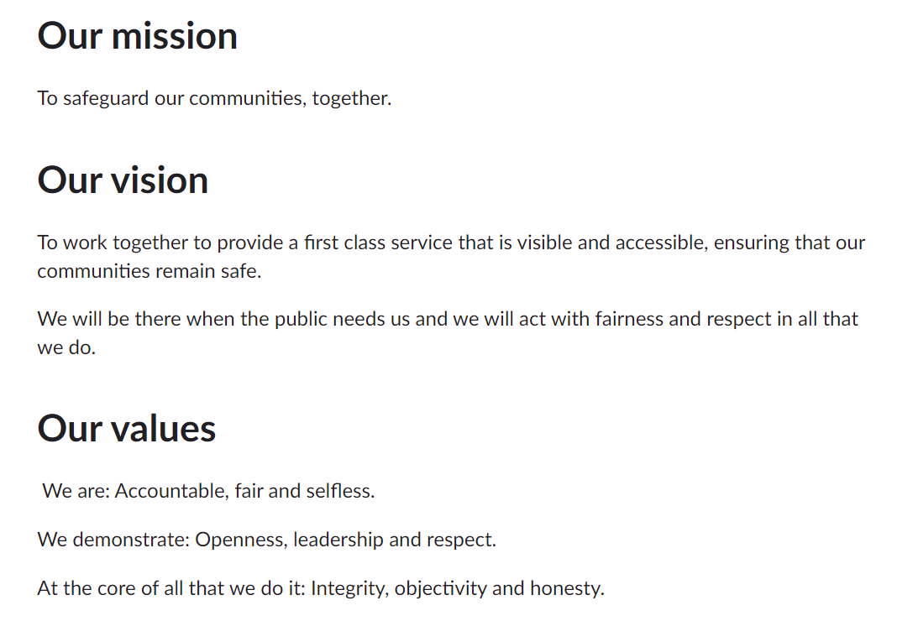

Figure 4 - Mission and Vision (DPP, 2021)
In critique, the vision is too long and thus plausible, to have become distorted through different interpretations (Borum, 2004) and the mission is unclear of DPPs purpose. Conger (1991) advocates framing, bold, memorable and punchy visions to hit the target. Additionally, DPPs values replicate Code of Ethics principles (COE, 2014) and therefore, are impersonal and dont resonate with the workforces’ identity, when values are generic, they become valueless (McKeown, 2020).
In developing a vision for DPPs performance strategy, it’s prudent for it to be kept simple and for it to be aligned to the Chief Constables vision and delivery plan. The Chief Constable has committed to 100-days of stakeholder engagement to establish perspectives and expectations to inform the future vision, mission, values and objectives.
Language is a powerful dynamic that must not be overlooked, thus Leaders must remain conscious of the language they use, for negative connotations breed resistance (Johnson et al. 2005). Change must be spoken about positively, Sullivan (1988) argues, leaders that use motivational language, better engage and create shared visions with employees, thus improving performance and engendering organisational pride (Dowling and Moran, 2012). As such, it’s prudent to adopt the fundamentals of Motivating Language Theory (MLT) (Sullivan, 1988), to form the basis of a communication strategy, to provide clarity to stakeholders of the performance strategy objectives and to keep the workforce informed and focused.
Supporting literature shows, that active employee engagement and participation is key to building commitment and improving productivity and therefore, is a prudent consideration for the plan (Gottschalk and Gudmundsen, 2009 and Mayfield and Mayfield, 2012). Cialdini (2007), cites supporting research, that daily engagement persuades employees to buy-into organisational vision. Moreover, engagement activities will provided a hollistic overview of how performance is percieved and managed across the organisation and it will tease out barriers that could undermine the vision. Alarmingly, research shows, that 70% of strategies fail through poor engagement and execution (Niven, 2008, p.9).
In the plans development, its prudent to apply the feasiblity test (Goold and Campbell, 2002), to consider constraints that could derail implementation, e.g. DPP have procured a Niche-Records Management System, an IT platform that will change the way information is recorded, held and stored. A go-live date is scheduled for 2023, inevitably this hinders DPPs ability to develop and implement cloud-based performance products and is a key consideration for implementation.
Drawing on literature, McKeown (2020) argues individuals have different motivators, some are driven by aspirational visions, others align themselves to the mission they seek to achieve, others seek goals, whilst others are stirred by values, all are key considerations when developing the plan (figure 5). Complimenting this notion, Maxwell (2019) argues, there are varying levels of vision and no matter how well defined a vision is, some can’t see it (the wanderers), some see it but need a nudge to pursue it, whereas, others fully embrace it and help others see it (leaders). Drawing on these notions, leaders need to promptly identify the wanderers to sell the vision and explain how their role contributes to achieving overall objectives.
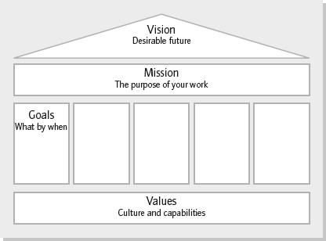

Figure 5 - House of Strategy (McKeown, 2020, p.238)
Culture is one of the most powerful forces on the planet in determining organisational success, yet the finer intricacies of how to influence it remain mysterious (Coyle, 2018). According to Mintzberg et al. (2009) culture is formed on a range of values, beliefs and assumptions that are shared by people and these become shaped by routines.
The performance of DPP had manifested into a notion thats lacked direction and ownership (HMICFRS, 2021b). Drawing on culture-layers theory (Johnson et al., 2005), a number of taken-for-granted assumptions had emerged, people shurked responsibility for performance that sat outside their areas of business, e.g., there was an assumption that Crime Data Integrity (CDI), sat with the Crime Audit Team and therefore, their issue to address. Competitive behaviours emerged, with business leads aiming to make their own areas look good. There was a belief and acceptance accountability, would sit with the business lead, yet this stance was out of kilter with DPPs values of selflessness and accountability.
To ignore cultural layers, when developing the plan would be foolish, as inevitably they undermine service-delivery. Supporting research appears in Appelbaum, Habashy, Malo and Hisham (2012), that 80% of change efforts fail because of cultural ignorance, put simply culture can make or destroy an organisation.
In this regard, ‘The Cultural School’ (Ferlie and Ongaro, 2015), reinforces the need for meaningful engagement to develop shared values. According to Kotter (1995), to effectively implement change, leaders must sell and anchor the mindset change and in this context, honest communications about the hardhitting facts will reinforce that performance is everyones responsibility and everyone must pull together, to do the right thing (NPCC, 2019), for if they don’t, victims will continue to be let down.
National cultures inevitably impact corporate cultures (Hammerick and Lewis, 2013), E.g., policing is non-devolved, thus DPP are influenced at a national level by the conservative governments ‘catch-and-convict’ ethos (Home Office, 2021a) and regionally Welsh Government (2017) endorse a culture of rehabilitation and diversion. In this regard, its prudent to consider the impact of varying stakeholder cultures on the plan, as these can either clash or act as blindspots, causing strategy to fail (Police Review, 1994 and Johnson et al., 2005)
Drawing on ‘Cultural Web’ theory (Johnson et al., 2005, p.99), its beneficial to delve into cultural assumptions. As aforementioned, DPP had a ‘paradigm’ that performance issues, were isolated to specific business areas and when considering the impact of ‘control-systems’, ‘power-structures’ and ‘organisational-structures’, one would argue the governance structure had merged to fit the paradigm e.g. performance issues, were being discussed in governance boards aligned soley to that business areas, thus encouraging willful blindness.
In supporting research by Rick (2013), culture will eat all that it destroys, including governance, put simply; strategy adopts a guiding path, whereas culture acts as a driving force that surpasses strategy everytime (figure 6).

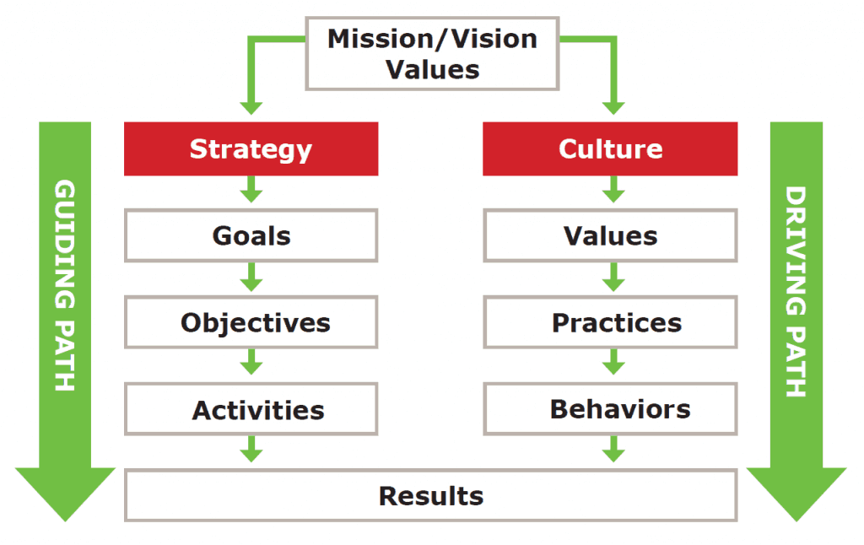

Figure 6 - Alignment (Rick, 2013)
It would be prudent to bring together a diverse group of individuals, that have the requisite skills, experience, power and knowledge to influence and make the changes happen (Kotter, 1995). Furthermore, its key for the team to be diverse in thought. Heffernan (2012), says surrounding yourself with people that challenge decisions, enables best thinking to emerge.
Strategy requires commitment from the top (Jung and Lee, 2013), thus the Chief Constable has committed long-term investment and has increased capacity within a centralised team of specalists. In the formation of the team, cognisance is given to theory of Tuckman and Jensen (1977), teams need time to bond before they become effective, this is a key consideration to manage realistic expectations for strategic delivery.
Next, its prudent to use stakeholder-mapping and power/interest matrix to identify stakeholders with the greatest influence and needs (Johnson et al., 2005) to evaluate levels of victim and stakeholder satisfaction. Furthermore, this will inform the communication strategy by rationalising engagement prioritisation e.g. engaging with key-players first (Appendix C).
Then, its prudent to draw on Resource-Based View (RBV) theory, as this will enable DPP to look within itself to develop and capitalise on available resource to achieve sustainable competitive advangage (Barney, 1991 and Furr and Eisenhardt, 2021). Whilst policing does not seek competitive advantage as such (Mulgan, 2010), it does seek to create resource efficencies on a backdrop of reduced budgets, by improving capabilities to create best value (Hansen and Ferlie, 2016). Complementing RBV theory, its prudent to apply ‘The People Test, to establish if DPP have the right people, in the right place to make the plan work (Goold and Campbell, 2002). In this context, DPP utilise response profiler, a process-evolution simulation model, as an evidence-base to create best value by identify opportunites to reduce waste-demand, make cost-savings, identify skills gaps and to rebalance utilisation rates by aligning resources to areas of greatest need.
Supplementing the environmental picture, its prudent to apply the Valuable, Rare, Inimitable and Organisational support (VRIO) framework (Barney, 1991 and Johnson et al., 2012) to distinguish the resources and capabilities available that create best-value and efficiencies (Barney, 1995).
Whilst the framework argues resources need to be rare and inimitable to give the organisation a competitive edge, this notion is not wholly compatible (Hansen and Ferlie, 2016), for policing is legislated to collaborate (Home Office, 2012) and its not in the publics interest to be protective over resource.
The need for collaborative planning (Bryson et al., 2018) is imperative now more than ever (Mintzberg, 2015) and in this regard, to deliver long-term, sustainable solutions in line with the performance strategy, a whole-system approach is to be considered to the pooling of resource and assets to deliver best public-value.
A dynamic application of RBV and VIRO, is more suited to policing, with emphasis on integration, development and reconfiguration of resources (Eisenhardt and Martin, 2000), to ensure the force are in a strong postion to meet future challenges (Teece et al., 1997).

Strategic Choices

Next, its prudent to determine the path to be followed. Drawing on the theory of Whittington, Regnér, Angwin, Johnson and Scholes (2020), there are four criterion to identify the best options; suitability, acceptability, feasiblity and evaluation, these are explored within the paper.
Firstly, applying suitability criterion, throughout the process, its prudent to consider if the proposed options, address the key opportunities, threats and constraints identified within the aforementioned environmental analysis of DPPs strategic position.
One acknowledges, that strategy cannot be a solo-sport (McKeown, 2020), its most effective when people of all levels are involved, yet due to the nature of policing, it blends itself to design-school assumptions, that organisations are hierarchical (Johnson et al., 2005). The Chief Constable is seen as the primary determinant (Finkelstein and Hambrick, 1996) at the apex making significant decisions (Mintzberg et al., 2009).
Decisions filter down the hierarchical structure, until they become implemented by middle-management positions. Elliot et al. (2020) define middle-management to range from Chief Superintendent to Inspector and direction filters down to Sergeants in their supervisory roles and subsequently, to lower-ranked personnel, that carryout the strategy decided at the top (Johnson et al., 2005).
Broadly speaking, policings top-leadership positions are far removed and have fundamentaly different perceptions to front-line practitioners, thus a top-down approach is potentially one of the greatest fallacies in strategic management (McKeown, 2020 and Carpenter and Saunders, 2009), often resulting in officer push-back, resistence and confusion. Mintzberg et al. (2009) raise scepticism, citing when thinking is done at the top and the doing is carried out lower-down there will be a disconnect in implementation. Kotter (1995) argues to the contrary, endorsing a top-down, leader-centric approach.
Considering the literature, its prudent to opt for a hybrid approach. The plan requires commitment from top-level management, however decisions, planning and implemention are to be driven by middle-managers, for they have a sound understanding of operational and organisational needs and their experience will ensure the plan is achievable.
The ethos of the performance plan, is to deliver better outcomes for victims and the public, as such, before making choices, its key to determine if DPPs assets are in the right place, to deliver public value. The aforementioned VCA is a key concept to adopt, in terms of analysing the combined value of DPPs activities against the value of service delivered to the public. Drawing on literature, this notion holds true to the public-value concept, defined by Moore (1995), the overall aim in the public-sector is to create public-value based on public needs (HM Treasury, 2019). However, therein lies the issue, today there may be certainty over the values, but tomorrow uncertainties will emerge as public and political needs change. Yet, despite these ambiguities policing needs to be able to account for the value of its activities.
Day-to-day policing activities, consume public money, thus it should touched with scrupulous transparency and managed effectively (ICAEW, 2018). If DPP are unable to account for the value of its activities, legitimacy will be diminished (Moore, 1995). It would be prudent to integrate the plan with the Medium Term Financial Plan and Force Management Statement, for this will incorporate foresight to inform decision-making (Bryson, 2011) and it will make best use of finite resource, by aligning capacity against DPPs greatest risks.
Furthermore, the Strategic Triangle Model (STM), will help DPP evaluate the impact of public value against the plan (Moore, 1995). This would act as a sense-check, to analyse if the plan was making a difference and to assess how effective resources, process and structures are, in achieving public value outcomes (Collis, 2021) (Appendix E). Yet, cognisance is given to the conflicting view of Benington (2010), that the model may prove difficult to operationalise. Considering this argument, whilst the concept is sound, caution must be applied, for it may prove problematic, to determine public value across multiple communities, as all have varying needs.
It would be prudent for the plan to be deliberate in formation, built around regulation, funding, technological and resource constraints (Johnsen, 2015), yet one acknowledges that due to the unpredictability of policing the intended strategy may become emergent, as policing inevitably learns and adapts with the passing of time (Mintzberg et al., 2009). Furthermore, it must incorporate flexiblity, as strategies often emerge as a result of political or external influence e.g., Violence Against Women and Girls agenda and the Black Lives Matter movement, necessitated policing to adopt emergent strategies to maintain public safety and address calls for greater scrutiny (Rogers et al., 2020 and Goold and Campbell, 2002).

Strategy in Action

Policing has a well-defined hierarchical structure, with clear roles and responsibilities and one of its core strengths, is its ability to respond to spontaneous incidents through a well-rehearsed command structure. Whilst policing has the ability to lean on its hierarchical structure to implement change, one acknowledges hierarchy can hinder lower-level innovation and participation (Mintzberg et al., 2009).
Next, for the plan to be effectively implemented, it is prudent that DPPs structures and systems are reconfigured Drawing on design-school assumptions, Mintzberg et al. (2009, p.33), when a new strategy is formed, structures must be considered anew, for ‘structure follows strategy’. McKeown (2020) agrees, that if you change strategy but don’t change structure, it will prove fruitless.
Reflecting on aforementioned environmental analysis, the governance structure for DPP, is overly complex with performance loosely aligned (HMICFRS, 2021b), (Appendix J). This is a contributing factor to DPPs underperformance, resulting in diminished responsiblities that have been intensified by having no performance strategy. Johnson et al. (2005) argue, governance structures are pivotal to strategy development and are fundamental in determining priorities, service outcomes and accountability. With this in mind, it is prudent for a streamlined (meeting and reporting) structure to be put in place that is strategically aligned to the performance strategy.

Drawing on the literature, DPP operates a hybrid functional and divisional structure (Johnson et al., 2005). Within the functional arm, DPP is divided into areas of responsibility and specialist functions are centralised to Headquarters. This affords centralised direction, yet in critique, force performance has fallen between gaps, for it has sat under two different corporate functions, thus responsibilities have been diluted and ownership lost. Under the new strategy, performance management is to sit solely under Corporate services.
Within the divisional arm, the Chief Constable is strategically positioned at the apex and directly below are centralised support services that are predominantly controlled by Headquarters and sitting below are local divisional functions that have been divided into geographical policing areas.
On reflection, one would argue, that whilst efforts are made to centrally govern, there is a danger of fragmentation, with areas becoming their own ‘mini’ forces, all operating within different processes, in different directions, focused on different local priorities and all within different micro-cultures. These factors must be taken into consideration to drive a consistent performance management approach.
To execute the plan DPPs top-leaders have a fundamental role to play (Mayfield, et al., 2015) in encouraging employees to enact the vision (Kotter, 1995). This can only be truly achieved through leaders advocating and talking about the new vision, with employees to encourage open dialogue about the why, what and how (Appelbaum et al., 2012). Leaders must listen to concerns and unembellished truths (Zweifel and Borey, 2014), for this will tease out barriers that could undermine the new approach.
Yet, one acknowledges, ‘how vision is communicated, becomes just as important as to what is communicated’ (Westley and Mintzberg, 1989, p.19) and one would argue in favour of a transformational leadership approach to cultivate particpation (NPIA, 2011). There is an abundance of literature, evidencing that transformational leaders inspire others to achieve organisational goals (Capon, 2008).
Strategy implementation is a challenge, often leaders perceve employees have a sound knowledge of prioirites, yet in reality the percentage is extremely low (Coyle, 2018). To raise awareness, its prudent leaders check and test awareness amongst the workforce and to communicate the vision and objectives at every given opportunity– on walls, emails, in conversations and repeated over and over (Coyle, 2018) until it flows through the organisations bloodstream.
People make strategy happen and its fundamental that staff appraisals are aligned to the performance strategy, force objectives and personal goals, as this will add value to measure and improve performance, and support development and wellbeing (Johnson et al., 2005). Underpinning the plan, a culture that rewards good work is key, for effective recognition can be just as motivational as finanical incentives (Kalyal, Huey, Blaskovits and Bennell, 2020).
Furthermore, ‘best-in-class benchmarking’ (Johnson et al, 2005, p.145 and Osborne and Gaebler, 1992), provides DPP with a method of comparison with others and enables methods of best-practice to be identified. In this context, Merseyside Police are viewed as outstanding at performance management and through consultation, bestpractice ideas and arguments for change have been captured and presented to DPPs Chief Officer Group for consideration.
In the plan it is important to keep things simple, to focus on the things that matter. Performance metrics both qualitative and quantitative, should be succinct and add value to enable actions and interventions to be put in place to deliver desired outcomes. This is more productive than pursuing a wide range of actions in an unfocussed way, as it could dissipate momentum and create confusion (NIAO, 2018).
One would opt, to use the ‘Balanced Scorecard’ (BCU) as a performance framework for the plan. Thus, enabling a multi-dimensional perspective of performance to be gleamed (Ljungholm, 2015).
Literature advocates, BSC to be a well established tool that translates the vision, mission and values into definitive objectives and measures (Niven, 2008 and Ferlie and Ongaro, 2015) and incorporates a whole-system overview, of finance, learning, people, performance and processes (Awadallah and Allam, 2015). In practice, quadrants based on the forces strategic objectives are broken down and areas of focus identified (Appendix F).
Within the plan, Performance Questions (PQs) will support delivery and PowerBi data-visualisation dashboards will encaptulate, the Key Performance Indicators (KPIs) and outcomes (Appendix G and H). Identifying the right metrics and management information is key, literature shows inadequate metrics, make it nigh-on-impossible to evaluate progress (Ferlie and Ongaro, 2015). Bovaird and Loeffler (2016), argue, whilst people support performance being measured, many don’t want their individual performance reported and in this regard, sensitivies must be factored into the plan to maximise learning and participation.
For the plan to make a real difference, it needs to be a living framework that that guides activities (Schraeder, 2002). The dashboard will enable the force to measure and monitor performance outcomes and outputs live-time and insightful analysis will support data driven decision-making (EFQM, 2021). Furthermore the insights will enable prompt learning and development to occur from what works and what doesn’t (Bryson et al., 2018). The dashboard will act as a self-service system, electronically connecting employees directly to the performance strategy (Zweifel and Borey, 2014) thus encouraging wider ownership and responsibility (Appendix G).
Strategy visualisation curtails information overload, thus, its prudent to develop a plan on a page to provide absolute clarity of the of DPPs vision (Eppler and Platts, 2009) (Appendix I).
Lastly, its fundamental to regularly review and monitor the plan, to establish if its achieving strategic objectives (Kotter, 1995) and to determine if a change of direction is required. Knowing when to concede, is a strategic management strength, for continuing with a strategy that no longer adds public value is foolish. (Espindola and Wright, 2021).

Conclusion

In conclusion, it is evident that strategic management is critical to improving performance across policing. Through a lack of strategy, Dyfed-Powys Police had lost its way, resulting in wide-spread confusion over strategic direction, a lack of ownership and accountability over performance, with leaders pulling in different directions but most worryingly so, the force had let victims and its communities down.
The pause button has been pressed and strategic direction will be imminently re-set, thus presenting a great opportunity for a performance strategy and supporting performance framework to be introduced to bolster the Chief Constables vision.
Drawing on the research of this paper, one has visually presented the strategic management models that have proven fundamental to these findings; see (Appendix K).

Recommendations

- Performance Management:
- Introduction of a performance strategy and performance management framework (PMF) which is built around key priorities for DPP and its communities.
- Governance and Accountability:
- Immediate review of the force governance structure, to streamline and align to the performance strategy. This will encourage a culture of everyone taking responsibility for performance.
- Immediate restructure of departmental and force led performance meetings. To ensure there is synergy and consistency, thus maximising a corporate approach to performance management.
- Strategic Clarity:
- Implementation of a clearly defined Vision, Mission and Values is that resonates with the workforce and provide absolute clarity over DPPs purpose.

Appendices

Appendix A - SWOT Analysis

SWOT Analysis
Dyfed-Powys Police
STRENGTHS | WEAKNESSES
- The Force Management Statement (FMS) is aligned to the Medium-Term Financial Planning Cycle (MTFP).  - The Force have invested in a new response and investigation model, that went live in November 2021 (End-to-End), this places the force in an improved position in terms of increasing capacity, reducing waste and demand and ensuring resources are better aligned to meet demand. Improved victims’ satisfaction and user expectations.  - The pandemic has changed working practices including increased agile working arrangements, desk-based investigations and electronic witness statements. This has seen the method in which the public contact the police change i.e. Single Online Home.  - Culturally we are a ‘family force’, that care deeply about providing the best service for our communities, however processes have hindered our ability to effectively deliver. | - The force does not have a Performance Management Framework (PMF), hence there being a lack of true accountability. No clear plan of focus on performance. Inconsistent checks and balances.  - HMIC and Force reality testing results show that there is a lack of direction and clarity. There is uncertainty amongst the workforce of the force vision and strategic objectives.  - There is Insufficient lower level autonomy over decision-making with all matters going to Chief Officers for sign off.  - HMICFRS Inspection (PEEL 2020/21), highlighted areas that the Force require improvement and have issued a number of inadequate gradings. Accelerated area of concern for Crime Data Integrity and Services to Victims (the force is failing to identify crimes within crimes). (HMICFRS, 2021)  - The Force lack audit capability- failure to carry out effective audits will result in failure to fully understand the force’s CDI compliance.  - Cluttered Governance structure that is failing to hold people to account.  - The Force are not conducting mandatory Domestic Abuse Surveys and have a very poor audit capability.
OPPORTUNITIES | THREATS
- The appointment of a new chief constable brings new opportunities to review force Governance, Performance and Accountability.  - NPCC Guidance on Performance, enables the organisation to explore and introduce a Performance Management Framework.  - Opportunity to work with partners, to gather performance metrics to monitor effectiveness of safeguarding communities, reducing crime and ASB.  - Opportunity within FMS to prioritise finance around greatest risks i.e. realign analytical resources to introduce an audit function.  - Op Uplift provides the force with an opportunity to increase resources in areas of greatest need.  - The force is moving to NicheRMS, this will improve systems, processes and how the force operates.  - Knowledge sharing throughout the organisation from the bottom up and externally. | - The Home Office have stipulated a requirement for Police Forces to report on National Performance Measures and Metrics. There is no PMF in place to meet this requirement.  - Victim Satisfaction and Force reputation at risk of deteriorating through poor governance and accountability.  - The force is not complying with legal requirements i.e. Domestic Abuse surveys and Health and Safety Inspections. Risk of litigation.  - Threat of Victims not being correctly identified within hidden crimes (Crime Data Integrity) and thus, posing safeguarding issues in particular to victims of domestic abuse.  - Technological threats – keeping up with the pace of change. Robotics and automation. Lack of capacity within Performance Team to build PMF Dashboards.  - Speed of change and increasing uncertainty.  - Historic performance culture acting as barrier.
Figure 7 - SWOT Analysis for Dyfed-Powys Police 2022


Appendix B – PESTEL(O) Analysis
Changing environment – Climate Change, environmental decline and competition for resources and increasing protests, sustainability, wellbeing, Cop – What works.
Reduction of police estate in light of increased agile working.
PESTEL(O) Analysis – Dyfed-Powys Police
Local Profiles & Changing Demographics - Aging population, rising population, tourism deprivation, poverty, increasing ill health and health pandemics, mental health, rural sparsity, impact of vulnerability on demand, rising public expectations, rising inequality and social fragmentation (COVID).
Migration - People moving into Dyfed-Powys from other parts of the country, due to ease of agile working and cheaper housing. Immigration from other parts of the globe due to civil unrest. Increase in hate related crime.
SOCIAL
Legitimacy – a changing trust landscape / Stop and Search and Use of Force analysing disproportionately. Diversity & representation across workforce to represent the communities. Increase in Organised Crime, ASB and emerging psychoactive substances. Increase in public health and social care needs.

Austerity – Reduced budgets and increasing demands, increased Overtime, resource implications. Impact on public services and demands on public services from victims and vulnerable people. Public sector organisations ‘shrinking budgets. Welfare reform - impact of universal credit and increased poverty – increase in acquisitive and behavioural crimes.

ECONOMIC
Health and Wellbeing – Child Poverty and Abuse, rising unemployment, increasing modern day slavery and human trafficking, increasing Vulnerable adults and exploitation.
Economic transitions – furlough scheme, business and social care taxes

Police and Crime Commissioner Manifesto and Priorities
Collaborations (Local, Regional and National)
Staff Unions – Federation & Unison

POLICTICAL
Home Office and Government – implications from Central Government and Welsh Government and Policing being non-devolved. Op Uplift and extra resources.
New legislation and strategies including – Beating Crime Plan / National Performance Measures and Metrics / Violence Against Women and Girls (VAWG) agenda.
College of Policing and National Police Chiefs Council - New policies and guidance for delivery. Including – Performance Management Framework and Hallmarks, Future Operating Environment 2040, Vision 2025.
IMPACT ON POLICING AND CRIME
IT Changes – significant changes to technology locally and nationally. Introduction of O365, Virtual meetings, NicheRMS, Robotics, Workforce Automation, Harnessing artificial Intelligence, Single Online Home.
Changing shape of crime – Growth in online crime, social media and Cyber related fraud. Increasing online vulnerability Connectivity inequality and Data Sharing. Expanding and unregulated information space. Digital Forensic Unit backlogs. File build and CPS – electronic portal. Storage capacity.
TECHNOLOGICAL
Challenges – Changing demands from changing demographics. Growing influence of non-state actors.
Sharing of resource and capabilities with partners to meet demands.
ENVIRONMENTAL
Strategic Policing Requirement – Building capability to understand and respond to national threats against security i.e. Terrorism, Civil emergencies, organised crime, public order, large scale cyber incident. Duty of PCC to include in P&CP.

- Information sharing barriers amongst partners (GDPR).
- MOPI requirements.
- Crime and Disorder Act 1998 – Community Safety Partnerships
- Domestic Abuse Survey & obligations

ORGANISATIONAL
Funding - Comprehensive Spending Review and Barnett Formula. Reduced budgets. MTFP on FMS Risks. Change of Leadership – new P&CP and new Chief Constable appointment, resulting in new priorities. Thus, requiring new governance structure and clear direction and a Performance Management Framework to ensure best value outcomes for the public. HMICFRS – Requires improvement in a number of areas, in particular accelerated area of concern for Crime Data Integrity and identifying victims from crimes hidden within crimes, in particular Domestic victims. Response Model (End-to-End) – Capacity and Capability to meet demand and improve standards. Is this improving public service outcomes? – benefits realisation. Analytical Capacity – requirement for increased analytical capacity to identify increasing demand and efficiencies to ensure value for money.
LEGAL

Figure 8 – PESTEL Analysis of Dyfed-Powys Police (adapted from Ferlie and Ongaro, 2015. Pg. 13)

Appendix C – Stakeholder Mapping
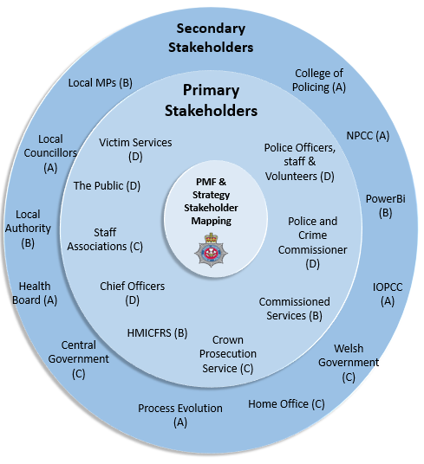
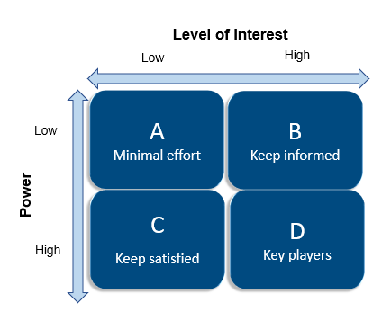
Figure 9 - Adapted Stakeholder mapping and the power/interest Matrix (cited by Johnson et al., 2015 p.182)

Appendix D – Value Chain Analysis (VCA)
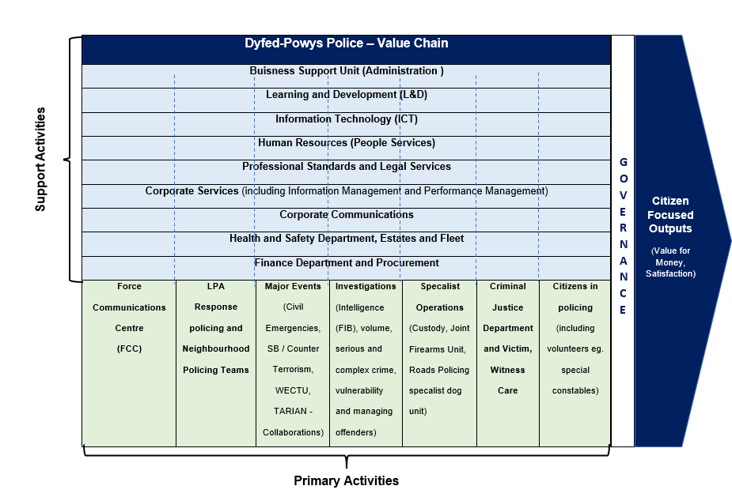

Figure 10 - Adaptation of Porters Generic Value Chain Analysis (VCA) (cited in Mintzberg, Ahlstrand and Lampel, 2009, p.109)

Appendix E - The Strategic Triangle
Operational Capacity
Operationally & Administratively feasible

Authorising Environment
Defining Public Value
Sources of Support & Legitimacy
Understanding the environment and working with stakeholders to deliver sustainable solutions.
- The public
- Chief Officers
- Police Crime Commissioner
- LPA Commanders
- Heads of Department
- Staff Union and Federation
- Professional Standards Department (PSD)
- HMICFRS
- IOPCC
- Home Office
- Crown Prosecution Service
- Victim Support Services
- Commissioned Services (OPCC)
- Probation
- Welsh Government
- External stakeholders i.e. Local Authority, Health, Third Sector Organisations, WAST, MAWWFRS.

Legitimate & Politically Sustainable
Substantively valuable
Organised & Operated
The manner in which resources are organised and utilised to achieve organisational objectives and deliver
- Governance Structure
- Force Performance Framework
- Resource Operating Model – Mobilising of resources
- Finance
- Skills mapping
- Workforce Utilisation (RBV)
- Technology
- Force Communications Centre (FCC) and the response to public calls for service
- Multi-agency resources
Mission Purpose
What are we trying to achieve?
- Improved public service outcomes for victims of Domestic Abuse and VAWG
- Better Performance Management
- Improved accountability and Governance
- Improved service provisions
- Better quality investigations
- Improved Crime Data Integrity – so all victims of crime are correctly identified and supported.
- Increased public trust and confidence

Three Activities:
- The activity of continually judging the value of public value proposition.
- The ongoing activity of managing upward, towards politics, to get or maintain legitimacy and support for the public value proposition.
- The ongoing activity of managing downward towards improving operating capacity for achieving authorised public value proposition.

Three Questions:
- Is your public value proposition purpose publicly valuable?
- Is your public value proposition politically and legally possible?
- Is your public value proposition administratively and operationally possible?

Figure 11 - The Strategic Triangle (adapted from Moore, 1995)

Appendix F – BSC Dyfed-Powys Police

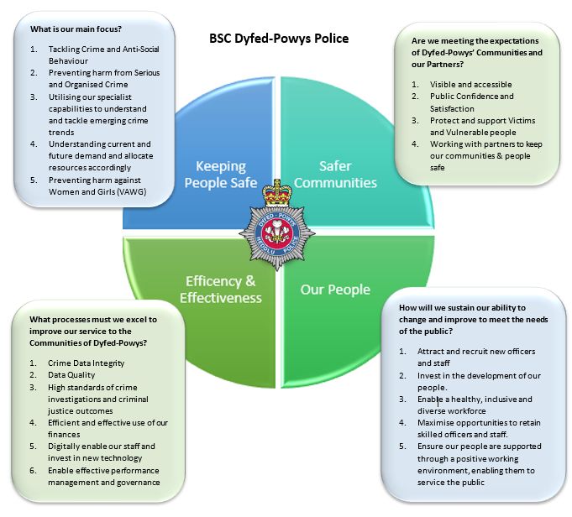

Figure 12 – Balanced Score Card for Dyfed-Powys Police (adapted from Ferlie and Ongaro, 2015)

Appendix G – Screenshot of Dyfed-Powys Power Bi Dashboard (PMF)
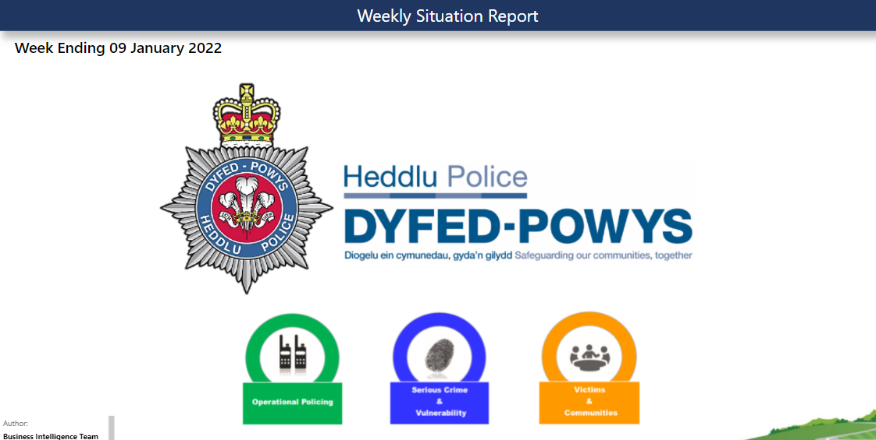

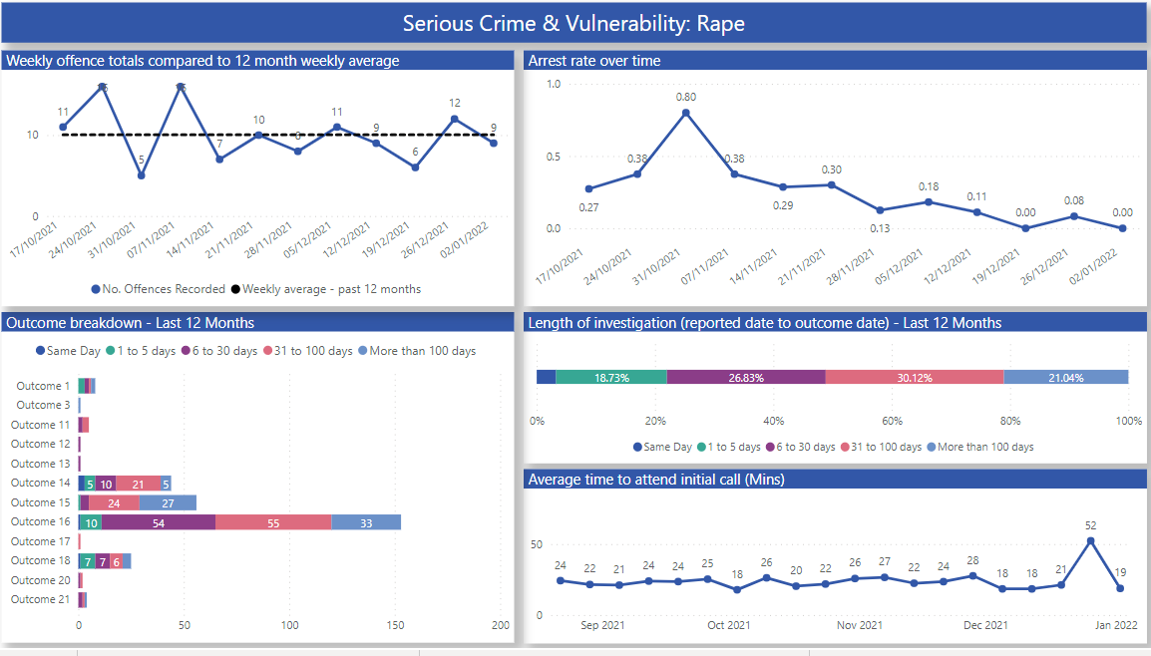

Figure 13 -Screenshots from Dyfed-Powys Police PowerBi Weekly Performance Dashboard (under development 2022)

Appendix H – Strategic Performance Delivery Plan, Dyfed-Powys Police
Performance Questions / Qualitative and Quantitative Measures

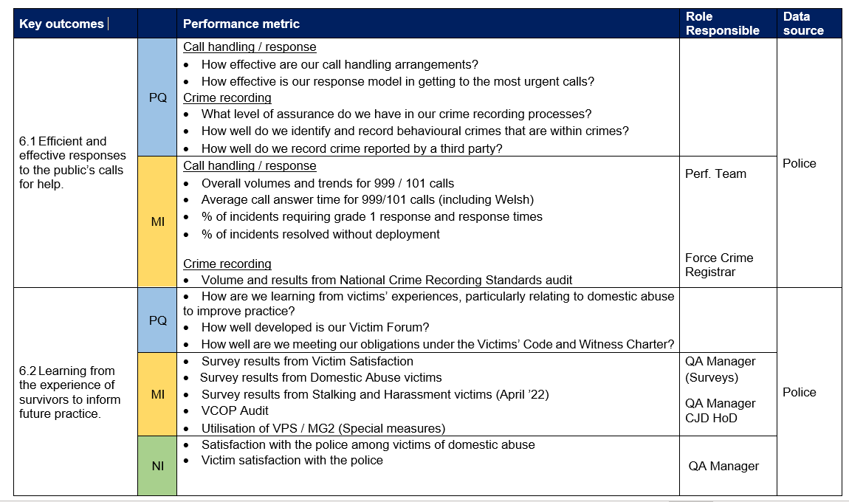

Performance reports and insights – PowerBi

Figure 14 - Dyfed-Powys Police PMF Framework based on BSC, Draft 2022

Appendix I – Plan on a page
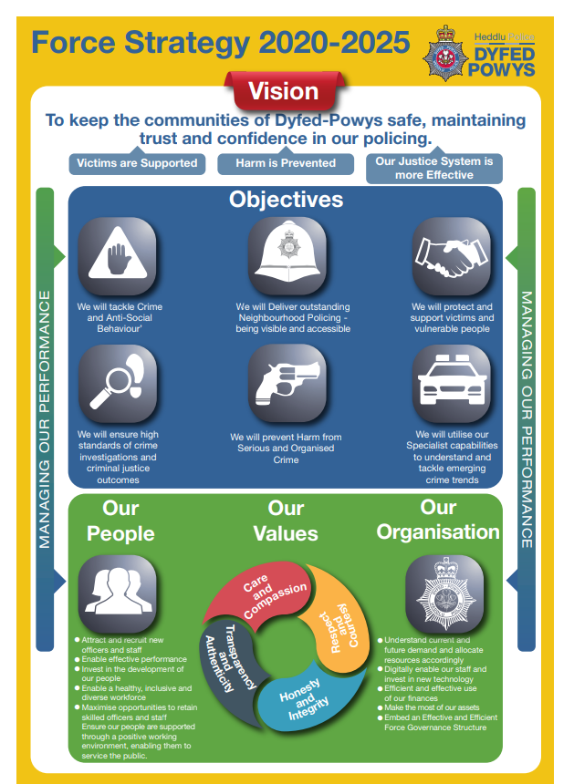
Figure 15 - Plan on a page proposal for Dyfed-Powys Police, pending clarification over the force objectives. 2022

Appendix J – Governance structure for Dyfed-Powys Police
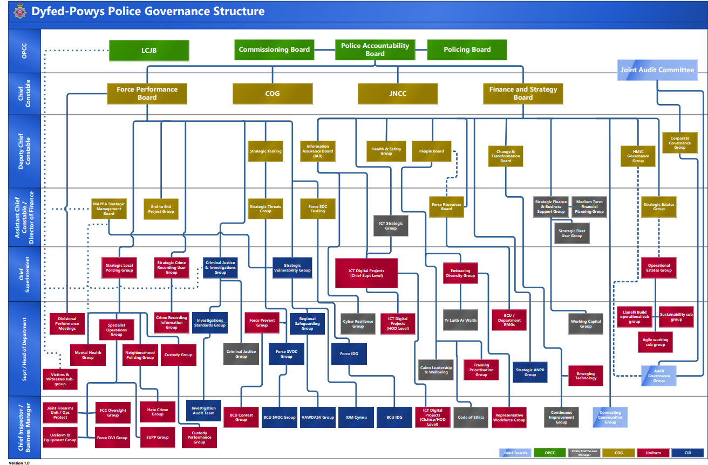
Figure 16 - Corporate Governance structure for Dyfed-Powys Police (2022). (Note: One has included for illustration of the landscape but acknowledges this will not be legible).

Appendix K – Visualisation of Performance Strategy Process
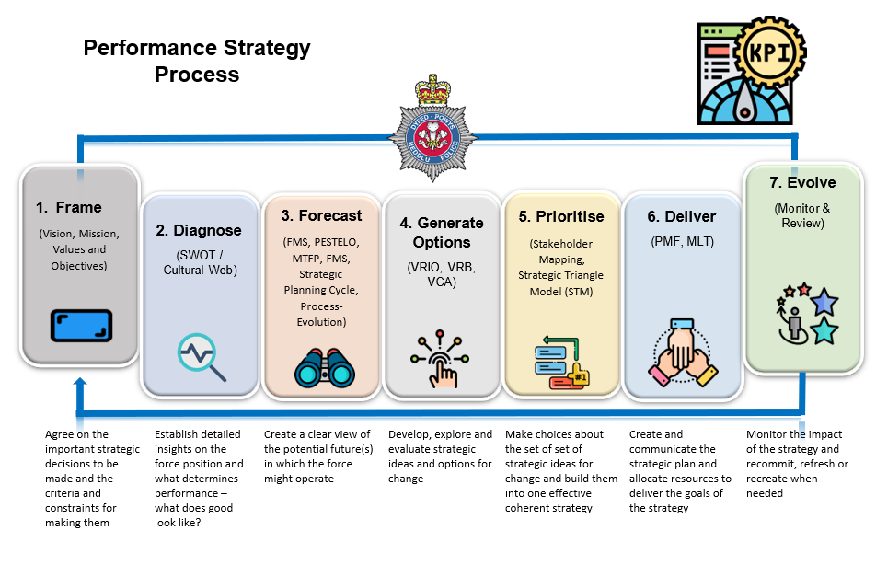

Figure 17 - Visualisation of Performance Strategy Process drawn from academic theory and literature

References

