Research on Enterprise Information Security Management System under the Background of Big Data
1 Introduction
  - Research Background
Since entering the 21st century, with the continuous progress of computer technology, information security has changed from the original characteristics of simple security to today's complex and dangerous situation ^{[1]}. On the one hand, the booming Internet and the Internet of Things have brought convenient information communication channels for enterprises, making the Internet of everything possible, but at the same time, it also makes the risk of enterprise information resource leakage gradually increased; On the other hand, the application of various emerging information technologies has improved the efficiency of enterprise operation and management, but also increased the probability of various malicious attacks on enterprises.
In recent years, there have been frequent information security incidents at home and abroad, such as Trojan virus, ransomware, sensitive data leakage, DDOS denial-of-service attacks, webpage tampering, etc. In April 2013, a serious breach of information broke out in the European Union. More than two million pieces of personal financial information were leaked, covering more than one hundred thousand people in more than one hundred countries. In May, the information of 22 million Yahoo Users in Japan was stolen. In June, Edward Snowden shocked the world by leaking secret documents about the NSA's surveillance programs to the media and was wanted by the US government. In May 2017, the notorious WannaCry malware infected computers in more than one hundred countries and more than 300,000 users, causing economic losses of more than 8 billion worldwide, using previously leaked system vulnerabilities. The security risks related to information are constantly increasing, and information security events emerge endlessly.
Many enterprises have not noticed the change of information security, the understanding of information security is still in the primary stage. They do not realize the importance, necessity and urgency of enterprise information security management, and some large enterprises do not even have a complete information security management system, which leads to heavy losses when enterprises encounter information security threats. Although some enterprises are aware of the importance of information security, they still think that as long as they deploy a series of security equipment and prevent it technically, they can rest easy and ignore the importance of information security management. 
All the above indications show that enterprises are facing complex and changeable challenges of business information theft and anti-theft. The problem of network information security is becoming more and more prominent. How to further implement the enterprise network security protection strategy, ensure information security, build a perfect information security system, prevent data information from malicious theft or destruction, maintain the healthy development of the network environment, is an urgent problem to be solved by enterprises.

  - Research Purpose
With the continuous development of computer technology, the information level of enterprises is constantly improving, production and operation increasingly rely on information system, enterprises have accumulated a large number of information assets, which make the company's requirements for information security constantly improve. Company information security environment is becoming more and more bad, however, computer virus infection, information disclosure, hackers illegal invasion, such as security risk increasing, so how to effectively improve enterprise information safety management level, reduce the enterprise facing the information security risks, to achieve the company to provide powerful information security development strategy is a pressing problem facing the current enterprise. At the same time, it puts forward new requirements for information security management.
This study intends to choose an enterprise information security problems as case analysis, analysis of the present, and a variety of information security problems faced to establish information security management system to meet the national level, at the same time the company director unit and monitoring unit of information security management requirements, proposed conforms to the system integration of information security management system, make it meet the security and compliance requirements of the sustainable development of enterprises.
This study aims to achieve the following:
(1) Have a deep understanding of the theoretical basis of information security;
(2) To study the main needs of national and enterprise information security management;
(3) To sort out the current situation and existing problems of safety management in this case;
(4) Put forward the information security management system framework or optimize the existing information security management system;
(5) Elaborate the content or optimization scheme of the information security management system framework;
(6) Overview of implementation methods and key points;
(7) Evaluate the implementation effect and put forward research prospects;
(8) To provide reference for other enterprises to improve the level of information security management.

1.3 Research Significance
Although this study only selected a certain enterprise as a case study, but the weak awareness of information security, less investment in information security technology, lack of information security management and other problems are the common phenomenon of information security management of enterprises across the country. Enterprises either do not pay attention to information security, or do not know how to manage information security, from this point of view, this study is of great significance. The specific significance of this study is as follows: 
(1) It is helpful to improve the information security of the case enterprise.
This study for an enterprise as an example, the information security management system as the research object, according to the situation of the case enterprise information safety management, combined with a series of methods, in information security risk assessment, comprehensive assessment company risks in the information security management, find the problems, analyze reasons. The strategy of optimizing enterprise information security management system is put forward and implemented from management and technology. Through the means of management and technology, the company's information security is effectively managed, reduce the company's information security risks, effectively protect the company's information assets, improve the company's information security management level, meet the company's continuous development of information security management of the new requirements, to achieve the company's development strategy to provide a strong guarantee.
(2) It is conducive to the fusion of multidisciplinary knowledge and the selection and application of information security standards.
The construction of the information security management system and the design of the implementation plan, the implementation process, is the comparison, selection and application of all kinds of information security management standards, is the process of management, computer network, engineering project management, operation management, information security technology and other fields of knowledge integration.
(3)Contribute to the construction of similar enterprise information security management system
Through the research of this paper, but also to further improve the national enterprise information security management level of beneficial exploration, for the same type of enterprises to provide reference, promote the promotion of the national enterprise overall information security management level.

1.4 Key Concepts in the Study
1.4.1 Big Data
Professor Viktor Mayer-Schōnberger pointed out ^{[2]} that the value of big data lies in the products and services with huge value that can be obtained by analyzing massive data. Although "big data" can be literally understood as a large amount of data, it is still impossible to distinguish "big data" from "massive data" and "super-large data" in the order of magnitude alone.
At present, there is no clear conclusion on the definition of big data. There are many ways to define it, but it is basically defined on the basis of exposition and induction based on the characteristics of big data. Among many definitions, the 3V definition is recognized by the industry ^{[3]}, which refers to the three characteristics of big data, namely diversity, scale and high speed. Diversity refers to the diversity of types and sources; Scale refers to the large amount of data, including collection, storage and calculation of the amount is very large; High speed refers to the fast growth of data, fast processing speed and high timeliness requirements. The 4V definition adds a new element on the basis of the 3V concept. However, at present, there is not a unified statement on the concept of 4V. Some internationally famous data companies believe that big data also has the Value feature, that is, the data Value density is relatively low. IBM insists that authenticity should become the fourth feature of big data.
Based on the above understanding of the connotation of big data, the following big data concepts are sorted out: Big data refers to the efficient extraction of massive and diverse transaction data, interactive data and sensing data with high value from massive data through a series of means of acquiring, processing and analyzing data. Magnanimity and diversity measure data in terms of quantity and type of data. Efficiency is the speed at which useful information can be extracted from big data. High value is the purpose and significance of acquiring, processing and analyzing big data. Transaction, interaction and sensing data are the main sources of big data. Among them, transaction data is mainly obtained from enterprise ERP system, various POS terminals, online payment system and other business systems. Interactive data comes from mobile communication records and social media including online communities and open comments of online media. The sensor data comes from GPS devices, RFID devices, and video surveillance devices. 

1.4.2 Information
Information, simply meaning meaningful data, is an important asset for an organization. It is as valuable to the organization as any other important asset and needs to be protected by appropriate measures.
In ISO/IEC27000:2016, the definition of information is summarized as: information is an asset that can be stored in a variety of forms, including digital form, physical form, and information that exists but has not been expressed in the form of employee knowledge. Common means of information transmission include messenger, electronic communication or oral information communication, etc. ^{[4]}. Common information asset classifications are shown in Table 1.
Table 1 Common Information Asset Classification
Classification | Description
Hardware | Hardware information devices in an organization, such as computers, servers, switches, firewalls, printers, scanners, and physical network links 
Software | Software running in the organization, software licenses, stored media, etc. Such as: operating system, office software, OA software, financial system, human resource management system, video surveillance system, etc 
Data | All data and software output generated by the organization's operation. Such as: rules and regulations, contracts, financial data, human resources data, database backup, account information, information system operation and maintenance logs, etc 
Personnel | The people and organizations involved in information management in an organization. Such as: network administrator, system administrator, operator, security, outsourcing service personnel 
Environment | Environment facilities that support IT system operation. Such as UPS, air conditioner, access control, and equipment room 
Service | It exists in the form of organization operation management and commercial business. Such as: network communication services, equipment maintenance, software outsourcing, security inspection services 

1.4.3 Information security
Regarding information security, the International Organization for Standardization in ISO/IEC27000:2016 gives the definition of "information security is the maintenance of confidentiality, integrity and availability of information" ^{[4]}. It is customary to combine them simply as the CIA triad, as shown in the figure. At the other end of the spectrum is the DAD triad of leaks, tampering, and sabotage.
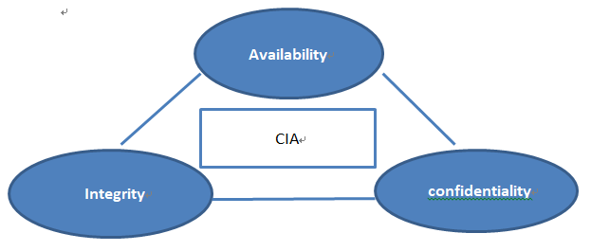
Figure 1 The CIA of Information
Confidentiality refers to the implementation of appropriate security protection measures during the storage, transmission, and use of information to ensure that information can only be transmitted to authorized users or entities and will not be disclosed to unauthorized users or entities.
Integrity is used in information storage, transmission, process, level of security protection measures are imposed to protect information correct and complete, to ensure that information is not tamper with the user or entity without authorization, at the same time to prevent being authorized user or entity is not properly modified, maintain the consistency of the information, the external.
Availability refers to the implementation of appropriate security protection measures during the storage, transmission and use of information to ensure that authorized users or entities can access the information in a timely and reliable manner and will not be abnormally rejected ^{[5]}.
Information security is keeping the CIA triad of information and avoiding the DAD triad. To take necessary measures to protect information security is the essence of organizational information assets, keep the CIA, to make information assets not because have no intention or malicious invasion by DAD, ensure the normal running of the information system can be sustained, reliable, and reduce the effects on the organization's business security events to a minimum, ensuring that the organization business operations in a row. So as to achieve the role of supporting the organization to achieve its expected goals.

1.4.4 Enterprise information security
Enterprise information security is to protect enterprise information assets from internal and external threats, so as to ensure the sustainable development of the main business of the enterprise. Common information security problems faced by enterprises include information leakage and IT system security. The former includes disclosure of strategic planning, financial statements, salary information, product research and development information, bidding price, customer information, supplier information, product quotation information and email information, etc. The latter includes: core server crash, data loss, special line failure, network breakdown, mail domain name blacklisted, data error, computer failure, password theft and violation of national network security laws and regulations.

1.4.5 Enterprise information security management
Information security management is through reasonable planning, organization and coordination, comprehensive use of information technology means and management means, in order to achieve the realization of information security objectives. Enterprises must comprehensively consider, comprehensively use physical control measures, information security technology control measures and personnel control measures (management system, etc.) to form an organic combination of the three, so as to achieve effective control of the three factors. Only in this way can we minimize the information security risks faced by enterprises and promote the development of enterprise business strategies.

1.4.6 Information security management system
Information security management system is an integral part of the organization of the entire management system, in accordance with the requirements of the relevant information security management system standards, to develop the organization of information security management principles, objectives and strategies, the use of risk management theory of information security effective management system. The effective operation of this work system can comprehensively protect the key information assets of the organization, so that the organization can maintain competitive advantages. Can enable the organization to effectively prevent emergencies, once the organization's information system is attacked illegally; Can minimize business losses, and make the basic business can continue to develop; Can make the organization's partners and customers full of confidence in the organization; It enables organizations to update information systems regularly, patch newly discovered vulnerabilities, and effectively respond to emerging new information security threats. A complete information security management system usually includes safety policy strategy, information security management organization, information asset management, personnel safety, environmental and physical security, access control, operation and communication management, information system development and maintenance, information security incident management, business continuity management, compliance, etc.
1.4.6.1 PDCA Cycle
Process method is the basic method of information security management. PDCA cycle is a common process method in management. It was first conceived by Hughart, and then popularized by Deming. PDCA cycle is a model of continuous improvement based on the process method of Plan - Do - Check - Act. The PDCA cycle can be easily summed up in four sentences:
(1) A plan is a document stating what should be done;
(2) Implementation is to do things according to the provisions of the document;
(3) check is to review whether the documents do meet the requirements;
(4) Improvement means taking corrective and preventive measures and making continuous improvement.  
In application, a complete P-D-C-A cycle can be regarded as A cycle in the management of the organization according to the order of P-D-C-A. Every P-D-C-A cycle, the management system of the organization will be improved to some extent.
Information security management system is a PDCA cycle body, based on business risks, through P (establishment of the system) -D (implementation and operation system) -C (monitoring the implementation and evaluation of the operation effect) -A (maintenance and improvement of the system) process to manage the organization's information security.

2 Literature Review
2.1 Qualitative and quantitative study of information security risk
The development of information security has gone through five stages, namely communication security, computer security, information system security, information security, network space security/information security. As shown in Table 2.
Table 2 Information security development stages
Stage | Age | Typical Threat | Security Measures
Communication Security ^{[6]} | Before the 1870s | Wire tapping, cryptanalysis | Encryption technology
Computer Security^{[7]} | The 1970s and 1980s | Illegal access, malicious code | Secure operating system technology
Information System Security | In the 1990s | Technical failure, network intrusion, Trojan virus damage, etc | Firewall, antivirus, vulnerability scanning, intrusion detection, public key infrastructure, disaster recovery
Information Security | Since 1996 | Black guest, natural disaster, etc | Technology, management, engineering, personnel training, etc
Cyberspace Security/Information Security Assurance | Since 2009 | Terrorists, information warfare, etc | Rise to national security, deterrence - based defense, attack, intelligence trinity
By the development process of information security is: with the development of information technology and information security development, each stage with the typical threat faced by changing and upgrading, the safety of the quantitative measures also adjust accordingly, in the form of security is more and more comprehensive, also can saying is constantly optimize the information security management process. Current researches on information security risks mainly include:
Australian scholars Chiang and Braun (2007) studied the information risk elements faced by networks and information systems and proposed an information base model of object-oriented management. By evaluating the risks encountered by autonomous communication networks, the access rights of each file were configured to improve security risks ^{[8]}. Patil et al. (2012), a Canadian information security researcher, applied the fault tree model in engineering to conduct in-depth analysis and security risk assessment of information system, striving to objectively and truly express the security performance of information system, and analyzed the key factors affecting security of information system based on the model ^{[9]}. Wiesche et al. (2013) from University of Munich, Germany, theoretically discussed the principle and future development trend of information security risk assessment based on their years of theoretical research and practical experience ^{[10]}. Bharathi (2017) took big data as the research background, studied the risk factors affecting enterprise information security, constructed a big data information security risk spectrum composed of 25 clearly defined risk factors, and used fuzzy mathematics to rank the risk factors ^{[11]}. Wangen (2018), and other scholars to the information security risk assessment (ISRA) study, think its although can be very complete and standard of information security risk assessment, but a set of standards can only cope with a few fixed, the lack of universality, which in turn can build a "catch-all" at the core of the unified framework (CURF) risk, The risk assessment criteria are inclusive ^{[12]}. Argyropoulos et al. (2018) sought to make scenario-specific decisions while taking risks into account, and proposed a relatively complete engineering method for security requirements called Secure Tropos ^{[13]}. Westland (2020) on the sarbanes - oxley act (the SOX act) has carried on the full study, combining with telecom fraud case in the United States, analysis the "sarbanes - oxley act” of influential factors, for enterprise information security for information security risk evaluation index selection provides a reliable reference ^{[14]}.

2.2 Information security management standards and models
With the continuous development of information technology, people in the world are gradually focusing on the field of information security. Governments, enterprises, institutions and organizations around the world are seeking solutions to ensure information security. It is mainly reflected in the following two points:
2.2.1 Information security Management standards 
The formulation of information security management standards can be roughly divided into three stages internationally:
The first stage is from the early 1970s to the end of the 1980s, which is the embryonic stage of the initial establishment of computer information security standards. As shown in figure 2.
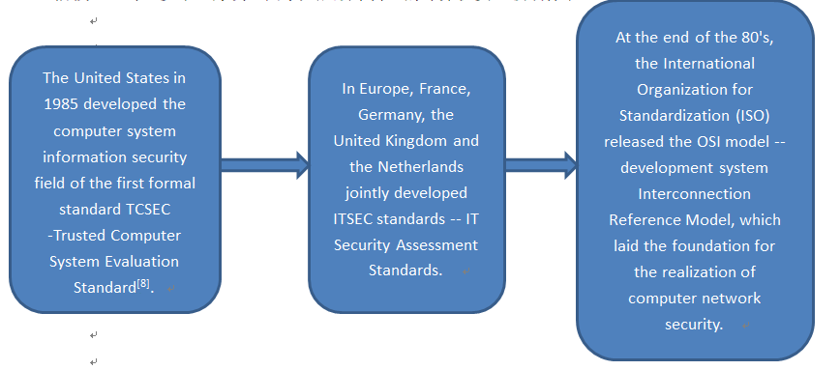
Figure 2 Embryonic stage
The second stage is the 1990s, at this time for computer information security standards gradually perfect stage of development. As shown in figure 3.
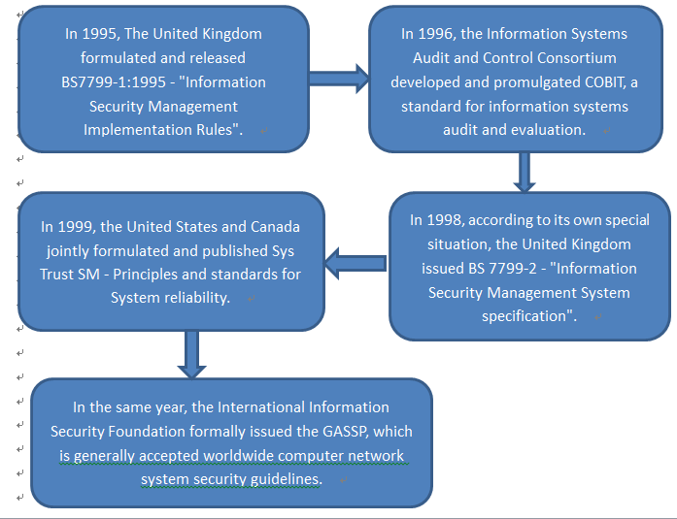
Figure 3 Perfect stage of development
The third stage is the shaping period of the organization and systematization of computer information security standards after entering the 21st century ^{[15]}. As shown in figure 4.
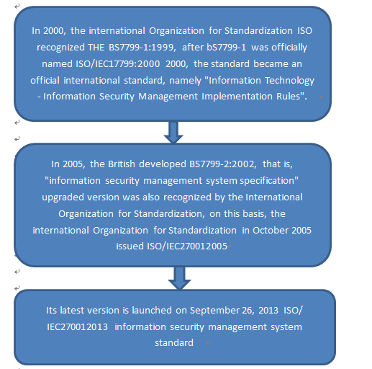
Nasser Modiri et al. (2015) pointed out that most information security management guidelines do not pay attention to the differences of enterprises or organizations, and at the same time, the content and characteristics of ISO/IEC27000 and ISO/IEC15408 standard systems are compared and analyzed from two aspects of scope and content ^{[16]}. Xiaoxiao Yan(2017) in the project "A financial institution carries out information security management system Construction and Certification based on ISO27000", combined with the project practice, analyzes the methods and processes used in information security risk assessment, security planning and security system measurement and evaluation in the process of information security management system construction of the financial institution. In particular, an empirical study was conducted on the validity, design and application of the measurement method ^{[17]}. Jinsong DU and Fei LU(2018) analyzed the current situation and causes of information security faced by domestic enterprises and made detailed studies. Based on ISO/IEC27000 information security management system, the establishment, implementation, operation, monitoring and review of information security management system were conducted. Corresponding maintenance and improvement suggestions are put forward ^{[18]}.

2.2.2 Information security management model
Jian ZHANG and Weihua YUAN(2011) analyzed the factors of security threats in IT governance and their impact on information systems. Based on the characteristics of information systems in IT governance, they built a THREE-DIMENSIONAL model of security management with risk control as the goal, improved the operation mode of PDCA, and achieved security objectives ^{[19]}. Jingjing LIU (2015) Was based on ISO27000 information security management standard system and "PDCA" management model in the process of information security management system construction of a Beijing enterprise. Through promoting information security awareness, determining relevant control measures, compiling program files of information security management system and adopting relevant technical means, the information security risk level of the enterprise is reduced, and the information security management system is successfully established and implemented in the enterprise ^{[20]}. Robyn et al. (2016) developed a model using COBIT4.1 maturity model Rubrics to objectively measure the effectiveness of enterprise information security management plans ^{[21]}. Valeriy G et al. (2017), mainly introduced the information security threat management method based on functional model and context model ^{[22]}. Kimmi Kumari(2018) studied the data outsourcing and third-party data processing business in the big data environment, expounded the existing problems of data security and data privacy, and focused on the relevant models of Hadoop, MapReduce Framework and HDFS. Two attributes about data privacy are proposed: privacy retention and privacy accountability ^{[23]}. Hongzhi YIN(2019) investigated the status quo of enterprise information security, sorted out and analyzed the problems found, innovatively combined ISO27000 information security management system standard with China's information security level protection 2.0 standard, and improved the construction process of enterprise information security management system based on integrated standards. The emphases and difficulties of enterprises in the process of system construction are analyzed ^{[24]}. Iftekhar Ahmed(2020) proposed a new Model that can provide access control for sensitive data in the Zero Trust Model (ZTM). In this model, access control agents are introduced to analyze access requests, user types and other factors to monitor access, so as to protect sensitive data in zero-trust model ^{[25]}.
Combined with the above research found that information security management is mainly around the information risk to carry out, mainly including risk identification, risk management, effect assessment and other content, mostly using ISO/IEC27000 standard system, more combined with PDCA management model for information security management, it is instructive for the risk identification and security management of information assets in this paper. 

3 Methods
This study mainly combines theoretical analysis with empirical research, including literature research method, case analysis method, inductive summary method, comparative analysis method, systematic analysis method, analytic hierarchy process and other methods. 
- Literature research method
Through the network information query channels such as Elsevier ScienceDirect database, IEEE/IET Electronic Library, SCI database and SSCI database. In recent years related to information security, information security management and information security management system and model of the domestic and foreign literature, query, summarizing, sorting and analysis, access to the domestic and foreign scholars in the field of information security management within the published a large number of research data, understand the enterprise information safety management research related to the latest research trend of theory and practice, formed the preliminary scientific cognition to the relevant knowledge point. It lays a theoretical foundation for the research of information security management system construction and plays an important theoretical guiding role in my research.
- Case study method
Case study method is defined as an empirical research method that examines a phenomenon in a real environment. This method is very common for qualitative analysis, which is suitable for analyzing complex or specific problems in reality. Through the use of this method, people can see the phenomenon and things in life have a specific understanding and analysis. Such a case study not only enables us to update and test existing theories in our research, but also enables us to realize new relevant theories.
This study use case study method of target enterprise information safety management status of objective and fair evaluation, find the reasons of information security incidents, find out the existing information security loopholes in management rules, and combining with the previous theoretical analysis, explore the company information security management system established and implementation, ensure the information security of the target enterprise, the process. This case also provides reference for similar enterprises in the construction and implementation of information security management system.
(3) Induction and summary
The solutions and management system models of enterprise information security are summarized, and the design ideas of enterprise information security management system are put forward.
(4) Quantitative and qualitative analysis
This study mature at home and abroad and referring to information security management system architecture, draw lessons from advanced experience and methods of the existing literature, combining with service characteristics of case of enterprise operation and, with the risk assessment system architecture, the risk existing in the current status of information security management, which can identify and the risk of are identified for quantitative and qualitative analysis, In order to strengthen the logical structure of this study, to ensure that information security risk identification and assessment can be objective and effective, so as to put forward effective solutions for the case enterprises to strengthen information security management and put forward suggestions for optimizing countermeasures.
(5) Systematic analysis.
In the era of information network, the system engineering theory is used to connect the parts of the relevant information security management system and organize them into a whole for systematic analysis and research. Each element in the system is closely linked. The information security management system of the branch is not only the improvement of the work of the relevant scientific and technical personnel, but also the management system of the strategic objectives of the branch, the characteristics of the organization personnel, the resources and environmental conditions. Using analytic hierarchy process, fuzzy evaluation method and other methods to analyze the information security system, and as the theoretical basis of information security system improvement design scheme.
(6) Analytic Hierarchy Process
Through the analytic hierarchy process (AHP), the existing information security risks of enterprises are analyzed step by step, and the security risks are subdivided to make the risk analysis results more consistent with the actual situation.

4 Result
This paper intends to select an enterprise facing information security risks as a case study, sort out the problems existing in the information security management of the enterprise, and analyze the causes of the current situation from the four aspects of information security organization, information security strategy, human resource security, operation and maintenance security and access control.
With the guidance of PDCA model method, the process of information security management system planning, implementation, monitoring, evaluation and preservation and improvement is completed. In the PLAN stage, the related architecture, security operation and maintenance system, specification writing, security system document writing, assessment system and training system of the whole group information security management system are planned and constructed. In DO and CHECK stages, make implementation steps and implement the construction plan; through monitoring and review process, complete information security management system audit. Through ACT stage, continuously optimize and improve the effect of information security management system. In the information security management system establishment stage, the information security implementation method, information security general outline, information security architecture, security management system, security technology system, security operation and maintenance system, standard compilation, security system documentation, assessment system and training system and other content to establish.

5 Evaluation
Due to the limitations of author's ability, research time and data accuracy, this study may have the following limitations:
First of all, the theory of information security in the unceasing development, the enterprise also in development, to further after she steps on domestic and international latest theory and model of management system and information security risk assessment methods, improve the company's own security management system, improve the effectiveness of the risk assessment and objectivity, to explore the influence of the benefit of the enterprise information security management model, Research can effectively protect information security and improve the efficiency of the solution.
Second, the enterprise information safety management problems will be more and more brought to the attention of the corporate management, due to the different enterprise is different, the style and the demand for information security management, this paper choose the case study, some enterprise does not have fully representative, will in future study of enterprises of the same industry or different industries, summarized the enterprise comparative study.

References
[1] Fenghua Li. Development trend of information technology and cyberspace security [J]. Journal of network and information security,2015,1(01):8-17.
[2]Saint, John, Walker. Big Data: A Revolution That Will Transform How We Live, Work, and Think[J]. International Journal of Advertising the Review of Marketing Communications, 2014.
[3] D Laney. 3-D Data Management: Controlling Data Volume, Velocity, and Variety. 2001.
[4]EN ISO/IEC 27000-2017, Information Technology - Security Technology - Information Security Management Systems - Overview and Vocabulary (ISO / IEC 27000:2016)[S].
[5] Tittel E , Stewart J M . CISSP Certified Information Systems Security Professional Study Guide, 7th Edition[J]. SYBEX Inc. 2016.
[6] Shannon C E . Communication Theory of Secrecy Systems[J]. Bell System Technical Journal, 1949, 28(4):656–715.
[7] Jahl C . Common Criteria for Information Technology Security Evaluation[C]// Software Engineering, 1991. Proceedings. 13th International Conference on. IEEE Xplore, 1991.
[8] F Chiang, Braun R . Self-adaptability and Vulnerability Assessment of Secure Autonomic Communication Networks[C]// Managing Next Generation Networks & Services, Asia-pacific Network Operations & Management Symposium, Apnoms, Sapporo, Japan, October. DBLP, 2007.
[9] Patil P , Zavarsky P , Lindskog D , et al. Fault Tree Analysis of Accidental Insider Security Events[C]// International Conference on Cyber Security. IEEE, 2013.
[10] Wiesche M , Keskinov H , Schermann M , et al. Classifying Information Systems Risks: What Have We Learned So Far?[J]. 2013.
[11] Bharathi S V . Prioritizing and Ranking the Big Data Information Security Risk Spectrum[J]. Global Journal of Flexible Systems Management, 2017, 18(3):183-201.
[12] Wangen G , Hallstensen C , Snekkenes E . A framework for estimating information security risk assessment method completeness[J]. International Journal of Information Security, 2017.
[13] Nikolaos Argyropoulos, Konstantinos Angelopoulos, Haralambos Mouratidis, Andrew Fish. Risk-aware Decision Support with Constrained Goal Models [J]. Information and Computer Security, 2018, 26(4): 136-140.
[14] J. Christopher Westland. The Information Content of Sarbanes-Oxley in Predicting Security Breaches [J]. Computers & Security, 2020, 90(1):257-261.
[15]ISO27001-2013， Information Technology-Security Techniques –Information Security Management Systems Requirements[S]，2013.
[16] Modiri N , Sobhanzadeh Y M . Information Security Management[J]. Edpacs, 2015, 27(12):1-1.
[17] Xiaoxiao Yan. Construction of enterprise information security management system based on ISO27001 [D]. Beijing institute of technology, 2017. DOI: 10.26948 /, dc nki. Gbjlu. 2017.000319. [18] Jinsong Du, Fei Lu. Enterprise information security management system construction research [J]. Science and technology innovation herald, 2018 (9) : 157-159 + 161. DOI: 10.16660 / j.carol carroll nki. 1674-098 - x. 2018.09.157.
[19] Jian Z , Yuan W H , Qi W J . Research on security management and control system of information system in IT governance. IEEE, 2011.
[20] Jingjing Liu. The establishment and implementation of Beijing XX enterprise information security Management System based on ISO27001 [D]. Shandong University,2015.
[21]Robyn, L, Raschke, et al. SECURQUAL: An Instrument for Evaluating the Effectiveness of Enterprise Information Security Programs[J]. Journal of information systems, 2016, 30(1):71-92.
[22] Semin V G , Shmakova E G , Los A B . The information security risk management[C]// 2017 International Conference "Quality Management,Transport and Information Security, Information Technologies" (IT&QM&IS). 2017.
[23] Kumari K , Mrunalini M . A SURVEY ON BIG DATA PROCESSING: TECHNIQUES, ISSUES AND CHALLENGES. 2018.
[24] Zhihong Yin. Research on enterprise Information Security Management System Construction based on ISO27001 [C]//. Proceedings of the 33rd China (Tianjin) 2019 'IT, Network, Information Technology, Electronics, Instrumentation Innovation Conference.,2019:92-96.
[25] Ahmed I , Nahar T , Urmi S S , et al. Protection of Sensitive Data in Zero Trust Model[C]// ICCA 2020: International Conference on Computing Advancements. 2020.

