

Student name: AHOU ANNA YASMINE KRAMO
Student ID: 2437213
Module name: INTRODUCTION TO HEALTH AND SOCIAL CARE
Module code : LCHS4003
Lecturer name : MARK KANE
Content page

Element 1 ………………………………………………………………Page 1

Element 2 ………………………………………………………………Page 2

Element 3 ………………………………………………………......... Page 3

Element 4 ……………………………………………………………. Page 4
EXPLANATION OF HEALTHCARE SERVICE AND AMBULANCE SERVICE
Healthcare, provided by the National Health Service (NHS), is a universal, publicly funded system that is free at the point of use for residents and paid for through general taxation. Social care, which provides practical help for those with long-term needs due to age, disability, or illness, is delivered by local authorities and is means-tested, meaning individuals may have to contribute to the cost based on their income and savings. Also, National Health Service (NHS) came into existence on 5 July 1948. Established on the 1st of February 1915, the London Ambulance Service is one of the world’s oldest and largest ambulance services. We have a unique, long and interesting history supported by a large collection of historical vehicles, equipment and items which have been collected over the years.
KEY PRINCIPLE OF UNITED KINGDOM AMBULANCE SERVICE:
Firstly, their main role is to respond to emergency 999 calls, providing medical care to patients across the capital, 24-hours a day, 365 days a year. Also, the ambulance service offers other services, including pre-arranged patient transport and finding hospital bed finding. In collaboration with the police and the fire service, we are prepared for deal with major or large-scale or major incidents in the capital. According to NHS England ambulance the key principles of the United Kingdom: Free at the Point of Use, Responsive, Regulated, patient Centered, Clinical Governance, Efficient and effective, digitally fit for the future.

. Lost time: Ambulances are frequently delayed waiting outside hospitals to hand over patients to A&E staff. This "lost time" means those ambulances are unavailable to respond to new emergency calls. Ambulance services are finding it increasingly difficult to cope with rising demand for urgent and emergency services. According to the National Audit Office.
Two challenges faced by Ambulance service in United Kingdom
. Growing call volume: The number of ambulance calls has risen significantly due to an aging population, more people with multiple chronic conditions, and issues like alcohol and mental health problems.
AMBULANCES SERVICES
AHOU ANNA YASMINE KRAMO, INTRODUCTION TO HEALTH AND SOCIAL CARE

Current functioning of the Ambulance service
In 2025, the UK ambulance service is undergoing a significant transition, moving from a transport-focused model to one of integrated, community-based care. Key themes in current publications include the need for greater collaboration between ambulance services and hospitals, improved support for staff well-being, and a focus on patient safety, including better training for paramedics. The service is also embracing lessons learned from the COVID-19 pandemic to improve future service delivery and clinical care
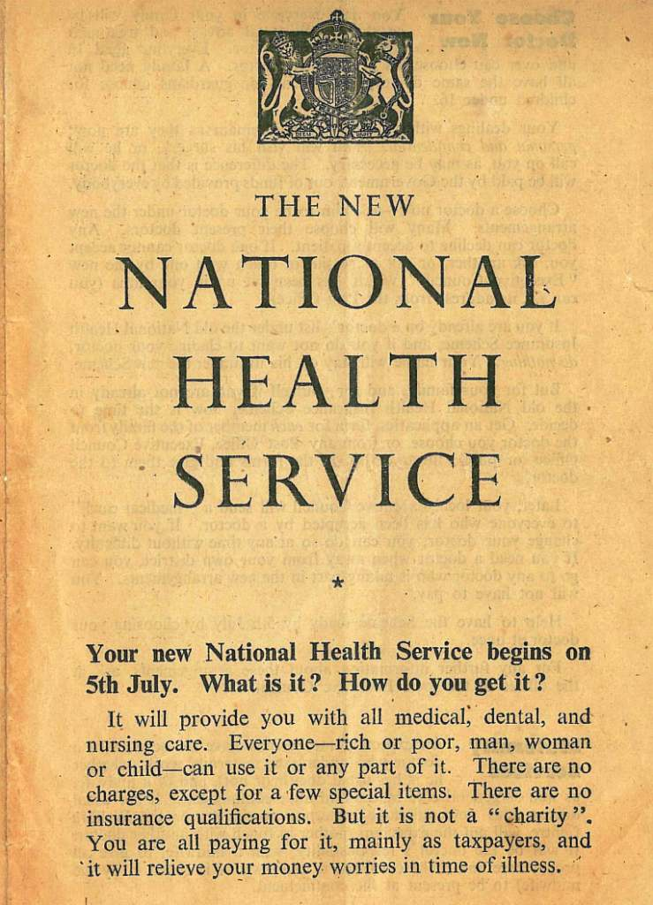
Task 2.

Origins of NHS
This essay will discuss the NHS, the NHS originated in 1948 by History of the NHS - Health Service Navigator History of the NHS - Health Service Navigator the NHS originated from the recommendations of the 1942 Beveridge Report, which proposed a welfare state including a universal, tax-funded healthcare system.

Historical context
The history of UK health and social care is marked by a shift from religious and Poor Law-based systems to the comprehensive, state-funded National Health Service (NHS) and social care system established in 1948. Likewise, to fully develop a high level of understanding of health and social care practices, it is useful to begin in a historical and organisational context. Historically, care for the poor, infirm and elderly was provided through religious orders and monasteries, although following the dissolution under King Henry VIII, much of this care was removed. Almshouses, established under Queen Elizabeth I, brought together under the Poor Law Act (1601), provided some support for the neediest. According to Medium “A brief history of the UK health and social care services (1601–2015).

Key principles of the NHS and establishment

National Health Service (NHS) in the UK is founded on several key principles:
- Universal Access: The NHS provides comprehensive healthcare to all British citizens, regardless of their ability to pay.
- Free at the Point of Use: Patients do not pay directly for NHS services, with funding coming from general taxation and National Insurance contributions.
- Comprehensive Care: The NHS provides a wide range of services, including primary care, hospital care, mental health services, and community health services.
- Equity: The NHS aims to provide equal access to healthcare services for all, based on clinical need rather than ability to pay.
- Quality: The NHS strives to provide high-quality care, with a focus on patient safety, effectiveness, and patient-centered care.
In addition, some key figures involved in the establishment of the NHS include
- Aneurin Bevan: The Minister of Health who played a crucial role in the establishment of the NHS.
- Clement Attlee: The Prime Minister who oversaw the establishment of the NHS as part of the post-war welfare state reforms.

Two challenges faced by NHS service in United Kingdom

The main challenges faced by NHS historically have been staffing retention, bureaucracy, lack of digital technology, and obstacles to sharing data for patient healthcare : These have changed significantly as the major challenges faced by NHS currently are the aging population, the need for digitalization of services, lack of resources or funding, increasing number of patients with complicated health needs, staff retention, and primary healthcare issues, issues with staff morale, communication breakdown, backlog in-clinic appointments and procedures worsened by COVID 19 pandemic. According to National Library of Medicine.
Increasing patient demand and waiting lists: Demand for services is growing due to an aging population that requires more complex and long-term care. According to The Health Foundation.

CURRENT OF THE FUNCTIONING ON NHS
As of November 2025, the NHS in England is experiencing record demand for services, particularly in urgent and emergency care, but has seen some improvements in reducing the longest elective waiting times. For example: Mental Health, demand for mental health services is at record levels, with 1.8 million adult open referrals recorded in September 2025. Efforts are focused on accelerating patient flow and improving access to children and young people's service. However, the government's focus is on recovery and reform through the "three shifts": moving care from hospitals to the community, from illness to prevention, and from analogue to digital. Initiatives include expanding community diagnostic centres, increasing the use of the NHS App for appointments and records, and developing neighborhood health services.
References

The NHS constitution for England (2023) How Corner Place Surgery implements the NHS Constitution, Available at: NHS Constitution for England - Corner Place Surgery (Accessed: 17/11/2025).
https://www.nhsconfed.org/publications/202526-nhs-priorities-and-operational-planning-guidance-what-you-need-know#:~:text=The%202025/26%20NHS%20Planning,%2C%20(3)%20improve%20patients'
https://cornerplacesurgerypaignton.nhs.uk/surgery-policies/nhs-constitution-for-england
https://www.londonambulance.nhs.uk/talking-with-us/making-requests-for-the-records-we-hold/
https://www.gov.uk/armed-forces-covenant-businesses/central-ambulance-service

