DIGITAL SKILLS AND RESEARCH METHODS
Table of Contents
Introduction 3
Evaluating effectiveness if modern technology in workplaces 3
Exploring social media marketing tool 5
Business communication and information gathering in workplaces 6
Practical application and employment benefits 7
Conclusion 8
Reference List: 9

Introduction
This study has aimed at developing a report on the effectiveness of modern technologies in global businesses. For this purpose this study has considered an organisation of UK, named as Charlie Bigham’s, which is associated with the food and drinks industry. The implementation processes and purposes of modern technologies have been discussed in this study critically with the prior focus on two major modern technologies, such as web conferencing and cloud computing. This study also has assessed the advantages and disadvantages of both these technologies in light of employability opportunities as well for the purpose of recommending needful actions regarding technological usages.

Evaluating effectiveness if modern technology in workplaces
The present era of business around the world is extensively dependent on the uses of modern technology, as most of the business purposes are operated through diverse utilisation of modern technologies. In addition to it, modern technologies are also found potential in designing the organisational needs according to the comprehensive business growth strategies. For this purpose, the managements of the organisations acknowledge the uses of modern technologies in order to continue with desired business growth strategies. In the words of Bower (2015), the management of Charlie Bigham’s is also required to acknowledge the utilisation and benefits of the modern technology for the purpose of leading their business growth strategies ahead. The management of Charlie Bigham’s has always aimed at pursuing the advantages of the emerging consumer trends in regards with fine dining and unconventional cuisine. Providing such facilities and ensuring the qualities have allowed this brand to become one of the known brands in food and beverage sector of UK. However, the acknowledgement of modern technologies has also played pivotal roles behind their successes.
As per the effectiveness of modern technologies is concerned, the management of Charlie Bigham’s has purposefully utilised them for the marketing and distribution of their products. Emphasising on the social media marketing has allowed them acknowledging the consumer trends through enhanced knowledge on customer trends and satisfaction. In addition to it, they also have empowered certain modern technological uses including cloud file storage system and web conferencing system. As opined by Chang et al. (2016), the prior utilisation of web conferencing system and cloud computing system has allowed the management of Charlie Bigham’s to expand their business to several areas of UK and gain knowledge about the cuisine trends best suitable for the customers of these areas. Their concern about the utilisation of both these technologically advanced system is to align their business with expansion strategies and marketing benefits.
The reason behind acknowledging the use of web conferencing system by the management of Charlie Bigham’s was to connect with the people around the world, who are associated with the food and drinks industry, food production and food health consultants. With the help of web conferencing system, the management of Charlie Bigham’s had been capable of ensuring global trends to their business with the prioritisation on customer needs Park and Kim (2014). Web conferencing system also allowed them to connect with their suppliers and instruct them about their needs more directly. The major benefit derived from the uses of web conferencing system is aligned with the time management purpose, as the management of Charlie Bigham’s can become capable of managing time constraints by utilising the web conferencing system. With the help of this system, an organisation can reduce time consumption by conducting direct conversation with the business parties and partners. Additionally, web conferencing is also potential in reducing operational costs, as it helps the management of Charlie Bigham’s to plan their business or send contents or conducting meetings without moving to different places.
On the other hand, the implementation of cloud file storage system had allowed the management of Charlie Bigham’s to ensure large amount of data storage in regards with their food menu, health consultant reports, food quality reports, research reports, customer feedback reports, shareholder information, and food and drinks delivery information. In addition to it, cloud computing system has also allowed the management of Charlie Bigham’s to safeguard their confidentiality of data and customer information. In the words of Rittinghouse and Ransome (2016), cloud computing system also allows the management of Charlie Bigham’s to share their needful information with the authorised professionals and send needful documents or contents or business report materials to anywhere and everywhere around the world. Cloud computing also enables encryption to restrict third party interference.

Exploring social media marketing tool
Although it seems, but social media is not always for amusement only, as it promotes serious business goals as well. In the emerging business competitiveness around the world, the managements of the organisations have started emphasising on the utilisation of it as a major tool for their marketing purposes. In most of the cases, the social media platforms are extensively used for the promotion of products and services. Thus, the management of Charlie Bigham’s is also required to focus on it for the purpose of promoting their business deliverables and other facilities they offer to their customers Hsu et al. (2014). Social media platforms have been found extensively useful for the small and medium scale businesses as well, as it helps them reach diverse customer groups around the world. Social media marketing tool is also helpful for the small and medium scale organisation in terms of cost-effectiveness. In most of the cases, social networking sites help their business to flourish even within a monopolistic market.
Most of companies around the world have started exploring the benefits and outcomes of social networking, which are potentially liable to enable extensive business approaches to the present customers of the brand as well as the new customers. Additionally, social networking in marketing also helps the managements of the organisations to connect with their target customers more directly and evaluate their feedbacks more efficiently. In the words of Kasemsap (2015), social networking marketing tool has enabled the managements of the organisations to prioritise their initiatives in regards with performance perspectives, where they can enhance their business abilities by acknowledging the customer feedbacks directly. In line with it, they also can provide reliable services by hearing the demands directly form the customers. There are diverse social media platforms that serve the managements of the organisations differently. In most of the cases, the managements of the organisations are found liable in categorising them according to their product or service provisions followed by their range of deliverables. Starting from Facebook, Twitter, YouTube and other few highly popular social networking platforms, this marketing tool also provides businesses opportunities for the niche marketing through the comparatively less popular social networking sites like LinkedIn, Instagram, Flicker and so on Oliveira et al. (2014). The marketing tool of social networking is also associated with Blogging, which also allows the managements of the organisations to keep connected with their target customers by sharing events details, product updates, service developments and other developments going on within the organisations.

Business communication and information gathering in workplaces
Business communication is always required to be prioritised by the managements of the organisations in order to run a successful business. However, it is also required for ensuring sustainability objectives of the managements in the competitive market structures. Thus, the managements of the organisations are always required to enable the most effective approaches towards business communication in order to emphasise on the connectivity with all the external and internal stakeholders associated with the companies. In the words of Mezger (2014), the management of Charlie Bigham’s is also required to enable this purpose, as they always intend to provide their innovative services to more customers in UK. As per their business communication objectives are concerned, they have focused on web conferencing and social media approaches. Enabling web conferencing has allowed them to stay connected with their partners and other internal stakeholders more effectively and directly. It also allowed them to manage time constraints and cost-effectiveness, as this system is operated through only a strong internet connection, a furnished conference room and visual screen.
As monitored by Or et al. (2017), G Suite and Skype for business are recognised as the two most promising web conferencing service providers around the world. The first one, in this context, is associated with Google and the second one has partnered with Microsoft. G Suite is referred as the collaboration products for large teams along with small business. It allows the managements to conduct conferencing, business scheduling and file sharing. On the other hand, Skype for Business ensures remote access for to the managements for vide calling along with more delegate facilities that include group calling, messaging, screen sharing and so on.
In addition to it, the management of Charlie Bigham’s has also considered cloud computing system for their business purposes. In the words of Golonka et al. (2014), cloud computing system allows them to preserve research works for the further utilisations and incorporate during future decision-making. Preservation of data through cloud computing system is also liable to provide multiple access of the authorised teammates at the same time along with the facilities of file sharing, sending and safeguarding confidentiality. Cloud file storage system is also liable to access huge amount of data and enables big data system for the businesses.
As per the facilities of cloud computing system are concerned, Amazon and IBM are considerable two major service providers around the world. Amazon cloud computing is considered to be the most popular service provider in this context, as they have been continuing their services since the early days of inception of this technology. However, it is incapable of end-to-end software chops like IBM. In the words of Hair (2015), IBM cloud computing system is technically stronger than the other cloud computing service providers since they have managed to develop an area of software expertise. They also have managed to acknowledge all the types of cloud computing system including SaaS, IaaS, and PaaS.

Additionally, the approaches towards social media and social networking have allowed the management of Charlie Bigham’s to connect with their extremely stakeholders like customers. However, with the help of both these modern technologies, they have extended their business connectivity with more people. According to Lai et al. (2016), the management of Charlie Bigham’s has considered an innovative concern by initiating the storage of customer feedbacks and results to their cloud networking system. This arrangement has allowed them to access these feedbacks during the further production or market planning.

Practical application and employment benefits
Practical application of the modern technologies including web conferencing and cloud computing have opened up the most efficient avenues for the managements of the organisation, through which they have become of ensuring sustainability goals in the competitive markets. However, employability is another major concern that has been prioritised with the emergence of both these technological advancements and implementations. In the words of Lim et al. (2013), the implementations of cloud computing system and web conferencing system have generated massive employability for the young competent candidates since the last few years.
As per the employability through cloud computing system is concerned, it has generated extensive job opportunities for the candidates around the world. The most promising job opportunities for the cloud computing learners are Cloud Architect, Cloud Sales Executive, Cloud Engineer, Cloud Marketing Manager, Cloud System Protector, Cloud Service Developer, Cloud System Engineer, Cloud System Operator, Cloud Products Manager, and Cloud Network Engineer (Zhu et al. 2013). On the other hand, web conferencing system is also liable to generate necessary job roles within the large-scale corporations and small-scale organisations that include Virtual Instructor, IT Operational Supervisor, Network Administrative Assistant, Technical Support Analyst, Web Conferencing Operator and Curriculum Developer.

Conclusion
In conclusion, the uses of modern technologies have become phenomena in modern era of business, for which the managements of both large-scale and small-scale industries have emphasised on the implementation of it. This study has assessed the implementations purposes and strategies of these modern technologies with the prior consideration of Charlie Bigham’s, which is one of the popular brands of UK food and drinks industry. In addition to it, this study has extended the focus on the usages of web conferencing system and cloud computing system. This study also has analysed the advantages and disadvantages of both these technologies considering the deliverables of different service providers. It also has extended the analysis towards the social networking advantages along with the employability opportunities through the usages of the considered modern technologies.

https://www.facebook.com/Wonder-Grill-1778149749154221/
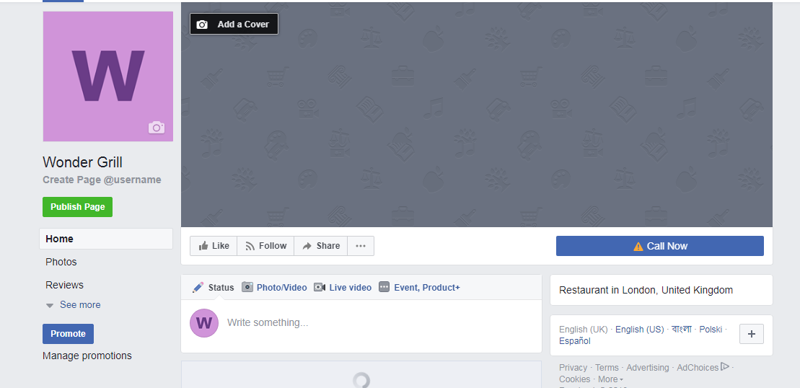

https://twitter.com/Esrarchoudhury

https://www.linkedin.com/in/esrar-choudhury-4bb80b5b/



Reference List:
Bower, M., 2015. A framework for adaptive learning design in a web-conferencing environment. Learning Design: Conceptualizing a Framework for Teaching and Learning Online, p.223.
Chang, V., Kuo, Y.H. and Ramachandran, M., 2016. Cloud computing adoption framework: A security framework for business clouds. Future Generation Computer Systems, 57, pp.24-41.
Golonka, E.M., Bowles, A.R., Frank, V.M., Richardson, D.L. and Freynik, S., 2014. Technologies for foreign language learning: a review of technology types and their effectiveness. Computer Assisted Language Learning, 27(1), pp.70-105.
Hair, J.F., 2015. Essentials of business research methods. New York: ME Sharpe.
Hsu, P.F., Ray, S. and Li-Hsieh, Y.Y., 2014. Examining cloud computing adoption intention, pricing mechanism, and deployment model. International Journal of Information Management, 34(4), pp.474-488.
Kasemsap, K., 2015. The role of cloud computing adoption in global business. Delivery and adoption of cloud computing services in contemporary organizations, pp.26-55.
Lai, C., Shum, M. and Tian, Y., 2016. Enhancing learners’ self-directed use of technology for language learning: the effectiveness of an online training platform. Computer Assisted Language Learning, 29(1), pp.40-60.
Lim, C.P., Zhao, Y., Tondeur, J., Chai, C.S. and Chin-Chung, T., 2013. Bridging the gap: Technology trends and use of technology in schools. Journal of Educational Technology & Society, 16(2).
Mezger, F., 2014. Toward a capability‐based conceptualization of business model innovation: insights from an explorative study. R&D Management, 44(5), pp.429-449.
Oliveira, T., Thomas, M. and Espadanal, M., 2014. Assessing the determinants of cloud computing adoption: An analysis of the manufacturing and services sectors. Information & Management, 51(5), pp.497-510.
Or, C.K., Tao, D. and Wang, H., 2017. The effectiveness of the use of consumer health information technology in patients with heart failure: A meta-analysis and narrative review of randomized controlled trials. Journal of telemedicine and telecare, 23(1), pp.155-166.
Park, E. and Kim, K.J., 2014. An integrated adoption model of mobile cloud services: exploration of key determinants and extension of technology acceptance model. Telematics and Informatics, 31(3), pp.376-385.
Rittinghouse, J.W. and Ransome, J.F., 2016. Cloud computing: implementation, management, and security. Florida: CRC press.
Zhu, S., Yang, X. and Wu, X., 2013, September. Secure cloud file system with attribute based encryption. In Intelligent Networking and Collaborative Systems (INCoS), 2013 5th International Conference on (pp. 99-102). IEEE.

