

NAME- Gingu Alexandra
ID-2538474

Task 1 – Reading Task Template
Upload your photo of your A3 in-class notes here:
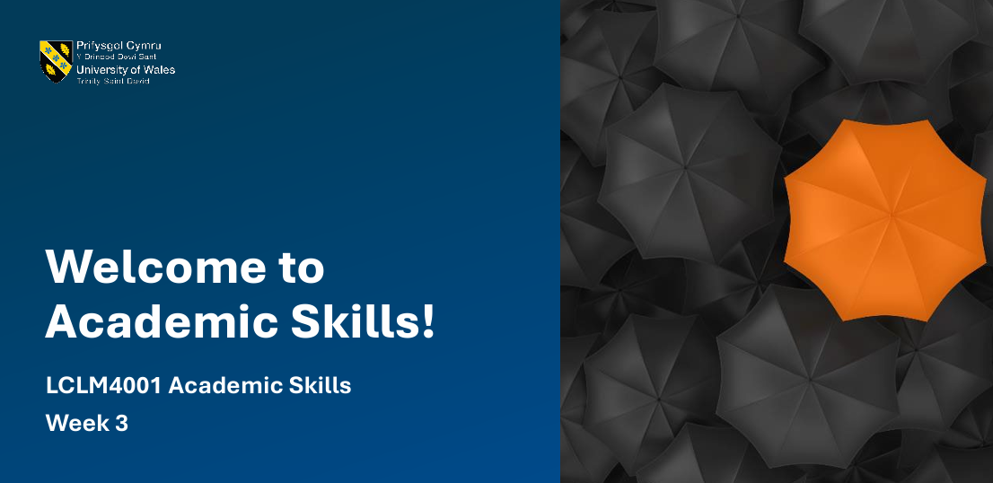

1. Answer these questions using the sentence starters below
a. What is the main idea of the text?
The main subject of the reading is on a chicken shop which has been highly focused as it has become very unique and the customers have been drawn to the shop though the shop is located in remote regions. The observation shows how the shop has the capability of influencing customer behaviour in a strategic manner and to penetrate geographical barriers.
b. What are two key points?
One of the main details of the text is the marketing strategy of the chicken shop. The business was able to get the attention of people outside its locality through the use of social media and online promotion. This was an added customer interest and it induced people to travel.

The other important aspect is the innovation of the menu of the shop. The adventurous clients were attracted to exclusive food products and were offered with a memorable experience of eating. These innovative products helped the business to be distinct among its competitors, customer loyalty and popularity.
c. What part of the text did you find most important? Why?
The most interesting part is the way the shop is differentiated among other shops. This is the reason why customers are ready to go a long way and demonstrates how differentiated products and marketing are the keys to succeeding in business.
d. Was anything unclear or difficult to understand?
I did not understand how the chicken shop could handle such a high number of customers. How they handled staff, inventory control and operational strategies that they used to maintain efficiency was not clearly explained.
e. How did your group help you understand the text better?
My group assisted me by discussing the article and giving various opinions. Their ideas helped me to understand the problematic issues in the business, to see the key points and to understand the information presented in a more suitable manner.
3. One sentence reflection
Question: What did you find challenging about this task?
The hardest part of this reading and note-taking was to synthesize the main points and exclude any important information. This had to be done with a lot of care as all critical aspects had to be covered and clarity and coherence had to be ensured. Both exercises made me realize the importance of having a systematic approach to the analysis of multifaceted texts and the need to have the ability to balance detail and brevity.


