Assignment 2
Assignment 2: Practical
Professor: Koushik Modak| Cloud Computing | Cloud Computing Architecture
Carlos Abreu ¦ Student ID: 2023693

Task 1
(Demonstration of VMs, and how VMs are created and managed, vNets, network security group, and screenshot in Microsoft Azure)

Managing Resources in the Microsoft Azure Portal

Using Azure Portal and its resources it’s possible to manage all resources and life cycle development available in our subscription.
Starting off setting up resource group because it is a container that holds all related resources for a particular Azure solution.
Resource group can include for example, resources for an entire solution or only those resources the Admin expected to manage as a group.
For example, if we have a web solution that need to be high available and included a couple of web apps, load balancer to manage a traffic, what we do is to group all together in same resource group so it can easy be deployed, update, manage, delete, etc.
Resources allow to group all resources together logically, tags also allow to group these resources in additional way so in a larger grouping we can cover up a smaller group of resources and associate them in a different attributes such as department as a name and IT as a value. [1]
Another usage of tags is tagging Production and Development machines.
If we have 500 VMs running around in Dashboard or in a Portal, what we can do instead of struggling to determine which one are production and development we can tag them so to have a better idea which server belongs in which environment.
Ultimately, defining tags that makes the most sense for the organisation or environment is helpful.
But so should keep in mind there a few limitations that applied to tags.
For example, each resource or resource group can only have a maximum 15 tags and a tag name is limited to 512 characters.
The tags values is limited to 256 characters and also, tags applied to resource group are not inherited by resources in that resource groups.
At the end of day, tagging is another way to logically grouping resources within an Azure subscription. [2]

Virtual Network or vNet

Virtual network is the building block for private network in Microsoft Azure, just like a physical network allows communication of physical machine, virtual network in Azure allows the Admin or a developer or a user to facilitate communication among different types of Azure resources like virtual machine, scale sets, storage accounts, all kind of Azure resources that have an IP address.
Everything that communicate will communicate over that network.
We can also use vNet to communicate with internet and establish connectivity back to and on physical network through the usage of VPN connection.
There are 4 keys vNet concepts to be aware of: the address spaces, subnets, regions, and subscription.
During the creation of a vNet it will prompt to specify an address space. This is something we don't need in a physical environment when you create a network, we simply go on and create the subnet on our physical network device.
When we create a virtual network what we need first do is specify an address space that network will consume.
Azure will then assign addresses to the resources from the pool of IP addresses that make up the address space defined.
Now a subnet is a piece of network that Admin or someone else is carving out. It's no difference in a physical sense.
In this case, we have the virtual network with an address space of, let's say, 192.168.0.0/16.
So, we define an address space for a virtual network that way with that range of addresses, what we can then do is further carve out that virtual network into separate subnets.
In this example, outlined below on screenshot we create a subnet of 192.168.0.0/24.
That subnet would be a subspace of that address space that we defined for our virtual network.
Again, this is really no different than carving up our network in a physical environment.
Now, the third term I want to touch on here is the region.
This is important because when you deploy a vNet, that vNet is going to be scoped to a single region.
Now, that being the case, if we need to facilitate communication across regions, which will obviously sometimes happen, what we can do is peer multiple networks, multiple virtual networks, I should say, from different regions using Azure virtual network pairing option.

Resource groups will house all the remaining resources the deploy throughout the building an VM, vNet, etc.
Resource group is a container you use to hold all related resourses for a specific Azure solution.
An example will be a lab course with all Azure resources will be deploy all kind belong together, so it makes sense to keep then within their own resource group, and use resource group as management boundary.

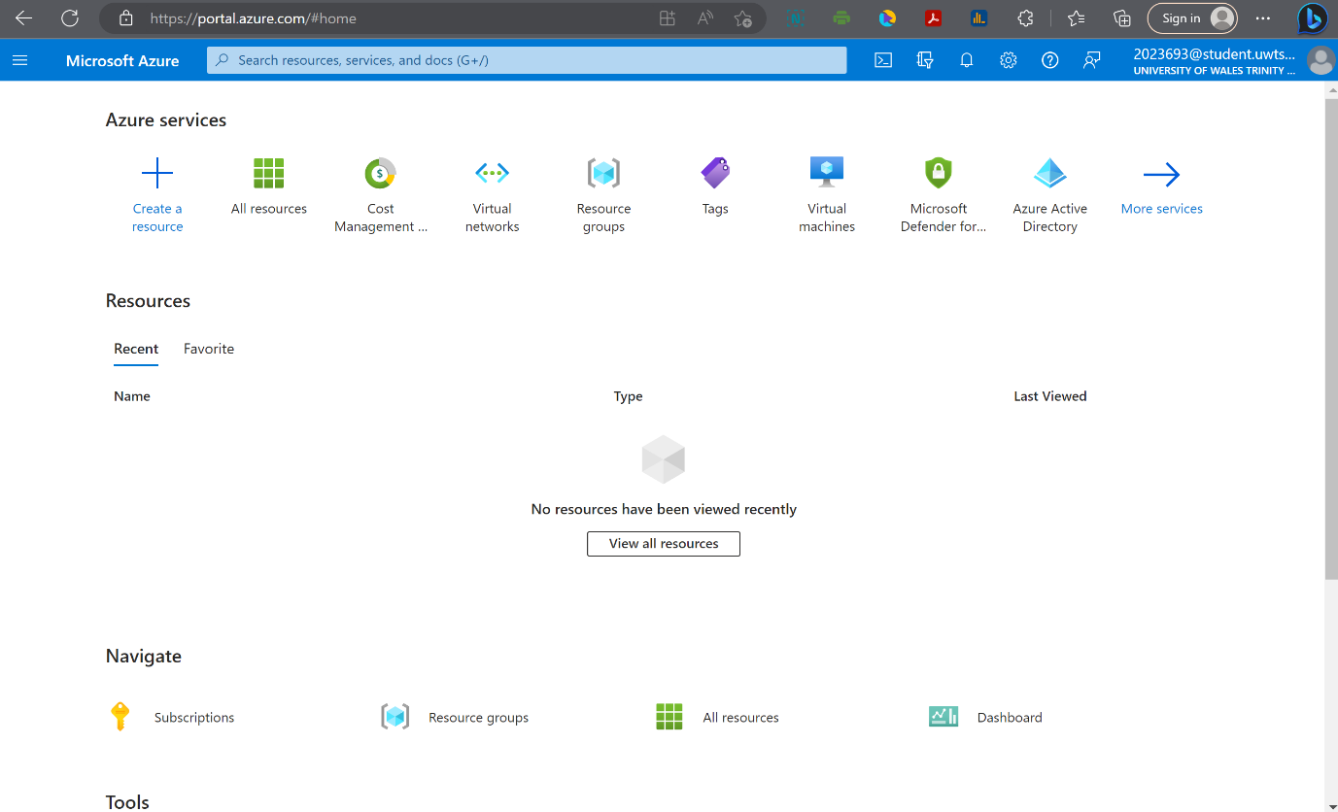

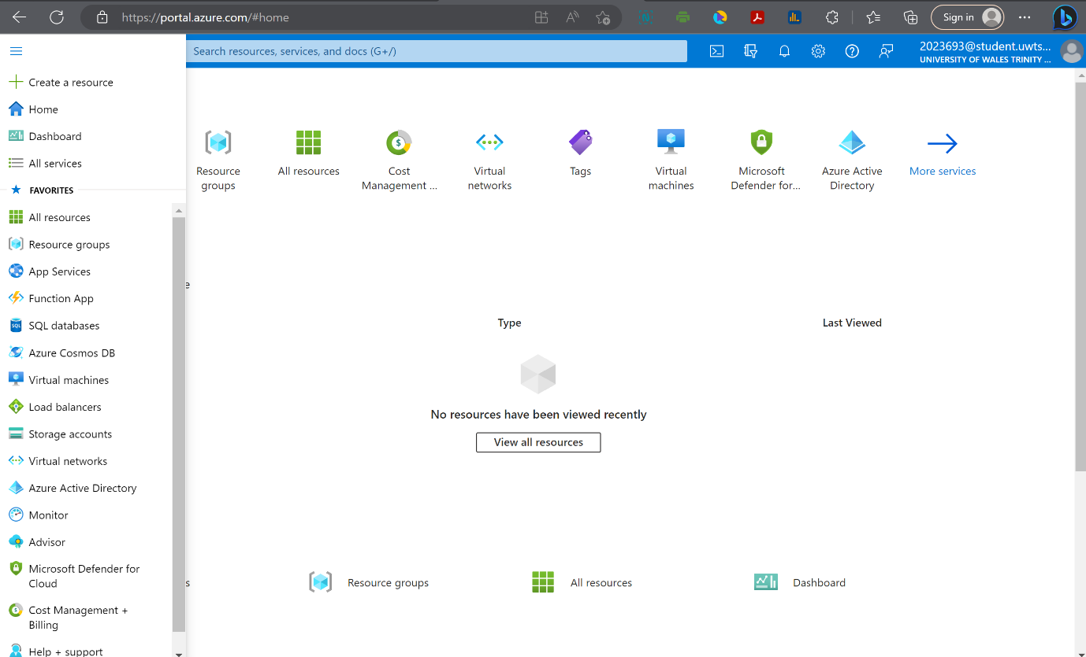

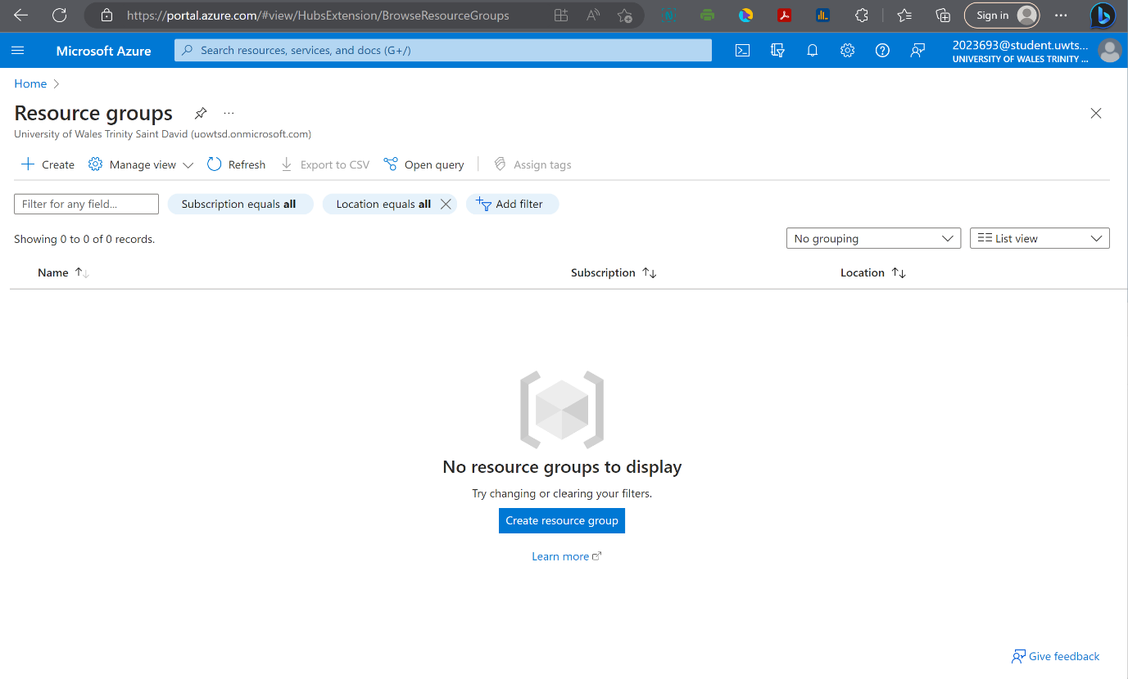

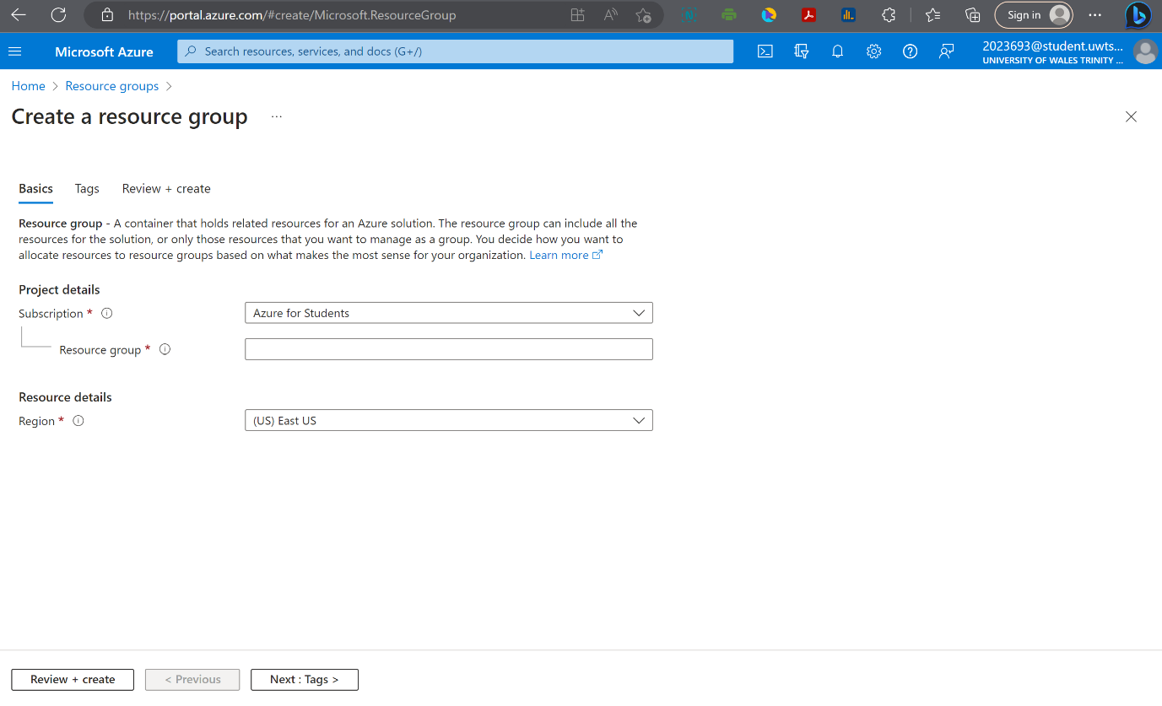

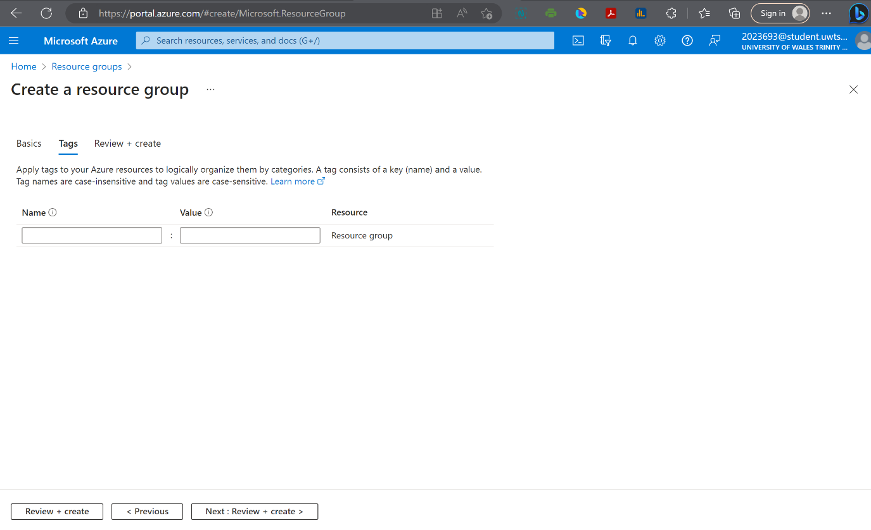

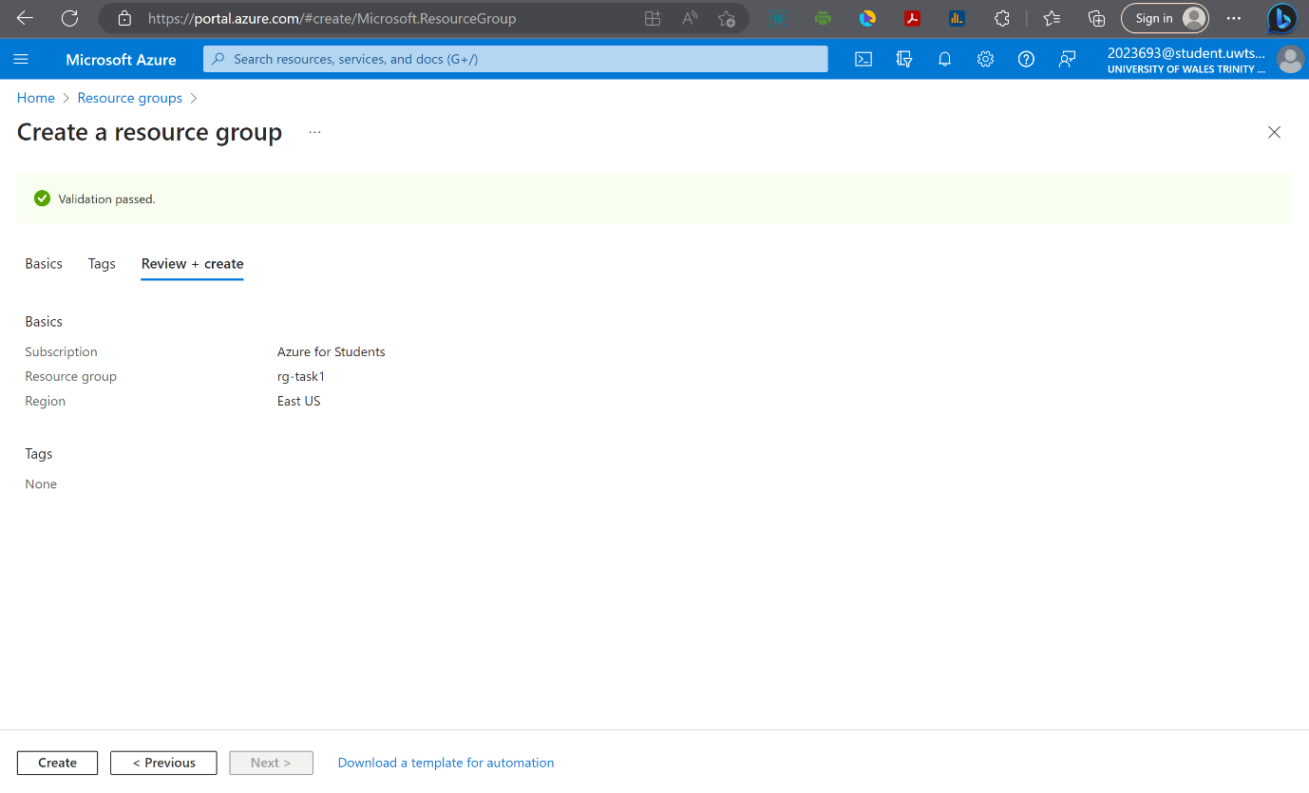

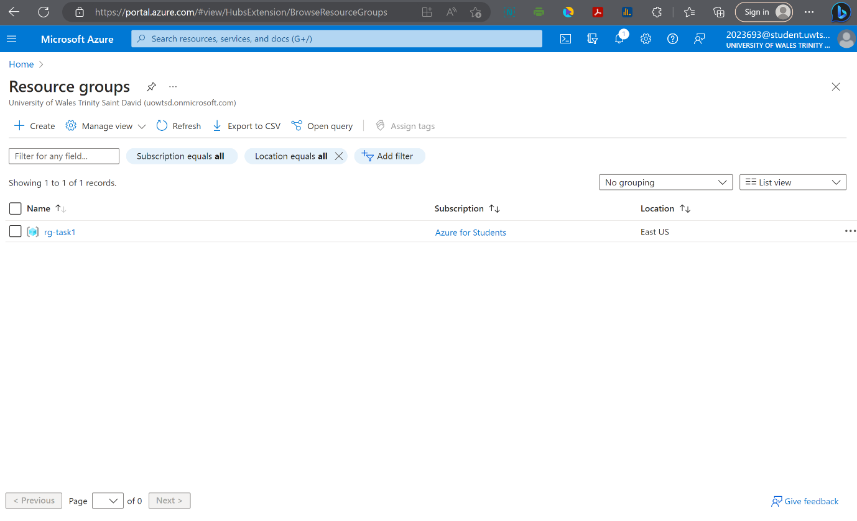

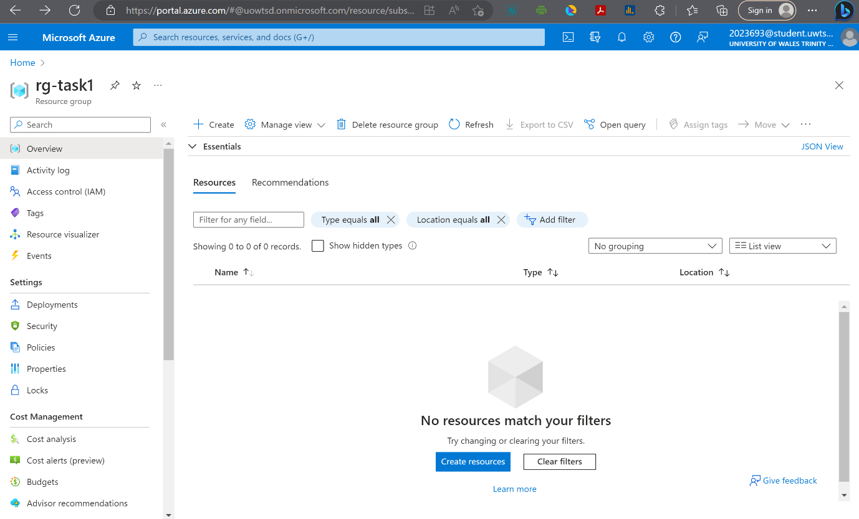

So, in the scenario of the Assessment 2 let’s keep that in mind that when we're deploying a network, and the vNet its scope's to a single region.
And lastly, it’s important to talk a little bit about subscriptions because like region, virtual networks are scoped to a specific subscription.
That being the case, you can implement multiple virtual networks within each Azure subscription and of course, within each Azure region.
So, what we're going to do is deploy a virtual network and run through some of the basic configuration tasks for that virtual network.
I'm in my resource group, the rg-task1 Resource Group that we deployed earlier and what we're going to do to provision our virtual network in this resource group is click add and, we'll search the marketplace for virtual network.
And we can select it form the search results and then we can see in the overview, Azure tells us a little bit about what a virtual network is.
So, what we'll do to begin the deployment is click create, and now we have a couple of configuration tabs here that we need to be concerned with. Some of this information is mandatory, some is optional.
We need to tell Azure which subscription we want to deploy to (in our case we got only one, Student Subscription) and to which resource group we want to deploy to.
And under instance details, we need to tell Azure what the name of our vNet is and in what region we want to deploy to.
We're deploying everything into (US) East US and for this virtual network, I'll just call this vnet-task1.
We could have click "Review + create" but I don't want to do that because as we'll notice, we haven't had an opportunity to configure the address space for our network, nor the address range for our subnet.
So, what we'll do to make that happen is click on next for IP address down at the bottom.
Now, from the IP addresses pane, we can see that by default Azure is going to give us an address of 10.0.0.0/16 and I don't want do that.
So, what we'll do, instead of using the 10.1.0.0/16 address space, we're going to create a 192.168.0.0/16 address space.
Then what we'll do is add a subnet and we'll call this subnet1.
The address range here, needs to fall within the address space of a parent virtual network.
We'll give an address range for our subnet of 192.168.0.0/24.
If we hover over the icon, we can see that what this does is allow us to enable one or more service.
What that means is that we can create these endpoint policies that allow traffic to specific Azure resources from this virtual network over the service end points.
Now we have our virtual network with an address space of 192.168.0.0/16 and then we have a portion of this virtual network carved out into a subnet called subnet1 with an address space of 192.168.0.0/24.
If we bounce into security tab we can see we have a couple different options in this security tab.
So, what we can do is review and create. And Azure goes in, validates our options and says, we're good to go.
What we can do at this point is create our virtual network.
Now, the deployment of the virtual network takes a little bit longer than a resource group, but not terribly long, and we see the deployment is complete if we go to our resource were taken to the overview page where we can look at some of the information about our virtual network, we can look at the different connected devices, we can look at the address space, the DNS servers that are assigned to this network, and of course, if we go under settings, we can look at the address space itself.
Going back to the overview page and at this point we have our first virtual network deployed.

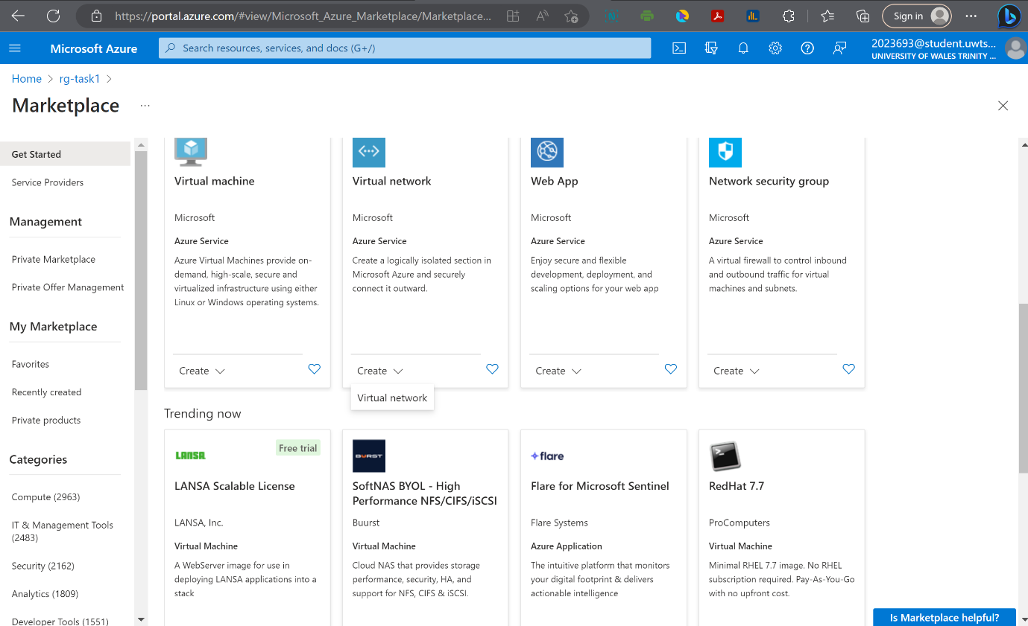

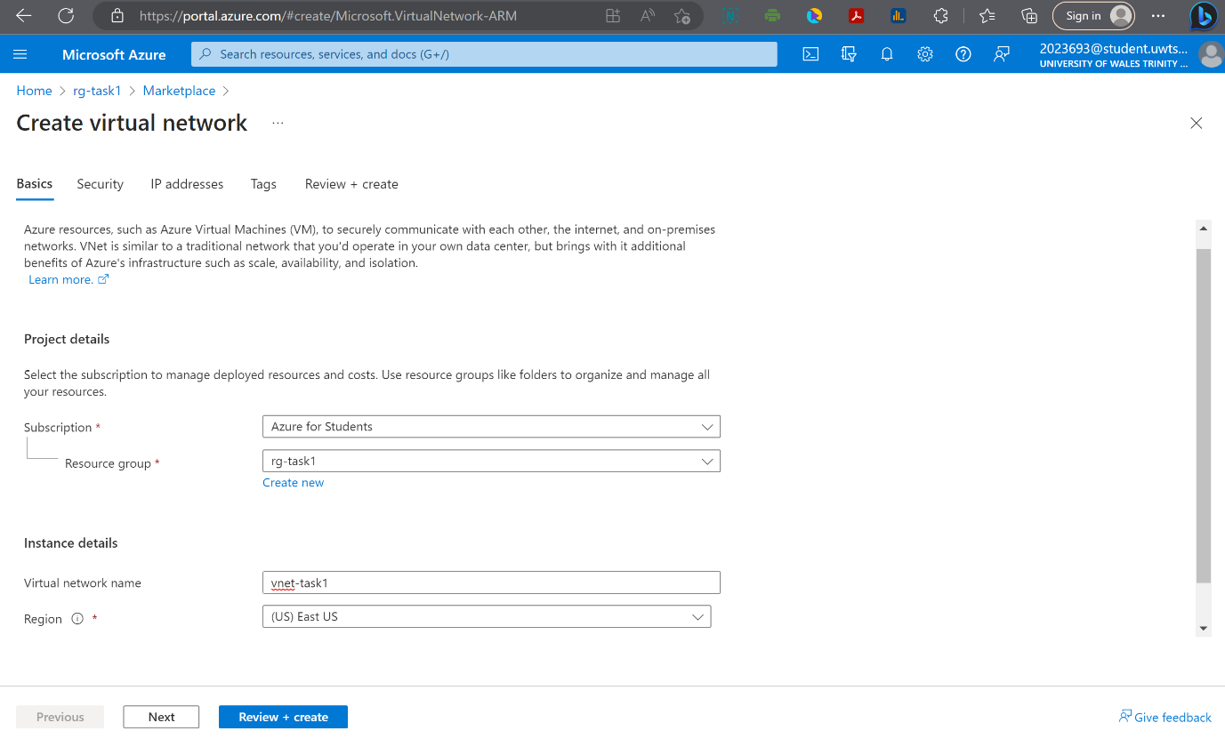

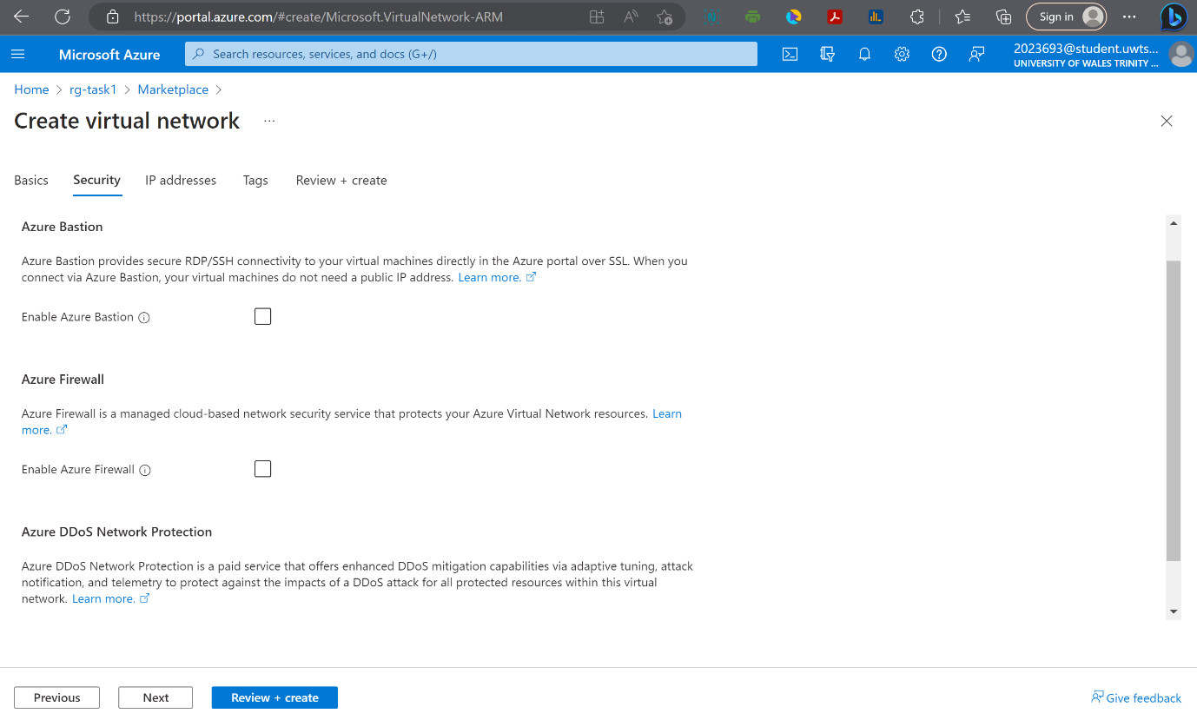

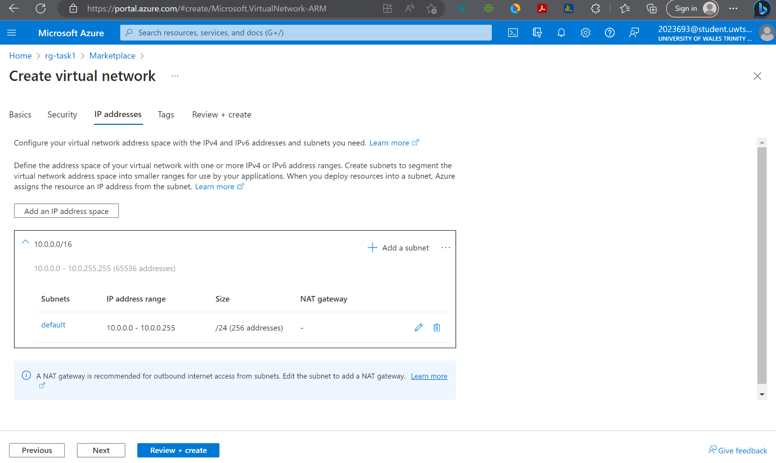

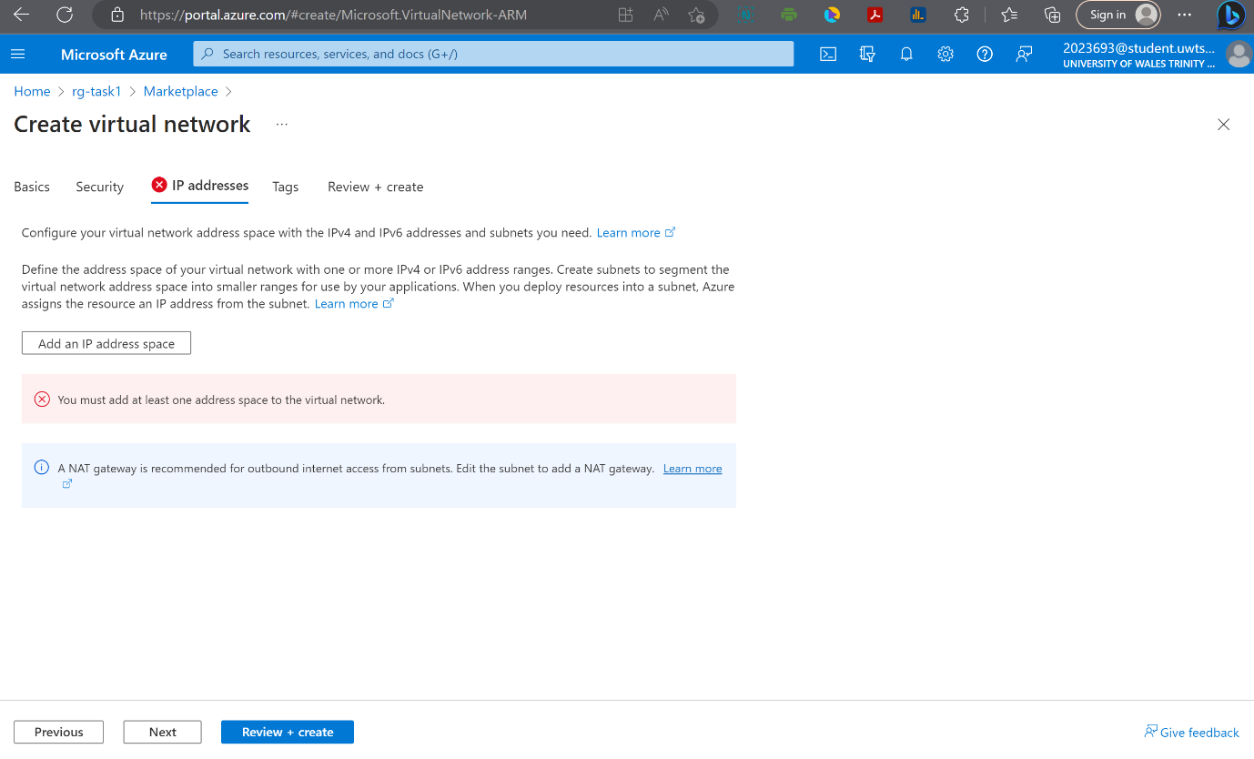

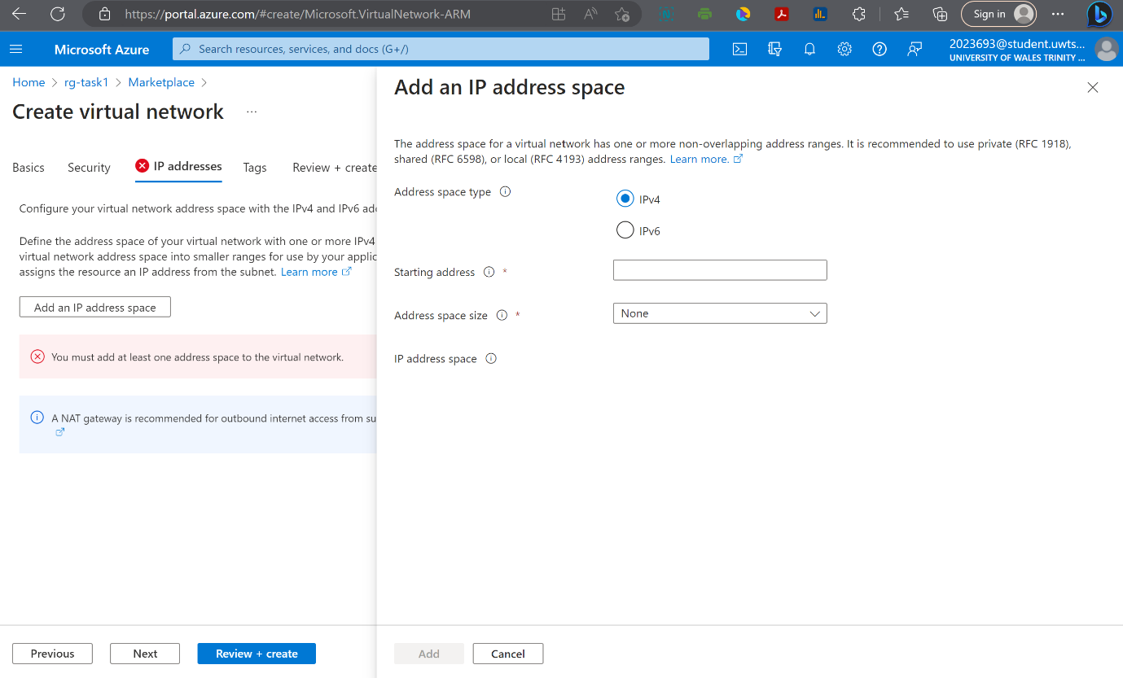

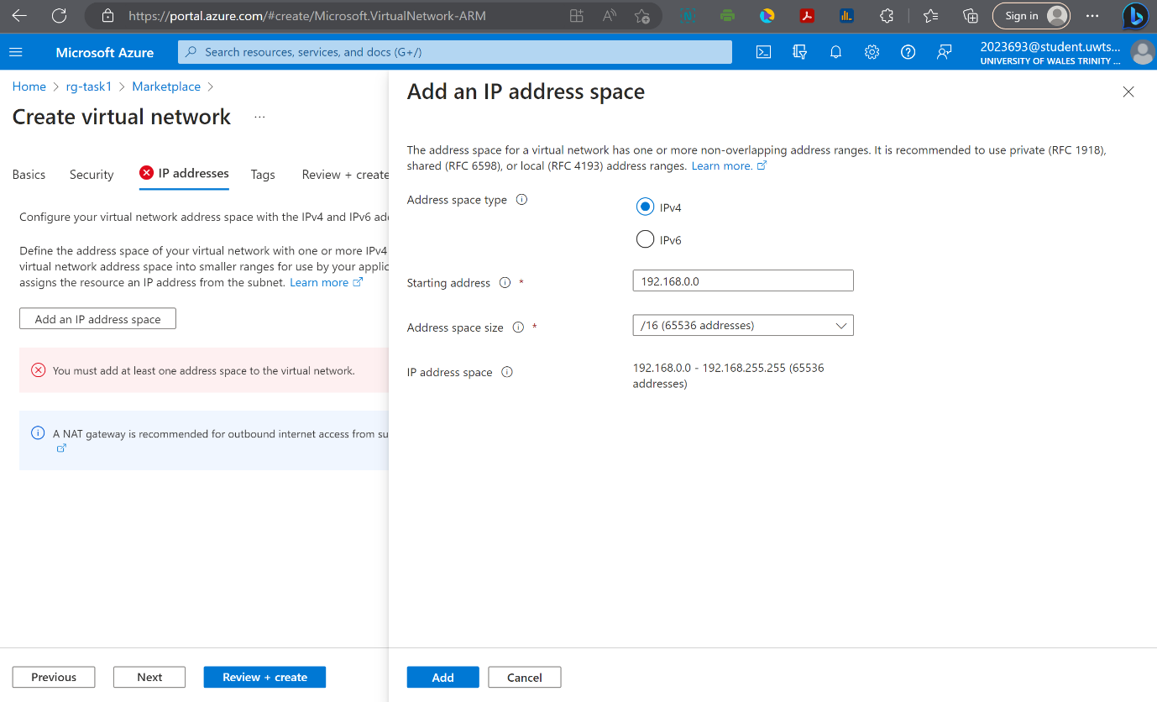

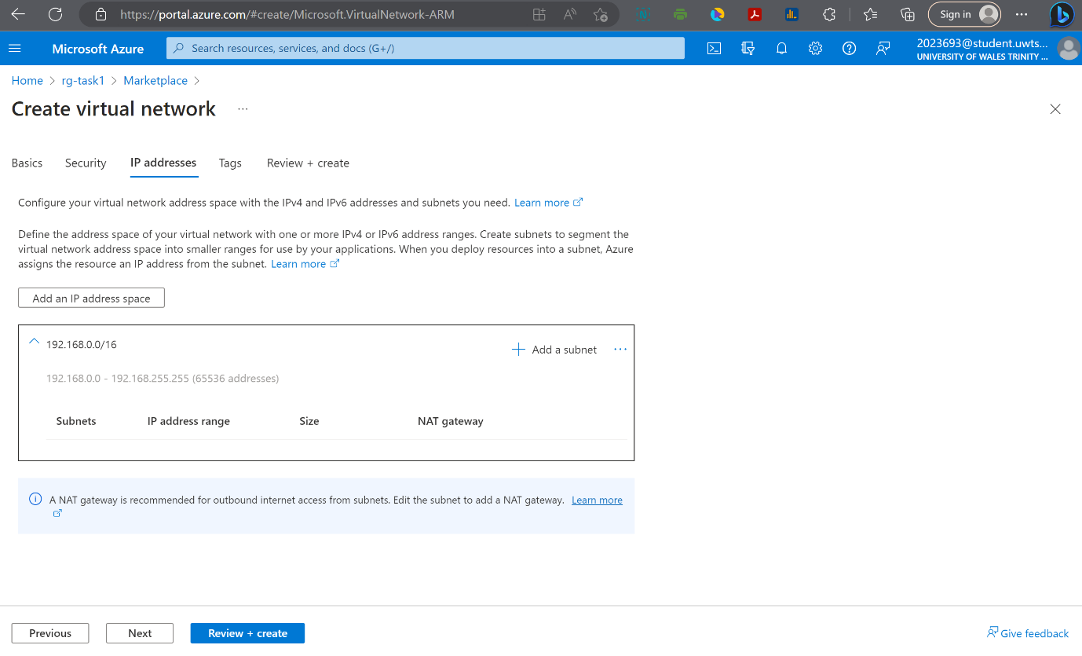

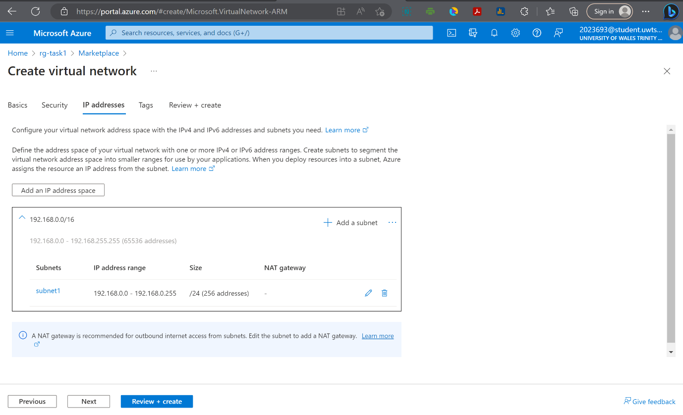

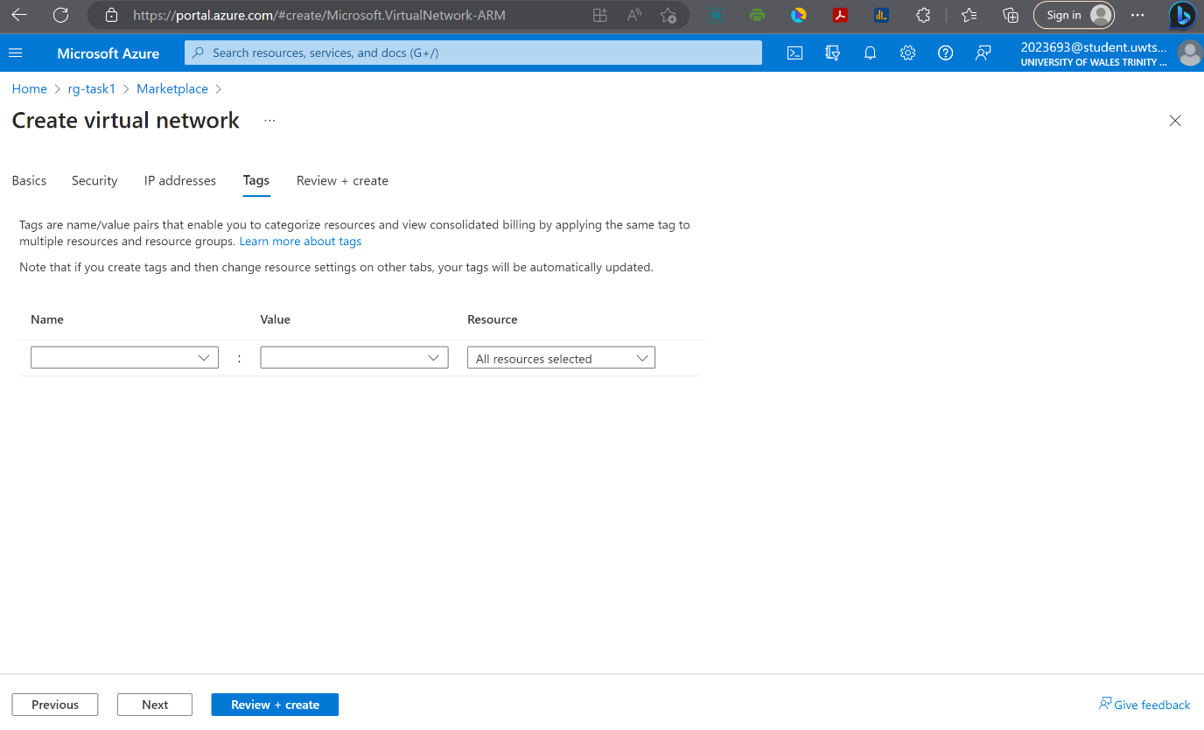

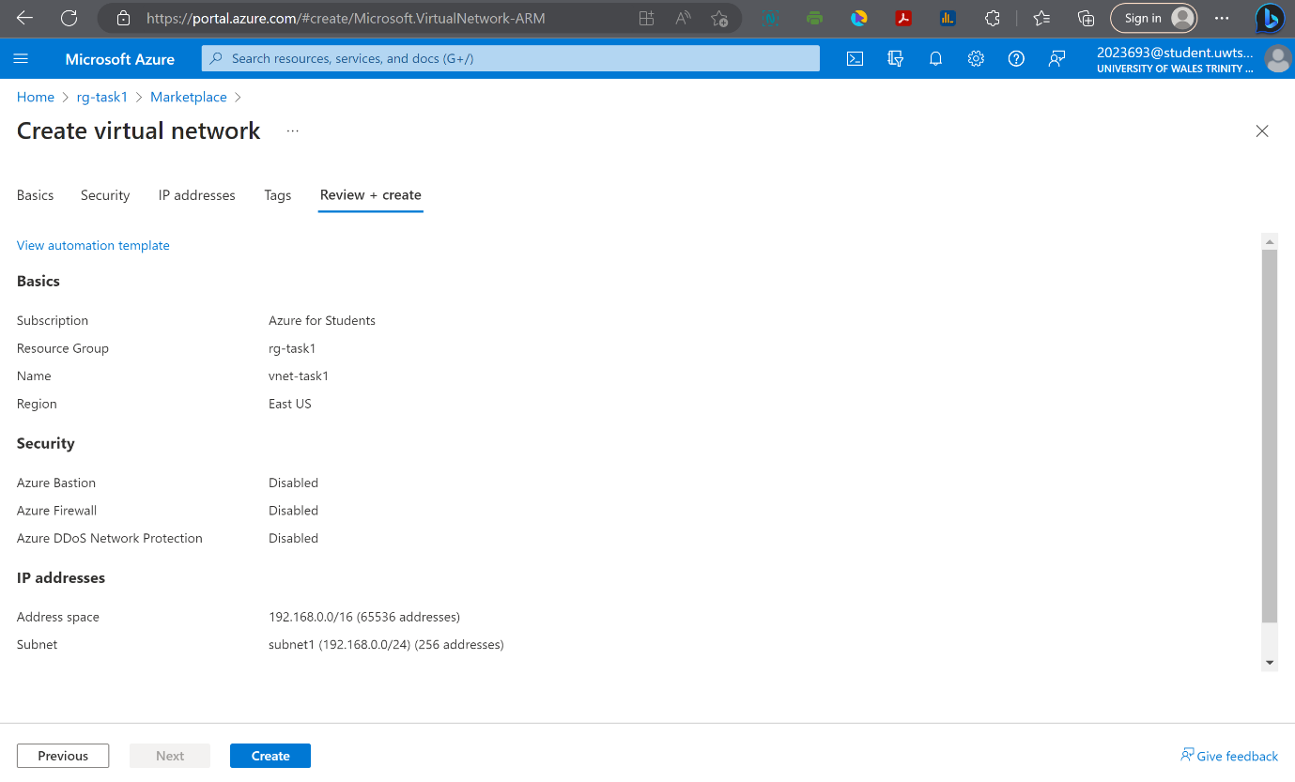

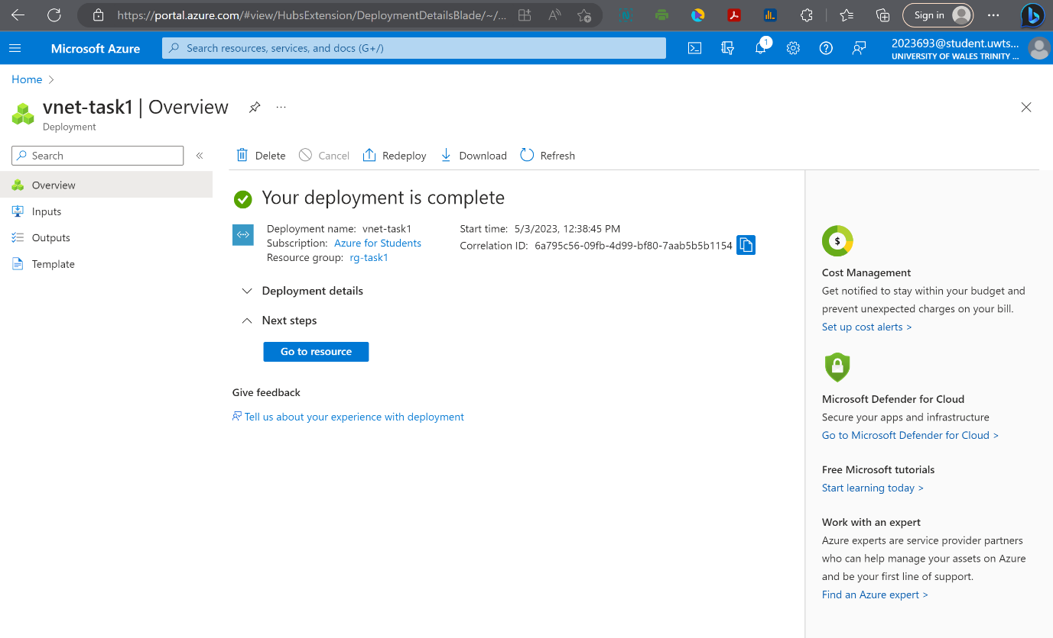

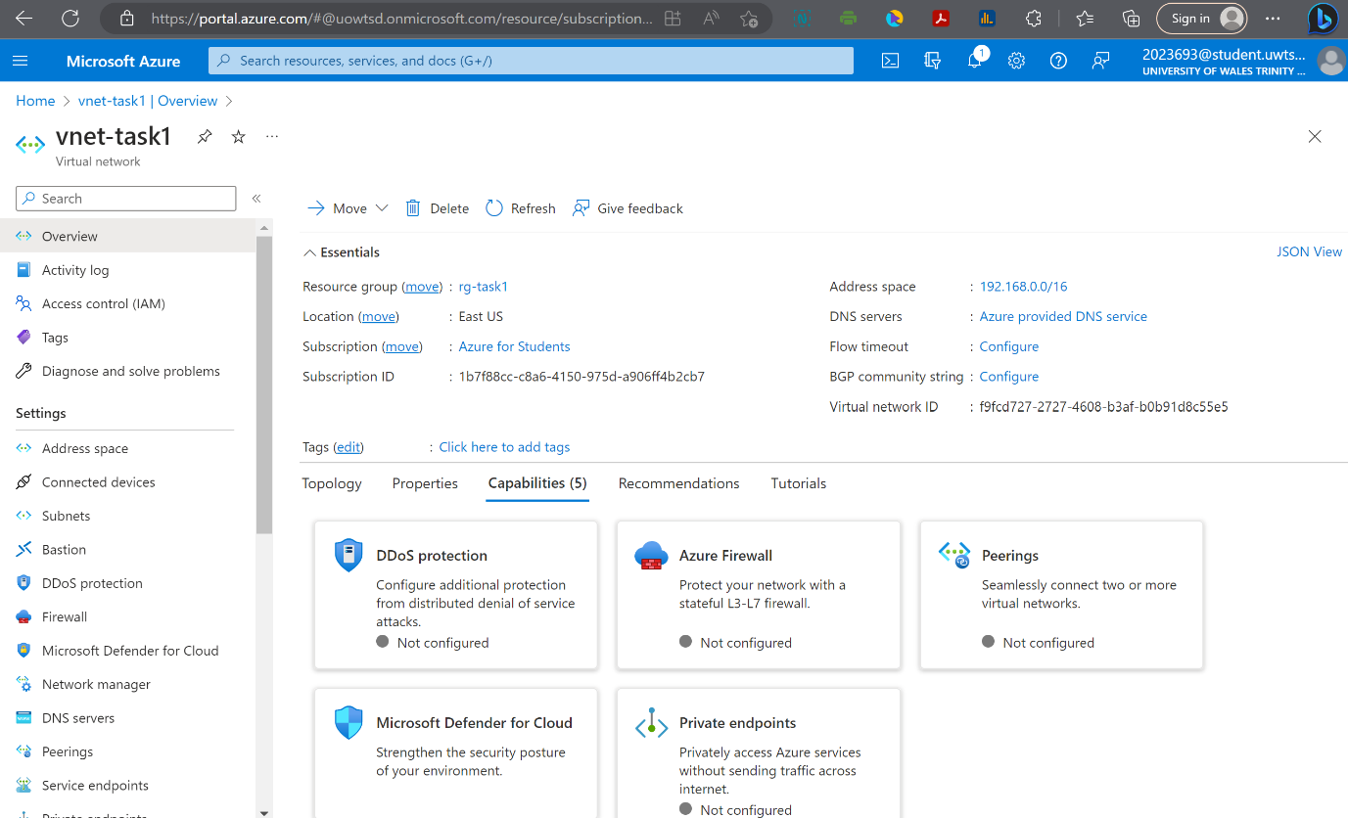

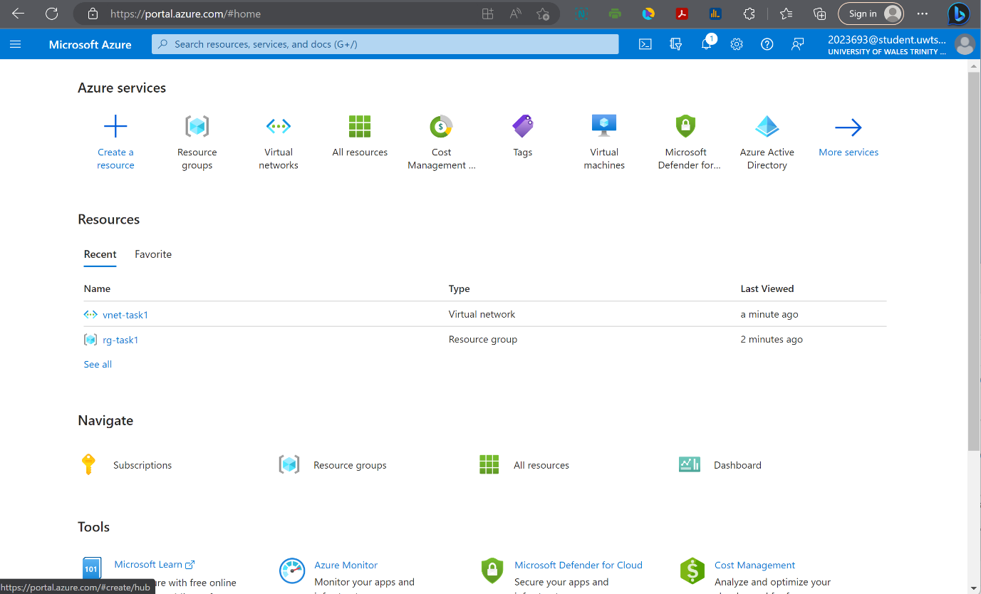

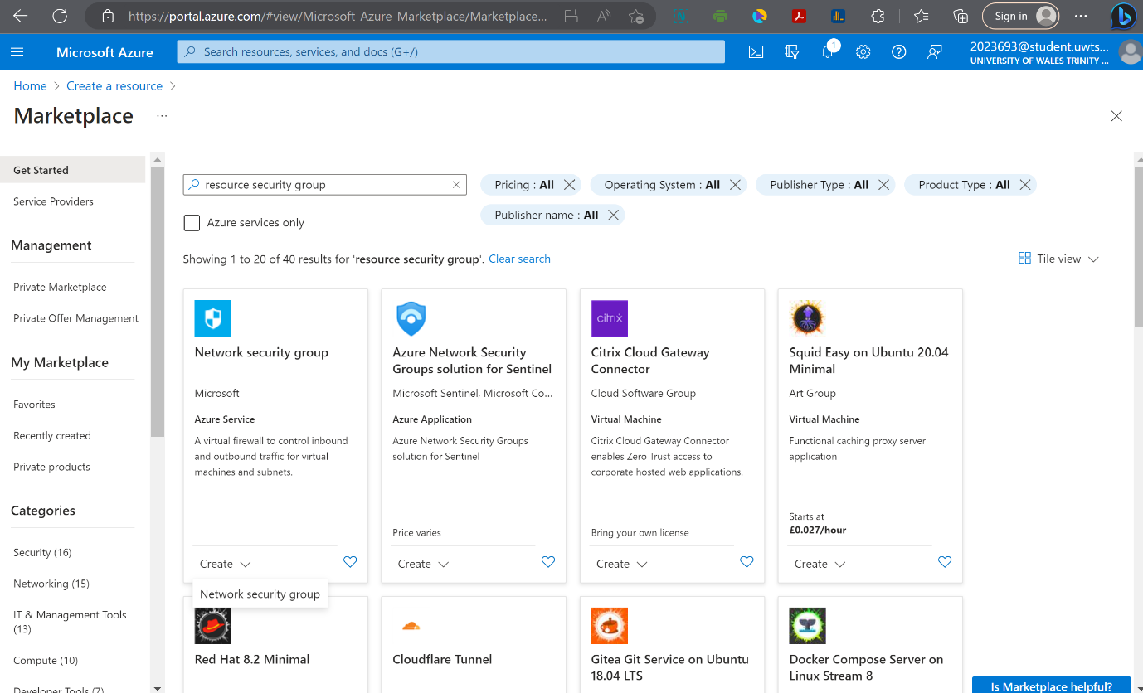

Deploying a Network Security Group via the Azure Portal

To protect that vNet we use what's called network security group.
What a network security group does is filter network traffic to and from Azure resources that are connected to a specific Azure virtual network. The network security group that we define will contain security rules that allow or deny inbound and outbound traffic to and from the resources that are connected to that network. Now, what we're going to do is create a network security group that allows RDP in from the internet, so when we deploy our virtual machine later on, we can get access to it from the internet.
We're at the overview page now to create our first network security group that's going to allow RDP traffic.
What we'll do is will go to the hamburger menu up and click create a resource.
And from the marketplace will search for network security group, and it shows up in the results and then again in the overview pane we can see Azure tells us what a network security group does, what it's used for, some details that kind of help to understand what the network security group is.
There is some basics and there's some tags. What it does it creates security group. Then we have to go in and define our role.
We're going to deploy into rg-task1 and will deploy into the (US) East U.S. region and the name we're going to give for my network security group, I'll just call it my rsg-sec-task1.
We get a successful validation, so we'll go ahead and create our network security group.
Now, once this is deployed, we need to associate this network security group with a subnet that we want to protect with it.
We can see that this network security group actually came out of the box with a half a dozen pre-existing default rule.
We have three default inbound security rules and three default outbound security rules.
The three inbound rules allow traffic from the virtual network in, they allow traffic from low balancers in, but then they deny everything else.
So, unless traffic is coming from vNet or from a load balancer, traffic coming in is locked down.
The outbound security rules that are created automatically do the same thing, but the opposite.
They allow vNet traffic out, they allow internet traffic out, but they block everything else.
If I click the ellipsis, the option to delete these default rules is grey out.
That's because we can't delete these default rules.
But what you can do is create custom rules Port_3389_in that override them, but we can't delete these rules.
After setting and create our inbound security rules, clicking in outbound security rules we can see that all traffic to the internet is allowed so we don't have to create that rule Port_3389 for outbound because we're already allowing traffic out to the internet.
Now that we have our security rules created, let's go ahead and associate this network security with subnet.
What we want to do is protect the subnet called subnet1 that we created early on.
And to do that we click on Associate and then in the virtual network drop down we can select virtual network vnet-task1,subnet name subnet1, service protocol RDP, port 3389.

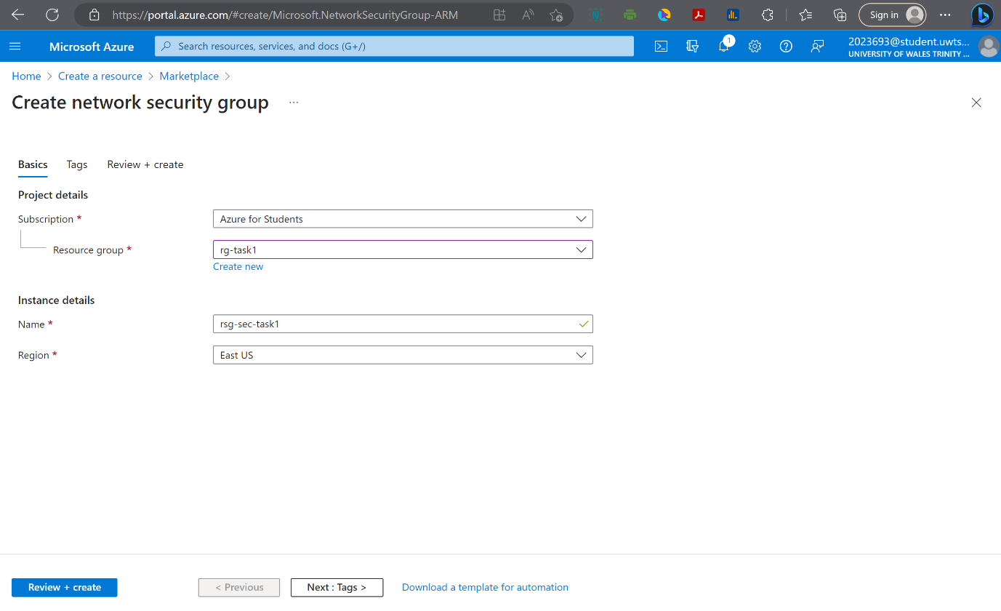

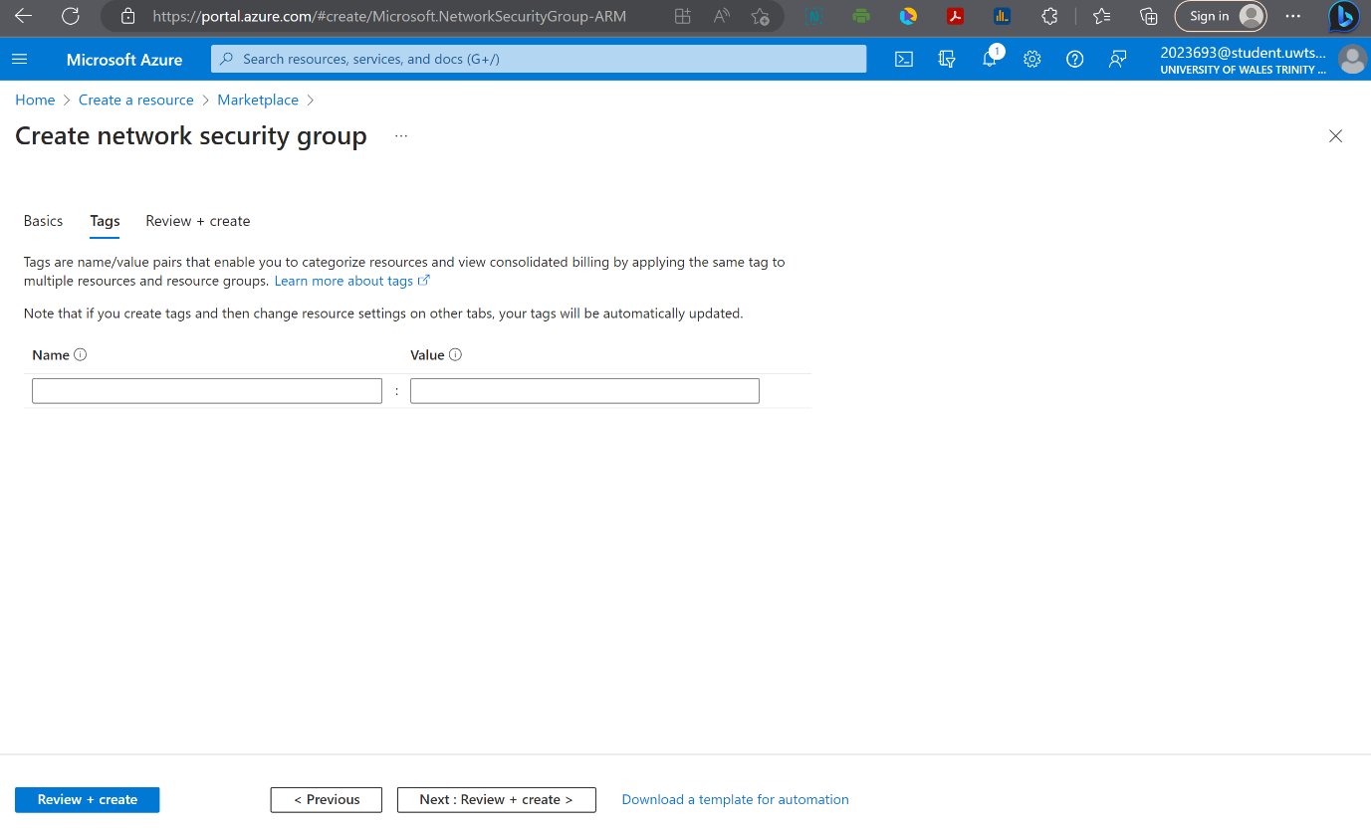

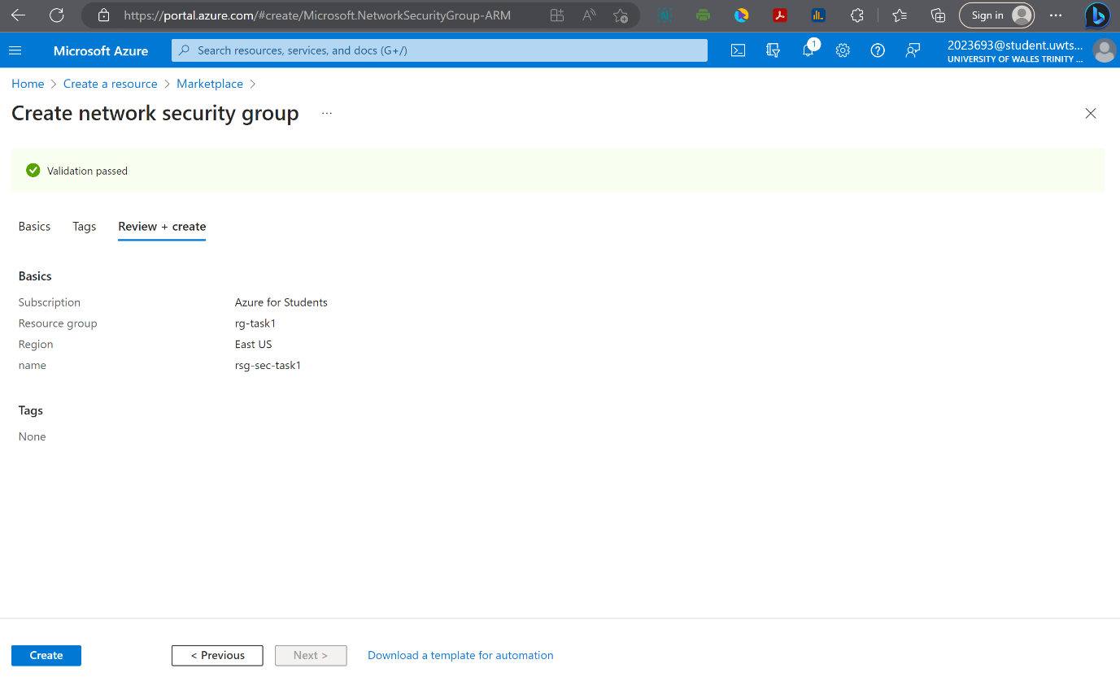

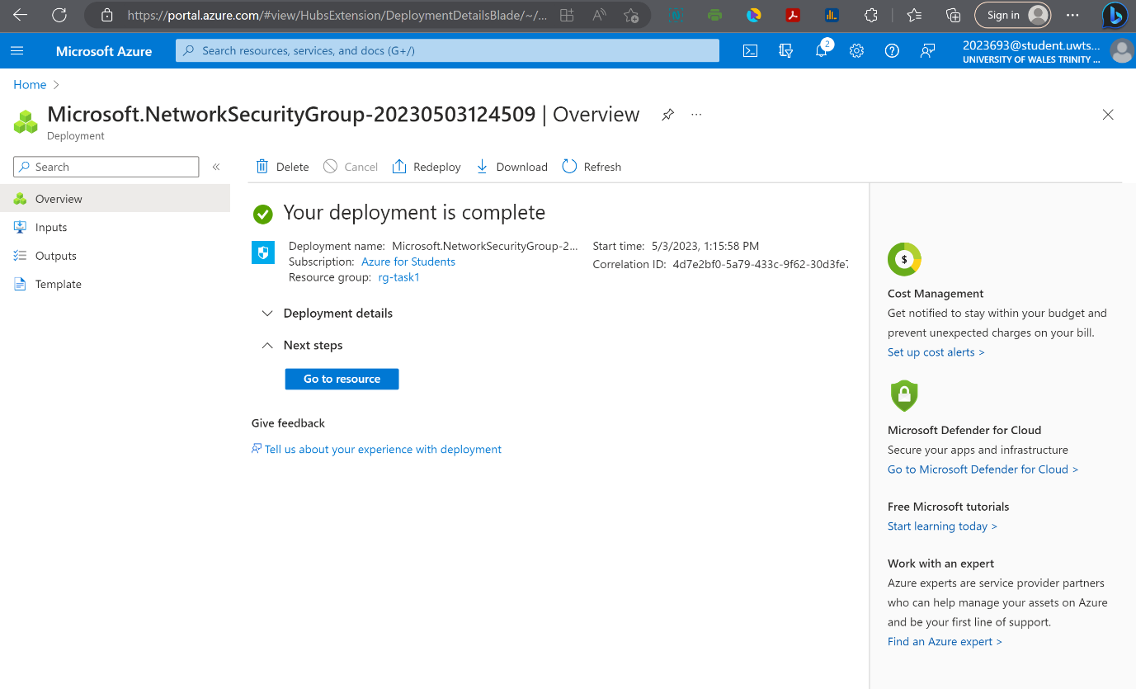

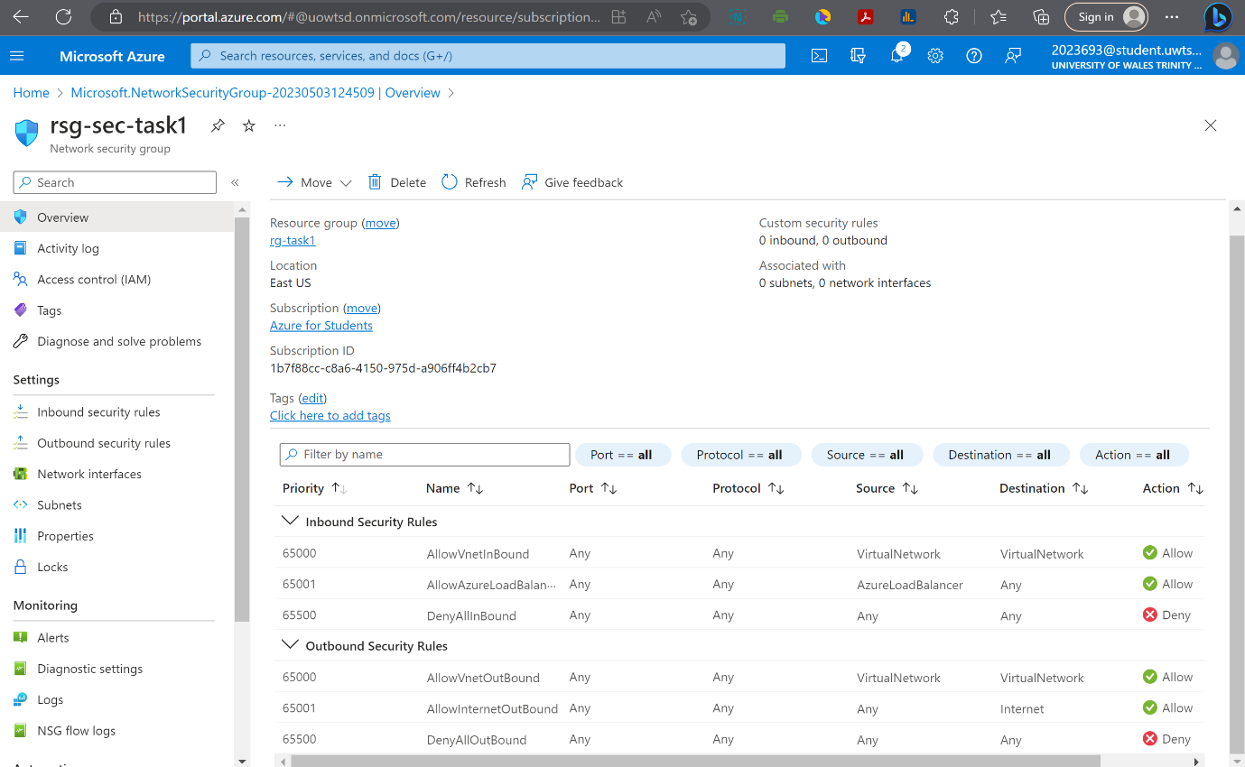

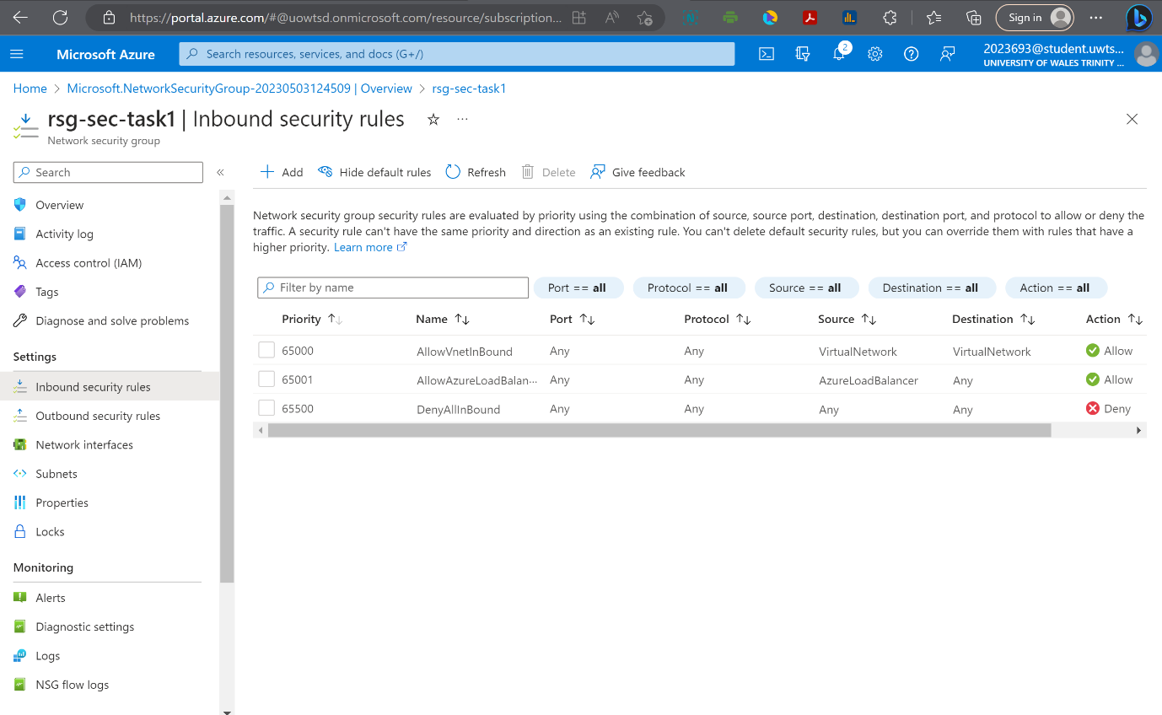

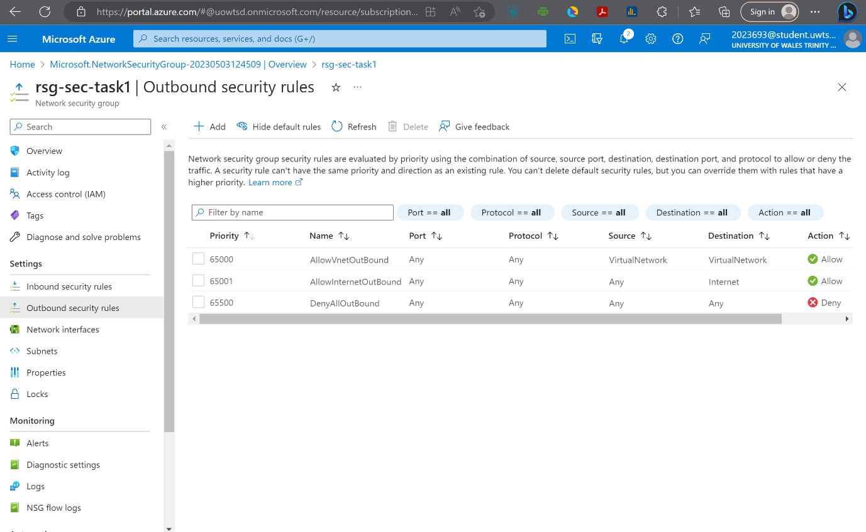

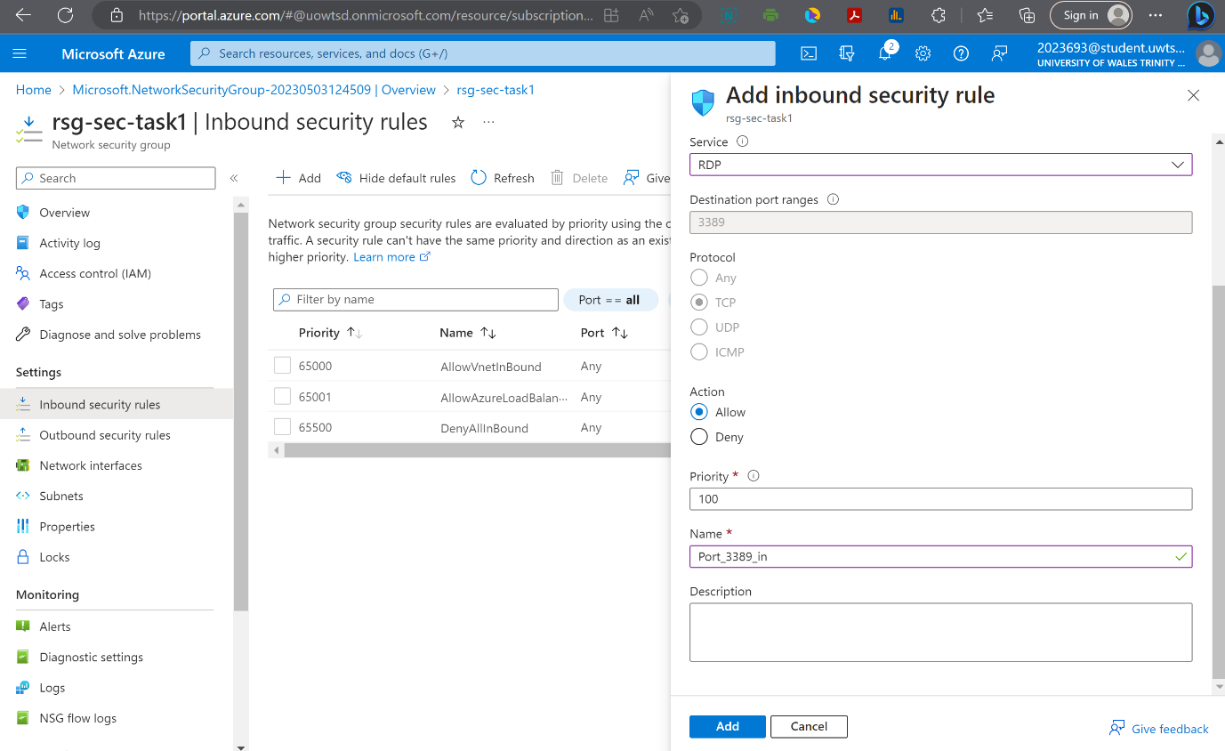

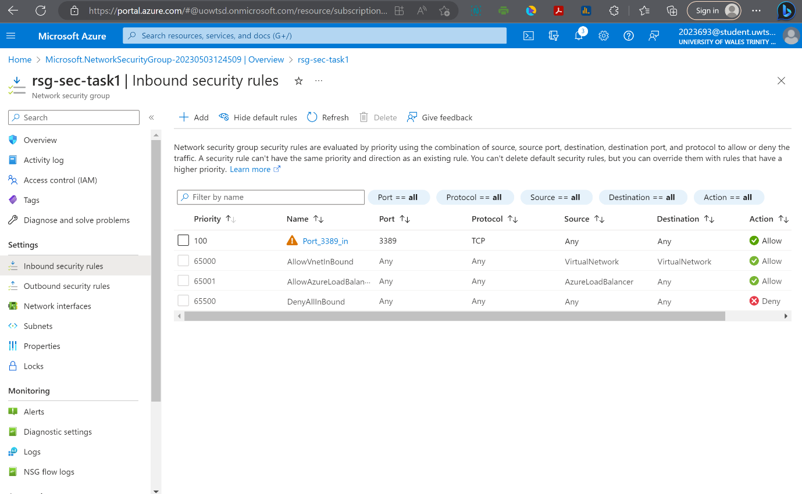

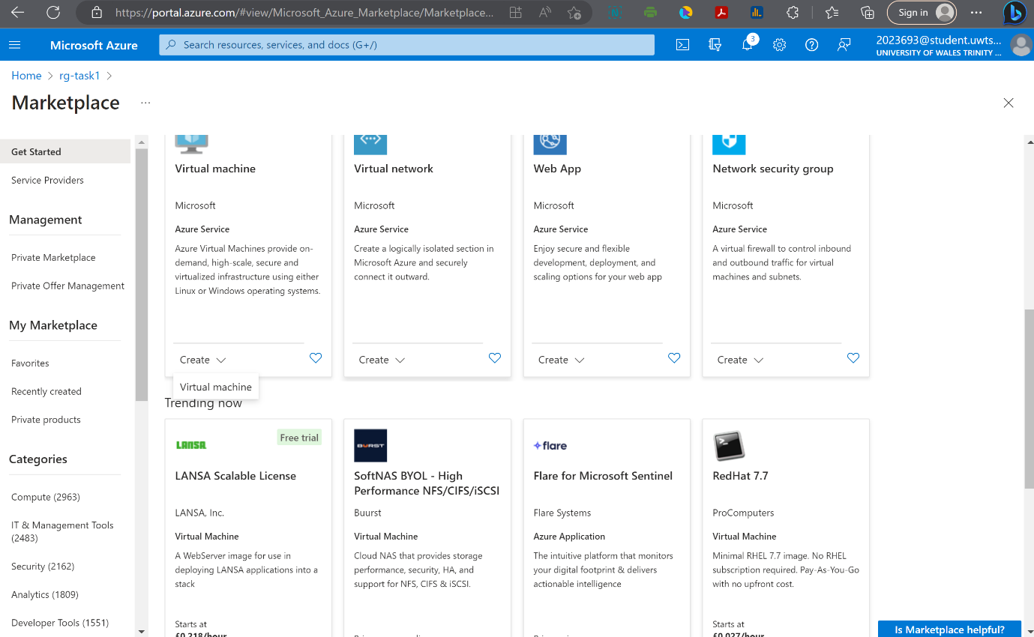

Deploying a Virtual Machine via Microsoft Azure Portal

In the previous session, we walked through the process of the deployment and configuration of our first network security group, what we're going to do now is walk through the process of deploying our Windows virtual machine. And when we deploy this virtual machine, we're going to attach it to the subnet called subnet1 which is the subnet that's protected by the network security group that we have provisioned.
To deploy our virtual machine, I can click the hamburger button and then create a resource. I want to do is deploy a Windows Server 2019 machine. I don't see Windows Server 2019, so what I can do is browse to compute in left-hand pane, and then when I browse to compute we can see Windows Server 2019 Data Center is down at the bottom. Now, when we create a virtual machine, we have six different tabs to complete.

In Instance details, if I hover over the icon what this tells us is that a virtual machine in Azure has two different names.
It has a virtual machine name that is shown in the Azure portal and then it has a guest host name. So that's the host name within the operating system. When we create a VM in the portal, the same name that we give it in the portal is automatically used as the host name for the OS. We cannot change the name in the portal. We can change the name that's within the operating system, the hostname.
Best practice would be calling our server what we want to be called in both the Azure portal and on the guest operating system, so we're not trying to figure out which servers are which. So, in this case, we're calling this server vm-task1 and we're going to deploy into the (US) East U.S. region. Now, the availability options allow us to deploy into an availability zone and availability set or have no infrastructure redundancy at all. Now, we're not going to use any availability options.
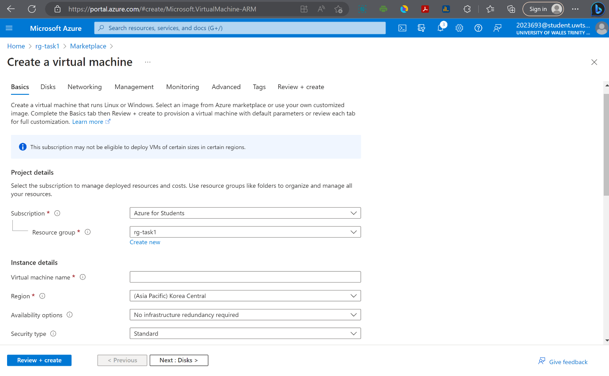

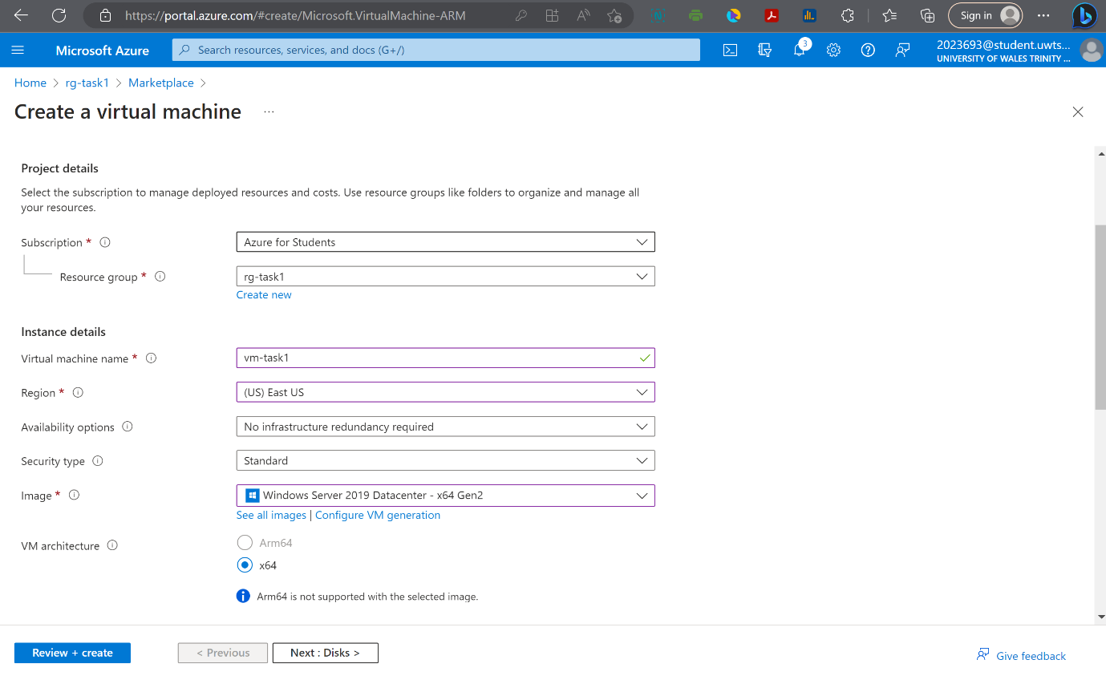

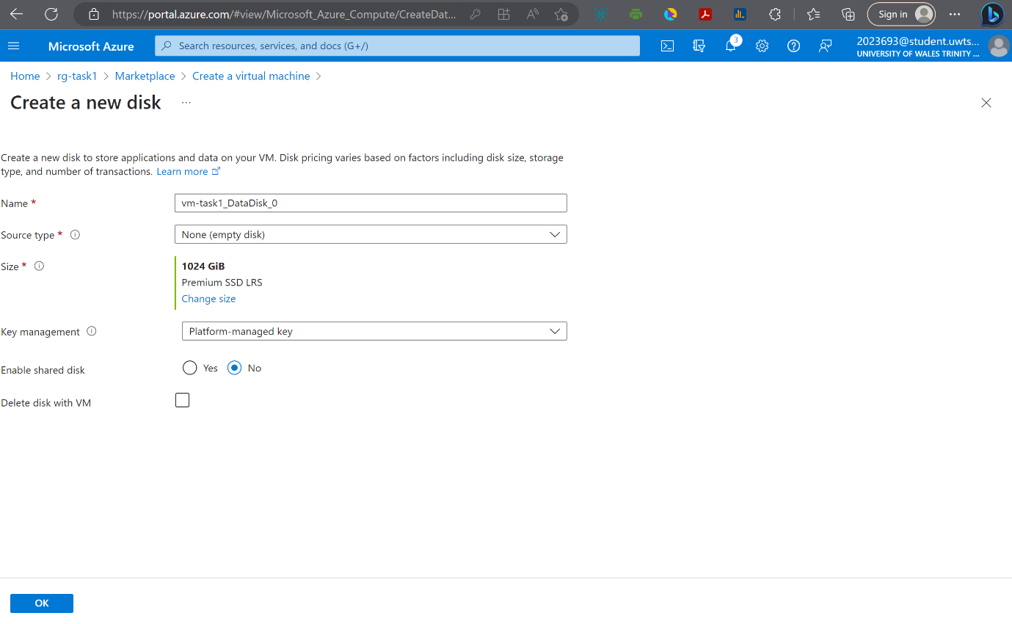

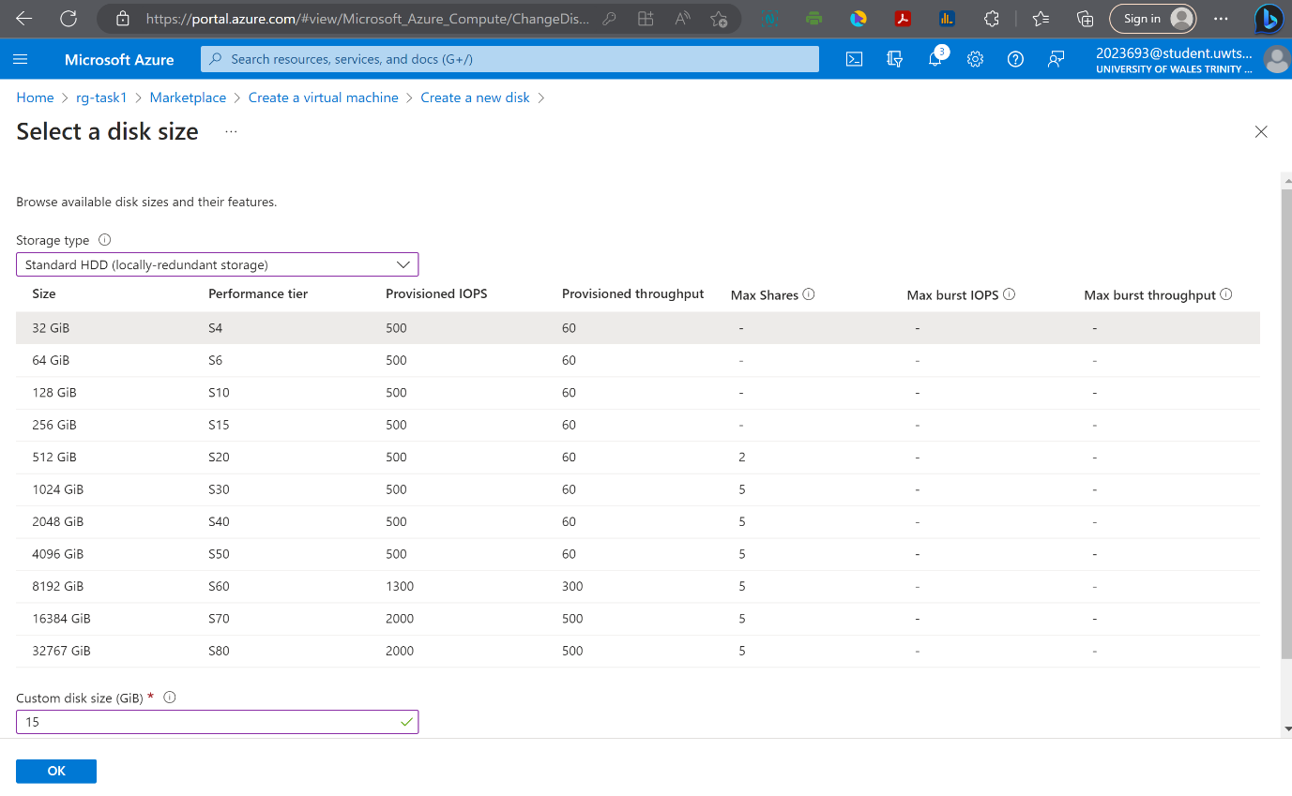

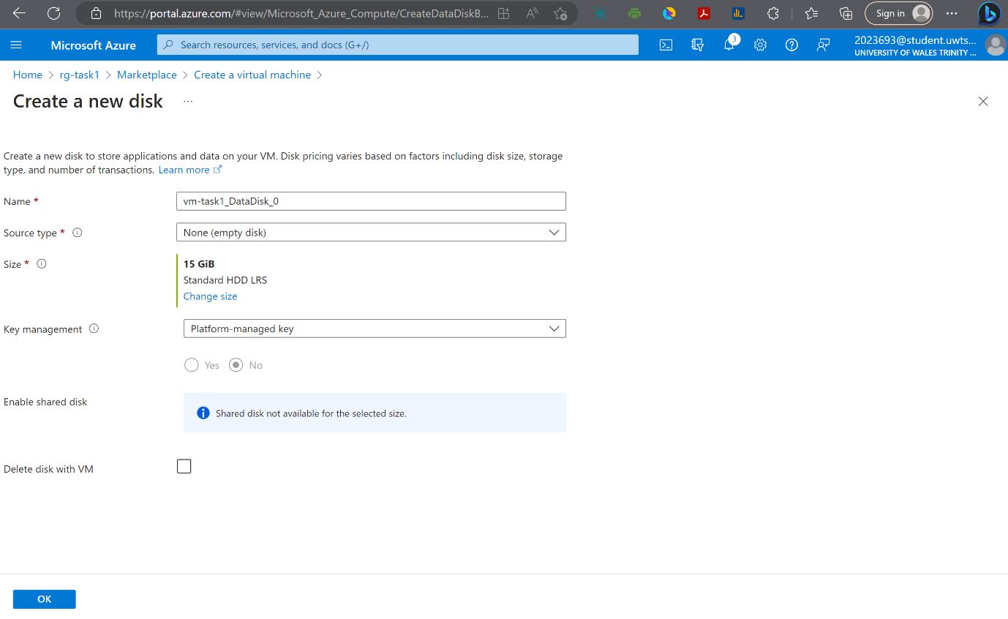

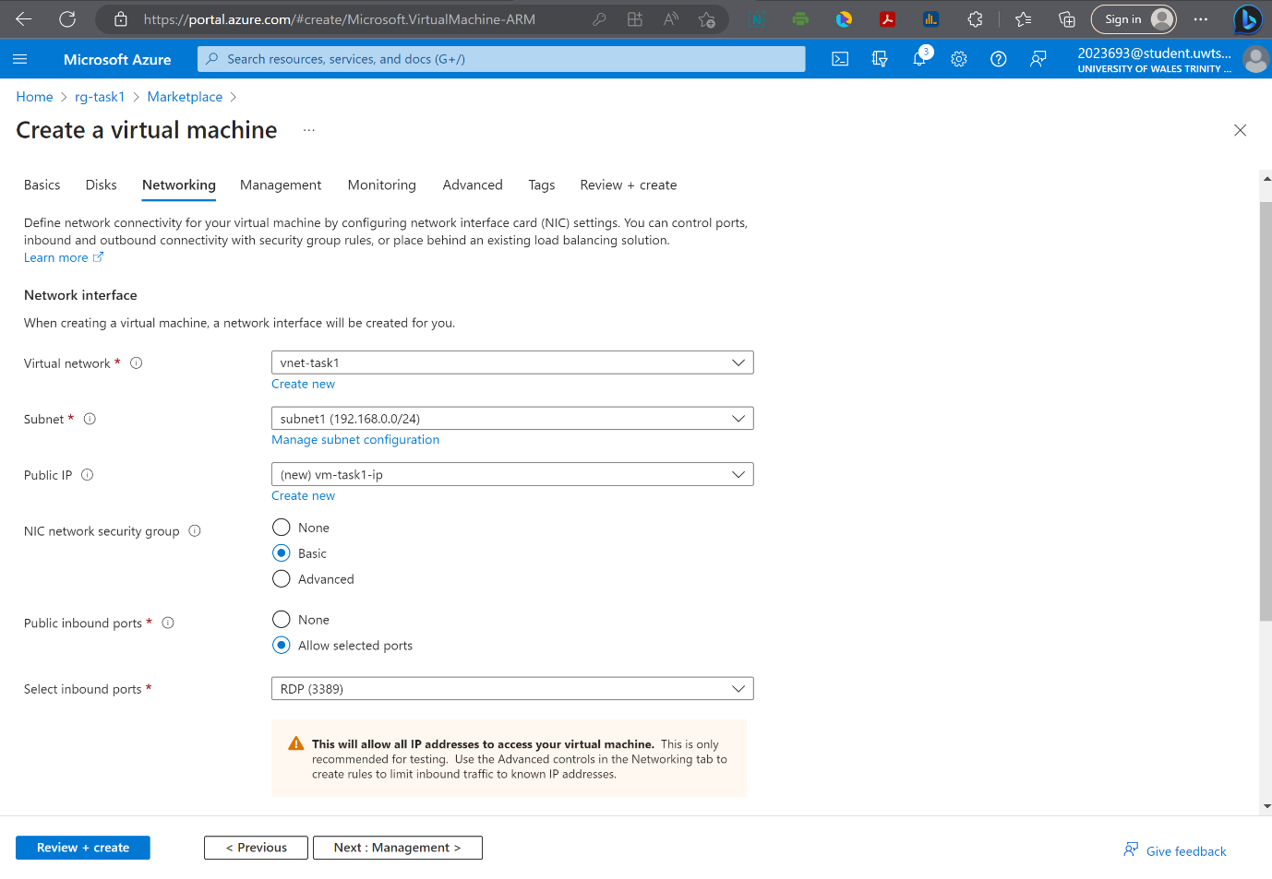

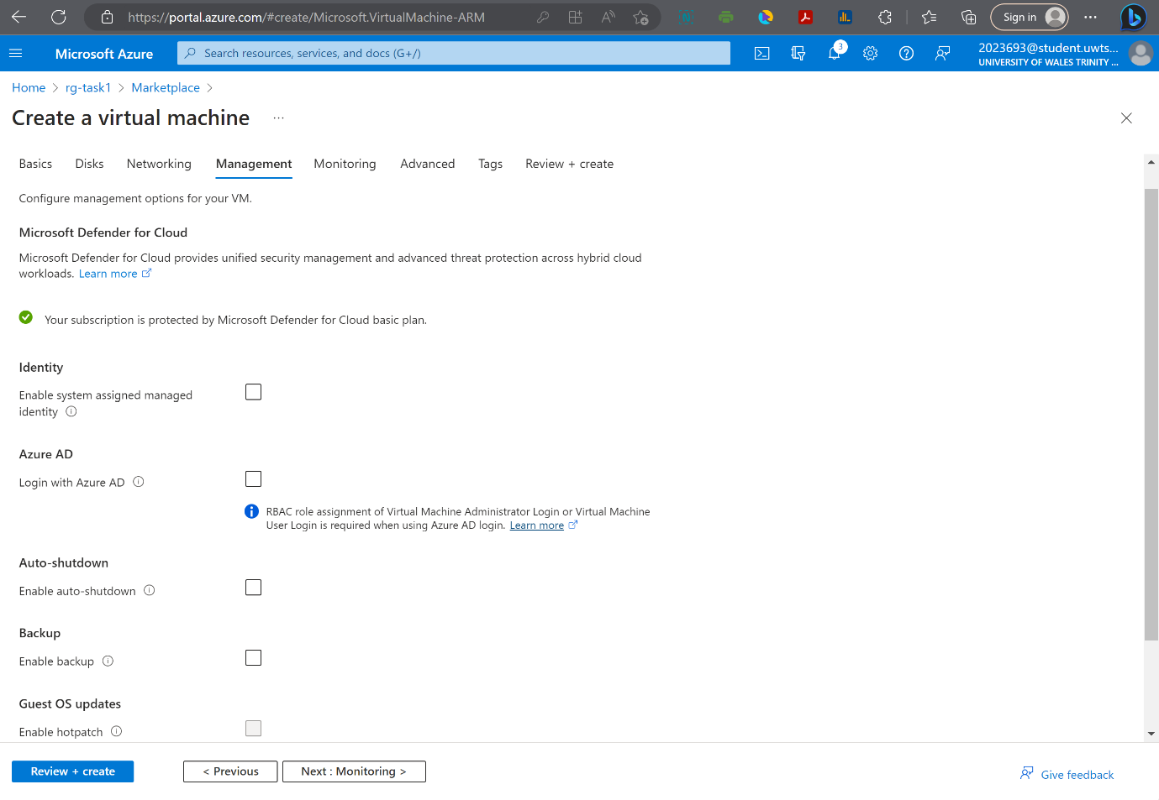

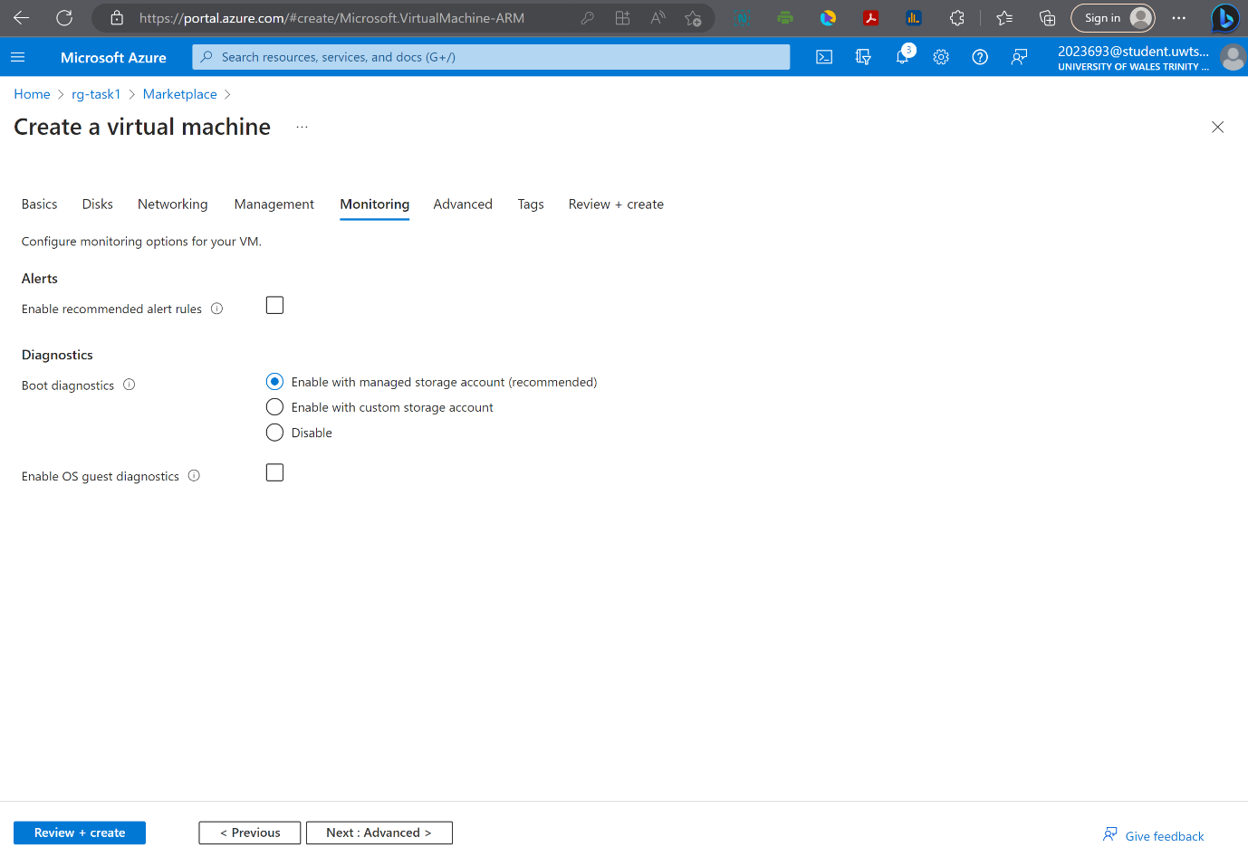

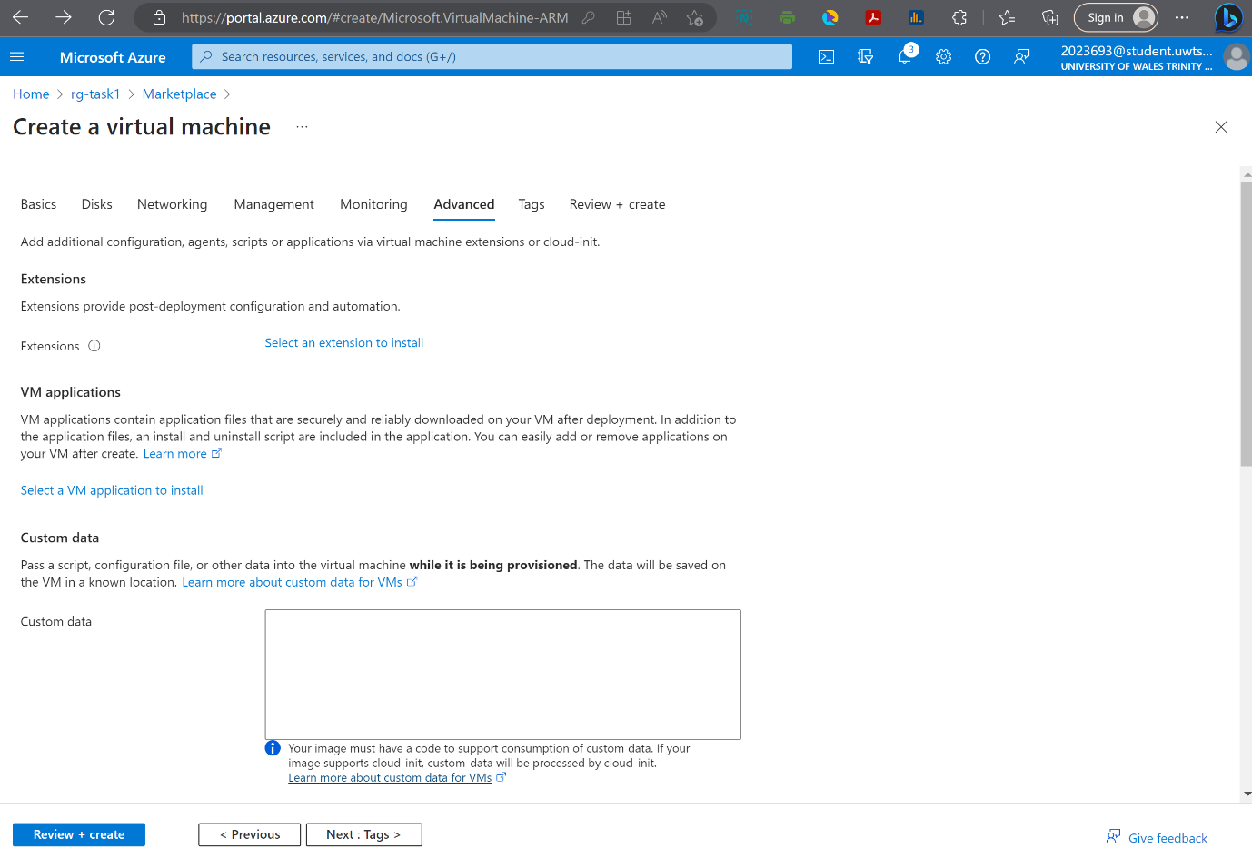

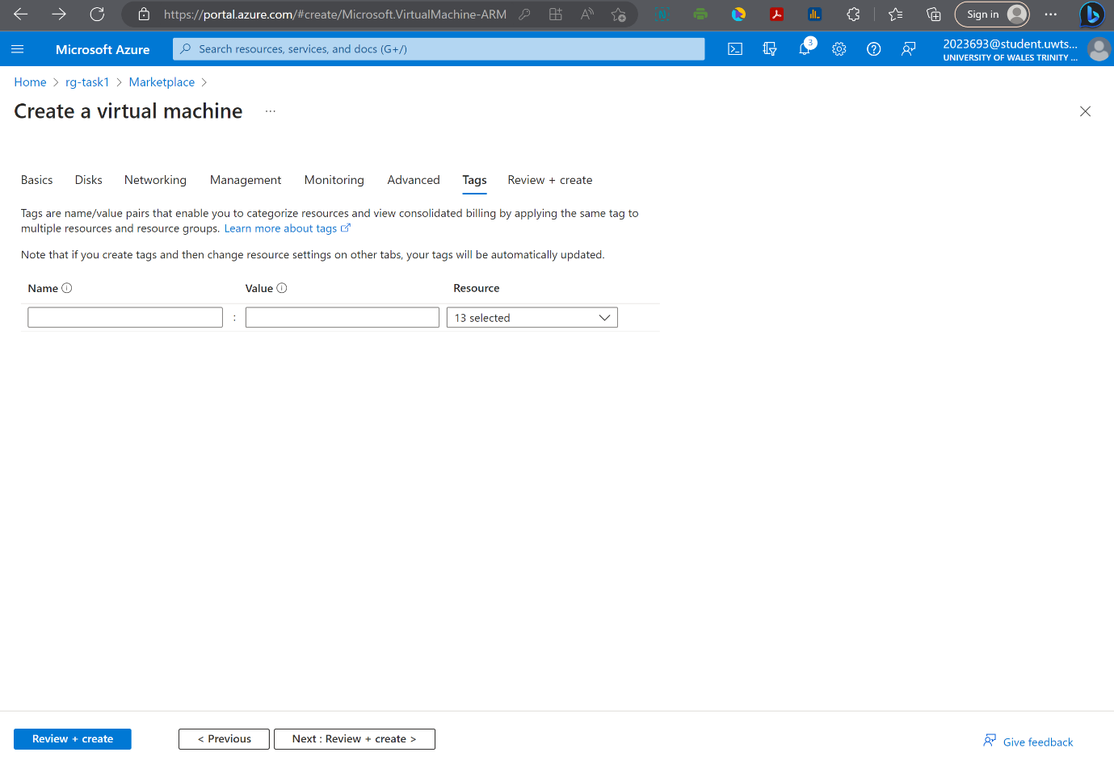

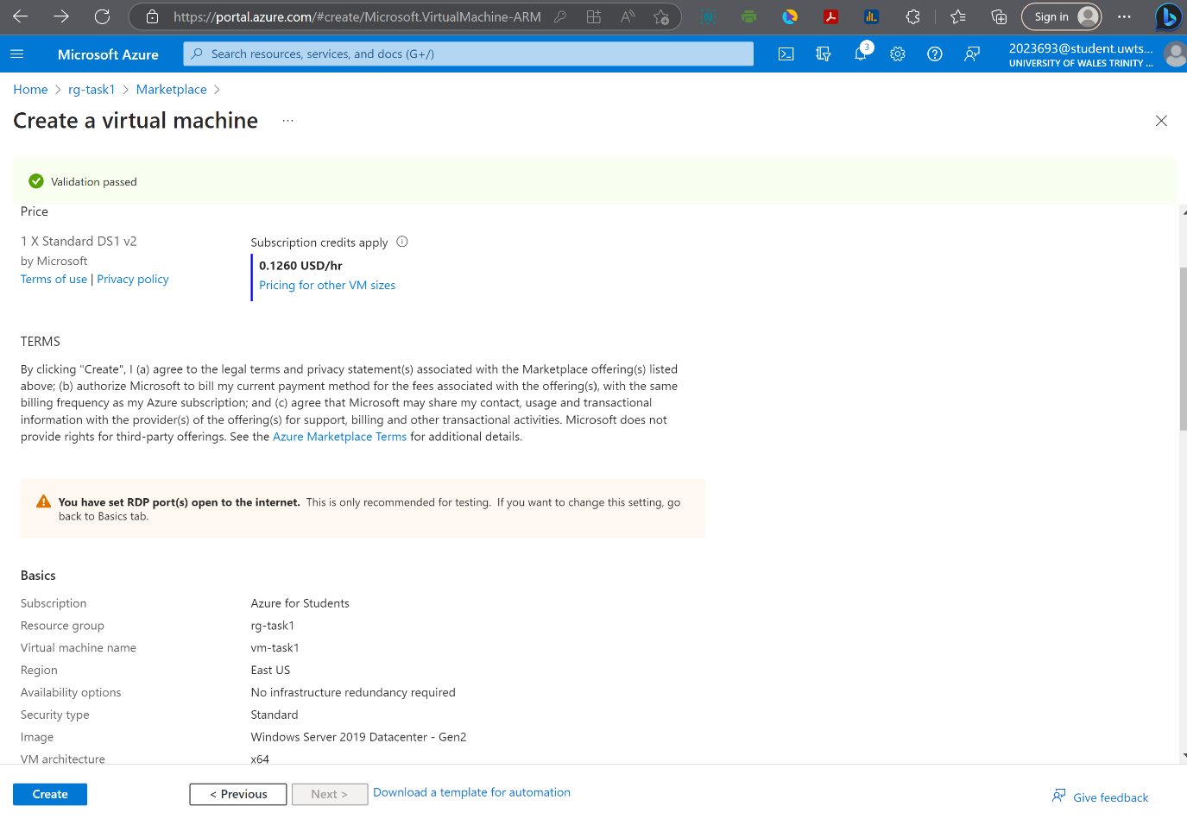

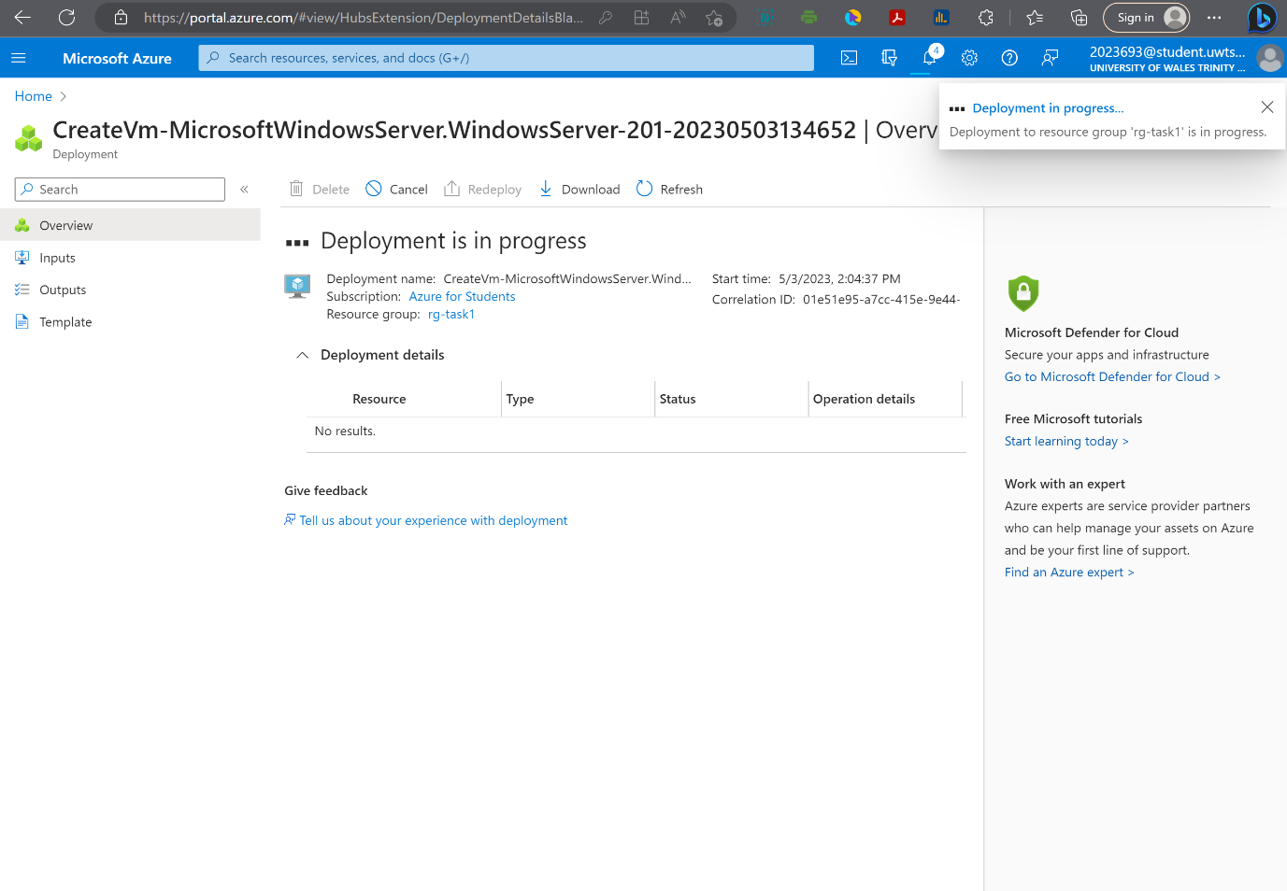

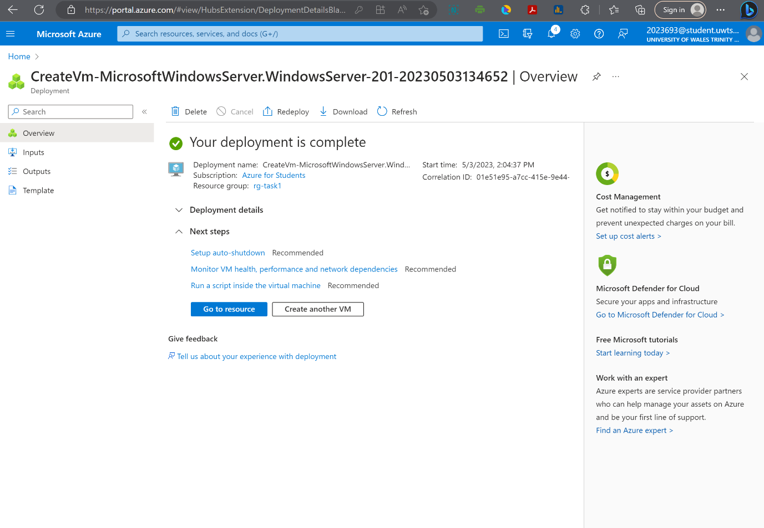

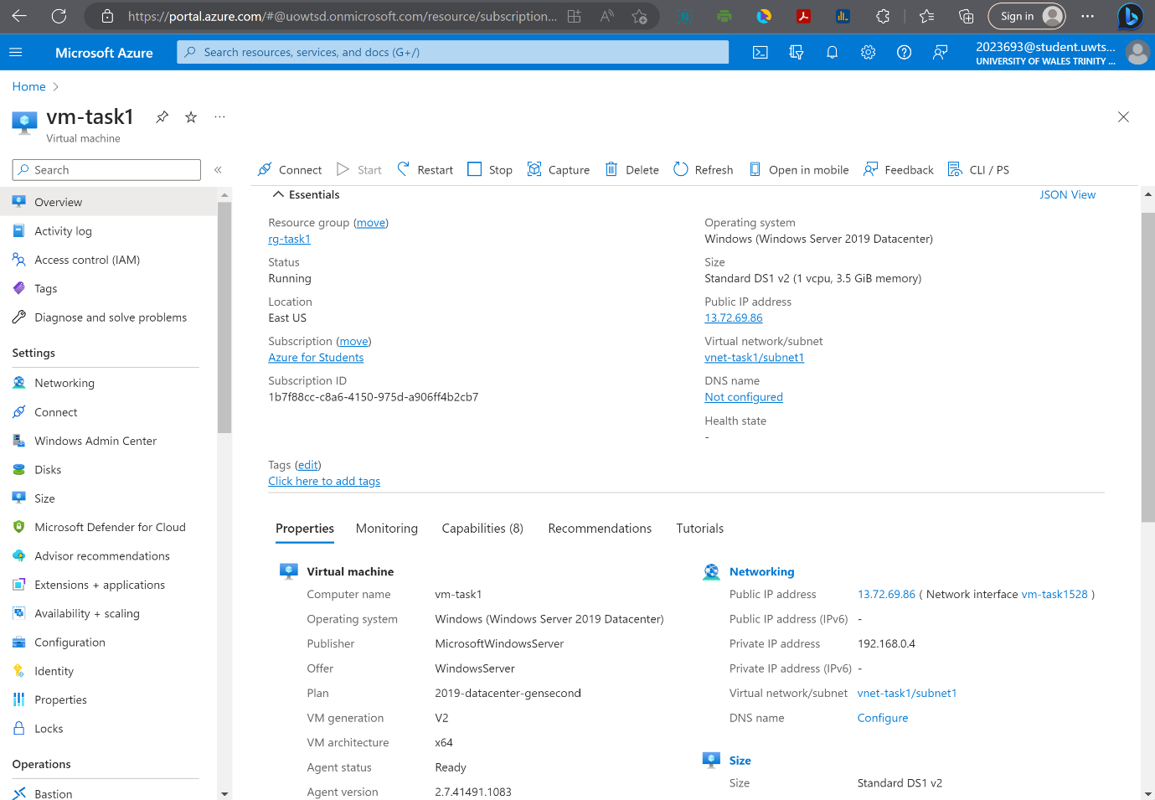

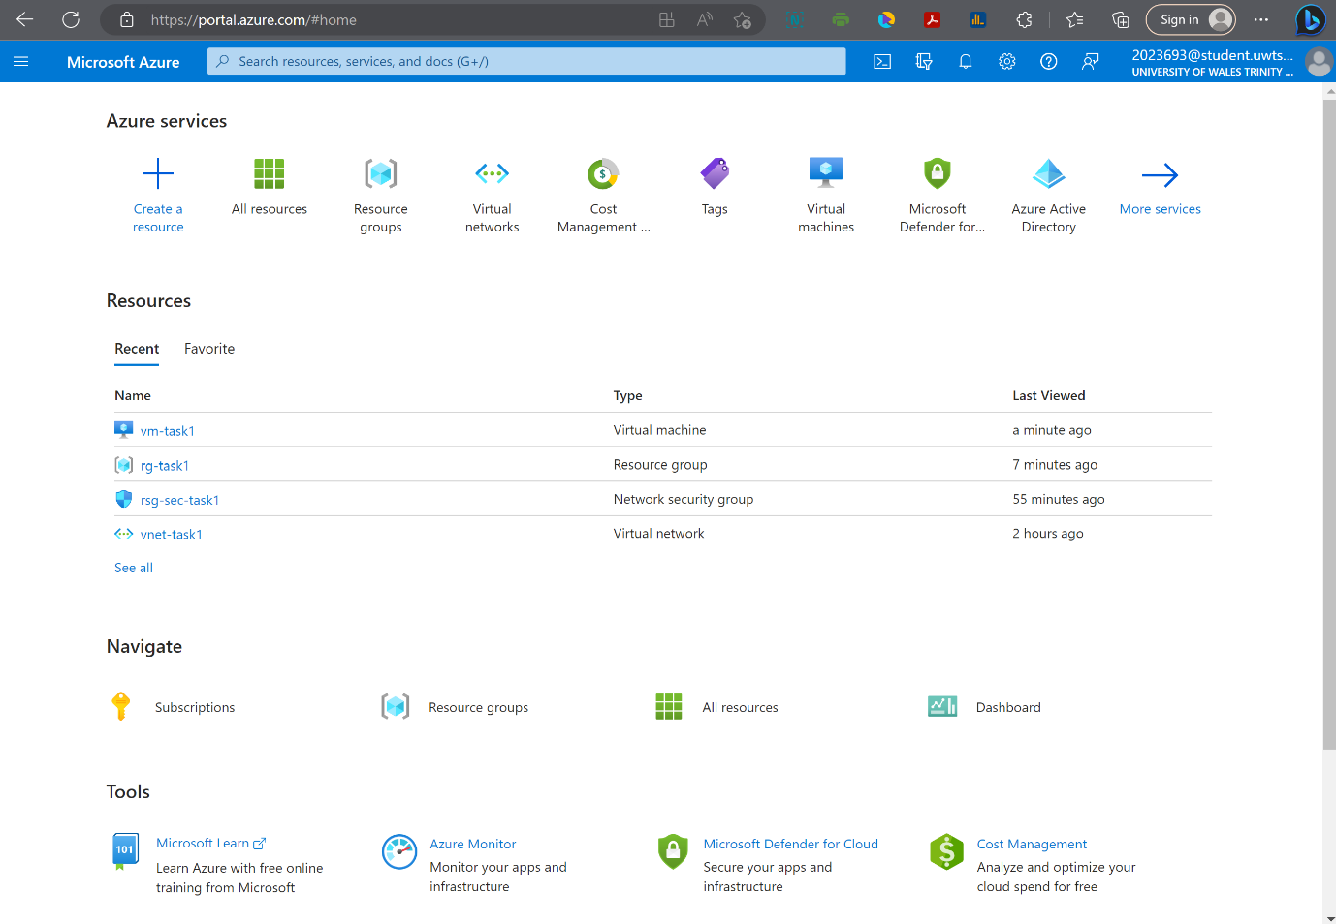

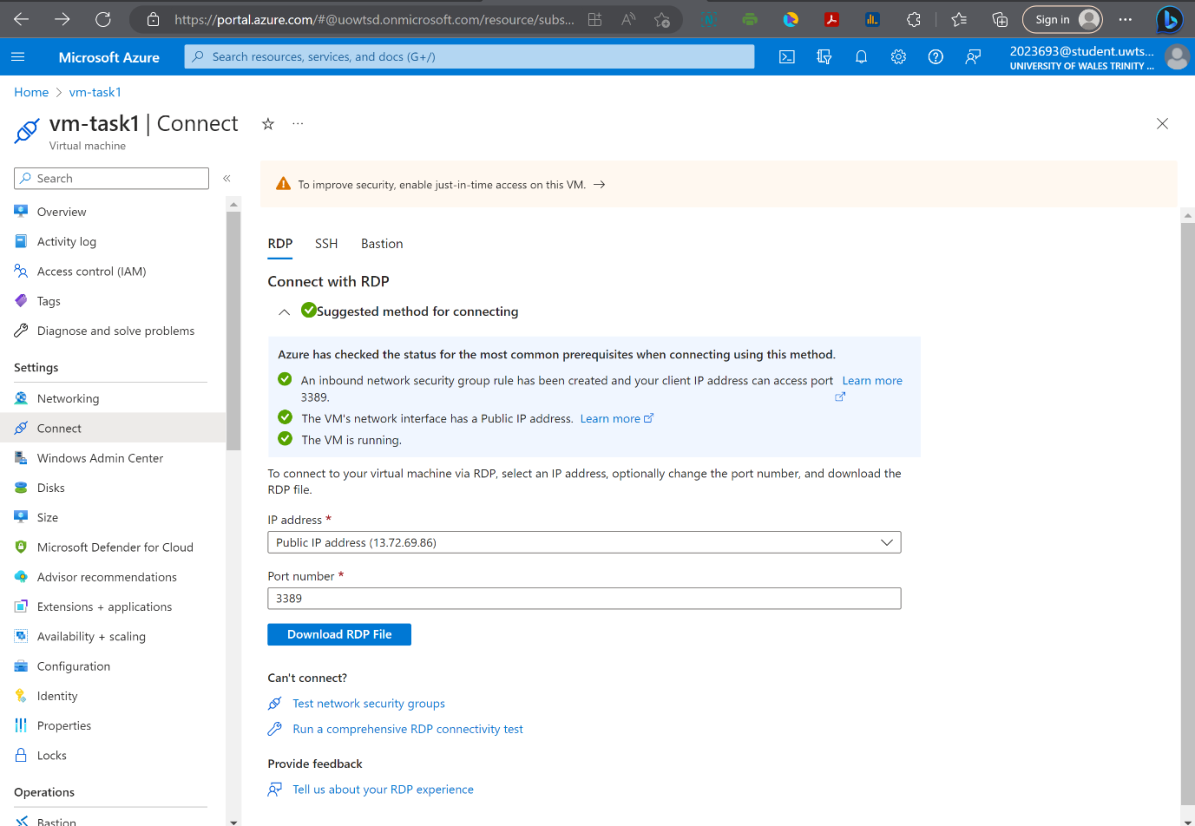

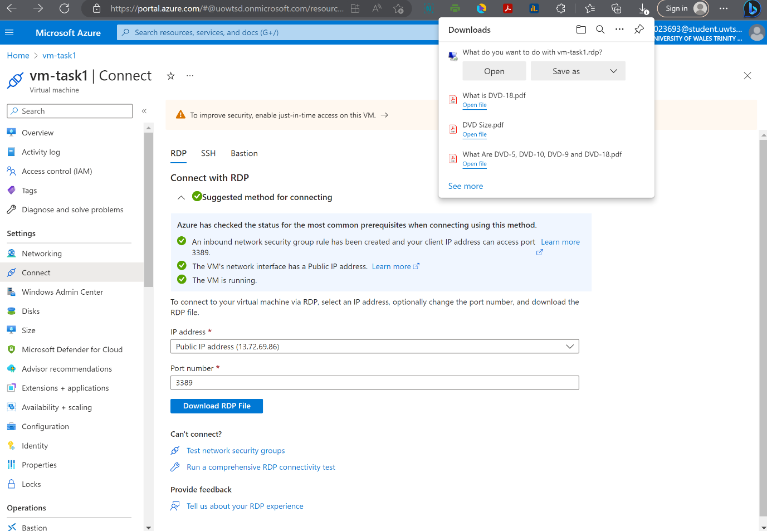

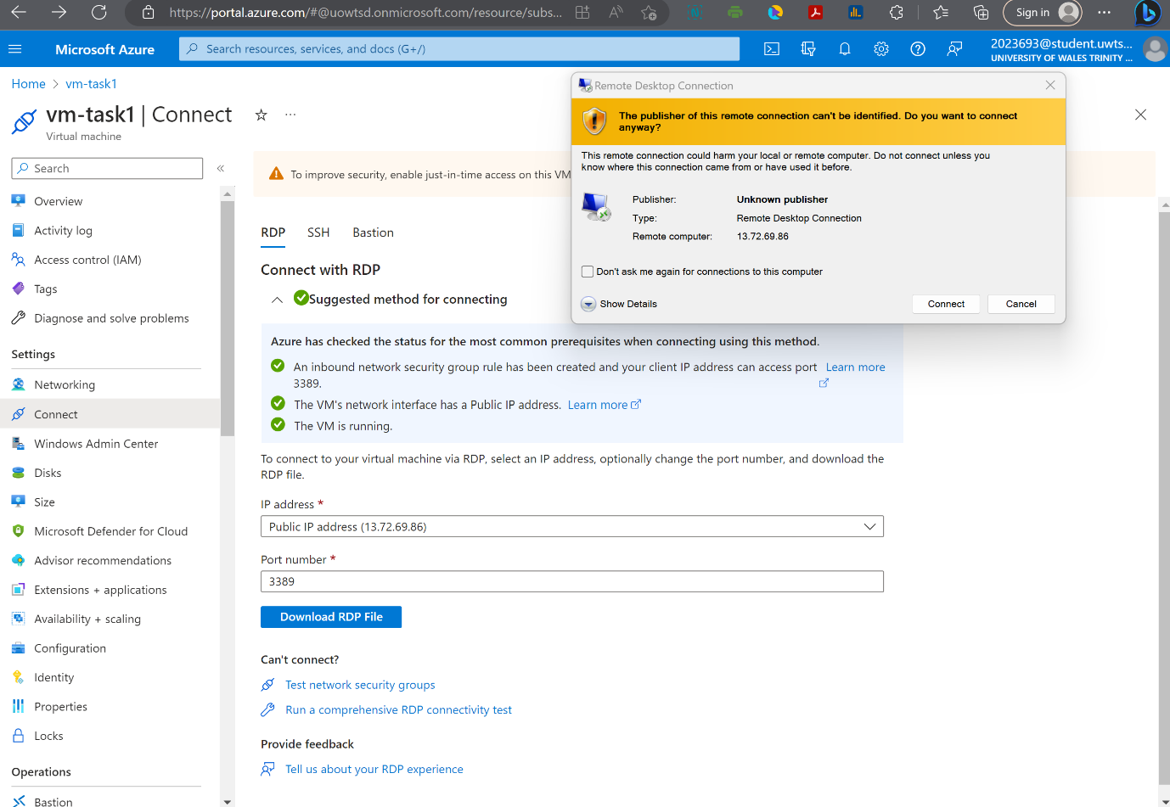

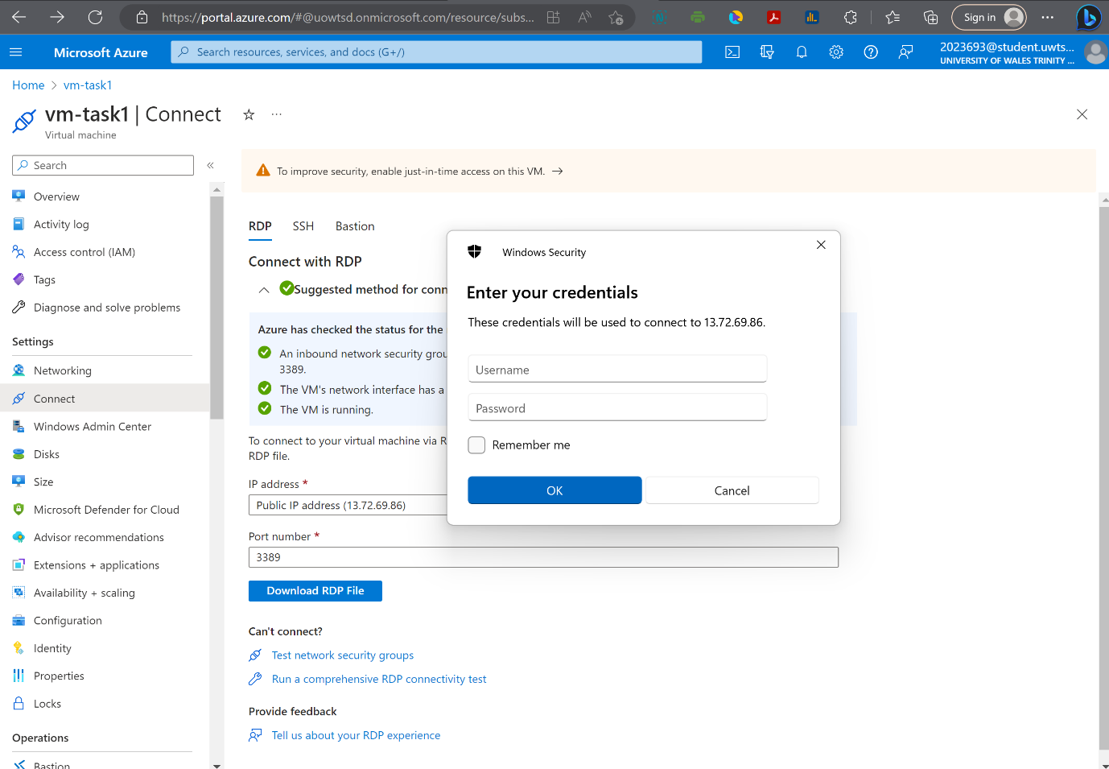

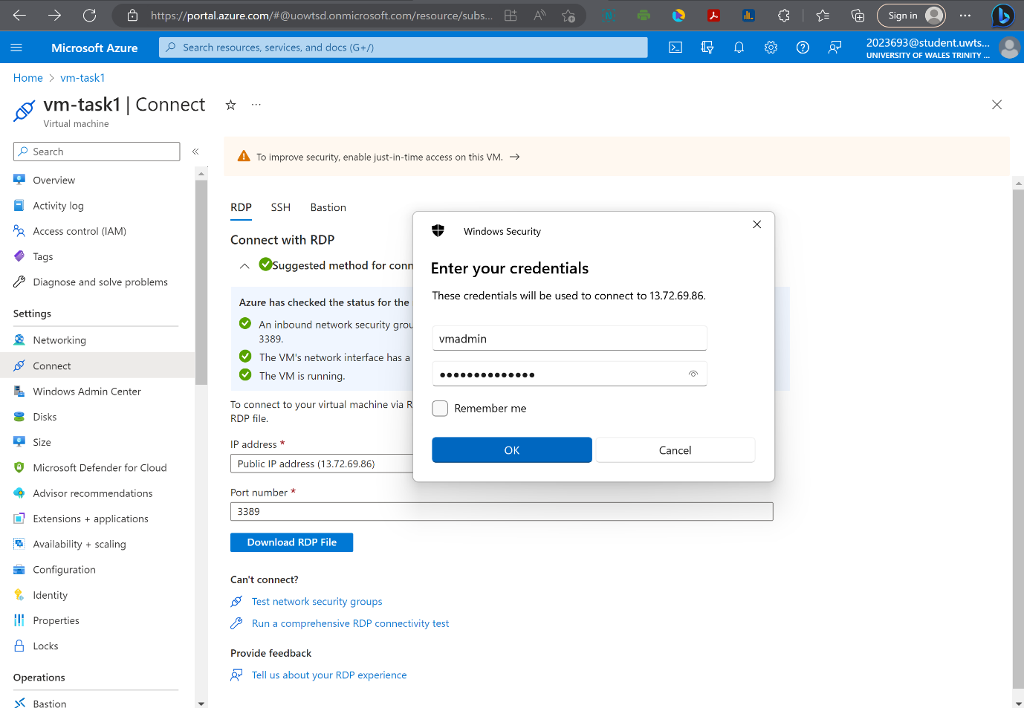

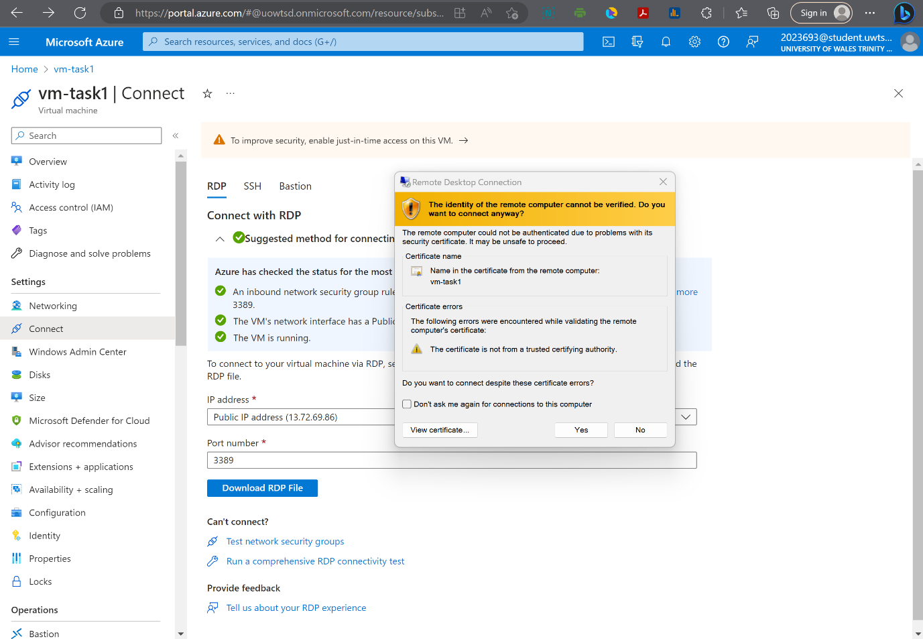

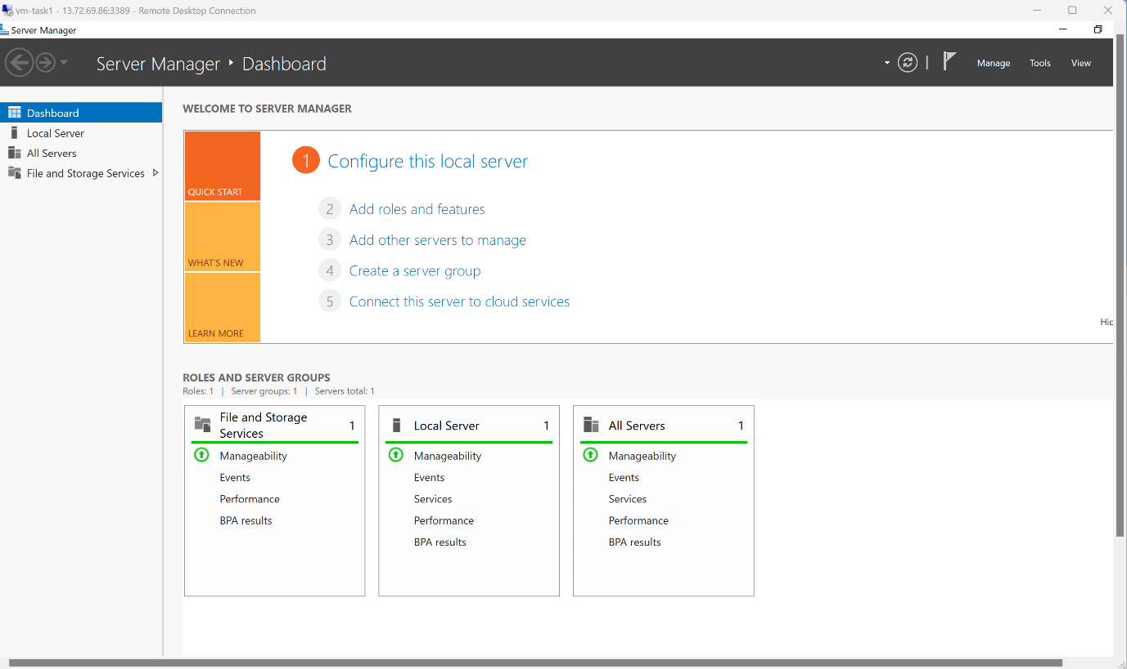

Task 2
(Additional Exercise)

In this part first we create a Resource Group as container for a virtual network named vnet-task2 with two subnets, subnet1 and subnet2, and two virtual machines (VMs), named vm1-task2 and vm2-task2. Both VMs were installed Linux image.
Network security group that we define contain security rules that allow or deny inbound and outbound traffic to and from the resources that are connected to that network. We create a network security group that allows SSH in from the internet, so when we deploy our virtual machine, we can access it from the internet.
We define some rules on network security group that's going to allow traffic on SSH (port 22, Nginx (http, https on port 80 and 443 respectively), and MySQL (port 3306). [3]
On vm1-task2 we installed Ubuntu Server 22.04 and vm2-task2 Centos 8.2.2004 Linux images.
Virtual network was assigned IP address 192.168.0.0/16, subnet1 192.168.0.0/24, and subnet2 192.168.1.0/24. [4]

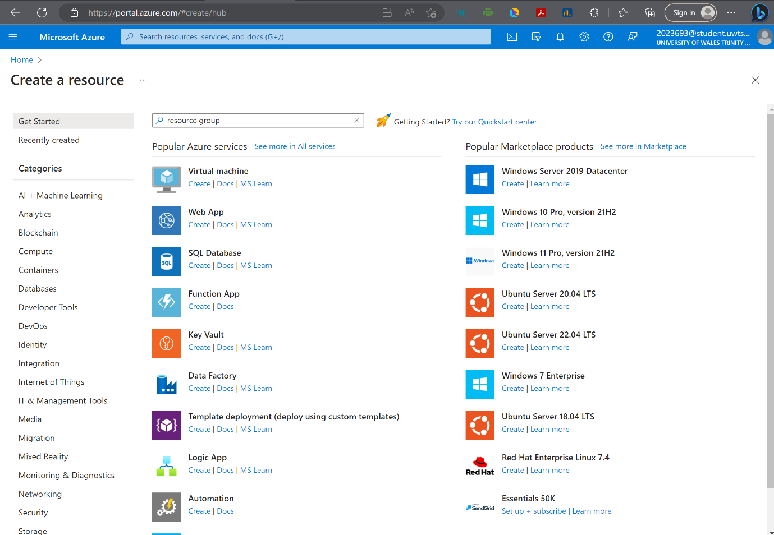

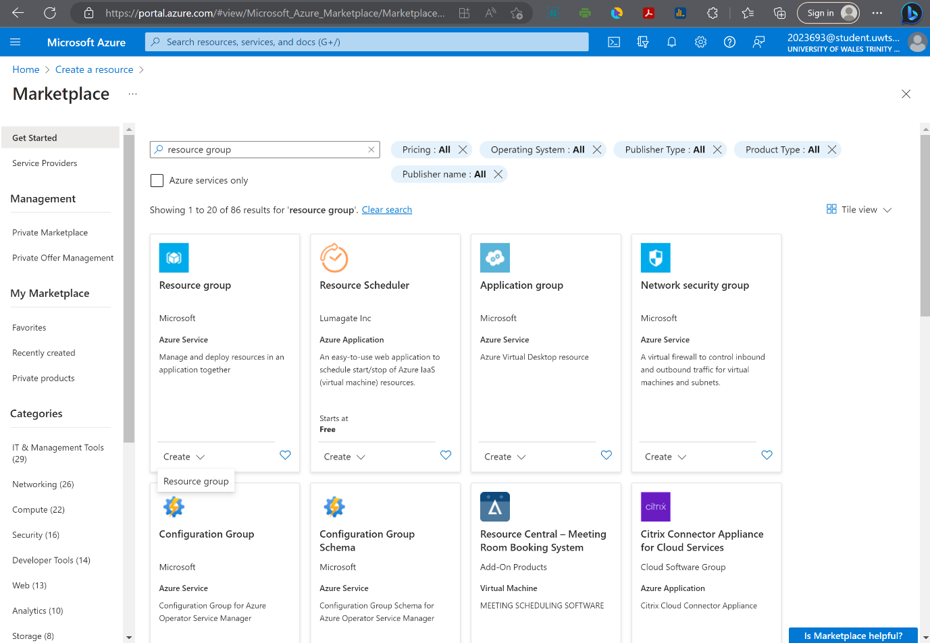

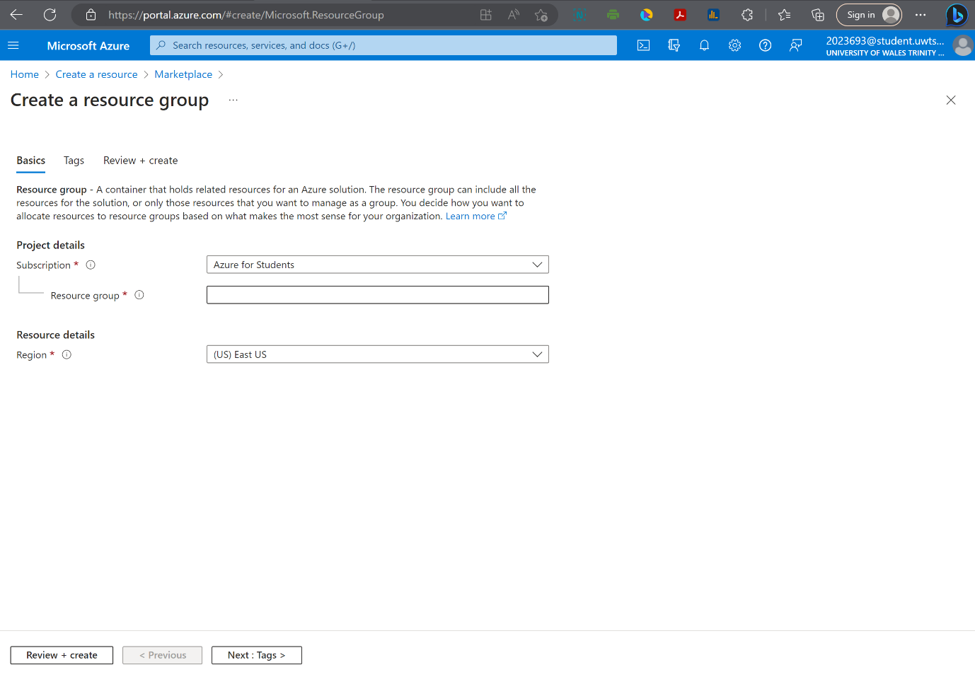

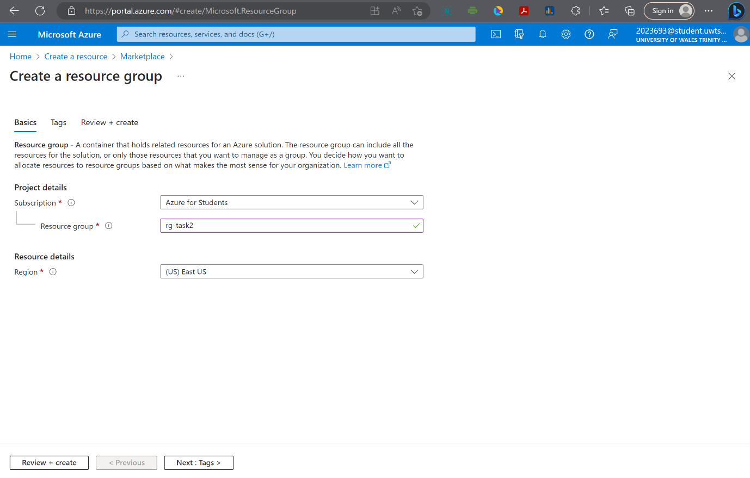

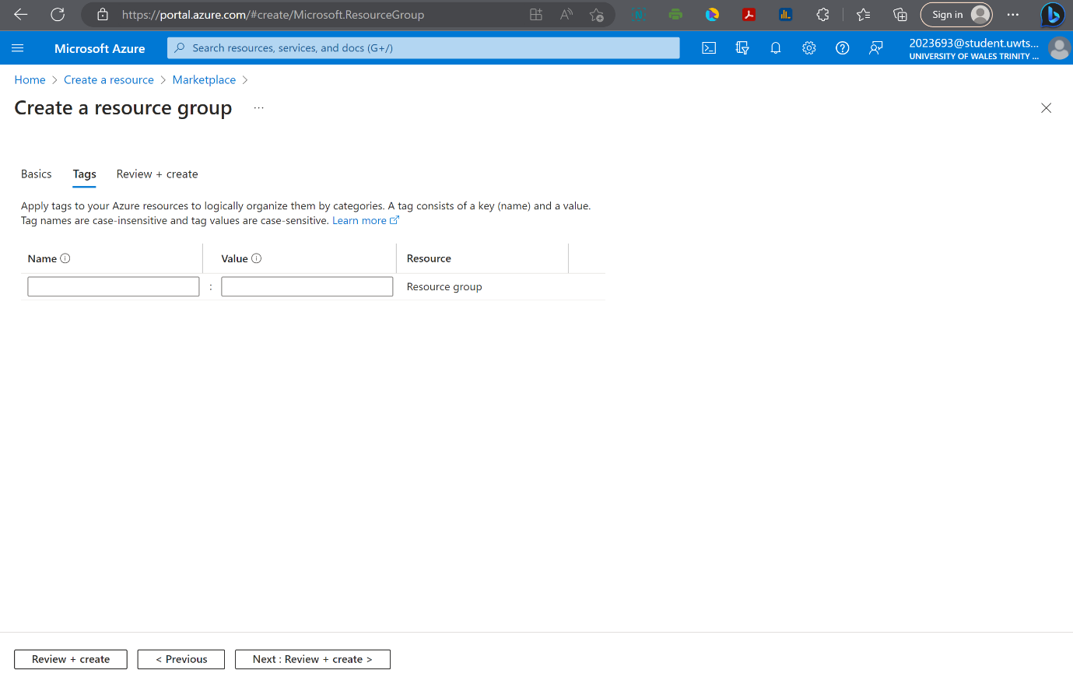

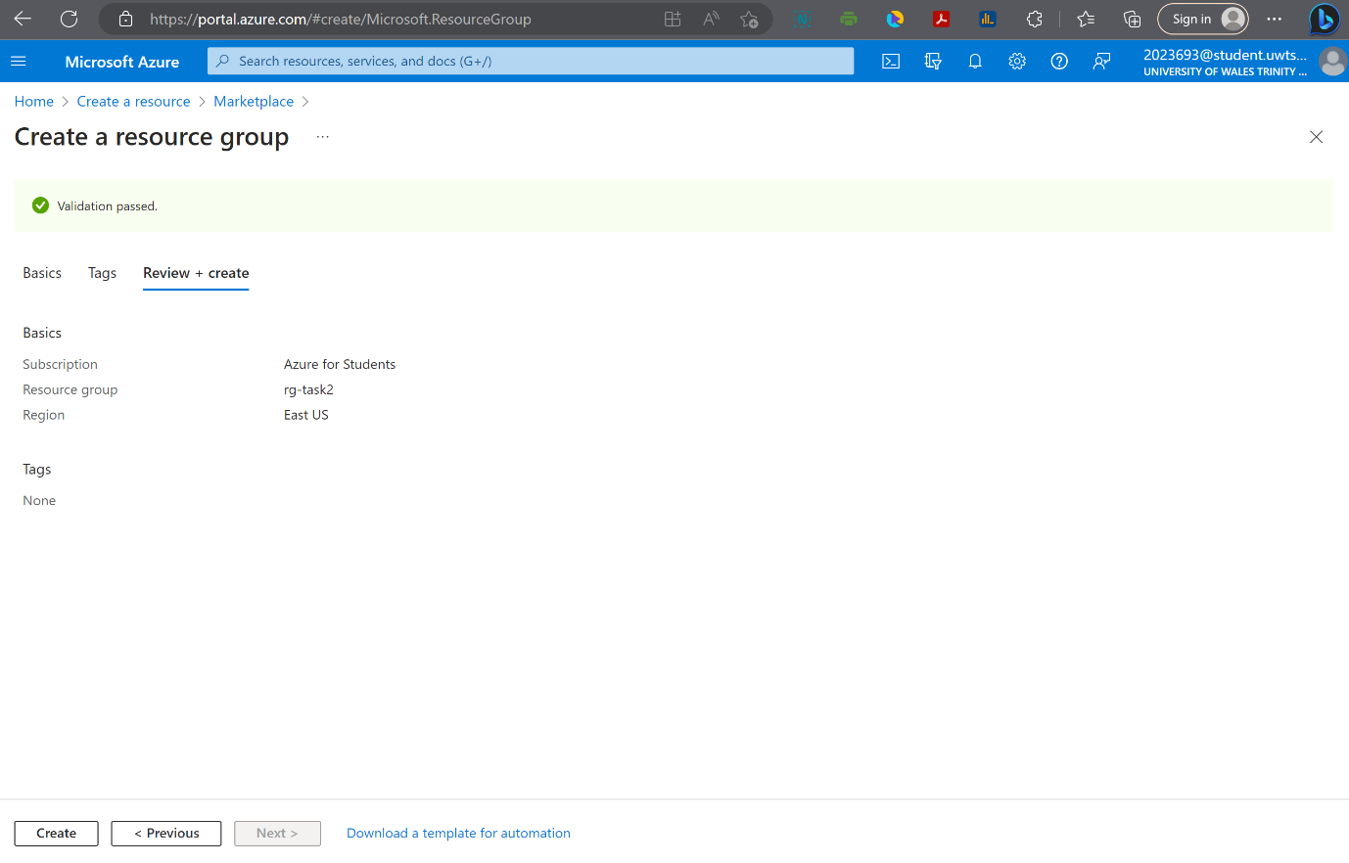

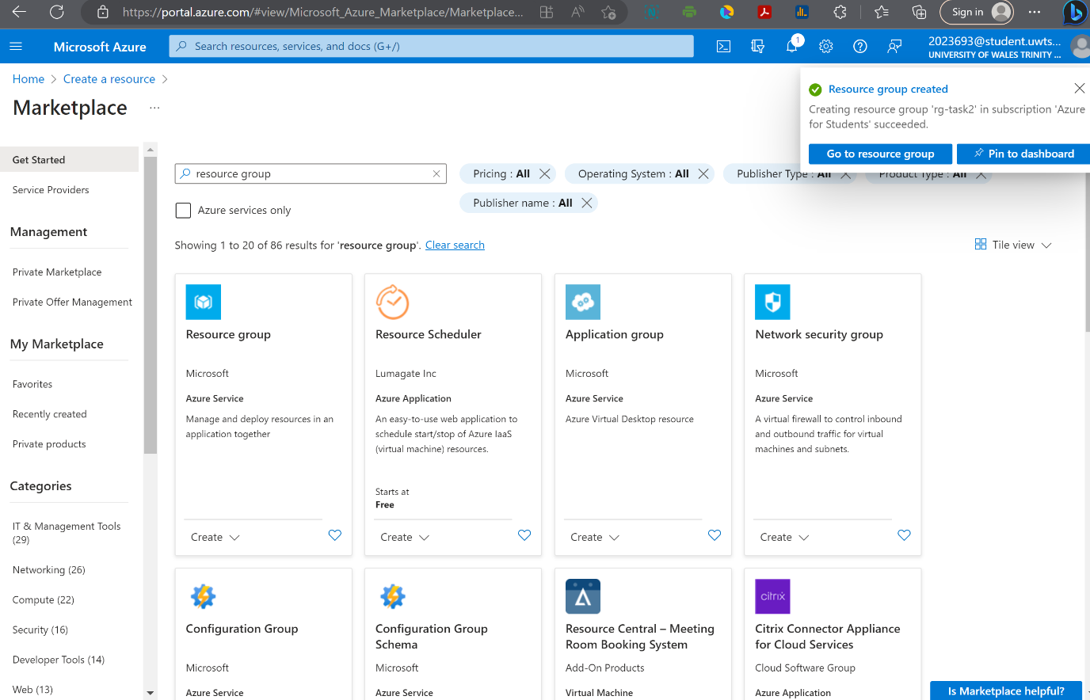

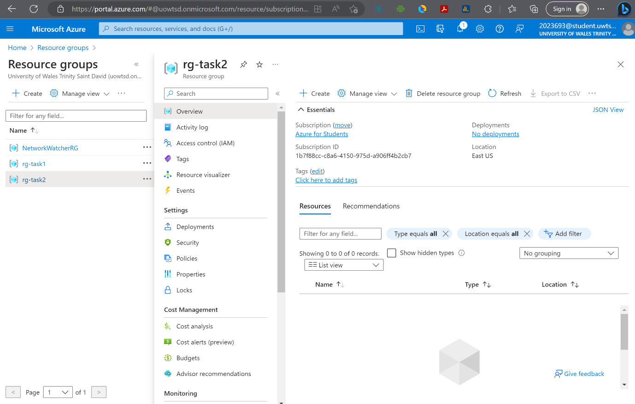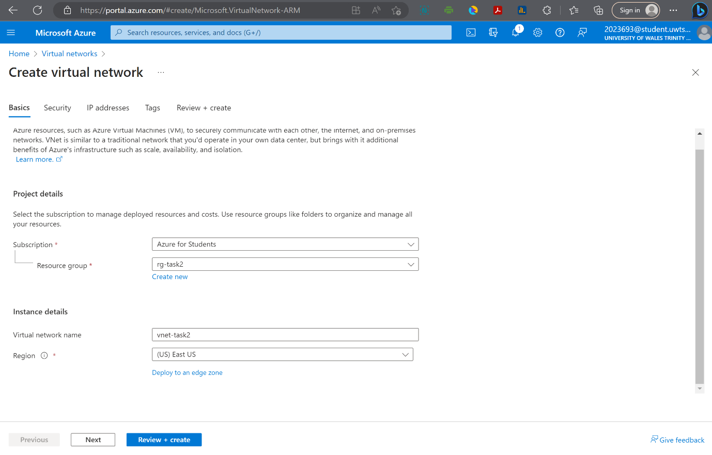

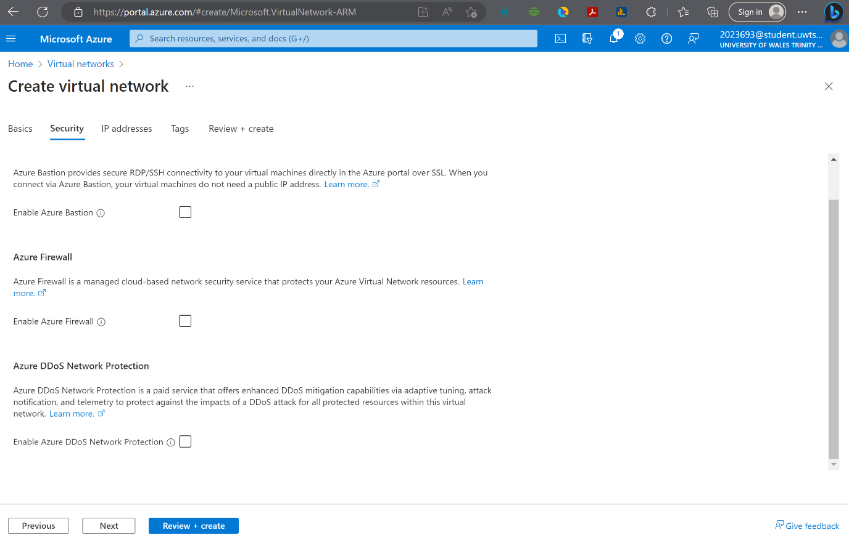

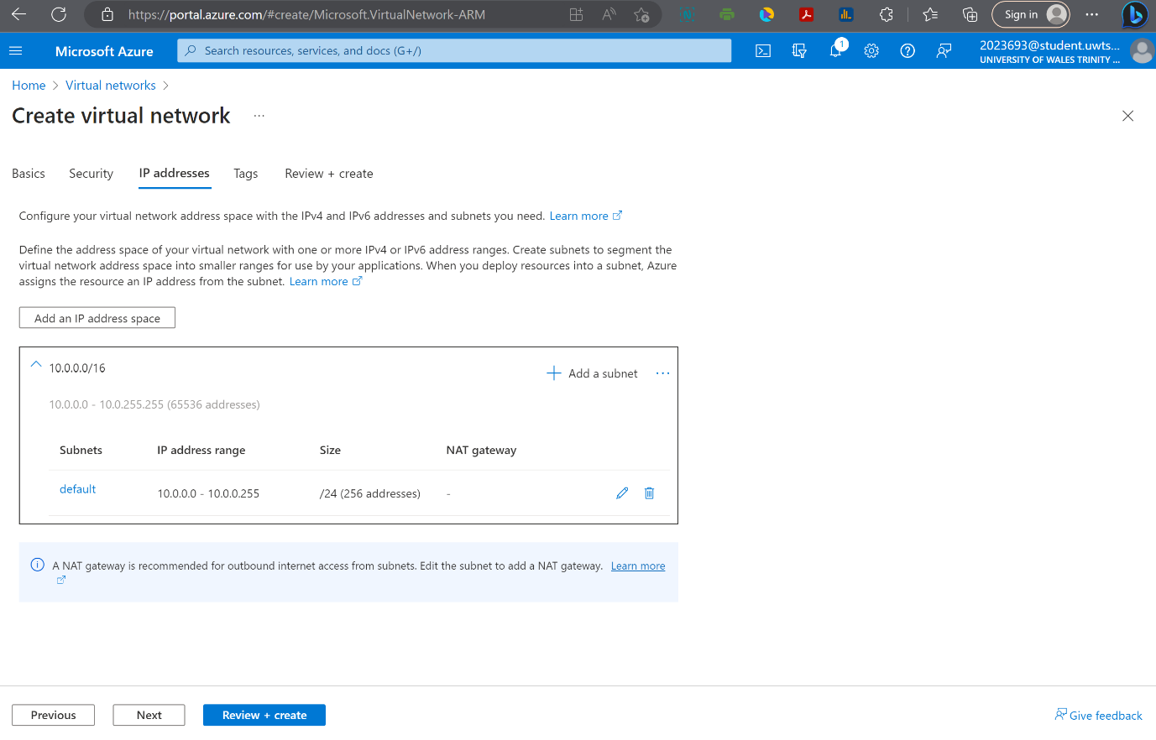

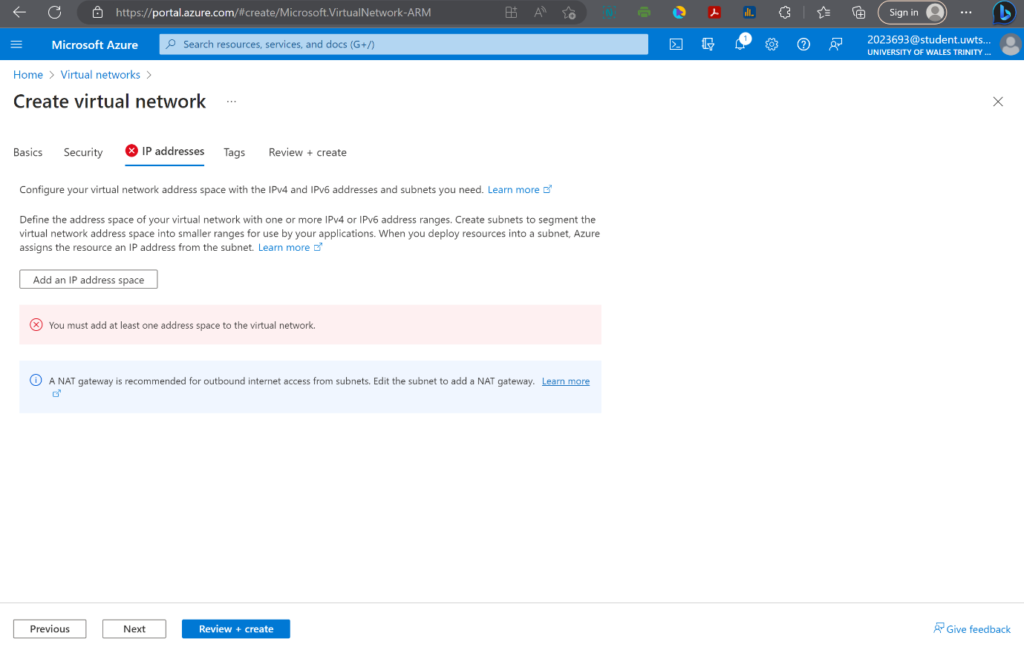

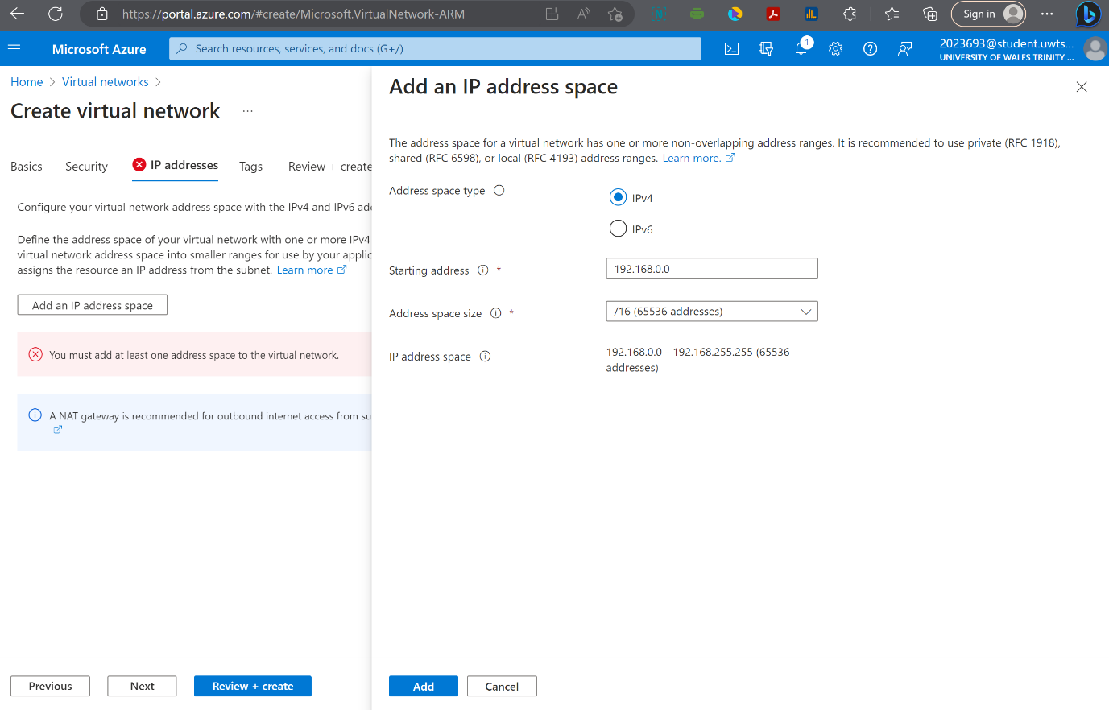

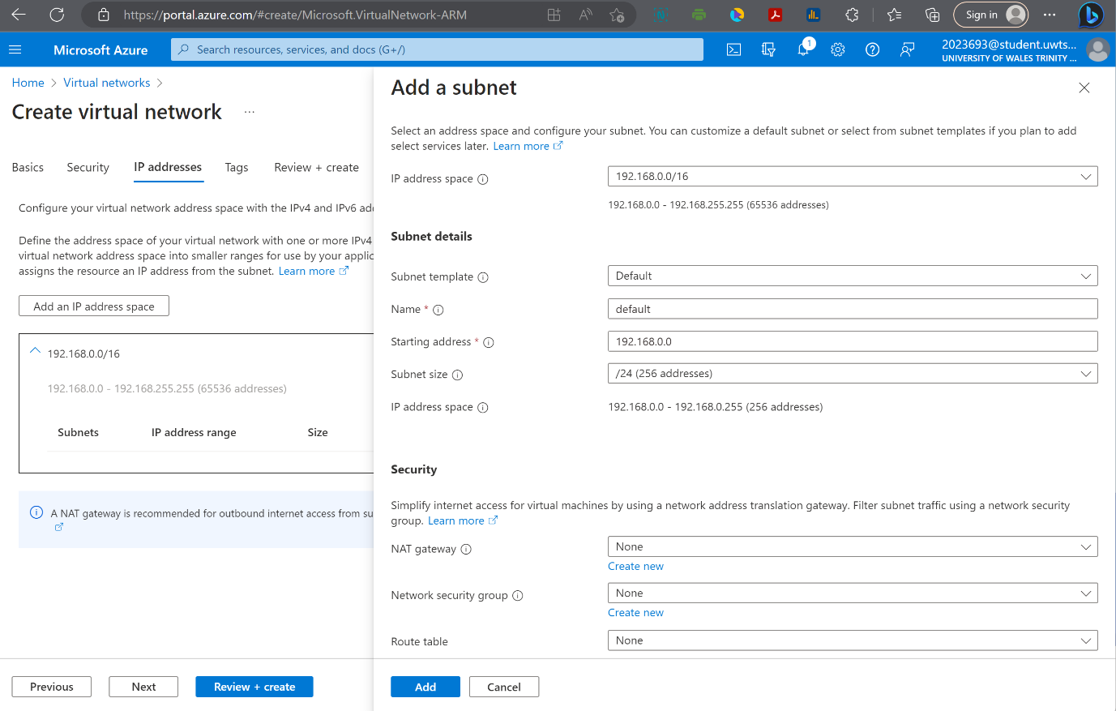

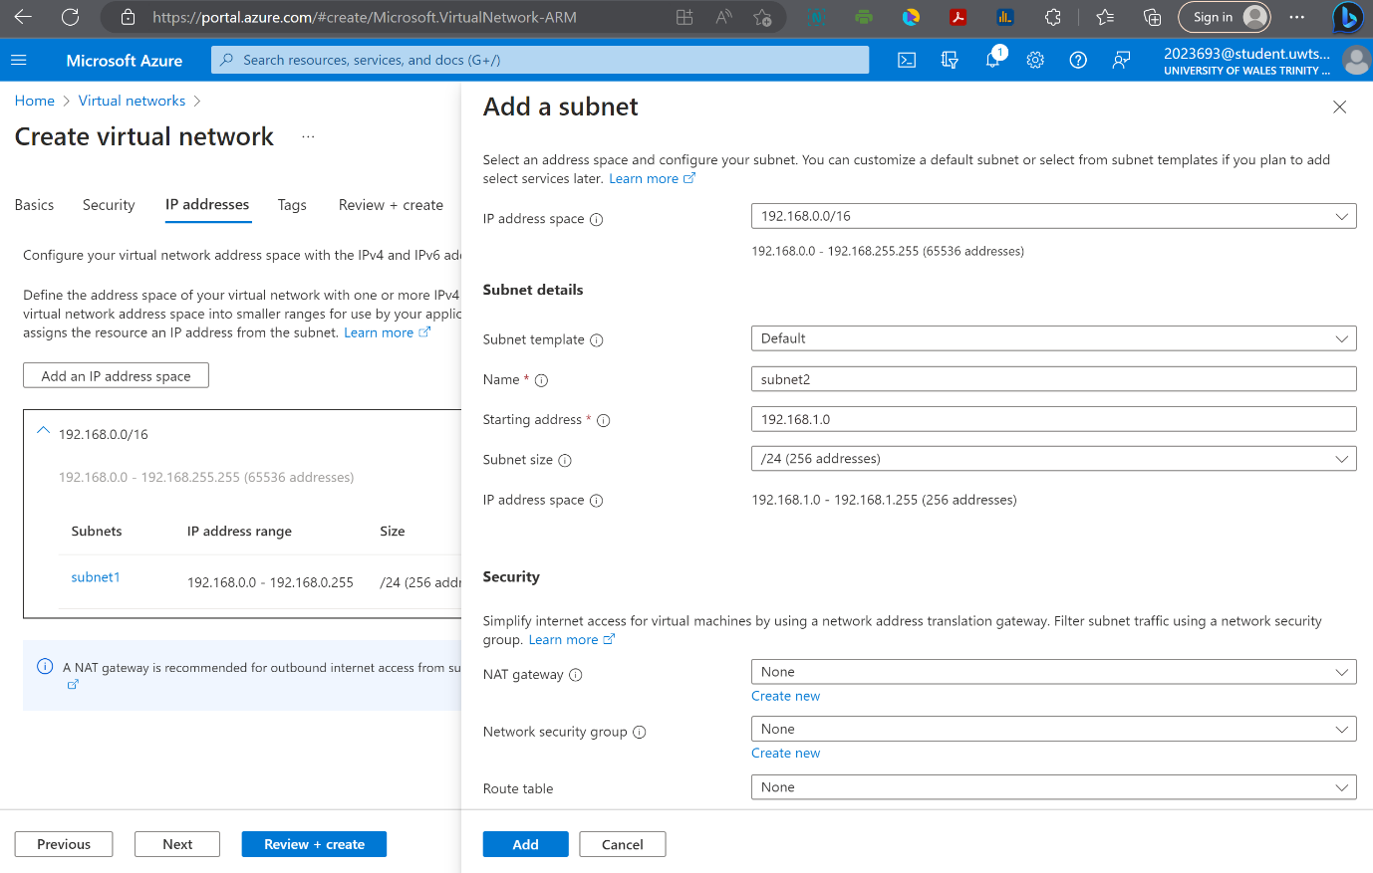

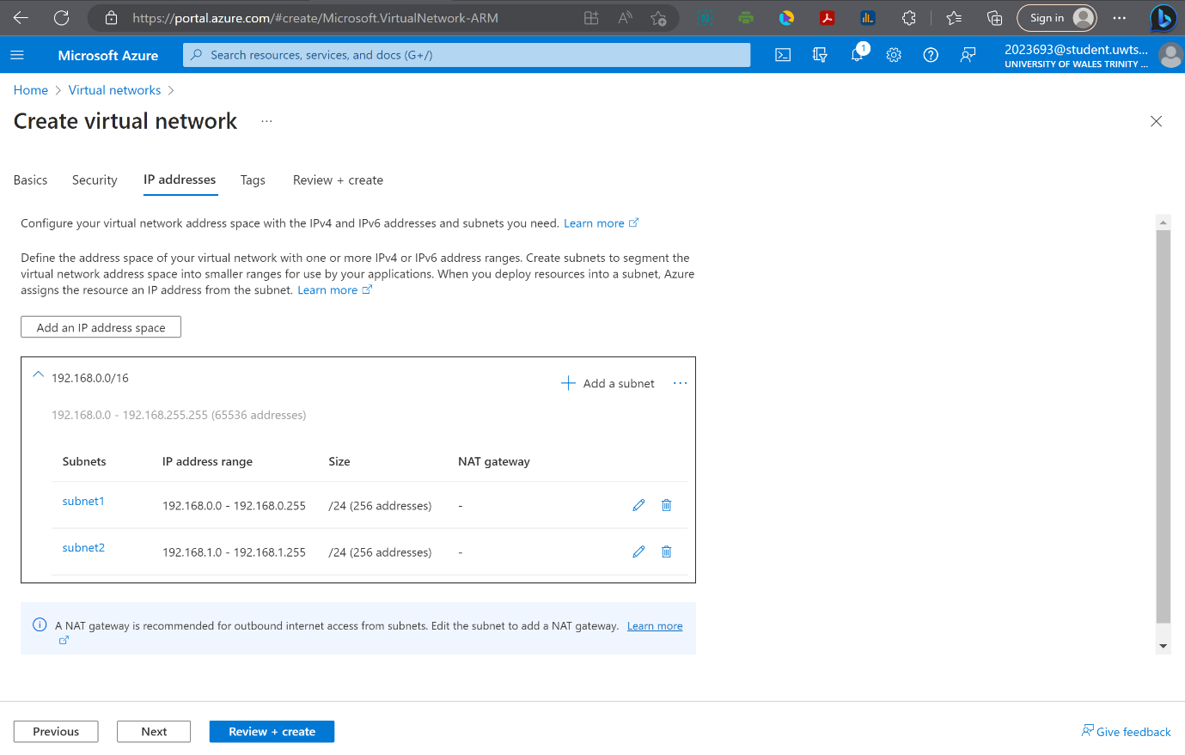

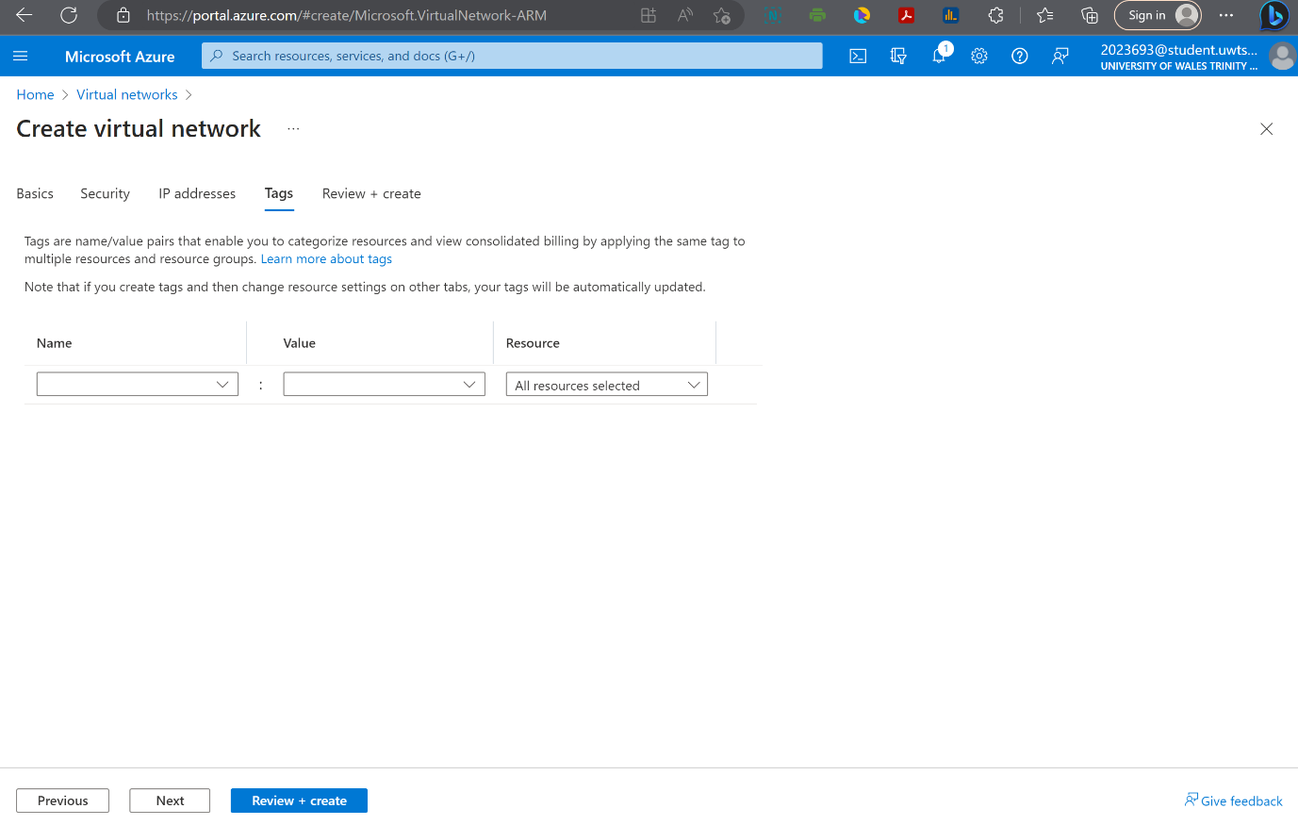

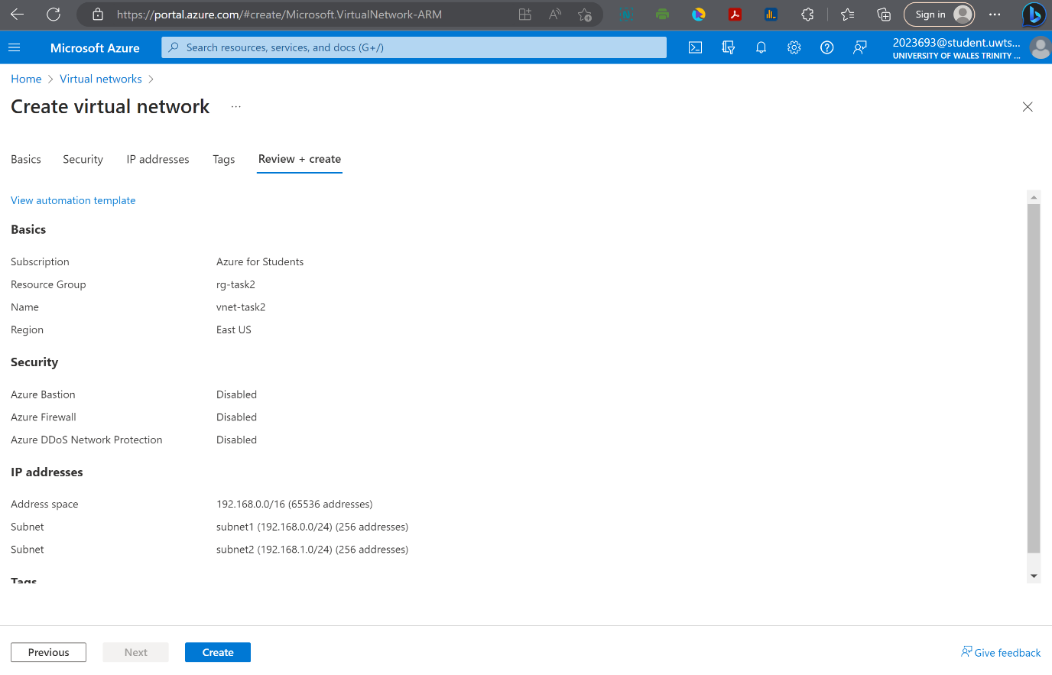

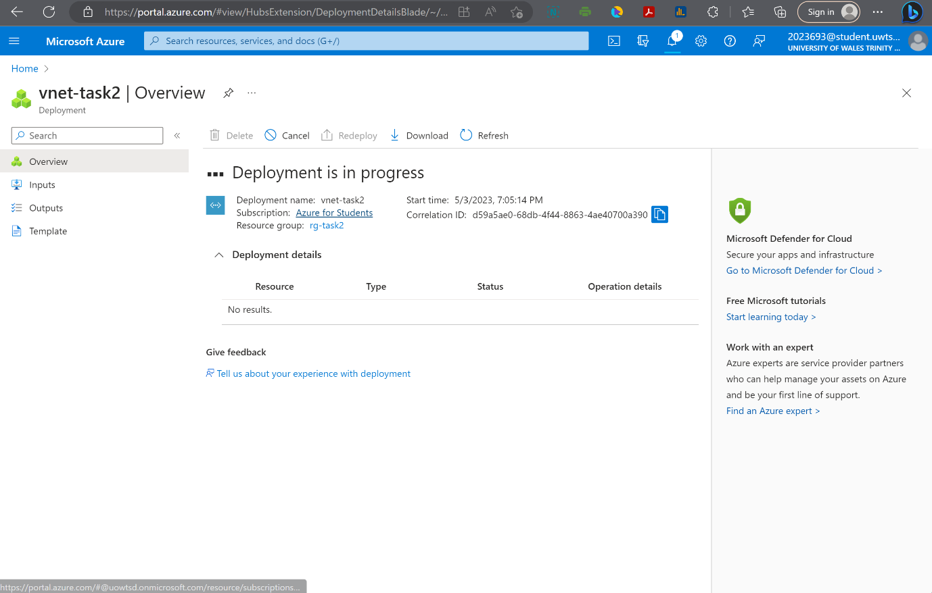

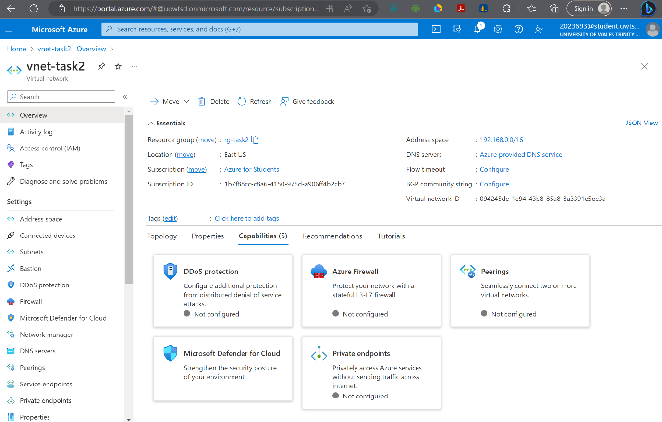

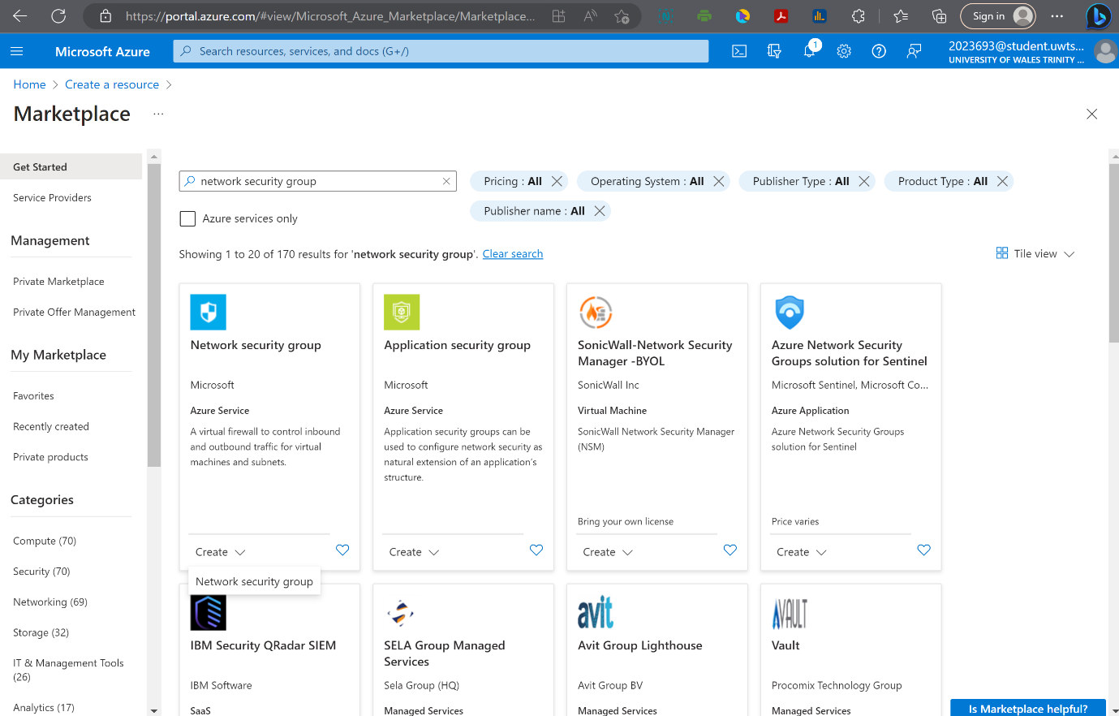

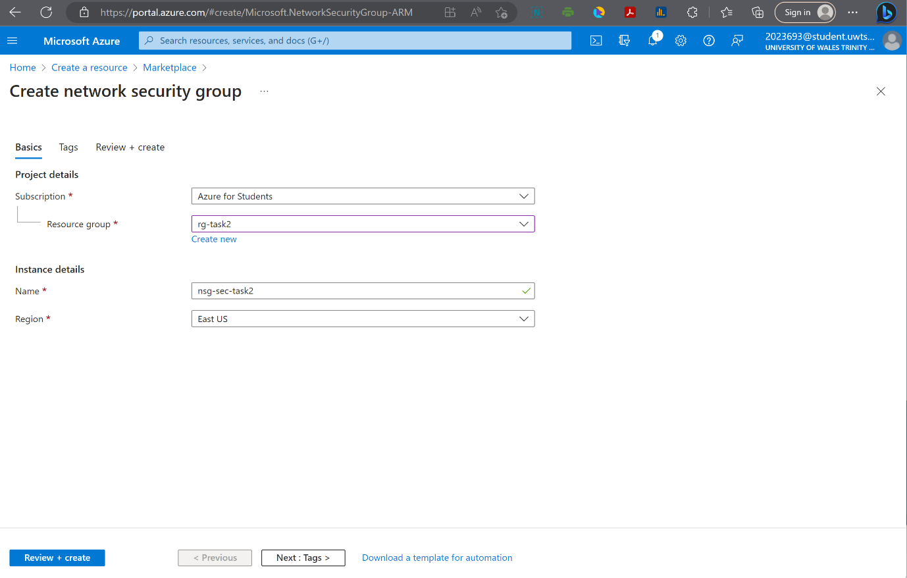

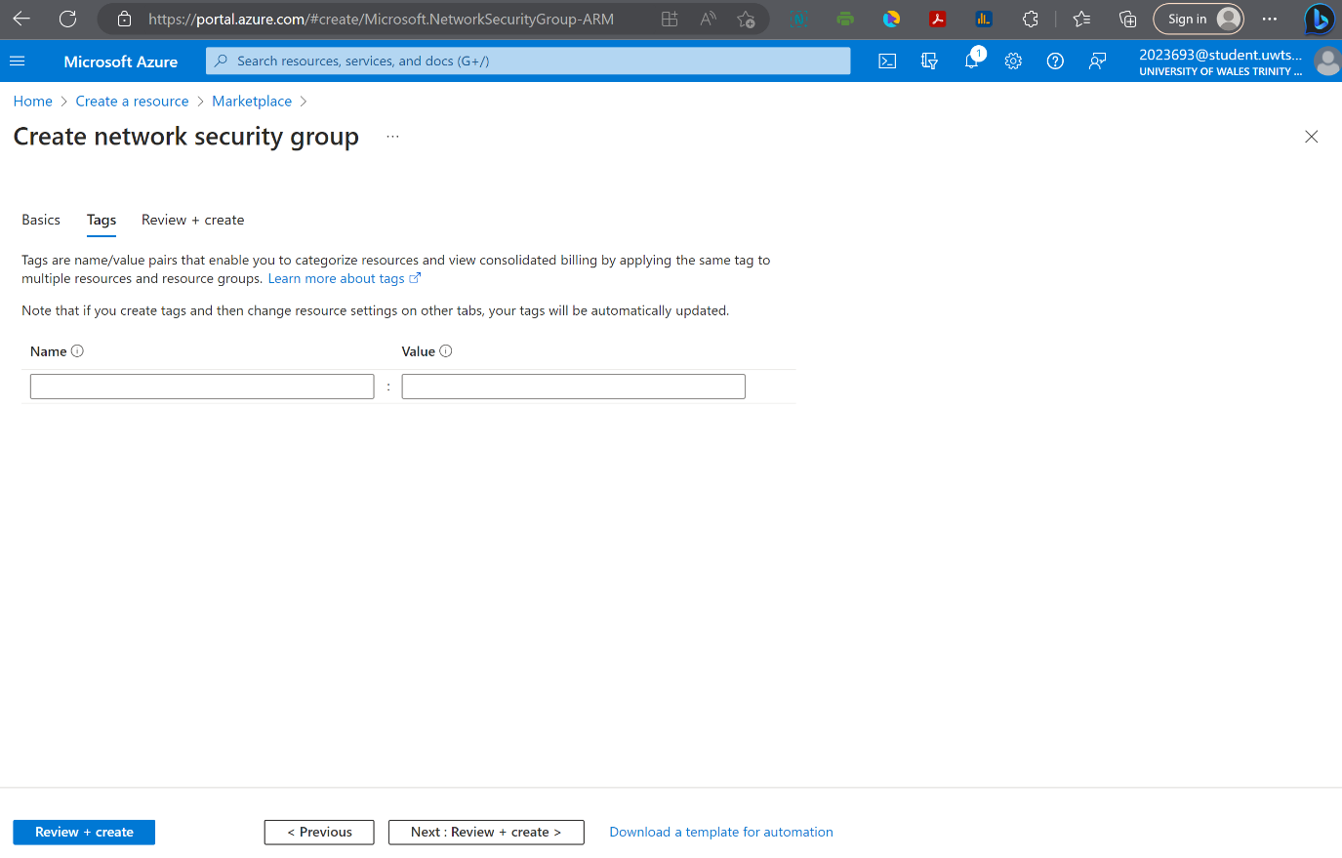

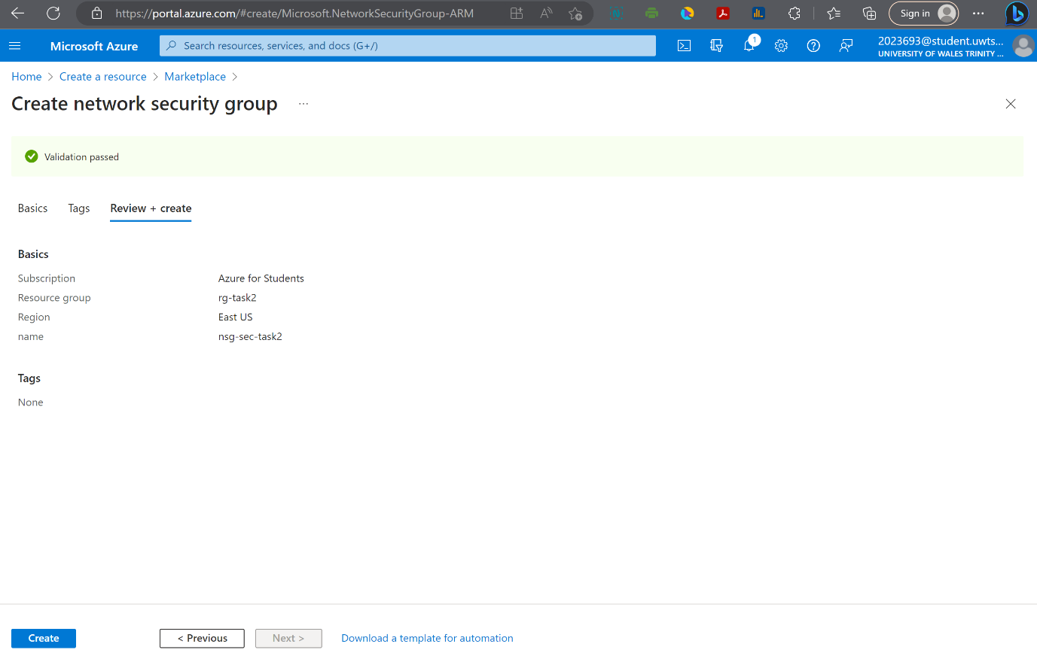

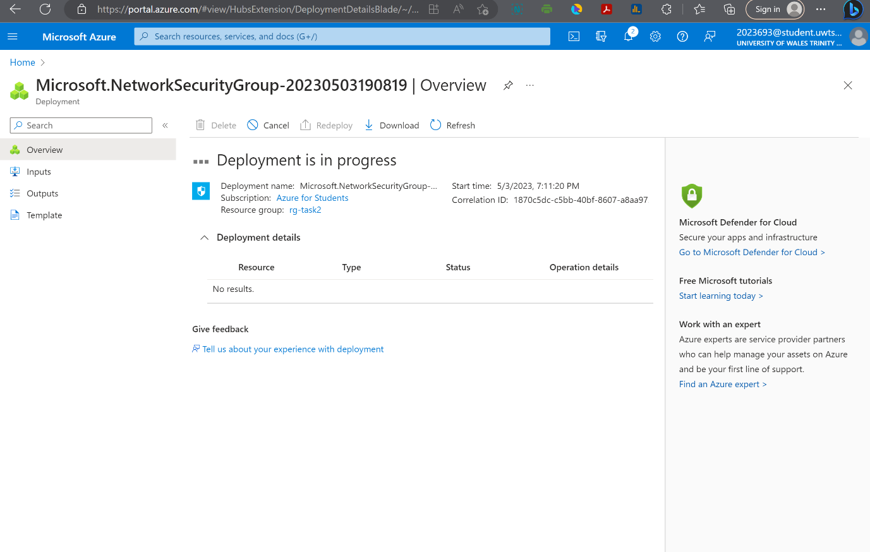

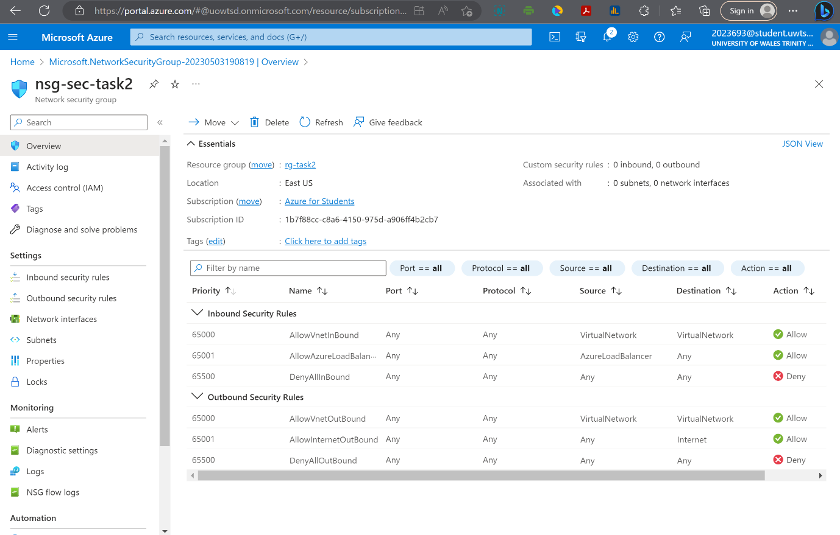

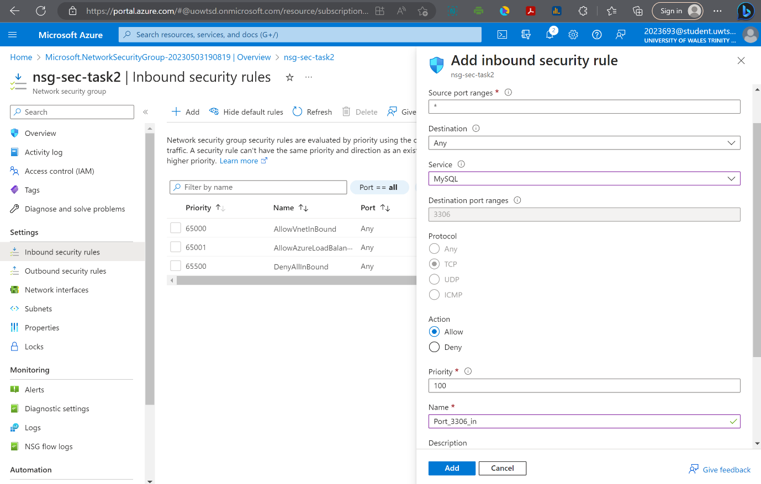

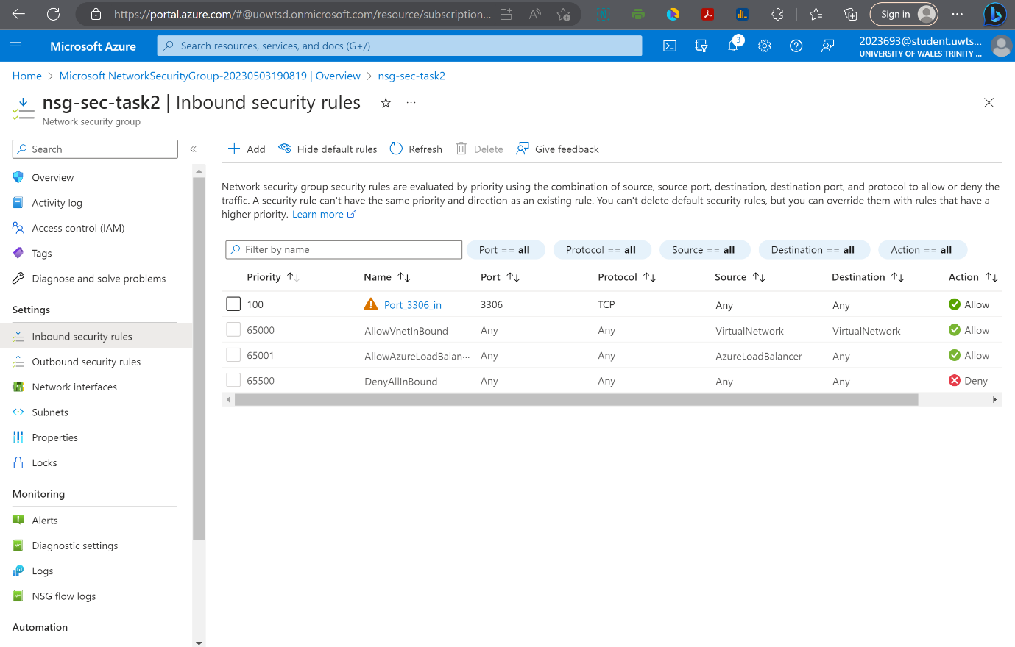

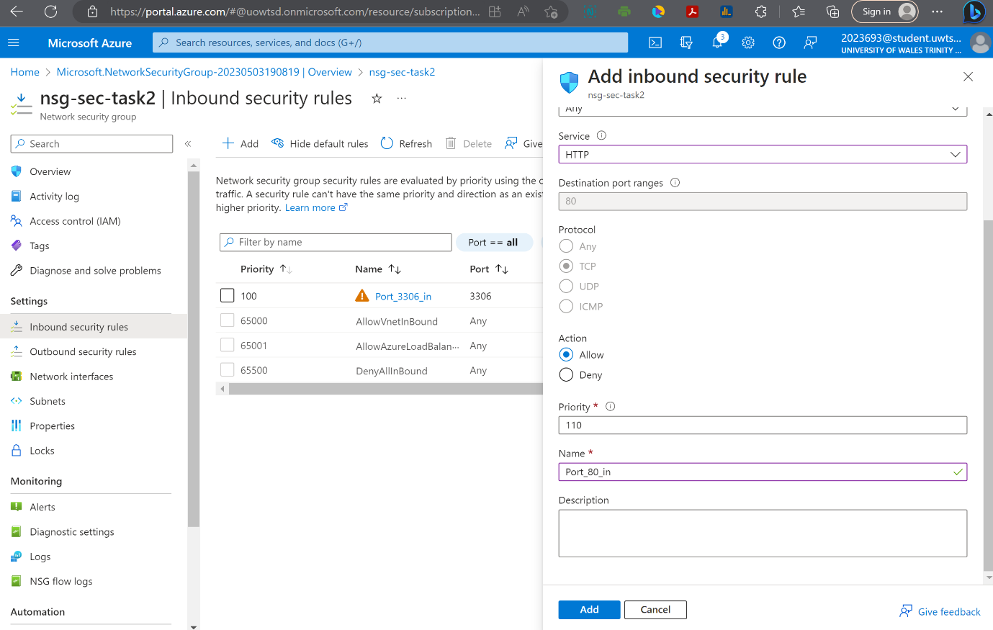

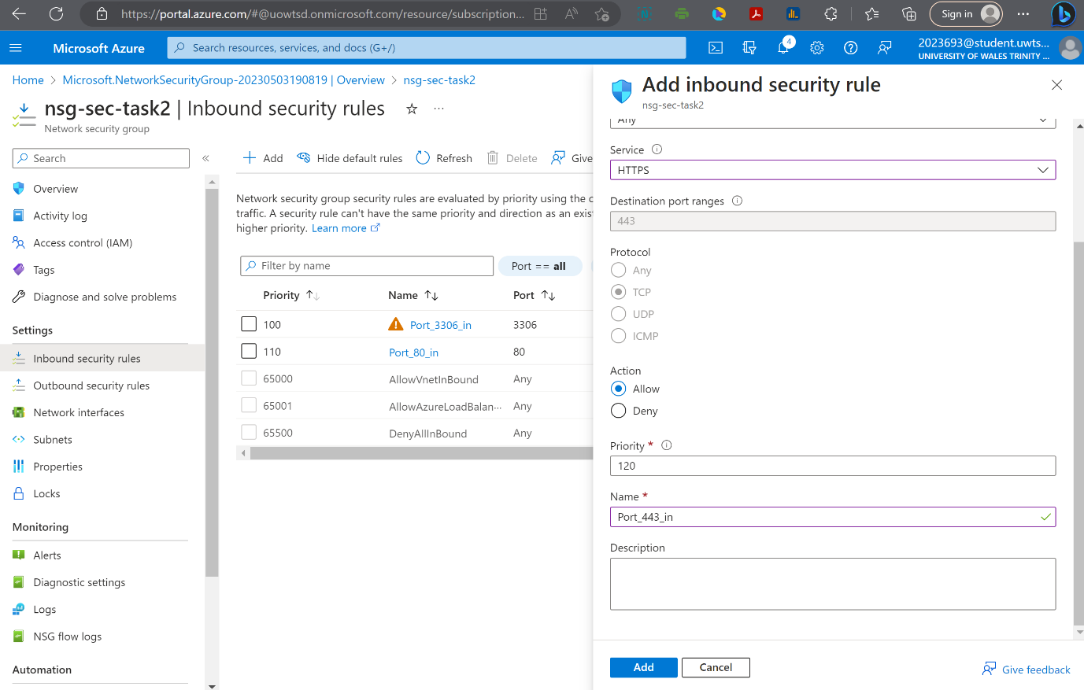

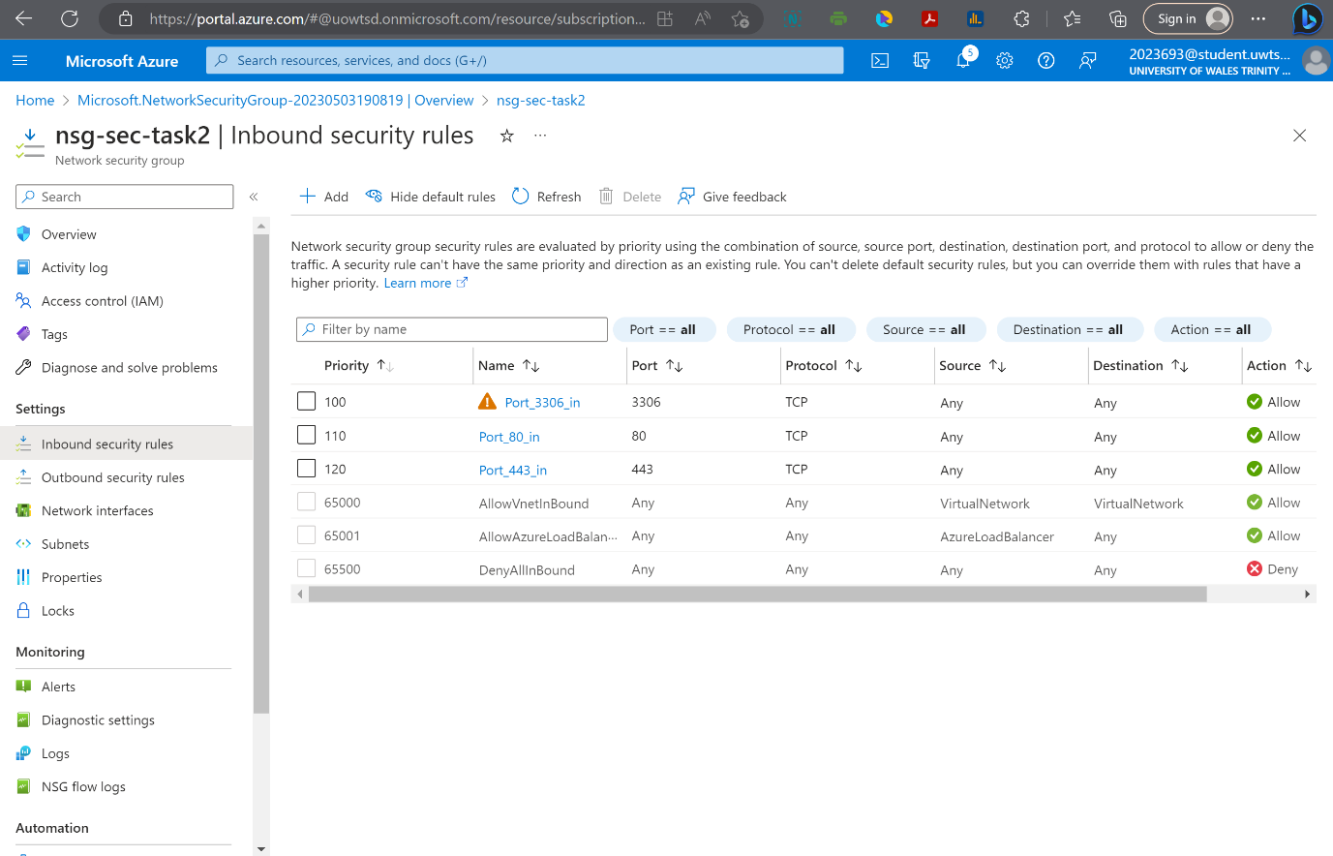

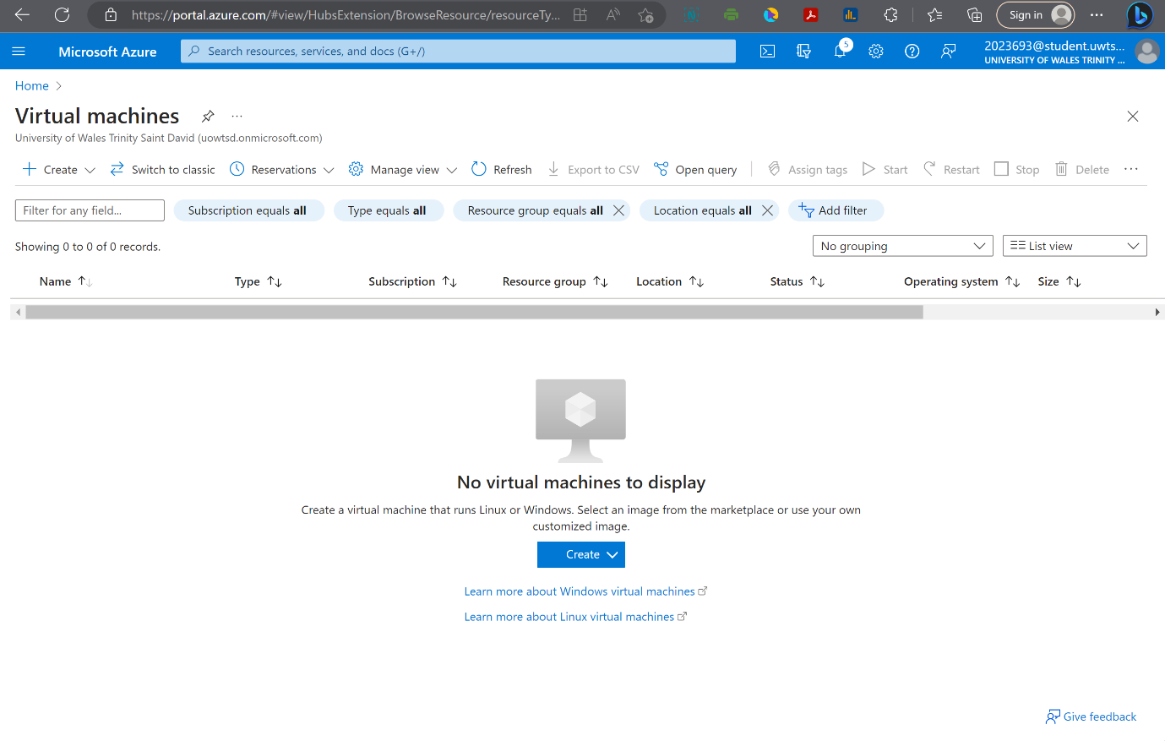

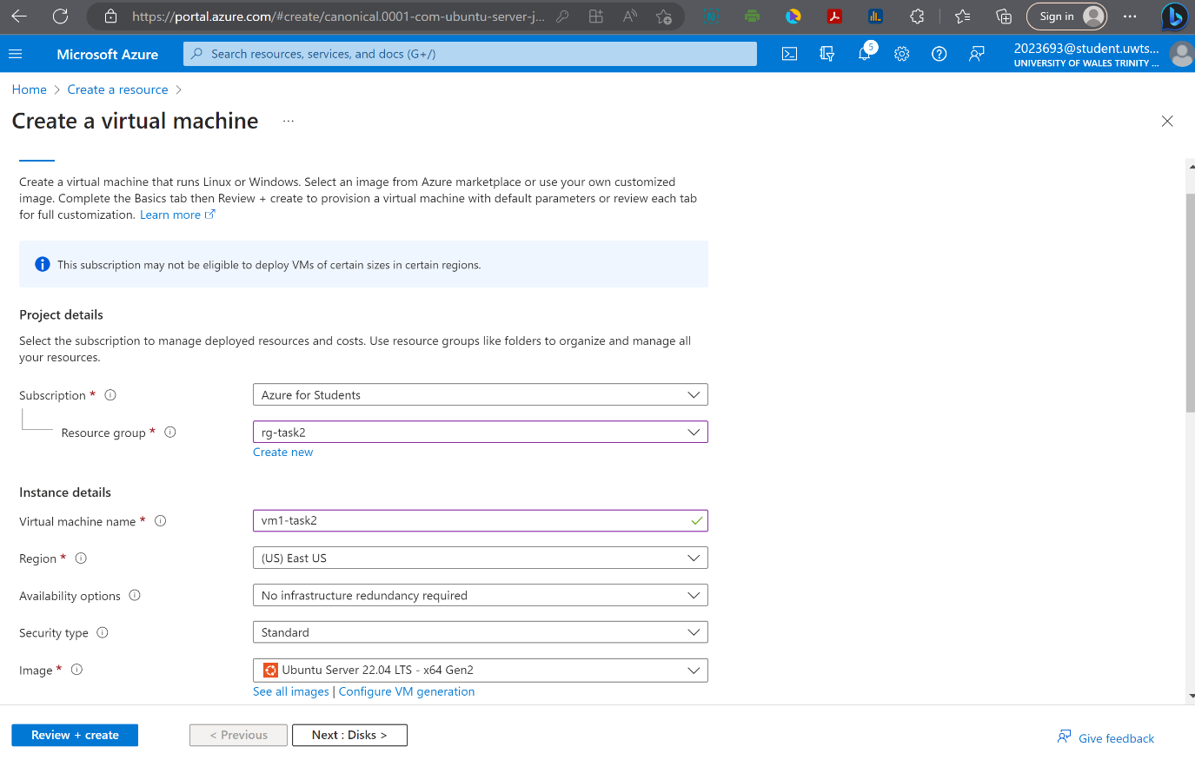

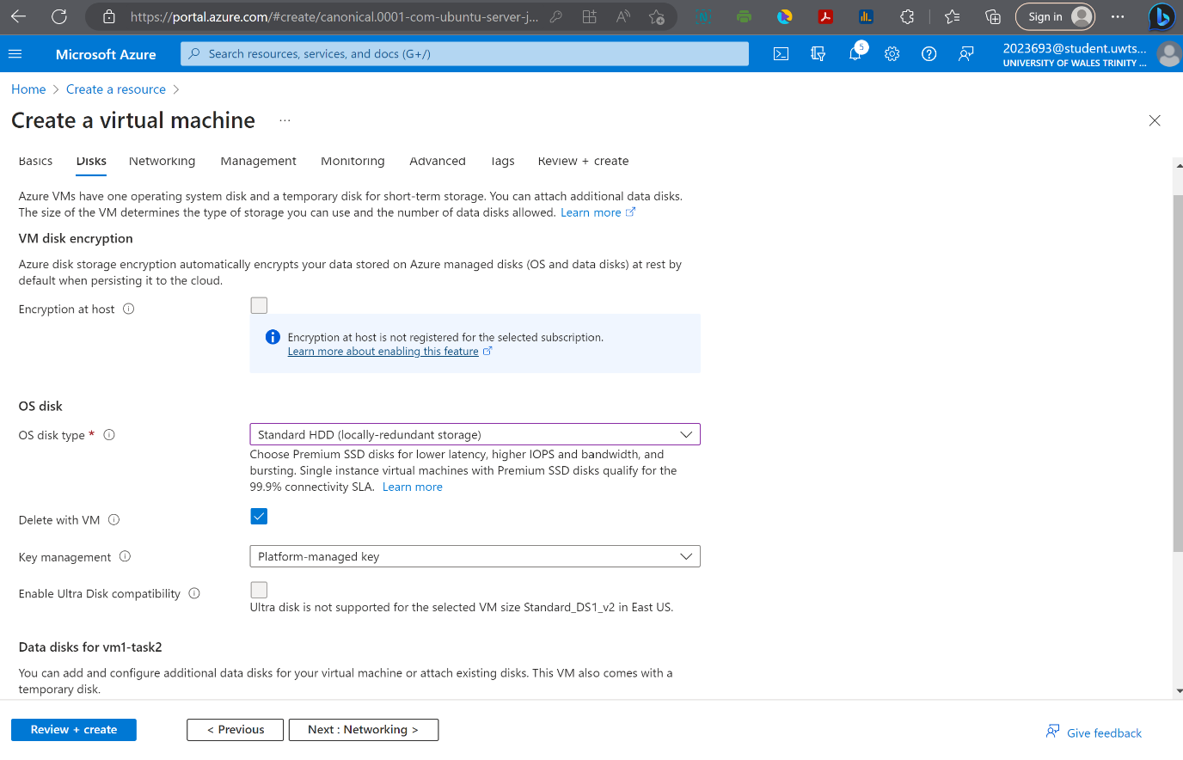

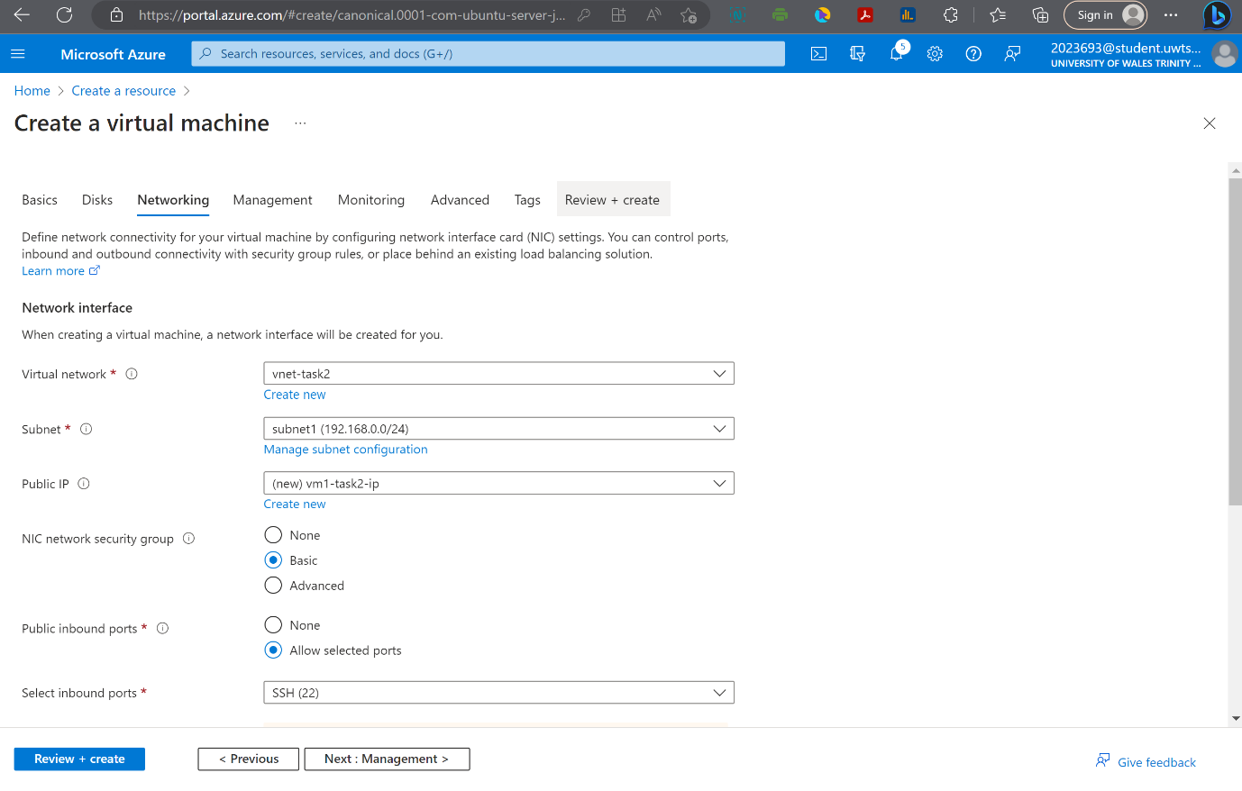

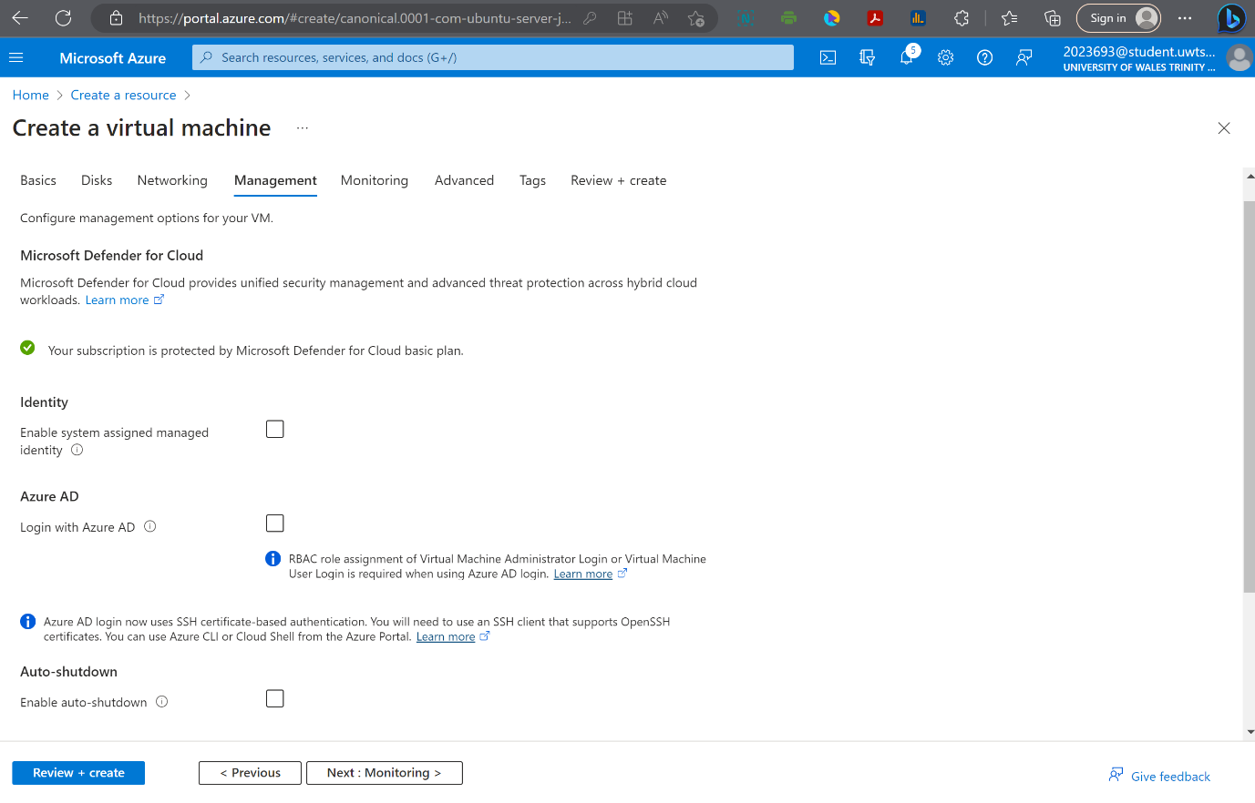

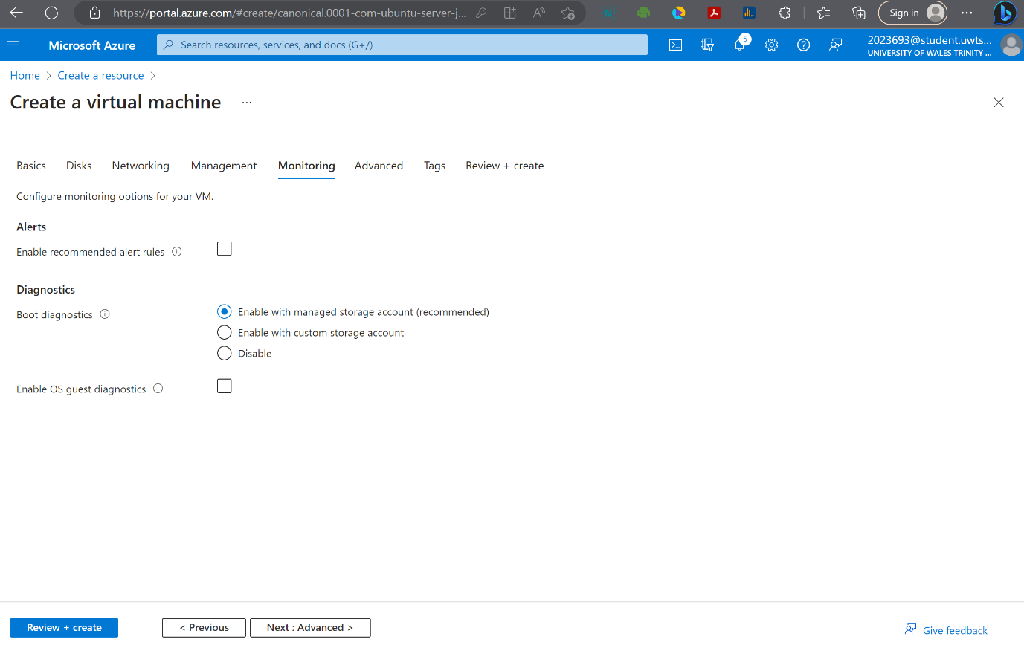

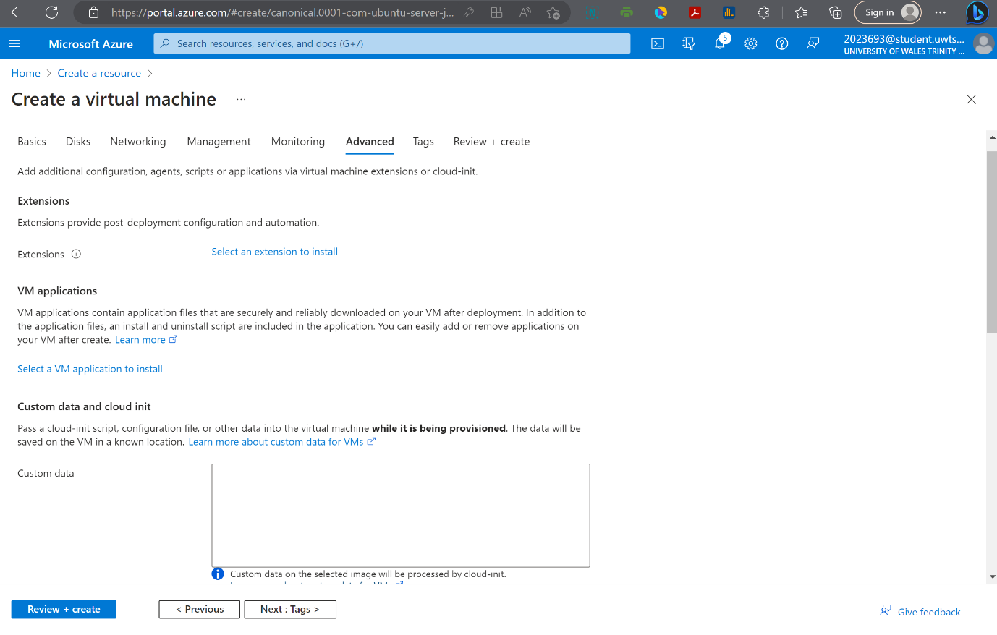

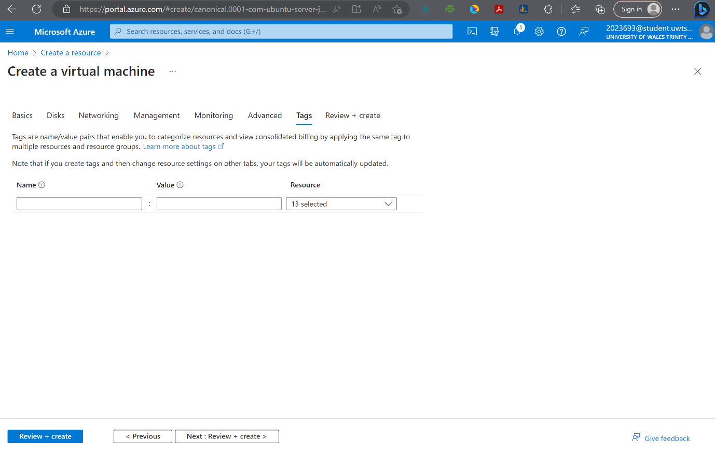

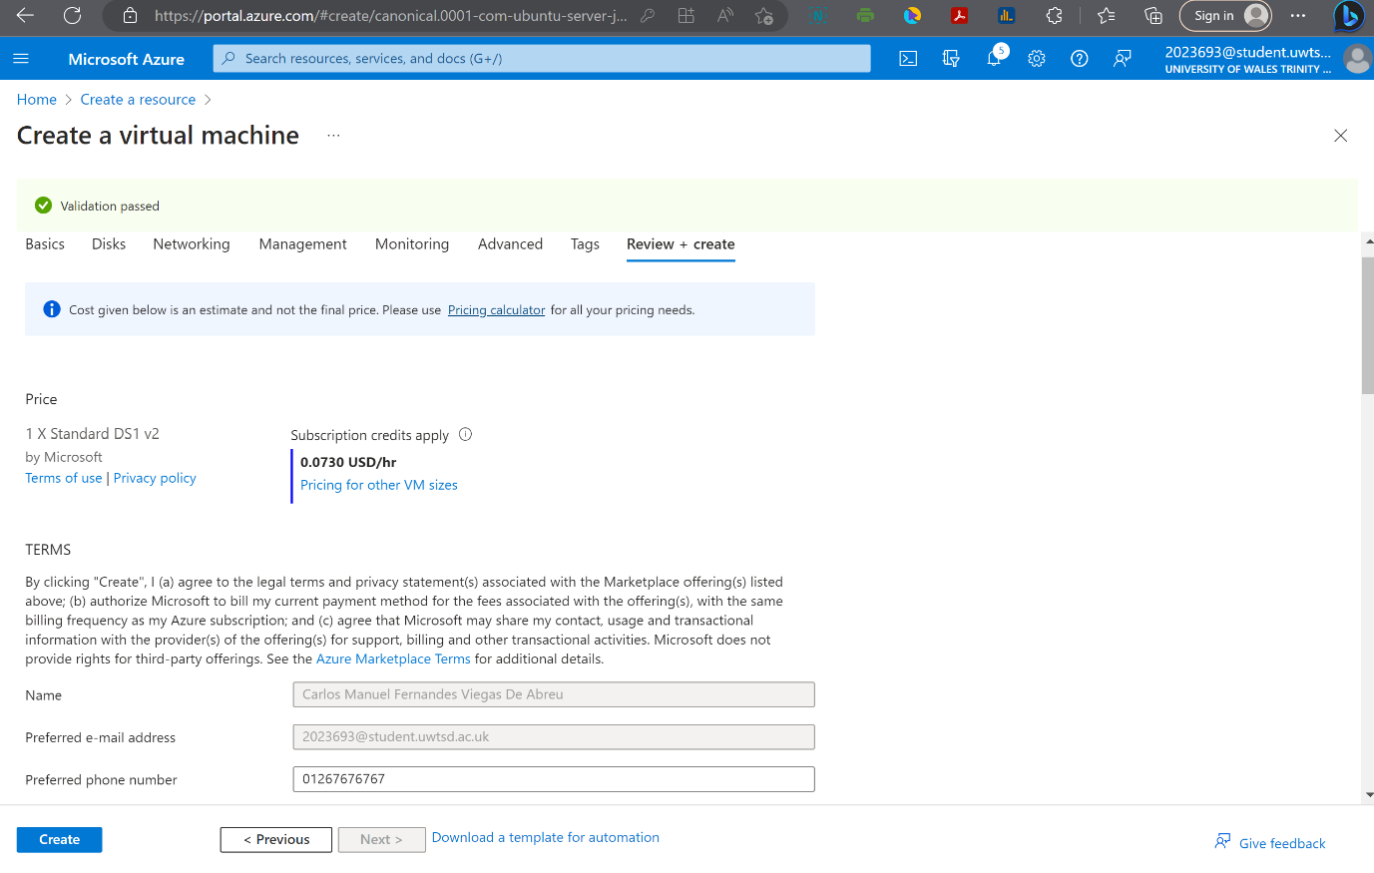

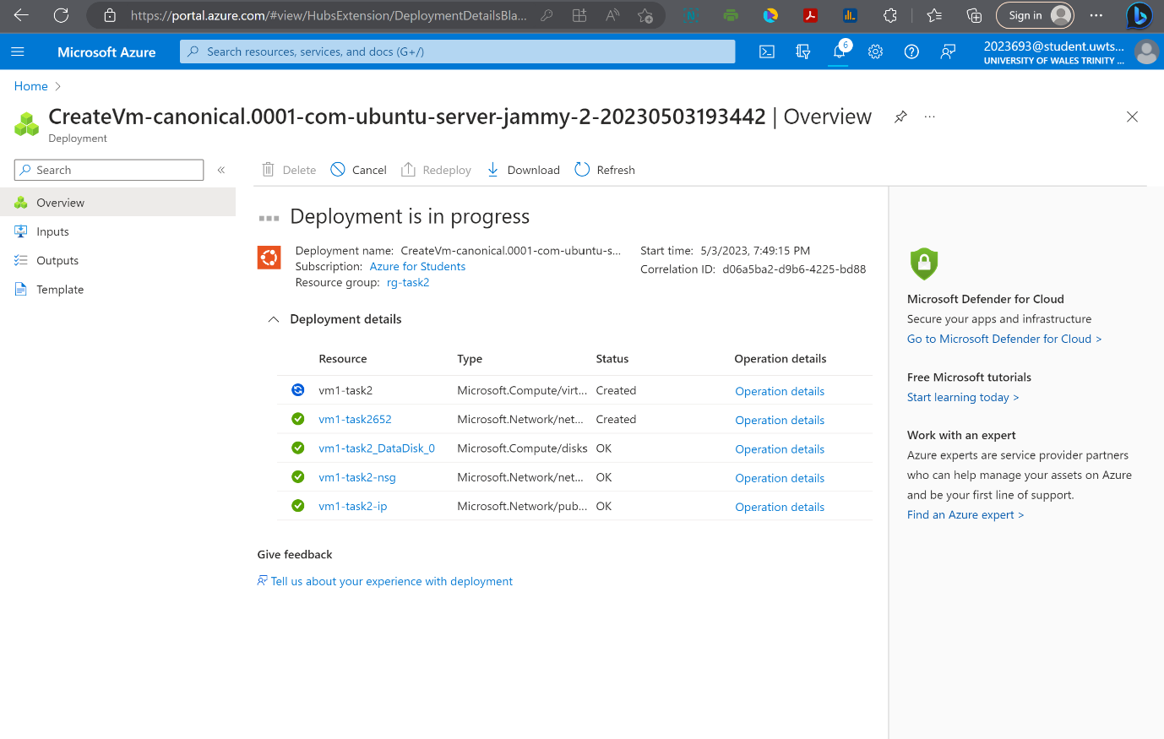

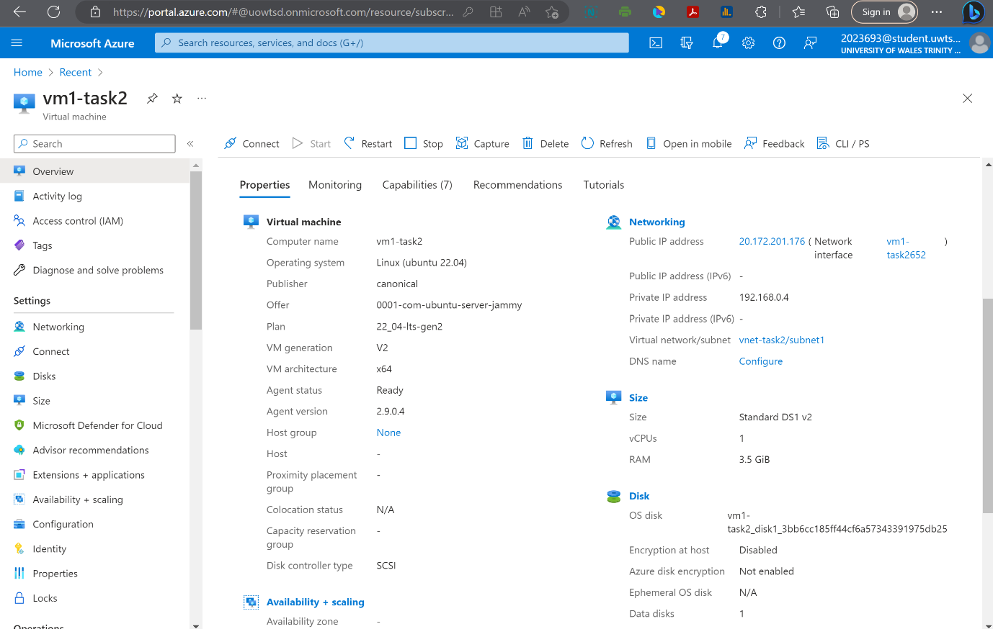

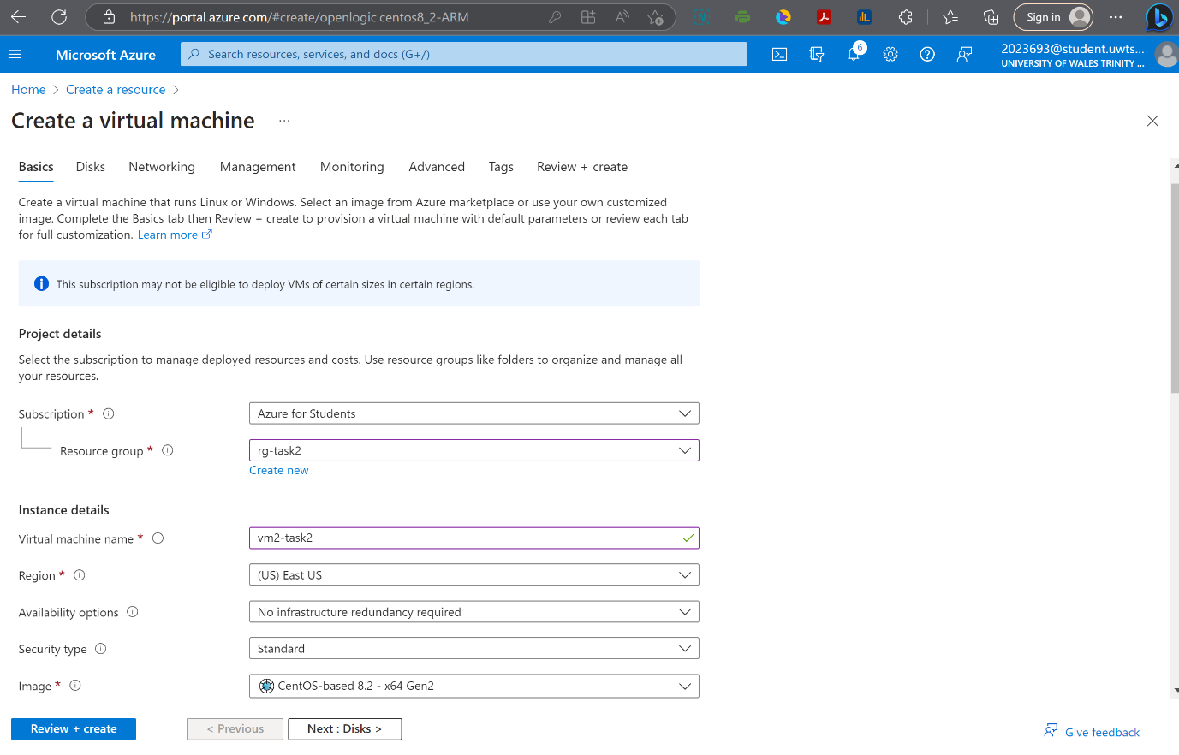

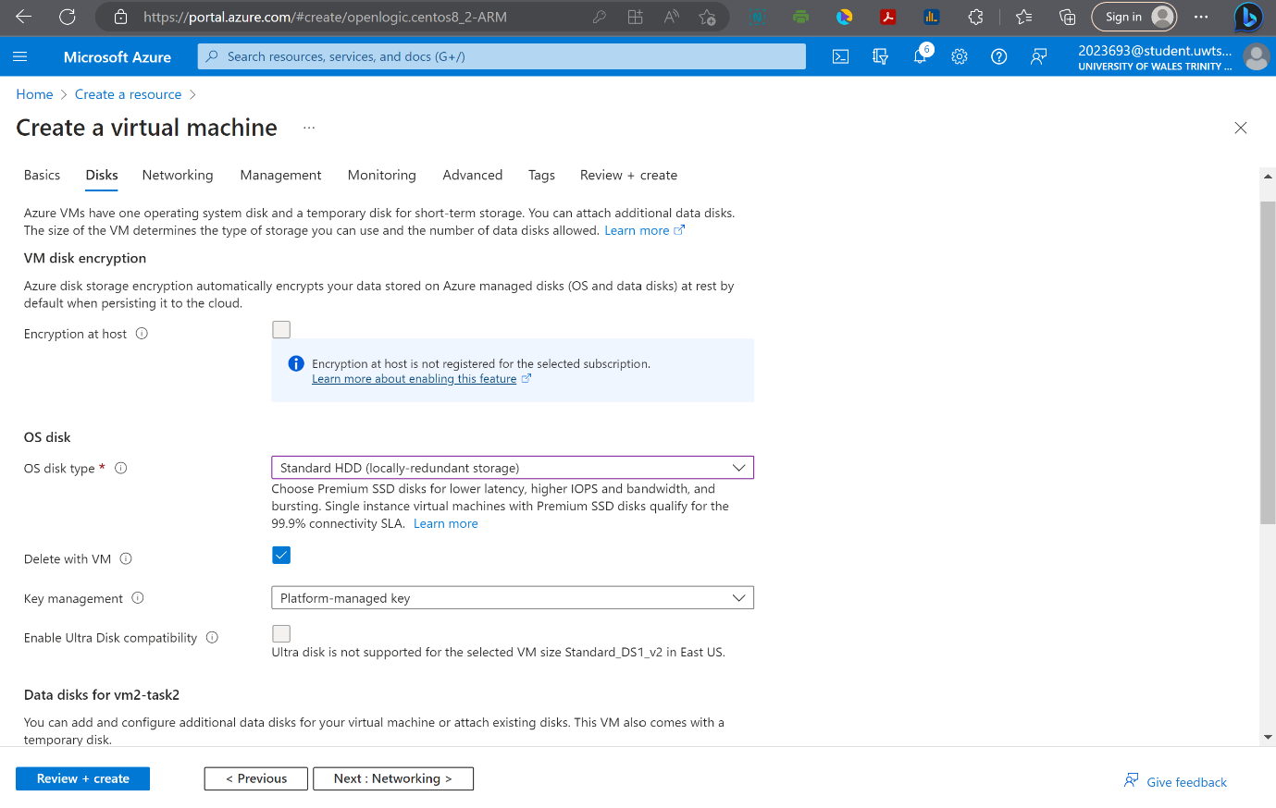

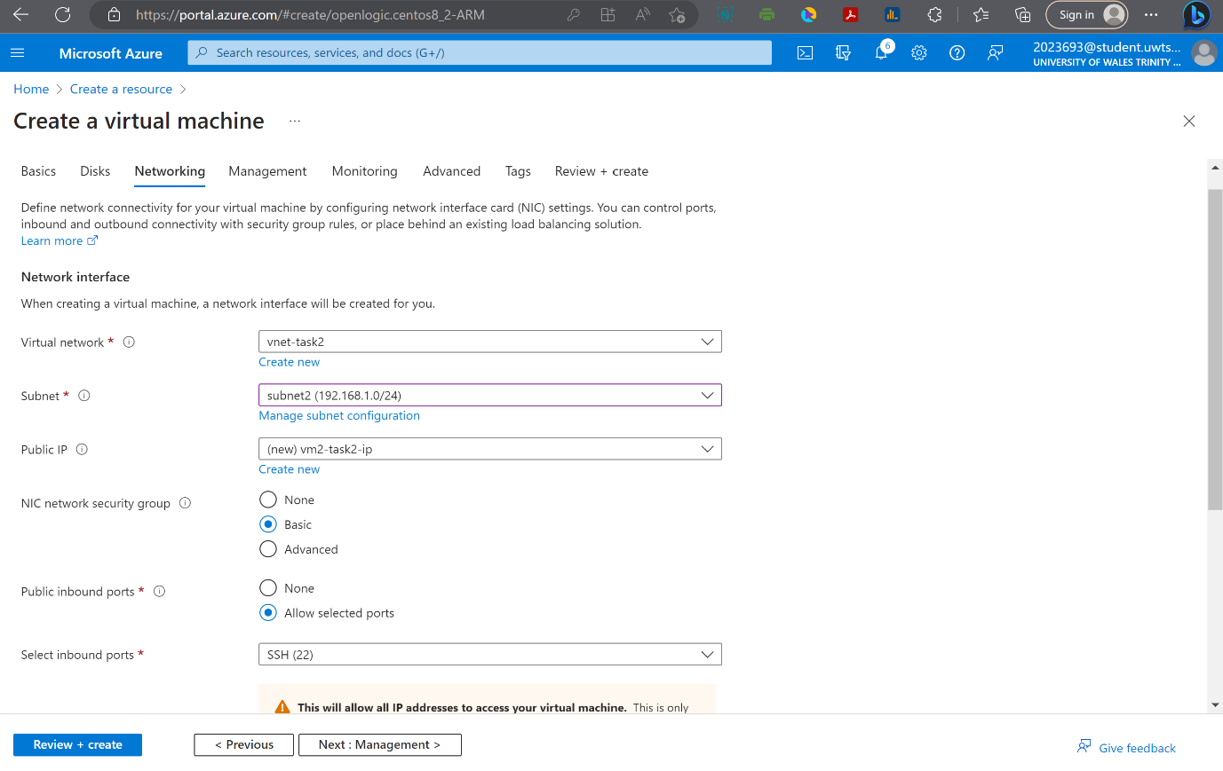

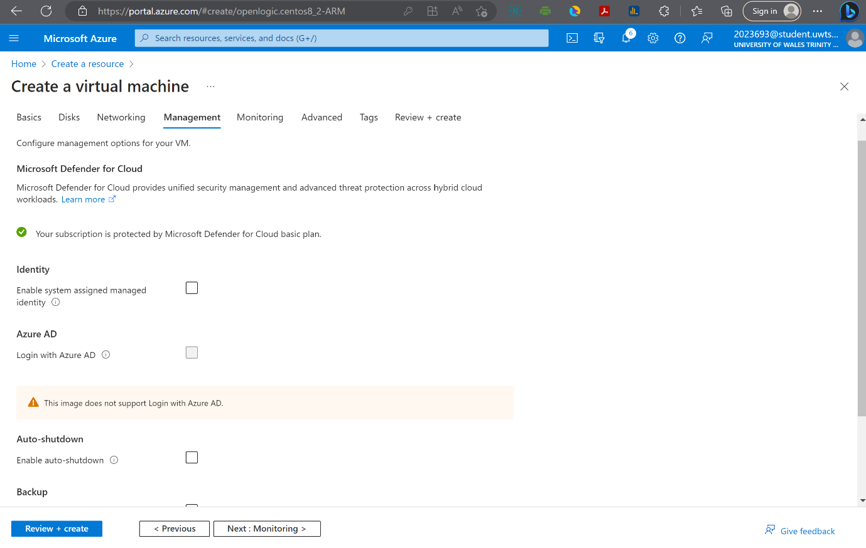

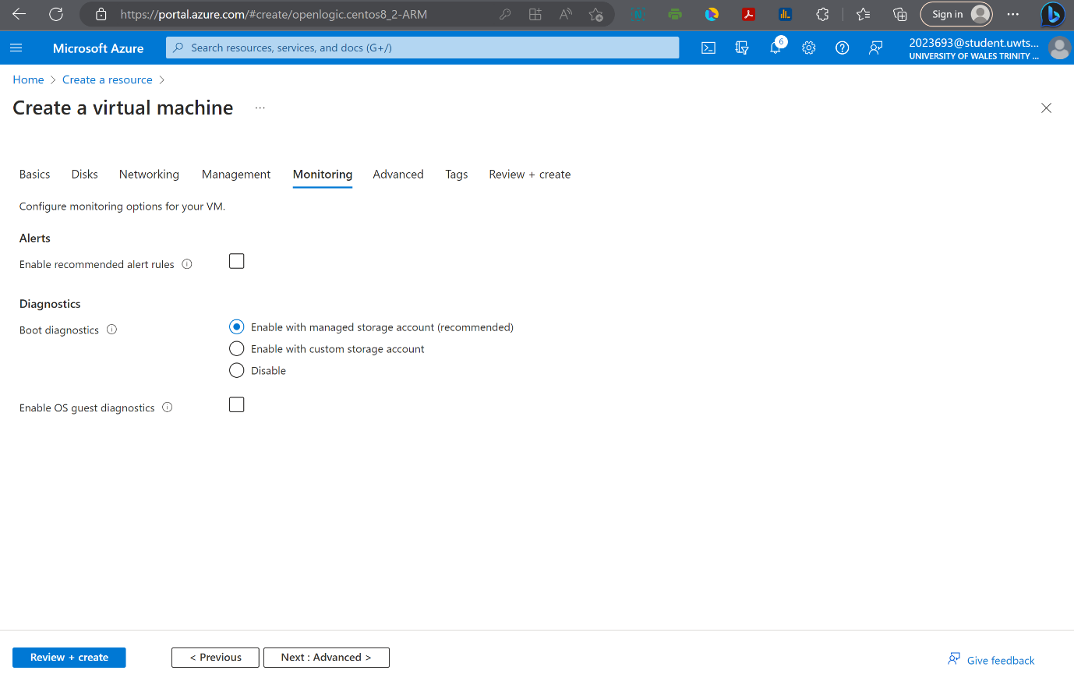

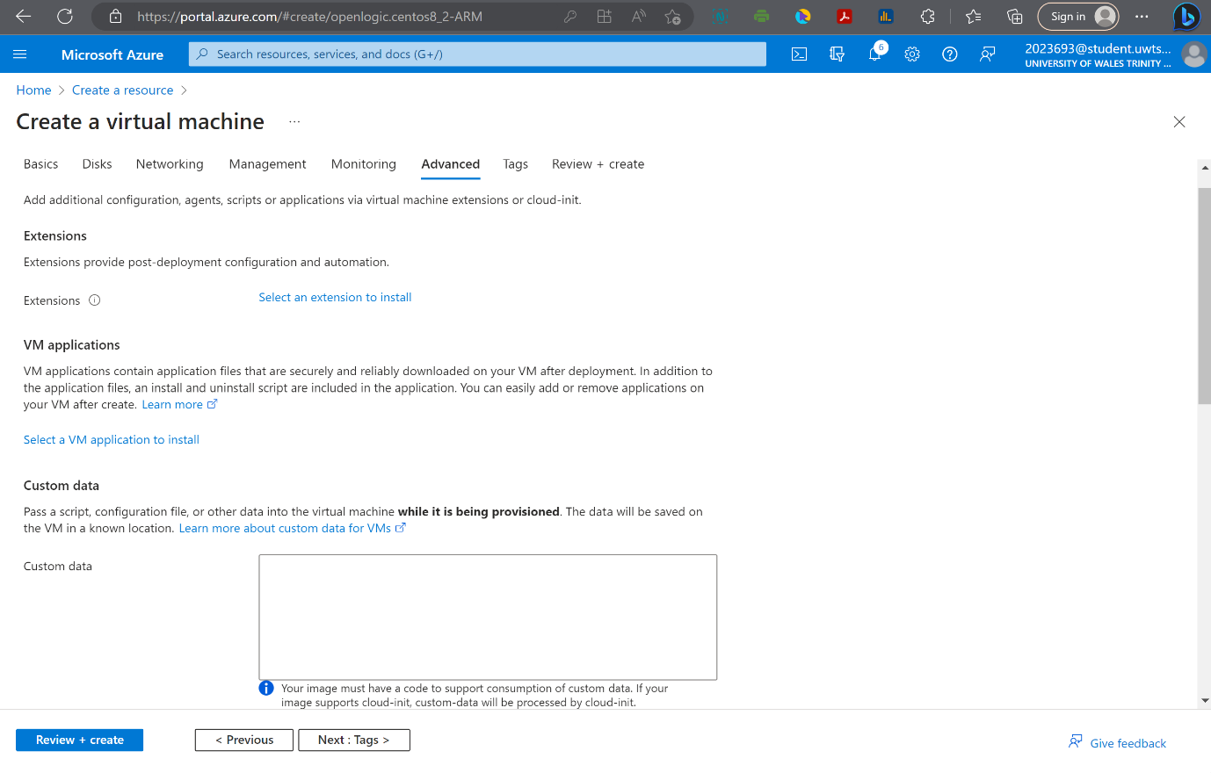

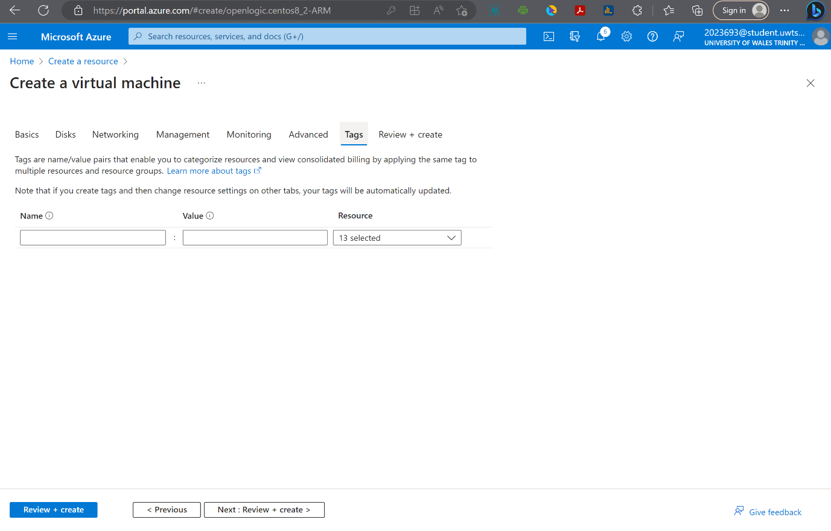

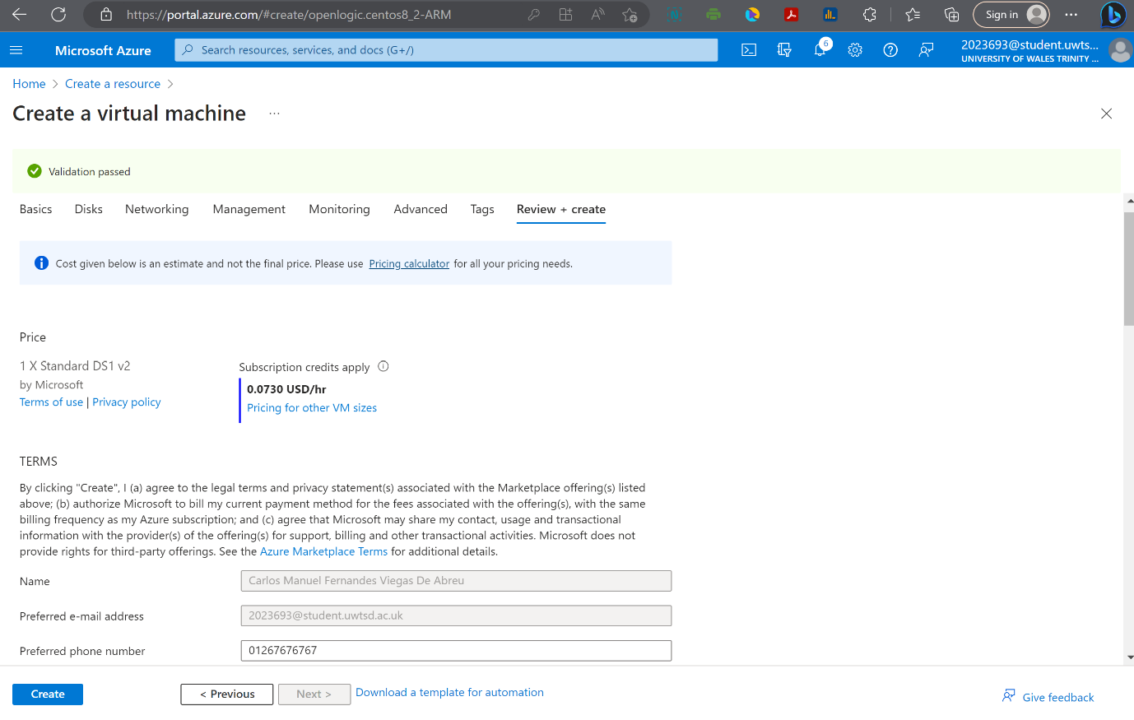

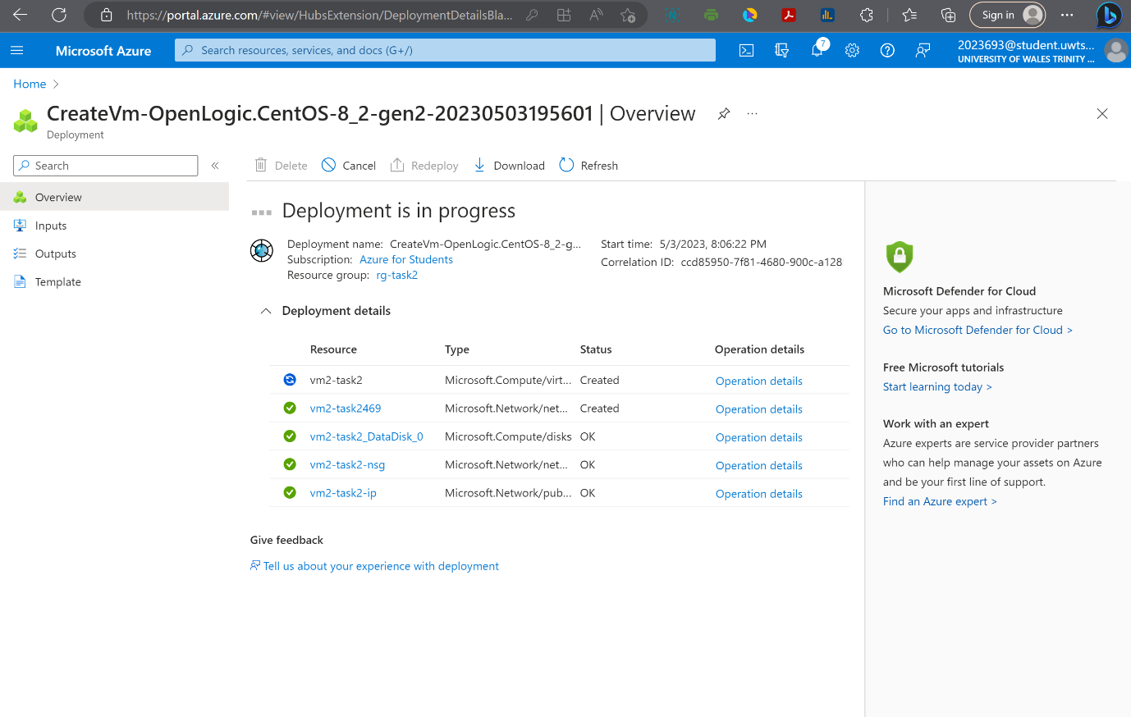

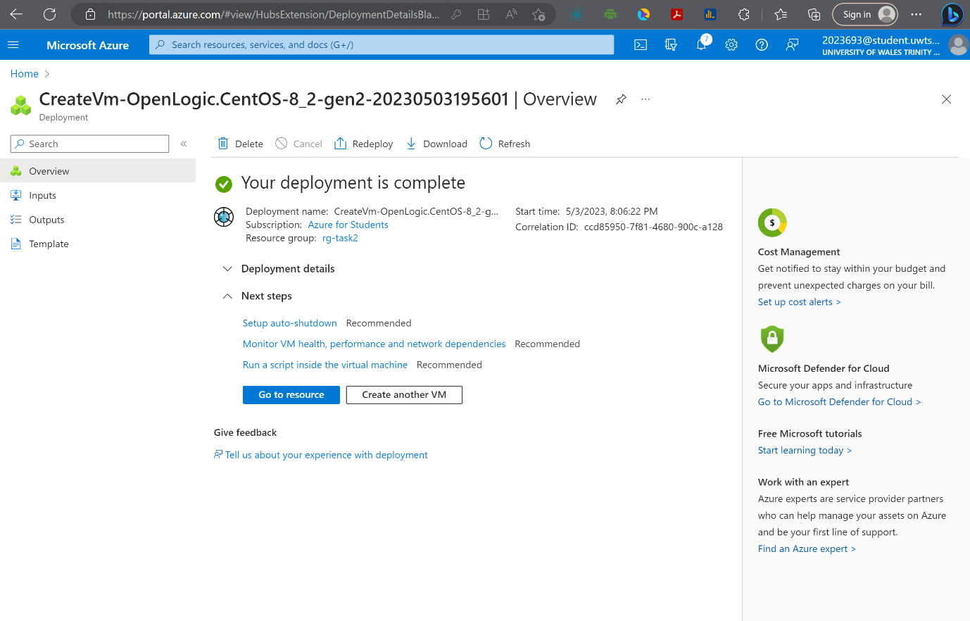

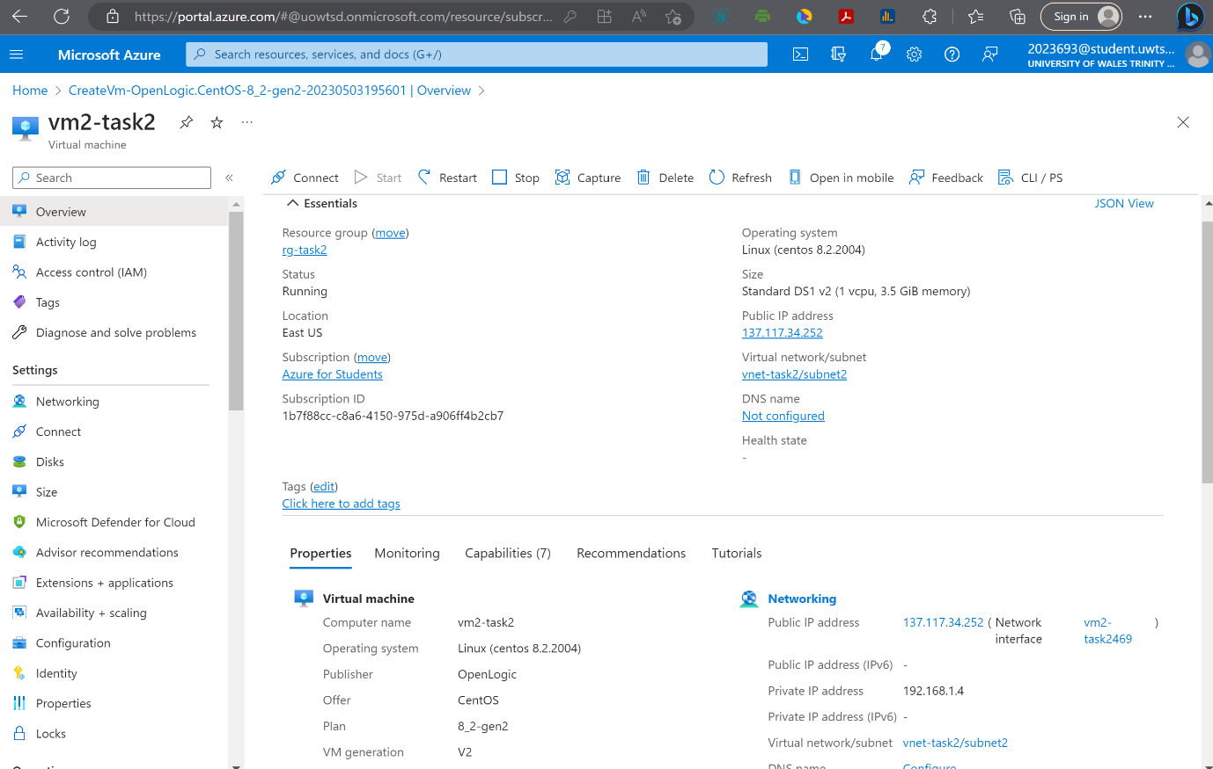

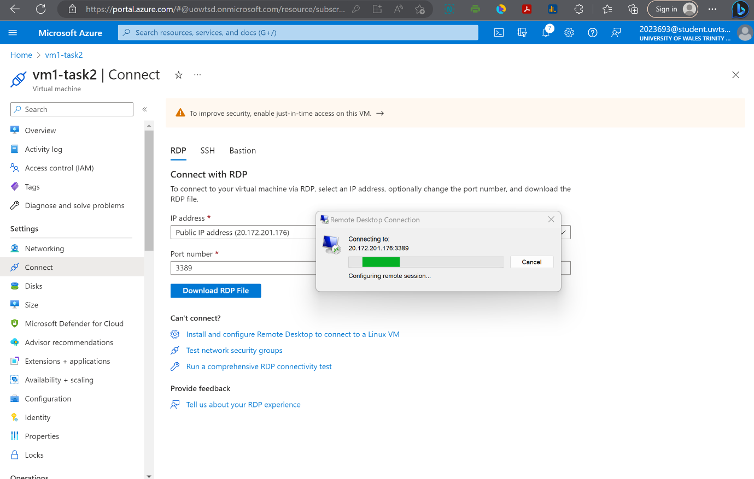

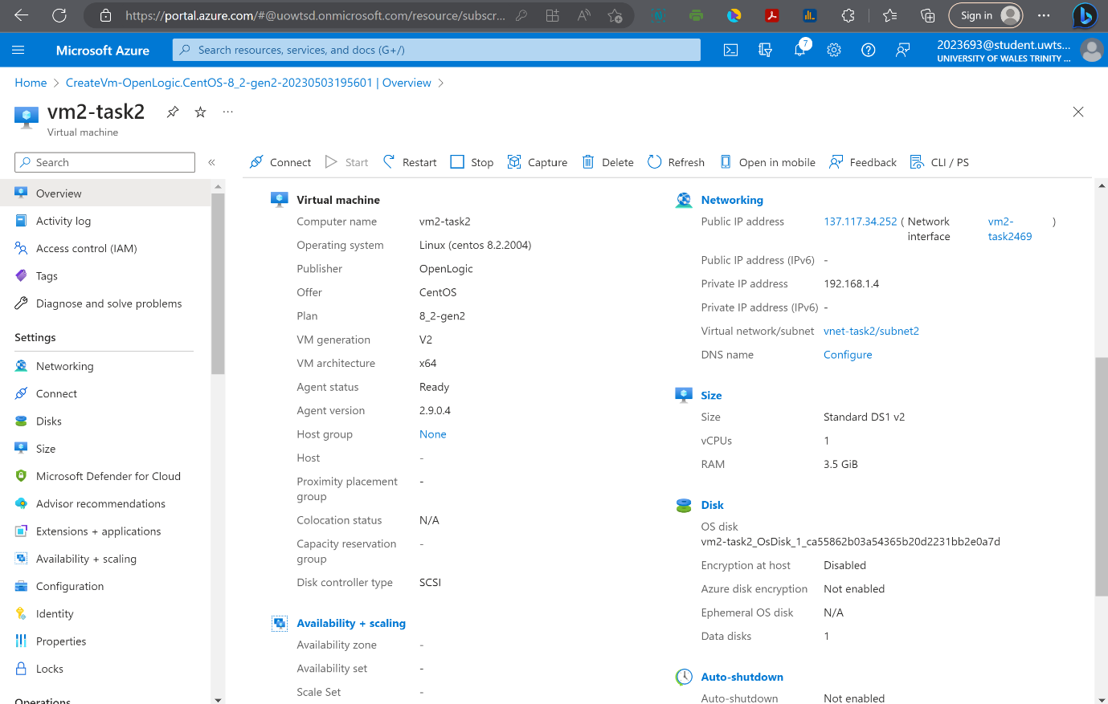

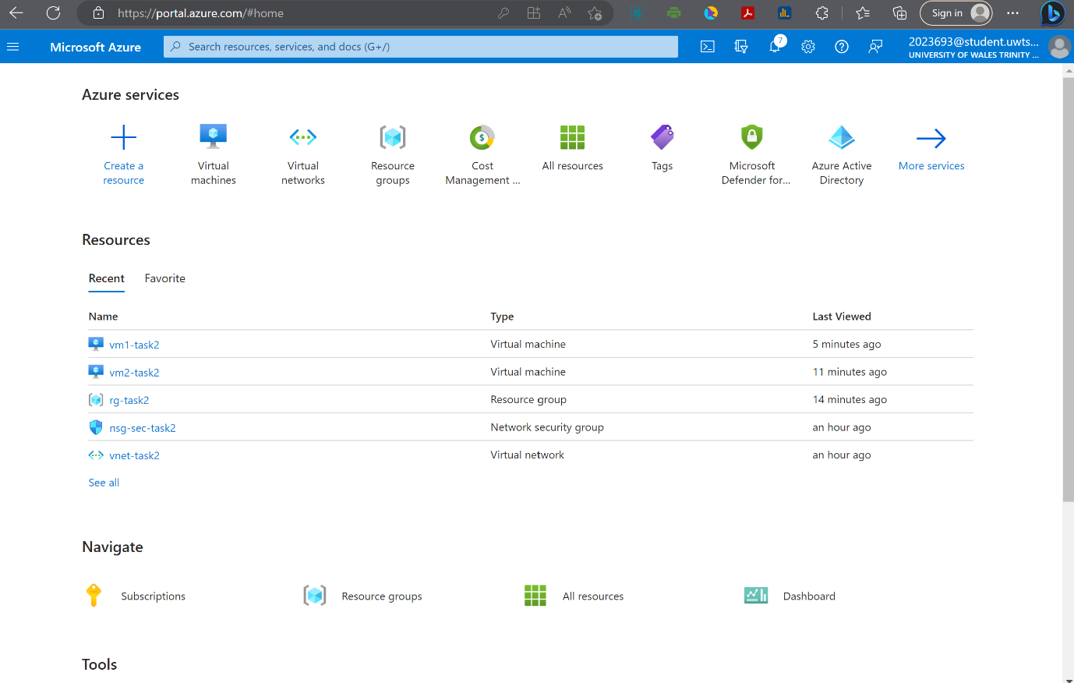

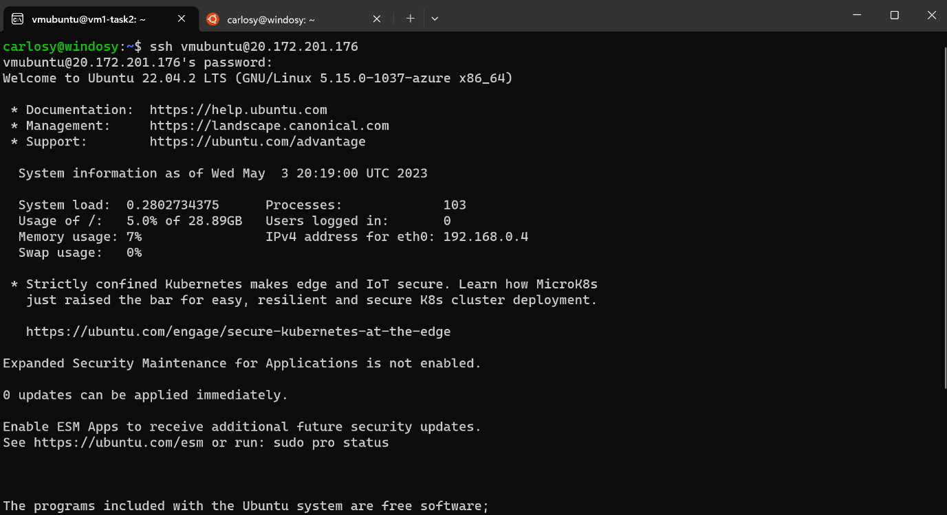

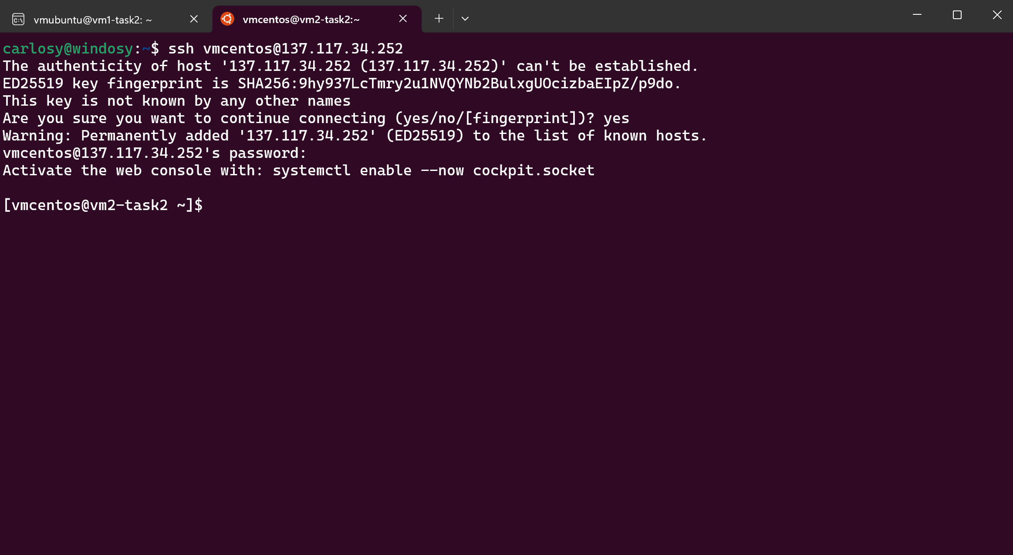

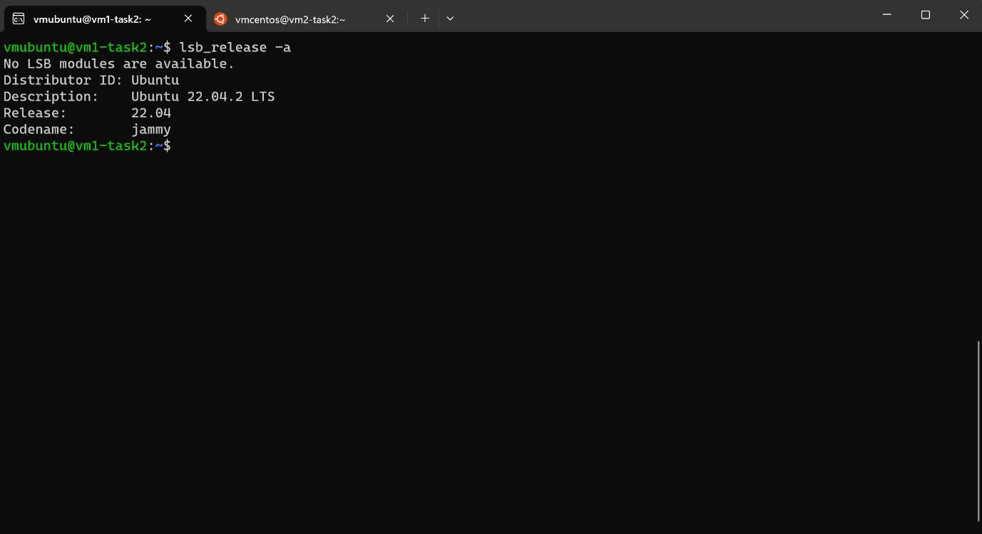

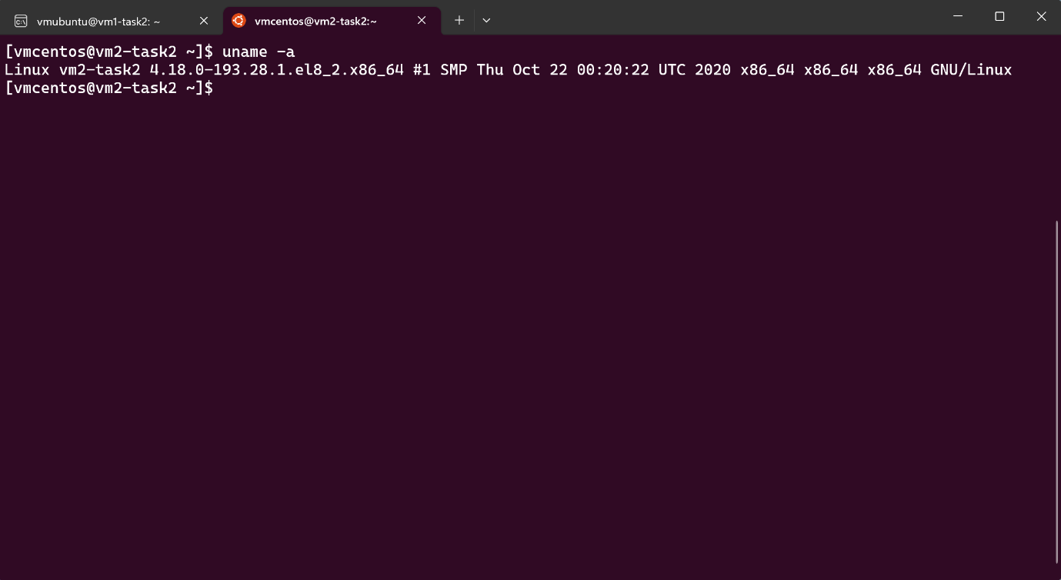

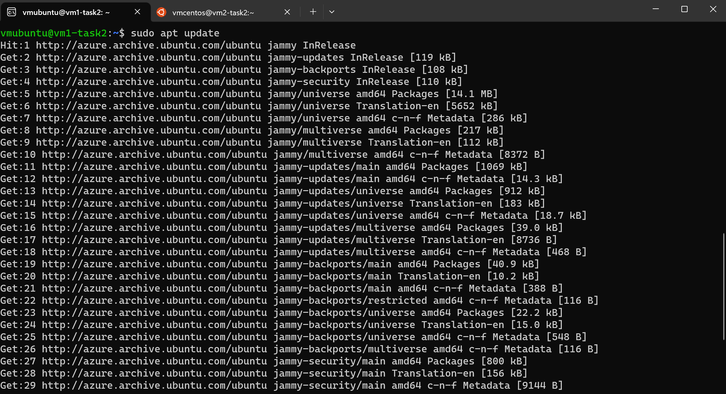

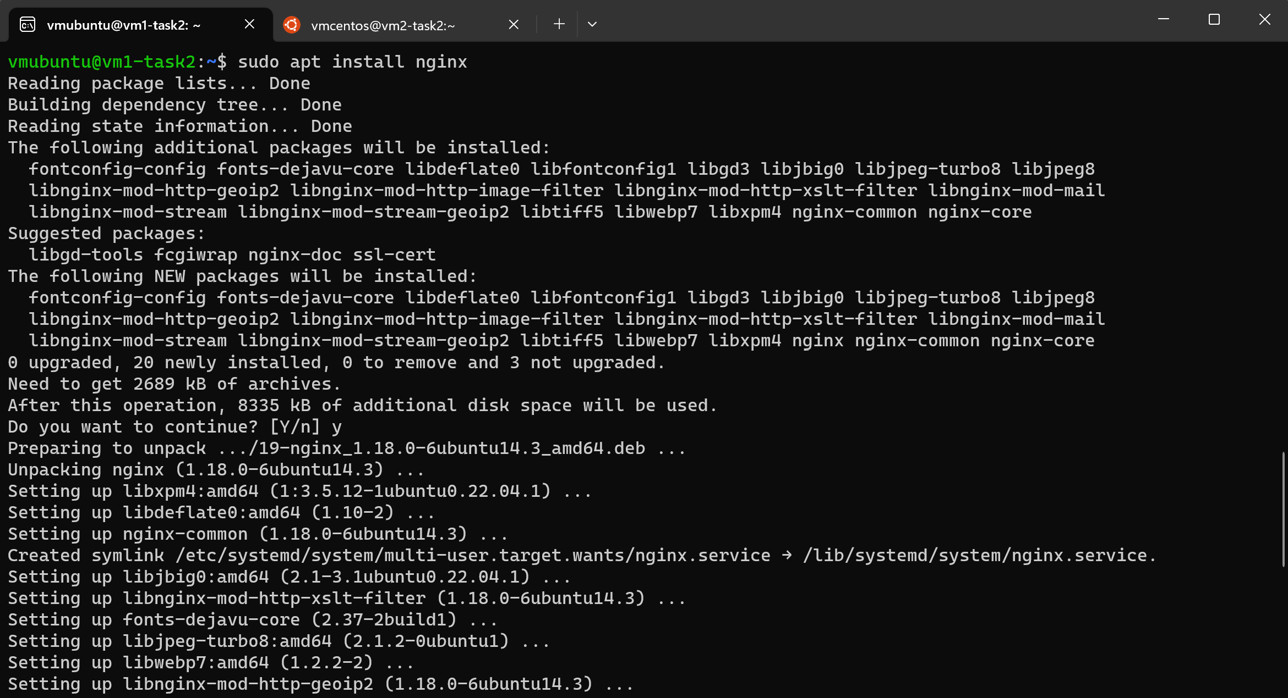

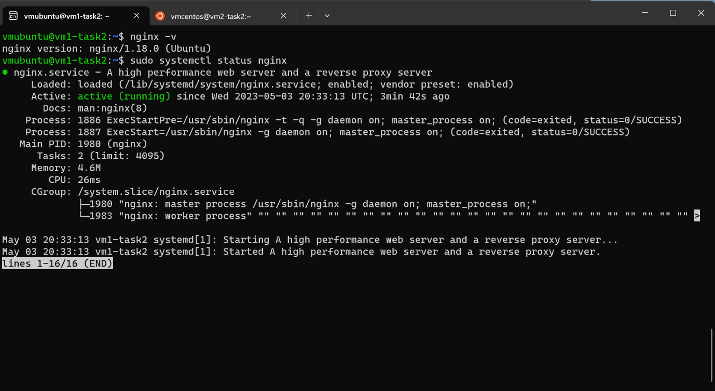

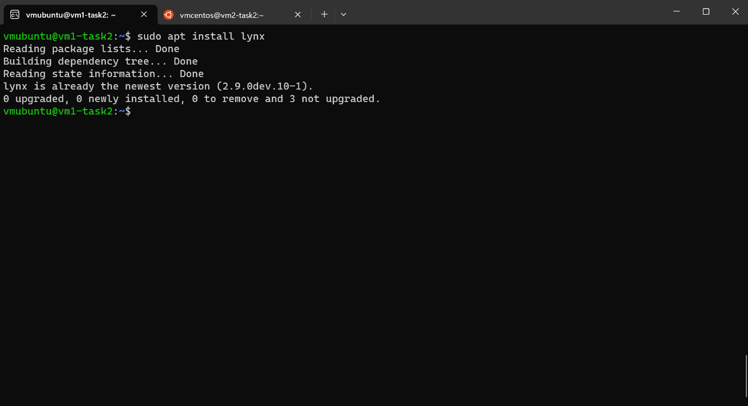

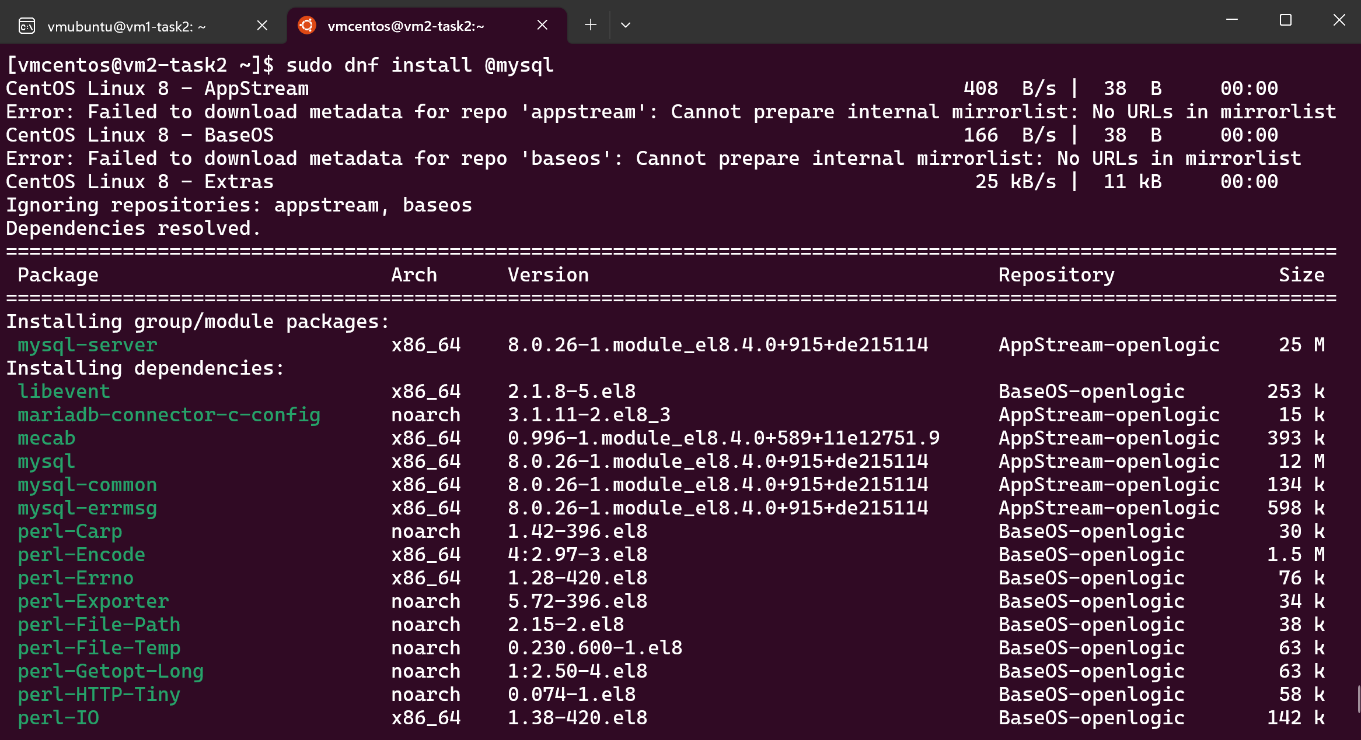

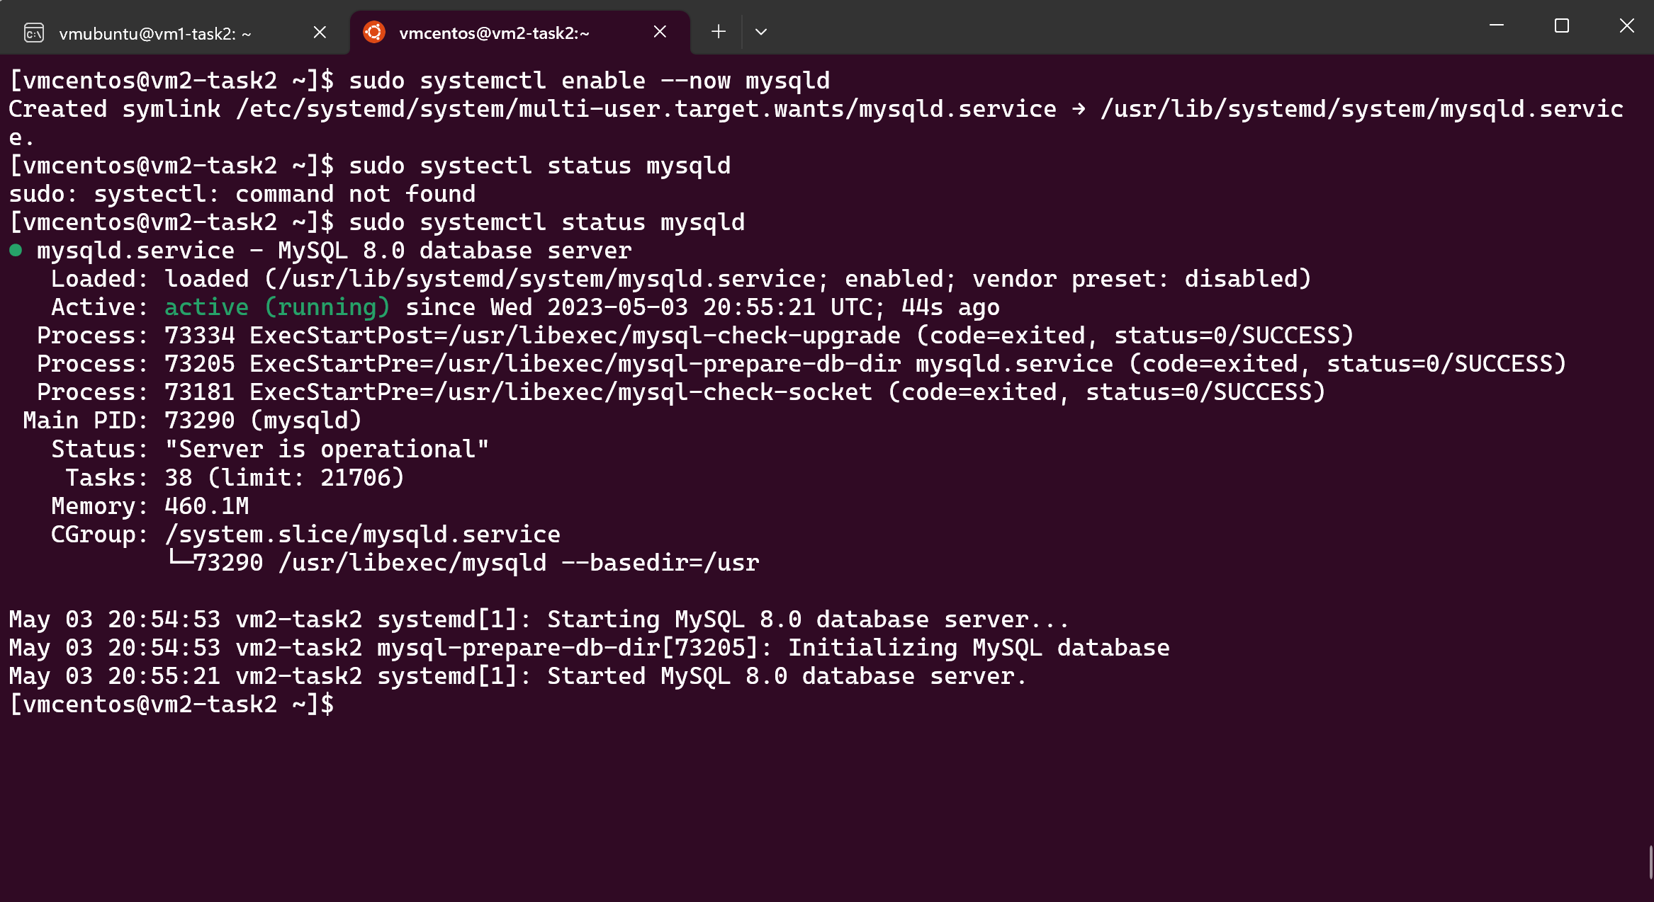

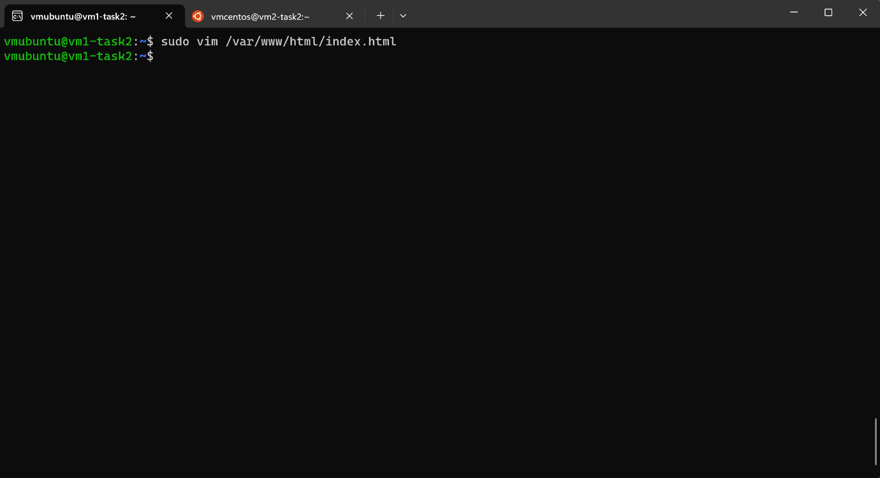

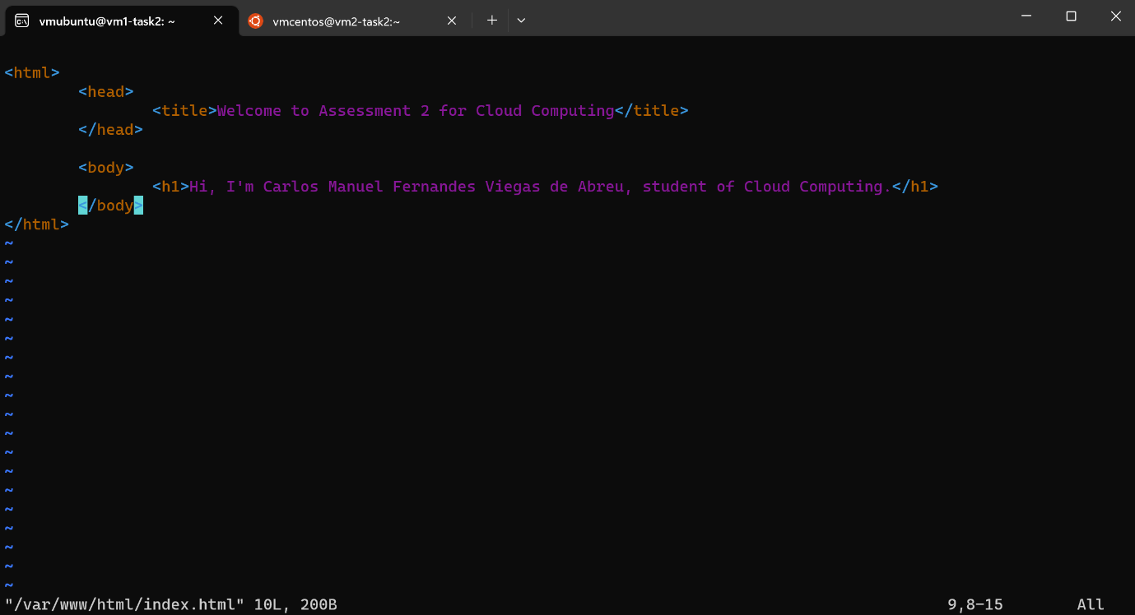

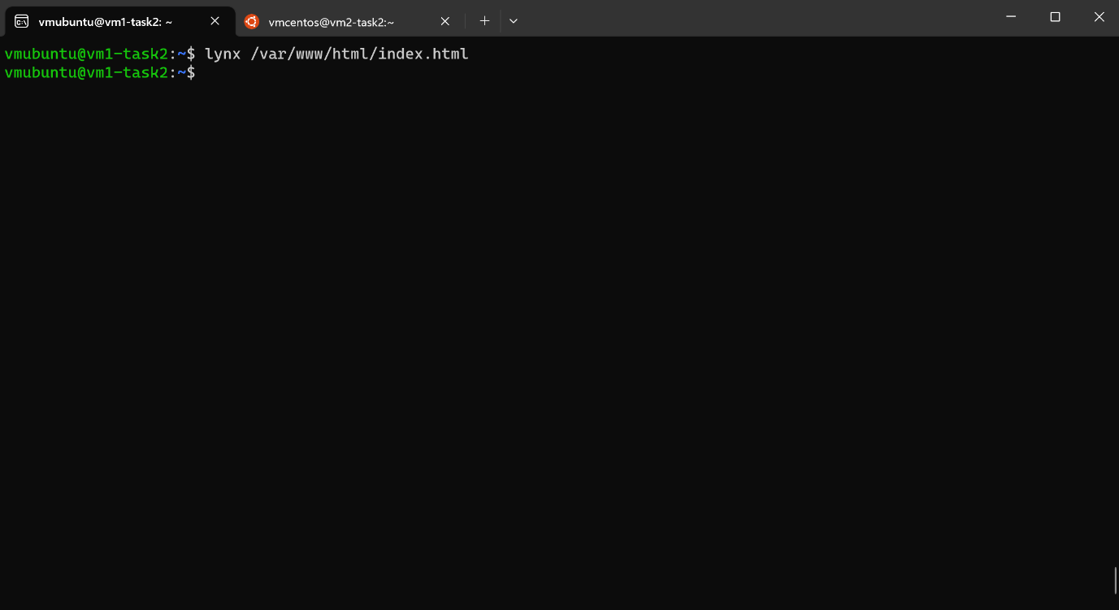

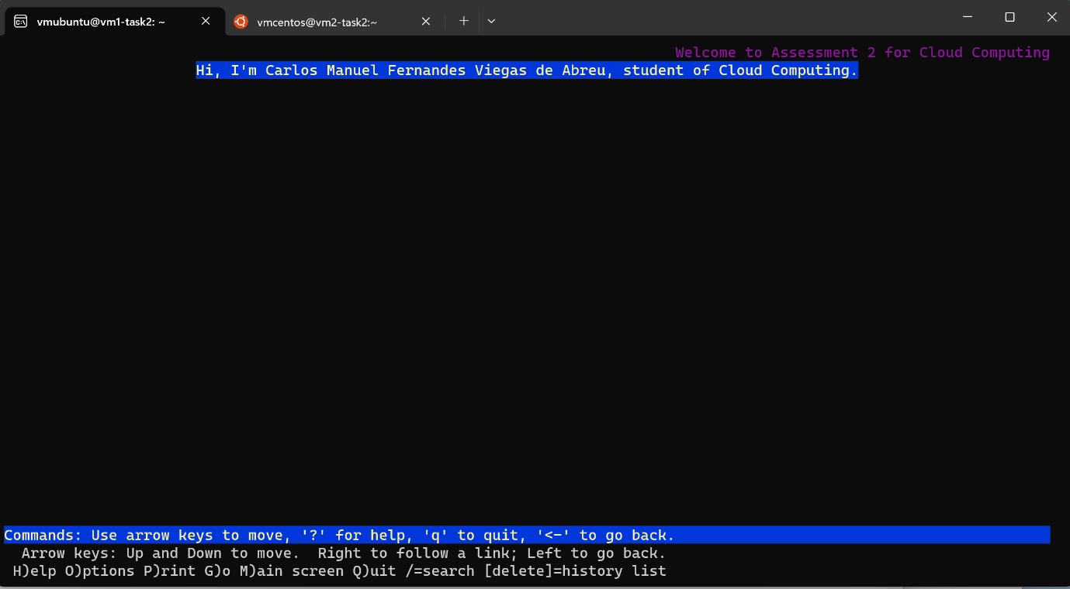

Bibliography
[1] | S. K. N. S. Alex Belotserkovskiy, Building Web Services with Microsoft Azure, Packt Publishing , 2015.
[2] | R. Sahay, Microsoft Azure Architect Technologies Study Companion: Hands-on Preparation and Practice for Exam AZ-300 and AZ-303, Apress, 2020.
[3] | C. Negus, Linux Bible, 10th ed., Indianapolis, Indiana: John Wiley & Sons, Inc, 2020.
[4] | H. Bai, Zen of Cloud: Learning Cloud Computing by Examples, CRC Press, 2015.

