Working with relational databases in REST
Last week, we explored using Spring to create a REST service, automatically generating endpoints to a database through the JPA. This, however, was a fairly simple flat table structure. Relationships add a layer of complexity because, not only do we need to consider their implementation in the database, but also their implementation in Java, such that the REST service can handle a browser-appropriate format for them, convert it into a Java object, representing relationships through object associations, before ultimately moving into an appropriate database format.
Spring does a huge amount of the work for us here – though there is, undeniably, a lot of nuance which is unique to the framework to grasp.
In this tutorial, we’ll be taking the work from last week and extending it to move the “course” field from being a text field to a third normal form table structure.
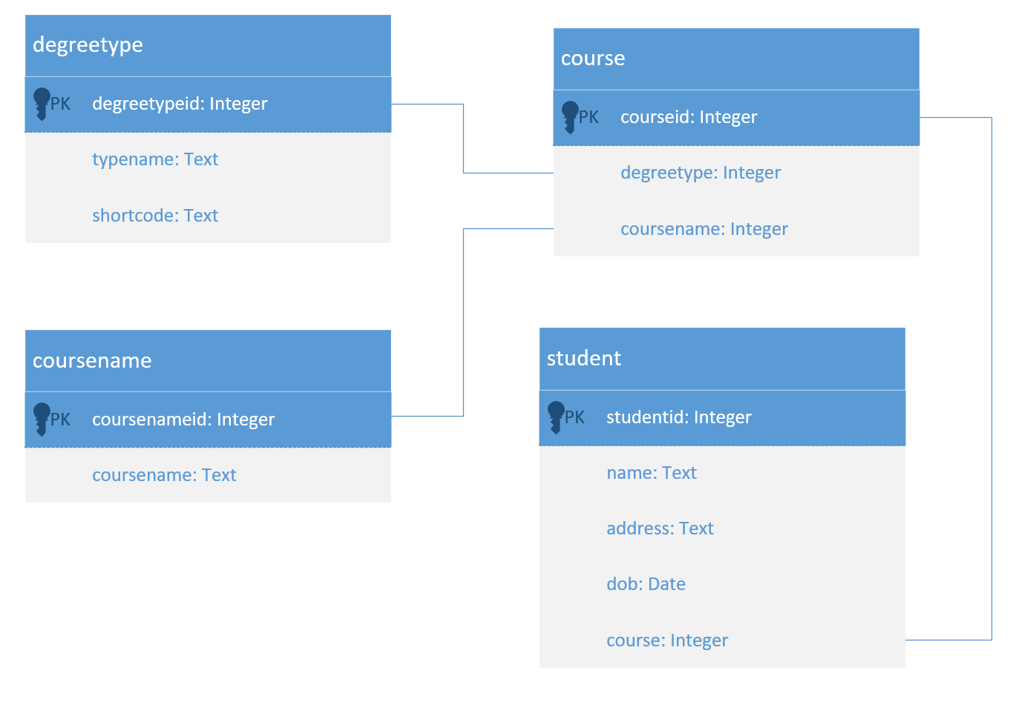
Coursename
Degreetype

Creating the project
You can work from last week’s project if you like, but I’m going to be starting fresh and bringing in the files we need.
Either through creating from scratch or some judicious copy and paste:
- Import the student class we used last week.
- Create a basic PagingAndSortingRepository.
- Set up your application.properties.

Exercise
Set up the Entity classes for two of your new tables: degreetype and coursename. Be careful when naming these – they’re case sensitive in a way you wouldn’t anticipate. The first letter of all Java classes needs to be capitalised – this is fine, while we named our database tables with a lower case first letter, Hibernate will sort this out for us. What we need to be careful of is that any capital letter subsequent to the first will prepend an underscore to that capital letter when mapping to the table. So if, for example, you named your class DegreeType, it would look for the table degree_type. So we need to be careful to name our classes Degreetype and Coursename with exactly that capitalisation.
Create repositories for each of these classes. Note that the decision of which specific kind of repository to use is down to you as the developer. I would suggest that, unlike students, we’re unlikely to want to browse or search a degreetype or coursename, so CrudRepository will be suitable. A little later we’ll need to pick whether to use CrudRepository or PagingAndSortingRepository for course. Picking incorrectly isn’t a big deal – this is trivial to change later if you realise you’ve made the wrong choice.

Lazy Hibernate/Jackson serialisation and marshalling
Your entity classes should already be annotated with @Entity. Additionally, add the annotation:
@JsonIgnoreProperties({"hibernateLazyInitializer", "handler"})
The reason this is necessary is complex and a tad esoteric. Spring uses Jackson, a popular Java serialisation library, to marshal and unmarshal json. However, Hibernate pulls data from the database attached to additional session and state information – which Jackson will mistakenly attempt to marshal. This is particularly a problem because we’re going to do a “lazy” fetch, which won’t pull data from the database until a direct request is made for it. This is the correct call for a system like this where we clearly might have a huge number of students. Still, this requires a significant amount of complex management, which interferes with Jackson. So this annotation effectively warns Jackson’s type introspection engine of the need to strip Hibernate’s session management data.
This is a lot deeper into the complexities of how Java technologies interact than I’d really prefer to go, but omitting this annotation will result in an error message which is exceptionally hard to decipher.

The Course class
The initial stages of building this class should be familiar:
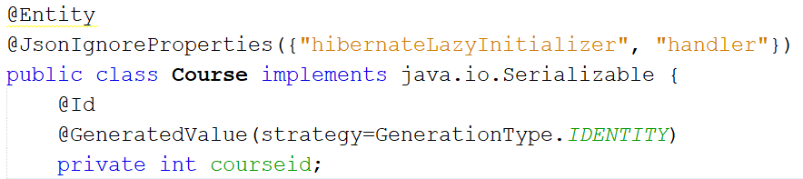
However, the two entity members for this class are foreign keys to other tables – the id fields of degreetype and coursename. We can represent these using their Entity class types. We need, however, to specify two annotations:
@JoinColumn – this indicates that this is the “owner” end of a foreign key relationship – i.e. it holds a reference to a primary key elsewhere. We need to use the “name” property to specify the table field.
@ManyToOne – this specifies the sort of relationship this member belongs to. There are a few parameters we can specify here – in this case, as mentioned earlier, we’ll state that the fetch type is lazy. There are, of course, also @OneToMany, @OneToOne and @ManyToMany annotations.
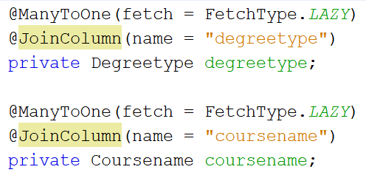
Note: the opposite of FetchType.LAZY is FetchType.EAGER.
On the opposite side of the relationship in Degreetype and Coursename, we need to provide the reverse mapping. As this is ManyToOne from Course to the other two classes, we can probably infer that in the opposite direction, this must be OneToMany. As such, we need to create a list of Course objects to hold the reverse reference.
Here, targetEntity references the class that owns the reference and mappedBy holds the attribute name. Note that targetEntity is generally optional, but can be used to disambiguate. Here, I’m using it mostly for clarity.
Remember: all of these require getters and setters. Have the IDE refactor them in.

Student
We can now edit our Student class to include the Course object reference:
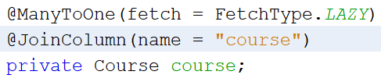
And create the opposite relationship in Course:
Again, don’t forget getters and setters – you’ll need to update constructors etc. in Student in particular.

Testing
Let’s insert some test data.
POST http://localhost:8080/degreetype
{"typename":"Bachelor of Science","shortcode":"BSc"}
{"typename":"Master of Science","shortcode":"MSc"}
{"typename":"Higher National Diploma","shortcode":"HND"}
Should give a 201 response like:
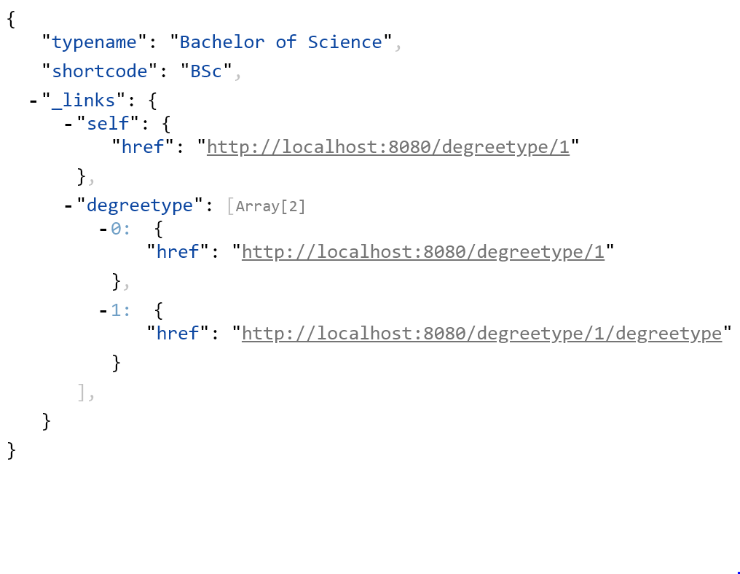

POST http://localhost:8080/coursename
{"coursename":"Web Development"}
{"coursename":"Software Engineering"}
{"coursename":"Data Science"}
POST http://localhost:8080/course
Here’s the interesting thing. When taking action which specifies a reference, we can simply link to that reference. So here, to create a course like “BSc Web Development”, we can do:
{"degreetype":"http://localhost:8080/degreetype/1/","coursename":"http://localhost:8080/coursename/1/"}
And MSc Web Development:
{"degreetype":"http://localhost:8080/degreetype/2/","coursename":"http://localhost:8080/coursename/1/"}

You can check how this is represented in the database. It is, as we’d hope and expect:
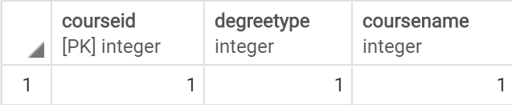
Finally, let’s POST a student.
{"name": "Fred Davies", "address": "123 Some Road", "dob": "1980-04-05", "course": "http://localhost:8080/course/1"}
And now let’s browse around a little. Firstly, let’s view the student. In this case, they were created with id 2. Navigating to /student/2 gives:
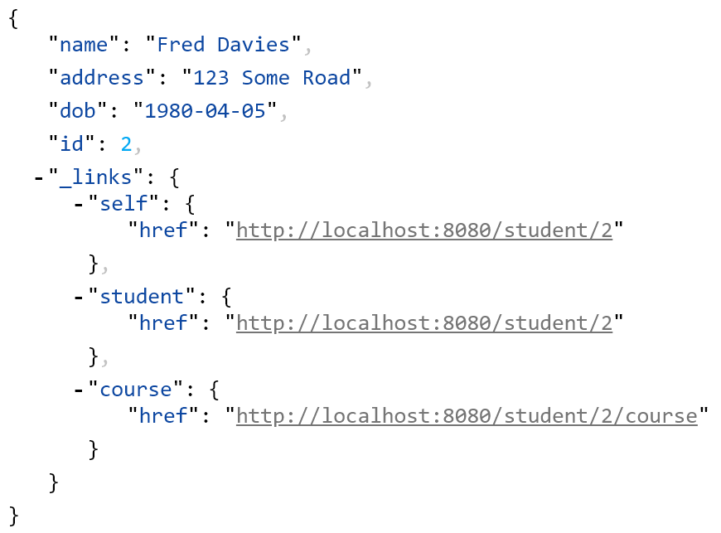
Which gives the student record and a link to their associated course record. Following this (/student/2/course) gives us:
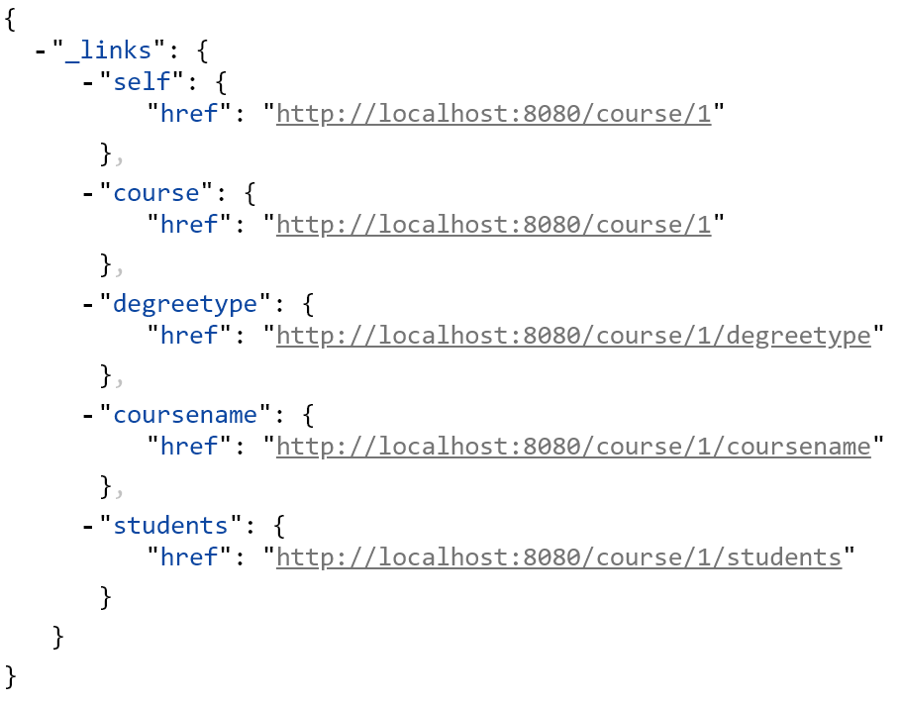
Again, we can follow the /course/1/degreetype or /course/1/coursename links to find specific information about the course.
There is, however, another way we can view this information. We can view, for example, all students who are on course 1 by navigating to /course/1/students:
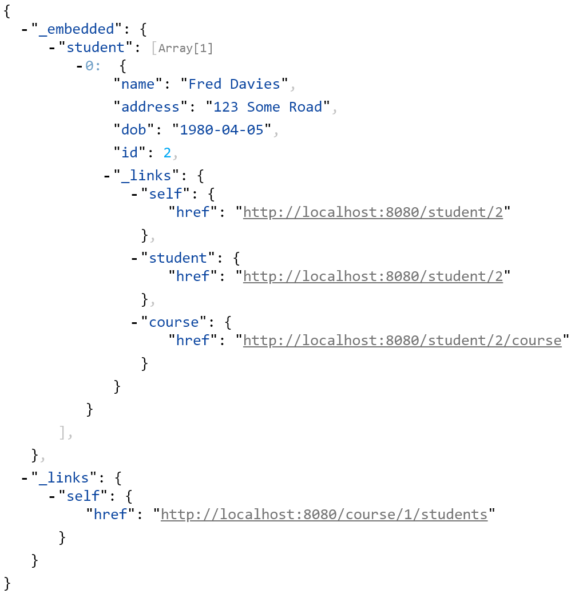
We can do this will all the 4 endpoints we have access to.
You might notice that the id field has been omitted in the marshalled json in all objects bar Student. This isn’t necessarily a problem (for now), but actually will make working with this API automatically more difficult. We’ll be doing this next week. An easy fix, however. Add a configuration class which specifies that the Id should be exposed.
public class RestConfig implements RepositoryRestConfigurer
{
@Override
public void configureRepositoryRestConfiguration(RepositoryRestConfiguration config, CorsRegistry cors)
{
config.exposeIdsFor(Coursename.class);
config.exposeIdsFor(Course.class);
config.exposeIdsFor(Degreetype.class);
config.exposeIdsFor(Student.class);
}
}

Exercise

Add functionality to represent modules, including their associated lecturers. Consider:
How many students does a module usually contain? How many modules does a student usually study? Map this information carefully to the type of relationship you specify.
Similarly, consider carefully the relationship between modules and lecturers.

Before next session…
Please read up on OpenAPI (Swagger).
You will need Swagger Codegen installed and operational. There is a brief guide for doing this on Moodle. Please ensure this is done ahead of class.

Appendix: code
This appendix contains all the code for the completed system.

Course.java
import com.fasterxml.jackson.annotation.JsonIgnoreProperties;
import jakarta.persistence.*;
import java.util.List;

@Entity
@JsonIgnoreProperties({"hibernateLazyInitializer", "handler"})
public class Course implements java.io.Serializable {

@Id
@GeneratedValue(strategy = GenerationType.IDENTITY)
private int courseid;

@ManyToOne(fetch = FetchType.LAZY)
@JoinColumn(name = "degreetype")
private Degreetype degreetype;

@ManyToOne(fetch = FetchType.LAZY)
@JoinColumn(name = "coursename")
private Coursename coursename;

@OneToMany(fetch = FetchType.LAZY, mappedBy = "course")
private List<Student> students;

public int getCourseid() {
return courseid;
}

public void setCourseid(int courseid) {
this.courseid = courseid;
}

public Degreetype getDegreetype() {
return degreetype;
}

public void setDegreetype(Degreetype degreetype) {
this.degreetype = degreetype;
}

public Coursename getCoursename() {
return coursename;
}

public void setCoursename(Coursename coursename) {
this.coursename = coursename;
}

public List<Student> getStudents() {
return students;
}

public void setStudents(List<Student> students) {
this.students = students;
}
}

CourseNameRepository.java
import org.springframework.data.repository.CrudRepository;
import org.springframework.data.rest.core.annotation.RepositoryRestResource;

@RepositoryRestResource(collectionResourceRel = "coursename", path = "coursename")
public interface CourseNameRepository extends CrudRepository<Coursename, Integer> {
}

CourseRepository.java
import org.springframework.data.repository.CrudRepository;
import org.springframework.data.repository.PagingAndSortingRepository;
import org.springframework.data.rest.core.annotation.RepositoryRestResource;

@RepositoryRestResource(collectionResourceRel = "course", path = "course")
public interface CourseRepository extends PagingAndSortingRepository<Course, Integer>, CrudRepository<Course, Integer> {
}

Coursename.java
import com.fasterxml.jackson.annotation.JsonIgnoreProperties;
import jakarta.persistence.*;

import java.util.List;

@Entity
@JsonIgnoreProperties({"hibernateLazyInitializer", "handler"})
public class Coursename implements java.io.Serializable
{
public int getCoursenameid() {
return coursenameid;
}

public void setCoursenameid(int coursenameid) {
this.coursenameid = coursenameid;
}

public String getCoursename() {
return coursename;
}

public void setCoursename(String coursename) {
this.coursename = coursename;
}

public List<Course> getCoursenames() {
return coursenames;
}

public void setCoursenames(List<Course> coursenames) {
this.coursenames = coursenames;
}

@Id
@GeneratedValue(strategy= GenerationType.IDENTITY)
private int coursenameid;
private String coursename;
@OneToMany(fetch = FetchType.LAZY, targetEntity=Course.class, mappedBy = "coursename")
private List<Course> coursenames;

}

DegreeTypeRepository.java
import org.springframework.data.repository.CrudRepository;
import org.springframework.data.rest.core.annotation.RepositoryRestResource;

@RepositoryRestResource(collectionResourceRel = "degreetype", path = "degreetype")
public interface DegreeTypeRepository extends CrudRepository<Degreetype, Integer>
{
}

Degreetype.java
import com.fasterxml.jackson.annotation.JsonIgnoreProperties;
import jakarta.persistence.*;

import java.util.List;

@Entity
@JsonIgnoreProperties({"hibernateLazyInitializer", "handler"})
public class Degreetype implements java.io.Serializable {
public int getDegreetypeid() {
return degreetypeid;
}

public void setDegreetypeid(int degreetypeid) {
this.degreetypeid = degreetypeid;
}

public String getTypename() {
return typename;
}

public void setTypename(String typename) {
this.typename = typename;
}

public String getShortcode() {
return shortcode;
}

public void setShortcode(String shortcode) {
this.shortcode = shortcode;
}

public List<Course> getDegreetype() {
return degreetype;
}

public void setDegreetype(List<Course> degreetype) {
this.degreetype = degreetype;
}

@Id
@GeneratedValue(strategy = GenerationType.IDENTITY)
private int degreetypeid;
private String typename;
private String shortcode;
@OneToMany(fetch = FetchType.LAZY, targetEntity = Course.class, mappedBy = "degreetype")
private List<Course> degreetype;
}

Student.java
import jakarta.persistence.*;
import java.time.LocalDate;

@Entity
public class Student implements java.io.Serializable
{
@Id
@GeneratedValue(strategy= GenerationType.IDENTITY)
private int studentid;
private String name;
private String address;
private LocalDate dob;
@ManyToOne(fetch = FetchType.LAZY)
@JoinColumn(name = "course")
private Course course;

public Student()
{

}

public Student(String name, String address, LocalDate dob, Course course)
{
this.name = name;
this.address = address;
this.dob = dob;
this.course = course;
}

public Student(String name, String address, String dob, Course course)
{
this(name, address, LocalDate.parse(dob), course);
}

public int getId() {
return studentid;
}

public void setId(int studentid) {
this.studentid = studentid;
}

public String getName() {
return name;
}

public void setName(String name) {
this.name = name;
}

public String getAddress() {
return address;
}

public void setAddress(String address) {
this.address = address;
}

public LocalDate getDob() {
return dob;
}

public void setDob(LocalDate dob) {
this.dob = dob;
}

public void setDob(String dob)
{
setDob(LocalDate.parse(dob));
}

public Course getCourse() {
return course;
}

public void setCourse(Course course) {
this.course = course;
}
}

StudentRepository.java
import org.springframework.data.repository.CrudRepository;
import org.springframework.data.repository.PagingAndSortingRepository;
import org.springframework.data.rest.core.annotation.RepositoryRestResource;

import java.util.List;

@RepositoryRestResource(collectionResourceRel = "student", path = "student")
public interface StudentRepository extends PagingAndSortingRepository<Student, Integer>, CrudRepository<Student, Integer> {
}

