

Student Name: Harsh Hareshkumar Barot

Student ID: 2531265

Module Name: Marketing Management

Module Code: LCMB7024

Assessment 1 : Marketing Environment analysis

Lecturer’s Name: Dr. Laila Maazouz

Work Count: 2515

Term 1

Table of Contents
1. Introduction 2
2. Task 1: Critical Evaluation of the Macro Environment of Marketing 3
2.1 Macro Marketing Environment 3
2.2 Assessment of the Macro Factor 1: Technological Environment 4
2.2.1 Impact posed on the pioneer company 4
2.2.2 Impact created on the follower organisation 5
2.3 Analysis of the Macro Factor 2: Socio-Cultural Environment 7
2.3.1 Influence on the pioneer firm 7
2.3.2 Influence on the firm that is the follower 8
3. Task 2: Strategic Responses provided by the Follower and the Pioneer organisations 9
3.1 Highlighting the strategic responses of the Pioneering Organisation 9
3.2 Strategic responses provided by the follower company 10
4. Conclusion 12
References 13
Appendices 15

1. Introduction
This report seeks to address the purpose of analysing the aspects of strategic marketing involving the rapid interpretations and capabilities of effective responses by the organisations regarding the external forces. Moreover, this report emphasises the importance of organisational responses to market forces in ensuring long-term growth and competitive positioning. In this regard, the global fashion industry is characterised by rapid digitalisation, cycles of industry trends, and increased sustainability requirements. The global apparel market size in 2025 was estimated at USD 1.84 trillion, which is expected to grow by 2033 to USD 2.54 trillion (Grandviewresearch, 2026).
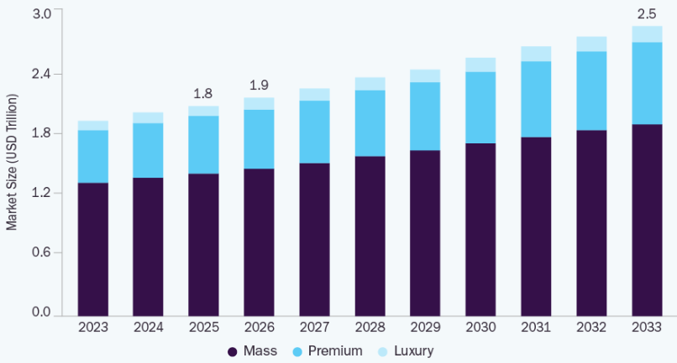
Figure 1: Global Apparel Market Size
(Source: Grandviewresearch, 2026)
This reflects that the global fashion industry has been rapidly evolving following the high demand within the market. Furthermore, the rise of the fashion industry was driven by the increased consciousness regarding fashion, coupled with the mass production transitions, along with the changing behaviour of the consumers. Therefore, in effectively assessing these patterns and trends within the market of the fashion sector, the macro environmental analysis remains critical. Consequently, this report also conducts a critical evaluation regarding the macro environment which is affecting the business processes of Dior, a brand pioneering in the luxury segments and Shein, a follower that operates through fast fashion. Moreover, the structure of this report involves the evaluation of technological and socio-cultural forces creating challenges and opportunities for these aforementioned organisations. In addition to this, the analysis of these market forces in exposing vulnerabilities and fostering competitiveness is thereby considered as the scope of this report.

2. Task 1: Critical Evaluation of the Macro Environment of Marketing

2.1 Macro Marketing Environment
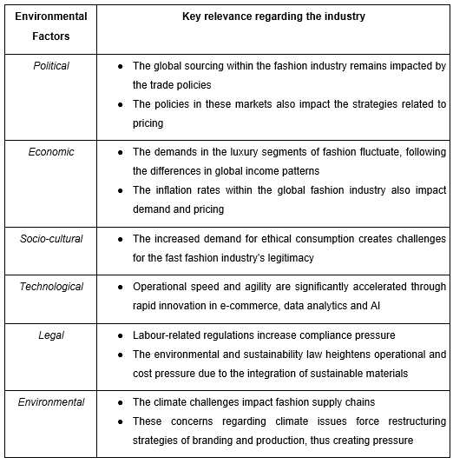
Figure 2: PESTLE Analysis
(Source: Refer to Appendix 1)
The analysis of the PESTLE framework has provided a structural lens to effectively assess the macro-environmental forces in the fashion industry, which shape the strategic decisions regarding marketing. Due to the direct influence on value creation and value perception, the technological and socio-cultural factors within the fashion industry are considered strategically significant. The fashion industry is able to evolve into a positive force of change and contribute to a more environmentally friendly global landscape by fostering conscious consumption, embracing sustainability and promoting fair labour practices. Moreover, in the fashion industry, digitalisation boosts the infrastructure, which is robust, innovative, real-time and sustainable, and tailors to the concerns of customers regarding flexibility and reliability within a sustainable process (Akram et al., 2022). The operational speed, scalability and data-driven analytics and responsiveness are determined by the technological factors, while the socio-cultural factors significantly impact the overall customer demands regarding sustainability and ethical aspects. These external forces act as a cultural shift that redefines competitive edge and creates opportunities as well as threats for the firms operating within this industry. In essence, the firm needs to incorporate adaptability in responding to the market failure within the highly polarised landscape of the industry to remain competitive.

2.2 Assessment of the Macro Factor 1: Technological Environment

2.2.1 Impact posed on the pioneer company
In the case of Dior as a pioneer company, technological advancements offer strategic opportunities while luxury branding creates constraints. The global luxury fashion market was valued at USD 261.0 billion in 2025, which is expected to grow by 2034 to USD 341.0 billion, driven by e-commerce, personalisation and exclusivity (Imarcgroup, 2026).
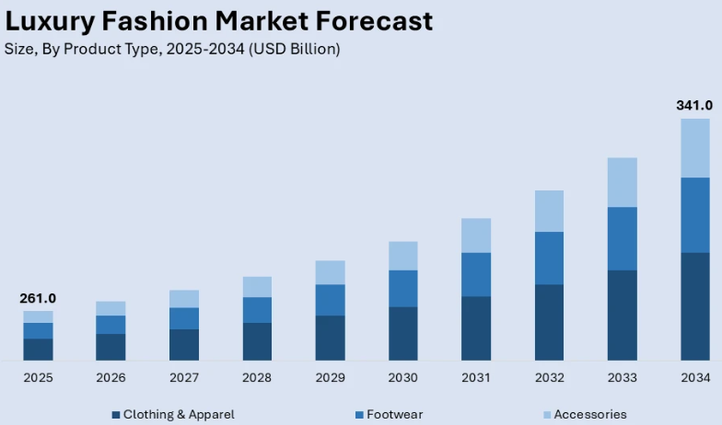
Figure 3: Luxury fashion market growth
(Source: Imarcgroup, 2026)
In correlation to this, the integration of digital platforms, including e-commerce, artificial intelligence and data analytics ensure global expansion of the brand, depicting online luxury consumption growth. Dior boutique integrated augmented reality (AR), which led to sustained interest of customers and increased involvement by offering storytelling and seamlessly intertwined connections to past and future, which increased interaction with the customers (Marques, 2025). This has reinforced differentiation for the company while strengthening customer satisfaction, thus enhancing market position within the fashion sector. However, the increased accessibility to these technologies creates a risk of eroding exclusivity, which is known to be the core driver within the luxury fashion segment. Furthermore, the implications for ensuring competitive advantage for Dior involve the suggestion to selectively adopt technology as the technological strategy of this firm offers restraint yet limits responsiveness.

2.2.2 Impact created on the follower organisation
The follower organisation, Shein, utilises the technological environment as a dominant opportunity which forms the foundation of its competitive strategy, thereby accelerating business growth. The global AI in fashion market size was expected to rise by USD 60.57 billion by 2034 from 2025 due to the growing demand for supply chain management (Precedenceresearch, 2026).
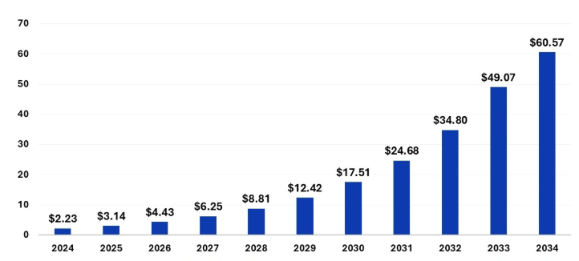
Figure 4: AI in Fashion
(Source: Precedenceresearch, 2026)
Therefore, AI-driven analytics and agile supply chains within the fashion industry enable rapid cycles of production within the company Shein. Additionally, this facilitates direct cause-and-effect dynamics regarding speed driven by the technological capabilities, which ensures a stable market position. The estimated market share of Shein in 2024 increased to 1.53% in the global apparel segment, which was driven by its ability to quickly react to fast fashion trends and its ultra-low price (Statista, 2026).
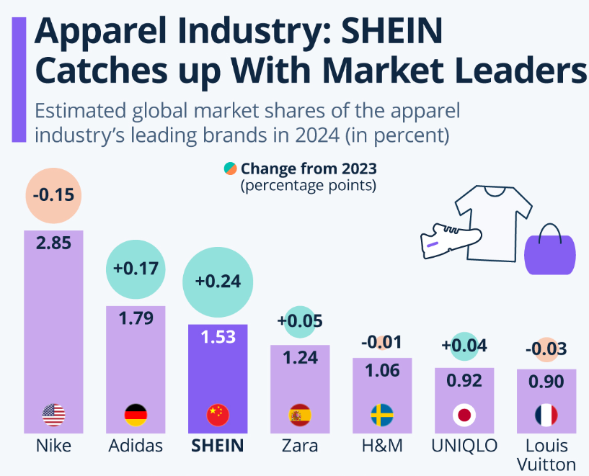
Figure 5: Shein’s Growth
(Source: Statista, 2026)
However, this technological dependence introduced a systemic threat following the increased risks regarding overproduction and reputational exposure. The ability to identify market trends effectively demonstrates the high operational adaptability of Shein, while rapid technological dependence reflects strategic vulnerability. Moreover, the implication for its market position reflects a highly competitive and unstable advantage for Shein, which requires technological leadership.

2.3 Analysis of the Macro Factor 2: Socio-Cultural Environment

2.3.1 Influence on the pioneer firm
The socio-cultural shift towards sustainability within the fashion industry illustrates a considerable opportunity for Dior due to the increased favour of consumers towards responsible consumption. It has been identified that the customers within the fashion industry have been showcasing heightened desire for more conscious and sustainably-driven alternatives following the growing concerns of ethical and ecological impact of purchasing clothes (Bumin and Bumin, 2024). This thereby reflects a shift among the customers towards value-driven purchasing rather than a status-driven pattern, which reinforces durability and craftsmanship within Dior, aligned with its business model.
Dior underscores the commitment to environmental responsibility by prioritising natural ingredients by 2030 within 80% of its products, which will comprise 90% of natural materials (Weiler, 2024). This environmental stewardship towards its consumers strengthened its position and enhanced brand legitimacy following the alignment with ethical industry requirements. Despite these abilities, the heightened scrutiny demands expose the firm towards threats within the socio-cultural environment of the competitive fashion sector. The competitive advantage implications remain conditional for Dior, as its socio-cultural alignment poses benefits yet requires authenticity in practices. Consequently, Dior requires continuous adaptation to sustain a premium position in the fashion market, as these trends in the market significantly shift the differentiation strategy.

2.3.2 Influence on the firm that is the follower
In the case of Shein, the socio-cultural transformation primarily hints toward a structural threat within the firm. Increased awareness of consumers regarding the ethical and environmental issues created by the fast fashion business model reflects challenges in this sector. The fast fashion industry remains responsible for 10% of global annual carbon footprint and consumes vast amounts of natural resources, including an annual 141 billion cubic meters of water (Refer to Appendix 2). This increases criticism for Shein regarding its high operational footprints and consumption of resources within its fast fashion business model. The excessive style at Shein has led to damaging environmental consequences, which reflect that overproduction within this company demonstrates its lack of sustainability (Tosun, 2025). Therefore, this posits a negative perception of customers towards the brand, which reduces trust, thus gradually reducing brand equity. Moreover, the increasing importance of the ethical requirements within the fashion industry in this segment points out challenges for Shein despite its ability to serve cost-effective customers. The comparative vulnerability and adaptability within Shein depict limited ability of adaptation, whereas the implications for its market position demonstrate erosion of brand legitimacy and socio-cultural constraint.

3. Task 2: Strategic Responses provided by the Follower and the Pioneer organisations

3.1 Highlighting the strategic responses of the Pioneering Organisation
The pioneering organisation Dior and the strategic responses of this firm are critically interpreted by the implementation of Porter’s Generic Strategies, which allows businesses to achieve sustainable competitive advantages. Moreover, this framework reflects three fundamental approaches, which involve differentiation, cost leadership and focus, which guide the process of ensuring competitive edge for a firm. The strategies provided by Porter allow the organisations to create a structure which ensures a high competitive advantage, which ultimately supports organisational growth (Acar, 2024). This model emphasises that Dior sustains its differentiation strategy through the effective integration of the requirements within socio-cultural and technological aspects. The company reinforces exclusivity through controlled innovation and the selective integration of technologies, including e-commerce and AI. Dior has reported an 85% reduction in shipping control time by partnering with Hardis Supply Chain, which integrates AI to create innovation and accelerate operations (Technologymagazine, 2026). This reflects the strategic choice of this firm in enhancing brand value without causing symbolic dilution, thus reflecting a response to the challenges within Task 1. Additionally, Prada, a fashion brand, has implemented Adobe’s AI and Adobe Sensei with the help of its internal data security team to deliver high-quality content by gaining richer customer insights (Pradagroup, 2026). This thereby reflects that operational exclusivity is reinforced by the effective and selective integration of technologies, which positively influences brand value.
On the other hand, based on the socio-cultural aspects, the increasing emphasis of Dior regarding sustainability and responsible sourcing patterns denotes alignment with shifting consumer patterns. In this regard, Dior has initiated the goal of attaining 100% certified strategic raw materials by 2026, in comparison to its 81% organic materials in 2024, which will strengthen responsibility and sustainability within its supply chain (Dior, 2026). This response represented a deliberate repositioning of the fashion luxury segment towards a more ethical and sustainable approach, which demonstrates the capacity of Dior in translating the external pressure into a competitive advantage. In accordance with this, a luxury fashion brand, Chanel, has also prioritised the aim of achieving carbon neutrality by 2030 following the rising demand of consumers towards environmental accountability (Chau and Rangaraju, 2023). From a critical context, the approach of Dior conveys that differentiation is anchored in value congruence rather than solely focusing on aesthetics regarding societal concerns. Furthermore, the differentiation strategy imposed by Dior also involves some constraints despite the substantial opportunities. The high cost structure associated with balancing innovation, craftsmanship and ethical requirements creates pressure on the reduced margins of Dior during the economically volatile situation. Additionally, the selective digital integration further increases the risk of under-engagement with the digital native consumers of this company. Regardless of these limitations, the ability of this organisation in terms of strategic coherence in prioritising brand equity over operational efficiency allows it to transform the external challenges within the mechanism of long-term competitive advantage.

3.2 Strategic responses provided by the follower company
In terms of analysing the strategic trajectory of the follower company Shein, the Ansoff Matrix is implemented, which provides a structured approach to aligning business objectives with growth directions. The model illustrates four strategies for organisation growth within a market, which involve market penetration, diversification, product development and market development. For the ability to recognise a balance within the organisational realities along with the strategic goals, the Ansoff Matrix remains adaptable across different situations (Qomaro et al., 2024). By implementing this model, it has been identified that Shein incorporated an aggressive low-cost business expansion model within the opportunities provided by the technological factors in the fashion industry. The dominant business approach of Shein, including the utilisation of ultra-low pricing along with the algorithm-driven product personalisation, enables it to capture wide market demand, which aligns with market penetration. The low-priced strategy of Shein has enabled it to attract price-sensitive customers while exposing the worries associated with product durability and quality (YAN et al., 2025). Additionally, the capability of rapid product development following the integration of real-time data analytics also allows the integration of trend-responsive product designs, which exploits the technological advantages illustrated in Task 1. Similar to Shein, Temu also intensively integrates AI in the case of personalisation, content generation and systems of recommendation in terms of remaining competitive within the discount-driven fast-fashion market (Papastamoulou and Antonopoulos, 2025).
Furthermore, the extensive market development strategy of Shein, including the expansion within Western countries, demonstrates its ability to rapidly scale. The technology-driven model of Shein has allowed it to expand its reach towards different audiences across the market and reshaped expectations of consumers through enhancing accessibility to fashion (Qu, 2024). This reveals enhanced accessibility and operational flexibility of Shein, which brings forth short-term competitiveness while also reflecting the critical imbalance between sustainability and business growth. Moreover, in effectively responding to the socio-cultural pressures within the fashion industry, the company has integrated incremental adjustments, including sustainability messaging and limited initiatives regarding transparency. Shein has announced its commitment towards reducing environmental footprint by working with its suppliers and operational teams who prioritised the transition of 31% used polyester to recycled polyester within its SHEIN-branded products by 2030 (Sheingroup, 2026).
However, these efforts remained peripheral as it failed to address the structural contradictions within the ethical consumption practices and strategic requirements of the fast fashion segment. Similarly, Boohoo, a fast fashion company, has also made efforts regarding the replacement of virgin polyester, while these efforts have remained insufficient in creating any meaningful impact (Cousins, 2025). Moreover, despite the sustained business growth, the model of Shein demonstrates a lack of ethical conduct, which requires alignment with the evolving customer needs. As per a critical perspective, the Ansoff-oriented growth of the organisation reveals reputational and operational risk despite the increase in market share. Thereafter, the evaluation reflects that competitive advantage remains contingent upon the ability to ensure speed and cost effectiveness, which makes this fragile under the situation of regulatory and socio-cultural shift.

4. Conclusion
The critical analysis conducted within this report points out that the technology, along with the socio-cultural forces within the business market of the fashion industry, creates uneven yet decisive opportunities and threats. Moreover, these external factors within the fashion market have been fundamentally reshaping the market position and competitive advantage of the previously considered organisations, Shein and Dior. The technological advancements provide an opportunity to increase organisational reach and efficiency, while the strategic value of this factor varies depending on the ability of the firm to align technology with its core positioning. In addition to this, the socio-cultural factors provided the organisations with the capability to effectively tailor to customer needs, thus accelerating business value while requiring the capability of balancing long-term operational agility with environmental compliance. The selective adaptability of Dior allows it to sustain differentiation, while the technology-driven model of Shein enables the organisation to ensure high adaptability, yet showcases structural vulnerability to socio-cultural issues. Furthermore, the findings of this report highlight that a coherent strategic response remains essential in terms of complementing the effective environmental scanning. Moreover, by integrating these external forces within a contextually aligned and resilient business model, long-term competitiveness may be achieved.

References
Acar, S., 2024. A review of Porter’s generic strategies: Strategy examples in international firms. International Social Sciences Studies Journal, 10(11), pp.1902-1918.
Akram, S.V., Malik, P.K., Singh, R., Gehlot, A., Juyal, A., Ghafoor, K.Z. and Shrestha, S., 2022. Implementation of digitalized technologies for fashion industry 4.0: Opportunities and challenges. Scientific Programming, 2022(1), p.7523246.
Bumin, Z. and Bumin, M., 2024. Analysis of consumer preferences in sustainable fashion consumption. Journal of Innovations and Sustainability, 8(3), pp.01-01.
Chau, N. and Rangaraju, S., 2023. Strategic Management and Competitive Analysis of Chanel. Business and Technology, 2(20233).
Cousins, C., 2025. Sustainable Product Development in the UK Fast Fashion Supply Chain: Exploring Solutions for a Sustainable Fashion Industry (Doctoral dissertation, Manchester Metropolitan University).
Dior, 2026 https://www.dior.com/en_in/fashion/news-savoir-faire/folder-news-and-events/environment.
Grandviewresearch, 2026 Apparel Market Size, Share & Growth Analysis Report, 2030, www.grandviewresearch.com. Available at: https://www.grandviewresearch.com/industry-analysis/apparel-market-report.
Imarcgroup, 2026 www.imarcgroup.com. Available at: https://www.imarcgroup.com/luxury-fashion-market.
Marques, A.L., 2025. Beyond haute couture: the impact of storytelling and augmented reality in luxury experiential retail. Understanding consumer experience and consumer valuations through the sequential mediating effects of emotional curiosity and flow state within store atmospherics of luxury fashion brands.
Papastamoulou, P. and Antonopoulos, N., 2025. Artificial Intelligence in E-Commerce: A Comparative Analysis of Best Practices Across Leading Platforms. Systems, 13(9), p.746.
Pradagroup, 2026 PradaGroup. Available at: https://www.pradagroup.com/en/news-media/news-section/prada-group-expands-collaboration-with-adobe.html.
Precedenceresearch, 2026 AI in Fashion Market Size to Hit USD 49.07 Billion by 2033, www.precedenceresearch.com. Available at: https://www.precedenceresearch.com/ai-in-fashion-market.
Qomaro, G.W., Nasrulloh, N. and Salleh, A.Z., 2024. Leveraging The Ansoff Matrix for Strategic Growth in Packaged Food Micro-Enterprises. Dinar: Jurnal Ekonomi dan Keuangan Islam, 11(1), pp.51-66.
Qu, Z., 2024. The rise of SHEIN: navigating the digital era of fast fashion and its comprehensive impacts. Advances in Economics Management and Political Sciences, 76(1), pp.248-254.
Sheingroup, 2026 Our Impact - SHEIN Group, SHEIN Group. Available at: https://www.sheingroup.com/our-impact/#planet.
Statista, 2026 Infographic: Apparel Industry: SHEIN Catches up With Market Leaders, Statista Daily Data. Statista. Available at: https://www.statista.com/chart/35441/leading-brands-global-apparel-industry-by-market-share/?srsltid=AfmBOoog_Q6NSqV6Q9U89xHgpzS9Q8dtSvt6qVJHXqQ4i284FdkhO-eT (Accessed: 26 March 2026).
Technologymagazine, 2026 Dior Uses AI & Data Capture to Transform Warehouse Logistics, Technologymagazine.com. Bizclik Media Ltd. Available at: https://technologymagazine.com/news/dior-uses-ai-data-capture-to-transform-warehouse-logistics.
Tosun, Z., Sustainability: Dior vs. Shein.
Weiler, S., 2024. How can storytelling with sustainability claims benefits the luxury industry?.
YAN, F.N., LIU, Z.C., ZHEN, L.W., ERIC, C.H.M., CHENG, H.T. and LAN, Y.Y., SHEIN.

Appendices
Appendix 1
Environmental Factors | Key relevance regarding the industry
Political | - The global sourcing within the fashion industry remains impacted by the trade policies  - The policies in these markets also impact the strategies related to pricing
Economic | - The demands in the luxury segments of fashion fluctuate, following the differences in global income patterns  - The inflation rates within the global fashion industry also impact demand and pricing
Socio-cultural | - The increased demand for ethical consumption creates challenges for the fast fashion industry's legitimacy
Technological | - Operational speed and agility are significantly accelerated through rapid innovation in e-commerce, data analytics and AI
Legal | - Labour-related regulations increase compliance pressure  - The environmental and sustainability law heightens operational and cost pressure due to the integration of sustainable materials
Environmental | - The climate challenges impact fashion supply chains  - These concerns regarding climate issues force restructuring strategies of branding and production, thus creating pressure

Appendix 2
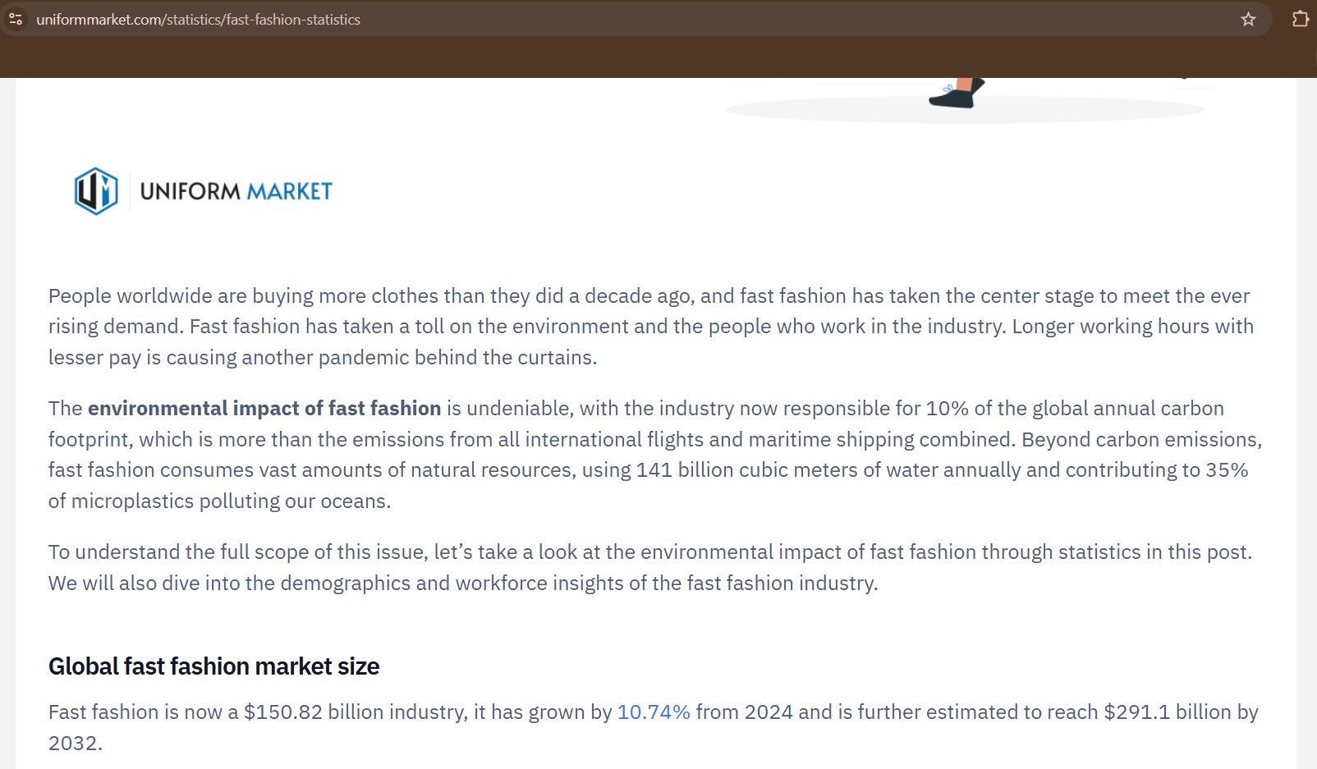
https://www.uniformmarket.com/statistics/fast-fashion-statistics

