Contents Page

- Contents
- Six Sigma
- Six Sigma
- Aston Martin Problem solving example
- Aston Martin Problem solving example
- Aston Martin Problem solving example
- Lean Manufacturing
- Lean Manufacturing
- References

Process Improvement Methodologies

Six Sigma
Six Sigma is a vital tool when problem solving and improving business goals. This tool is mainly used to quantify process improvements as and where applicable. It is widely used throughout various industries to ensure that any problem that is identified, is dealt with in the correct manner and an appropriate and replicable solution is achieved and applied.
When referring to Six Sigma, it is widely referred to as DMAIC or the updated version DMAIC R. this stands for: Define Measure Analyse Improve Control (Replicate).
Define:
This is the first step and most vital when trying to problem solve and trying to ensure the correct aspects of an issue are identified. This is the step where actions such as process walks are carried out to identify what the issue actually is and where this is occurring.
Measure:
This is where the process/problem has its performance measured against a standard. This step helps to define the scale of the issue in question and how to prioritise activities to solve. The measure step also allows the team carrying out the problem-solving activity to focus on what the “Customer” of this issue is receiving and whether it meets the required standard.
Analyse:
During the analyse step, the project team will define and analyse the issue raised. This is also where the root cause will be defined. In this step it is vital for the project team to resist jumping to conclusions and ensure an accurate and defined root case is identified. Without correct and in-depth analysis, an appropriate solution cannot be manufactured. This is where in most cases a problem-solving activity can go wrong. This is due to the wrong solution or non-robust solution being implemented, this can potentially waste a large amount of team resources such as time, material and can potentially cause entirely new issues.
Improve:
This is where the project team will establish a robust and effective improvement to the process that meets all specified criteria. By implementing improvements, it’s subsequently solving the issue initially raised the project team. The project team will have carried out extensive research into developing a solution that is completely fit for purpose having a positive impact on the process where the issue is occurring. The project team before implementing permanent corrective action, will brainstorm ideas, then refine and develop the chosen ideas(s)/solution(s). Once the team has finalised and fully developed the appropriate solution, they will run a trial implementation period. During this period a team member will be present at the process and or implementation station monitoring what has been changed and recording data in an appropriate form to show visually the improvement that has been made whether it’s a time/cost saving or waste saving improvement.

Control:
At this stage the improvement has been implemented. The trial has been carried out and was successful. The project team will then continue to monitor and identify further changes to ensure a consistent improvement rate is achieved. The team will identify further ways to track to them improvement over a longer period of time to ensure that the adjustments made to the process are still robust and effective as an improvement.
Replicate:
This is an additional stage to the standard practice of DMAIC. This step is mainly to ensure that all of the previous steps are fulfilled correctly. It also validates all investigation work within the previous steps carried out and ensures that no vital components to the process improvements have been missed. Using information recorded in the control step of the process improvement, this will highlight whether the improvements that have been implemented are able to be repeated on a continuous cycle basis.
Behind the acronym DMAIC R, there are specific questions that need to be asked at each step to begin to solve the problem/issue in question. These are:
Define: What actually is the problem/issue in question?
Measure: Where is the process compared to the set standard?
Analyse: What is causing the issue identified?
Improve: What can be done to improve current condition or eliminate the issue?
Control: How can the identified improvements be applied and kept?
Replicate: Is the solution able to be replicated on a continuous cycle basis?

*PLEASE SEE ATTACHED PROBLEM SOLVING ACTIVITY CARRIED OUT AT ASTON MARTIN USING THE ABOVE PRINCIPLES*

Problem solving title key.
Red – Define and Measure
Orange - Analyse
Yellow - Improve
Green - Control and Replicate

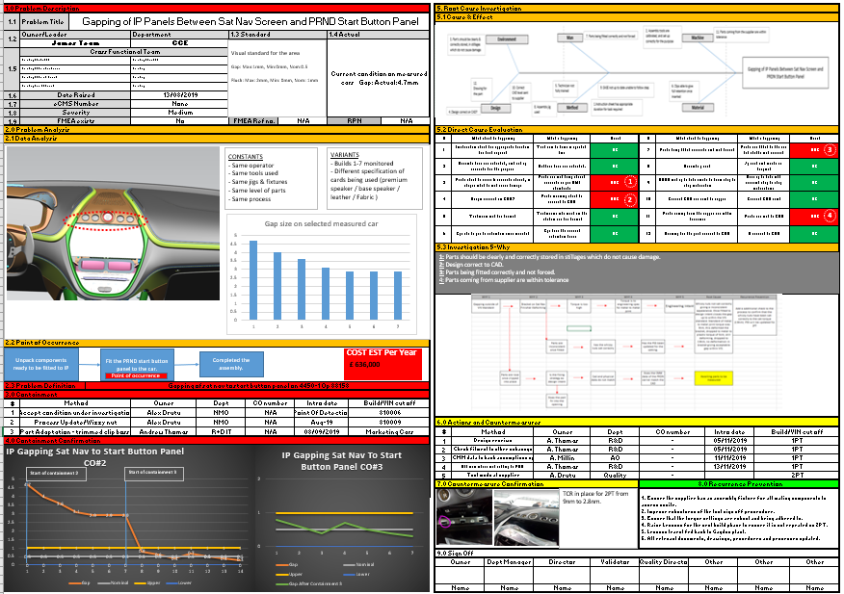
Red – Define and Measure
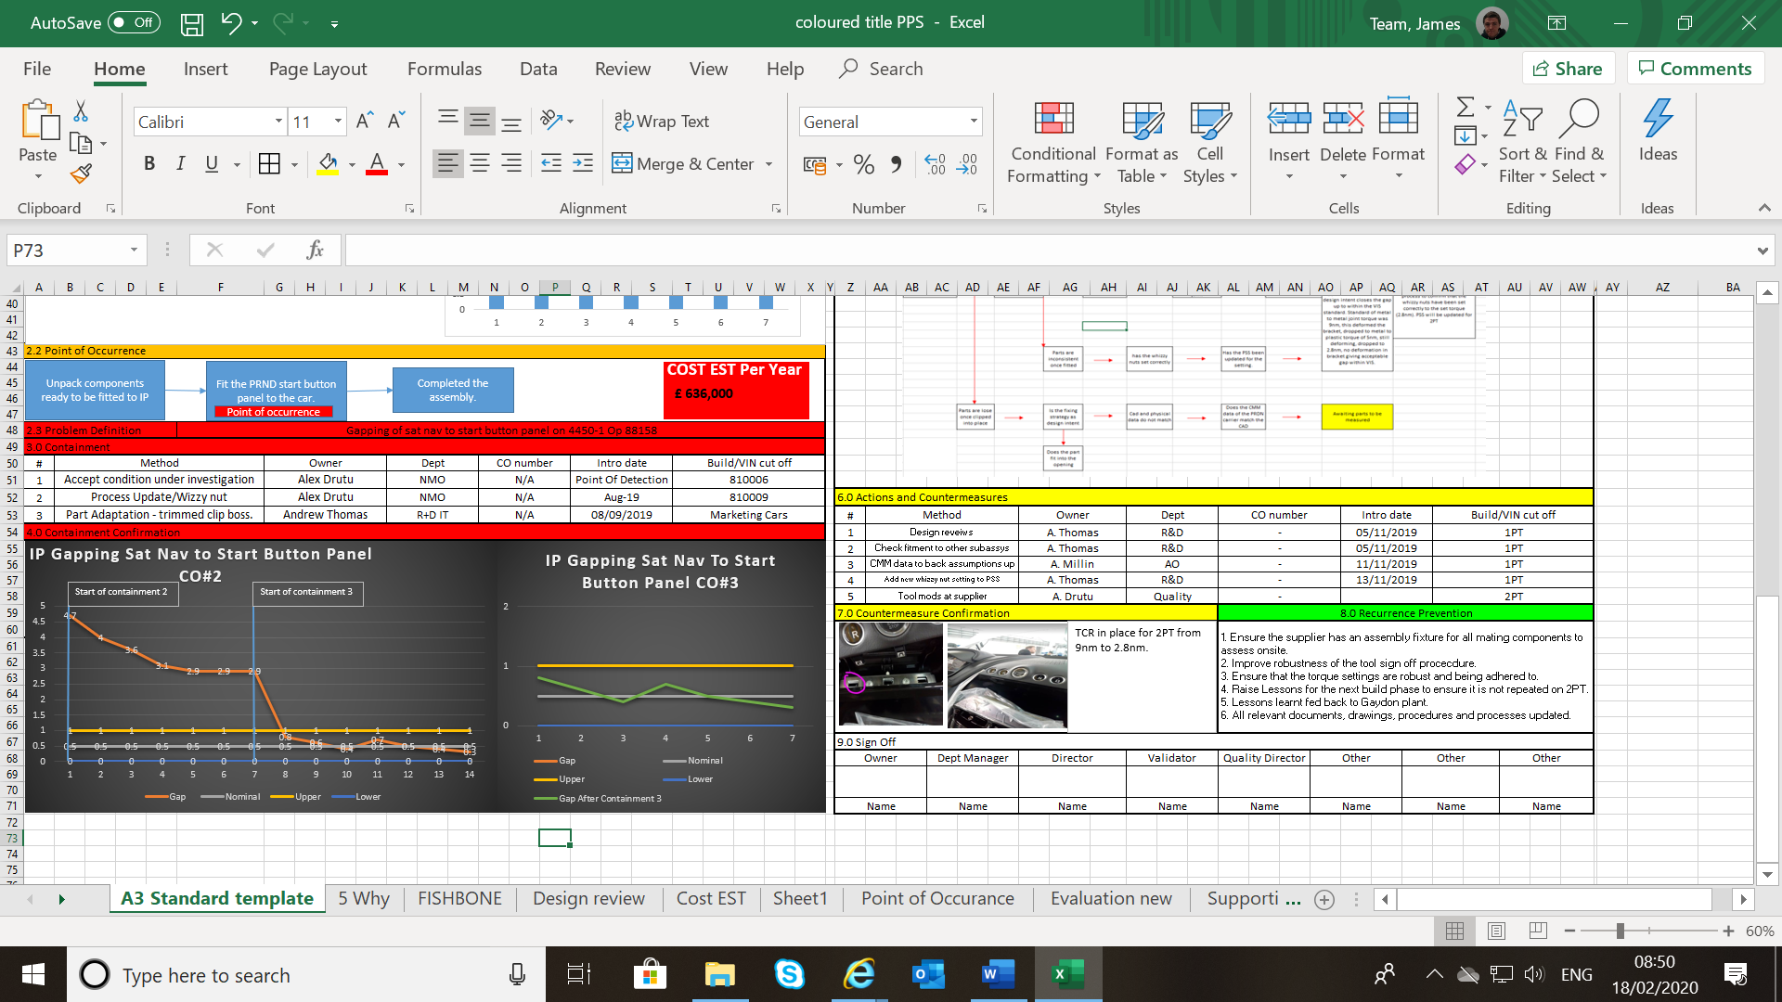
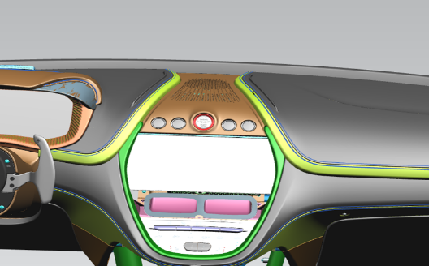
In my Aston Martin problem solving activity shown above the red highlighted titles are where I have defined and measured the problem. So, in this example the defined problem was a gapping issue between the PRND panel and sat nav screen. And to define the scale of the issue, I used measurement tools such as Vernier callipers and feeler gauges to ensure accurate measurements were obtained. Once measurements were obtained, I added the to the “standard” and “actual” boxes. This gave a clearer scale of the issue.
Once the containments were initially implemented to the process, I created the graphs seen on the bottom left of the example, this was showing initial results, the results after the containment implementation, then final results after process updates. The use of graphs showing results for each stage of the problem solving gives a much clearer visual of progress.
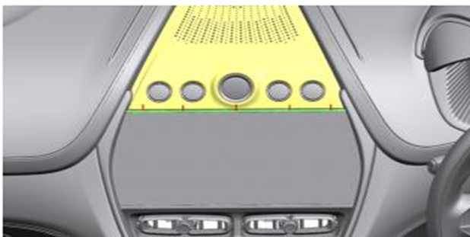
Orange – Analyse
During this stage of the problem-solving activity, I analysed the data from my measurements to see if there was an initial trend in the gap. From taking measurements at the same 5 points across a sample of same specification vehicles, I was able to get an average gap across the measurement points.
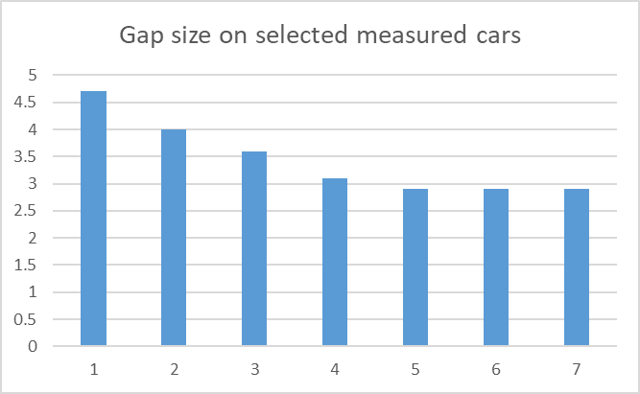
From this data I was able to show that there was a consistent gap on one side of the panel when fitted.
Once I obtained this data I started to go into the RCA (Root Cause Analysis) aspect of the problem-solving activity. I initially looked into the standard areas of investigation to create a Fishbone diagram (Ishikawa). These are Man, Method, Material, Machine, Environment and Design.

Yellow – Improve
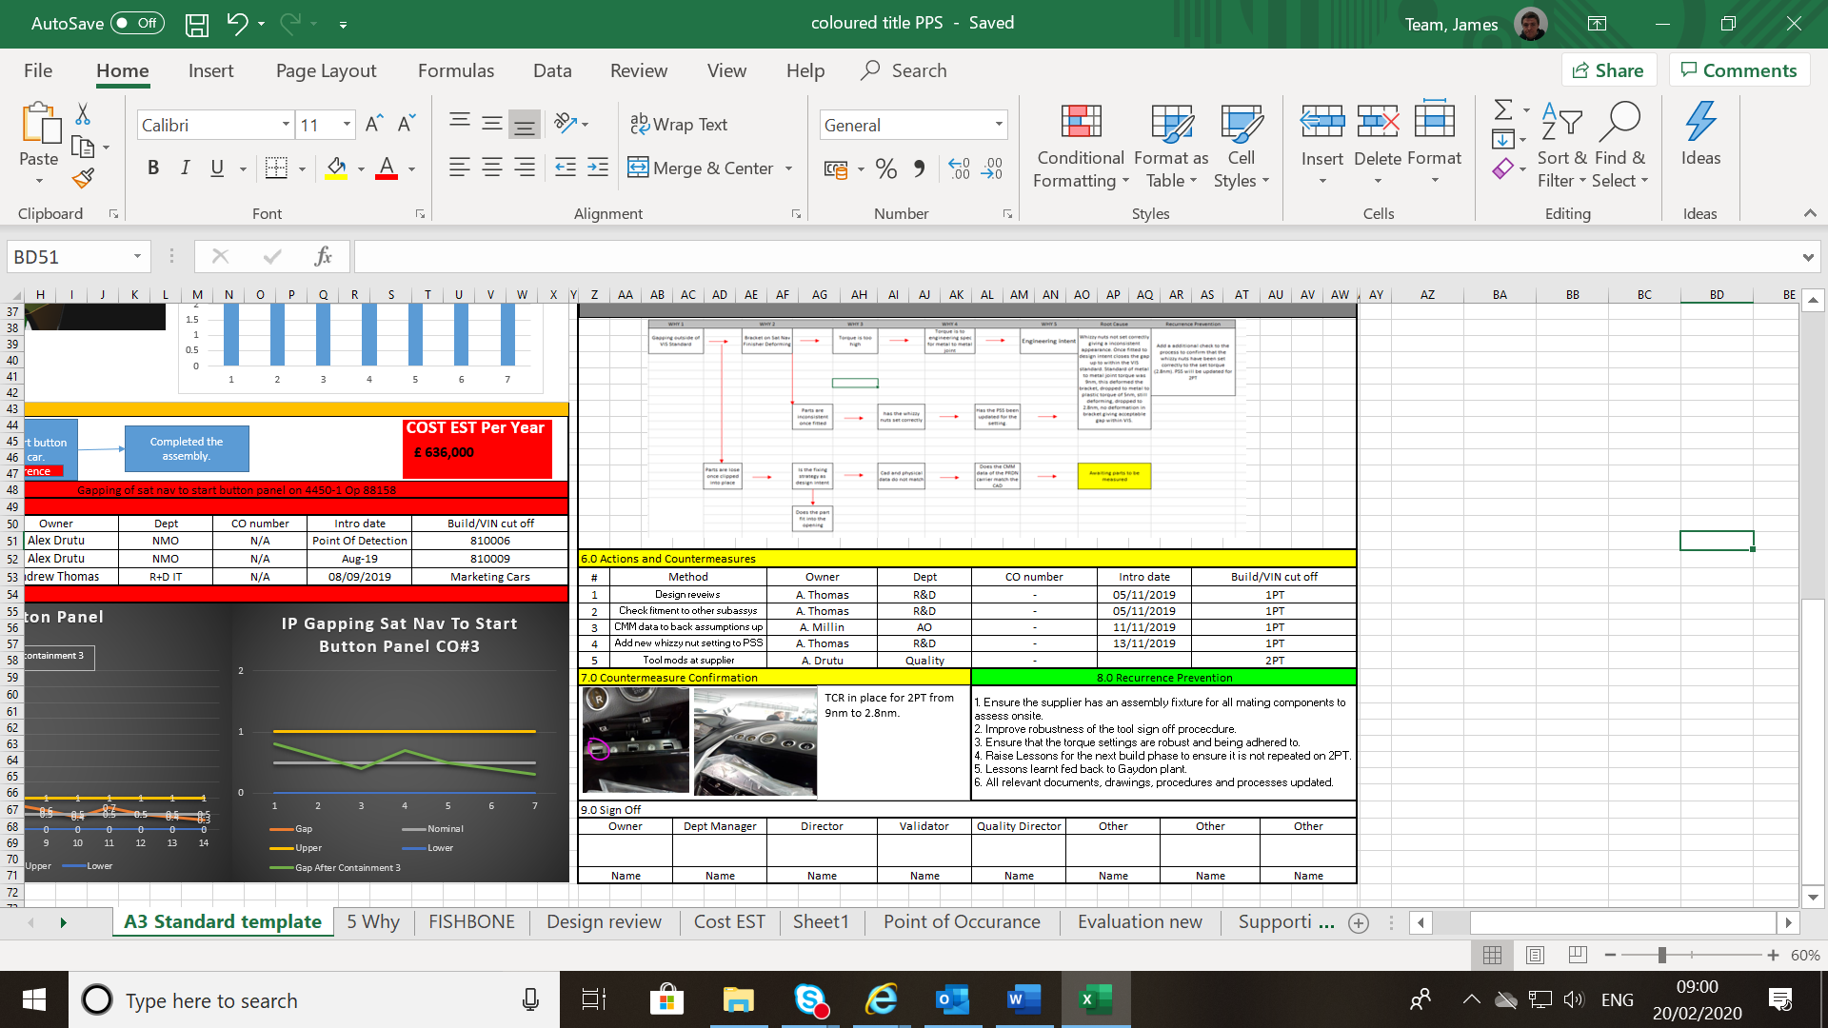
After defining appropriate areas to improve via my Ishikawa I moved on the improvement stage. In this stage I was able to identify appropriate actions to contain current build and improve the process. The improvements to the process after investigation I made, were to comply with current build time given per cycle and have minimal to no impact with current cycle process as apart from this issue the build process in terms of assembly was robust and working to satisfy current standards. ** TCR = Torque Change Request**.
Green - Control and Replicate
In the final stage of the problem-solving process I refined the process where necessary and ran a trial to ensure the corrective action was appropriate and effective, but most importantly solving the issue. Once the trial was conducted and the corrective actions that were implemented were proven to work, I made the list found opposite to take away findings from this activity, ensure the issue remained controlled and was replicable.
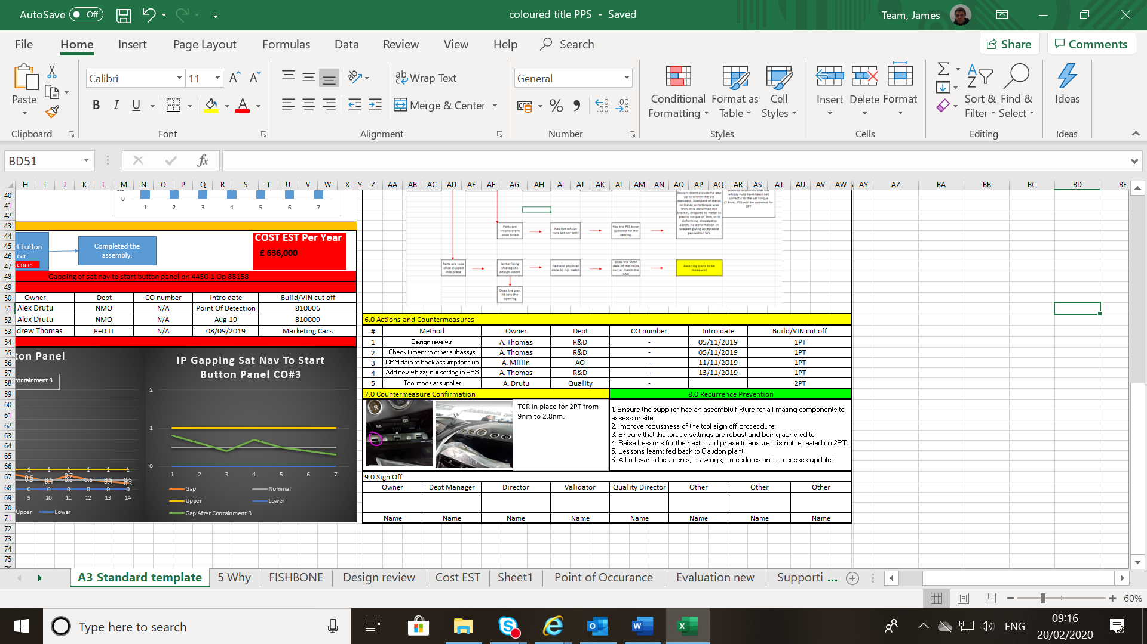

Lean Methodologies

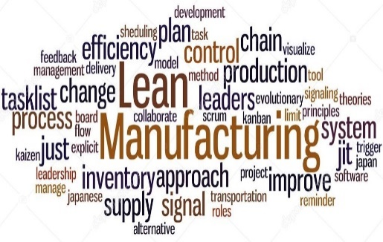
When referencing the term “Lean”, it is commonly understood as an item or process with minimal waste to ensure the item and or process is as efficient as possible as well as being as cost effective.
Lean manufaturing is made up of 7 wastes, or the 7 Mudas. These are:
Fig1
- Overproduction – this is where a product is produced above a given target that is required. This product is then waiting to be processed further or shipped. When over production is in place it has a massive knock on effect to the rest of the process and can significantly increase any of the other 6 Wastes.
- Waiting - This is where a product and or technician is not being utilised to the greatest efficency possible. It is where a process or technician is waiting to progress further in the build process. For example if a technician does not have the correct supply of parts to fullfill his process then they will be waiting until sufficient parts are delivied. This could be down to another of the wastes such as transport.
- Transportation - This waste is where a part, shipment or technician has unnecessary movement or requirements outside of their process time. For example a technician has just finished a single process cycle, between cycles they must return a part/tool to an alternative location and then return to carry out the next cycle. This would be classed as transportation waste. Each process should only have the absolute necessities to carry out that specific station’s process.
- Over Processing - This is where a a target or requirement is not possible to be met. For example a finished part has a specific VIS (Visual Inspection Standard) if this set standard has unrealistic ecpectations and requirements, it can delay the next process significantly if the part has to return to previous stations for rework. This again has a massive influence on the other wastes described.
- Inventory – This waste is where there is unnecessary materials to carry out a process or a process that is excess to requirement that may be partially or completely finished. This could also be parts/assemblies that are in WIP (Work In Progress) that are not value adding to the business. These could also be parts that a customer has not purchased which holds up potentially vital business funds, unless of coure the customer has a pre paid order.
- Motion – This is where a technician would be moving or operating with unnecessary movement during the process they are carrying out. By doing this it can have a negative impact on cycle times within their operating facility potentiall causing major impacts such as hightened costs and other unnecessary wases during their process. A combat to this would be ensuring that all vital equipment, tools and material are shadowboarded within a reasonable operating area which is easily accessable. This way excess motion is minimised and 5S standards for that area are still adhred to.
- Rework – This form of waste is extremly common within areas of manufacturing that have very high expectations and working standards. This has a chain reaction. By having sub standard parts supplied to a manufacturing facility it has a massive negative impact on the rest of the processes invoved with that product. Any sub standard part supplied then requires rework at some level. This requires more raw material and taking technicians out of regular process activity or hiring a rework team specifically to undertake sub standard parts. There is always potential for this process of watse to be repeated, depending on how thorough and to what standard the rework is completed to.
Examples in my workplace

Overproduction – Currently in my place of work, we are building our third phase prototypes of the DBX model. In certain areas such as tubs (Chassis build) we are +4 loaded into production compared to the required plan. This is overproduction and has raw material waiting in various areas of the facility for the rest of the plant to reach this stage in the plan. This means more raw material is non value added and is currently a waste. This adds to other wastes such as excess motion and transportations as these parts need to be stored somewhere suitable and then brough back into process when the facility reaches this point in the plan.
Waiting – In my workplace due to a completely new method of obtaining parts supply (Vastly outsourced compared to in house manufacturing at other facility) there is mass waste in technicians waiting. This is a massive time and cost waste during production hours. This can not be sustained during full production, the cost in wasted time is too great.
Transportation – Within areas of my workplace, our incoming parts enter the facility in a “Goods in” area. These are then sorted into appropriate areas within the goods in area. Once this has taken place and parts have been quality inspected they are then moved into a green are, then into the correct racking location ready for delivery to the production line. This gives too much potential for part damage via over handling parts. If this occurs potential reowrk is required and then the process is no longer cost effective.
Over Processing – To log faults during prototype build phases a process of raising a BIS (Build Issue Sheet) is carried out. This allows an owner to be allocated to resolve the issue directly. However AML has access to a system called FLAGS. FLAGS is a purposely designed tool to log and track faults and allows data to be extracted easily and present trends and findings appropriately. This is a tool manufactured to log faults, so introducing a new process to log faults classes as over processing.
Inventory – This Waste in in the same area as the over production situation I described. Where in chassis build the team are +4 chassis loaded into production compared to plan, excess to requirement raw material is used, this is adding no value to the extra production. It in fact causes more waste such as over transporting the material into storage in the facility while not required.
Motion – In various processes such as wheel fitment, there is excess motion implimented into the process overworking the technicians. A brief description is on both sides there is an appropriate wheel torque tool to seat and finally torque the wheels to the vehicle. As per the process the technician locates the wheel to the correct position on the vehicle, the torques each bolt to 9nm with appropriate tooling to seat the wheel, the go to the front of the vehicle and repeat this process. Then when at the front of the vehicle, torque the bolts up to the required torque with appropriate tooling. A more logical way and efficient way would be to locate and seat the wheel then set to final torque on each wheel one at a time, to minimise risk of mistakes and excess motion in the process.
Rework – one of the more prominent issues is parts being delivered to AML sub required quality standard. We have a dedicated rework team to contain this. This is a massive wasted cost to the business in the sense that parts during prototype phases should be much closer to customer acceptance level than what we are seeing. This rework should not be required to such an extreme therefore is a waste to the business.

References
Fig 1: https://qrminstitute.org/quick-response-manufacturing-vs-lean-manufacturing
Six Sigma: The Lean Six Sigma Pocket Tool book. George, Price, Rowlands, Maxey
Lean Manufacturing: https://www.six-sigma-material.com/7-Wastes.html and https://leanmanufacturingtools.org/77/the-seven-wastes-7-mudas/

