

The Impact of Remote Leadership Communication on Employee Engagement and Performance in the Financial Sector

A Dissertation submitted for the
Master of Arts Leadership (MA)
Submitted: 8th May 2026

Student: Andrei Stafi
Student number: 2114799
Supervisor: Sarah Peasley

Declaration/Statements page
DECLARATION
This work has not previously been accepted in substance for any degree and is not
being concurrently submitted in candidature for any degree.
Signed ...................................................................... (candidate)
Date ........................................................................
STATEMENT 1
This work is the result of my own investigations, except where otherwise stated.
Other sources are acknowledged by footnotes giving explicit references. A
bibliography is appended.
Signed ..................................................................... (candidate)
Date ........................................................................
STATEMENT 2
I hereby give consent for my work, if accepted, to be available for photocopying
and for inter-library loan, and for the title and summary to be made available to
outside organisations.
Signed .................................................................. (candidate)
Date ........................................................................

NB: Candidates on whose behalf a bar on access has been approved by the University
(see Note 1), should use the following version of Statement 2:
I hereby give consent for my work, if accepted, to be available for photocopying
and for inter-library loans after expiry of a bar on access approved by the University.
Signed ..................................................................... (candidate)
Date ........................................................................
Candidate's signature .............................................................. Date .........................................

NOTES
1 Provisions for Bars on Access to Higher Degree Dissertations
A student may request that a bar on photocopying and/or access to a dissertation may be put in place for a specified period of up to 5 years. Requests for a bar on access should normally be made in writing to the relevant Head of School immediately after the approval of the dissertation proposal. The title and summary of the dissertation should remain freely available.
2 Taught Master’s Dissertation Archive
The University will keep a record of all dissertations successfully submitted for Part II of a taught Master’s Degree. The record will include the student code, student name, the dissertation title and the mark awarded. The record will also include the title of the degree awarded and the year in which the award was conferred.
The University will keep one copy of each dissertation successfully submitted for Part II of a Taught Master’s Degree. Following the successful outcome of the relevant Progression/Award Examining Board, a printed copy of the dissertation will be sent to Library and Learning Resources for cataloguing and storage within the Library.
Dissertations will subsequently be available for reference use only.
An electronic copy of any dissertation deposited in the National Library of Wales will also be
deposited in the University’s digital repository.

3 National Library of Wales
In the event of the dissertation meeting the criteria for being deposited in the National Library of Wales, the candidate will be required to provide an additional copy in permanent, hardback binding.
Dissertations are only deposited in the National Library of Wales if:
(a) deemed by the examiners to be of Distinction standard
or
(b) if they are in the fields of Celtic Studies, Welsh or Welsh History;
or
(c) if they do not meet either of the above criteria, but are considered by the examiners to
be of particular relevance to Wales
Word Count
Chapter | Word Count
Introduction | 2218
Literature Review | 5154
Methodology | 3396
Analysis of Results | 3117
Conclusion and Recommendations | 1853
Total word count | 15738

Acknowledgements
I would like to express my sincere gratitude to my dissertation supervisor, Sarah, for her guidance, constructive feedback and support throughout this research project. Her advice helped me to refine the focus of the study, strengthen the methodology and develop a clearer approach to the analysis and final recommendations.

I would also like to thank the participants who contributed to this research by completing the questionnaire and taking part in the manager interviews. Their time, openness and professional insight were essential to the completion of this dissertation.

Finally, I would like to thank my family for their patience, encouragement and understanding during the completion of this work. Their support helped me to remain focused throughout the dissertation process.

This dissertation is the result of a challenging but valuable learning experience, and I am grateful to everyone who contributed to it directly or indirectly.

Abstract
This dissertation examines how leadership communication behaviours influence employee engagement and perceived performance in remote and hybrid financial-sector teams. The study responds to the growing reliance on digitally mediated communication in financial services, where clarity, trust, channel choice, and accountability are particularly important due to regulatory, operational, and compliance pressures.
The research adopted a mixed-methods design. Quantitative data were collected through an employee questionnaire, which generated 117 valid responses. Qualitative data were collected through five semi-structured interviews with managers working in different financial-sector contexts, including retail banking operations, insurance claims, asset management/compliance, fintech payments and KYC/AML operations. The study was informed by an integrated conceptual framework combining Transformational Leadership Theory, Leader–Member Exchange Theory and Media Richness Theory.
The findings indicate that leadership communication is widely recognised as important to productivity in remote and hybrid work environments. However, employee experiences of communication quality were mixed. A significant proportion of respondents reported unclear expectations, discomfort contacting managers for clarification, concerns around fairness and inappropriate channel choice for complex or sensitive issues. The manager interviews provided contextual explanation, showing that leaders used communication routines such as one-to-ones, written follow-ups, checklists, richer channels for complex issues and documented communication for auditability.
The study concludes that leadership communication affects engagement and perceived performance indirectly through clarity, appropriate media choice, relational trust, manager accessibility and psychological safety. A key contribution is the identification of a finance-specific tension between rich communication for ambiguity and written communication for compliance and auditability. The dissertation recommends that financial-sector organisations strengthen channel-use protocols, expectation-setting routines, manager accessibility, trust-based oversight and psychologically safe upward communication.

Table of Contents
Acknowledgements 6
Abstract 7
Contents of Tables and Figures 13
Chapter 1 - Introduction 14
1.1 Background and context 14
1.2 Research problem and gap 16
1.3 Study purpose, rationale and contribution 17
1.4 Aim, objectives and research questions 18
1.5 Conceptual orientation 20
1.6 Methodological overview 21
1.7 Dissertation structure 21
1.8 Chapter summary 23
Chapter 2 - Literature Review 24
2.0 Introduction to the Literature Review 24
2.1 Remote and Hybrid Working in the Financial Sector 25
2.2 Theoretical Models Informing Remote Leadership Communication 27
2.2.1 Transformational Leadership Theory 27
2.2.2 Leader Member Exchange (LMX) Theory 28
2.2.3 Media Richness Theory (MRT) 30
2.3 Leadership Communication Behaviours in Remote Teams 31
2.4 Employee Perceptions of Remote Leadership Communication 34
2.5 Employee Engagement in Remote Environments 37
2.6 Performance and Productivity in Remote Financial Teams 39
2.7 Gaps in the Literature 41
2.8 Conceptual Framework 43
Chapter 3 - Methodology 45
3.1 Introduction to Research Methodology 45
3.2 Research Aim, Objectives and Research Questions 46
3.3 Research Philosophy 48
3.4 Research Approach 49
3.5 Research Strategy 51
3.6 Methodological Choice: Mixed Methods 51
3.7 Data Collection Methods 52
3.7.1 Questionnaire Design 52
3.7.2 Interview Design 53
3.8 Sampling Strategy 54
3.9 Data Collection Procedure and Access 54
3.10 Data Analysis Procedures 55
3.10.1 Quantitative analysis 55
3.10.2 Qualitative analysis 56
3.11 Validity, Reliability and Trustworthiness 56
3.12 Ethical Considerations 57
3.13 Research Limitations 58
3.14 Chapter Summary 58
Chapter 4 – Findings and Analysis 60
4.1 Introduction 60
4.2 Overview of the Primary Research Sample 60
4.3 Quantitative Findings: Employee Questionnaire 62
4.3.1 Respondent Profile and Working Context 62
4.3.2 Communication Frequency and Channels 64
4.3.3 Leadership Communication Clarity, Frequency and Support 66
4.3.4 Fairness, Media Choice and Misunderstandings 68
4.3.5 Engagement and Perceived Performance Outcomes 70
4.3.6 Exploratory Cross-Tabulation and Relationship Analysis 71
4.4 Qualitative Findings: Manager Interviews 72
4.4.1 Theme 1: Communication Channels and Channel Choice 73
4.4.2 Theme 2: Complexity of Remote/Hybrid Working Arrangements 73
4.4.3 Theme 3: Clarity, Feedback and Performance Communication 74
4.4.4 Theme 4: Autonomy versus Accountability 75
4.4.5 Theme 5: Psychological Safety and Upward Communication 75
4.5 Integration of Quantitative and Qualitative Findings 76
4.6 Chapter Summary 77
Chapter 5 - Discussion, Conclusions and Recommendations 79
5.1 Introduction 79
5.2 Discussion of Key Findings in Relation to the Literature 79
5.2.1 Communication clarity and expectation-setting 79
5.2.2 Channel choice and media richness 80
5.2.3 Trust, support and relational quality 80
5.2.4 Engagement, motivation and perceived performance 81
5.3 Achievement of Research Aim, Objectives and Research Questions 81
5.4 Contribution to Knowledge and Practice 84
5.5 Recommendations for Financial-Sector Organisations 85
5.6 Limitations and Recommendations for Future Research 86
5.7 Final Conclusion 87
References 89
Appendices 95

Contents of Tables and Figures
Table:
Table 1 Interview participant profile………………………………………………………....61
Table 2: Achievement of research objectives………………………………………………...82

Figure:
Figure 1: Remote and hybrid work in regulated financial-sector environments……………..44
Figure 2: Age group of respondents………………………………………………………….62
Figure 3: Length of time in current organisation………………….…………………………63
Figure 4: Current working arrangement……………………………………………………...63
Figure 5: Preferred working arrangement …………………………………………………...64
Figure 6: Frequency of interaction with line manager……………………………………….65
Figure 7: Communication channels………………………………………………………….65
Figure 8: Clarity of manager communication about work expectations……………………..66
Figure 9: Perceived frequency of communication from manager……………………………66
Figure 10: Comfort contacting the manager………………………………………………….67
Figure 11: Perceived support…………………………………………………………………67
Figure 12: Fairness of communication……………………………………………………….68
Figure 13: Appropriateness of manager's……………………….……………………………69
Figure 14: Frequency of misunderstanding…………………………………………………..69
Figure 15: Effect of leadership communication………………………………..…………….70
Figure 16: Effect of leadership communication………………………………..……………70
Figure 17: Importance of leadership communication……………………...…………………71

Chapter 1 - Introduction

1.1 Background and context
Remote and hybrid working have become embedded operating models across many organisations, including financial services. Following the rapid shift to remote working during COVID-19, many banks and financial institutions retained elements of flexible working, supported by continued investment in digital collaboration platforms and redesigned operating processes (Deloitte, 2023; PwC, 2022). This change has altered how teams coordinate work, how managers maintain oversight, and how employees experience leadership communication, as much daily interaction is now mediated through technology rather than face-to-face contact (Avolio, Kahai, and Dodge, 2014).
In remote and hybrid environments, communication becomes both more frequent and more visible, as updates, decisions and performance discussions are increasingly captured through email, messaging applications and scheduled virtual meetings. Financial organisations have relied heavily on platforms such as Microsoft Teams, Zoom and other secure channels to sustain operations and collaboration (EY, 2021). While these tools enable continuity and speed, digitally mediated work can increase message volume and expectations of responsiveness, contributing to technology/communication overload and continual connectivity pressures (Karr-Wisniewski and Lu, 2010; Mazmanian, Orlikowski and Yates, 2013). In practice, this can create uncertainty around priorities, dilute accountability, and increase the likelihood of misunderstanding, particularly when work is complex or time-sensitive.
The financial sector represents a distinctive context for studying remote leadership communication. Unlike many industries, financial services operate under high levels of regulation and scrutiny, with strong expectations around documentation, conduct oversight, and risk management. Regulatory guidance and supervisory expectations often shape communication practices through requirements for auditability, record keeping and monitoring (Bank of England, 2022). These conditions can constrain informal dialogue and make employees less comfortable raising concerns or asking for clarification. At the same time, the consequences of error are significant: miscommunication can contribute to operational risk, compliance breaches, reputational damage and financial loss. As a result, leaders in financial organisations must balance clarity, speed and control with trust, psychological safety and sustainable performance.
Remote and hybrid working also changes the social conditions through which leadership influence is typically enacted. Reduced informal contact and fewer non-verbal cues can make it harder to convey tone, intention and empathy, increasing the risk that employees interpret messages as abrupt, unclear or overly directive (Avolio et al., 2014). Evidence from remote work research indicates that employees may experience reduced visibility, uncertainty about performance evaluations, and weaker connections to colleagues, which can affect engagement and well-being if communication is inconsistent or impersonal (Wang et al., 2021; Oakman et al., 2020). In parallel, blurred boundaries and constant connectivity can intensify fatigue and increase the risk of burnout, particularly when urgent messaging becomes normalised (Ipsen et al., 2021).
Within this environment, leadership communication is not a peripheral activity; it is a core mechanism through which remote work is coordinated and experienced. Understanding how leaders communicate, how employees interpret that communication, and how digital channels shape meaning-making is therefore important for both organisational practice and academic debate. This dissertation focuses on leadership communication in remote and hybrid financial-sector teams to examine how communication behaviours, employee perceptions and digitally mediated interaction relate to engagement and perceived performance outcomes.

1.2 Research problem and gap
The practical problem addressed in this dissertation is that remote and hybrid working in financial services has increased dependence on digitally mediated communication, while the consequences of miscommunication remain significant. In regulated financial environments, leaders must coordinate complex tasks, maintain conduct oversight and ensure clarity of expectations under time pressure. When leadership communication is unclear, inconsistent or poorly matched to the communication channel used, organisations face increased risks of misunderstanding, delayed decisions, reduced coordination and avoidable errors. These issues may affect operational efficiency and may also contribute to compliance failures and reputational exposure, given the sector's emphasis on auditability and risk management (Bank of England, 2022). At the employee level, poor communication can reduce perceived support, weaken trust, and create uncertainty around priorities and performance expectations, contributing to disengagement and strain in remote work settings (Wang et al., 2021; Oakman et al., 2020).
Several research gaps justify this study. First, sector-specific evidence focused on financial organisations remains limited. Much remote work research draws on general knowledge-work contexts and may not fully account for the regulatory, risk and confidentiality constraints that shape communication practices in financial services (Bank of England, 2022; Deloitte, 2023). Second, existing literature often examines leadership behaviours, relational dynamics and communication media separately, rather than integrating them to explain how leadership communication operates in digitally mediated work (Daft and Lengel, 1986; Graen and Uhl-Bien, 1995). Third, limited empirical work captures both employee and manager perspectives within the same study, despite communication effectiveness depending on the alignment between leadership intent and employee interpretation (Graen and Uhl-Bien, 1995; Martin et al., 2018).
Addressing these gaps is important because financial organisations require communication practices that preserve clarity, trust, engagement and reliable performance under remote and hybrid conditions. This dissertation, therefore, investigates leadership communication in remote and hybrid financial-sector teams using an integrated conceptual lens and a mixed-methods approach to capture both employees' experiences and managers' decision-making.

1.3 Study purpose, rationale and contribution
From an academic perspective, this study is justified by clear gaps in existing research on remote work and leadership communication. While scholarship on virtual leadership and remote work has expanded, much of the evidence is drawn from general knowledge work settings. It does not sufficiently account for the regulated, risk-sensitive environment of financial services. In such contexts, communication is shaped by stronger requirements for documentation, auditability and conduct oversight, which may alter how leadership behaviours are enacted and how employees interpret communication (Bank of England, 2022). This dissertation contributes to the literature by applying an integrated conceptual lens that connects leadership communication behaviours, relational dynamics and media choice within a single framework. Specifically, it draws on Transformational Leadership Theory, Leader–Member Exchange (LMX) Theory and Media Richness Theory to examine how leadership communication operates in digitally mediated work and how it relates to engagement and perceived performance. By combining leader and employee perspectives through mixed methods, the study also responds to the limited empirical work that examines perceptual alignment between leadership intent and employee interpretation, an issue central to communication effectiveness in remote teams (Graen and Uhl-Bien, 1995; Creswell and Plano Clark, 2018).
From a practical perspective, the study addresses a relevant organisational problem: how to sustain effective communication, engagement and reliable performance when financial teams work remotely or in hybrid arrangements. Remote work can increase ambiguity, weaken informal coordination, and intensify communication strain, especially when message volume is high and channel choice poorly matches task complexity (Daft and Lengel, 1986; Wang et al., 2021). By identifying which communication practices employees experience as clear, fair and supportive, and by examining how managers make communication decisions under regulatory and operational constraints, this research can inform leadership development and internal communication guidance. The results can help organisations refine practical routines such as expectation-setting, feedback conversations, and communication norms for complex or sensitive issues. In addition, findings may support HR and leadership teams in designing interventions that strengthen engagement and reduce avoidable friction in remote/hybrid work, including clearer channel protocols, improved trust-building practices, and more consistent communication across dispersed teams. These contributions are intended to be actionable within financial organisations while also informing broader debate about leadership communication in digitally mediated work environments.

1.4 Aim, objectives and research questions
A clear research aim, supported by specific objectives and research questions, is necessary to maintain focus and ensure alignment between the topic under investigation and the methodological choices made (Saunders, Lewis and Thornhill, 2019). In this dissertation, the aim and objectives reflect the study's focus on leadership communication in remote and hybrid financial-sector teams, while also addressing the identified gaps around sector-specific evidence, integrated theoretical analysis, and the need to consider both employee and manager perspectives.
Research aim
This study aims to examine how leadership communication behaviours influence employee engagement and perceived performance in remote and hybrid financial-sector teams by integrating employee and manager perspectives.
Research objectives
To achieve this aim, the study is guided by the following research objectives:
- To examine leadership communication behaviours enacted by managers and experienced by employees in remote and hybrid financial-sector teams.
- To explore how employees perceive leadership communication, including trust, support and relational quality, in digitally mediated work environments.
- To assess how communication channels and media choice shape the effectiveness of leadership communication in remote financial contexts.
- To investigate how leadership communication behaviours, employee perceptions and communication media relate to engagement and perceived performance outcomes.
- To compare employee and manager perspectives to identify areas of alignment, tension or communication gaps in remote and hybrid financial-sector teams.
Research questions
Based on the research aim and objectives, the study addresses the following research questions:
- How are leadership communication behaviours enacted by managers and experienced by employees in remote and hybrid financial-sector teams?
- How do employee perceptions of leadership communication affect engagement and perceived performance outcomes?
- How does the choice of communication media influence the effectiveness of leadership communication in remote financial work environments?
- How do employee and manager perspectives align or differ regarding leadership communication effectiveness in remote and hybrid financial-sector teams?

1.5 Conceptual orientation
This dissertation is guided by an integrated conceptual orientation developed from the literature review. Rather than examining leadership behaviour, relationship quality and media choice as separate issues, the study brings these elements together to understand leadership communication in remote and hybrid financial-sector teams.
Three theoretical lenses inform the study. Transformational Leadership Theory helps explain how leadership communication can provide clarity, motivation and support in settings where informal interaction is reduced (Bass and Riggio, 2018). Leader–Member Exchange (LMX) Theory focuses on the relational quality of leader–employee interaction, including trust, fairness and accessibility, which are especially important when employees are less visible in remote or hybrid work (Graen and Uhl-Bien, 1995). Media Richness Theory adds a communication-channel perspective by considering how the suitability of media affects clarity, interpretation and misunderstanding when messages are complex or sensitive (Daft and Lengel, 1986).

Together, these theories provide the conceptual basis for examining how leadership communication is enacted by managers, interpreted by employees and shaped by digital communication channels. This orientation informs the questionnaire and interview design and provides the framework for interpreting findings on engagement and perceived performance.

1.6 Methodological overview
To address the research questions, this study adopts a mixed-methods design combining an employee questionnaire with semi-structured interviews with managers in financial-sector organisations, enabling both employee perceptions and manager decision-making to be examined. Mixed methods are appropriate where the research seeks both (a) an overview of patterns across a group and (b) a deeper explanation of how and why those patterns occur in context (Creswell and Plano Clark, 2018). The questionnaire provides structured data on employees' experiences of leadership communication in remote and hybrid work, including perceptions of clarity, support, and fairness, as well as the perceived implications for motivation and work effectiveness. In parallel, manager interviews provide qualitative insight into how leaders enact communication behaviours, how they decide which channels to use for complex or sensitive issues, and how regulatory and organisational constraints influence communication practice. Combining these methods supports complementarity by linking employee perceptions with leader decision-making and enables triangulation during interpretation, strengthening the credibility of the overall findings (Saunders, Lewis and Thornhill, 2019).

1.7 Dissertation structure
This dissertation is organised into five chapters. Chapter 1 introduces the study by outlining the background context of remote and hybrid working in financial services, defining the problem addressed, and presenting the research aim, objectives and questions. It also explains the conceptual orientation and provides a high-level overview of the research design.
Chapter 2 presents the literature review. It synthesises relevant theory and empirical research on remote/hybrid work, leadership communication and employee outcomes in financial-sector contexts. It then develops the conceptual framework that links leadership communication behaviours, employee perceptions and communication media to engagement and perceived performance outcomes.
Chapter 3 sets out the methodology used to address the research questions. It justifies the philosophical and methodological choices and explains the mixed-methods design, including the employee questionnaire and manager interviews, sampling strategy, data collection procedures, and the approach to quantitative and qualitative analysis. It also addresses validity, reliability, and trustworthiness, as well as ethical considerations and research limitations.
Chapter 4 reports the findings. Quantitative results from the questionnaire are presented first to identify patterns and relationships across the key constructs. Qualitative findings from manager interviews are then reported as themes to provide a contextual explanation of communication practices and constraints in remote/hybrid financial work. The chapter concludes by integrating the two datasets to support interpretation.
Chapter 5 discusses the findings in relation to the conceptual framework and wider literature. It evaluates how the results extend or refine existing knowledge, considers the theoretical and practical implications for leadership communication in regulated financial environments, and concludes the dissertation by summarising key findings, outlining practice recommendations, and identifying limitations and opportunities for further research.

1.8 Chapter summary
This chapter has introduced the research context, defined the practical problem and research gap, and set out the aim, objectives and research questions guiding the dissertation. It has also provided a brief conceptual orientation and a high-level overview of the study's methodological approach. The next chapter reviews and synthesises the relevant literature and develops the conceptual framework that underpins the study.

Chapter 2 - Literature Review

2.0 Introduction to the Literature Review
The purpose of this literature review is to provide a critically informed overview of existing research on how remote leadership communication influences employee engagement and performance in the financial sector, with remote and hybrid work now embedded in organisational practice, particularly since COVID-19 leadership communication has become a key determinant of employee outcomes (CIPD, 2022; Wang et al., 2021). This is especially important in financial organisations, where regulatory demands and the need for accuracy and productivity heighten the importance of effective digital communication (Deloitte, 2023).
The chapter synthesises contemporary theories, empirical findings and debates from leadership, communication and remote-working research. It is structured thematically in line with the research objectives. It first examines the development of remote and hybrid work in financial settings and the contextual challenges that shape leadership communication. It then evaluates three core theoretical frameworks informing this study: Transformational Leadership Theory, Leader–Member Exchange (LMX) Theory and Media Richness Theory (MRT), which collectively offer insight into communication behaviours, relational dynamics and channel effectiveness (Bass & Riggio, 2018; Graen & Uhl-Bien, 1995; Daft & Lengel, 1986).
Subsequent sections analyse empirical evidence on leadership communication behaviours in remote teams, employee perceptions of communication quality, and the links among communication, engagement and performance. Throughout, the review emphasises critical analysis by comparing differing viewpoints and highlighting inconsistencies within the literature (Men & Yue, 2019; Martin et al., 2018).

2.1 Remote and Hybrid Working in the Financial Sector
The financial sector has experienced rapid transformation driven by technological change, regulatory pressures and global disruptions such as COVID-19. Remote and hybrid working models, once viewed as incompatible with financial services due to concerns around supervision, compliance and data security, are now widely adopted across banks and financial institutions (Deloitte, 2023; PWC, 2022). This shift has reshaped organisational structures, communication processes and employee expectations, creating both opportunities for flexibility and new operational challenges.
Digitalisation accelerated sharply during the pandemic, with financial institutions increasingly relying on platforms such as Microsoft Teams, Zoom, Slack and Bloomberg messaging to sustain daily operations (EY, 2021). These tools improved continuity and coordination (Susskind & Susskind, 2020), but they also increased communication volumes and shortened response-time expectations (McKinsey, 2021). Research suggests that such communication intensity may contribute to overload, reducing message clarity and impairing decision-making (Wu et al., 2021). In parallel, regulatory requirements have continued to shape remote work practices, with enhanced monitoring, documentation and communication protocols necessary to ensure auditability and conduct oversight (Bank of England, 2022). While essential, these constraints may limit openness and reduce psychological safety if not carefully managed (Brock et al., 2021).
Remote and hybrid working also has notable psychological and social implications. Employees in financial organisations frequently report reduced visibility, professional isolation and uncertainty regarding performance evaluation (Wang et al., 2021). Digital communication channels, while efficient, restrict non-verbal cues and emotional expression, potentially increasing misinterpretation and relational distance (Goleman, Boyatzis & McKee, 2021). As a result, employees may experience a weakened connection to leaders and organisations when communication is unclear or inconsistent.
Hybrid working arrangements offer benefits such as increased flexibility and improved work–life balance, but they may also blur boundaries between work and personal life and intensify workload pressures (OECD, 2020; Ipsen et al., 2021). Evidence regarding productivity remains mixed. Consultancy reports often highlight performance gains associated with flexibility (PWC, 2022; Deloitte, 2023), whereas academic studies caution that long-term outcomes may be undermined by reduced collaboration and deteriorating communication quality (Oakman et al., 2020; Wang et al., 2021).
Despite the growing body of research on remote work, sector-specific insight into financial organisations remains limited. Many studies generalise findings from other industries, overlooking the distinctive regulatory environment, risk culture and performance demands that shape communication practices in financial services (Saunders, Lewis & Thornhill, 2023). In addition, existing research rarely integrates both leader and employee perspectives, despite evidence that perceptions of communication quality often differ between these groups (Martin et al., 2018).
From a leadership communication perspective, the shift to remote and hybrid working highlights the central role of leaders' communication, rather than the mere presence of digital technologies (Avolio et al., 2014; Wang et al., 2021). While prior research outlines the structural and psychological challenges associated with remote work, fewer studies explicitly examine how leadership communication behaviours influence employee engagement and performance within highly regulated financial environments (Saunders, Lewis & Thornhill, 2023).

2.2 Theoretical Models Informing Remote Leadership Communication
Transformational Leadership Theory, Leader–Member Exchange (LMX) Theory and Media Richness Theory are selected because each addresses a distinct but complementary dimension of leadership communication: communicative behaviours and motivation, relational quality and trust, and the effectiveness of communication channels, respectively (Bass & Riggio, 2018; Graen & Uhl-Bien, 1995; Daft & Lengel, 1986). Together, these theories provide an integrated foundation for examining how leadership communication operates in remote and hybrid financial contexts, and they guide the interpretation of empirical evidence on employee engagement and performance.

2.2.1 Transformational Leadership Theory
Transformational Leadership Theory is widely used to explain how leadership communication shapes employee attitudes and outcomes, particularly through motivation, trust and psychological connection (Bass & Riggio, 2018). Communication is central to this approach, functioning as both a relational mechanism and a means of articulating purpose, expectations and organisational values. Empirical studies consistently link transformational communication with higher levels of trust, psychological safety and engagement, all of which are especially relevant in remote working contexts where relational cues are reduced (Breevaart & Zacher, 2019; Men & Yue, 2019).
In remote and hybrid environments, transformational leadership assumes heightened importance due to the absence of informal interactions and nonverbal signals that typically support meaning-making and relationship-building (Avolio et al., 2014). Research suggests that leaders must adapt transformational communication to digital settings by emphasising clarity, emotional intelligence and personalised support (Purvanova & Bono, 2009). Practices such as regular check-ins, transparent updates and empathic communication through digital channels have been associated with higher employee motivation and wellbeing in remote teams (Dirani et al., 2020; Goleman, Boyatzis & McKee, 2021).
However, the effectiveness of transformational leadership in virtual contexts remains contested. Some scholars argue that transformational behaviours are more challenging to enact remotely, as leaders cannot rely on physical presence, charisma or spontaneous interaction (Neufeld et al., 2010). Others suggest that virtual environments may amplify transformational effects by enabling more structured communication and equitable participation (Montano & Kasprzyk, 2021). These contrasting perspectives highlight the need for sector-specific analysis, particularly within financial organisations, where hierarchical structures, regulatory demands, and risk controls may limit leaders’ capacity to consistently enact transformational behaviours (Manea & Virlanuta, 2022).
Further criticism suggests that transformational communication may contribute to emotional overextension if leaders emphasise inspiration and commitment without addressing workload intensity or boundary management (Arnold, 2017). In high-pressure financial contexts, such messaging may be perceived as unrealistic or even manipulative, undermining trust rather than strengthening it (Smollan, 2017). These limitations underscore the importance of critically examining the effects of transformational leadership communication rather than assuming universally positive outcomes in remote and hybrid settings.

2.2.2 Leader Member Exchange (LMX) Theory
Leader–Member Exchange (LMX) Theory provides a relational perspective on leadership communication, focusing on the quality of interactions between leaders and individual employees (Graen & Uhl-Bien, 1995). High-quality LMX relationships are characterised by trust, mutual respect and open communication, and are consistently associated with positive employee attitudes and work-related outcomes (Martin et al., 2018). In contrast, low-quality exchanges tend to be more transactional and limited, offering fewer opportunities for dialogue and relational support.
LMX theory is particularly relevant to remote leadership contexts, where relationship quality depends heavily on communication frequency, responsiveness and perceived accessibility. Physical separation reduces informal interaction and social presence, making it more difficult for leaders to build rapport and assess employee wellbeing (Mulki et al., 2009). Research indicates that remote employees often experience reduced visibility, which may weaken trust and lower perceptions of relationship quality if communication is inconsistent or impersonal (Golden & Veiga, 2008). These challenges are especially salient in financial organisations, where trust and psychological safety underpin collaboration, ethical behaviour and error prevention (Bank of England, 2022).
However, evidence also suggests that remote working can support high-quality LMX relationships when leaders communicate intentionally. Regular virtual check-ins, transparent information sharing and deliberate relationship-building behaviours have been shown to enhance trust and perceived leader accessibility in remote teams (Newman & Ford, 2021). Digital communication may also reduce hierarchical distance by enabling more frequent and structured interaction, potentially increasing perceptions of fairness when communication is evenly distributed (Gilson et al., 2015).
Despite these potential benefits, LMX theory has been criticised for its implications for fairness and inclusion. High-quality exchanges may foster perceptions of favouritism and in-group bias, particularly in remote environments where uneven visibility and selective communication can exacerbate inequality (Harris et al., 2014). In financial institutions, where performance evaluation and career progression are closely linked to managerial relationships, such dynamics may have significant implications for employee wellbeing and organisational justice. These limitations highlight the need to examine LMX processes critically within remote and hybrid financial contexts.

2.2.3 Media Richness Theory (MRT)
Media Richness Theory (MRT) explains how communication channels vary in their capacity to convey information, reduce ambiguity and support understanding (Daft & Lengel, 1986). Rather than focusing on leadership behaviour directly, MRT provides a framework for analysing how the choice of communication media influences message interpretation and coordination. This perspective is particularly relevant to remote and hybrid working environments, where leadership communication relies heavily on digitally mediated channels.
In financial organisations, where accuracy, compliance and timely decision-making are critical, communication frequently occurs through relatively lean media such as email, instant messaging and shared digital platforms (Liu et al., 2020). MRT suggests that such channels may be insufficient for conveying complex, ambiguous or sensitive information, increasing the risk of misunderstanding and delayed action. Empirical research indicates that richer media, such as video-based communication, are often associated with greater clarity and improved coordination in remote teams (Wang et al., 2021; Gilbert et al., 2021).
Despite its relevance, MRT has been widely criticised for oversimplifying the measurement of communication effectiveness by prioritising technical characteristics over social and contextual factors. Critics argue that perceived media richness depends on user experience, shared norms and organisational context rather than channel features alone (Carlson & Zmud, 1999). In practice, digitally skilled employees may find lean media sufficient for both task coordination and relational interaction, particularly when communication expectations are well established (Majchrzak et al., 2018).
Further criticism highlights MRT’s limited ability to explain why some remote teams perform effectively using predominantly lean media. Research suggests that leadership behaviour, communication norms and team culture may exert a more substantial influence on communication effectiveness than media choice itself (Klitmøller & Lauring, 2013). These limitations indicate that while MRT offers valuable insight into channel selection, it must be considered alongside leadership and relational theories to understand communication outcomes in remote financial contexts.

2.3 Leadership Communication Behaviours in Remote Teams
Leadership communication behaviours in remote teams can be understood through the combined lenses of Transformational Leadership Theory, Leader–Member Exchange (LMX) Theory and Media Richness Theory. Transformational leadership emphasises how inspirational and supportive communication shapes motivation and connection. LMX theory explains how communication quality underpins trust and relational exchange, while Media Richness Theory clarifies how channel choice affects clarity and meaning-making in digitally mediated work (Bass & Riggio, 2018; Graen & Uhl-Bien, 1995; Daft & Lengel, 1986). Together, these frameworks provide a basis for analysing how leadership communication operates in remote financial contexts.
Leadership communication is widely recognised as a critical factor influencing coordination, trust and employee outcomes in remote and hybrid working environments, where digital platforms replace face-to-face interaction (Avolio et al., 2014; Wang et al., 2021). As financial organisations increasingly depend on virtual communication, leaders must adapt their behaviours to address challenges associated with physical distance, reduced social presence and heightened performance and compliance demands (Deloitte, 2023).
A central theme in the literature is the frequency and consistency of communication. Remote employees often experience reduced visibility and uncertainty regarding expectations, making regular communication essential for maintaining connection and clarity (Golden & Veiga, 2008; Mulki et al., 2009). Studies indicate that proactive and consistent leader communication is associated with stronger engagement and reduced stress, as employees feel more informed and supported (Men & Yue, 2019; Newman & Ford, 2021). In financial organisations, frequent check-ins have also been linked to improved oversight and error prevention (Manea & Virlanuta, 2022). However, excessive or poorly targeted communication may contribute to overload and cognitive fatigue, particularly when messages lack relevance or prioritisation (Wu et al., 2021). From an LMX perspective, communication frequency supports relationship quality by reinforcing trust, accessibility and mutual obligation, which are particularly vulnerable in remote contexts (Graen & Uhl-Bien, 1995; Martin et al., 2018).
Communication clarity is a critical leadership behaviour in remote contexts. Clear expectations, transparent decision-making and unambiguous task instructions are essential for employees who rely heavily on written or asynchronous communication, particularly in financial environments where ambiguity can increase error risk and stress (Purvanova, 2014; Hackman & Johnson, 2018; Bank of England, 2022). Media Richness Theory suggests that complex or high-risk tasks require appropriate channel selection and careful message framing to reduce misunderstanding, although clarity alone may be insufficient when emotional nuance is lost (Daft & Lengel, 1986; Liu et al., 2020).
Empathy and emotional intelligence, therefore, play a significant role in effective remote leadership communication. Leaders who listen actively, acknowledge challenges and demonstrate understanding foster stronger trust and psychological safety, even when non-verbal cues are limited (Dirani et al., 2020; Goleman et al., 2021). These behaviours reflect transformational leadership principles, where individualised consideration helps sustain motivation and connection despite physical distance (Bass & Riggio, 2018). Nevertheless, scholars caution that excessive emotional labour may place additional strain on leaders managing large or dispersed teams, particularly in high-pressure financial environments (Arnold, 2017).
Closely linked to empathic communication is the creation of psychological safety. Psychological safety enables employees to raise concerns, ask questions and admit mistakes without fear of negative consequences, which is particularly important in remote teams where informal peer support is limited (Edmondson, 2019). In financial organisations, psychological safety has been associated with improved risk awareness, ethical conduct and decision quality (Schaubroeck et al., 2011). Leaders who communicate transparently, invite employee input and acknowledge uncertainty are more likely to foster such climates (Carmeli et al., 2010). However, remote environments may undermine psychological safety when communication becomes overly transactional or when monitoring technologies generate perceptions of surveillance (Brock et al., 2021). LMX theory suggests that psychological safety emerges through high-quality relational exchanges, where open communication signals trust and reduces perceived interpersonal risk (Graen & Uhl-Bien, 1995).
Leadership communication also shapes collaboration and team cohesion in remote settings. Effective leaders structure communication intentionally, encourage dialogue and ensure inclusive participation during virtual interactions, thereby strengthening coordination and reducing isolation (Gilson et al., 2015; Ford et al., 2021). Conversely, poorly managed communication, such as unstructured meetings or last-minute messaging, may silence contributions and weaken team cohesion (Sutanto et al., 2018). While technological proficiency can support collaboration, evidence suggests that leadership communication practices remain the primary driver of cohesion in remote teams (Gilson et al., 2015).
Finally, feedback quality represents a key component of leadership communication in remote environments. With fewer opportunities for informal correction, remote employees depend on timely, constructive feedback to guide performance and development (Baker et al., 2019). In financial services, where errors carry significant regulatory and commercial consequences, inadequate feedback may heighten anxiety and impair performance (Deloitte, 2023). Conversely, structured digital feedback practices, such as scheduled performance discussions and coaching-oriented conversations, have been shown to support accountability and learning (Ford et al., 2021).
These leadership communication behaviours do not operate in isolation; their effectiveness depends on how employees interpret and experience them.

2.4 Employee Perceptions of Remote Leadership Communication
Employee perceptions of leadership communication play a critical role in shaping how communication behaviours are interpreted in remote and hybrid working environments. While leaders enact communication practices, it is employees’ perceptions of clarity, reliability, support and authenticity that determine how those practices are experienced (Men & Yue, 2019; Wang et al., 2021). Remote work intensifies the importance of these perceptions because digital communication limits nonverbal cues and informal interaction that would otherwise support sense-making (Golden & Veiga, 2008).
Trust emerges as a central perceptual mechanism in the literature. Employees’ trust in leaders is strongly influenced by perceived communication frequency, transparency and consistency (Dirks & Ferrin, 2002). In remote contexts, employees rely heavily on leadership communication to understand priorities and expectations, making trust particularly sensitive to ambiguity or inconsistency (Bentley et al., 2016). Transparent and predictable communication strengthens trust, whereas unclear or delayed messages may increase uncertainty and perceived risk (Edmondson, 2019; Newman & Ford, 2021). From an LMX perspective, these perceptions reflect the quality of relational exchange, with consistent and open communication signalling reliability and mutual respect in the absence of physical proximity (Graen & Uhl-Bien, 1995; Martin et al., 2018).
Perceived communication quality also shapes how leadership communication is evaluated. Employees value messages that are clear, relevant and appropriately framed, particularly when written or asynchronous communication dominates (Hackman & Johnson, 2018; Purvanova, 2014). In financial organisations, where work is often complex and compliance-driven, poorly constructed messages may increase confusion and error risk (Bank of England, 2022; Manea & Virlanuta, 2022). Media Richness Theory helps explain these perceptions, as lean communication channels heighten the risk of misinterpreting tone and intent in high-stakes tasks requiring precision and accountability (Daft & Lengel, 1986; Liu et al., 2020).
Emotional tone and empathy further influence employee interpretations of leadership communication. Even in digital environments, employees are sensitive to emotional cues conveyed through language, timing and responsiveness (Goleman, Boyatzis & McKee, 2021). Empathic communication contributes to feelings of inclusion and support, particularly when leaders acknowledge challenges and demonstrate understanding (Dirani et al., 2020). Transformational leadership theory suggests that such behaviours are interpreted as individualised consideration, strengthening psychological connection in remote settings (Bass & Riggio, 2018). However, employees may perceive digital empathy as insincere if it is not accompanied by tangible support or consistent action (Arnold, 2017).
Responsiveness represents another key perceptual dimension. In remote work, employees often interpret leader responsiveness as a signal of accessibility and recognition, particularly when other indicators of attention are absent (Golden & Veiga, 2008; Gilson et al., 2015). While timely responses can enhance perceptions of support, excessive expectations for immediate replies may generate pressure and contribute to perceptions of constant availability (Mazmanian et al., 2013; Ipsen et al., 2021). Consequently, responsiveness is perceived positively only when clear boundaries are maintained.
Perceptions of isolation and relational distance are also prominent in the literature. Remote employees frequently report missing informal interactions that support social connection and shared identity (Wang et al., 2021). Without compensatory communication practices, such as structured team interactions or opportunities for informal exchange, employees may feel disconnected from leaders and colleagues (Oakman et al., 2020). However, individual preferences vary, with some employees valuing reduced social interaction in remote arrangements (OECD, 2020).
Fairness further shapes how leadership communication is perceived. Unequal access to information or inconsistent communication may create perceptions of in-groups and out-groups, consistent with LMX theory (Harris et al., 2014; Martin et al., 2018). Reduced visibility in remote settings can intensify such concerns, particularly when communication is selective or informal (Golden & Veiga, 2008). Inclusive communication practices, including equal access to information and structured opportunities for participation, may mitigate these perceptions (Ford et al., 2021).
Finally, employee perceptions of leadership communication are influenced by organisational climate. Cultures that emphasise transparency and psychological safety encourage positive interpretations of leadership communication, whereas highly hierarchical or compliance-driven cultures may constrain dialogue and foster perceptions of control (Schein & Schein, 2017; Hodgkinson et al., 2021).

2.5 Employee Engagement in Remote Environments
Employee engagement is widely recognised as a critical attitudinal outcome linked to motivation, involvement and discretionary effort at work (Kahn, 1990; Schaufeli & Bakker, 2004). In remote and hybrid working arrangements, engagement becomes more fragile due to reduced social interaction, fewer informal learning opportunities and greater reliance on self-regulation (Wang et al., 2021). As a result, leadership communication plays a particularly influential role in shaping engagement in virtual environments (Men & Yue, 2019; Newman & Ford, 2021).
Engagement is commonly conceptualised as comprising cognitive, emotional and behavioural dimensions (Rich et al., 2010). Remote work disrupts traditional engagement drivers such as face-to-face supervision, spontaneous feedback and team-based interaction, placing greater emphasis on intentional communication to sustain motivation and involvement (Avolio et al., 2014; Dirani et al., 2020). A consistent finding across the literature is that communication quality is central to engagement. Clear expectations, transparent updates and meaningful interaction support employees’ sense of purpose and connection, whereas ambiguity and inconsistency undermine engagement (Men & Yue, 2019; Wang et al., 2021). From a transformational leadership perspective, such communication enhances engagement by providing meaning, direction and emotional connection, which are especially important when informal reinforcement is limited (Bass & Riggio, 2018).
Perceived organisational support also strongly influences engagement in remote contexts. Employees who perceive leaders as supportive, responsive and flexible report higher commitment and involvement (Rhoades & Eisenberger, 2002; Dirani et al., 2020). In financial services, where workloads and performance pressure are often high, leadership communication that signals care and understanding is particularly salient (Deloitte, 2023). LMX theory suggests that such perceptions are reinforced through high-quality relational exchanges, in which consistent and supportive communication strengthens mutual obligation and attachment to the organisation (Graen & Uhl-Bien, 1995; Martin et al., 2018).
Psychological safety further contributes to engagement by enabling employees to express ideas, raise concerns and participate actively without fear of negative consequences (Edmondson, 2019). Leadership communication that invites input, acknowledges uncertainty and encourages dialogue has been shown to support engagement in remote teams (Carmeli et al., 2010; Newman & Ford, 2021). However, remote financial contexts may weaken psychological safety when communication becomes overly transactional or when monitoring practices create perceptions of surveillance (Brock et al., 2021).
Work–life balance is another factor shaping engagement. While remote work offers flexibility, it can also blur boundaries and increase emotional fatigue, particularly when communication signals constant availability or urgency (Ipsen et al., 2021; Mazmanian et al., 2013). Financial-sector employees frequently report heightened exhaustion linked to sustained connectivity and performance demands (Manea & Virlanuta, 2022). Leaders who communicate realistic expectations and model healthy boundaries are therefore more likely to support sustained engagement (Gallup, 2022).
The debate persists over the overall impact of remote work on engagement. Industry reports emphasise autonomy and flexibility as factors that enhance engagement (PWC, 2022; Deloitte, 2023), while academic research highlights risks associated with reduced cohesion and prolonged uncertainty (Oakman et al., 2020; Wang et al., 2021). Hybrid arrangements are increasingly viewed as offering a more balanced approach, combining flexibility with opportunities for relational connection (Ipsen et al., 2021).
Overall, the literature indicates that employee engagement in remote and hybrid contexts is highly contingent on leadership communication. Transformational and relational leadership styles, characterised by clarity, support and trust-building communication, are more likely to sustain engagement than directive or control-oriented approaches, particularly within highly regulated financial environments (Bass & Riggio, 2018; Breevaart & Zacher, 2019).

2.6 Performance and Productivity in Remote Financial Teams
Performance and productivity in remote financial teams are closely linked to leadership communication, with engagement, trust and clarity acting as key mediating mechanisms. Drawing on Transformational Leadership Theory and Leader–Member Exchange (LMX) Theory, performance can be understood as an outcome of motivational communication and relationship quality, while Media Richness Theory highlights how communication channel choice influences accuracy, coordination and error reduction in digitally mediated work (Bass & Riggio, 2018; Graen & Uhl-Bien, 1995; Daft & Lengel, 1986).
In financial-sector organisations, performance is defined not only by output but also by accuracy, compliance and timely decision-making. The transition to remote and hybrid working has generated mixed evidence regarding productivity, reflecting variation in communication quality, task complexity and leadership practices (Wang et al., 2021). Consulting reports often suggest productivity gains linked to increased autonomy and reduced commuting (PWC, 2022; Deloitte, 2023), particularly in analytical roles typical in finance. However, academic research cautions that perceived productivity improvements may reflect short-term intensification of effort rather than sustainable performance, especially when leaders emphasise commitment without addressing workload and boundary management (Arnold, 2017; Oakman et al., 2020).
Communication clarity is a critical determinant of performance in remote financial contexts. Ambiguity around expectations, priorities and decision authority can reduce efficiency and increase error risk, particularly when employees lack informal opportunities for clarification (Purvanova, 2014; Gilson et al., 2015). This is especially problematic in finance, where errors carry significant regulatory and commercial consequences (Bank of England, 2022). Media Richness Theory suggests that complex or high-risk tasks require richer communication channels to minimise misunderstandings, yet such channels are not consistently used in remote work (Daft & Lengel, 1986; Liu et al., 2020).
Collaboration further influences performance outcomes. Financial work often involves interdependent tasks that require coordination across teams and functions (Manea & Virlanuta, 2022). While digital platforms can support collaboration, their effectiveness depends on leadership communication that structures interaction, sets clear agendas and encourages participation (Ford et al., 2021). Poorly managed virtual meetings, inconsistent messaging and lack of facilitation can fragment teamwork and slow decision-making (Sutanto et al., 2018). These findings reinforce the view that technology alone does not determine productivity; rather, leadership communication shapes how collaboration is enacted in remote environments.
Trust also plays a significant role in sustaining performance. High-trust environments encourage initiative, information sharing and discretionary effort, whereas low trust may prompt risk-averse behaviour and reduced collaboration (Dirks & Ferrin, 2002; Martin et al., 2018). In remote financial teams, reduced visibility can lead leaders to increase monitoring and control (Brock et al., 2021). While monitoring may support short-term accountability, LMX theory suggests that excessive surveillance signals low relational trust, potentially undermining motivation and long-term performance (Graen & Uhl-Bien, 1995). Leadership communication that conveys confidence, autonomy and recognition is therefore more likely to support sustained performance.
Digital monitoring and analytics are increasingly used within financial institutions to manage productivity and ensure compliance (Bank of England, 2022). Research indicates that their impact depends heavily on how they are communicated. Transparent explanations that frame monitoring as supportive and proportionate are more likely to be accepted, whereas unclear or inconsistent communication may lead employees to perceive surveillance as unfair or controlling (Brock et al., 2021; Hodgkinson et al., 2021).
Finally, employee wellbeing is closely connected to long-term performance. Remote financial employees frequently report fatigue, blurred boundaries and prolonged screen exposure (Ipsen et al., 2021; Wang et al., 2021). Leadership communication that ignores wellbeing concerns may reduce team capacity over time, whereas communication that recognises workload pressures, supports balance and models healthy practices contributes to more sustainable performance (Gallup, 2022).
Overall, the literature suggests that performance and productivity in remote financial teams depend less on remote work itself and more on how leadership communication shapes clarity, trust and coordination. These mixed findings underline the need for sector-specific research examining how leadership communication supports sustained performance within remote and hybrid financial environments.

2.7 Gaps in the Literature
Despite growing scholarship on remote work and leadership communication, the literature remains fragmented, particularly with respect to how communication behaviours, relational dynamics and media choice interact to influence engagement and performance within financial-sector organisations. Much existing research treats these elements in isolation, limiting explanatory depth and practical relevance for highly regulated contexts.
Although research on remote work, leadership communication and employee outcomes has expanded, several gaps remain, particularly within the financial sector. Much existing evidence focuses on general business or technology environments (Wang et al., 2021; Gilson et al., 2015), while relatively few studies examine financial organisations, which face distinctive regulatory, risk and confidentiality demands (Bank of England, 2022; Deloitte, 2023). These unique conditions shape communication and employee expectations, limiting the extent to which findings from other sectors can be generalised. This highlights the need for sector-specific research on how remote leadership communication affects engagement and performance in the finance sector.
A further gap relates to the limited integration of leader and employee perspectives. Studies often examine communication from either the leader’s viewpoint (Avolio et al., 2014; Newman & Ford, 2021) or the employee’s viewpoint (Men & Yue, 2019; Ipsen et al., 2021). However, communication is a relational process requiring shared understanding (Graen & Uhl-Bien, 1995). Few studies compare both perspectives within remote financial teams, leaving open questions about perceptual mismatches or communication asymmetries that may influence engagement and performance.
The literature also seldom considers how multiple theoretical frameworks interact. Most studies draw on a single lens, limiting insight into how leadership behaviours, relationship quality and media choice combine to influence communication outcomes (Breevaart & Zacher, 2019; Liu et al., 2020).
Lastly, research on the long-term performance effects of remote work in the financial sector remains limited. While consultancy reports suggest stable productivity (PWC, 2022), academic findings are inconsistent and often based on short-term or self-reported data (Oakman et al., 2020). More rigorous mixed-method studies are needed to evaluate how communication quality supports sustained engagement and performance over time.

2.8 Conceptual Framework
The conceptual framework synthesises key insights from the literature by linking leadership communication behaviours, employee perceptions and communication media to engagement and performance outcomes in remote financial-sector contexts. Informed by Transformational Leadership Theory, Leader–Member Exchange (LMX) Theory and Media Richness Theory, the framework reflects the sequential and interrelated processes identified across Sections 2.3 to 2.7. It provides a structured basis for the empirical investigation.
Within the framework, Transformational Leadership Theory explains how leadership communication functions as a motivational driver. Inspirational, supportive and emotionally intelligent communication shapes employees’ sense of purpose and psychological connection to organisational goals, which is particularly important in remote settings where informal interaction and non-verbal cues are limited (Bass & Riggio, 2018; Avolio et al., 2014). Transformational communication, therefore, influences how employees interpret leadership intent and organisational support.
LMX Theory operates within the framework as a relational mechanism. It explains how the quality of leader–employee communication influences trust, fairness perceptions and reciprocity, which mediate the relationship between leadership behaviours and employee outcomes (Graen & Uhl-Bien, 1995; Martin et al., 2018). In remote financial teams, where visibility and informal contact are reduced, these relational dynamics depend heavily on consistent, meaningful communication.
Media Richness Theory provides a contextual and technological dimension to the framework. It highlights how communication effectiveness depends on the alignment between message complexity and communication channel, particularly in digitally mediated work (Daft & Lengel, 1986). In financial environments characterised by high task complexity and regulatory risk, media choice plays a critical role in shaping clarity, coordination and accuracy (Liu et al., 2020). Within this framework, Media Richness Theory serves as a moderating factor, shaping how leadership communication behaviours are experienced and interpreted.
Together, these theories enable a holistic understanding of how leadership communication behaviours, relational quality and communication media interact to shape employee engagement and performance in remote financial contexts. Figure 1 illustrates the conceptual framework developed from the literature and guides the design of the empirical research.
Figure 1: Remote and hybrid work in regulated financial-sector environments.
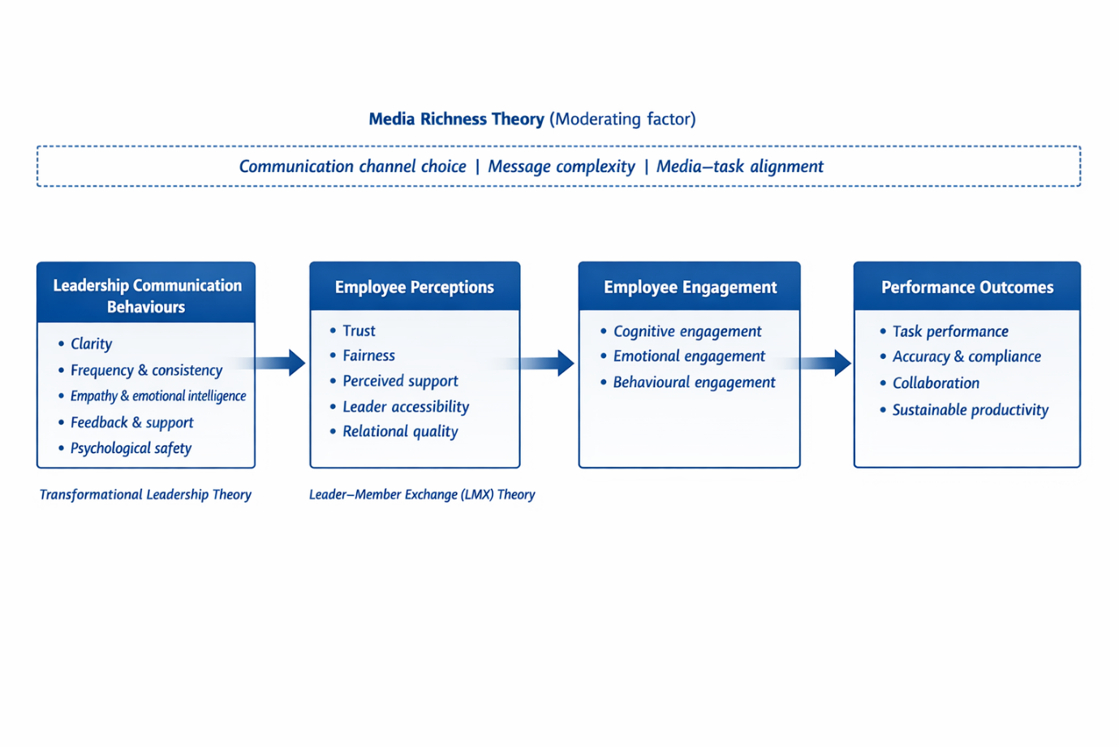

Chapter 3 - Methodology

3.1 Introduction to Research Methodology
Research methodology provides the overarching framework that guides the design, conduct, and evaluation of a research study. It refers not only to the techniques used to collect and analyse data but also to the philosophical assumptions, research approach, and strategic choices that underpin the research process (Saunders, Lewis and Thornhill, 2019).
Research methodology concerns the logic of inquiry and the justification of research choices, including philosophical positioning, research design and overall strategy. In contrast, research methods refer to the specific tools and techniques used for data collection and analysis, such as questionnaires, interviews or statistical tests (Creswell and Creswell, 2018).
In business and management research, methodological transparency is crucial due to the complexity of organisational contexts and the interpretive nature of many research phenomena (Bryman and Bell, 2015). Studies examining leadership, communication and employee behaviour often involve subjective perceptions alongside observable patterns, requiring careful consideration of how knowledge is generated and interpreted (Saunders et al., 2019). A well-structured methodology allows the researcher to demonstrate that the chosen approach is appropriate for addressing the research aims and questions.
To provide a coherent overview of the research design, this chapter is structured using the Research Onion model proposed by Saunders, Lewis and Thornhill (2019). The Research Onion offers a systematic way to explain methodological choices, progressing from broader philosophical assumptions to more practical considerations, such as data collection and analysis. By adopting this framework, the chapter describes the research philosophy, approach, methodological choice, research strategy, data collection methods, sampling, data analysis procedures, ethical considerations, and research limitations in a logical, transparent manner.
This study adopts a mixed-methods design to explore leadership communication in remote and hybrid financial-sector teams. Given the complex and context-dependent nature of leadership communication, the methodology combines quantitative and qualitative approaches to capture both patterns and in-depth experiences.

3.2 Research Aim, Objectives and Research Questions
A clearly defined research aim, supported by specific objectives and research questions, is essential for ensuring methodological coherence and focus (Saunders et al., 2019). The aim and objectives guide the selection of research philosophy, methods, and analytical techniques, ensuring alignment between what the study seeks to investigate and how it is conducted.
Research Aim
This study aims to examine how leadership communication behaviours influence employee engagement and performance in remote and hybrid financial-sector teams.
This aim reflects the core themes identified in the literature review, particularly the importance of leadership communication, employee perceptions and digitally mediated work environments within regulated financial contexts.
Research Objectives
To achieve this aim, the study is guided by the following research objectives:
- To examine key leadership communication behaviours experienced by employees in remote and hybrid financial-sector teams.
- To explore how employees perceive leadership communication, including trust, support and relational quality, in digitally mediated work environments.
- To investigate the relationship between leadership communication, employee engagement and perceived performance outcomes.
- To assess how communication channels and media choice shape the effectiveness of leadership communication in remote financial contexts.
Research Questions
Based on the research aim and objectives, the study addresses the following research questions:
- How do leadership communication behaviours influence employee perceptions in remote and hybrid financial-sector teams?
- How do employee perceptions of leadership communication affect engagement and perceived performance outcomes?
- How does the choice of communication media influence the effectiveness of leadership communication in remote financial work environments?
The research questions are exploratory and explanatory in nature, reflecting the study's focus on understanding relationships, perceptions and contextual factors rather than testing a single causal hypothesis. This orientation supports the adoption of a mixed-methods approach, allowing quantitative data to identify patterns and qualitative data to provide deeper insight into employee experiences (Creswell and Plano Clark, 2018).
Together, the research aim, objectives and questions establish a clear foundation for the methodological choices discussed in the following sections of this chapter.

3.3 Research Philosophy
Research philosophy refers to the assumptions about the nature of reality and knowledge that underpin a research study and influence how data are collected, analysed and interpreted (Saunders, Lewis and Thornhill, 2019). In business and management research, philosophical positioning is crucial because organisational phenomena such as leadership, communication, and employee behaviour are complex, socially constructed, and context-dependent (Bryman and Bell, 2015). Clearly articulating research philosophy enables the reader to assess the coherence and appropriateness of the methodological choices adopted.
Two philosophical positions commonly associated with management research are positivism and interpretivism. Positivism assumes that reality is objective and can be measured through observable and quantifiable data, typically using structured instruments and statistical analysis (Creswell and Creswell, 2018). While this approach is practical for identifying patterns and relationships among variables, it has been criticised for overlooking the subjective meanings and contexts that are central to leadership and communication research (Bryman and Bell, 2015). Interpretivism, by contrast, assumes that reality is socially constructed and that knowledge is derived from individuals' interpretations of their experiences (Saunders et al., 2019). Although this perspective enables in-depth exploration of perceptions and meanings, it may limit generalisability and the identification of broader patterns.
Given the limitations of adopting either philosophy in isolation, this study is positioned within a pragmatic research philosophy. Pragmatism emphasises the research problem as the starting point and supports the use of methods most effective in addressing it, rather than adherence to a single philosophical stance (Saunders et al., 2019). Pragmatic research accepts that both objective and subjective forms of knowledge can contribute to understanding complex organisational issues (Morgan, 2014).
Pragmatism is appropriate for this study for several reasons. First, the research examines leadership communication in remote and hybrid financial-sector teams, a phenomenon that involves both measurable elements (such as communication frequency and perceived effectiveness) and interpretive dimensions (such as trust, engagement and relational quality). A pragmatic stance enables the integration of quantitative data to identify patterns alongside qualitative data to explore employee experiences (Creswell and Plano Clark, 2018). Second, the study draws on multiple theoretical perspectives, including Transformational Leadership Theory, Leader-Member Exchange (LMX) Theory, and Media Richness Theory, which collectively address the behavioural, relational, and technological dimensions of leadership communication. Pragmatism supports this theoretical integration by prioritising explanatory value over philosophical purity.
In summary, this study adopts a pragmatic research philosophy, providing a flexible yet rigorous foundation for the mixed-methods approach employed.

3.4 Research Approach
The research approach defines how theory and data are connected within a study and determines whether reasoning proceeds from theory to data, from data to theory, or through an iterative combination of both (Saunders, Lewis and Thornhill, 2019). The three main research approaches commonly discussed in business and management research are deductive, inductive and abductive.
A deductive approach begins with existing theory and hypotheses, which are then tested using empirical data. This approach is typically associated with quantitative research and is effective for examining causal relationships between predefined variables (Bryman and Bell, 2015). However, deduction may limit the researcher's ability to capture context-specific insights and emergent meanings, particularly in studies of leadership and communication. An inductive approach, by contrast, begins with data collection and seeks to generate theory from observed patterns and themes. While induction enables rich exploration of lived experiences, it may lack theoretical grounding and limit explanatory coherence when used in isolation (Creswell and Creswell, 2018).
This study adopts an abductive research approach, which combines elements of both deduction and induction. Abduction involves iteratively moving between theory and data, allowing existing theoretical frameworks to inform data collection while remaining open to new insights arising from empirical findings (Saunders et al., 2019). This approach is particularly suitable for organisational research, where complex social processes require both theoretical guidance and empirical sensitivity.
In this study, existing theories: Transformational Leadership Theory, Leader-Member Exchange (LMX) Theory and Media Richness Theory inform the design of the research instruments. The questionnaire and interview questions were developed based on constructs identified in the literature, including leadership communication behaviours, employee perceptions, engagement, and performance. At the same time, the abductive approach allows empirical data to refine, extend or challenge these theoretical assumptions. For example, employee experiences captured through interviews may reveal contextual nuances or relational dynamics not fully accounted for in existing models.
By adopting an abductive approach, the study achieves a balance between theoretical structure and empirical openness. This enhances the research's explanatory power and supports a nuanced understanding of leadership communication in remote and hybrid financial-sector teams.

3.5 Research Strategy
A research strategy outlines how the research questions will be addressed through an overall plan that links data collection and analysis (Saunders, Lewis, and Thornhill, 2019). This study uses two complementary strategies: an employee survey and semi-structured interviews with managers. Survey research is appropriate for collecting standardised data across a broader employee group and for identifying patterns in experiences of leadership communication, engagement, and perceived performance in remote and hybrid work (Bryman and Bell, 2015). However, survey data may not explain why patterns occur, particularly where communication practices are shaped by regulation, risk culture and compliance constraints.
Semi-structured interviews address this limitation by exploring processes, meanings and constraints in greater depth. Interviews enable probing into leader decision-making (e.g., channel choice, feedback practices, and trust-building) and contextual influences that are difficult to capture with fixed-response items (Kvale and Brinkmann, 2009). Using both strategies supports methodological triangulation by producing complementary evidence and strengthening credibility through convergence and complementarity across methods (Denzin, 1978; Creswell and Plano Clark, 2018).

3.6 Methodological Choice: Mixed Methods
This study adopts a mixed-methods design, defined as the planned integration of quantitative and qualitative data within a single study to develop a more complete understanding of a research problem than either approach alone (Creswell and Plano Clark, 2018). The quantitative component is an employee questionnaire, providing breadth and enabling an exploratory examination of relationships among constructs such as perceived communication clarity, support, engagement, and perceived performance (Bryman and Bell, 2015). The qualitative component consists of semi-structured interviews with managers/leaders, providing depth by exploring how communication behaviours are enacted, how media choices are made, and how contextual constraints shape leadership communication in remote and hybrid settings (Kvale and Brinkmann, 2009; Patton, 2015).
The mixed-methods approach aligns with the conceptual framework by capturing both employee perceptions and leader practices, enabling complementary interpretation (Morgan, 2014; Creswell and Creswell, 2018). As flagged by the supervisor, this design may adapt if access to managers is limited; in that case, the questionnaire will proceed as the primary dataset, and interviews will be conducted to the extent feasible, with reduced qualitative depth treated as a limitation (Saunders et al., 2019).

3.7 Data Collection Methods
This study uses two primary data collection methods, an employee questionnaire and semi-structured interviews with managers, to address the research questions through complementary forms of evidence. In mixed-methods research, combining standardised survey data with qualitative interview data supports both breadth and depth, enabling patterns to be identified and then explored in context (Creswell and Plano Clark, 2018; Bryman and Bell, 2015).

3.7.1 Questionnaire Design
The questionnaire targets employees in financial-sector organisations who work remotely or in a hybrid model and have a direct line manager. It captures employees' experiences and interpretations of leadership communication, along with their perceived implications for engagement and performance. Item sequencing follows established survey design guidance to support completion and reduce early drop-off: brief demographics and work-context items (including remote-working duration and whether respondents were office-based before moving to remote/hybrid working) precede items on leadership communication experiences, engagement and perceived performance (Dillman, Smyth and Christian, 2014; Fowler, 2014).
Multiple response formats are used rather than relying only on Likert scales. The questionnaire includes categorical items, frequency options, evaluative ratings, and an optional open-text item for brief comments. Varying formats can improve data quality by matching response options to constructs and reducing satisficing behaviour (Fowler, 2014). Prior to distribution, the questionnaire will be piloted with approximately 3–5 individuals meeting the inclusion criteria to test clarity and completion time, with revisions made where needed (Dillman et al., 2014; Bryman and Bell, 2015).

3.7.2 Interview Design
Semi-structured interviews will be conducted with managers/leaders in financial-sector organisations who manage remote or hybrid team members. This format balances consistency across interviews with flexibility to probe for examples and explanation, which is appropriate for exploring trust-building, psychological safety and communication channel choice in digitally mediated leadership (Kvale and Brinkmann, 2009; Patton, 2015). Interview questions were derived from the literature review and conceptual framework to focus on leadership communication behaviours, relational mechanisms and media choice decisions, extending (rather than duplicating) employee questionnaire content (Creswell and Plano Clark, 2018).
The target is 4-5 manager interviews, each lasting up to 30 minutes. This is feasible within the dissertation timeframe and sufficient to generate focused thematic insight, given the clearly defined scope and theory-informed interview guide (Guest, Bunce and Johnson, 2006; Patton, 2015).
The interview guide will be limited to 8-10 core questions to support depth within the 30 minute time limit.

3.8 Sampling Strategy
A non-probability sampling strategy is adopted due to practical access constraints in regulated financial organisations and the absence of accessible sampling frames (Saunders, Lewis and Thornhill, 2019). Two target populations are defined: employees working remotely/hybrid in financial-sector organisations with a direct line manager (questionnaire sample) and managers/leaders who supervise remote/hybrid team members (interview sample). For the questionnaire, recruitment will use a controlled convenience approach guided by purposive inclusion criteria, recognising that probability sampling is unlikely to be feasible due to organisational gatekeeping and confidentiality constraints (Saunders et al., 2019).
The target questionnaire sample size is approximately 50-100 responses, which is appropriate for descriptive patterns and exploratory comparisons within a dissertation timeframe (Fowler, 2014). For interviews, purposive sampling will be used to recruit 4-5 managers, with limited snowballing where appropriate to extend reach while maintaining inclusion criteria (Patton, 2015). Anticipated constraints include managers' limited availability and sensitivity to communication practices; these constraints will be managed through flexible scheduling and confidentiality assurances, and acknowledged as limitations where relevant (Saunders et al., 2019).

3.9 Data Collection Procedure and Access
The questionnaire will be distributed online using Microsoft Forms to support standardised administration and straightforward export for analysis (Dillman, Smyth and Christian, 2014; Fowler, 2014). An information statement will explain the study purpose, voluntariness and withdrawal prior to submission. Anonymity will be preserved by not requesting identifying details (e.g., name, employer, specific job title, location or manager identity) and by configuring settings so that contact information is not collected; findings will be reported only in aggregate, consistent with ethical guidance for organisational research (British Psychological Society, 2021).
Interview participants will be approached through purposive outreach via professional networks, sector contacts, and, where appropriate, professional platforms (e.g., LinkedIn). Invitations will outline the topic, expected duration (up to 30 minutes), confidentiality arrangements and consent to recording for accurate transcription (Kvale and Brinkmann, 2009). Interviews will be conducted online (e.g., Teams/Zoom) and scheduled at times convenient to participants. Recruitment and scheduling are expected to require sustained outreach over several weeks, reflecting practical constraints in organisational fieldwork (Saunders et al., 2019; Patton, 2015).

3.10 Data Analysis Procedures
Quantitative and qualitative datasets will be analysed using method-appropriate procedures and integrated during interpretation to address the research questions (Creswell and Plano Clark, 2018).

3.10.1 Quantitative analysis
Survey data will be cleaned and coded in Excel and analysed in SPSS (or equivalent). Descriptive statistics (frequencies, percentages and appropriate measures of central tendency) will summarise the sample profile and response patterns (Field, 2018). Inferential analysis will be exploratory and aligned with data types and sample size. Planned analyses include cross-tabulations and chi-square tests for associations between categorical variables, and nonparametric tests for group differences, as relevant to the conceptual framework (Field, 2018). When item sets are combined into composite indicators, an appropriate ordinal data correlation analysis will be used to explore relationships between key constructs (Field, 2018).

3.10.2 Qualitative analysis
Interview recordings will be transcribed and anonymised prior to analysis. Thematic analysis will be applied following Braun and Clarke's (2006) staged process: familiarisation, initial coding, theme development, review and definition. Coding will combine theory-informed codes derived from the conceptual framework (e.g., communication behaviours, trust/fairness dynamics and media-choice decisions) with inductive codes capturing unanticipated themes (Braun and Clarke, 2006). Qualitative findings will then be integrated with survey results during interpretation to explain or contextualise quantitative patterns, strengthening the overall inference through complementarity (Creswell and Plano Clark, 2018).

3.11 Validity, Reliability and Trustworthiness
Ensuring validity, reliability and trustworthiness supports methodological rigour and enables the reader to judge the credibility of findings (Bryman and Bell, 2015). For the quantitative questionnaire, validity is supported through direct alignment with the conceptual framework and the literature-derived constructs (Saunders, Lewis and Thornhill, 2019). Content validity will be strengthened through pilot testing to assess item clarity, interpretation, and coverage before full distribution (Dillman, Smyth, and Christian, 2014). Reliability will be supported through clear wording and consistent response options (Fowler, 2014). When items are combined into composite indicators, internal consistency will be assessed (e.g., Cronbach's alpha) to determine whether the items measure the same underlying construct (Field, 2018).
For the qualitative interviews, trustworthiness will be addressed through credibility and dependability (Lincoln and Guba, 1985). Credibility will be supported through a theory-informed interview guide and a systematic thematic analysis, with illustrative excerpts used to demonstrate clear links between the data and interpretation (Braun and Clarke, 2006). Dependability will be supported by maintaining an audit trail of coding decisions and theme development notes (Lincoln and Guba, 1985).
Across methods, triangulation strengthens the overall inference by comparing employee survey patterns with manager accounts, supporting convergence and complementarity during interpretation (Denzin, 1978; Creswell and Plano Clark, 2018).

3.12 Ethical Considerations
This study will comply with institutional ethics requirements and will commence data collection only after ethics approval is confirmed (Saunders, Lewis and Thornhill, 2019). Participants will receive an information sheet explaining the study purpose, what participation involves, and how data will be used. Informed consent will be obtained prior to participation: electronically at the start of the questionnaire and in writing for interviews, including consent for audio recording (British Psychological Society, 2021).
Confidentiality and anonymity will be maintained through data minimisation and anonymisation. The questionnaire will avoid collecting identifiable details. Interview transcripts will be anonymised, and any potentially identifying organisational references will be removed. Findings will be reported in aggregate and, where quotations are used, they will be non-identifiable. Participants will be reminded not to disclose confidential organisational or client information during interviews.
Participants have the right to withdraw without penalty. Questionnaire respondents may withdraw before submission; due to anonymity, responses cannot be removed after submission. Interview participants may withdraw up to a stated point, after which removal may no longer be feasible if data have been anonymised and integrated into the analysis (British Psychological Society, 2021).
Data will be stored securely on university-approved, password-protected systems accessible only to the researcher and supervisor, retained for the required period, and then securely deleted.

3.13 Research Limitations
Several limitations should be considered when interpreting the results. First, the study uses non-probability sampling because access to participants in financial organisations is constrained. However, inclusion criteria are applied to control for convenience sampling, and some sampling bias is likely; the results should not be treated as statistically representative (Saunders, Lewis and Thornhill, 2019).
Second, the study relies on self-reported data from employees and managers, which may be affected by social desirability bias, recall errors, and differences in interpretation (Bryman and Bell, 2015). Triangulation across employee and manager perspectives can strengthen interpretation, but cannot eliminate self-report bias.
Third, the focus on the financial sector improves relevance for regulated, high-stakes settings, but limits transferability to sectors with different communication norms and constraints (Saunders et al., 2019).
Finally, time and access constraints may limit the sample size, particularly in manager interviews, thereby reducing coverage across organisational contexts. These constraints will be managed through a clearly defined scope, piloted instruments, and transparent reporting of participant characteristics to support appropriate interpretation.

3.14 Chapter Summary
This chapter has set out a coherent methodology for investigating leadership communication in remote and hybrid financial teams. A mixed-methods design combines an employee questionnaire with semi-structured manager interviews, supported by an explicit sampling strategy, data collection procedures, and planned quantitative and qualitative analysis techniques. Quality criteria, ethical safeguards and study limitations have been addressed to demonstrate rigour and feasibility. The next chapter reports the findings, presenting survey results and interview themes, and integrates them to explain how leadership communication relates to employee engagement and perceived performance in remote and hybrid work.

Chapter 4 – Findings and Analysis

4.1 Introduction
This chapter presents and analyses the primary research findings from the employee questionnaire and manager interviews. The analysis is organised around the study's research focus on how leadership communication behaviours, employee perceptions and communication media relate to engagement and perceived performance in remote and hybrid financial-sector teams. In line with the mixed-methods design outlined in Chapter 3, the quantitative findings are presented first using descriptive statistics, visual material and exploratory cross-tabulations. Descriptive statistics are appropriate for summarising response patterns across the questionnaire sample (Field, 2018). The qualitative findings are then presented through thematic analysis of the manager interviews, using anonymised participant codes M1–M5. Thematic analysis supports the identification of patterned meanings across interview data (Braun and Clarke, 2006). Presenting the datasets separately before integration supports analytical clarity and enables each method to contribute distinct evidence to the research questions (Creswell and Plano Clark, 2018). The chapter ends by integrating key insights from both datasets, while broader interpretation, conclusions and recommendations are reserved for Chapter 5.

4.2 Overview of the Primary Research Sample
This study draws on two primary data sources: an employee questionnaire and semi-structured interviews with managers working in financial-sector contexts. The questionnaire generated 117 valid responses, providing quantitative data on employees' experiences of leadership communication in remote and hybrid financial work. The survey captured working arrangements, preferred working arrangements, communication frequency, channel use, perceived clarity, support, fairness, motivation and perceived performance.
The sample included respondents across different age groups and organisational tenure categories. The largest age group was 35–44 (50 respondents), followed by 25–34 and 45–54 (27 respondents each). The largest tenure group had worked in their current organisation for 4–6 years (55 respondents). This suggests that many respondents had sufficient organisational experience to comment meaningfully on leadership communication practices, although the sample remains non-probabilistic and should not be treated as statistically representative of the wider financial-sector workforce.
The qualitative component consisted of five manager interviews from different financial-sector contexts: retail banking operations, insurance claims, asset management/compliance, fintech payments operations and KYC/AML operations. This variation supports the analysis because communication demands may differ across operational, compliance, customer-facing and incident-driven work. To protect confidentiality, participants are identified using codes M1–M5, consistent with ethical practice in qualitative organisational research (Saunders, Lewis and Thornhill, 2019).
Table 1: Interview participant profile
Participant ID | Role | Organisation type | Working arrangement
M1 | Operations Team Leader | Retail banking operations | Hybrid
M2 | Claims Manager | Insurance claims | Mostly remote
M3 | Compliance Manager | Asset management/compliance | Hybrid
M4 | Payments Operations Manager | Fintech/payments operations | Remote-first
M5 | KYC/AML Operations Manager | Financial crime / KYC/AML operations | Hybrid

The combined sample supports the mixed-methods design by enabling comparisons between employee perceptions and managers' accounts of communication practice, thereby supporting triangulation and contextual understanding (Creswell and Plano Clark, 2018).

4.3 Quantitative Findings: Employee Questionnaire
This section presents the questionnaire findings using descriptive statistics and exploratory cross-tabulations. The analysis focuses on the respondent profile, communication frequency and channels, perceived communication quality and fairness, media choice, misunderstandings, motivation, and perceived performance. Descriptive statistics are used to summarise the response patterns, while cross-tabulations provide limited exploratory comparison between selected variables (Field, 2018).

4.3.1 Respondent Profile and Working Context
The questionnaire generated 117 valid responses. The available profile variables were age group, organisational tenure, current working arrangement and preferred working arrangement. Gender, role level, length of remote/hybrid working and previous office-based status were not included in the final Microsoft Forms output and are therefore not reported.
Figure 2: Age group of respondents
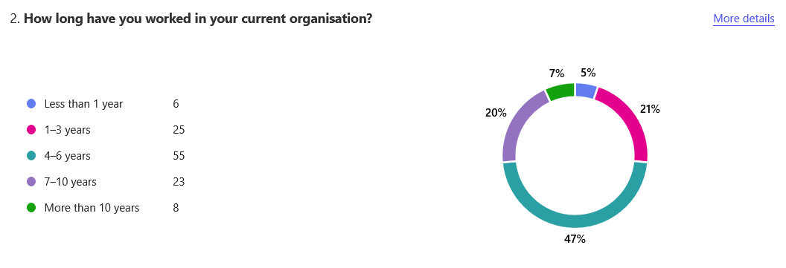

Figure 2 shows that the largest age group was 35–44 (50 respondents; 43%). The groups 25–34 and 45–54 each included 27 respondents (23%), while smaller groups were aged 18–24 and 54+. This suggests that the sample mainly consisted of mid-career employees with relevant workplace experience.
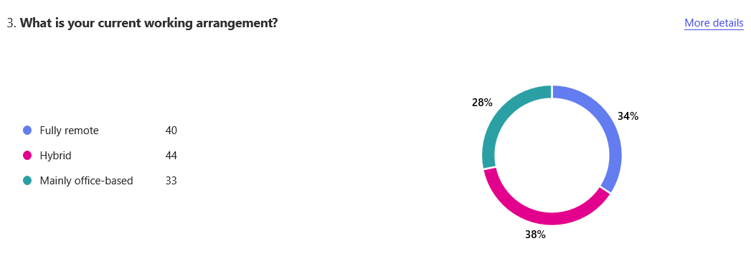
Figure 3 : Length of time in current organisation

Figure 3 shows that the largest group had worked in their current organisation for 4–6 years (55 respondents; 47%), followed by 1–3 years (25 respondents; 21%) and 7–10 years (23 respondents; 20%). This indicates that many respondents had sufficient organisational experience to evaluate communication practices over time.
Figure 4: Current working arrangement
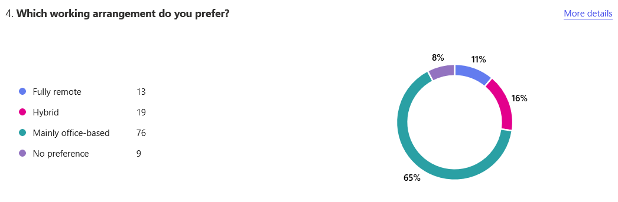

Figure 4 shows that 44 respondents (38%) worked in a hybrid arrangement, 40 (34%) were fully remote and 33 (28%) were mainly office-based. The sample is therefore relevant to the study because most respondents were working remotely or in hybrid arrangements.
Figure 5: Preferred working arrangement
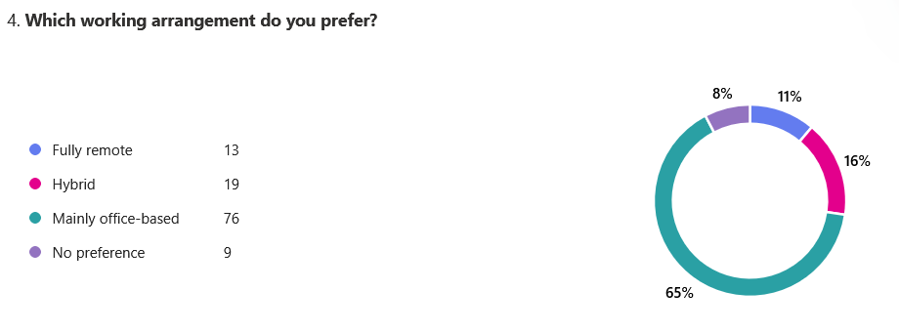

Figure 5 shows that 76 respondents (65%) preferred office-based work, compared with 19 (16%) who preferred hybrid work and 13 (11%) who preferred fully remote work. A further 9 respondents (8%) had no preference. This difference between current and preferred arrangements provides useful context for interpreting later findings on clarity, support and performance.

4.3.2 Communication Frequency and Channels
Communication frequency and channel use are important because remote and hybrid leadership is often conveyed through digital media rather than face-to-face interaction (Avolio, Kahai, and Dodge, 2000). Media Richness Theory also suggests that communication channels vary in their ability to convey feedback, tone and contextual cues (Daft and Lengel, 1986).

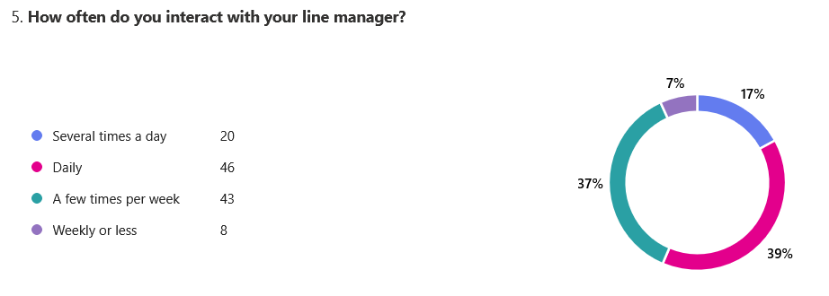
Figure 6: Frequency of interaction with line manager

Figure 6 shows that respondents had regular contact with line managers. 46 respondents (39%) interacted daily, 43 (37%) interacted a few times per week, 20 (17%) interacted several times a day, and 8 (7%) reported contact weekly or less. However, frequency alone does not show whether communication was clear, supportive or appropriately timed.
Figure 7: Communication channels
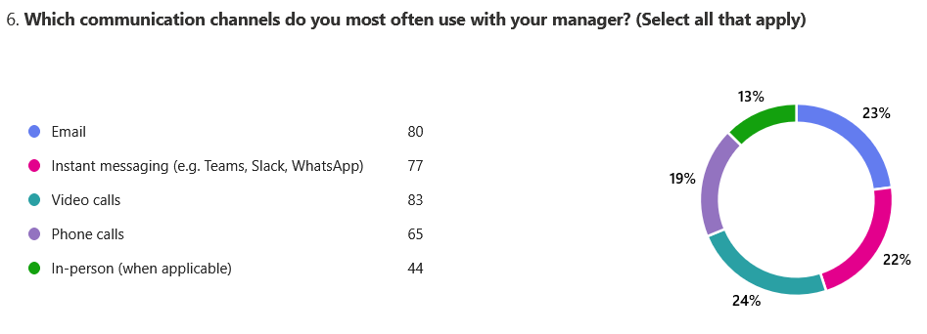

Figure 7 shows that digital channels dominated communication. The most common channel was video calls (83 respondents; 71%), followed by email (80; 68%), instant messaging (77; 66%) and phone calls (65; 56%). In-person communication was selected by 44 respondents (38%), indicating that digitally mediated communication was central to manager–employee interaction.

4.3.3 Leadership Communication Clarity, Frequency and Support
This subsection examines communication clarity, perceived frequency, comfort contacting managers and support. These factors are relevant because leadership communication can reduce uncertainty and support employee engagement when it is clear, accessible and responsive (Men and Yue, 2019; Wang et al., 2021).
Figure 8: Clarity of manager communication about work expectations
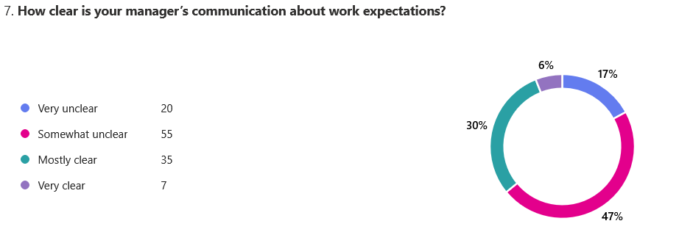

Figure 8 shows that 75 respondents (64%) rated their manager's communication as somewhat or very unclear, while 42 (36%) rated it as mostly or very clear. This indicates a notable weakness in perceived clarity.
Figure 9: Perceived frequency of communication from manager
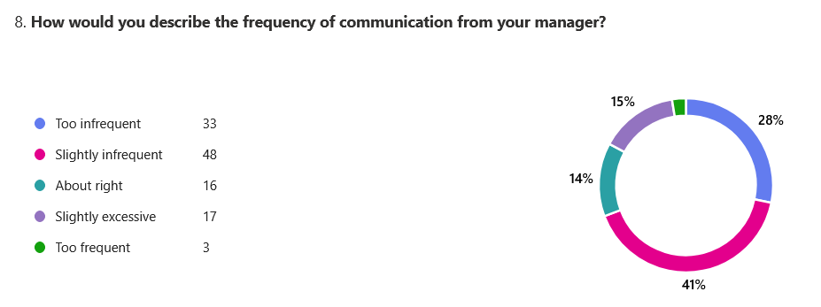

Figure 9 shows that 81 respondents (69%) viewed manager communication as too infrequent or slightly infrequent. Only 16 respondents (14%) felt communication frequency was about right, while 20 (17%) viewed it as excessive to some degree. This suggests that regular contact did not always translate into perceived communication adequacy.
Figure 10: Comfort contacting the manager
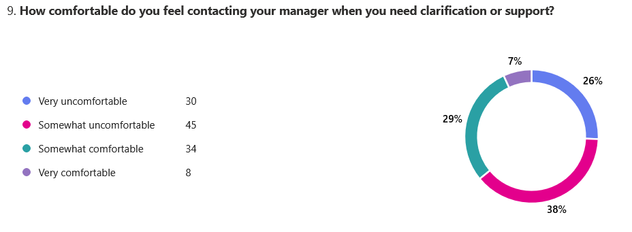

Figure 10 shows that 75 respondents (64%) felt uncomfortable or somewhat uncomfortable contacting their manager for clarification or support. In contrast, 42 respondents (36%) felt somewhat or very comfortable. This is relevant to Leader–Member Exchange (LMX) Theory, as accessibility and trust are central to relationship quality (Graen and Uhl-Bien, 1995).
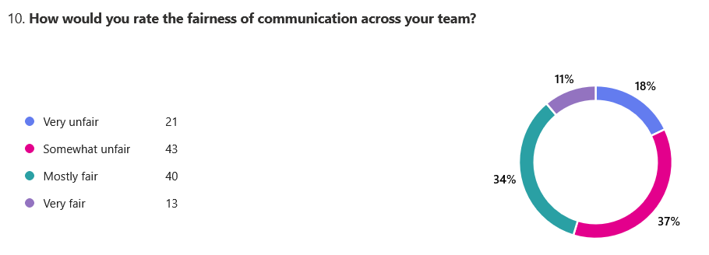
Figure 11: Perceived support

Figure 11 presents a mixed pattern. 56 respondents (48%) felt well or somewhat supported, 30 (26%) were neutral, and 31 (27%) felt somewhat unsupported or unsupported. The questionnaire did not include a separate performance feedback item, so feedback was further explored through the manager interviews.

4.3.4 Fairness, Media Choice and Misunderstandings
This subsection examines fairness, channel appropriateness and misunderstandings. These findings connect directly with LMX Theory and Media Richness Theory.
Figure 12: Fairness of communication
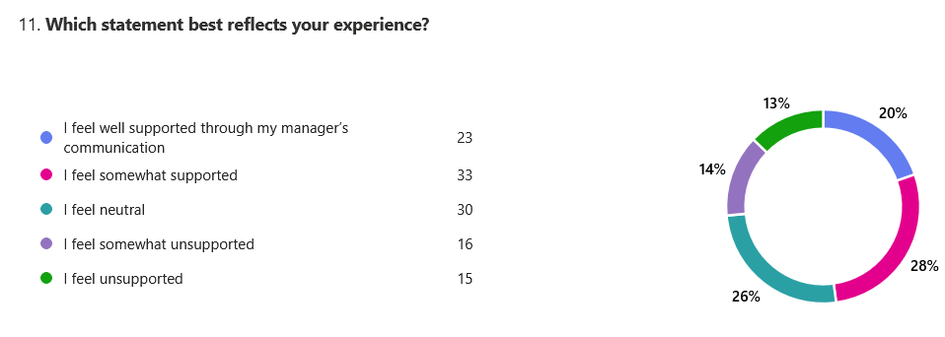

Figure 12 shows that 64 respondents (55%) rated communication across the team as very or somewhat unfair, while 53 (45%) rated it mostly or very fair. This indicates divided perceptions of fairness, which may reflect unequal access to information or uneven visibility in remote/hybrid teams.

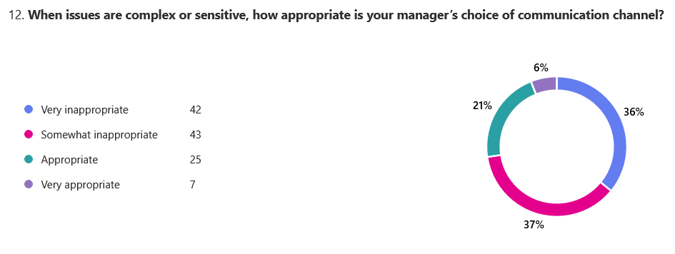
Figure 13: Appropriateness of manager's

Figure 13 shows that 85 respondents (73%) rated channel choice as very or somewhat inappropriate for complex or sensitive issues, while only 32 (27%) rated it appropriate or very appropriate. This is significant because complex or ambiguous messages usually require richer channels to enable clarification and reduce misunderstanding (Daft and Lengel, 1986).
Figure 14: Frequency of misunderstanding
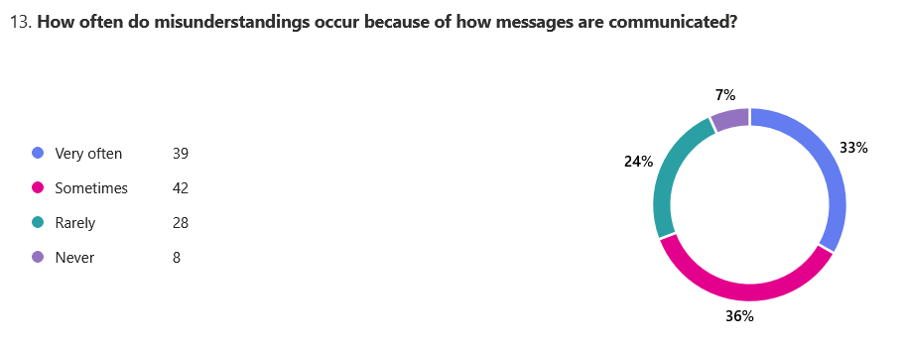

Figure 14 shows that misunderstandings were common. 39 respondents reported misunderstandings very often, and 42 reported them sometimes, for a total of 81 respondents (69%) who experienced misunderstandings at least sometimes. This supports the relevance of communication clarity and channel selection to remote/hybrid leadership communication.

4.3.5 Engagement and Perceived Performance Outcomes
The questionnaire did not include a separate engagement item; therefore, motivation is treated as the closest engagement-related indicator, alongside perceived performance and productivity.
Figure 15: Effect of leadership communication
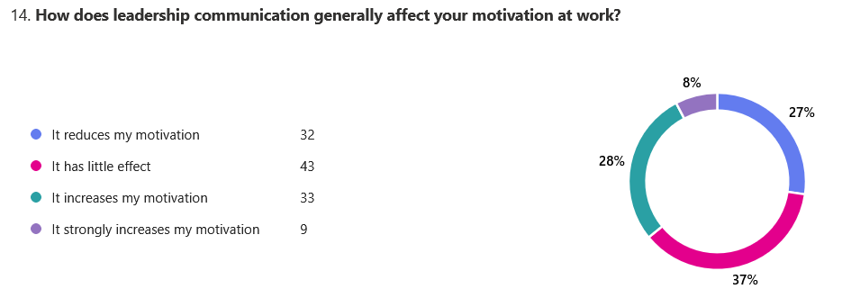

Figure 15 shows mixed motivational effects. 32 respondents said leadership communication reduced motivation, and 43 reported a little effect, for a total of 75 respondents (64%) with negative or limited motivational impact. By contrast, 42 respondents (36%) said it increased or strongly increased motivation.
Figure 16: Effect of leadership communication
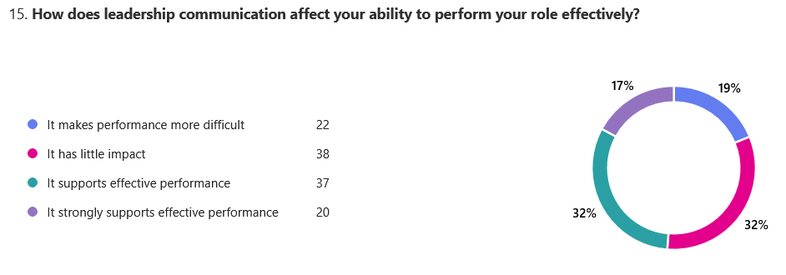

Figure 16 shows a more balanced pattern. 60 respondents (51%) said leadership communication made performance more difficult or had little impact, while 57 (49%) said it supported or strongly supported effective performance. This suggests variation in how leadership communication is experienced as a performance resource.
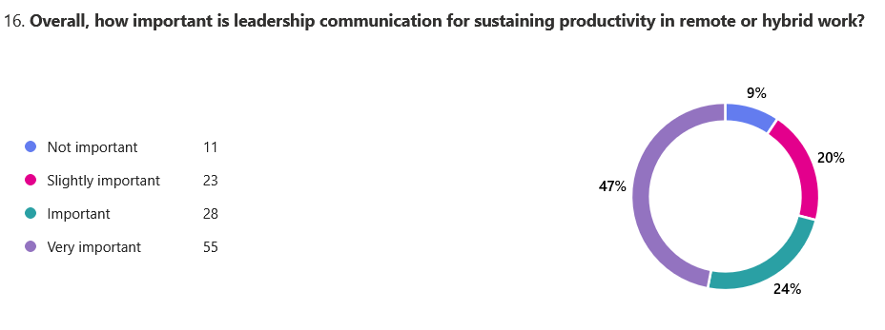
Figure 17: Importance of leadership communication

Figure 17 shows that 83 respondents (71%) rated leadership communication as important or very important for sustaining productivity. Only 11 respondents (9%) rated it as not important. This indicates that respondents recognised leadership communication as important, even where their personal experience of it was mixed.

4.3.6 Exploratory Cross-Tabulation and Relationship Analysis
To move beyond frequencies, three exploratory cross-tabulations were used. Because the data are ordinal/categorical and based on a non-probability sample, the analysis focuses on patterns rather than generalisable statistical claims (Field, 2018).
Communication clarity vs motivation - showed little difference between clarity groups. Among respondents reporting unclear/somewhat unclear communication, 36% still reported increased or strongly increased motivation. Among those reporting mostly/very clear communication, the figure was 35.7%. This suggests that factors beyond communication clarity alone may shape motivation.
Channel appropriateness vs misunderstandings - showed that misunderstandings were common across both groups, though they were more concentrated among respondents who viewed channel choice as inappropriate. This pattern supports the relevance of Media Richness Theory, but it should be interpreted cautiously because the association is descriptive rather than conclusive.
Comfort contacting manager vs perceived performance - indicated a clearer directional pattern. Among respondents who were comfortable contacting their manager, 54.8% reported that leadership communication supported or strongly supported performance, compared with 45.3% among those who felt uncomfortable. This aligns with LMX Theory, which emphasises leader accessibility, trust and relational quality as important to employee outcomes (Graen and Uhl-Bien, 1995).
Overall, the quantitative findings show that respondents recognised leadership communication as important for productivity, but their experiences of clarity, support, fairness and media choice were mixed. These patterns provide the basis for the qualitative thematic analysis that follows.

4.4 Qualitative Findings: Manager Interviews
The interview data were analysed thematically. Participants are referred to using codes M1–M5 to preserve anonymity, and full anonymised transcripts are included in the appendices. The themes were developed from the interview questions and conceptual framework, while allowing additional patterns to emerge from the data. Thematic analysis is appropriate because it enables the identification of patterned meanings across qualitative data and their organisation into themes that address the research questions (Braun and Clarke, 2006). The analysis focuses on how managers communicate in remote and hybrid financial-sector teams, how they select channels, and how they balance clarity, performance, autonomy, accountability and psychological safety.

4.4.1 Theme 1: Communication Channels and Channel Choice
A clear theme across the interviews was that managers selected communication channels based on message purpose, complexity, and risk. Digital channels such as Teams, Slack, email, video calls and shared work-tracking systems were central to daily communication. M1 used "Teams chat for quick questions, email for anything that needs a record, and video calls for weekly team meetings", while M4 used Slack/Teams for rapid coordination, Jira for tracking work and video for daily stand-ups. This indicates that remote leadership communication was not channel-neutral; managers matched tools to the task at hand.
Richer channels were preferred for complex, sensitive or ambiguous issues. M2 explained that "complex issues start with a call", while M4 used video for complex decisions and one-to-one calls for sensitive topics. This aligns with Media Richness Theory, which argues that richer media are better suited to ambiguous communication because they enable faster feedback and greater contextual understanding (Daft and Lengel, 1986). However, auditability was also important in financial work. M3 stated, "If it needs an audit trail, it is email", suggesting that managers prioritised both clarity and documentation.

4.4.2 Theme 2: Complexity of Remote/Hybrid Working Arrangements
A second theme was the operational complexity created by remote and hybrid working patterns. Managers described hybrid teams with set office days, mostly remote teams and remote-first teams across different locations. M1 managed a hybrid team where staff worked "three days at home, two in the office", while M4 described a remote-first fintech team operating "across different locations".
The main challenge was not simply physical distance, but coordination, visibility and reduced informal learning. M4 noted that for new joiners, "without hallway learning, you must coach deliberately", while M2 observed that remote feedback is harder because managers "do not notice stress as easily". Managers did not present fully remote work as automatically more problematic than hybrid work. Instead, complexity appeared to depend on task type, team maturity and communication structure. This supports remote work research showing that effective virtual leadership depends on deliberate coordination and communication design (Wang et al., 2021).

4.4.3 Theme 3: Clarity, Feedback and Performance Communication
A third theme was the importance of clarity and structured feedback. Managers described clarity as essential because mistakes could affect accuracy, compliance and performance. M1 clarified "what is priority today, what 'good' looks like, and deadlines", while M3 used structured templates covering the issue, rule reference, risk level, required action and deadline.
Feedback was usually delivered through scheduled one-to-ones, short calls and written follow-up. M1 used "monthly one-to-ones by video, with written notes", while M5 used weekly or fortnightly one-to-ones and screen sharing to coach employees through cases. Managers also recognised that tone is harder to manage remotely. M1 noted that "some people read a message as criticism", and M3 stated that short messages can sound "directive". This theme links to transformational leadership communication because managers used clarity, coaching and individualised support to reduce ambiguity and sustain performance (Bass and Riggio, 2018). It also reflects the wider view that leadership communication shapes how employees understand expectations and performance requirements (Hackman and Johnson, 2018).

4.4.4 Theme 4: Autonomy versus Accountability
A fourth theme was the tension between employee autonomy and managerial accountability. Managers described trust as important but also emphasised that oversight was unavoidable in the financial sector. M1 stated, "I trust people, but oversight is necessary", explaining that productivity and error rates were tracked and framed as "support and risk control, not surveillance". M5 similarly explained that oversight involved "audits, QA checks, metrics", but that managers needed to explain the purpose so that "trust remains intact".
This theme shows that compliance controls, performance metrics and risk management expectations shaped accountability. However, managers recognised the need to avoid micromanagement. M2 described oversight through "sampling and peer review, not constant monitoring", while M4 stated that they "trust by default" but review agreed standards and outcomes. This reflects LMX theory, as high-quality leader–employee relationships depend on trust, mutual respect and perceived fairness (Graen and Uhl-Bien, 1995). In this context, the challenge was to preserve autonomy while maintaining regulatory accountability.

4.4.5 Theme 5: Psychological Safety and Upward Communication
The final theme concerns psychological safety and upward communication, particularly how managers encouraged employees to raise concerns, ask questions and report mistakes. This was especially important in financial-sector contexts, where delayed escalation can lead to operational, compliance, or customer risk consequences. M1 stated that they made it "normal to ask questions" and told staff that "if you are unsure, that is a risk, ask early". M3 similarly argued that psychological safety was critical because employees "must escalate issues early".
Managers used several practices to support speaking up. M2 described using "no blame" language for near-misses and allowing concerns to be raised privately or in meeting chat. M4 highlighted blame-free post-incident reviews, where employees can say, "I made a mistake" without punishment. M5 linked escalation directly to compliance, stating that "in compliance work, silence is dangerous". This theme closely aligns with psychological safety theory, in which employees feel able to speak up without fear of negative consequences (Edmondson, 1999). In financial services, such communication supports trust, early risk identification and performance reliability.

4.5 Integration of Quantitative and Qualitative Findings
The quantitative and qualitative findings show several points of connection between employee perceptions and manager accounts. In mixed-methods research, integration enables one dataset to explain or contextualise the other, strengthening the overall interpretation of findings (Creswell and Plano Clark, 2018). In this study, the questionnaire findings provided breadth by identifying patterns in employee responses. In contrast, the interviews provided depth by explaining how managers make communication decisions in remote and hybrid financial-sector work.
First, the questionnaire indicated weaknesses in communication clarity: 64% of respondents rated the manager's communication about expectations as very or somewhat unclear. The interviews helped explain the operational challenge behind this pattern. Managers described financial work as high-volume, compliance-heavy and risk-sensitive. For example, M3 used structured templates covering "issue, rule reference, risk level, required action, deadline", while M5 provided examples of "acceptable evidence" and "common errors". This suggests that managers recognised the need for clarity, although employees did not always find the communication sufficiently clear.
Second, the questionnaire showed concern around channel choice, with 73% rating managers' channel choice for complex or sensitive issues as inappropriate to some degree. The interviews showed that managers used richer channels, such as calls or video, for sensitive or ambiguous matters, while relying on email for audit trails. This aligns with Media Richness Theory, which argues that communication effectiveness depends partly on matching the channel to the message's complexity (Daft and Lengel, 1986).
Third, the survey showed mixed perceptions of support, fairness and comfort contacting managers. The interviews indicated that managers were aware of the importance of trust and accessibility but had to balance these with oversight, monitoring and compliance controls. This aligns with LMX Theory, which holds that relationship quality is shaped by trust, fairness, and communication access (Graen and Uhl-Bien, 1995).
Overall, the integrated findings suggest that employees and managers both recognise leadership communication as important, but effectiveness depends on clarity, channel discipline, trust and opportunities for upward communication.

4.6 Chapter Summary
This chapter presented the findings from the employee questionnaire and the thematic analysis of manager interviews. The quantitative findings identified patterns in employee perceptions of leadership communication, including communication frequency, channel use, clarity, support, fairness, misunderstandings, motivation and perceived performance. Overall, employees recognised leadership communication as important for productivity, but their experiences of communication quality were mixed, particularly around clarity, channel appropriateness and comfort contacting managers.
The qualitative findings provided contextual insight into how managers communicate in remote and hybrid financial-sector teams. The thematic analysis identified five themes: communication channels and channel choice; the complexity of remote/hybrid working arrangements; clarity and performance feedback; autonomy versus accountability; and psychological safety/upward communication. The integration of both datasets highlighted areas of alignment and tension between employee perceptions and manager accounts. The next chapter discusses these findings in relation to the literature, the research objectives, and the conceptual framework, before developing conclusions and recommendations.

Chapter 5 - Discussion, Conclusions and Recommendations

5.1 Introduction
This chapter discusses the findings from Chapter 4 in relation to the literature review, the conceptual framework, and the research aim and objectives. Its purpose is to interpret the findings regarding leadership communication in remote and hybrid financial-sector teams. In line with mixed-methods principles, the chapter considers how the questionnaire findings and manager interviews complement each other (Creswell and Plano Clark, 2018).
The chapter discusses key findings related to Transformational Leadership, LMX, and Media Richness Theory. It then evaluates whether the aim, objectives, and research questions were achieved before presenting contributions, recommendations, limitations, and future research. This supports a coherent conclusion grounded in both theory and practice (Saunders, Lewis and Thornhill, 2019).

5.2 Discussion of Key Findings in Relation to the Literature

5.2.1 Communication clarity and expectation-setting
A key finding was that communication clarity remained a significant issue. In Chapter 4, 64% of respondents rated their manager's communication about work expectations as very or somewhat unclear. This matters because remote and hybrid work reduces informal opportunities for clarification, making explicit communication of priorities, standards and deadlines more important (Wang et al., 2021). Manager interviews showed that leaders recognised this challenge, using templates, checklists, written follow-ups and examples to clarify tasks with compliance or risk implications.
This partly supports Transformational Leadership Theory, which emphasises direction, support and meaning-making (Bass and Riggio, 2018). However, the findings also reveal a gap between leadership intention and employee interpretation. Managers may believe they communicate clearly, but employees may still experience ambiguity when messages are fragmented, inconsistent or insufficiently contextualised.

5.2.2 Channel choice and media richness
Channel choice was another major concern. The questionnaire showed that 73% of respondents rated managers' channel choice for complex or sensitive issues as inappropriate to some degree. This closely aligns with Media Richness Theory, which argues that complex or ambiguous issues require richer channels because they enable feedback, social cues, and clarification (Daft and Lengel, 1986).
The interviews added a financial-sector dimension. Managers used video or calls for sensitive issues, but also relied on email or written summaries for audit trails. This shows a tension between richness and recordability. In financial services, effective communication may require both richer interaction for understanding and written confirmation for compliance. This explains why employees may still perceive channel choice as ineffective even where managers believe they are using appropriate tools.

5.2.3 Trust, support and relational quality
The findings also highlighted concerns about trust, accessibility, and support. In the survey, 64% of respondents felt uncomfortable or somewhat uncomfortable contacting their manager for clarification or support. Perceptions of fairness and support were also mixed. This aligns with LMX Theory, which argues that relationship quality shapes trust, access and perceived fairness (Graen and Uhl-Bien, 1995).
Manager interviews showed that leaders valued trust but also had to maintain oversight through QA checks, metrics and audit processes. This creates a tension: oversight may be necessary in regulated work, but it can be interpreted as surveillance if poorly communicated. This supports LMX research suggesting that perceived inequity and differentiated access can affect employee outcomes (Martin et al., 2018). Remote leadership communication is therefore both relational and informational.

5.2.4 Engagement, motivation and perceived performance
The questionnaire showed that 71% of respondents viewed leadership communication as important or very important for productivity. However, its effect on motivation and perceived performance was mixed. This suggests that employees recognise communication as important but do not always experience it as motivational or performance-enhancing.
This aligns with engagement literature, which links engagement to meaningfulness, support, and access to resources (Kahn, 1990; Schaufeli and Bakker, 2004). Interviews helped explain the variation, as managers used one-to-ones, coaching, written follow-ups and escalation practices to support performance. However, these practices only improve engagement and performance when employees experience them as clear, supportive and appropriately delivered. Overall, leadership communication matters, but its effect depends on clarity, channel fit and relational trust.

5.3 Achievement of Research Aim, Objectives and Research Questions
This section evaluates whether the study achieved its research aim, objectives and research questions. This is important because the final chapter should clearly align the study's purpose, the evidence collected, and the conclusions drawn (Saunders, Lewis, and Thornhill, 2019). The mixed-methods design enabled employee questionnaire findings and manager interview accounts to be considered together, supporting a more complete response to the research aim (Creswell and Plano Clark, 2018).

Table 2: Achievement of research objectives
Research objective | Evidence from findings | Achieved?
1. To examine leadership communication behaviours enacted by managers and experienced by employees in remote and hybrid financial-sector teams. | The questionnaire showed frequent use of digital communication channels, while interviews identified manager behaviours such as expectation-setting, feedback routines, written follow-ups, monitoring and channel selection. | Yes
2. To explore how employees perceive leadership communication, including trust, support and relational quality, in digitally mediated work environments. | Survey findings showed mixed perceptions of support and fairness, with many respondents uncomfortable contacting managers for clarification. Interviews showed that managers recognised the importance of trust, accessibility and psychological safety. | Yes
3. To assess how communication channels and media choice shape the effectiveness of leadership communication in remote financial contexts. | Survey findings showed concern about the appropriateness of channels for complex or sensitive issues. Interviews explained how managers used richer channels for ambiguity and email or written summaries for auditability. | Yes
4. To investigate how leadership communication behaviours, employee perceptions and communication media relate to engagement and perceived performance outcomes. | Questionnaire findings showed mixed effects on motivation and perceived performance, but strong recognition that leadership communication is important for productivity. | Yes
5. To compare employee and manager perspectives to identify areas of alignment, tension or communication gaps in remote and hybrid financial-sector teams. | The integrated analysis showed alignment around the importance of leadership communication, but tension between managers' intended communication practices and employees' experience of clarity, support and channel suitability. | Yes

The research aim was to examine how leadership communication behaviours influence employee engagement and perceived performance in remote and hybrid financial-sector teams by integrating employee and manager perspectives. The findings indicate that this aim was achieved. Leadership communication was found to influence engagement and perceived performance indirectly through clarity, channel appropriateness, trust, support and manager accessibility. However, the findings also show that communication does not automatically improve motivation or performance simply because it is frequent.
The research questions were also addressed. The study showed how managers enact communication behaviours and how employees experience them; how employee perceptions of communication relate to engagement and perceived performance; how media choice shapes communication effectiveness; and how employee and manager perspectives align or differ. Overall, the objectives and research questions were met, while also revealing important communication gaps in remote and hybrid financial-sector teams.

5.4 Contribution to Knowledge and Practice
This study makes a modest but specific academic contribution by examining remote and hybrid leadership communication in financial-sector teams through an integrated conceptual lens. By combining Transformational Leadership, LMX, and Media Richness Theory, the study shows that leadership communication is not only about direction but also about trust, fairness, access, and channel suitability (Bass and Riggio, 2018; Graen and Uhl-Bien, 1995; Daft and Lengel, 1986).
The study also adds sector-specific evidence from financial services, where communication is shaped by regulation, risk, accuracy and documentation. A key contribution is the finding that managers must balance rich communication for complex issues with written records for auditability and compliance. This adds nuance to Media Richness Theory because richer communication alone is not always sufficient in regulated contexts.
In practice, the study provides financial organisations with evidence of communication weaknesses in remote/hybrid teams, particularly around clarity, channel appropriateness, fairness, and manager accessibility. It identifies improvement areas including expectation-setting, channel-use protocols, feedback routines, psychological safety and escalation practices. The contribution is therefore grounded: it does not propose a universal communication model. However, it highlights practical areas where leadership communication can be made clearer, more consistent and better aligned with remote/hybrid financial work.

5.5 Recommendations for Financial-Sector Organisations
Financial-sector organisations with remote or hybrid workforces should improve the quality and consistency of leadership communication rather than simply increasing communication volume.
Recommendation 1: Create clear channel-use protocols.
Organisations should clarify which channels are suitable for different messages. Routine updates may be appropriate for Teams, Slack or similar platforms, while complex or sensitive issues should be handled through video or phone, followed by a written summary. Compliance or risk decisions should be documented after discussion to preserve an audit trail. This reflects Media Richness Theory while recognising the financial sector's need for recordability (Daft and Lengel, 1986).
Recommendation 2: Strengthen expectation-setting routines.
Managers should use written priorities, deadlines, action owners, checklists and examples of acceptable work. For high-risk tasks, they should confirm understanding. This responds directly to the finding that many employees experienced communication about expectations as unclear. In regulated financial work, expectation-setting should be treated as a core leadership responsibility rather than an administrative task (Bass and Riggio, 2018).
Recommendation 3: Make manager accessibility visible.
Organisations should encourage regular one-to-ones, clear escalation routes and an "ask early" culture. This matters because many respondents felt uncomfortable contacting managers. In remote/hybrid teams, accessibility must be deliberately designed because employees cannot rely on informal office contact. From an LMX perspective, access and trust are central to relationship quality (Graen and Uhl-Bien, 1995).
Recommendation 4: Balance oversight with trust.
Monitoring, QA and performance metrics are necessary in financial work, but managers should explain their purpose. Metrics should be framed as coaching, risk control and workload support rather than surveillance. This helps preserve autonomy while maintaining accountability.
Recommendation 5: Build psychological safety into remote communication.
Organisations should use no-blame near-miss reviews, private routes for raising concerns and regular upward feedback. This is important because delayed escalation can increase operational or compliance risk. Psychological safety enables employees to ask questions and report mistakes without fear of punishment (Edmondson, 1999).
Together, these recommendations show that effective remote leadership communication requires clear channels, structured expectations, visible access, transparent accountability and safe upward communication.

5.6 Limitations and Recommendations for Future Research
This study has several limitations. First, the questionnaire used a non-probability sample. Although this was appropriate given access constraints in financial-sector organisations, it limits generalisability (Saunders, Lewis and Thornhill, 2019). The questionnaire generated 117 responses, which provided useful descriptive data, but remained below the level normally associated with stronger quantitative generalisability at the postgraduate level.
Second, the qualitative component included five manager interviews. These provided useful depth but limited breadth, so the interview findings should be treated as contextual rather than representative of all financial-sector managers. Third, both the questionnaire and interviews relied on self-reported data, which may be affected by individual interpretation, recall bias or social desirability bias (Podsakoff et al., 2003).
A further limitation is that some potentially useful profile variables, such as role level, gender, length of remote/hybrid working and previous office-based status, were not available in the final questionnaire output, limiting subgroup analysis.
The sector-specific focus is also a limitation. It strengthened relevance to regulated financial work but limits transferability to sectors with different communication pressures and compliance requirements.
Future research could use a larger multi-organisation sample and compare sub-sectors such as banking, insurance, fintech, asset management and compliance operations. Longitudinal research could examine how leadership communication affects engagement and performance over time. Where access allows, future studies could include objective performance indicators such as error rates, retention, absence or productivity data. Matched samples of managers and employees within the same organisations would also allow for a closer analysis of the alignment between leadership intention and employee experience.

5.7 Final Conclusion
The central finding of this dissertation is that leadership communication is important for engagement and perceived performance in remote and hybrid financial-sector teams. However, its effectiveness depends on clarity, appropriate channel choice and relational trust. Frequent communication alone is not sufficient. Employees need communication that clarifies expectations, supports access to managers, uses appropriate channels, and builds confidence to raise concerns.
This dissertation contributes by integrating Transformational Leadership, LMX and Media Richness Theory within the specific context of remote and hybrid financial work (Bass and Riggio, 2018; Graen and Uhl-Bien, 1995; Daft and Lengel, 1986). It also compares employee questionnaire findings with manager interview accounts, showing both alignment and tension between managerial intention and employee experience.
For financial-sector organisations, this matters because communication failures can affect motivation, performance, accuracy, escalation and compliance. Remote and hybrid work, therefore, requires deliberate communication design. The contribution of this dissertation is not only to confirm that communication matters, but also to show that, in remote and hybrid financial work, communication must be clear, relationally trusted, and channel-appropriate if it is to support engagement and reliable performance.

References
Arnold, K.A. (2017) ‘Transformational leadership and employee psychological wellbeing: A review and directions for future research’, Journal of Occupational Health Psychology, 22(3), pp. 381–393.
Avolio, B.J., Kahai, S.S. and Dodge, G.E. (2000) ‘E-leadership: Implications for theory, research, and practice’, The Leadership Quarterly, 11(4), pp. 615–668.
Avolio, B.J., Sosik, J.J., Kahai, S.S. and Baker, B. (2014) ‘E-leadership: Re-examining transformations in leadership source and transmission’, The Leadership Quarterly, 25(1), pp. 105–131.
Baker, R., Perreault, D., Reid, A. and Blanchard, C. (2019) ‘Feedback and remote working: Communication strategies for improved performance’, Journal of Business Communication, 56(4), pp. 523–545.
Bank of England (2022) Financial Stability Report: July 2022. London: Bank of England.
Bank of England (2022) Operational Resilience and Remote Working in UK Financial Services. London: Bank of England.
Bass, B.M. (1985) Leadership and Performance Beyond Expectations. New York: Free Press.
Bass, B.M. and Riggio, R.E. (2018) Transformational Leadership. 3rd edn. New York: Routledge.
Bentley, T., Teo, S., McLeod, L., Tan, F., Bosua, R. and Gloet, M. (2016) ‘The role of organisational support in teleworker wellbeing’, Applied Ergonomics, 52, pp. 207–215.
Bloom, N., Liang, J., Roberts, J. and Ying, Z.J. (2015) ‘Does working from home work? Evidence from a Chinese experiment’, The Quarterly Journal of Economics, 130(1), pp. 165–218.
Braun, V. and Clarke, V. (2006) ‘Using thematic analysis in psychology’, Qualitative Research in Psychology, 3(2), pp. 77–101.
Breevaart, K. and Zacher, H. (2019) ‘Main and interactive effects of weekly transformational and laissez-faire leadership on followers’ trust in the leader and leader effectiveness’, Journal of Occupational and Organizational Psychology, 92(2), pp. 384–409.
British Psychological Society (2021) Ethics Guidelines for Internet-mediated Research. Leicester: British Psychological Society.
Brock, M.E., Phillips, J.M. and Thatcher, J.B. (2021) ‘Remote monitoring, surveillance and the erosion of trust’, Journal of Management Studies, 58(7), pp. 1891–1918.
Bryman, A. (2016) Social Research Methods. 5th edn. Oxford: Oxford University Press.
Bryman, A. and Bell, E. (2015) Business Research Methods. 4th edn. Oxford: Oxford University Press.
Carlson, J.R. and Zmud, R.W. (1999) ‘Channel expansion theory and the experiential nature of media richness perceptions’, Academy of Management Journal, 42(2), pp. 153–170.
Carmeli, A., Brueller, D. and Dutton, J.E. (2010) ‘Learning behaviours in the workplace: The role of high-quality interpersonal relationships and psychological safety’, Systems Research and Behavioral Science, 26(1), pp. 81–98.
Cheshin, A., Kim, Y., Nathan, D. and Braun, O. (2013) ‘Virtual teams and technology adoption: Behavioural and cultural impacts’, Small Group Research, 44(6), pp. 714–738.
CIPD (2022) Flexible and Hybrid Working: Insights and Practice. London: CIPD.
Creswell, J.W. and Creswell, J.D. (2018) Research Design: Qualitative, Quantitative, and Mixed Methods Approaches. 5th edn. London: Sage.
Creswell, J.W. and Plano Clark, V.L. (2018) Designing and Conducting Mixed Methods Research. 3rd edn. London: Sage.
Daft, R.L. and Lengel, R.H. (1986) ‘Organizational information requirements, media richness and structural design’, Management Science, 32(5), pp. 554–571.
Deloitte (2023) 2023 Global Human Capital Trends: New Fundamentals for a Boundaryless World. Deloitte Insights.
Dennis, A.R. and Kinney, S.T. (1998) ‘Testing media richness theory in the new media: The effects of cues, feedback, and task equivocality’, Information Systems Research, 9(3), pp. 256–274.
Dennis, A.R., Fuller, R.M. and Valacich, J.S. (2008) ‘Media, tasks, and communication processes: A theory of media synchronicity’, MIS Quarterly, 32(3), pp. 575–600.
Denzin, N.K. (1978) The Research Act: A Theoretical Introduction to Sociological Methods. 2nd edn. New York: McGraw-Hill.
Dillman, D.A., Smyth, J.D. and Christian, L.M. (2014) Internet, Phone, Mail, and Mixed-Mode Surveys: The Tailored Design Method. 4th edn. Hoboken, NJ: Wiley.
Dirani, K.M., Abadi, M., Alizadeh, A., Barhate, B., Garza, R.C., Gunasekara, N., Ibrahim, G. and Majzun, Z. (2020) ‘Leadership competencies and the essential role of human resource development in times of crisis: A response to Covid-19 pandemic’, Human Resource Development International, 23(4), pp. 380–394.
Dirks, K.T. and Ferrin, D.L. (2002) ‘Trust in leadership: Meta-analytic findings and implications for research and practice’, Journal of Applied Psychology, 87(4), pp. 611–628.
Edmondson, A. (1999) ‘Psychological safety and learning behavior in work teams’, Administrative Science Quarterly, 44(2), pp. 350–383.
Edmondson, A.C. (2019) The Fearless Organization: Creating Psychological Safety in the Workplace for Learning, Innovation, and Growth. Hoboken, NJ: Wiley.
EY (2021) How COVID-19 has Changed the Way Financial Services Work. London: Ernst & Young.
Field, A. (2018) Discovering Statistics Using IBM SPSS Statistics. 5th edn. London: Sage.
Ford, D., Storey, M.A., Zimmermann, T., Bird, C., Jaffe, S., Maddila, C., Butler, J.L., Houck, B. and Nagappan, N. (2021) ‘A tale of two cities: Software developers working from home during the COVID-19 pandemic’, ACM Transactions on Software Engineering and Methodology, 31(2), pp. 1–37.
Fowler, F.J. (2014) Survey Research Methods. 5th edn. Thousand Oaks, CA: Sage.
Gallup (2022) State of the Global Workplace Report. Washington, DC: Gallup.
Gilbert, S., Harriott, T. and Gupta, N. (2021) ‘Virtual collaboration and performance in remote teams’, Journal of Business and Psychology, 36(2), pp. 213–229.
Gilson, L.L., Maynard, M.T., Jones Young, N.C., Vartiainen, M. and Hakonen, M. (2015) ‘Virtual teams research: 10 years, 10 themes, and 10 opportunities’, Journal of Management, 41(5), pp. 1313–1337.
Golden, T.D. and Veiga, J.F. (2008) ‘The impact of superior-subordinate relationships on the commitment, job satisfaction, and performance of virtual workers’, The Leadership Quarterly, 19(1), pp. 77–88.
Goleman, D., Boyatzis, R. and McKee, A. (2021) Primal Leadership: Unleashing the Power of Emotional Intelligence. Boston: Harvard Business Review Press.
Graen, G.B. and Uhl-Bien, M. (1995) ‘Relationship-based approach to leadership: Development of leader-member exchange (LMX) theory of leadership over 25 years: Applying a multi-level multi-domain perspective’, The Leadership Quarterly, 6(2), pp. 219–247.
Guest, G., Bunce, A. and Johnson, L. (2006) ‘How many interviews are enough? An experiment with data saturation and variability’, Field Methods, 18(1), pp. 59–82.
Hackman, M.Z. and Johnson, C.E. (2018) Leadership: A Communication Perspective. 7th edn. Long Grove, IL: Waveland Press.
Harris, T.B., Li, N. and Kirkman, B.L. (2014) ‘Leader-member exchange, internalisation, and change commitment’, Journal of Applied Psychology, 99(2), pp. 201–212.
Hodgkinson, I.R., Ravishankar, M.N. and Aitken-Fischer, M. (2021) ‘Digital surveillance and employee reactions’, Journal of Business Ethics, 171(3), pp. 387–404.
Ipsen, C., van Veldhoven, M., Kirchner, K. and Hansen, J.P. (2021) ‘Six key advantages and disadvantages of working from home in Europe during COVID-19’, International Journal of Environmental Research and Public Health, 18(4), article 1826.
Kahn, W.A. (1990) ‘Psychological conditions of personal engagement and disengagement at work’, Academy of Management Journal, 33(4), pp. 692–724.
Karr-Wisniewski, P. and Lu, Y. (2010) ‘When more is too much: Operationalizing technology overload and exploring its impact on knowledge worker productivity’, Computers in Human Behavior, 26(5), pp. 1061–1072.
Klitmøller, A. and Lauring, J. (2013) ‘When global virtual teams share knowledge: Media richness, cultural difference and language commonality’, Journal of World Business, 48(3), pp. 398–406.
Kvale, S. and Brinkmann, S. (2009) InterViews: Learning the Craft of Qualitative Research Interviewing. 2nd edn. London: Sage.
Lincoln, Y.S. and Guba, E.G. (1985) Naturalistic Inquiry. Newbury Park, CA: Sage.
Majchrzak, A., Malhotra, A. and John, R. (2018) ‘Understanding digital collaboration in teams’, MIS Quarterly, 42(1), pp. 73–102.
Martin, R., Guillaume, Y., Thomas, G., Lee, A. and Epitropaki, O. (2018a) ‘Leader-member exchange (LMX) and performance: A meta-analysis’, Personnel Psychology, 69(1), pp. 67–121.
Martin, R., Thomas, G., Legood, A. and Dello Russo, S. (2018b) ‘Leader-member exchange (LMX) differentiation and work outcomes: Conceptual clarification and critical review’, Journal of Organizational Behavior, 39(2), pp. 151–168.
Mazmanian, M., Orlikowski, W.J. and Yates, J. (2013) ‘The autonomy paradox: The implications of mobile email devices for knowledge professionals’, Organization Science, 24(5), pp. 1337–1357.
McKinsey & Company (2021) The Future of Hybrid Working in Global Financial Services. New York: McKinsey & Company.
Men, L.R. and Yue, C.A. (2019) ‘Creating a positive emotional culture: Effect of internal communication and impact on employee supportive behaviors’, Public Relations Review, 45(3), article 101764.
Morgan, D.L. (2014) Integrating Qualitative and Quantitative Methods: A Pragmatic Approach. Thousand Oaks, CA: Sage.
Mulki, J.P., Bardhi, F. and Lassk, F.G. (2009) ‘Set up remote workers to thrive’, MIT Sloan Management Review, 51(1), pp. 63–69.
Neufeld, D.J., Wan, Z. and Fang, Y. (2010) ‘Remote leadership, communication effectiveness and leader performance’, Group Decision and Negotiation, 19(3), pp. 227–246.
Newman, A., Donohue, R. and Eva, N. (2020) ‘Psychological safety: A systematic review of the literature’, Human Resource Management Review, 30(2), article 100709.
Newman, S.A. and Ford, J. (2021) ‘Five steps to leading your team in the virtual COVID-19 workplace’, Organizational Dynamics, 50(1), article 100802.
Northouse, P.G. (2022) Leadership: Theory and Practice. 9th edn. Thousand Oaks, CA: Sage.
Oakman, J., Kinsman, N., Stuckey, R., Graham, M. and Weale, V. (2020) ‘A rapid review of mental and physical health effects of working at home: How do we optimise health?’, BMC Public Health, 20, article 1825.
OECD (2020) Productivity Gains or Losses from Remote Work. Paris: OECD Publishing.
Patton, M.Q. (2015) Qualitative Research and Evaluation Methods. 4th edn. Thousand Oaks, CA: Sage.
Podsakoff, P.M., MacKenzie, S.B., Lee, J.Y. and Podsakoff, N.P. (2003) ‘Common method biases in behavioral research: A critical review of the literature and recommended remedies’, Journal of Applied Psychology, 88(5), pp. 879–903.
Purvanova, R.K. (2014) ‘Face-to-face versus virtual teams: What have we really learned?’, The Psychologist-Manager Journal, 17(1), pp. 2–29.
Purvanova, R.K. and Bono, J.E. (2009) ‘Transformational leadership in context: Face-to-face and virtual teams’, The Leadership Quarterly, 20(3), pp. 343–357.
PwC (2022) Workforce Hopes and Fears Survey 2022. London: PricewaterhouseCoopers.
Rhoades, L. and Eisenberger, R. (2002) ‘Perceived organizational support: A review of the literature’, Journal of Applied Psychology, 87(4), pp. 698–714.
Rich, B.L., Lepine, J.A. and Crawford, E.R. (2010) ‘Job engagement: Antecedents and effects on job performance’, Academy of Management Journal, 53(3), pp. 617–635.
Saunders, M., Lewis, P. and Thornhill, A. (2019) Research Methods for Business Students. 8th edn. Harlow: Pearson Education.
Schaubroeck, J.M., Lam, S.S.K. and Peng, A.C. (2011) ‘Cognition-based and affect-based trust as mediators of leader behavior influences on team performance’, Journal of Applied Psychology, 96(4), pp. 863–871.
Schaufeli, W.B. and Bakker, A.B. (2004) ‘Job demands, job resources, and their relationship with burnout and engagement: A multi-sample study’, Journal of Organizational Behavior, 25(3), pp. 293–315.
Schein, E.H. and Schein, P. (2017) Organizational Culture and Leadership. 5th edn. Hoboken, NJ: Wiley.
Smollan, R.K. (2017) ‘Supporting staff through stressful organisational change’, Human Resource Development International, 20(4), pp. 282–304.
Susskind, R. and Susskind, D. (2020) The Future of the Professions: How Technology Will Transform the Work of Human Experts. Updated edn. Oxford: Oxford University Press.
Sutanto, J., Kankanhalli, A., Tan, B.C.Y. and Weill, P. (2018) ‘Managing remote teams’, Information Systems Research, 29(1), pp. 1–15.
Treviño, L.K., Daft, R.L. and Lengel, R.H. (2000) ‘Understanding managers’ media choices: A symbolic interactionist perspective’, Organization Science, 11(2), pp. 163–175.
Wang, B., Liu, Y., Qian, J. and Parker, S.K. (2021) ‘Achieving effective remote working during the COVID-19 pandemic: A work design perspective’, Applied Psychology, 70(1), pp. 16–59.

Appendices
Appendix 1A: Cover Letter to HR Departments / Organisational Contacts
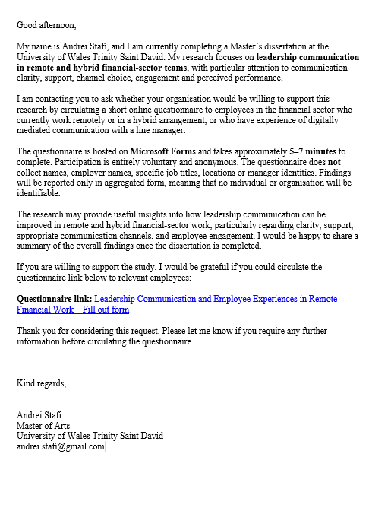

Appendix 1B: Online Questionnaire Cover Letter / Participant Introduction
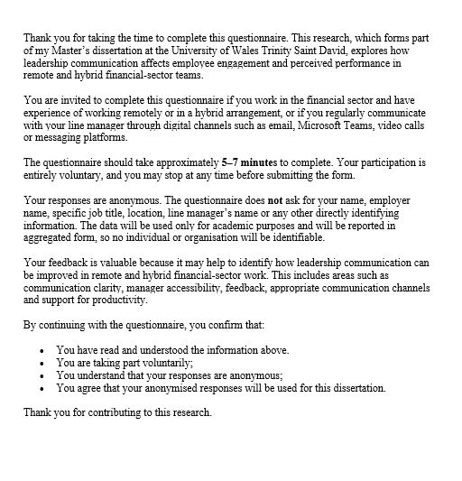

Appendix 2 - Online Questionnaire
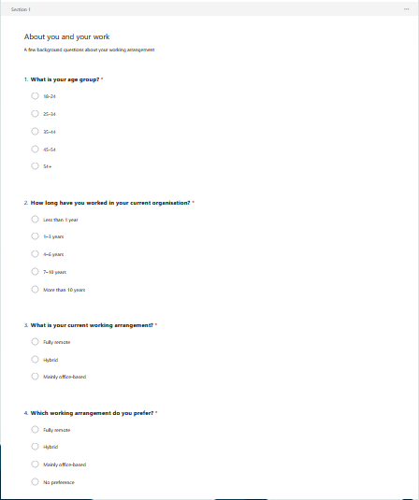

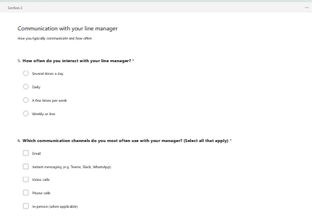

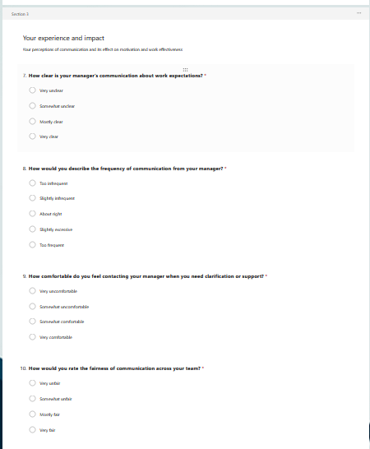

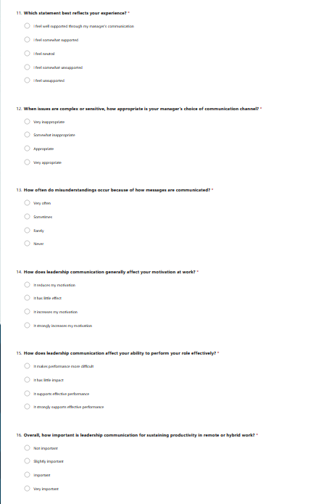

Appendix 3 – Interviews
Interview 1 - Retail bank operations team leader
Q1. Role and team context
A1. I’m a team leader in retail banking operations, managing 11 case handlers. We’re hybrid: most people do three days at home, two in the office. Work is high-volume, customer requests, account changes, and checks with compliance implications.
Q2. Communication routines
A2. Mostly Teams chat for quick questions, email for anything that needs a record, and video calls for weekly team meetings. I do short daily check-ins via chat and a 15-minute stand-up twice a week.
Q3. Clarity and expectation-setting
A3. I try to be very explicit: what’s priority today, what “good” looks like, and deadlines. For riskier tasks I use a checklist and confirm understanding, either a quick “reply with your next step” or a short call. I’d rather repeat myself once than fix an error later.
Q4. Channel choice
A4. Routine updates go in Teams and then pinned. If it’s sensitive, performance, conduct, or customer complaints, I use a call or video. If it’s complex and people need to follow steps, I send an email summary after a call so there’s a clear record.
Q5. Feedback and performance conversations
A5. Informal feedback is daily: quick messages or a short call. Formal feedback is monthly one-to-ones by video, with written notes. The challenge with tone is that some people read a message as criticism. For corrective feedback, I always use voice first.
Q6. Trust, autonomy, and oversight
A6. I trust people, but oversight is necessary. We track productivity and error rates. I’m transparent about it: I frame metrics as support and risk control, not surveillance. Autonomy increases with demonstrated competence, new starters get more frequent check-ins.
Q7. Psychological safety
A7. I make it normal to ask questions. In meetings, I say “if you’re unsure, that’s a risk, ask early.” I also share mistakes I’ve made to reduce fear. The hardest part is getting quieter staff to speak up online, so I use chat prompts and follow up 1:1.
Q8. Examples and improvement
A8. A good example was a process change: we ran a short video briefing, shared a one-page guide, and had a dedicated Q&A channel. Errors dropped quickly. A bad example was when an urgent update went out by chat only, half the team missed it. Going forward, I’d use one standard “single source of truth” and reinforce it consistently.
Interview 2 - Insurance claims manager
Q1. Role and team context
A1. I manage an insurance claims team of eight. We’re mostly remote, with one office day per month. Work involves sensitive customer situations, and accuracy matters because decisions can be challenged.
Q2. Communication routines
A2. Teams for day-to-day coordination, weekly video team meeting, and fortnightly one-to-ones. Email is used for anything policy-related or where the audit trail matters.
Q3. Clarity and expectation-setting
A3. I separate “what must be done” from “what’s optional.” For complex claims I clarify decision ownership: who signs off, what evidence is required, what timescales apply. I also write decisions in plain language to reduce back-and-forth.
Q4. Channel choice
A4. Complex issues start with a call. I don’t rely on chat for emotionally sensitive situations. For policy interpretation, I use email and reference the policy clause. For team learning points, I share short written summaries.
Q5. Feedback and performance conversations
A5. Remote feedback is harder because you don’t notice stress as easily. I ask directly, “How are you coping with the workload?” For performance concerns, I use a call, then follow up in writing. The upside is that people sometimes open up more from home.
Q6. Trust, autonomy, and oversight
A6. Autonomy is high because experienced handlers know their work. Oversight is through sampling and peer review, not constant monitoring. If error rates rise, we increase coaching rather than micromanaging.
Q7. Psychological safety
A7. We use “no blame” language for near-misses. People can raise concerns in the meeting chat or privately. I also rotate who presents a tricky case so everyone contributes, and it normalises uncertainty.
Q8. Examples and improvement
A8. When communication works well, it’s predictable: everyone knows where to find updates. When it fails, it’s usually because people get different messages from different leaders. Improvement would be clearer coordination across management, one message, one channel, one timing.
Interview 3 - Asset management compliance manager
Q1. Role and team context
A1. I’m a compliance manager at an asset management firm, leading a team of 5. We’re hybrid: two office days. Our work is advisory and monitoring, policy, conduct, and regulatory reporting.
Q2. Communication routines
A2. Email for formal guidance, Teams for quick coordination, and video for decision meetings. We have a weekly compliance huddle and ad hoc calls when regulatory issues arise.
Q3. Clarity and expectation-setting
A3. Clarity is essential because misinterpretation can create regulatory exposure. I use structured templates: issue, rule reference, risk level, required action, deadline. I also confirm understanding by asking colleagues to summarise the agreed action.
Q4. Channel choice
A4. If it needs an audit trail, it’s email. If it’s complex and contentious, it starts as a discussion on a call, then we document the conclusion. For sensitive issues, potential breaches, I restrict discussion to approved channels and small groups.
Q5. Feedback and performance conversations
A5. Feedback is regular because compliance work is judgment-heavy. Remotely, I’m careful to avoid ambiguity, short messages can sound directive. I prefer a quick call, then notes. For development, we review case decisions together.
Q6. Trust, autonomy, and oversight
A6. High autonomy, but there are controls. We document the rationale for decisions and maintain logs. Oversight is mainly quality assurance and peer challenge rather than productivity metrics.
Q7. Psychological safety
A7. Psychological safety is critical because people must escalate issues early. I encourage challenge by explicitly asking “What’s the risk we might be missing?” and thanking people for raising concerns. The risk in finance is that people fear consequences, so leaders need to respond constructively.
Q8. Examples and improvement
A8. A good example: a regulatory update, briefed on a call, then documented with action owners. A bad example: a complex issue discussed informally in chat, which led to confusion and inconsistent advice. Improvement: stricter discipline on channel choice for high-risk topics.
Interview 4 - Fintech payments operations manager
Q1. Role and team context
A1. I manage payment operations in a fintech. Team of 12 across different locations. Remote-first, with optional co-working meetups. Work is incident-driven, payment failures, reconciliations, and partner escalations.
Q2. Communication routines
A2. Slack/Teams for rapid coordination, Jira for work tracking, daily stand-up on video. Email only for external partners or formal notices. During incidents we use a dedicated channel and a named incident lead.
Q3. Clarity and expectation-setting
A3. We define roles upfront: who leads, who communicates, who documents. For normal work we use written tickets with acceptance criteria. It reduces ambiguity, especially across time zones.
Q4. Channel choice
A4. Incidents: live chat plus short calls. Complex decisions: video. Routine updates: written. Sensitive topics: 1:1 call. The key is not mixing channels randomly, people miss things.
Q5. Feedback and performance conversations
A5. Feedback is frequent and specific: “what went well, what to improve.” Remotely, I schedule one-to-ones consistently. The challenge is new joiners, without hallway learning, you must coach deliberately.
Q6. Trust, autonomy, and oversight
A6. We trust by default but track outcomes: incident resolution time, error rates, and post-mortems. I avoid micromanagement; instead, we agree standards and review performance against them.
Q7. Psychological safety
A7. Post-incident reviews are blame-free. People can say “I made a mistake” without punishment. That’s critical; otherwise issues get hidden. I model it by owning my own errors.
Q8. Examples and improvement
A8. Best: a major incident, clear roles, frequent updates, documented decisions. Worst: when a leader sent a late-night “urgent” message without context; it created panic. Improvement: standardise urgency labels and expectations for response times.
Interview 5 - KYC/AML operations manager
Q1. Role and team context
A1. I’m an AML/KYC operations manager in a financial services firm. I manage 15 analysts. Hybrid: two days in office. Work is compliance-heavy and deadline-driven.
Q2. Communication routines
A2. Teams for daily work and questions, email for policy and escalations. We do a Monday planning call and short midweek check-ins. I also use a shared dashboard for workload.
Q3. Clarity and expectation-setting
A3. I clarify priorities based on risk rating and SLA deadlines. I provide examples of “acceptable evidence” and “common errors.” People need certainty because the rules are strict.
Q4. Channel choice
A4. For case discussions, Teams works if it’s simple. For complex or borderline cases, I use a call to talk it through, then document the decision. For sensitive performance issues, always a private call.
Q5. Feedback and performance conversations
A5. Remote makes it harder to catch issues early unless you check in. I do weekly one-to-ones with newer staff and fortnightly with experienced staff. I use screen share to coach through cases.
Q6. Trust, autonomy, and oversight
A6. Oversight is a reality: audits, QA checks, metrics. I explain the “why”, it protects the firm and the individual. If people understand the purpose, they respond better and trust remains intact.
Q7. Psychological safety
A7. I encourage escalation by rewarding it, if someone flags a risk early, I recognise it. I avoid blaming when someone asks a “basic” question. In compliance work, silence is dangerous.
Q8. Examples and improvement
A8. Good: a policy change communicated via a brief video and a written checklist; adoption was smooth. Bad: inconsistent guidance from different managers; it created rework. Improvement: align managers first, then communicate one consistent message.

